S-Figure 1. Flow diagram of research screening.
Identification of studies via databases and registers

Records removed before screening:
- Duplicate records removed (n = 80)
- Records marked as ineligible by automation tools (n = 0)
- Records removed for other reasons (n = 0)
Records identified from:
Medline (n = 86)
LILACS (n= 96)

Total = 182

Identification

Records excluded (n = 86):
- Background article (n = 11)
- Publication type not of interest (n = 58)
- Population not of interest (n= 10)
- Outcome not of interest (n = 7)
Records screened
(n = 102)

Reports not retrieved (n = 0)
Reports sought for retrieval
(n = 16)
Screening

Reports excluded (n = 0):
Reports assessed for eligibility
(n = 16)

Studies included in review
(n = 16)

Included

Medline: ((((multiple myeloma[Title/Abstract]) OR (myeloma[Title/Abstract])) AND ((((((((((bispecific antibod*[Title/Abstract]) OR (BiTEs[Title/Abstract])) OR (elranatamab[Title/Abstract])) OR (teclistamab[Title/Abstract])) OR (talquetamab[Title/Abstract])) OR (CAR-T[Title/Abstract])) OR (idecabtagene[Title/Abstract])) OR (idecel[Title/Abstract])) OR (ciltacabtagene[Title/Abstract])) OR (ciltacel[Title/Abstract]))) AND (infection[Text Word])) NOT (review[Publication Type])) NOT (lymphoma[Title])
#1 Multiple myeloma [Ti/Ab] OR myeloma [Ti/Ab] - #2 bispecific [Ti/Ab] OR bites [Ti/Ab] OR elranatamab [Ti/Ab] OR teclistamab [Ti/Ab] OR talquetamab [Ti/Ab] OR CAR-T [Ti/Ab] OR idecabtagene [Ti/Ab] OR ciltacabtagene [Ti/Ab] - #3 infection [TW] - #4 review [PT] - #5 lymphoma [Ti]. #1 AND #2 AND #3 NOT #4 NOT #5.

LILACS: (ti:(myeloma)) AND (ti:(bispecific )) OR (ti:(car-t)) AND (safety)

S-Table 1. Quality assessment of the studies.
Study | 1 | 2 | 3 | 4 | 5 | 6 | 7 | 8 | 9 | 10 | 11 | 12 | 13 | 14 | 15 | 16 | 17 | 18 | 19 | 20 | Quality score
BiTEs
Mohan  2024 | Y | N | Y | Y | Y | Y | Y | Y | Y | Y | N | Y | Y | Y | Y | Y | Y | Y | Y | Y | 18/20
Riedhammer  2024 | Y | N | Y | Y | Y | Y | Y | Y | Y | Y | N | Y | Y | Y | Y | Y | Y | Y | Y | Y | 18/20
Al Hadidi  2025 | Y | N | Y | Y | Y | Y | Y | Y | Y | Y | N | Y | Y | Y | Y | Y | Y | Y | Y | Y | 18/20
Cani  2025 | Y | N | N | Y | Y | Y | Y | Y | Y | Y | N | Y | Y | Y | Y | Y | Y | Y | Y | Y | 17/20
Frenking  2025 | Y | N | Y | Y | Y | Y | Y | Y | Y | Y | N | Y | Y | Y | Y | Y | Y | Y | Y | Y | 18/20
Mian  2025 | Y | N | Y | Y | Y | Y | Y | Y | Y | Y | N | Y | Y | Y | Y | Y | Y | Y | Y | Y | 18/20
Razzo  2025 | Y | N | Y | Y | Y | Y | Y | Y | Y | Y | N | Y | Y | Y | Y | Y | Y | Y | Y | Y | 18/20
Sheu  2025 | Y | N | N | Y | Y | Y | Y | Y | Y | Y | N | Y | Y | Y | Y | Y | Y | Y | Y | Y | 17/20
Stork  2025 | Y | N | Y | Y | Y | Y | Y | Y | Y | Y | N | Y | Y | Y | Y | Y | Y | Y | Y | Y | 18/20
Tan  2025 | Y | N | Y | Y | Y | Y | Y | Y | Y | Y | N | Y | Y | Y | Y | Y | Y | Y | Y | Y | 18/20
Yi  2025 | Y | N | Y | Y | Y | Y | Y | Y | Y | Y | N | Y | Y | Y | Y | Y | Y | Y | Y | Y | 18/20
CAR-T
Logue  2022 | Y | N | Y | Y | Y | Y | Y | Y | Y | Y | N | Y | Y | Y | Y | Y | Y | Y | Y | Y | 18/20
Rejeski  2023 | Y | N | Y | Y | Y | Y | Y | Y | Y | Y | N | Y | Y | Y | Y | Y | Y | Y | Y | Y | 18/20
Dima  2024 | Y | N | Y | Y | Y | Y | Y | Y | Y | Y | N | Y | Y | Y | Y | Y | Y | Y | Y | Y | 18/20
Trando  2024 | Y | N | N | Y | Y | Y | Y | Y | Y | Y | N | Y | Y | Y | Y | Y | Y | Y | Y | Y | 17/20
Sidana  2025 | Y | N | Y | Y | Y | Y | Y | Y | Y | Y | N | Y | Y | Y | Y | Y | Y | Y | Y | Y | 18/20
Y = YES; N = NO; P = PARTIAL; U = UNCLEAR. A study with ≥ 70% of positive responses (12/18 or 14/20) was considered to be of acceptable quality.

Institute of Health Economics (IHE). Quality Appraisal of Case Series Studies Checklist. Edmonton (AB): Institute of Health Economics; 2014. Available from: http://www.ihe.ca/research-programs/rmd/cssqac/cssqac-about
References:
Moga C, Guo B, Schopflocher D, Harstall C. Development of a quality appraisal tool for case series studies using a modified Delphi technique. Edmonton: Institute of Health Economics; 2012. Available at http://www.ihe.ca/advanced-search/development-of-a-quality-appraisal-tool-for-case-series-studies- using-a-modified-delphi-technique . Accessed January 8, 2016.
Guo B, Moga C, Harstall C, Schopflocher D. A principal component analysis is conducted for case series quality appraisal checklist. Journal of Clinical Epidemiology 2016;69:199-207.
S-Table 2. Summary of Findings Table.
- Summary of findings table for BiTEs therapy.
Certainty assessment |  |  |  |  |  |  | № of patients |  | Effect |  | Certainty | Importance
№ of studies | Study design | Risk of bias | Inconsistency | Indirectness | Imprecision | Other considerations | Treated | Untreated | Relative  (95% CI) | Absolute  (95% CI) | Certainty | Importance
Infection risk for BiTEs therapy (follow-up: mean 7.8 months; assessed with: proportion rate)
11ª | non-randomised studies | serious^{b} | not serious^{c} | not serious | not serious^{d} | publication bias suspected^{e} | 1,602 | -^{f} | - | 0.26  (0.23 to  0.30) | ⨁⨁◯◯  Low | CRITICAL

CI: confidence interval.

Explanations
a. All included studies scored above 70% on the IHE checklist, indicating good methodological quality.
b. All included studies were retrospective observational analyses. As such, they are subject to inherent limitations, including potential selection bias, incomplete outcome reporting, and variability in follow-up and infection ascertainment. However, the outcome (grade 3-4 infections) is relatively objective, which mitigates some risk. Overall, the risk of bias was considered serious.
c. Moderate heterogeneity was observed (I²=50.6%), indicating variability among study estimates. The direction of the effect was consistent across studies, and the confidence interval of the pooled proportion was relatively narrow (0.23-0.30). Therefore, inconsistency was judged not serious.
d. The pooled infection rate was 0.26 (95% CI 0.23-0.30), with a narrow confidence interval indicating a precise estimate of the proportion of patients experiencing infection. The sample size and number of events were sufficient to ensure statistical stability, and therefore imprecision is not considered serious.
e. Publication bias was assessed using a funnel plot of Freeman–Tukey transformed proportions and further tested with Egger’s regression. The funnel plot indicates a potential publication bias. The Egger's test supports the presence of funnel plot asymmetry (intercept: 3.14, 95% CI:1.66 - 4.62, t: 4.162, p-value: 0.002). The certainty of the evidence was downgraded by one level for suspected publication bias.
f. Control group are not considered in this meta-analysis.

- Summary of findings table for CAR-T therapy.
Certainty assessment |  |  |  |  |  |  | № of patients |  | Effect |  | Certainty | Importance
№ of studies | Study design | Risk of bias | Inconsistency | Indirectness | Imprecision | Other considerations | Treated | Untreated | Relative  (95% CI) | Absolute  (95% CI) | Certainty | Importance
Infection risk for CAR-T therapy (follow-up: mean 10 months; assessed with: proportion rate)
5ª | non-randomised studies | serious^{b} | serious^{c} | not serious | not serious^{d} | publication bias not suspected^{e} | 495 | -^{f} | - | 0.19  (0.12 to  0.27) | ⨁⨁◯◯  Low | CRITICAL

CI: confidence interval.

Explanations
a. All included studies scored above 70% on the IHE checklist, indicating good methodological quality.
b. All included studies were retrospective observational analyses. As such, they are subject to inherent limitations, including potential selection bias, incomplete outcome reporting, and variability in follow-up and infection ascertainment. However, the outcome (grade 3-4 infections) is relatively objective, which mitigates some risk. Overall, the risk of bias was considered serious.
c. High heterogeneity was observed (I²=70.9%), indicating high variability among study estimates. The direction of the effect was consistent across studies, and the confidence interval of the pooled proportion was relatively narrow (0.12-0.27). Therefore, inconsistency was judged serious.
d. The pooled infection rate was 0.19 (95% CI 0.12-0.27), with a narrow confidence interval indicating a precise estimate of the proportion of patients experiencing infection. The sample size and number of events were sufficient to ensure statistical stability, and therefore imprecision is not considered serious.
e. Publication bias was assessed using a funnel plot. The funnel plot does not indicate a potential publication bias. The Egger's test does not support the presence of funnel plot asymmetry (intercept: 2.54, 95% CI:-1.93 - 7.01, t: 1.113, p-value: 0.347).
f. Control group are not considered in this meta-analysis.
S-Figure 2. Meta-regression analysis for percentage of BCMA exposed patients prior BiTEs therapy.
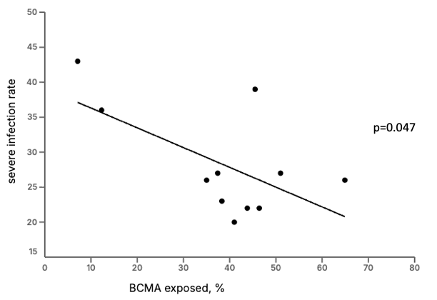
Meta-regression analysis for percentage of BCMA exposed patients for each study on infection rate (%).
S-Figure 3. Meta-analysis excluding outlier studies.
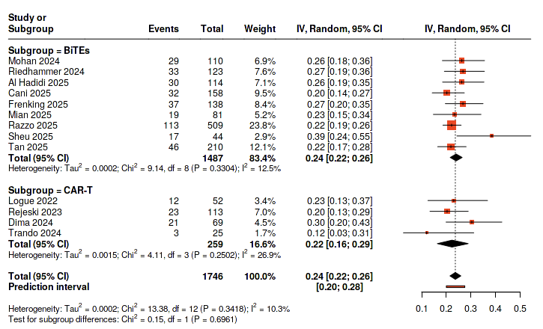
Meta-analysis of patients with multiple myeloma assessing grade 3-4 infection events excluding outlier studies. Effects are expressed as pooled event rates with 95% confidence intervals (CIs).
S-Table 3. Severe infection rate, BiTEs and CAR-T-related toxicities, overall remission rate and substitutive immunoglobulins use across the studies.
study,  year | n° patients | patients with Grade 3-4 infection,  n° (%) | CRS all grade, % | ICANS, % | ORR, % | Immunoglobulins supplementation, %
Mohan, 2024 | 110 | 29 (26) | 56 | 11 | 62 | 43
Riedhammer, 2024 | 123 | 33 (26.8) | 58.5 | 7.3 | 59.3 | n.a.
Al Hadidi, 2025 | 114 | 20 (17.5) | 54* | 9.8* | 73* | 61
Cani, 2025 | 158 | 39 (24.7) | 25 | 11 | n.a. | 70*
Frenking, 2025 | 138 | 37 (28.2) | 70* | 9* | 65 | 50
Mian, 2025 | 81 | 19 (23.4) | 49.4 | 16.9 | 63* | n.a.
Razzo, 2025 | 509 | 113 (22) | 54 | 11 | 53* | 38
Sheu, 2025 | 44 | 17 (38.6) | n.a. | n.a. | n.a. | 65.2
Stork, 2025 | 73 | 26 (35.6) | 47.9 | 2.7 | 58.8* | 75.3
Tan, 2025 | 210 | 46 (21.9) | 54 | 7.3* | 67 | 62*
Yi, 2025 | 42 | 18 (42.9) | 47.6 | 0 | 66.7 | 50
Logue, 2022 | 52 | 12 (23) | 85 | 20 | 92 | 13
Rejeski, 2023 | 113 | 23 (20.4) | n.a. | 20.4 | 85.2 | 21.2
Dima, 2024 | 69 | 21 (30) | 81 | 28 | 93 | n.a.
Trando, 2024 | 25 | 3 (12) | 92 | 12 | 84 | 80
Sidana, 2025 | 236 | 49 (20.8) | 75.3* | 13.9* | 89 | n.a.
total | 2,097 | 505 (24.2)§ | 57.5§ | 11.6§ | 67.8§ | 48.4§

CRS, cytokine release syndrome; ICANS, immune effector cell-associated neurotoxicity syndrome; n.a., not available; ORR, overall response rate.
*Percentage is calculated based on total of patients assessed for that clinical manifestation.
§The denominator does not include patients that were not assessed for that clinical manifestation.

