Supplementary Information (SI)

Plasma Sheath Effects on Reactivity and Selectivity in Nonthermal Plasma Catalysis

Jiangqi Niu^{a,b}, Shaowei Chen^{a,c}, Yibing Muª, Tianqi Liuª, Liguang Dou^{d}, Qingyang Lin^{a,e}, Jianguo Huangª, Quan Manh Phung^{f,g}, Ho Ngoc Nam^{h,*}, Yusuke Yamauchi^{h,i}, Annemie Bogaerts^{j}, Tao Shao^{k,*}, Huanhao Chen^{c,*}, Xiaolei Fan^{a,l,m∗}

ªWenzhou Key Laboratory of Novel Optoelectronic and Nano Materials, Institute of Wenzhou, Zhejiang University, Wenzhou 325006, China
^{b}Department of Chemical and Biomolecular Engineering, National University of Singapore, Engineering Drive 4, Singapore 117585, Singapore
^{c}State Key Laboratory of Materials-Oriented Chemical Engineering, College of Chemical Engineering, Nanjing Tech University, Nanjing 211816, China
^{d}Institute of Electrical Engineering, Chinese Academy of Sciences, Beijing 100190, China
^{e}State Key Laboratory of Clean Energy Utilization, Zhejiang University, Hangzhou 310027, China
^{f}Department of Chemistry, Graduate School of Science, Nagoya University, Furu-cho, Chikusa-ku, Nagoya 464–8602, Japan
^{g}Institute of Transformative Bio-Molecules (WPI-ITbM), Nagoya University, Furu-cho, Chikusa-ku, Nagoya 464–8601, Japan
^{h}Department of Materials Process Engineering, Graduate School of Engineering, Nagoya University, Furu-cho, Chikusa-ku, Nagoya 464–8603, Japan
^{i}School of Chemical Engineering and Australian Institute for Bioengineering and Nanotechnology (AIBN), The University of Queensland, Brisbane, QLD 4072, Australia
^{j}PLASMANT, Centre of Excellence PLASMA, and Electrification Institute, University of Antwerp, 2020 Antwerp, Belgium
^{k}State Key Laboratory of Power Grid Environmental Protection, School of Electrical Engineering and Automation, Wuhan University, Wuhan 430072, China
^{l}Ningbo China Beacons of Excellence Research and Innovation Institute, University of Nottingham Ningbo China, 211 Xingguang Road, Ningbo 315048, China
^{m}Department of Chemical Engineering, School of Engineering, The University of Manchester, Oxford Road, Manchester M13 9PL, United Kingdom

Supplemental Contents
Section 1. Historical Milestones and Key Studies on Plasma Sheaths
Section 2. Estimation of Boundary Layer Thickness over Catalyst Particles under Different Gas Compositions
Section 3. Catalytic Performance Evaluation
Section 4. Supplementary Experimental Methods
Section 5. Supplementary Characterization of Catalysts
Section 6. Literature Comparison of Plasma Catalytic Reactions
Section 7. Supplementary Method of Lissajous-figure for Power Calculation of DBD
Section 8. Supplementary Analysis of Plasma Properties of DBD
Section 9. Supplementary Method for Plasma Parameter Calculations Using OES
Section 10. Debye Length and Plasma Sheath Calculation
Section 11. Supplementary Method for Numerical Simulation of Particle Dynamics in Plasma Catalysis
Section 12. Supplementary Analysis of Plasma Properties of the DRIFTS Cell
Section 13. Supplementary In-situ DRIFTS Characterization
Section 14. Supplementary Details of DFT Calculations
Section 15. Supplementary Content of Reaction Pathways
Section 16. Timescale Comparison Between Plasma-Species Lifetime and Internal Diffusion
Supplementary References
Monte Carlo Simulation Code

Section 1. Historical Milestones and Key Studies on Plasma Sheaths
Table S1. Overview of key research on sheath dynamics and their role in energy transfer and mass transport.
Year | Authors | Title | Methods | Key Conclusions
1923 | Langmuir¹ | Positive Ion Currents from the Positive Column of Mercury Arcs. | Observations on Mercury Arc Discharges and Theoretical Analysis. | The sheath, first described by Langmuir in 1923, acts as a positive ion-dominant region near electrodes where electron density is nearly zero. This generates an electric field that accelerates positive ions, regulates the flux and energy of reactive species, and mediates energy partitioning and momentum transfer between the discharge bulk and the surface of the electrode.
1928 | Langmuir² | Oscillations in Ionized Gases. | Plasma Oscillation Equations. | First introduced the term ‘plasma’ into the subject of ionized gases. He wrote ‘except near the electrodes, where there are sheaths containing very few electrons, the ionized gas contains ions and electrons in about equal numbers so that the resultant space charge is very small. We shall use the name plasma to describe this region containing balanced charges of ions and electrons.
1929 | Langmuir³ | The Interaction of Electron and Positive Ion Space Charges in Cathode Sheath. | Plasma Balance Equations and Steady-State Analysis. | The sheath edge marks the transition between quasi-neutral plasma and the sheath. Proposed plasma balance equations, where particle generation matches wall losses. Extend the sheath theory to define the sheath edge and analyze plasma-sheath transitions.
1949 | Bohm⁴ | The Characteristics of Electrical Discharges in Magnetic Fields. | Introduced the Bohm Criterion via Theoretical Derivations. | Provide a criterion for ion velocity at the sheath edge to ensure proper sheath formation based on three assumptions, including firstly that the ionization in the sheath is negligible, secondly that the electric field at the plasma edge is negligible, and thirdly that the energy distribution of the ions can be neglected.
1991 | Riemann⁵ | The Bohm Criterion and Sheath Formation. | Kinetic and Fluid Models of Plasma-Sheath Dynamics. | The transition problem of plasma sheath under the small Debye length limit was discussed, as the extension of the Bohm criterion and its adaptation to different ion-electron distribution and boundary conditions, and proposed that due to the singularity of the sheath edge field, the smooth transition between the front sheath and the sheath requires additional transition layers.
2003 | Sternberg & Godyak⁶ | Patching Collisionless Plasma and Sheath Solutions to Approximate the Plasma-Wall Problem. | Developed Direct Patching Methods for Plasma and Sheath Solutions. | Proposed an efficient patching technique to approximate the plasma-wall problem, bypassing the need for intermediate layers.
2003 | Franklin⁷ | The Plasma–Sheath Boundary Region. | Review of Theoretical Developments from Langmuir to Modern Dynamic Sheath Theories. | Review of historical and contemporary theories on plasma-sheath boundaries, emphasizing the Bohm criterion's role and modern developments like PUL-driven sheath dynamics.
2004 | Kato et al.⁸ | Freestanding Individual Single-Walled Carbon Nanotube Synthesis Based on Plasma Sheath Effects. | Plasma-Enhanced CVD (PECVD) Method. | Owing to a strong electric field in a plasma sheath region, all of the CNTs are individually standing in a vertical direction along the electric field in the plasma sheath region at relatively low temperatures.
2005 | Hershkowitz⁹ | Sheaths: More Complicated Than You Think. | Probe Method. | This study presents experimental investigations of sheaths and presheaths in weakly collisional plasmas using emissive probes operated at the "zero emission limit." These probes achieve high potential resolution (0.1 V) and spatial resolution (0.1 cm), enabling sensitive diagnostics of plasma potential.
2006 | Qin &  McTeer¹⁰ | A Nonperturbing Real-Time In Situ Plasma Diagnosis Technique Using an Optical Emission Spectrometer (OES). | OES Method. | This paper presents the first method using OES to measure the sheath thickness, δ_{s}, (dark space) in pulsed glow discharges in real-time and without perturbing the plasma. The δ_{s}, depends on ion density and applied voltage. The OES technique is suitable for pulse-mode plasmas and can create detectable sheaths in continuous plasmas.
2007 | Sternberg & Godyak¹¹ | The Bohm Plasma-Sheath Model and the Bohm Criterion Revisited. | Geometric Theory of Differential Equations. | This paper reexamines the Bohm criterion in the plasma-sheath model, highlighting Bohm's misinterpretation of the reference point and sheath edge, leading to the incorrect application of the Bohm criterion to the sheath edge. The paper clarifies that the Bohm criterion indicates ions in the sheath must have a velocity greater than the ion sound speed, but it does not specify the sheath boundary.
2011 | Kato et al.¹² | Diameter Tuning of Single-Walled Carbon Nanotubes by Diffusion Plasma CVD. | Plasma-Enhanced CVD (PECVD) Method. | Since the polarization constant of SWNTs in an axial direction is extremely high, a strong dipole moment is induced in the axial tube direction in the presence of electric fields.
2011 | A E Rider  et al.¹³ | Minimizing the Gibbs–Thomson Effect in the Low-Temperature Plasma Synthesis of Thin Si Nanowires. | Plasma-Enhanced CVD (PECVD) Method. | Allows one to produce nanowires at temperatures below 600 °C and reduce their lowest possible thickness (size limit), in part due to the enhanced flux of vapor-phase species through the plasma sheath and more effective dissolution.
2012 | Neyts & Bogaerts  et al.¹⁴ | Electric Field Effect in the Simulation of CNT Growth. | Computational Modeling. | This study focused on the effect of applying an electric field on the SWNT growth process, as one of the sheath effects coming into play in PECVD. Using sufficiently strong fields results in (a) alignment of the growing SWNTs, (b) a better ordering of the carbon network, and (c) a higher growth rate relative to the thermal growth rate.
2012 | Wang & Kong | Wall Fluxes of Reactive Oxygen Species of a PUL Atmospheric-Pressure Plasma and Their Dependence on Sheath Dynamics. | Computational Modeling. | The study found that in PUL atmospheric-pressure plasmas, the wall fluxes of reactive oxygen species are primarily composed of neutral oxygen, oxygen molecular cations, and oxygen anions. These fluxes originate from a boundary layer of 3–300 micrometers near the electrode, and the thickness of this layer is related to the sheath. The flux of neutral species remains largely constant.
2014 | Chabert¹⁵ | What is the Size of a Floating Sheath? | Numerical Integration of the Fluid Equations. | In the case of low-pressure plasmas, the floating sheath size varies between approximately 7 and 14 Debye length. However, if the sheath edge is defined as a region with significant space charge, the floating sheath size is almost independent of discharge parameters and can be approximated as 5 Debye length.
2016 | Neyts¹⁶ | Plasma-Surface Interactions in Plasma Catalysis. | Reviewed the Surface Interaction Processes Occurring in Plasma Catalysis. | The paper emphasizes that the core dynamic process in plasma catalysis is plasma-surface interaction, and points out that the energy of ions in the sheath consists of kinetic energy and potential energy. The kinetic energy of the ions is described by the ion energy distribution function (IEDF) and is determined by the sheath potential and the collisional processes in the sheath.
2015 | Neyts, Ostrikov & Bogaerts  et al.¹⁷ | Plasma Catalysis: Synergistic Effects at the Nanoscale. | Reviewed the Sheath Effect in the Plasma-Surface Interactions. | The sheath is extremely important in plasma-processing applications, as it determines the fluxes and energies of the (charged) species reaching the surface. Also, the plasma−surface interactions are determined, to a large extent, by the electric field distribution in the plasma and especially in the sheath, as well as by closely related plasma characteristics.
2016 | Zhang & Bogaerts  et al.¹⁸ | Can Plasma Be Formed in Catalyst Pores? A Modeling Investigation. | A Two-Dimensional Fluid Model. | This paper investigates the microdischarge behavior inside catalyst pores and concludes that the sheath inside the pore is formed due to the strong electric field and high electron temperature. Specifically, for pore sizes larger than 200 μm, the electron and ion densities inside the pore show a significant increase, indicating that microdischarges are formed within the pore (in the case of He discharge).
2018 | He-Ping Li  et al.¹⁹ | The Energy Tree: Non-Equilibrium Energy Transfer in Collision-Dominated Plasmas. | Fluid Modeling in Atmospheric-Pressure DBD Plasmas with Low Knudsen Numbers. | Highlighted the significance of sheath dynamics in collision-dominated plasmas (CDPs), demonstrating their role in energy transfer and mass transport, particularly at low Knudsen numbers (Kn < 0.1). Plasma sheath models are divided into simplified models, which neglect the sheath but ensure current flow, and complex models, which divide the sheath into sub-layers to predict arc plasma characteristics, with the sheath primarily affecting cathode heating, arc column heating, and electrode attachment modes.
2018 | Zhang & Bogaerts²⁰ | Propagation of a Plasma Streamer in Catalyst Pores. | PIC-MCC Simulations of Plasma Streamers in Nanopores. | Plasma streamers can penetrate pores when the pore diameter is larger than the Debye length (typically above 500 nm for typical plasma catalysis applications). For pores of approximately 50 nm, the plasma streamer can only partially penetrate for a short time, after which a sheath is formed on the surface.
2019 | Carreon²¹ | Plasma Catalysis: A Brief Tutorial. | Reviewed the Sheath Effect in the Plasma-Surface Interactions. | This work reviewed that the sheath is that it is a thin region surrounding the plasma, typically an ion sheath, which serves to balance the electron and ion currents lost from the plasma. In DBD, the sheath layer is usually a few micrometers and helps to improve the interaction between the catalyst and plasma species.
2021 | Song et al.²² | Plasma-Enhanced Catalytic Reduction of SO₂: Decoupling Plasma-Induced Surface Reaction from Plasma-Phase Reaction. | Experimental Study in Non-Thermal Plasma with Catalyst Surfaces. | This study mentions the effect of the sheath, where plasma application causes all exposed surfaces to acquire a negative charge, creating a region with an excess of positive charges near the surface, known as the plasma sheath. The presence of the sheath may alter the behavior of adsorbed species, leading to partial desorption before the thermal effects occur.
2021 | Bruggeman et al.²³ | Tuning Plasma Parameters to Control Reactive Species Fluxes to Substrates in the Context of Plasma Catalysis. | Experimental Study of Plasma Jet. | The study mentions that when a sheath forms on the catalytic substrate, the role of ions may be more significant compared to when there is no sheath. When the electric field is enhanced in the plasma jet system, the ion flux increases by one order of magnitude, which is consistent with the increase in ion density on the surface.
2021 | Vanraes & Bogaerts²⁴ | The Essential Role of the Plasma Sheath in Plasma–Liquid Interaction and Its Applications —A Perspective. | Theoretical Review and Analysis of Plasma-Liquid Interfaces. | Highlighted sheath roles in regulating electric fields, ion energy, and chemical reactions at liquid interfaces. Sheaths act as microreactors, accelerating surface interactions and material synthesis processes.

Section 2. Estimation of Boundary Layer Thickness over Catalyst Particles under Different Gas Compositions
To assess whether the plasma sheath region can be considered within the gas boundary layer (and thus treated as a quasi-stationary region), we estimated the viscous boundary-layer thickness (δ_{v}) over spherical catalyst particles (diameter L = 50 μm) under different gas compositions, all at a total volumetric flow rate of 50 mL min^{‒1} through a 6 mm inner-diameter tubular reactor. The average gas velocity was calculated from the flow rate and cross-sectional area, yielding u ≈ 0.03 m s^{‒1}.
The boundary-layer thickness (as summarized in Table S2) was estimated using the classical Blasius-type correlation²⁵ for laminar flow:
(Eq. S1)
Where:
μ: dynamic viscosity of the gas mixture
ρ: gas mixture density
L: particle diameter
u: gas velocity

Table S2. Estimation of boundary-layer thickness over catalyst particles under different gas compositions (gas mixture density and viscosity were calculated using mole-fraction-weighted averages based on standard values at ambient conditions).
Gas Composition | ρ (kg m^{‒3}) | μ (Pa s) | Reynolds Number (Re) | δ_{v} (mm)
CO₂ (50 mL min^{‒1}) | 1.84 | 1.47 × 10^{‒5} | 1.8 × 10^{‒1} | 0.58
H₂ (50 mL min^{‒1}) | 0.09 | 8.90 × 10^{‒6} | 1.5 × 10^{‒2} | 2.05
N₂ (50 mL min^{‒1}) | 1.17 | 1.76 × 10^{‒5} | 9.8 × 10^{‒2} | 0.80
CO₂ (10 mL min^{‒1})  H₂ (40 mL min^{‒1}) | 0.44 | 1.01 × 10^{‒5} | 6.4 × 10^{‒2} | 0.98
CO₂ (10 mL min^{‒1})  H₂ (30 mL min^{‒1}) | 0.53 | 1.03 × 10^{‒5} | 7.5 × 10^{‒2} | 0.91
N₂ (25 mL min^{‒1})  H₂ (25 mL min^{‒1}) | 0.63 | 1.33 × 10^{‒5} | 8.4 × 10^{‒2} | 0.86

Section 3. Catalytic Performance Evaluation
Ni-based catalysts supported on layered double hydroxides (LDH), mesoporous silica (MCM-41), and zeolites (HZSM-5) are among the most widely used and well-understood platforms for plasma-assisted CO₂ methanation, NH₃ synthesis, and CO₂ hydrogenation to CH₃OH, respectively. Their established activity, stability, and well-documented reaction pathways make them suitable model systems for probing plasma-induced interfacial effects. Catalytic performance for CO₂ methanation, N₂ hydrogenation to NH₃, and CO₂ hydrogenation to CH₃OH was evaluated using standard metrics, including conversion, selectivity, yield, and reaction rates. The calculation methods for these metrics are provided below.
General definition and treatment of gas expansion
All catalytic performance metrics reported in this work (conversion, selectivity, yield, and reaction rate) were calculated on a molar-flow basis. Specifically, for each gaseous species i, the outlet molar flow rate n_{i,out} was determined as n_{i,out} = y_{i,out} × n_{tot,out}, where y_{i,out} is the outlet molar fraction measured by gas chromatography, and n_{tot,out} is the total outlet molar flow rate. The latter was independently measured using an external flow measurement (external standard or flow meter) under identical reference temperature and pressure. Analogously, the inlet molar flow rate was defined as n_{i,in} = y_{i,in} × n_{tot,in}, with n_{tot,in} controlled by calibrated mass flow controllers.
This procedure explicitly accounts for reaction-induced changes in total gas flow rate (gas expansion or contraction), which are inherent to CO₂ methanation, N₂ hydrogenation, and CO₂ hydrogenation reactions. Consequently, all conversions, selectivities, and yields reported herein were derived from inlet and outlet molar flow rates (n), rather than from molar fractions alone. This approach follows established best practices for correct performance analysis in plasma-assisted gas conversion systems, as recommended by Wanten et al²⁶.
CO₂ methanation
The CO₂ conversion (X_{CO2}) is defined as the fraction of CO₂ reacted, calculated using the following equation:
(Eq. S2)
Where n_{CO2,in} and n_{CO2,out} are the inlet and outlet molar flow rate of CO_{2,} respectively.
The selectivity towards CH₄ (S_{CH4}) is given by:
(Eq. S3)
Where n_{CH4} represents the molar flow rate of CH₄ produced.
The CO selectivity (S_{CO}) is calculated as:
(Eq. S4)
Where n_{CO} denotes the molar flow rate of CO produced.
The yield for CH₄ (Y_{CH4}) is defined as:
(Eq. S5)
N₂ hydrogenation to NH₃
The N₂ conversion (X_{N2}) is calculated as:
(Eq. S6)
Where n_{N2,in} and n_{N2,out} represent the inlet and outlet molar flow rates N₂, respectively.
The NH₃ concentration (C_{NH3}) is defined as the volumetric concentration of ammonia in the reactor effluent, expressed as the amount of NH₃ produced per unit gas volume under the same reference temperature and pressure conditions:
(Eq. S7)
Where n_{NH3} is the amount (or molar flow) of NH₃ produced.
The yield for NH₃ (Y_{NH3}) is defined as:
(Eq. S8)
Where X_{N2} is the N₂ conversion, and C_{NH3} is the NH₃ concentration expressed on a percentage (or normalized) basis.
CO₂ hydrogenation to CH₃OH
For CO₂ hydrogenation to CH₃OH, the conversion of CO₂ (X_{CO2}) is calculated using:
(Eq. S9)
The CO selectivity (S_{CO}) for the CH₃OH reaction is defined as:
(Eq. S10)
Similarly, CH₄ selectivity (S_{CH4}) and CH₃OH selectivity (S_{CH3OH}) are defined as:
(Eq. S11)
(Eq. S12)
It should be noted that Eq. (12) represents an apparent CH₃OH selectivity, obtained under the assumption that all converted carbon not detected as gaseous CO or CH₄ is incorporated into oxygenated products, predominantly CH₃OH. In plasma-assisted CO₂ hydrogenation, however, carbon closure may be affected by undetected liquid-phase products and/or solid carbon (soot) deposition, and therefore, a strict carbon balance cannot always be guaranteed without direct online detection of all carbon-containing species. In principle, accurate determination of CH₃OH selectivity requires online quantification of methanol, combined with an explicit carbon balance accounting for all gaseous, liquid, and solid products. The limitations of difference-based selectivity definitions in plasma catalysis, as well as the potential impact of carbon deposition, have been discussed in detail in recent perspective works by Bogaerts and co-workers^{27,28}.
The yield for CH₄ (Y_{CH4}) and CH₃OH (Y_{CH3OH}) is calculated as:
(Eq. S13)
Section 4. Supplementary Experimental Methods
Characterization of catalysts
X-ray diffraction (XRD). XRD patterns were collected using a SmartLab diffractometer equipped with Cu-Kα radiation operated at 40 kV and 30 mA to determine the crystal phases of the samples. Scans were performed in the 2θ range of 10°–80° with a scanning speed of 10° min^{‒1}.
Inductively coupled plasma optical emission spectroscopy (ICP-OES). Metal element compositions were analyzed using a Thermo ICAP PRO ICP-OES system. Before analysis, samples were dissolved via microwave digestion in a mixture of 2 mL nitric acid, 1 mL hydrochloric acid, and 1 mL perchloric acid, followed by heating at 260 °C and 4 MPa pressure for 1 hour.
Inductively coupled plasma mass spectrometry (ICP-MS). Further metal analysis was conducted using an Agilent 7700X ICP-MS instrument. Samples were prepared through microwave digestion in a mixture of 1 mL nitric acid, 1 mL hydrochloric acid, and 1 mL hydrofluoric acid.
Hydrogen temperature-programmed reduction (H₂-TPR) and carbon dioxide temperature-programmed desorption (CO₂-TPD). H₂-TPR and CO₂-TPD measurements were performed on a BELCAT II instrument equipped with a thermal conductivity detector (TCD). H₂-TPR: A 10 mg catalyst sample was loaded into a quartz tube reactor and pretreated at 300 °C under argon flow for 1 hour. A mixture of 10% H₂ with 90% Ar was introduced at a flow rate of 30 mL min⁻¹, and the system was heated to 800 °C at a ramp rate of 10 °C min^{‒1}. CO₂-TPD: A 10 mg catalyst sample was first reduced under a mixture of 10% H₂ with 90% Ar atmosphere at 300 °C for 1 hour. After cooling to room temperature under helium flow, a mixture of 10% CO₂ with 90% He was introduced at a flow rate of 30 mL min^{‒1} for 1 hour. Subsequently, helium was used to purge the reactor at room temperature for 1 hour to remove physisorbed CO₂. Temperature-programmed desorption was conducted by ramping the temperature from room temperature to 900 °C at a rate of 10 °C min^{‒1} under helium flow.
High-resolution transmission electron microscopy (HRTEM). HRTEM analysis was carried out on an FEI Talos F200 X microscope equipped with a Super-X detector, operating at an accelerating voltage of 200 kV. Energy-dispersive X-ray spectroscopy (EDS) was performed for elemental mapping and composition analysis.
Scanning transmission electron microscopy (STEM). STEM analysis was obtained using a FEI Titan G2 80-200 spherical aberration-corrected ChemiSTEM, equipped with a high-angle annular dark field (HAADF) detector. Energy-dispersive X-ray spectroscopy (EDX) mapping was conducted for detailed elemental mapping and composition analysis.
Experimental setup
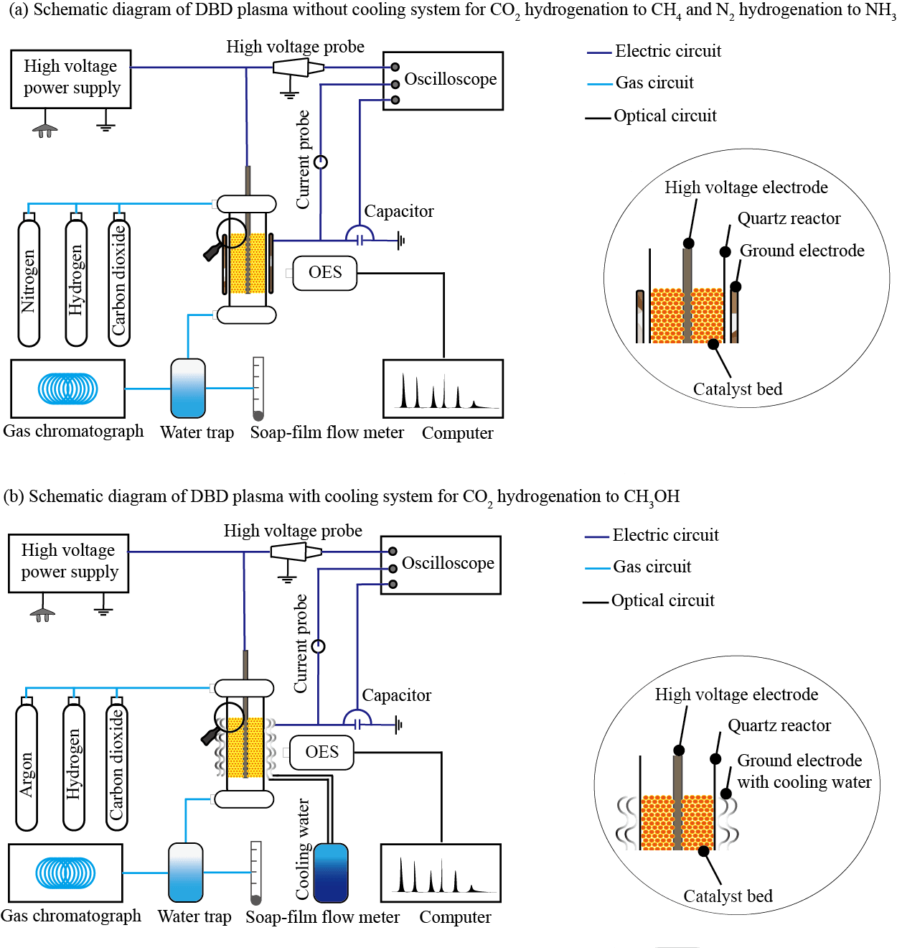
Figure S1. Schematic of the experimental setup for the DBD plasma system and reactor diagram, with and without a cooling system, for catalytic (a) CO₂ methanation and N₂ hydrogenation to NH₃, (b) CO₂ hydrogenation to CH₃OH.
Section 5. Supplementary Characterization of Catalysts
Catalyst characterization. The physical and chemical properties of these catalysts were characterized using several techniques, including X-ray diffraction (XRD), inductively coupled plasma-optical emission spectroscopy/mass spectrometry (ICP-OES/MS), high-resolution transmission electron microscopy/scanning transmission electron microscopy (HRTEM/STEM), and physicochemical adsorption (CO₂-TPD and H₂-TPR).
XRD patterns (Figure S2) revealed the 5Ni/LDH-IM catalyst exhibited a breakdown of the Mg-Al hydrotalcite structure after calcination, with peaks indicating the presence of MgO and MgAl₂O₄ spinel phases²⁹. The metal loading of Ni was determined to be 9 wt% via ICP-OES analysis (Table S3). Similarly, the 10Ni/MCM-41 catalyst displayed a broad peak corresponding to amorphous silica³⁰, with a metal loading of 10 wt%. The 3NiCu/HZSM-5 catalyst showed diffraction peaks characteristic of zeolite³¹, with Ni and Cu loadings of 0.02 wt% and 0.1 wt%, respectively. No diffraction peaks for the metal species were observed, indicating excellent metal dispersion across all catalysts.
HRTEM/HAADF images of the 5Ni/LDH-IM catalyst (Figure S3) revealed a uniform dispersion of Ni nanoparticles with an average size of ~5 nm, suggesting an ideal structure for catalytic activity. The 10Ni/MCM-41 catalyst (Figure S4) exhibited well-dispersed Ni particles (~10 nm) within the mesoporous MCM-41 framework. For the 3NiCu/HZSM-5 catalyst (Figure S5), HRTEM/HAADF imaging confirmed the formation of an alloyed cluster structure with Cu and Ni uniformly distributed³², which is crucial for high catalytic performance in CO₂ hydrogenation reactions.
The CO₂-TPD profiles of the catalysts showed distinct desorption peaks, which are associated with weak, medium, and strong basic sites³³. The 5Ni/LDH-IM catalyst (Figure S6) exhibited prominent desorption peaks at 100–200 °C, 300–450 °C, and 500–650 °C, with medium- and weak-strength basic sites playing the most significant role in CO₂ methanation³⁴. The H₂-TPR analysis revealed a strong hydrogen desorption peak at 760°C for the 5Ni/LDH-IM catalyst, indicating a high density of exposed Ni₀ sites³⁵. Similarly, the 10Ni/MCM-41 catalyst (Figure S7) demonstrated a notable desorption peak at 508°C, indicating a high concentration of basic sites, which are essential for NH₃ synthesis. The 3NiCu/HZSM-5 catalyst (Figure S8) exhibited a strong CO₂ desorption peak at 581 °C, confirming its superior CO₂ adsorption capacity, which is important for CO₂ hydrogenation to CH₃OH³⁶.
These characterizations underscore the importance of metal dispersion and the distribution of acidic and basic sites in determining the catalytic performance of these materials.

5Ni/LDH-IM Catalyst: The XRD pattern (Figure S2) revealed the complete breakdown of the Mg-Al hydrotalcite layered structure after calcination. Notable peaks at 43.6° and 62.9° were observed, confirming the formation of MgO species, while a peak at 37.0° corresponds to the formation of MgAl₂O₄ spinel²⁹.
10Ni/MCM-41 Catalyst: The XRD pattern shows a broad peak between 20° and 25°, which is characteristic of amorphous silica, indicating the support material³⁰.
3NiCu/HZSM-5 Catalyst: XRD diffraction peaks at 23.05°, 23.85°, and 24.3° correspond to the zeolite structure, confirming the structural integrity of the support³⁷.
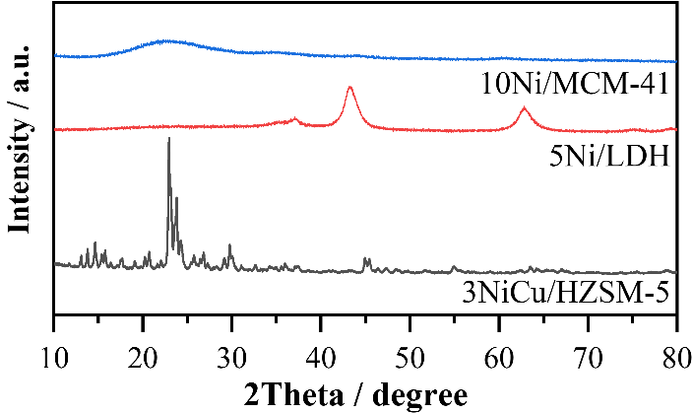
Figure S2. XRD patterns of the 5Ni/LDH-IM, 10Ni/MCM-41, and 3NiCu/HZSM-5.
Table S3. The metal loading amount of the catalysts for the different reactions.
Reaction | Catalyst | Ni (wt%) | Cu (wt%) | Method
CO₂ methanation | 5Ni/LDH-IM | 9 | n/a | ICP-OES
N₂ hydrogenation to NH₃ | 10Ni/MCM-41 | 10 | n/a | ICP-OES
CO₂ hydrogenation to CH₃OH | 3NiCu/HZSM5 | 0.02 | 0.1 | ICP-MS

The HRTEM image reveals the crystal structure and nanoparticle morphology of a/ahe 5Ni/LDH-IM catalyst. Ni nanoparticles are evenly dispersed on the LDH support. The Ni particles have an average size of approximately 5 nm, indicating a fine and uniform dispersion, which is conducive to a high density of active sites. The presence of distinct lattice fringes in the Ni particles suggests that they are crystalline and exhibit good crystallinity. HAADF imaging, which highlights high atomic number elements, shows Ni as bright spots, uniformly distributed across the sample³². This confirms that the Ni nanoparticles are well-dispersed without significant aggregation. This uniform distribution is indicative of a high number of active sites, making the catalyst suitable for catalytic reactions.
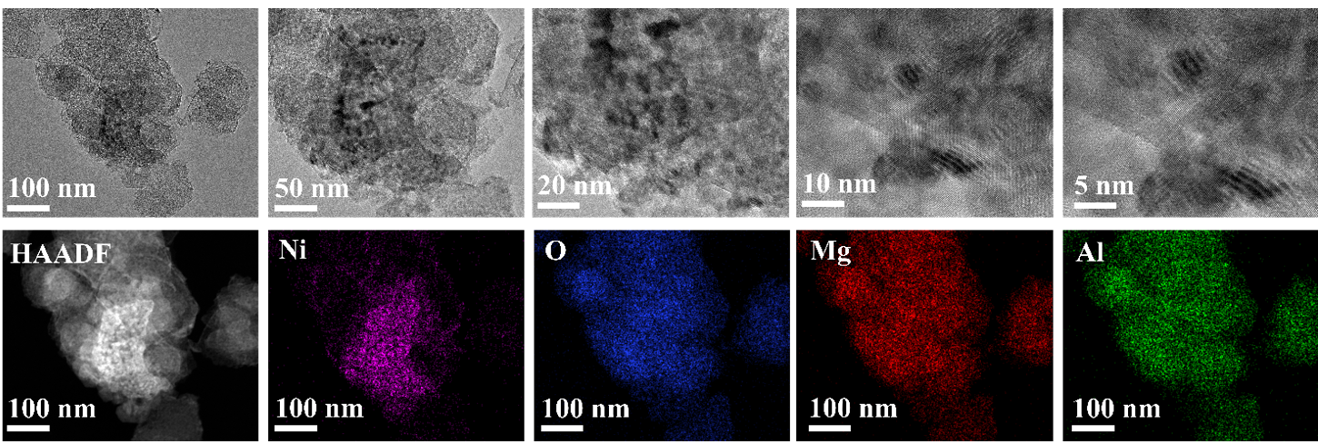
Figure S3. HRTEM, HAADF, and elemental mapping of the selected area of 5Ni/LDH-IM catalyst.

The HRTEM image displays the hexagonal, ordered pore structure of MCM-41. Ni particles, approximately 10 nm in size, are evenly distributed within the pores of MCM-41 rather than aggregating on the material’s surface. This distribution enhances both the stability and reactivity of the catalyst. In the HAADF image, Ni nanoparticles are prominently displayed, showing a uniform distribution on the MCM-41 support. This uniformity suggests that the catalyst possesses excellent dispersion, thereby enhancing its catalytic activity.
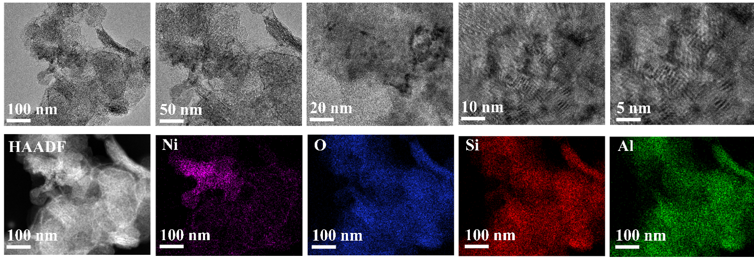
Figure S4. HRTEM, HAADF, and elemental mapping of the selected area of 10Ni/MCM-41 catalyst.
For the 3NiCu/HZSM-5 catalyst, we observed a hollow structure with an approximate particle size of 200 nm and a well-defined shape. Although HRTEM did not reveal distinct metal particles, HAADF imaging combined with energy-dispersive X-ray spectroscopy (EDX) confirmed that both Cu and Ni are uniformly dispersed within the framework of the HZSM-5 support. Notably, the Cu loading is significantly higher, consistent with the results obtained from ICP-MS. The high dispersion of the metals, along with the formation of nano-clusters in an alloyed state, ensures the catalyst’s high activity. These features indicate that the catalyst not only exhibits excellent metal dispersion but also benefits from the alloying effect, which is particularly advantageous for reactions requiring active sites. In summary, the high dispersion of the metals and the alloyed nano-cluster structure are key factors contributing to the catalytic activity of the 3NiCu/HZSM-5 catalyst. The even distribution of Cu and Ni further enhances its catalytic performance.
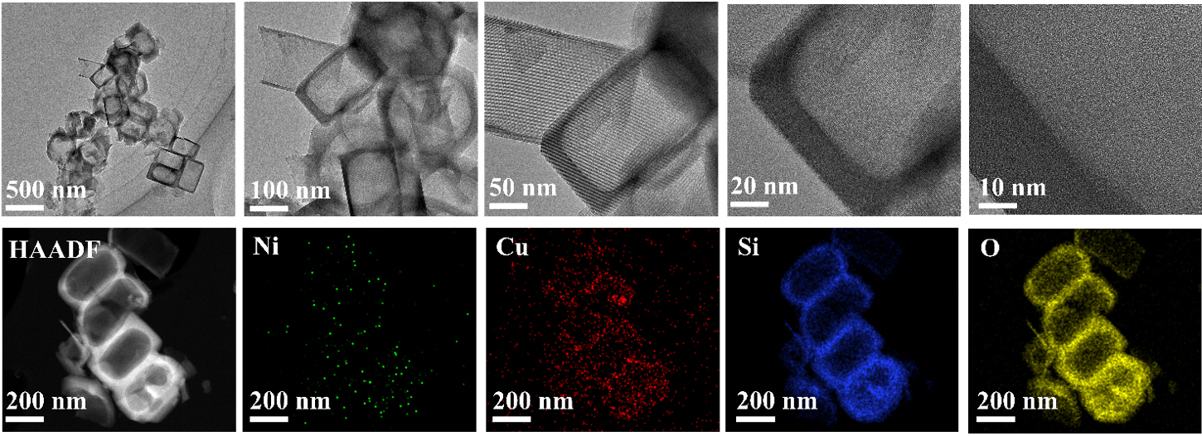
Figure S5. HRTEM, HAADF, and elemental mapping of the selected area of 3NiCu/HZSM5 catalyst.
CO₂-TPD and H₂-TPR of 5Ni/LDH catalyst
(a) The CO₂-TPD profile (Figure S6(a)) reveals distinct desorption peaks at 100–200 °C, 300–450 °C, and 500–650 °C, corresponding to weak, medium, and strong basic sites, respectively³³. Studies suggest that medium-strength and weak basic sites play a significant role in CO₂ methanation, while CO₂ adsorbed at strong basic sites is more difficult to desorb³⁴. This catalyst shows pronounced desorption peaks at medium and weak strengths, with a relatively weaker peak at high temperatures, which likely contributes to its high catalytic activity.
(b) The H₂-TPR profile (Figure S6(b)) displays two distinct desorption peaks: one at low temperatures (<400 °C) and another at higher temperatures (>400 °C). The low-temperature peak corresponds to H₂ desorption from metal surfaces, with the larger desorption area indicating a high density of exposed Ni sites. The highest desorption peak around 760 °C suggests enhanced hydrogen chemisorption, leading to hydrogen spillover³⁵.
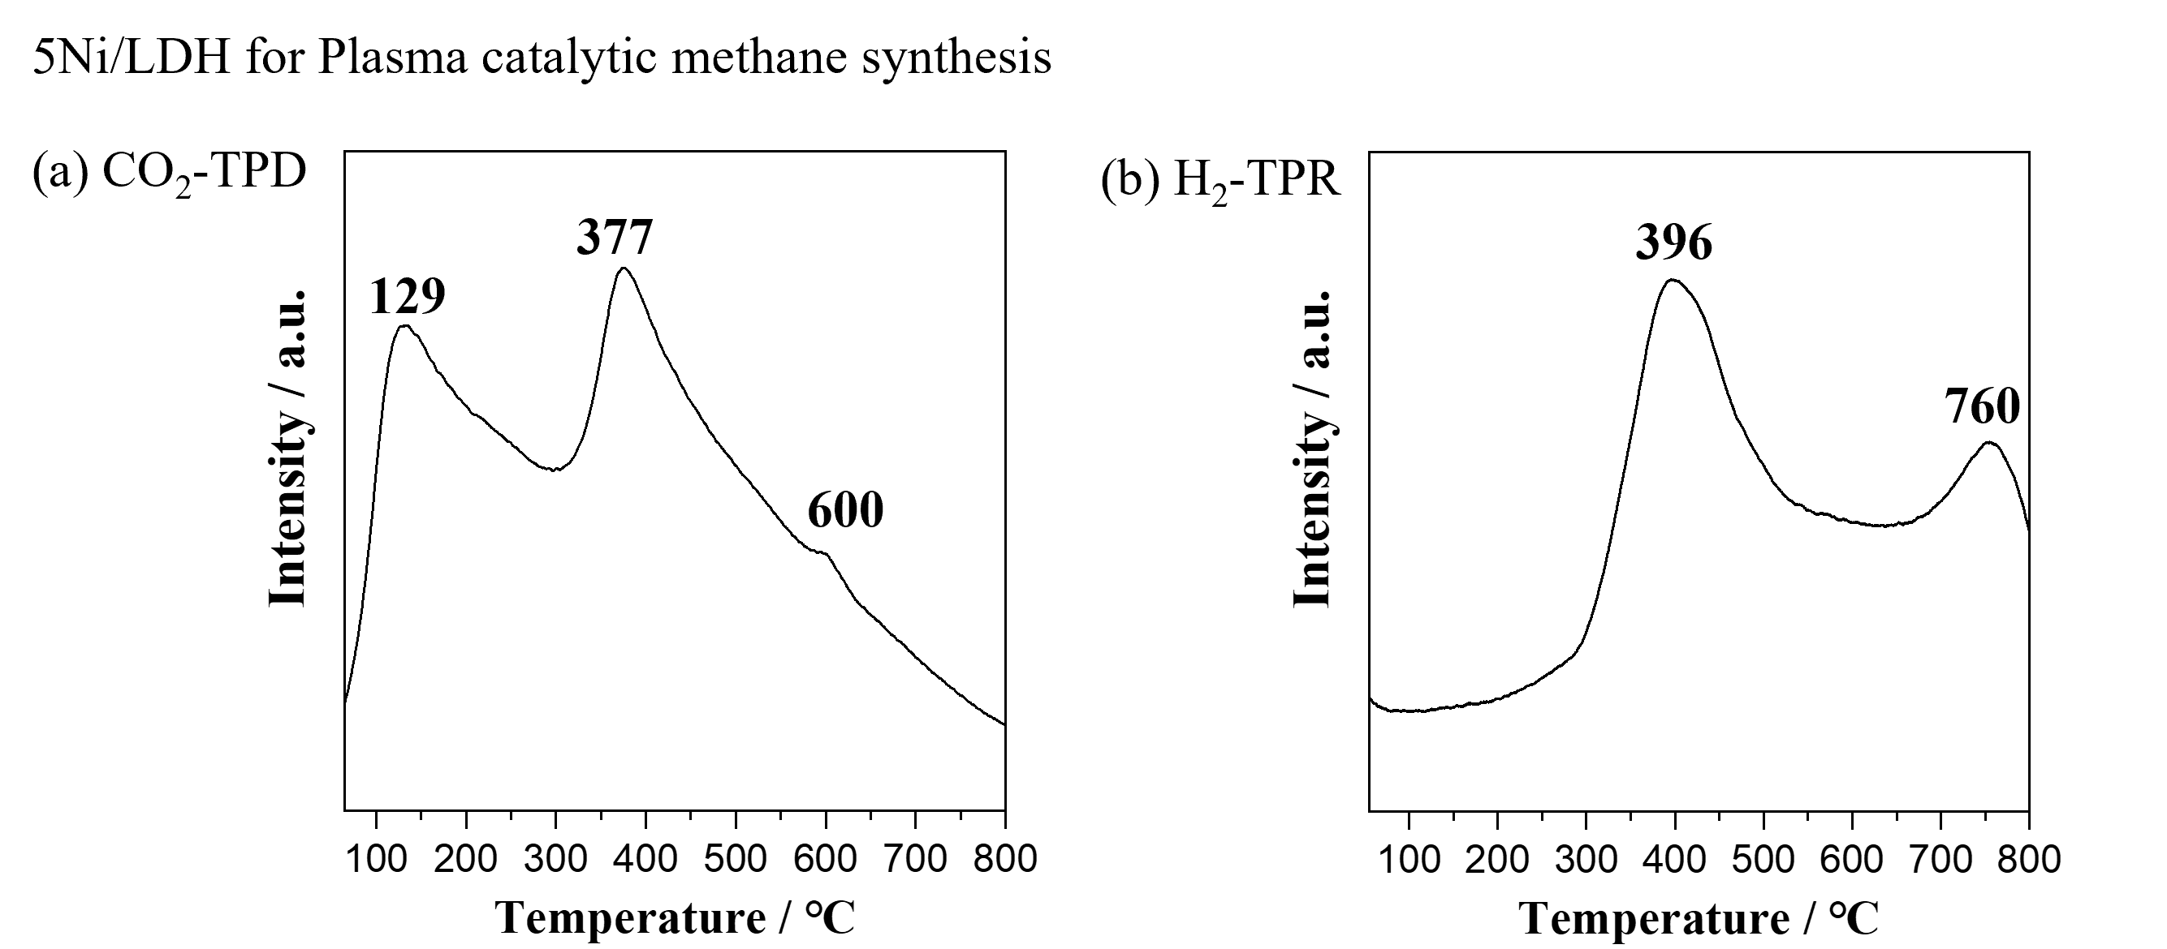
Figure S6. Characterization of the 5Ni/LDH catalyst for CO₂ methanation, including (a) CO₂-TPD and (b) H₂-TPR.

CO₂-TPD and H₂-TPR of 10Ni/MCM-41 catalyst
(a) The CO₂-TPD profile (Figure S7(a)) shows two distinct desorption peaks at 100–200 °C and 300–800 °C, corresponding to weak and medium basic sites, respectively. Higher CO₂ desorption suggests a greater number of basic sites, with the desorption temperature indicating the strength of these sites. A prominent peak at 508 °C demonstrates a rich concentration of basic sites, which likely enhances the catalytic performance of the catalyst³³.
(b) The H₂-TPR (Figure S7(b)) profile exhibits a broad desorption peak between 300–700 °C, indicative of a wide distribution of Ni particle sizes or multiple nickel species with varying adsorption strengths. A significant H₂ desorption area suggests the presence of Ni₀ sites. A higher-temperature desorption peak at 773 °C is attributed to the strong adsorption and/or chemical adsorption of H₂, promoting the activation of H-H bonds.
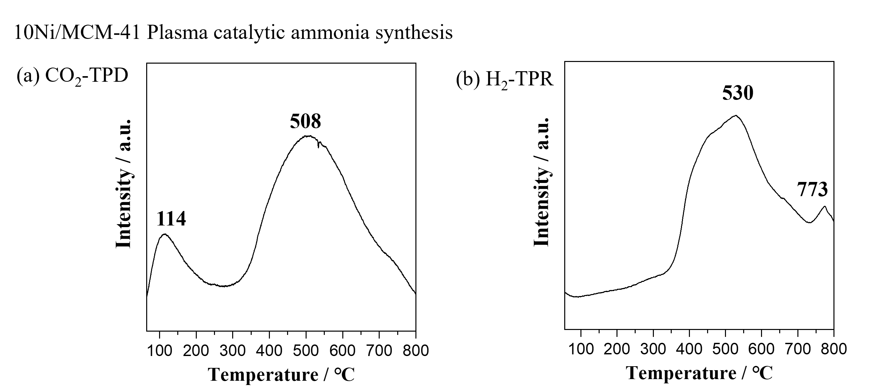
Figure S7. Characterization of the 10Ni/MCM-41 catalyst for NH₃ synthesis, including (a) CO₂-TPD and (b) H₂-TPR.

CO₂-TPD and H₂-TPR of 3NiCu/HZSM-5 catalyst
(a) The CO₂-TPD profile (Figure S8(a)) reveals three desorption peaks at 100–200 °C, 350–460 °C, and 500–650 °C, corresponding to weak, medium, and strong basic sites, respectively. A strong desorption peak at 581 °C indicates significant CO₂ adsorption capacity, while medium-strength peaks are associated with CO₂ adsorption via Lewis acid-base pairs and surface hydroxyl groups, which are key to the catalytic process³⁶.
(b) The H₂-TPR profile (Figure S8(b)) shows three desorption peaks, indicating multiple H₂ adsorption sites. Peaks below 400 °C are attributed to hydrogen adsorbed on metal sites, while higher temperature peaks (>400 °C) are linked to hydrogen spillover. A weaker peak at 345 °C suggests a lower number of exposed Ni sites, while stronger peaks in the 500–800 °C range point to metal-support interactions, promoting hydrogen spillover from metal sites to the support surface. This interaction is important for the catalytic activity, enhancing hydrogen migration between the NiCu metal sites and the HZSM-5 support.
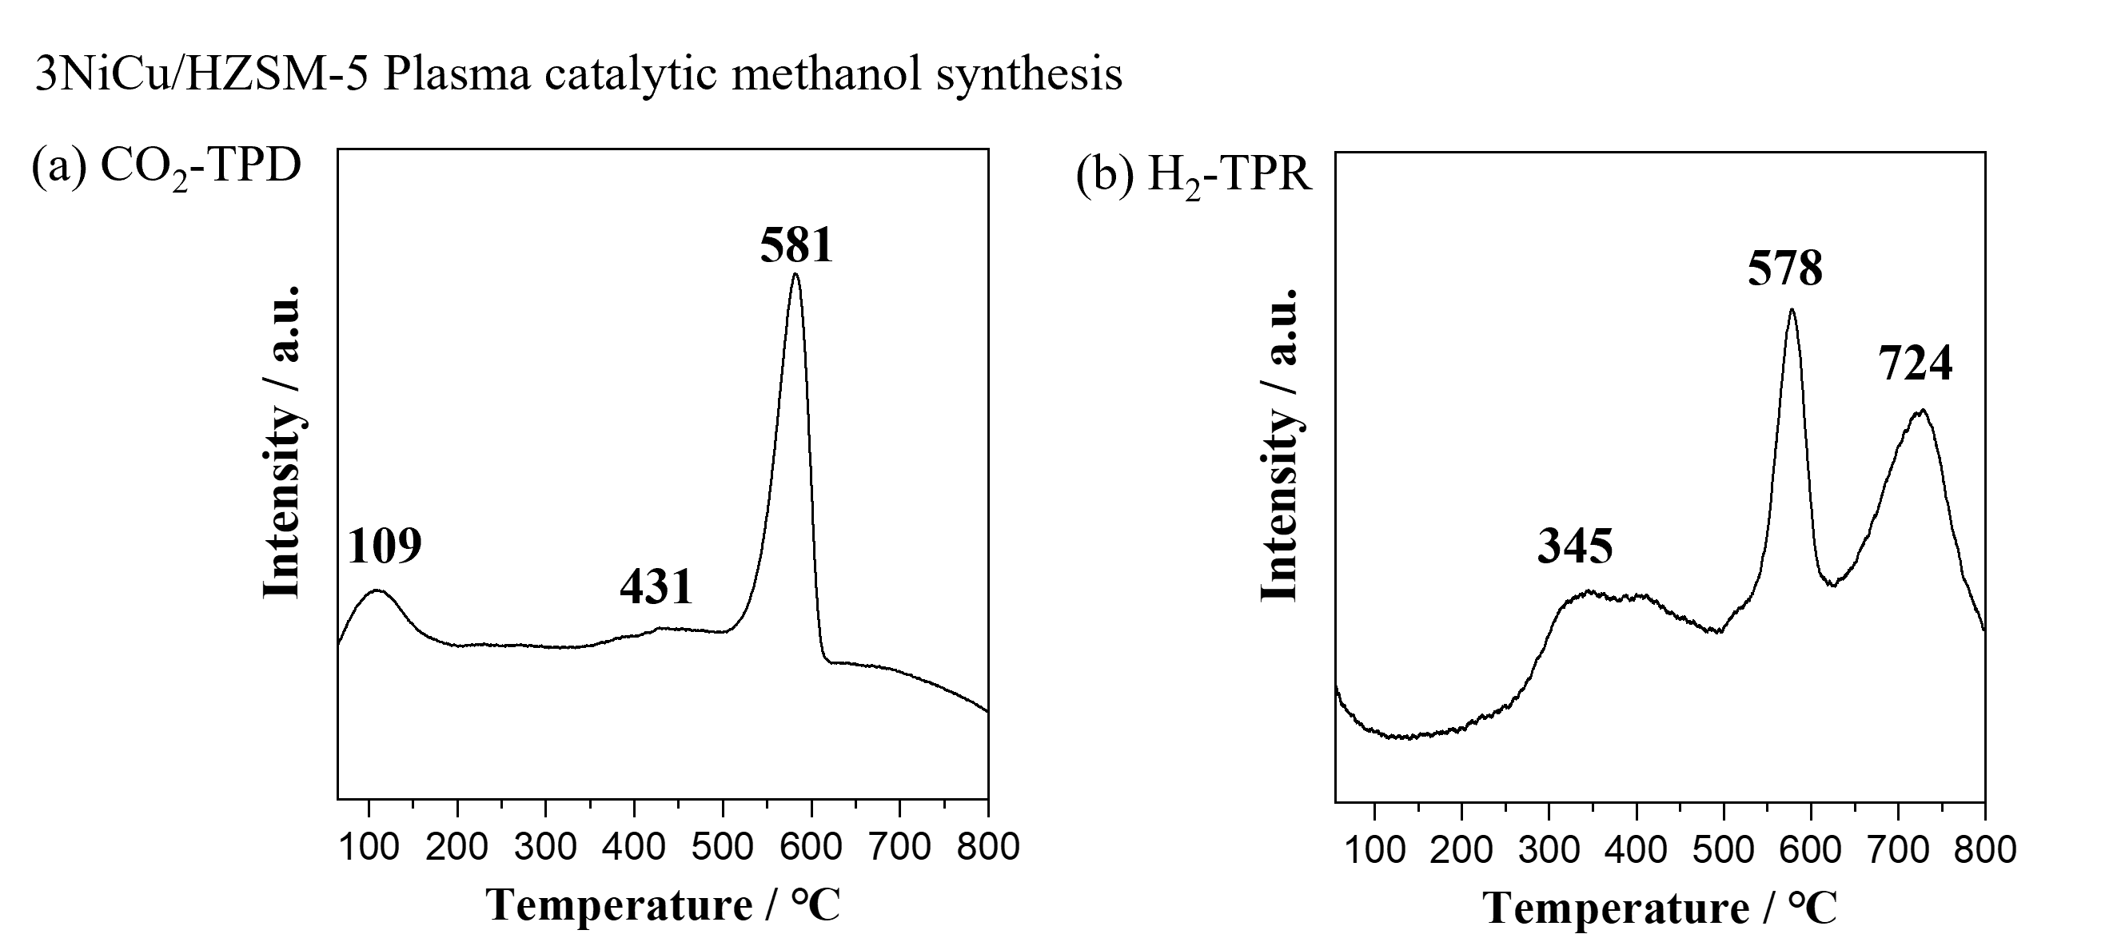
Figure S8. Characterization of the 3NiCu/HZSM-5 catalyst for CO₂ hydrogenation to methanol, including (a) CO₂-TPD and (b) H₂-TPR.
Section 6. Literature Comparison of Plasma Catalytic Reactions
Table S4. Comparison of the current state-of-the-art performance in the NTP catalytic CO₂ methanation using the DBD system under relatively mild conditions (i.e., <200 °C and atmospheric pressure).
CO₂ flow rate  (mL min^{‒1}) | Power  (W) | Catalyst | CO₂ conversion  (%) | CH₄ selectivity  (%) | Yield  (%) | CH₄ energy yield  (g kWh^{‒1})​ | Refs.
4 | 2.4 | Co/Al₂O₃ | 44 | 90 | 39.6 | 25.96 | ³⁸
6 | 13 | Ru/γ-Al₂O₃-C | 52 | 93 | 48.4 | 8.78 | ³⁹
6 | 13 | Ru/γ-Al₂O₃ | 76 | 98 | 74.5 | 13.52 | ³⁹
6 | 13 | Au/γ-Al₂O₃ | 17 | 0.4 | 0.1 | 0.01 | ³⁹
6 | 13 | Co/γ-Al2O3 | 25 | 96 | 24 | 4.36 | ³⁹
6 | 13 | AuRu/γ-Al₂O₃ | 82 | 98 | 80.4 | 14.59 | ³⁹
6 | 13 | CoRu/γ-Al₂O₃ | 80 | 98 | 78.4 | 14.23 | ³⁹
25 | 55 | La–Ca–Ni | 82.3 | 81.2 | 66.8 | 11.95 | ⁴⁰
25 | 55 | La–Pr–Ni | 78 | 81.3 | 63.4 | 11.34 | ⁴⁰
25 | 55 | La–Sr–Ni | 74.3 | 83.3 | 61.9 | 11.07 | ⁴⁰
25 | 55 | La–Ce–Ni | 78.7 | 80.7 | 63.5 | 11.36 | ⁴⁰
25 | 55 | La–Ni | 72.6 | 83.2 | 60.4 | 10.80 | ⁴⁰
14 | 30 | Ni/Al₂O₃ | 35 | 5 | 1.8 | 0.32 | ⁴¹
10 | 2 | 15Ni/UiO-66 | 89 | 99 | 88.1 | 173.30 | ⁴²
7 | 2 | Ru/SiO₂ | 65 | 97 | 63.1 | 86.81 | ⁴³
7 | 39 | Co/SiO₂ | 68 | 71 | 48.3 | 3.41 | ⁴⁴
7 | 39 | Ni/Al₂O₃ | 67.8 | 72.4 | 49.1 | 3.47 | ⁴⁴
10 | 2 | Ni/SiO₂ | 9.8 | 62 | 6.1 | 11.95 | ⁴⁵
15 | 2 | Ni/SiO₂ | 8.2 | 60 | 4.9 | 14.52 | ⁴⁵
20 | 2 | Ni/SiO₂ | 8.3 | 59 | 4.9 | 19.26 | ⁴⁵
10 | 9.9 | NiCo/CeO₂ | 60 | 80 | 48 | 19.07 | ⁴⁶
10 | 2 | Ru/MgAl | 85 | 98 | 83.3 | 163.84 | ⁴⁷
10 | 26 | Ru/ZSM5 | 48 | 43 | 20.6 | 3.12 | ⁴⁸
10 | 26 | Ru/ZSM5 | 54 | 78 | 42.1 | 6.37 | ⁴⁸
10 | 26 | Ru/ZSM5 | 93 | 85 | 79.1 | 11.96 | ⁴⁸
50 | 5.15 | Ni/LDH | 70 | 97 | 67.9 | 259.32 | This work, PUL 6 kV
50 | 5.15 | Ni/LDH | 66 | 91 | 60.1 | 229.38 | This work, PUL 5.5 kV
50 | 18.39 | Ni/LDH | 22 | 21 | 4.6 | 4.94 | This work, SIN 9 kV
50 | 18.39 | Ni/LDH | 61 | 90 | 54.9 | 58.71 | This work, SIN 10 kV

Table S5. Comparison of the current state-of-the-art performance in the NTP catalytic N₂ hydrogenation to NH₃ using the DBD system under relatively mild conditions (i.e., <200 °C and atmospheric pressure).
Flow rate (mL min^{‒1}) | Power  (W) | Catalyst | Yield  (%) | Energy yield  (g_{NH3} kWh^{‒1}) | Refs.
25 | 140 | Ni/SiO₂ | 5.9 | 0.44 | ⁴⁹
25 | 93 | Ni/SiO₂ | 3.8 | 0.43 | ⁴⁹
25 | 115 | Ni/SiO₂ | 6.4 | 0.57 | ⁴⁹
50 | 10 | M/Al₂O₃ | 2 | 0.89 | ⁵⁰
18 | 55 | Fe, Ni, Cu/Al₂O₃ | 0.9 | 0.29 | ⁵¹
18 | 55 | Fe, Ni, Cu/Al₂O₃ | 0.9 | 0.29 | ⁵¹
18 | 55 | Fe, Ni, Cu/Al₂O₃ | 0.8 | 0.25 | ⁵¹
200 | 60 | MgO | 4 | 1.29 | ⁵²
200 | 60 | MgO | 3.2 | 1.04 | ⁵²
12.5 | 20 | ZSM5 | 1.8 | 0.51 | ⁵³
50 | 10 | Al₂O₃ | 0.42 | 0.48 | ⁵⁴
400 | 46.7 | Al₂O₃ | 0.52 | 1.01 | ⁵⁵
400 | 46.7 | TiO₂ | 0.54 | 1.05 | ⁵⁵
400 | 46.7 | MgO | 0.48 | 0.94 | ⁵⁵
400 | 46.7 | CaO | 0.46 | 0.9 | ⁵⁵
120 | 50 | Ru/Al₂O₃ | 1.5 | 1.27 | ⁵⁶
120 | 38.4 | Ru/Al₂O₃ | 1.1 | 1.88 | ⁵⁶
20 | 5.05 | Ni/MCM-41 | 3.2 | 3.19 | This work, PUL 6 kV
20 | 6.09 | Ni/MCM-41 | 4.17 | 3.37 | This work, PUL 6.7 kV
20 | 20.12 | Ni/MCM-41 | 1.3 | 0.57 | This work, PUL 9.4 kV
20 | 15.9 | Ni/MCM-41 | 0.58 | 0.48 | This work, PUL 8 kV

Table S6. Comparison of the current state-of-the-art performance in the NTP catalytic CO₂ hydrogenation to CH₃OH using the DBD system under relatively mild conditions (i.e., <200 °C and atmospheric pressure).
CO₂ flow rate  (mL min^{‒1}) | Power  (W) | Catalyst | CO₂ conversion  (%) | CH₃OH selectivity  (%) | Yield  (%) | CH₃OH energy yield  (g kWh^{‒1})​ | Refs.
18 | 26 | Cu/γ-Al₂O₃ | 9.8 | 47.5 | 4.7 | 2.53 | ⁵⁷
18 | 26 | Cu/γ-Al₂O₃ | 8.8 | 50.2 | 4.4 | 2.40 | ⁵⁷
18 | 26 | Cu/γ-Al₂O₃ | 8.4 | 53 | 4.5 | 2.42 | ⁵⁷
18 | 26 | Cu/γ-Al₂O₃ | 6.5 | 58.7 | 3.8 | 2.08 | ⁵⁷
18 | 26 | Cu/γ-Al₂O₃ | 4.2 | 65.2 | 2.7 | 1.49 | ⁵⁷
18 | 24 | CuO-MgO/Beta | 5.8 | 45 | 2.6 | 1.54 | ⁵⁸
18 | 24 | CuO-MgO/Beta | 6.1 | 50 | 3.1 | 1.80 | ⁵⁸
18 | 24 | CuO-MgO/Beta | 6.8 | 60 | 4.1 | 2.39 | ⁵⁸
18 | 24 | CuO-MgO/Beta | 8.5 | 72 | 6.1 | 3.61 | ⁵⁸
18 | 18 | Fe₂O₃/Al₂O₃ | 12 | 58 | 7 | 5.47 | ⁵⁹
18 | 18 | Fe₂O₃/Al₂O₃ | 15 | 20 | 3 | 2.36 | ⁵⁹
18 | 18 | Fe₂O₃/Al₂O₃ | 14 | 30 | 4.2 | 3.30 | ⁵⁹
18 | 18 | Fe₂O₃/Al₂O₃ | 12 | 39 | 4.7 | 3.68 | ⁵⁹
1.5 | 10 | CuZn/Z23 | 24.3 | 1.8 | 0.4 | 0.05 | ⁶⁰
1.5 | 10 | Cu/Z23 | 20.9 | 0.9 | 0.2 | 0.02 | ⁶⁰
1.5 | 10 | Z23 | 25.1 | 0.6 | 0.2 | 0.02 | ⁶⁰
1.5 | 10 | CuZn/γ-Al₂O₃ | 27.1 | 1.3 | 0.4 | 0.04 | ⁶⁰
1.5 | 10 | Cu/γ-Al₂O₃ | 28.3 | 1.3 | 0.4 | 0.04 | ⁶⁰
1.5 | 10 | γ-Al₂O₃ | 34.3 | 0.6 | 0.2 | 0.02 | ⁶⁰
7 | 10 | MgO | 27 | 10 | 2.7 | 1.49 | ⁶¹
7 | 10 | CoO/MgO | 30 | 30 | 9 | 4.95 | ⁶¹
10 | 5 | MnO_{x}/ZrO₂ | 7 | 9 | 0.6 | 0.99 | ⁶²
25 | 2 | NiO/Fe₂O₃/QW | 1.7 | 33.3 | 0.6 | 5.56 | ⁶³
10 | 30 | Pt/film/In₂O₃ | 37 | 62.6 | 23.2 | 6.07 | ⁶⁴
10 | 30 | film/In₂O₃ | 18 | 22 | 4.0 | 1.04 | ⁶⁴
10 | 30 | Cu/ZnO/Al₂O₃ | 22 | 36 | 7.9 | 2.07 | ⁶⁴
10 | 30 | Pt/In₂O₃-C | 24 | 38 | 9.1 | 2.39 | ⁶⁴
10 | 30 | In₂O₃ | 16 | 24 | 3.8 | 1.01 | ⁶⁴
40 | 15.0 | NiCu/HZSM5 | 22.9 | 12.6 | 2.9 | 6.07 | This work, PUL 5.5
40 | 19.9 | NiCu/HZSM5 | 23.8 | 7.7 | 1.8 | 2.89 | This work, PUL 7.2
40 | 21.4 | NiCu/HZSM5 | 14.7 | 15.9 | 2.3 | 3.44 | This work, SIN 8.5
40 | 22.3 | NiCu/HZSM5 | 17.9 | 19 | 3.4 | 4.78 | This work, SIN 9.5
Note: The product selectivity summarized in this table is derived from offline analysis. As discussed in recent studies, offline measurements may not fully reflect the intrinsic online selectivity due to possible condensation of oxygenated products and carbon deposition during plasma-assisted CO₂ hydrogenation. This limitation should be considered when comparing reported selectivity (see Refs. 27 and 28).
Section 7. Supplementary Method of Lissajous-figure for Power Calculation of DBD
In a DBD system, energy is delivered to the plasma as the voltage across the discharge gap changes. The Lissajous figure (Q-U plot) represents the relationship between the charge Q and the applied voltage U over a discharge cycle⁶⁵. The energy dissipated in each cycle can be calculated by integrating the product of voltage and current:
(Eq. S14)
Where W is the energy dissipated in each cycle, U(t) is the instantaneous applied voltage, I(t) is the instantaneous discharge current, and T is the period of the discharge cycle.
Since the current I(t) is the rate of change of charge Q(t), i.e., I(t) = dQ(t)/dt, the equation becomes:
(Eq. S15)
This integral can be visualized as the area enclosed by the Lissajous figure in the Q-U plot. The larger the area, the greater the energy dissipation during each discharge cycle. The power P dissipated in the system is the rate at which energy is delivered over time. It is calculated by dividing the energy dissipated per cycle by the cycle time T:
(Eq. S16)
Since the area of the Lissajous figure gives us the energy per cycle, we can directly use the enclosed area A to estimate the power dissipation:
(Eq. S17)
Where A is the area enclosed by the Lissajous figure.
Thus, the area of the Lissajous figure represents the energy dissipated per cycle and can be used to calculate the average power dissipated during the discharge cycle. By integrating these equations and analyzing the Lissajous figure, we can derive the power dissipated in the plasma and optimize the discharge conditions for better catalytic performance. To derive the formulas for the voltage U(t) and charge Q(t), we use the following parameters based on the DBD equivalent circuit model shown in Figure S9.
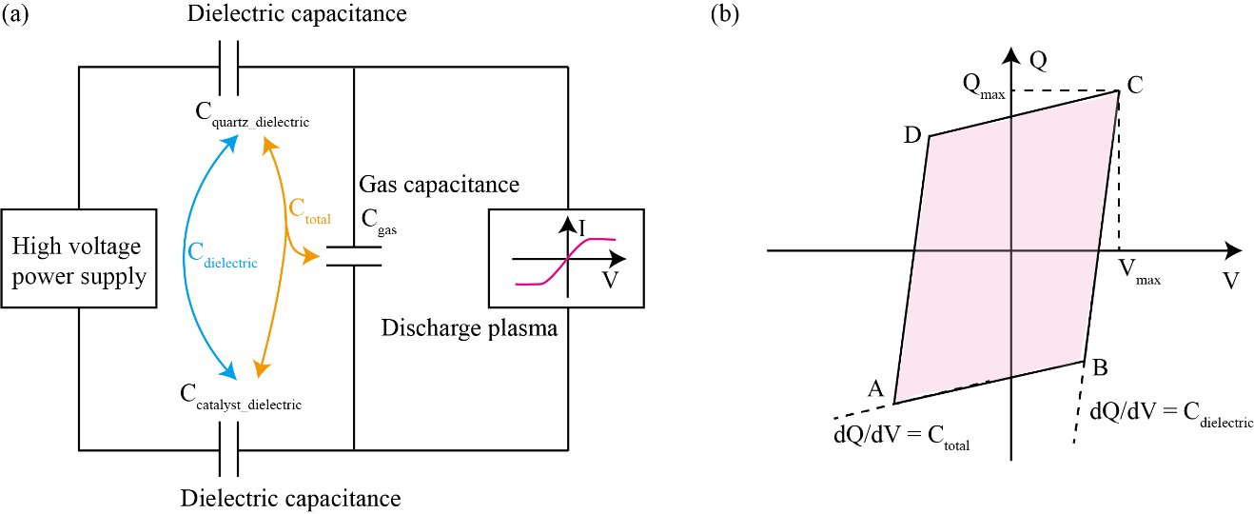
Figure S9. (a) Equivalent circuit model of a DBD with capacitance of solid and gas dielectric barrier, (b) Q-U plots.
Where C_{total} is the capacitance of the DBD cell, C_{gas} is the capacitance of the discharge gap, Q is the charge on the capacitor plates, and V_{max} is the maximum voltage required to initiate discharge.
In an idealized system, the voltage U(t) across the capacitor during one cycle is sinusoidal. Therefore, the charge Q(t) will accumulate as a function of the applied voltage:
(Eq. S18)
The voltage U(t) and charge Q(t) are related through the Lissajous curve, where the area of the figure corresponds to the energy dissipated. The total energy dissipated, W, can be calculated from the area of the Lissajous figure. By integrating the voltage-current relationship and analyzing the Lissajous figure, we can determine the power dissipated in the plasma and optimize the discharge conditions for enhanced catalytic performance.

Section 8. Supplementary Analysis of Plasma Properties of DBD
The PUL discharge waveform exhibits a multi-pulse discharge pattern with nearly zero capacitive current, which significantly reduces reactive power loss (Figure S10). In contrast, the SIN excitation waveform is sinusoidal, resulting in a typical multi-filament discharge current. Each filament represents a discharge event occurring at different times or spatial locations, with a pronounced capacitive current, which is a source of wasted power.
Figure S10. DBD discharge waveform of (a) PUL and (b) SIN excitation during CO₂ methanation under PUL 4.3 kV, 15 kHz, 10 μs and SIN 9 kV, 5 kHz.

The discharge photographs under SIN excitation reveal the clear shape of the inner electrode, which acts as the high-voltage electrode. This indicates that the plasma in SIN mode forms multi-filament discharges, exhibiting non-uniformity both in space and time (Figure S11). Small spark points indicative of localized spot discharges are visible, surrounding the inner electrode. In contrast, the PUL excitation produces a uniformly distributed plasma without any distinct electrode shapes, suggesting that the pulsed voltage generates a consistent discharge both temporally and spatially, contributing to more homogeneous plasma behavior.
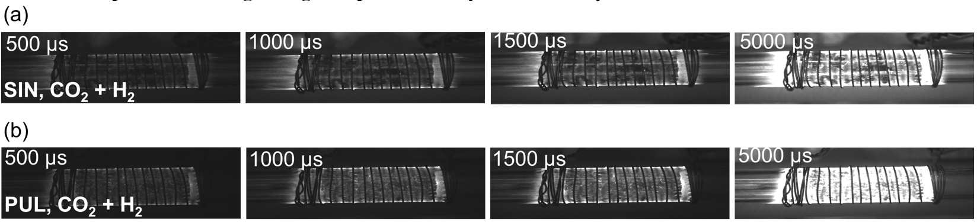
Figure S11. Discharge photographs of DBD under CO₂ and H₂ for CH₄ synthesis at varying exposure times (500 μs to 5000 μs) under (a) SIN 4.3 kV, 15 kHz, 10 μs and (b) PUL 9 kV, 5 kHz.

Section 9. Supplementary Method for Plasma Parameter Calculations Using OES
Optical Emission Spectroscopy (OES) is a widely used non-invasive diagnostic tool in plasma physics, enabling real-time monitoring of plasma processes⁶⁶. By analyzing the radiation emitted by various plasma species, OES allows for the determination of key plasma parameters. Despite its simplicity in experimental setup, especially in DBD systems, interpreting OES spectra in non-thermal plasmas remains complex due to their non-equilibrium nature.
9.1 Calculation from Balmer hydrogen lines
Electron temperature from the Balmer hydrogen lines
In emission spectroscopy, electron excitation of atoms, molecules, radicals, and ions causes transitions from lower energy levels (l) to higher levels (u), followed by de-excitation, which results in the emission of radiation⁶⁷. The intensity of emitted radiation is directly linked to the density of excited species.
The central wavelength (λ₀) of an emission line corresponds to the energy difference between the excited state (E_{u}) and the lower state (E_{l}), as given by the formula:
(Eq. S19)
Where h is Planck's constant, and c_{vac} is the speed of light. The transition intensity is characterized by the emission coefficient ε_{u}l:
(Eq. S20)
Here, n_{u} is the population density of species in the upper level, and A_{ul} is the Einstein transition probability.
For hydrogen, assuming thermal equilibrium of excited states, the population follows a Boltzmann distribution, and the intensity of the transition is given by:
(Eq. S21)
Using the measured intensities of the H_{α} and H_{β} lines, the electron excitation temperature T_{exc} can be calculated:
(Eq. S22)
Where K_{B} is the Boltzmann constant, g_{α} and g_{β} are statistical weights, and λ_{α} and λ_{β} are the wavelengths of the H_{α} and H_{β} lines⁶⁶. For specific hydrogen lines, spectral data (wavelengths and transition probabilities) can be found in Table S6.
Table S7. Spectral data of the Balmer hydrogen lines (NIST database).
Hydrogen line | gA  (s^{‒1}) | E  (cm^{‒1}) | λ  (nm)
α | 7.94 $×$ 10⁸ | 97492.30 | 656.30
β | 2.69 $×$ 10⁸ | 102823.90 | 486.10

Electron density from the Stark broadening of the Balmer hydrogen lines
The width of the spectral lines in the plasma is influenced by various collision processes that perturb the emitting species. The Stark broadening⁶⁸ of hydrogen lines is particularly useful for measuring the electron density n_{e}. The full width at half maximum (FWHM) of the emission line is a convolution of Gaussian and Lorentzian components:
(Eq. S23)
Where Δλ_{D} is the Doppler broadening, Δλ_{I} is the instrumental broadening, which is typically a known constant, in the current analysis, Δλ_{I} = 1 nm. Δλ_{W} is the van der Waals broadening, and Δλ_{Stark} is the Stark broadening, which is directly related to n_{e}.
The electron density measurement from the Stark broadening of the Balmer hydrogen lines works well if n_{e} values are 10²⁰ m^{‒1}. The computer fitting program suggests the use of the FWHM of the Stark profile line for a more precise calculation⁶⁶.
, for H_{α} | (Eq. S24)
Where n_{e} is in m^{‒1}, and FWHM is in nm.
The above method was utilized for the T_{e} and n_{e} calculation of plasma from DBD discharge in CO₂ and H₂ under SIN (Figure S12) or PUL (Figure S13) with different input voltages.
Figure S12. The Optical emission spectrum of the DBD discharge in the CO₂ methanation reaction under SIN conditions at 9 kV and 10 kV, including the T_{e} diagnosed from the Balmer Hydrogen Lines and n_{e} diagnosed by the Stark broadening method from Voigt fitting of H_{α}.
Figure S13. The Optical emission spectrum of the DBD discharge in the CO₂ methanation reaction under PUL conditions at 5.5 kV and 6 kV, including the T_{e} diagnosed from the Balmer Hydrogen Lines and n_{e} diagnosed by the Stark broadening method from Voigt fitting of H_{α}.
9.2 Calculation from argon lines
Electron temperature from emission intensity ratio of argon lines (750.4 nm and 811.5 nm)
The electron temperature T_{e} in argon-containing DBD systems can be determined using the intensity ratio of specific argon emission lines. The lines at 750.4 nm and 811.5 nm are used due to their sensitivity to electron collisions⁶⁹. The intensity ratio between these lines is related to the electron excitation rate coefficient k_{e}, from which T_{e} can be derived. The intensity of the emission lines is given by:
(Eq. S25)
(Eq. S26)
Here, C is a constant containing optical and geometrical factors; hν is the photon energy, given by hν = hc/λ (h is Planck's constant, c is the speed of light, and λ is the wavelength); A_{ij} is the transition probability; n_{e} and $n_{Ar}$ are the electron and argon atom densities, respectively; k_{e} is the electron excitation rate coefficient; A_{i} is the total transition probability, equivalent to the reciprocal of the natural lifetime (A_{i} = 1/τ₀); and k_{q} is the quenching rate coefficient for the excited argon state, as shown in Table S7. The argon atom density (n_{Ar}) can be calculated using the ideal gas law, n = p/(kT_{g}), where p = 1.01 × 10⁵ Pa is the gas pressure, and T_{g} is the gas temperature.
Using this ratio, T_{e} can be determined through empirical fitting, with the relationship between the electron excitation rate coefficients and T_{e} provided by the equation:
(Eq. S27)
By substituting the measured intensity ratio into this equation, the electron temperature T_{e} can be obtained.
Table S8. Spectral data of the Ar lines (NIST database).
Ar lines | λ (nm) | hυ (J) | A_{ij} (s^{‒1}) | A_{i} (s^{‒1}) | τ₀ (ns)
750.4 nm | 750.4 | 2.64 × 10^{‒19} | 4.45 × 10⁷ | 4.69 × 10⁷ | 21.3
811.5 nm | 811.5 | 2.45 × 10^{‒19} | 3.31 × 10⁷ | 3.31 × 10⁷ | 30.2
Electron density from the Stark broadening of the argon line
As with hydrogen lines, the width of the argon spectral lines is also affected by Stark broadening and the electron density n_{e} can be determined from the Stark width⁷⁰. For the argon emission line at 696.54 nm, Stark broadening plays a significant role, and the electron density is given by:
(Eq. S28)
This method provides a reliable way to determine n_{e} for atmospheric-pressure DBD plasmas.
The above method was utilized for the T_{e} and n_{e} calculation of plasma from DRIFTS cell discharge under SIN or PUL excitation (Figure S14), DBD discharge in CO₂, H₂, Ar under SIN (Figure S15) or PUL (Figure S16) with different input voltage.
Figure S14. The Optical emission spectrum of the DRIFTS cell discharge in the CO₂ methanation reaction under SIN 8 kV and PUL 5kV conditions, including the T_{e} diagnosed from the Ar Lines and n_{e} diagnosed by the Stark broadening method from Voigt fitting of Ar 696.53 nm.
Figure S15. The Optical emission spectrum of the DBD discharge in CO₂ hydrogenation to CH₃OH reaction under SIN conditions at 8.5 kV and 9.5 kV, including the T_{e} diagnosed from the Ar Lines and n_{e} diagnosed by the Stark broadening method from Voigt fitting of Ar 696.53 nm.
Figure S16. The Optical emission spectrum of the DBD discharge in CO₂ hydrogenation to CH₃OH reaction under PUL conditions at 5.5 kV and 7.2 kV, including the T_{e} diagnosed from the Ar Lines and n_{e} diagnosed by the Stark broadening method from Voigt fitting of Ar 696.53 nm.
9.3 Calculation from nitrogen lines
Electron temperature from the emission intensity ratio of nitrogen lines
In non-LTE plasmas, the electron temperature T_{e} can also be derived from the intensity ratio of nitrogen emission lines, specifically the transitions at 746 nm and 870 nm⁷¹. The relationship between the intensity ratio and T_{e} is governed by the Boltzmann distribution:
(Eq. S29)
Where E₁ and E₂ are the energies of the upper states of the transitions, and the intensities I₁ and I₂ are experimentally measured. Data for these nitrogen lines are provided in Table S8.
Table S9. Spectral data for 746 nm and 870 nm.
Wavelength (λ) | Ag (s^{‒1}) | Energy Level (E, eV)
746 nm | 7.84 × 10⁷ | 11.9
870 nm | 4.32 × 10⁷ | 11.75

Electron density from the Stark broadening of the nitrogen line
Nitrogen lines are particularly useful for determining n_{e} in non-LTE plasmas. Stark broadening of nitrogen lines at 493.2 nm provides a direct method for calculating n_{e}⁷². The Stark broadening of the nitrogen spectral lines is given by:
(Eq. S30)
Where Δλ_{FWHM} is the full width at half maximum of the nitrogen line, and N_{r} is the reference density.
The above method was utilized for the T_{e} and n_{e} calculation of plasma from DBD discharge in N₂, H₂ under SIN (Figure S17) or PUL (Figure S18) with different input voltage.
Figure S17. The Optical emission spectrum of the DBD discharge in N₂ hydrogenation to NH₃ reaction under SIN conditions at 8 kV and 9 kV, including the T_{e} diagnosed from the Nitrogen Line and n_{e} diagnosed by the Stark broadening method from Voigt fitting of N│493.5 nm.
Figure S18. The Optical emission spectrum of the DBD discharge in N₂ hydrogenation to NH₃ reaction under PUL conditions at 6.7 kV and 6 kV, including the T_{e} diagnosed from the Nitrogen Line and n_{e} diagnosed by the Stark broadening method from Voigt fitting of N│493.5 nm.

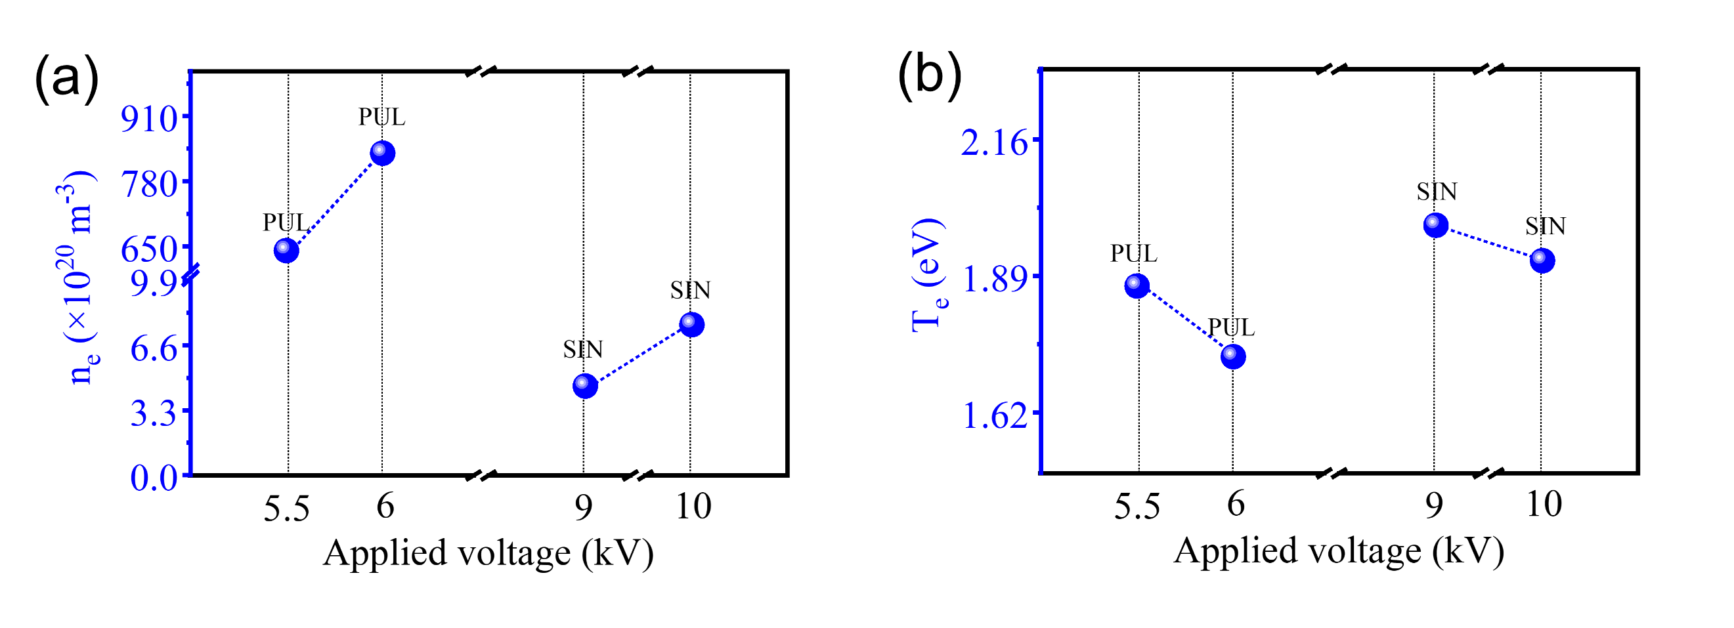
Figure S19. Plasma parameters, namely (a) n_{e}, and (b) T_{e}, as a function of applied voltage in the CO₂ and H₂ DBD discharge system for CH₄ synthesis under PUL 5.5 or 6 kV, 15 kHz, 10 μs and SIN 9 or 10 kV, 5 kHz.

Section 10. Debye Length and Plasma Sheath Calculation
10.1 Debye length
In plasma physics, the sheath region plays a crucial role in determining the boundary conditions for plasma behavior near surfaces. The Bohm criterion, first proposed by David Bohm in 1949⁴, is a fundamental condition for the formation of stable sheaths in plasmas. To ensure the stability of the sheath, ions must enter the sheath with a velocity that is at least equal to the ion sound speed. The ion sound speed is a fundamental quantity that reflects the propagation speed of ion-acoustic waves in a plasma, and it is given by the expression:
(Eq. S31)
Where ν_{i} is the ion velocity at the sheath boundary, c_{s} is the ion sound speed, and m_{i} is the ion mass.
The Debye length, λ_{D}, is a key characteristic of the plasma, defining the scale over which electric potentials are screened due to the collective effects of charged particles⁹. The λ_{D} is inversely proportional to the n_{e} and directly related to the temperature of the electrons. A larger λ_{D} indicates a weakly coupled plasma, whereas a shorter λ_{D} corresponds to a more strongly coupled plasma. This length scale is critical in determining the spatial extent of the sheath and its stability.
The formula for calculating the λ_{D} is:
(Eq. S32)
Where ε₀ is the vacuum permittivity, with a value of 8.854 × 10^{‒12} F m^{‒1}, and e is the elementary charge, with a value of 1.60217662 × 10^{‒19} C. The λ_{D} is essential for understanding the range of electrostatic interactions in the plasma, as it sets the scale for the screening of electric fields and determines the behavior of charged particles in the vicinity of material surfaces.
The sheath potential, V_{s}, is a crucial quantity in determining the energy dynamics of charged particles in the plasma-sheath boundary region. The potential determines the electric field strength, which governs the acceleration of ions toward the surface.
(Eq. S33)
The selection of the parameter α affects the magnitude of the sheath potential, which must be chosen carefully to ensure that the ion velocity satisfies both the Bohm criterion and the stability of the sheath. Based on the work of Sternberg and Godyak (2007)¹¹, we choose α = 1 for simplicity, which results in the sheath potential being:
(Eq. S34)
Ensuring that the ions achieve the required velocity to stabilize the sheath.
The sheath thickness, δ_{s}, defines the spatial extent of the sheath region and is an important factor in determining the interaction between DBD plasma and catalyst material surfaces⁹. From the Poisson equation and boundary conditions, δ_{s} can be related to λ_{D} by the expression¹⁵:
(Eq. S35)
Substituting $V_{s}=\frac{k_{B}T_{e}}{e}$ into this expression:
(Eq. S36)
This result shows that δ_{s} is approximately 1.41 times λ_{D}, meaning the sheath extends slightly beyond the typical screening length. This relation indicates that the potential in the sheath region is not completely screened out within a single λ_{D}, but the potential variations persist slightly beyond this length, influencing the behavior of ions near the plasma boundary.
10.2 Plasma frequency
The plasma frequency (ω_{pe}) is an important parameter as it provides insight into the characteristics of the electron oscillation within the plasma, which directly impacts the plasma's interaction with the catalyst surface⁷³. It was calculated for each condition using the following formula:
(Eq. S37)
Where ω_{pe} is the plasma frequency in radians per second, m_{e} is the electron mass, with a value of 9.10938356 × 10^{‒31} kg. The formula calculates the natural oscillation frequency of electrons within the plasma, known as the plasma frequency. After calculating ω_{pe} in radians per second, the frequency (in Hz) is obtained by dividing ω_{pe} by 2π:
(Eq. S38)

10.3 Sheath electric field strength
The Debye length λ_{D} represents the characteristic length scale for charge screening in plasmas. It quantifies the distance over which electric fields are shielded by the collective motion of free electrons and ions. The Debye length depends on the electron density n_{e} and electron temperature T_{e}. To ensure consistency with physical constants, T_{e} must be converted from electron volts to Kelvin using the conversion factor:
(Eq. S39)
The sheath electric field strength E within the plasma sheath can be derived from Poisson’s equation, which relates the electric field to the potential distribution and charge density in the plasma⁷⁴. The electric field strength within the sheath is given by:
(Eq. S40)
Where E is the sheath electric field strength (in V m^{‒1}).
10.4 Summary table of the above-calculated parameters
According to the above calculation method, key plasma parameters under various discharge conditions for the NTP catalytic production of CH₄, NH₃, and CH₃OH are summarized in Table S10. The table includes data for both SIN and PUL-driven DBD systems, as well as for DRIFTS cell and simulation input. All plasma parameters were calculated using full numerical precision. For discussion purposes, values in the main text are rounded to one decimal place to avoid overinterpretation of insignificant digits.
Table S10. The plasma parameters of NTP catalytic production of CH₄, NH_{3,} and CH₃OH.
Conditions |  |  | T_{e}  (eV) | T_{e}  (×10²⁰ m^{‒3}) | λ_{D}  (μm) | Error λ_{D}  (μm) | δ_{s}  (μm) | Error δ_{s}  (μm) | ω_{pe}  (×10¹¹ Hz) | E  (×10⁶ V m^{‒1})
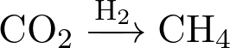 | SIN DBD | 9 kV | 1.99 | 4.524 | 0.493 | 0.0315 | 0.697 | 0.045 | 1.91 | 4.04
 | SIN DBD | 10 kV | 1.92 | 7.646 | 0.373 | 0.0238 | 0.527 | 0.034 | 2.48 | 5.15
 | PUL DBD | 6 kV | 1.53 | 746.3 | 0.034 | 0.0022 | 0.048 | 0.003 | 24.5 | 45.0
 | PUL DBD | 5.5 kV | 1.87 | 641.5 | 0.04 | 0.0026 | 0.057 | 0.004 | 22.7 | 46.8
 | SIN cell | 8 kV | 1.64 | 6.757 | 0.366 | 0.023 | 0.518 | 0.033 | 2.33 | 4.48
 | PUL cell | 5 kV | 1.26 | 32.41 | 0.147 | 0.0094 | 0.208 | 0.013 | 5.11 | 8.58
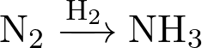 | SIN DBD | 8 kV | 0.359 | 0.0258 | 2.406 | 0.231 | 3.402 | 0.327 | 0.144 | 0.149
 | SIN DBD | 9 kV | 0.332 | 0.0317 | 2.773 | 0.2 | 3.921 | 0.283 | 0.16 | 0.116
 | PUL DBD | 6 kV | 0.677 | 0.088 | 1.932 | 0.161 | 2.732 | 0.228 | 0.266 | 0.351
 | PUL DBD | 6.7 kV | 0.395 | 0.078 | 1.756 | 0.146 | 2.483 | 0.206 | 0.251 | 0.225
 | SIN DBD | 8.5 kV | 0.92 | 0.01 | 7.31 | 0.609 | 10.336 | 0.861 | 0.09 | 0.126
 | SIN DBD | 9.5 kV | 3.58 | 0.7321 | 1.64 | 0.137 | 2.319 | 0.194 | 0.768 | 2.18
 | PUL DBD | 5.5 kV | 0.86 | 0.08 | 2.437 | 0.203 | 3.446 | 0.287 | 0.254 | 0.353
 | PUL DBD | 7.2 kV | 2.32 | 0.5521 | 1.524 | 0.127 | 2.155 | 0.180 | 0.667 | 1.52
Simulation | SIN | / | 1.23 | 1.67 |  |  | 6.31 | / | / | 5×10⁻³
Simulation | PUL | / | 0.98 | 2.24 |  | / | 3.17 | / | / | 5×10⁻²
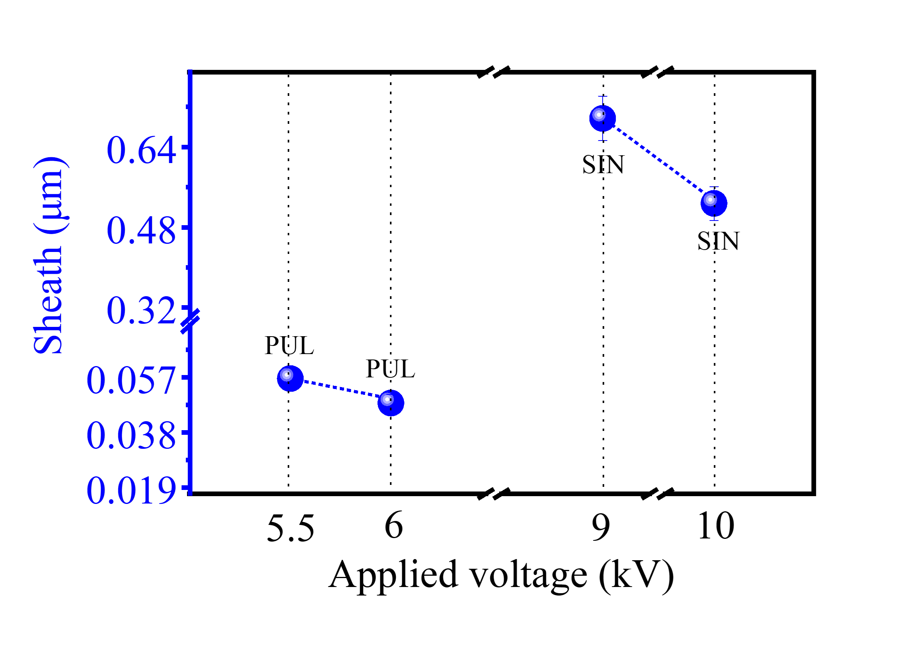
Figure S20. Sheath thickness as a function of applied voltage in the CO₂ and H₂ DBD discharge system for CH₄ synthesis under PUL 5.5 or 6 kV, 15 kHz, 10 μs and SIN 9 or 10 kV, 5 kHz.

Section 11. Supplementary Method for Numerical Simulation of Particle Dynamics in NTP Catalysis
A simplified kinetic Monte Carlo (kMC, which does not solve the Poisson equation for self-consistent fields nor include detailed reaction kinetics)⁷⁵⁻⁸² model was implemented to simulate the random walk, surface interactions, and pseudo reaction steps of various reactive species (*CO₂, *CO, H⁺, *N₂, N⁺) within the plasma sheath region under representative SIN and PUL plasma conditions. The choice to simulate these particular species is driven by their physical and chemical properties. Neutral species like CO₂ and CO participate in plasma chemistry by directly interacting with charged particles or electrons, generating reactive intermediates that affect the overall plasma behavior. Given the relatively large mass of these neutral species, their motion in the electric field is slower, and they primarily interact through collision processes with ions and electrons. In contrast, ionized species, especially H⁺ and N⁺, are crucial for understanding the electrical characteristics and reactivity of the plasma, particularly in the sheath region, where their accelerated motion and surface interactions are critical. Overall, the decision to simulate these particles is based on their unique presence, response to electric fields, and their essential role in both the reactive dynamics and electrical behavior of the plasma system.
11.1 Physical parameters and initial conditions
Fundamental physical constants were utilized, including the Boltzmann constant (k_{B} = 1.38064852 × 10^{‒22} J K^{‒1}), elementary charge (e = 1.60217662 × 10^{‒19} C), and vacuum permittivity (ε₀ = 8.854 × 10^{‒12} F m^{‒1}). The masses of the particles were assigned based on their molecular or atomic weights, for example, the mass of CO₂ molecules (m_{CO2} = 7.308 × 10^{‒26} kg). The simulation involved a total of N = 10,000 particles, with a total simulation time of t_{total} = 10^{‒5} s. Different time steps were used for SIN (Δt_{SIN} = 10^{‒8} s) and PUL (Δt_{PUL} = 10^{‒9} s) conditions to accommodate the respective frequencies. The T_{e} in the simulation reflects the average values observed under SIN (1.23 eV) and PUL (0.98 eV) excitations for CO₂ methanation. These values align with experimental measurements, ensuring the simulations capture realistic energy distributions. Sheath thickness, δ_{s}, in the simulation (6.39 μm for SIN and 3.17 μm for PUL) corresponds to the range observed experimentally under similar plasma conditions. The electric field strengths (E_{SIN} = 5 × 10³ V m^{‒1} and E_{PUL} = 5 × 10⁴ V m^{‒1}) in the simulation represent typical peak field intensities, consistent with experimental results scaled for the simulated system.
11.2 Incorporation of plasma shielding effect
The plasma electrons and ions exhibit a shielding effect on the external electric field, especially pronounced at high frequencies. To account for this, a frequency factor $\text{FF}$ was introduced to adjust the effective electric field acting on charged particles. The frequency factor depends on the ratio of the external electric field frequency $f$ to the plasma frequency ω_{pe}, calculated as:
(Eq. S41)
Where m_{e} is the electron mass.
The frequency factor⁸³ is calculated differently for SIN and PUL conditions to account for distinct plasma shielding behaviors under quasi-steady and transient excitations.
SIN Condition:
(Eq. S42)
Which follows the classical frequency-dependent plasma dielectric response, where increasing excitation frequency enhances electron screening and reduces the effective electric field acting on charged species.
PUL Condition:
(Eq. S43)
In contrast to sinusoidal excitation, pulsed discharges operate under strongly non-steady-state conditions characterized by rapid voltage rise times, transient electron density modulation, and microdischarge events. In this regime, electron shielding cannot fully develop within the pulse duration, leading to enhanced electric-field penetration into the sheath. The exponent 0.25 is therefore introduced as a phenomenological scaling parameter to partially relax the classical high-frequency shielding and account for incomplete screening under pulsed excitation. While not derived from first-principles electrodynamics, this effective correction is commonly employed to capture transient field-penetration effects in pulsed and nanosecond plasma discharges⁸⁴.
11.3 Particle dynamics and Monte Carlo processes
The initial positions and velocities of particles were randomly distributed to simulate their stochastic distribution within the sheath. Positions were initialized within the δ_{s} range, and velocities were assigned based on the Maxwell-Boltzmann distribution:
(Eq. S44)
Where T_{gas} = 300 K is the gas temperature, and m is the mass of the particle.
At each time step, the positions and velocities of the particles were updated. For charged particles (e.g., H⁺ and N⁺), the acceleration due to the electric field was calculated using Newton's second law:
(Eq. S45)
The velocities and positions were then updated:
(Eq. S46)
(Eq. S47)
Neutral particles (CO₂, CO, N₂, N) were unaffected by the electric field, and their motion was governed by thermal velocities and collisions. Collisions were treated stochastically within a kinetic Monte Carlo framework. For each particle and time step, the probability of undergoing a collision was calculated as P_{collision} = 1 – exp(–Δr∑_{j} n_{j} σ_{j}), where Δr = νΔt is the distance traveled during the time step, n_{j} is the number density of collision partner 𝑗, and 𝜎_{𝑗} is the corresponding effective collision cross-section. The summation runs over all relevant collision partners. Upon a collision event, particle velocities were reassigned according to momentum and energy redistribution consistent with thermal scattering. Upon collision, particle velocities were adjusted to simulate energy and momentum exchange. Adsorption and desorption processes at the catalyst surface (z = 0) were treated stochastically within the Monte Carlo framework. When particles reach the catalyst surface, adsorption is handled using predefined adsorption probability P_{ads}. In the present implementation, only one generic surface is considered, and the same P_{ads} value is applied to all particle species; no multiple surface states are defined. Once adsorbed, species either remain adsorbed, desorb back into the gas phase, or undergo surface reactions according to predefined stochastic rules implemented in the code. These adsorption, desorption, and dissociation probabilities, as well as the allowed surface events, are summarized in Tables S11 and S12, respectively. This explicit definition ensures full reproducibility of the Monte Carlo implementation.

Table S11. Adsorption/desorption/dissociation probabilities implemented in the provided code (note: only one generic surface at z = 0, no multiple surface states defined).
Adsorbed species | Event trigger | Probability | Notes
CO₂ (positions_CO2) | Adsorption when z ≤ 0 | 0.001 | rand < 0.001
H (positions_H, treated as charged in field update) | Adsorption when z ≤ 0 | 0.001 | rand < 0.001
N₂ (positions_N2) | Adsorption when z ≤ 0 | 0.001 | rand < 0.001
N (positions_N) | Adsorption when z ≤ 0 | 0.001 | rand < 0.001
CO (positions_CO) | Adsorption | not defined as a separate adsorption step | CO is created directly as adsorbed after CO₂ dissociation
*CO₂ (adsorbed_CO2 = true) | Dissociation to CO | 0.0001 | rand < 0.0001 applied per time step to adsorbed_CO2
*CO (adsorbed_CO = true) | Desorption | 0.01 (SIN)/0.005 (PUL) | co_desorption_prob differs by condition

Table S12. Surface reactions/events allowed upon reaching (or being on) the surface in the code.
Adsorbed species | Allowed event in code | Implementation detail
*CO₂ | Remain adsorbed | Once adsorbed, the velocity is set to zero; no CO₂ desorption routine is coded
*CO₂ | Dissociation →*CO | dissociate_CO2 = adsorbed_CO2 & (rand < 0.0001); each dissociation creates new CO with adsorbed_CO = true and removes *CO₂
*CO | Desorption → CO (gas) | desorb_CO = adsorbed_CO & (rand < co_desorption_prob); then position/velocity reinitialized
*H | No post-adsorption events defined | Adsorbed_H set true; no desorption/reaction coded
*N₂ | No post-adsorption events defined | Adsorbed_N2 set true; no desorption/reaction coded
*N | No post-adsorption events defined | Adsorbed_N set true; no desorption/reaction coded

11.4 Collision and random diffusion simulation
Diffusion. In addition to the probabilistic collision step (implemented as a velocity damping when a collision event occurs), an effective “random diffusion” term was included as a stochastic thermal kick applied directly to particle velocities. Specifically, at each time step, the velocity of each non-adsorbed particle was updated by adding a 3D Gaussian random increment:
(Eq. S48)
Where 𝑇_{gas} is the gas temperature, 𝑚 is the particle mass, and Δ𝑡 is the simulation time step. Particle positions were then advanced using the updated velocities through the standard kinematic update 𝑟(𝑡 + Δ𝑡) = 𝑟(𝑡) + 𝑣(𝑡 + Δ𝑡)Δ𝑡 (Eq. 48).
We note that this implementation introduces an effective stochastic mixing term in velocity space and is intended to qualitatively capture random thermal scattering/mixing rather than to represent a rigorous overdamped Brownian diffusion model derived from the Einstein–Smoluchowski relation ⟨Δ𝑟²⟩=6𝐷𝑡. No explicit diffusion coefficient D or friction coefficient is prescribed in the present simplified kMC implementation.
Electric field. Specifically, the time- and space-dependent sheath electric field was prescribed as:
(Eq. S49)
Where L is the sheath thickness. This electric field was used exclusively to update the motion of positively charged species (H⁺, N⁺). Their acceleration along the sheath-normal (z) direction was calculated as:
(Eq. S50)
Where F_{field} is the frequency-dependent shielding factor defined in Section 11.2. Neutral species (CO₂, CO, N₂, N) were not subject to any electric-field force and evolved solely via thermal motion, stochastic collisions, and surface interactions.
Ion–neutral collision and velocity damping. Ion-neutral collisions were treated using a simplified probabilistic damping scheme⁸⁵. The collision probability was defined as:
(Eq. S51)
Where FF is the frequency-dependent shielding factor defined in Section 11.2, and P₀ = 0.1 is a predefined base collision probability used in the code. This parameter is introduced as an effective numerical constant to control the frequency of stochastic momentum-loss events and is not derived from microscopic collision cross-sections.
When a collision event occurs, the particle velocity is reduced to mimic momentum loss through ion–neutral scattering:
(Eq. S52)
Where α = 0.5 is a fixed damping factor specified in the code. This choice represents a heuristic momentum-reduction rule commonly adopted in simplified Monte Carlo transport models to capture dissipative effects without resolving detailed collision dynamics.
Additional random velocity perturbations were applied to represent thermal mixing:
(Eq. S53)
Where $N\left(0,1\right)$ is a standard normal random variable.
Surface adsorption was implemented as a stochastic event: when a particle reaches the sheath edge (z ≤ 0), adsorption occurs with a predefined probability P_{ads} = 0.001 (Table S11). Once adsorbed, species are immobilized in simulation.
Boundary reflection conditions assumed perfectly reflective walls, i.e., non-adsorbed particles reflect at z = 0 and z = L.
Section 12. Supplementary Analysis of Plasma Properties of DRIFTS Cell
The dome is directly applied to the grounded electrode to ensure uniformity of the electric field within the reaction space, thereby ensuring stable discharge conditions.
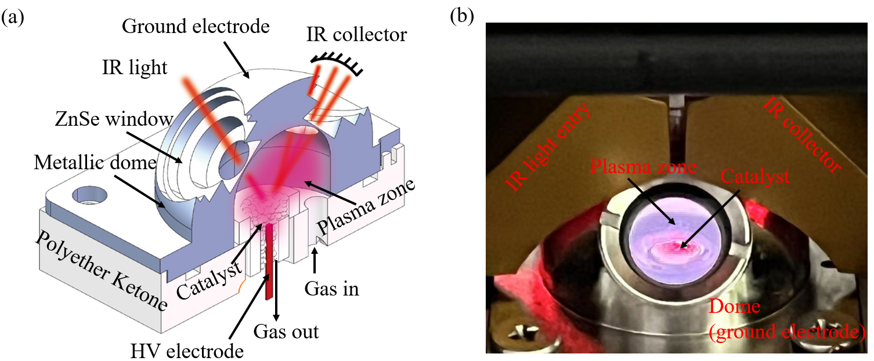
Figure S21. Schematic diagram of the (a) in-situ DRIFTS cell structure and (b) photographs of the actual discharge setup.

From Figure S22(a), based on over 30 measurements of discharge voltage and current, it is evident that the discharge modes of both DBD and DRIFTS cell operate at similar levels under SIN or PUL excitation. Notably, PUL excitation generates higher discharge power than SIN excitation, but at a lower discharge voltage.
From Figure S22(b), for the plasma produced under SIN excitation in the DRIFTS cell system, T_{e} and n_{e} show comparable values, while the PUL plasma exhibits trends similar to those seen in the PUL-driven DBD system, although there remains a gap in the plasma characteristics between the PUL cell and PUL DBD. Despite these differences, the relative trends of plasma parameters between SIN and PUL excitation in the DRIFTS cell system are consistent with those observed in DBD systems under corresponding conditions.
The sheath characteristics are particularly significant when comparing the results between DBD and DRIFTS cell plasma systems. From Figure S22(c), clear distinctions are observed between SIN- and PUL-driven DBD or cell systems, with variations in δ_{s} providing strong evidence for the influence of sheath dynamics on the differences observed in DRIFTS results. This comparison lays the foundation for further investigation into how sheath-induced changes affect catalytic performance.
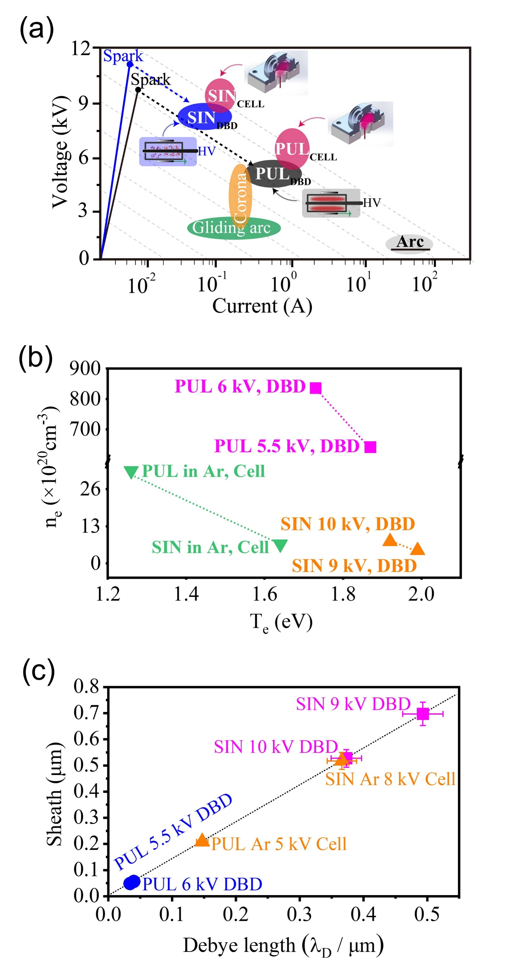
Figure S22. Comparison of plasma parameters between DBD and DRIFTS cell plasma for CO₂/H₂ discharge for CH₄ synthesis, including (a) discharge voltage-current characteristics, (b) n_{e} versus T_{e}, and (c) sheath thickness versus λ_{D}.

Section 13. Supplementary in-situ DRIFTS Characterization
Table S13. Peak assignments and vibrational modes for CO₂ methanation on 5 wt% Ni/LDH-IM catalyst.
(a) Under SIN excitation.
Surface Species | Peak Position (cm^{‒1}) | Vibrational Mode
Hydroxyl (–OH) | 3727, 3623 | O–H stretching vibration (increased intensity)
H₂O | 3300-3520 | H₂O stretching vibration
Gas Phase CO₂ | 2362 | High-frequency component of Fermi resonance (ν₃ + 2ν₂)
Gas Phase CO₂ | 2340 | Low-frequency component of Fermi resonance (ν₃ + 2ν₂)
Bicarbonate (HCO₃⁻) | 1674 | ν(C=O) stretching vibration
Bicarbonate (HCO₃⁻) | 1226 | Δ(OH) bending vibration
Bidentate Carbonate | 1313 | ν_{s}(OCO) symmetric stretching vibration
Monodentate Formate | 1574 | ν_{as}(OCO) asymmetric stretching vibration
Methoxy (H₃CO) | 1054 | ν(C–O) stretching vibration

(b) Under PUL excitation.
Surface Species | Peak Position (cm^{‒1}) | Vibrational Mode
Hydroxyl (–OH) | 3727, 3627 | O–H stretching vibration (increased intensity)
H₂O | 3300-3520 | H₂O stretching vibration
Gas Phase CO₂ | 2362 | High-frequency component of Fermi resonance (ν₃ + 2ν₂)
Gas Phase CO₂ | 2340 | Low-frequency component of Fermi resonance (ν₃ + 2ν₂)
Linearly Adsorbed CO | 2200 | C≡O stretching vibration
Bicarbonate (HCO₃⁻) | 1674 | ν(C=O) stretching vibration
 | 1411 | ν_{s}(OCO) symmetric stretching vibration
 | 1226 | Δ(OH) bending vibration
Bidentate Carbonate | 1313 | ν_{s}(OCO) symmetric stretching vibration
Formate | 1596 | ν_{as}(OCO) asymmetric stretching vibration
Methoxy (H₃CO) | 1098 | ν(C–O) stretching vibration

Table S14. Peak assignments and vibrational modes for N₂ hydrogenation to NH₃ on 10Ni/MCM-41 catalyst.
(a) Under SIN excitation.
Surface Species | Peak (cm^{‒1}) | Vibrational Mode
Adsorbed NH₃ | 3385, 3291 | N–H stretching vibration (NH₃ on Lewis acid sites)
*NH_{x} (x = 1, 2) species | 2859 | N–H stretching bands
*NH_{x} (x = 1, 2) species | 2923 | N–H stretching bands
Adsorbed N₂ (Ni–N≡N) | 2192, 2125 | Ni–N–N stretching vibration
Adsorbed N₂ | 1935 | N≡N stretching vibration
Coordinated NH₃ | 1687 | δ_{as}(NH₃) deformation vibration
Coordinated NH₃ | 1586 | δ_{as}(NH3) or δ_{as} (NH₄⁺)
Coordinated NH₂ | 1287 | NH₂ wagging band

(b) Under PUL excitation.
Surface Species | Peak (cm^{‒1}) | Vibrational Mode
Adsorbed NH₃ | 3361, 3280 | N–H stretching vibration (NH₃ on Lewis acid sites)
*NH_{x} (x = 1, 2) species | 2859 | N–H stretching bands
*NH_{x} (x = 1, 2) species | 2923 | N–H stretching bands
Adsorbed N₂ (Ni–N≡N) | 2192, 2125 | Ni–N–N stretching vibration (enhanced intensity)
Coordinated NH₃ | 1684 | δ_{as}(NH₃) deformation vibration
Coordinated NH₃ | 1580 | δ_{as}(NH3) or δ_{as}(NH₄⁺)
Coordinated NH₂ | 1287 | NH₂ wagging band

Table S15. Peak assignments and vibrational modes for CO₂ hydrogenation to CH₃OH on 0.3 wt% CuNi/HZSM-5 catalyst.
(a) Under SIN excitation.
Surface Species | Peak (cm^{‒1}) | Vibrational Mode
Hydroxyl (–OH) | 3732, 3640 | O–H stretching vibration (increased intensity)
Gas Phase CO₂ | 2359 | High-frequency component of Fermi resonance (ν₃ + 2ν₂)
Gas Phase CO₂ | 2340 | Low-frequency component of Fermi resonance (ν₃ + 2ν₂)
Bidentate Carbonate | 1345 | ν_{s}(O–C–O) symmetric stretching vibration
Linearly Adsorbed CO | 2154 | C≡O stretching vibration
Bridging Adsorbed CO | 1890 | C–O stretching vibration
Bidentate Carbonate | 1695 | ν_{as}(O–C–O) asymmetric stretching vibration
Bidentate Formate | 1578 | ν_{as}(OCO) asymmetric stretching vibration
Methoxy (–OCH₃) | 1055 | C–O stretching vibration

(b) Under PUL excitation.
Surface Species | Peak (cm^{‒1}) | Vibrational Mode
Hydroxyl (–OH) | 3732, 3640 | O–H stretching vibration (increased intensity)
Gas Phase CO₂ | 2359 | High-frequency component of Fermi resonance (ν₃ + 2ν₂)
Gas Phase CO₂ | 2340 | Low-frequency component of Fermi resonance (ν₃ + 2ν₂)
Linearly Adsorbed CO | 2157 | C≡O stretching vibration
Bridging Adsorbed CO | 1953, 1855 | C–O stretching vibration
Bidentate Carbonate | 1695 | ν_{as}(O–C–O) asymmetric stretching vibration
Bidentate Carbonate | 1444 | ν_{s}(OCO) symmetric stretching vibration
Formyl (HCO) Intermediate | 1753 | C=O stretching vibration
Formaldehyde (H₂CO) | 1305 | C–O stretching vibration
Bidentate Formate | 1575 | ν_{as}(OCO) asymmetric stretching vibration
Methoxy (CH₃O) | 1054 | ν(C–O) stretching vibration

Section 14. Supplementary Details of DFT Calculations
Table S16. Comparison of adsorption Gibbs free energy (G_{ad}) for adsorbates on Ni (111) surface under PUL and SIN conditions.
Adsorbate | PUL Condition G_{ad} (eV) | SIN Condition G_{ad} (eV)
ad-H | -0.41 | -0.36
ad-CO_{top} | -1.35 | -1.29
ad-CO_{bridge} | -1.69 | -1.66
ad-CHO | -2.38 | -2.30
ad-CH₂O | -0.63 | -0.49
ad-CH₃O | -2.48 | -2.36
ad-CH₃ | -1.88 | -1.86
ad-HCOO | -2.77 | -2.65
ad-CO₂ | -0.11 | -0.08

Table S17. The relative Gibbs free energy (ΔG) of reaction intermediates on the Ni (111) surface under PUL and SIN conditions. Steps 1–8 correspond to the full CO₂ methanation pathway toward CH₄, whereas steps 1–3c correspond to the CO₂ → CO pathway.
Step | Intermediate | PUL Condition Free Energy (eV) | SIN Condition Free Energy (eV)
1 | CO₂ | 0.00 | 0.00
2  3a | *CO₂  *HCOO | -0.11  0.02 | -0.08  0.15
3b | *CO_{top}  *CO_{bridge} | -0.72  -1.12 | -0.61  -0.99
4 | *CHO | 0.02 | 0.15
5 | *CH₂O | 0.23 | 0.41
6 | *CH₃O | 0.29 | 0.42
7 | *CH₃ | -0.04 | 0.02
8 | CH₄ | -0.62 | -0.62
Step | Intermediate | PUL Condition Free Energy (eV) | SIN Condition Free Energy (eV)
1 | CO₂ | 0.00 | 0.00
2 | *CO₂ | -0.11 | -0.08
3b | *CO_{top}  *CO_{bridge} | -0.72  -1.12 | -0.61  -0.99
3c | CO | 0.67 | 0.67

Section 15. Supplementary Content of the Reaction Pathway
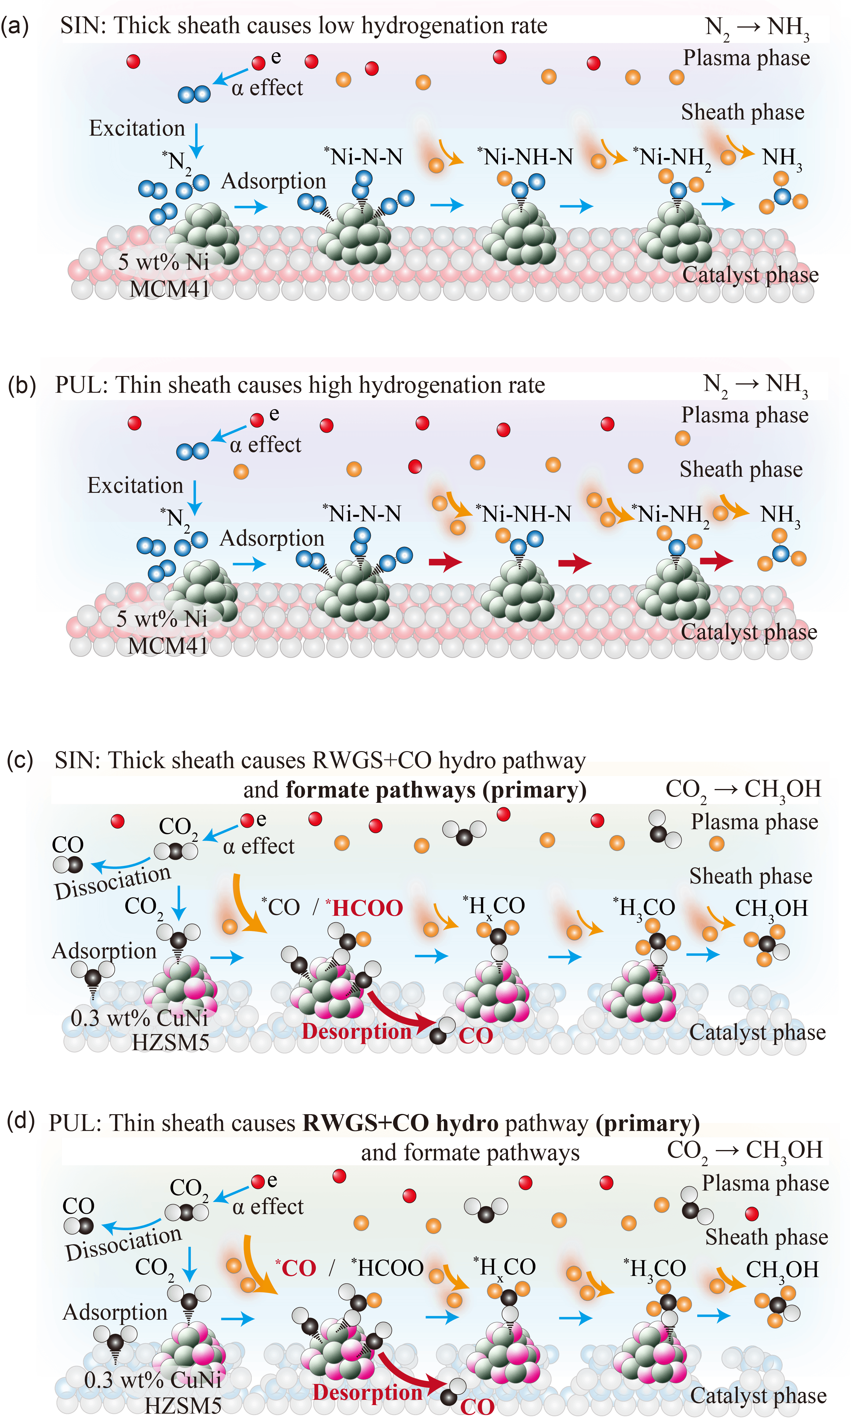
Figure S23. (a, b) Schematic reaction pathways for N₂ hydrogenation to NH₃ under SIN and PUL plasma conditions; (c, d) Schematic reaction pathways for CO₂ hydrogenation to CH₃OH under SIN and PUL plasma conditions.

Section 16. Timescale Comparison Between Plasma-Species Lifetime and Internal Diffusion
In the three plasma-catalytic systems studied in this work (CO₂ methanation over 5Ni/LDH-IM, NH₃ synthesis over 10Ni/MCM-41, and CO₂ hydrogenation to CH₃OH over 3NiCu/HZSM-5), we evaluate whether internal diffusion within porous catalyst particles contributes significantly to the overall reaction rate. Here, we compare the characteristic lifetime of plasma-generated active species with the characteristic diffusion timescale inside porous materials to justify the assumption that plasma-driven reactions occur predominantly on the external catalyst surface.
1. Lifetime of Plasma-Generated Active Species
Short-lived plasma species, including radicals (H·, N·, OH·, CO·), vibrationally/electronically excited molecules (CO₂*, N₂*, H₂*), and ions that rapidly neutralize, typically exhibit lifetimes at atmospheric pressure in the range ^{86,87}.
2. Diffusion Timescale Inside Porous Catalyst Particles
The characteristic time^{88,89} for a species to diffuse a length (L) in a porous solid is:
(Eq. S54)
Representative ranges of pore length scales, effective diffusivities, and corresponding diffusion times relevant to plasma catalysis are summarized in Table S18.
Table S18. Typical ranges for catalyst materials in most plasma catalysis studies.
Typical ranges | L | D_{eff} (m² s^{‒1}) | τ_{diff} (s)
Micropores/nanoporesª | 5‒50 nm | 10^{‒10}‒10^{‒9} | /
Mesoporous frameworks^{b} (e.g., MCM-41, HZSM-5) | 2‒10 µm | 10^{‒11}‒10^{‒9} | /
Particle-level transport (radius 5–50 μm)  (a) Nanopore diffusion | 50 nm | 10^{‒9} | 2.5×10^{‒6}
Particle-level transport (radius 5–50 μm)  (b) Particle-scale (intra-particle) diffusion | 10 µm | 10^{‒10} | 1
Note a: these values correspond to Knudsen or transition-regime diffusion in narrow pores, as reported for microporous and nanomesoporous catalyst supports^{90,91}. Note b: for ordered mesoporous materials and zeolitic frameworks, 𝐷_{eff} values are typically obtained from tracer diffusion experiments or estimated using porosity–tortuosity corrections applied to gas-phase diffusivities^{89,91}.
Comparing the two timescales clearly shows that , meaning that short-lived plasma species decay 10³–10⁸ times faster than they could diffuse into the interior of porous catalyst particles. Consequently, these species cannot penetrate deeply into the pore network before undergoing deactivation, recombination, or energy relaxation, and plasma-catalyst interactions are therefore restricted to the external surface or a very shallow near-surface region. This large disparity in characteristic timescales justifies the assumption that internal diffusion does not contribute to the overall reaction rate; instead, the plasma-catalytic processes investigated here are governed primarily by external mass transfer and surface reactions.
Supplementary References
1 Langmuir, I. Positive ion currents from the positive column of mercury arcs. Science 58, 290-291 (1923).
2 Langmuir, I. Oscillations in ionized gases. Proceedings of the National Academy of Sciences 14.8, 627-637 (1928).
3 Langmuir, I. The Interaction of Electron and Positive Ion Space Charges in Cathode Sheaths. Physical Review 33, 954-989 (1929). https://doi.org/10.1103/PhysRev.33.954
4 Bohm, D. The characteristics of electrical discharges in magnetic fields." Qualitative Description of the Arc Plasma in a Magnetic Field. Qualitative Description of the Arc Plasma in a Magnetic Field (1949).
5 Riemann, K. U. The Bohm criterion and sheath formation. Journal of Physics D: Applied Physics 24, 493 (1991).
6 Sternberg, N. & Godyak, V. Patching collisionless plasma and sheath solutions to approximate the plasma-wall problem. IEEE Transactions on Plasma Science 31, 1395-1401 (2003). https://doi.org/10.1109/tps.2003.821354
7 Franklin, R. N. The plasma–sheath boundary region. JOURNAL OF PHYSICS D: APPLIED PHYSICS 36, R309–R320 (2003).
8 Kato, T., Jeong, G.-H., Hirata, T., Hatakeyama, R. & Tohji, K. Freestanding Individual Single-walled Carbon Nanotube Synthesis Based on Plasma Sheath Effects. Japanese Journal of Applied Physics 43, L1278-L1280 (2004). https://doi.org/10.1143/jjap.43.L1278
9 Hershkowitz, N. Sheaths: More complicated than you think. Physics of Plasmas 12 (2005). https://doi.org/10.1063/1.1887189
10 Qin, S. & McTeer, A. A Nonperturbing Real-Time In Situ Plasma Diagnosis Technique Using an Optical Emission Spectrometer (OES). IEEE Transactions on Plasma Science 34, 1052-1058 (2006). https://doi.org/10.1109/tps.2006.877508
11 Sternberg, N. & Godyak, V. The Bohm Plasma-Sheath Model and the Bohm Criterion Revisited. IEEE Transactions on Plasma Science 35, 1341-1349 (2007). https://doi.org/10.1109/tps.2007.905944
12 Kato, T., Kuroda, S. & Hatakeyama, R. Diameter Tuning of Single-Walled Carbon Nanotubes by Diffusion Plasma CVD. Journal of Nanomaterials 2011, 1-7 (2011). https://doi.org/10.1155/2011/490529
13 Mehdipour, H., Ostrikov, K., Rider, A. E. & Furman, S. A. Minimizing the Gibbs-Thomson effect in the low-temperature plasma synthesis of thin Si nanowires. Nanotechnology 22, 315707 (2011). https://doi.org/10.1088/0957-4484/22/31/315707
14 Neyts, E. C., van Duin, A. C. & Bogaerts, A. Insights in the plasma-assisted growth of carbon nanotubes through atomic scale simulations: effect of electric field. J Am Chem Soc 134, 1256-1260 (2012). https://doi.org/10.1021/ja2096317
15 Chabert, P. What is the size of a floating sheath? Plasma Sources Science and Technology 23 (2014). https://doi.org/10.1088/0963-0252/23/6/065042
16 Neyts, E. C. Plasma-Surface Interactions in Plasma Catalysis. Plasma Chemistry and Plasma Processing 36, 185-212 (2015). https://doi.org/10.1007/s11090-015-9662-5
17 Neyts, E. C., Ostrikov, K. K., Sunkara, M. K. & Bogaerts, A. Plasma Catalysis: Synergistic Effects at the Nanoscale. Chem Rev 115, 13408-13446 (2015). https://doi.org/10.1021/acs.chemrev.5b00362
18 Zhang, Y.-R., Van Laer, K., Neyts, E. C. & Bogaerts, A. Can plasma be formed in catalyst pores? A modeling investigation. Applied Catalysis B: Environmental 185, 56-67 (2016). https://doi.org/10.1016/j.apcatb.2015.12.009
19 Li, H.-P., Ostrikov, K. & Sun, W. The energy tree: Non-equilibrium energy transfer in collision-dominated plasmas. Physics Reports 770-772, 1-45 (2018). https://doi.org/10.1016/j.physrep.2018.08.002
20 Zhang, Q.-Z. & Bogaerts, A. Propagation of a plasma streamer in catalyst pores. Plasma Sources Science and Technology 27 (2018). https://doi.org/10.1088/1361-6595/aab47a
21 Carreon, M. L. Plasma catalysis: a brief tutorial. Plasma Research Express 1 (2019). https://doi.org/10.1088/2516-1067/ab5a30
22 AlQahtani, M. S., Wang, X., Knecht, S. D., Bilén, S. G. & Song, C. Plasma-enhanced catalytic reduction of SO2: Decoupling plasma-induced surface reaction from plasma-phase reaction. Applied Catalysis B: Environmental 286 (2021). https://doi.org/10.1016/j.apcatb.2020.119852
23 Jiang, J. & Bruggeman, P. J. Tuning plasma parameters to control reactive species fluxes to substrates in the context of plasma catalysis. Journal of Physics D: Applied Physics 54 (2021). https://doi.org/10.1088/1361-6463/abe89a
24 Vanraes, P. & Bogaerts, A. The essential role of the plasma sheath in plasma–liquid interaction and its applications—A perspective. Journal of Applied Physics 129 (2021). https://doi.org/10.1063/5.0044905
25 Schlichting, H. G., Klaus. Boundary-Layer Theory. (Springer, 2016 ).
26 Wanten, B., Vertongen, R., De Meyer, R. & Bogaerts, A. Plasma-based CO2 conversion: How to correctly analyze the performance? Journal of Energy Chemistry 86, 180-196 (2023). https://doi.org/10.1016/j.jechem.2023.07.005
27 Van Turnhout, J., Rouwenhorst, K., Lefferts, L. & Bogaerts, A. Plasma catalysis: what is needed to create synergy? EES Catal 3, 669-693 (2025). https://doi.org/10.1039/d5ey00027k
28 Bogaerts, A. Plasma technology for the electrification of chemical reactions. Nature Chemical Engineering 2, 336-340 (2025). https://doi.org/10.1038/s44286-025-00229-3
29 Vijaya Kumar, P., Jafar Ahamed, A. & Karthikeyan, M. Synthesis and characterization of NiO nanoparticles by chemical as well as green routes and their comparisons with respect to cytotoxic effect and toxicity studies in microbial and MCF-7 cancer cell models. SN Applied Sciences 1 (2019). https://doi.org/10.1007/s42452-019-1113-0
30 Huo, C., Ouyang, J. & Yang, H. CuO nanoparticles encapsulated inside Al-MCM-41 mesoporous materials via direct synthetic route. Sci Rep 4, 3682 (2014). https://doi.org/10.1038/srep03682
31 (!!! INVALID CITATION !!! 28).
32 Chang, F. et al. Construction of Cu─Ni Atomic Pair with Bimetallic Atom‐Cluster Sites for Enhanced CO2 Electroreduction. Advanced Functional Materials 34 (2024). https://doi.org/10.1002/adfm.202400893
33 Zhang, M.-H., Liu, Z.-M., Lin, G.-D. & Zhang, H.-B. Pd/CNT-promoted CuZrO2/HZSM-5 hybrid catalysts for direct synthesis of DME from CO2/H2. Applied Catalysis A: General 451, 28-35 (2013). https://doi.org/10.1016/j.apcata.2012.10.038
34 Zhou, Y., Jiang, Y., Qin, Z., Xie, Q. & Ji, H. Influence of Zr, Ce, and La on Co 3 O 4 catalyst for CO 2 methanation at low temperature. Chinese Journal of Chemical Engineering 26, 768-774 (2018). https://doi.org/10.1016/j.cjche.2017.10.014
35 Chen, X. et al. Nickel–Silicon Intermetallics with Enhanced Selectivity in Hydrogenation Reactions of Cinnamaldehyde and Phenylacetylene. Industrial & Engineering Chemistry Research 51, 3604-3611 (2012). https://doi.org/10.1021/ie202227j
36 Pan, Q., Peng, J., Sun, T., Wang, S. & Wang, S. Insight into the reaction route of CO2 methanation: Promotion effect of medium basic sites. Catalysis Communications 45, 74-78 (2014). https://doi.org/10.1016/j.catcom.2013.10.034
37 da Silva, J. E. et al. Colored cotton wastes valuation through thermal and catalytic reforming of pyrolysis vapors (Py-GC/MS). Sci Rep 11, 16087 (2021). https://doi.org/10.1038/s41598-021-95043-1
38 Wang, J. et al. Synergetic effect of non-thermal plasma and supported cobalt catalyst in plasma-enhanced CO2 hydrogenation. Chemical Engineering Journal 451 (2023). https://doi.org/10.1016/j.cej.2022.138661
39 Di, L. et al. Cold plasma-prepared Ru-based catalysts for boosting plasma-catalytic CO2 methanation. Chemical Engineering Science 280 (2023). https://doi.org/10.1016/j.ces.2023.119056
40 Su, M., Li, X., Zhao, N., Ullah, N. & Li, Z. A Hybrid Plasma‐Catalysis System for CO2Hydrogenation over Perovskite‐Type Catalysts: Promoting Effect of A‐Site Substitution. Energy Technology 11 (2022). https://doi.org/10.1002/ente.202200817
41 Zeng, Y. & Tu, X. Plasma-catalytic hydrogenation of CO2for the cogeneration of CO and CH4in a dielectric barrier discharge reactor: effect of argon addition. Journal of Physics D: Applied Physics 50 (2017). https://doi.org/10.1088/1361-6463/aa64bb
42 Chen, H. et al. Nonthermal plasma (NTP) activated metal–organic frameworks (MOFs) catalyst for catalytic CO2 hydrogenation. AIChE Journal 66 (2019). https://doi.org/10.1002/aic.16853
43 Xu, S. et al. CO Poisoning of Ru Catalysts in CO2 Hydrogenation under Thermal and Plasma Conditions: A Combined Kinetic and Diffuse Reflectance Infrared Fourier Transform Spectroscopy–Mass Spectrometry Study. ACS Catalysis 10, 12828-12840 (2020). https://doi.org/10.1021/acscatal.0c03620
44 Zeng, Y., Chen, G., Liu, B., Zhang, H. & Tu, X. Unraveling Temperature-Dependent Plasma-Catalyzed CO(2) Hydrogenation. Ind Eng Chem Res 62, 19629-19637 (2023). https://doi.org/10.1021/acs.iecr.3c02827
45 Mu, Y. et al. Kinetic Study of Nonthermal Plasma Activated Catalytic CO2 Hydrogenation over Ni Supported on Silica Catalyst. Industrial & Engineering Chemistry Research 59, 9478-9487 (2020). https://doi.org/10.1021/acs.iecr.0c01477
46 Chen, H., Guo, W. & Fan, X. Mechanochemical Synthesis of Bimetallic NiCo Supported on a CeO2 Catalyst with Less Metal Loading for Non-Thermal Plasma Catalytic CO2 Hydrogenation. ACS Engineering Au 3, 7-16 (2022). https://doi.org/10.1021/acsengineeringau.2c00032
47 Xu, S. et al. Mechanistic study of non-thermal plasma assisted CO2 hydrogenation over Ru supported on MgAl layered double hydroxide. Applied Catalysis B: Environmental 268 (2020). https://doi.org/10.1016/j.apcatb.2020.118752
48 Xu, S., et al. Product selectivity controlled by the nano-environment of Ru ZSM-5 catalysts in nonthermal plasma catalytic CO2 hydrogenation. Applied Catalysis B: Environment and Energy 348 123826 (2024). https://doi.org/10.1016/j.apcatb.2024.123826
49 Akay, G. & Zhang, K. Process Intensification in Ammonia Synthesis Using Novel Coassembled Supported Microporous Catalysts Promoted by Nonthermal Plasma. Industrial & Engineering Chemistry Research 56, 457-468 (2017). https://doi.org/10.1021/acs.iecr.6b02053
50 Mehta, P. et al. Overcoming ammonia synthesis scaling relations with plasma-enabled catalysis. Nature Catalysis 1, 269-275 (2018). https://doi.org/10.1038/s41929-018-0045-1
51 Wang, Y. et al. Plasma-Enhanced Catalytic Synthesis of Ammonia over a Ni/Al(2)O(3) Catalyst at Near-Room Temperature: Insights into the Importance of the Catalyst Surface on the Reaction Mechanism. ACS Catal 9, 10780-10793 (2019). https://doi.org/10.1021/acscatal.9b02538
52 Xie, Q. et al. Non-thermal atmospheric plasma synthesis of ammonia in a DBD reactor packed with various catalysts. Journal of Physics D: Applied Physics 53 (2020). https://doi.org/10.1088/1361-6463/ab57e5
53 Shah, J. R., Gorky, F., Lucero, J., Carreon, M. A. & Carreon, M. L. Ammonia Synthesis via Atmospheric Plasma Catalysis: Zeolite 5A, a Case of Study. Industrial & Engineering Chemistry Research 59, 5167-5176 (2020). https://doi.org/10.1021/acs.iecr.9b05220
54 Zhu, X. et al. Ammonia synthesis over γ-Al2O3 pellets in a packed-bed dielectric barrier discharge reactor. Journal of Physics D: Applied Physics 53 (2020). https://doi.org/10.1088/1361-6463/ab6cd1
55 Patil, B. S. et al. Deciphering the synergy between plasma and catalyst support for ammonia synthesis in a packed dielectric barrier discharge reactor. Journal of Physics D: Applied Physics 53 (2020). https://doi.org/10.1088/1361-6463/ab6a36
56 Li, S., van Raak, T. & Gallucci, F. Investigating the operation parameters for ammonia synthesis in dielectric barrier discharge reactors. Journal of Physics D: Applied Physics 53 (2020). https://doi.org/10.1088/1361-6463/ab4b37
57 Cui, Z. et al. Plasma-Catalytic Methanol Synthesis from CO2 Hydrogenation over a Supported Cu Cluster Catalyst: Insights into the Reaction Mechanism. ACS Catalysis 12, 1326-1337 (2022). https://doi.org/10.1021/acscatal.1c04678
58 Chen, Q. et al. Plasma-catalytic CO2 hydrogenation to methanol over CuO-MgO/Beta catalyst with high selectivity. Applied Catalysis B: Environmental 342 (2024). https://doi.org/10.1016/j.apcatb.2023.123422
59 Meng, S. et al. Plasma‐driven CO2 hydrogenation to CH3OH over Fe2O3/γ‐Al2O3 catalyst. AIChE Journal 69 (2023). https://doi.org/10.1002/aic.18154
60 Feliz, M. Q., Polaert, I., Ledoux, A., Fernandez, C. & Azzolina-Jury, F. Influence of ionic conductivity and dielectric constant of the catalyst on DBD plasma-assisted CO2 hydrogenation into methanol. Journal of Physics D: Applied Physics 54 (2021). https://doi.org/10.1088/1361-6463/abfddd
61 Ronda-Lloret, M. et al. CO(2) Hydrogenation at Atmospheric Pressure and Low Temperature Using Plasma-Enhanced Catalysis over Supported Cobalt Oxide Catalysts. ACS Sustain Chem Eng 8, 17397-17407 (2020). https://doi.org/10.1021/acssuschemeng.0c05565
62 Zhang, X. et al. Boosting methanol productionviaplasma catalytic CO2hydrogenation over a MnOx/ZrO2catalyst. Catalysis Science & Technology 13, 2529-2539 (2023). https://doi.org/10.1039/d2cy02015g
63 Eliasson, B., et al. Hydrogenation of carbon dioxide to methanol with a discharge-activated catalyst. Industrial & engineering chemistry research 37, 3350-3357 (1998).
64 Men, Y.-L. et al. Highly dispersed Pt-based catalysts for selective CO2 hydrogenation to methanol at atmospheric pressure. Chemical Engineering Science 200, 167-175 (2019). https://doi.org/10.1016/j.ces.2019.02.004
65 Jiang, H., et al. Experimental study of QV Lissajous figures in nanosecond-pulse surface discharges. IEEE Transactions on Dielectrics and Electrical Insulation 20, 1101-1111 (2013).
66 Amamou, H., Escarguel, A. & Ferhat, B. Diagnostics of inhomogeneous plasmas: correction coefficients of the self-absorption and of the effect of spatial inhomogeneity. Journal of Plasma Physics 82 (2016). https://doi.org/10.1017/s0022377816000283
67 Zaplotnik, R., Primc, G. & Vesel, A. Optical Emission Spectroscopy as a Diagnostic Tool for Characterization of Atmospheric Plasma Jets. Applied Sciences 11 (2021). https://doi.org/10.3390/app11052275
68 Qian, M., Ren, C., Wang, D., Zhang, J. & Wei, G. Stark broadening measurement of the electron density in an atmospheric pressure argon plasma jet with double-power electrodes. Journal of Applied Physics 107 (2010). https://doi.org/10.1063/1.3330717
69 Hong, Y. et al. Electron temperature and density measurement of a dielectric barrier discharge argon plasma generated with tube-to-plate electrodes in water. Vacuum 130, 130-136 (2016). https://doi.org/10.1016/j.vacuum.2016.05.012
70 Subedi, D. P. et al. Investigation on Parameters of Atmospheric Pressure Plasma Jet by Electrical and Optical Methods. Journal of Nepal Physical Society 6, 50-56 (2020). https://doi.org/10.3126/jnphyssoc.v6i2.34857
71 IlİK, E., DurmuŞ, Ç. & Akan, T. Optical Investigations of N2 Atmospheric Pressure Plasma Jets. Adıyaman University Journal of Science (2020). https://doi.org/10.37094/adyujsci.701884
72 Noori, A. S., Aadim, K. A. & Hussein, A. H. Investigate and Prepare silver Nano Particles Using Jet Plasma. Iraqi Journal of Science, 2461-2469 (2022). https://doi.org/10.24996/ijs.2022.63.6.13
73 Allen, J. E. The plasma–sheath boundary: its history and Langmuir's definition of the sheath edge. Plasma Sources Science and Technology 18 (2009). https://doi.org/10.1088/0963-0252/18/1/014004
74 Hutchinson, I. H. Principles of plasma diagnostics. Plasma Physics and Controlled Fusion 44, 2603-2603 (2002).
75 Angelova, D. & Mihaylova, L. Extended Object Tracking Using Monte Carlo Methods. IEEE Transactions on Signal Processing 56, 825-832 (2008). https://doi.org/10.1109/tsp.2007.907851
76 Buitink, S., Huege, T., Falcke, H., Heck, D. & Kuijpers, J. Monte Carlo simulations of air showers in atmospheric electric fields. Astroparticle Physics 33, 1-12 (2010). https://doi.org/10.1016/j.astropartphys.2009.10.006
77 Liu, D. J. et al. Kinetic Monte Carlo Simulation of Statistical Mechanical Models and Coarse-Grained Mesoscale Descriptions of Catalytic Reaction-Diffusion Processes: 1D Nanoporous and 2D Surface Systems. Chem Rev 115, 5979-6050 (2015). https://doi.org/10.1021/cr500453t
78 Robertson, S. & Sternovsky, Z. Monte Carlo model of ion mobility and diffusion for low and high electric fields. Phys Rev E Stat Nonlin Soft Matter Phys 67, 046405 (2003). https://doi.org/10.1103/PhysRevE.67.046405
79 Morwald, T., Prankl, J., Zillich, M. & Vincze, M. Advances in real-time object tracking: Extensions for robust object tracking with a Monte Carlo particle filter. J Real Time Image Process 10, 683-697 (2015). https://doi.org/10.1007/s11554-013-0388-4
80 Liu, M. et al. An improved tracking method for particle transport Monte Carlo simulations. Journal of Computational Physics 437 (2021). https://doi.org/10.1016/j.jcp.2021.110330
81 Tenishev, V. et al. Application of the Monte Carlo Method in Modeling Dusty Gas, Dust in Plasma, and Energetic Ions in Planetary, Magnetospheric, and Heliospheric Environments. Journal of Geophysical Research: Space Physics 126 (2021). https://doi.org/10.1029/2020ja028242
82 Cao, Y., Huang, Z., Han, C. & Zhou, Y. Product Peroxidation Inhibition in Methane Photooxidation into Methanol. Adv Sci (Weinh) 11, e2306891 (2024). https://doi.org/10.1002/advs.202306891
83 Chen, F. F. Introduction to Plasma Physics and Controlled Fusion. (Springer, 2016).
84 Lichtenberg, M. A. L. J. Principles of Plasma Discharges and Materials Processing: Second Edition. (WILEY, 2003).
85 V. Vahedi, M. S. A Monte Carlo collision model for the particle-in-cell method: applications to argon and oxygen discharges. Computer Physics Communications 87, 179‒198 (1995).
86 Kim, H. H. Nonthermal Plasma Processing for Air‐Pollution Control: A Historical Review, Current Issues, and Future Prospects. Plasma Processes and Polymers 1, 91-110 (2004). https://doi.org/10.1002/ppap.200400028
87 Wang, W., Wang, Y., Li, H., Craven, M. & Tu, X. Electrifying Nitrogen Fixation: Plasma-Driven NO (x) Synthesis for Sustainable Fertilizer Production. JACS Au 5, 5888-5907 (2025). https://doi.org/10.1021/jacsau.5c01136
88 Crank, J. The Mathematics of Diffusion. (Oxford University Press, 1975).
89 Froment, G. F. B., K. B.; De Wilde, J. Chemical Reactor Analysis and Design. (Wiley, 2010).
90 Ruthven, D. M. Principles of Adsorption and Adsorption Processes. (Wiley, 1984).
91 Kärger, J. & Ruthven, D. M. Diffusion in nanoporous materials: fundamental principles, insights and challenges. New Journal of Chemistry 40, 4027-4048 (2016). https://doi.org/10.1039/c5nj02836a
92 Conde, L. in An Introduction to Plasma Physics and its Space Applications, Volume 1: Fundamentals and elementary processes (2018).
Monte Carlo Simulation Code
The Monte Carlo simulation code used to model the behavior of particles under different plasma conditions and calculate various plasma-related parameters is provided to editors and peer reviewers via a private, executable Code Ocean capsule during peer review. The capsule will be made publicly available upon publication.

*Corresponding authors’ emails: honam@nagoya-u.jp (H.N.); shaotao@whu.edu.cn (T.S.); h.chen@njtech.edu.cn (H.C.); xiaolei.fan@manchester.ac.uk (X.F.)

