Supplementary Information for
Chip-level voltage controlled magnetic p-bits array with variation compensation for stochastic neural network computation
Jiachen Bao¹, Songsong Li¹, Ruizhi Ren^{1,4} Zheng Zhu², Di Wu², Jiayong Wang², Minggao Zuo¹, Mingke Li¹, Duanzihua Cheng¹, Jianyu Lv¹, Lintong Zou¹, Chuyue Liu¹, Wangyang Hu¹, Yi Cao^{1,3,*}, Yuesheng Li^{2,*}, and Guanghua Yu^{1,3,*}
¹School of Materials Science and Engineering, University of Science and Technology Beijing, Beijing, 100083, China
²Institute of Integrated Circuits, Shanghai University, Shanghai, 201800, China
³Key Laboratory of Advanced Materials and Devices for Post-Moore Chips, Ministry of Education, University of Science and Technology Beijing, No. 30, Xueyuan Road, Haidian district, Beijing, 100083, China
⁴College of Sciences, Northeastern University, Shenyang, 110819, China
*Corresponding authors:
caoyi@ustb.edu.cn, ys.albert.li@gmail.com, ghyu@mater.ustb.edu.cn
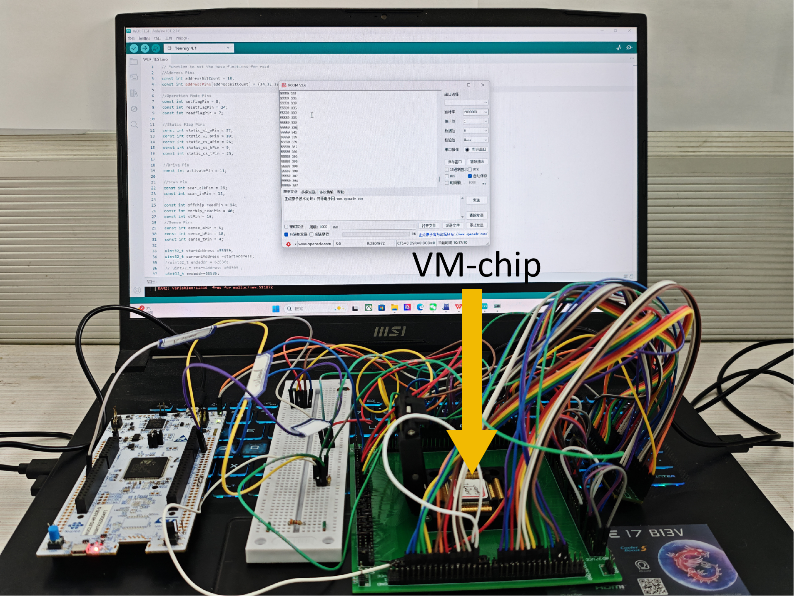
Supplementary Figure 1. Photograph of the complete VM-chip testing system. The Teensy 4.1 serves as the MCU, while the STM32 is used solely for voltage supply. The VM-chip is mounted on a custom-designed printed circuit board.
Supplementary Note 1. RBM and DBN model
Restricted Boltzmann machine (RBM) is an undirected stochastic neural network based on an energy function, employing a two-layer architecture consisting of a visible layer and a hidden layer to model the probability distribution of input data. Both layers are composed of a large number of binary neurons (0 or 1), where units between layers are connected through weighted couplings while no intra-layer connections are present. The overall interactions within the network are quantified by a global energy function:
$$E(v,h)=-\sum_{i}{ }a_{i}v_{i}-\sum_{j}{ }b_{j}h_{j}-\sum_{i,j}{ }v_{i}w_{ij}h_{j}$$
Here, a_{i} ​and b_{j} ​denote the biases of the visible and hidden neurons, respectively, and w_{ij} represents the weight connecting them. States with lower energy occur with higher probability, and their joint distribution follows the Boltzmann form:
$$P(v,h)=\frac{1}{Z}exp⁡(-E(v,h)/T)$$
Z is the partition function that normalizes the distribution so that the probabilities of all possible states sum to one. T is a temperature parameter that controls the level of stochasticity. To enable effective probabilistic computation, an RBM typically updates neuron states through Gibbs sampling, where the probability that the i-th neuron takes the value of 1 is determined by the influence of the other connected neurons and follows a sigmoid function:
$$P(v_{i}=1|h)=σ(a_{j}+\sum_{i}{ }h_{j}w_{ij})$$
$$P(h_{j}=1|v)=σ(b_{j}+\sum_{i}{ }v_{i}w_{ij})$$
Gibbs sampling facilitates efficient exploration of low energy regions in the state space, thereby reducing the risk of becoming trapped in local minima. Building upon this mechanism, deep belief network (DBN) constructs a deeper hierarchical architecture by stacking multiple RBM layers, where each layer is trained sequentially to learn increasingly abstract representations of the data. The joint probability distribution of a DBN can be expressed as:
$$P(v,h^{1},…,h^{L})=P(v∣h^{1})\left(\prod_{l=1}^{L-1}{ }P(h^{l}∣h^{l+1})\right)P(h^{L})$$
L denotes the total number of layers in the network. Each RBM within the DBN takes the activations of the hidden layer from the preceding RBM as its visible-layer input, and the conditional probabilities in every layer are computed through weighted summation followed by a sigmoid activation, consistent with the Gibbs-sampling formulation used in a single RBM. On the VM-chip, MTJs functioning as p-bits naturally support the extensive Gibbs-sampling operations required by RBMs and DBNs, while offering low power consumption and high parallelism, thereby enabling efficient deep probabilistic computation directly at the hardware level.
Supplementary Note 2. Details of the RBM implementation
Each image in MNIST was then flattened into a 784-dimensional vector, and data loaders were constructed with a batch size of 64 for the training set and 1,000 for the test set to facilitate mini-batch processing during model training and evaluation. The RBM consists of 784 visible nodes (with 784 visible biases) and 256 hidden nodes (with 256 hidden biases), with a weight matrix of size 784 × 256. The sampling process follows Gibbs sampling. We train the RBM using the contrastive divergence algorithm. After feeding the visible units, the hidden unit activation probabilities P are computed, and the hidden states h and reconstructed visible units v are sampled using the VM-chip. Gradients are computed according to:
$$ΔW=\frac{1}{N}(v_{0}^{T}h_{0}-v_{k}^{T}h_{k})$$
$$Δa=\frac{1}{N}(v_{0}-v_{k})$$
$$Δb=\frac{1}{N}(h_{0}-h_{k})$$
The trained RBM is used to extract 256-dimensional hidden layer activation probabilities as features, which are then fed into a linear classifier for 10-class image classification. The classifier is trained using the cross-entropy loss function and optimized with the Adam optimizer. During each training batch, both the RBM and the classifier are updated simultaneously. The test accuracy is evaluated every 100 iterations.
Supplementary Figure 2. Schematic of the RBM training process. The RBM unsupervised training phase is shown in purple, and the supervised recognition phase using the RBM is shown in orange.
Supplementary Figure 3. Additional validation experiments using MTJ-1 generated random bits. a, DBN classification on MNIST. The DBN is composed of three layers with 784 nodes, 512 nodes, and 256 nodes. b, RBM recognition on Fashion-MNIST.
Supplementary Figure 4. Probability distributions during RBM sampling. a, Reconstruction probability distribution of the visible layer. b, Activation probability distribution of the hidden layer.
Supplementary Note 3. 8-Bit Digitally Controlled Pulse-Shaping Module
The pulse-shaping module used in this work is based on an 8-bit digitally controlled network implemented through a set of binary-weighted discharge branches. The core idea is to employ eight discharge paths with different weighting factors to finely tune the effective conductance at the output node. Specifically, each Config [i] bit provides a simple 0/1 switching signal that determines whether the corresponding discharge branch is connected to the circuit. Config [0] controls 1 resistor, Config [1] controls 2 resistors, Config [2] controls 4 resistors, Config [3] controls 8 resistors, …, and Config [7] controls 128 resistors. By configuring the on/off state of each Config[i] bit, the circuit can generate any combination ranging from 0 to 255 discharge resistors, resulting in 256 distinct levels of effective resistance (or equivalently, conductance). Since the output pulse width is approximately linearly related to the effective resistance of the discharge path, these 256 discrete resistance states naturally correspond to 256 programmable pulse-width levels.
Supplementary Note 4. Anomaly Detection Algorithm
In this experiment, the RBM consisted of 784 visible units, corresponding to 784 input pixels, and 128 hidden units. During training, only normal samples (digit 1) were used to train the RBM, while other digits were excluded. The contrastive divergence algorithm was employed during training, and the sampling process was implemented via the VM-chip.
Each sample was evaluated using its Gibbs free energy to determine whether it was normal or anomalous. By ranking all samples according to their free energy, those with higher free energy were considered more likely to be anomalous. A threshold was set such that samples with free energy exceeding this threshold were classified as anomalies. The underlying principle is as follows. The joint probability of the RBM can be expressed as:
$$P(v,h)=\frac{1}{Z}e^{-E(v,h)}$$
By marginalizing over the hidden layer (summing over all possible hidden states), the probability of a visible sample can be obtained as:
$$P(v)=\frac{1}{Z}\sum_{h}{ }e^{-E(v,h)}=\frac{1}{Z}e^{-F(v)}$$
$$F(v)=-log⁡\sum_{h}{ }e^{-E(v,h)}⟹P(v)∝e^{-F(v)}$$
The free energy is inversely related to the probability of a sample. Therefore, a higher free energy indicates a lower probability, meaning the sample deviates from the training data distribution and can be classified as anomalous. Substituting $E\left(v,h\right)$ into the equation gives:
$$\sum_{h}{ }e^{-E(v,h)}=\sum_{h}{ }e^{v^{T}a+h^{T}b+v^{T}Wh}=e^{v^{T}a}\sum_{h}{ }e^{h^{T}(Wv+b)}$$
$$F(v)=-log⁡\left[e^{v^{T}a}\sum_{h}{ }e^{h^{T}(Wv+b)}\right]=-v^{T}a-log⁡\sum_{h}{ }e^{h^{T}(Wv+b)}$$
Since the hidden layer units are binary (0 or 1) and independent, we have:
$$\sum_{h}{ }e^{h^{T}(Wv+b)}=\prod_{j}{ }\sum_{h_{j}=0}^{1}{ }e^{h_{j}(Wv+b)_{j}}=\prod_{j}{ }\left(1+e^{(Wv+b)_{j}}\right)$$
Substituting this gives the formula for calculating the Gibbs free energy:
$$F(v)=-v^{T}a-log⁡\prod_{j}{ }\left(1+e^{(Wv+b)_{j}}\right)=-\sum_{i}{ }v_{i}a_{i}-\sum_{j}{ }log⁡(1+e^{(Wv+b)_{j}})$$
The term $-\sum_{i}{ }v_{i}a_{i}$ corresponds to the visible layer component. It depends only on the visible layer inputs and biases and measures how well the input sample matches the visible layer biases. The term $-\sum_{j}{ }log⁡(1+e^{(Wv+b)_{j}})$ corresponds to the hidden layer component and measures the ability of the hidden layer to explain the input sample.
Supplementary Figure 5. Implementation of RBM for anomaly detection based on VM-Chip a, ROC curve obtained from anomaly detection using RBM on the MNIST dataset, with the digit 1 treated as the normal sample and all other digits treated as anomalous samples. The dashed line represents the diagonal of a random classifier, and the area under the curve (AUC) is 0.998. b, The free energy distributions were used to verify potential overfitting. c, The table of Precision, Recall, F1-score and Accuracy. d, Top 10 ranked samples.
Supplementary Note 5. Image Generation Algorithm
In this work, we employ a Deep Boltzmann Machine (DBN) for digit image generation. The DBN consists of two stacked RBMs: the first RBM (RBM1) has a 784-512 structure, and the second RBM (RBM2) has a 512-256 structure, forming a three-layer network corresponding to the visible layer v, first hidden layer h₁​, and second hidden layer h₂​. The MNIST dataset is first binarized and then fed into the visible layer. The training procedure is as follows: RBM1 is trained first, and its hidden layer activations are then used as the visible layer input for RBM2; details of the training procedure are provided in Supplementary Note 1. Each RBM is trained for 5 epochs. After training, we compute the activation probabilities of each node in h₂​ and calculate their mean values, as described by the following formula:
$$P(h_{1}=1|input)=\frac{\sum_{i}{ }p_{h}}{n}$$
The h₂ state is first sampled based on the mean vector of the target digit, and the visible layer image is then iteratively reconstructed via Gibbs sampling. Due to the inherent stochasticity of the generative process, a self-consistency check is introduced to ensure reliability: only images whose top-layer hidden representations exhibit a cosine similarity above a predefined threshold with the target digit mean and are correctly classified are retained. The cosine similarity is computed using the following formula:
$$s_{c}=cos⁡(h^{(gen)},μ_{c})=\frac{h^{(gen)}⋅μ_{c}}{∥h^{(gen)}∥_{2}{∥μ_{c}∥}_{2}}=\frac{\sum_{i=1}^{d}{ }h_{i}^{(gen)}μ_{c,i}}{\sqrt{\sum_{i=1}^{d}{ }(h_{i}^{(gen)})^{2}}\sqrt{\sum_{i=1}^{d}{ }(μ_{c,i})^{2}}}$$
$h^{(gen)}$is the top-layer (h₂) hidden vector of the generated image, $μ_{c}$is the top-layer mean vector of the target digit c and d=256 is the number of h₂ nodes. The value of $s_{c}$​ ranges from -1 to 1, with values closer to 1 indicating that the generated vector is more similar to the mean vector of the target class. The selection criterion for the self-consistency check is given by:
$$accept(h^{(gen)})=\left\{\begin{aligned}&True, &&if \hat{c}=c and s_{c}≥τ_{c} \\ &False, &&otherwise && && &&\end{aligned}\right.$$
Let $\hat{c}$ denote the predicted class of the generated image, and $τ_{c}$ represent the predefined threshold.
Supplementary Figure 6. Image generation performed on the Fashion-MNIST dataset with DBN. Since the Fashion-MNIST dataset becomes difficult to recognize after binarization, the visible layer takes the original image vectors as input, while its output represents the activation probabilities of the visible nodes (grayscale values). During training, parameter updates are still performed using binarized samples.
Supplementary Figure 7. Image generation performed on the MNIST dataset with RBM. Compared with the DBN, the pixels forming the digits in RBM generated images are more sparsely distributed, resulting in a fragmented overall structure.

