Fig.1 C
ΔNp63α
GAPDH
ΔNp63γ
GAPDH
ΔNp63α
GAPDH

Fig.1 D
ΔNp63γ

GAPDH

Fig.1 E
ΔNp63α
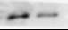
GAPDH
ΔNp63α
GAPDH

Fig.1 I
ΔNp63α
GAPDH

Fig.1 J
ΔNp63α
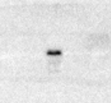
ΔNp63α
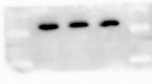
H1
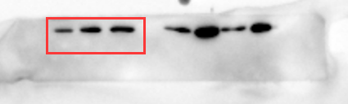

ΔNp63γ
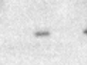

ΔNp63γ
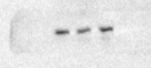

H1
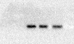

Fig.3 A
ΔNp63α
GAPDH

Fig.3 D
ΔNp63α
GAPDH
Fig.3 G
ΔNp63α
GAPDH

Fig.4 A
P-ERK
ERK
GAPDH

Fig.4 C
ΔNp63α
P-ERK
ERK
GAPDH

Fig.4 E
ΔNp63α
P-ERK
ERK
GAPDH

Fig.5 C
AKT
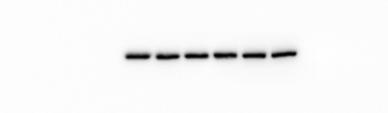
p-AKT
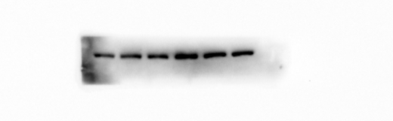
mTOR
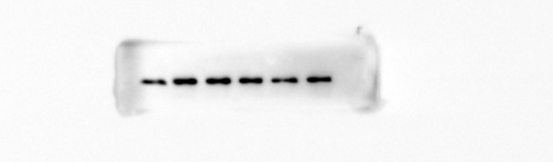
P-mTOR
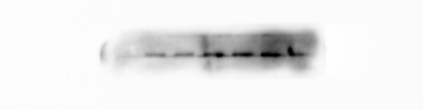
ERK
P-ERK
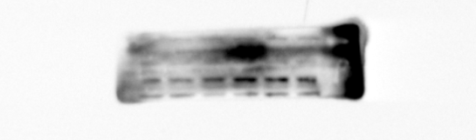
S6K
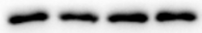
P-S6K
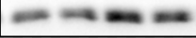
GAPDH
Fig.6 G
GAPDH
ERK P-ERK
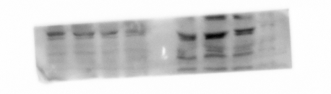
p-STAT3
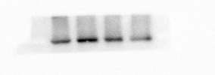
STAT3
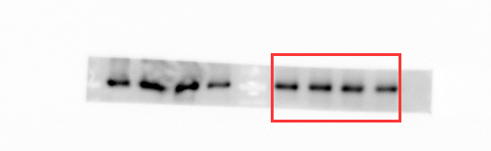

Fig.S1 A
P63
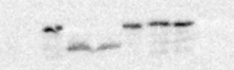
GAPDH
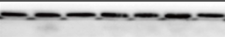

Fig.S1 B
ΔNp63α
GAPDH

Fig.S1 C
ΔNp63α
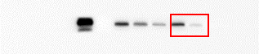
GAPDH
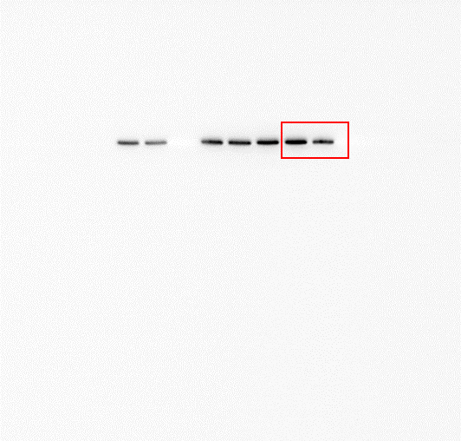

Fig.S1 D
ΔNp63α
GAPDH
ΔNp63α
GAPDH
Fig.S1 E
ΔNp63γ
GAPDH
Fig.S5 A
ΔNp63α
GAPDH
Fig.S5 D
ΔNp63α

GAPDH

Fig.S5 G
ΔNp63α/γ
GAPDH

Fig.S6 A
P-ERK
ERK
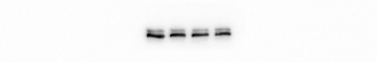
GAPDH

Fig.S6 B
ΔNp63α
GAPDH
Fig.S6 G
ΔNp63α
P-ERK
ERK
GAPDH

Fig.S6 I
ΔNp63α
P-ERK
ERK
GAPDH

Fig.S6 J
ΔNp63α
GAPDH

