Supplementary Materials for

Chemokine CCL5 is transcriptionally suppressed by ΔNp63 and facilitates progression of head and neck squamous cell carcinoma

Authors:
Xiushuang Luo, et al.

Correspondence: Chenghua Li, lichenghua@scu.edu.cn

Figure S1. Expression and roles of ΔNp63 in HNSCC cell Lines.
A. Expression of ΔNp63α and ΔNp63γ in squamous cell carcinoma multiple cancer cell lines were detected using immunoblotting (IB) with 293T cells transfected with ΔNp63α or ΔNp63γ as positive controls. B. Stable cell lines overexpressing ΔNp63α were established in CAL27 cells, cell migration ability was assessed via transwell assays, scale bar = 200 μm. C. Stable cell lines knocked down p63 were established in UM1 cells, cell migration ability was assessed via transwell assays , scale bar=200 μm. D. Stable cell lines overexpressing or knocking down ΔNp63α were established in MOC1 cells, cell migration ability was assessed via transwell assays ,scale bar=200 μm. E&F. Stable cell lines overexpressing ΔNp63γ were established in SCC7 cells, cell migration ability was assessed via wound healing assay(F, scale bar=200 μm); cell proliferation determined via colony formation assay (E, scale bar =1 cm). All panel data are presented as mean ± SD and analyzed using t-tests. **, p < 0.01; ***, p< 0.001.

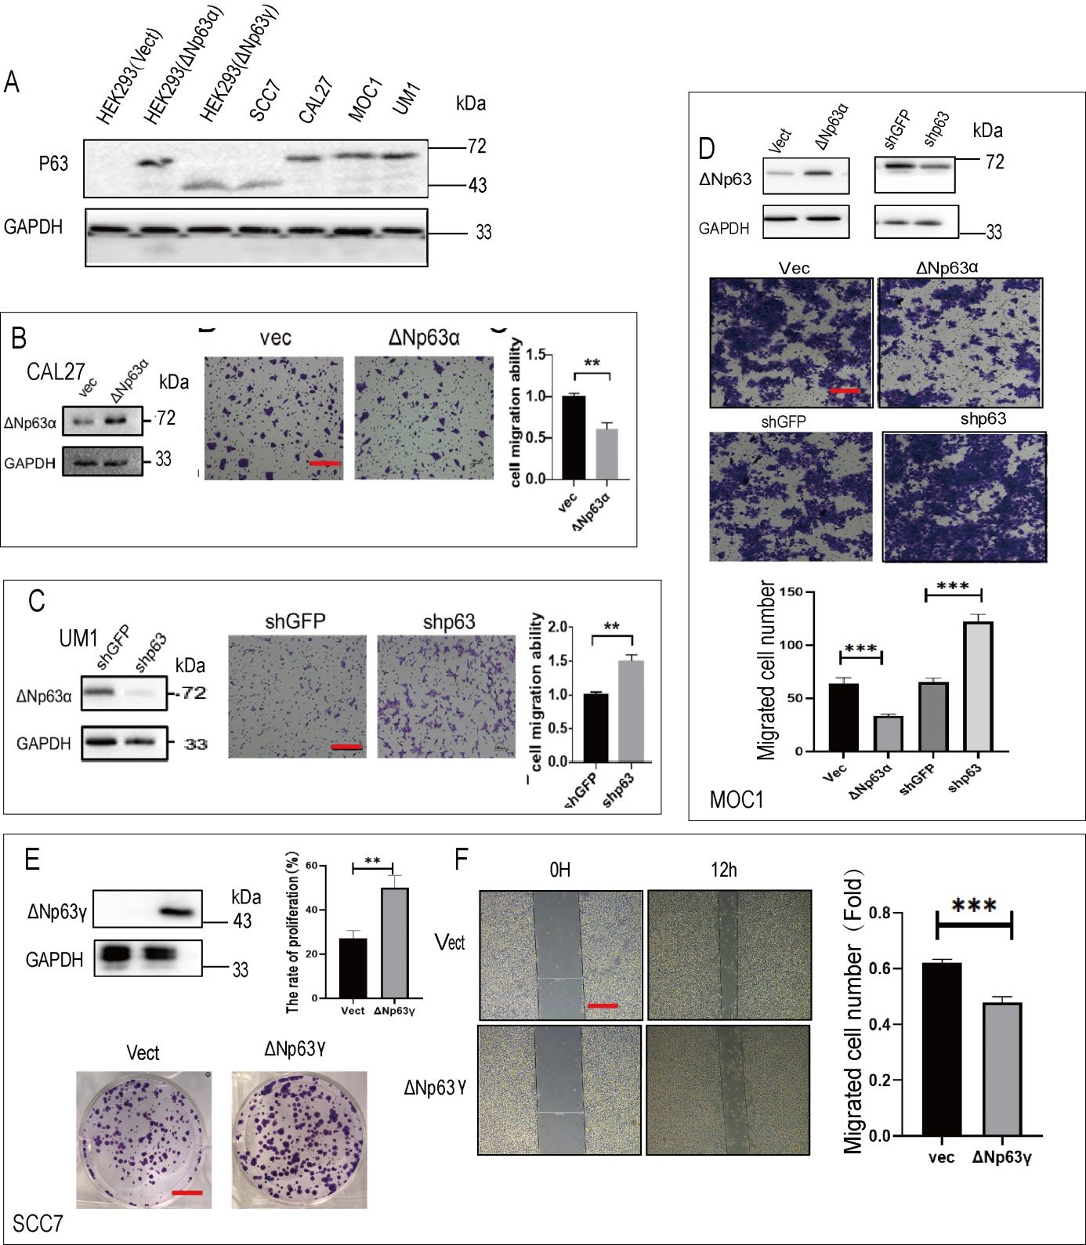
Figure S2. Expression and clinical significance of TP63 and CCL5 in HNSCC.
A&B. Boxplots showing the expression levels of TP63 (A) and CCL5 (B) in head and neck squamous cell carcinoma (HNSCC) tissues (n=519) compared with normal tissues (n=44). Data are presented as log2(TPM+1). * , p<0.05. C&D. GEPIA2-based disease-free survival (DFS) analysis of HNSCC patients via GEPIA2, stratified by high (75th percentile) and low (25th percentile) TP63 (C) and CCL5 (D) expression. The log-rank test p-values and hazard ratios (HR) are indicated. E&F. Boxplots showing the expression of TP63 (E) and CCL5 (F) in HNSCC patients based on nodal metastasis status, generated using the UALCAN online tool. Statistical significance is indicated as *, p < 0.05; **, p < 0.01; ***, p < 0.001.(N0: no regional lymph node metastasis; N1: metastasis in a single ipsilateral lymph node ≤3 cm; N2: metastasis in a single ipsilateral node >3 cm and ≤6 cm, or multiple ipsilateral nodes ≤6 cm, or contralateral/bilateral nodes ≤6 cm; N3: metastasis in a lymph node >6 cm)
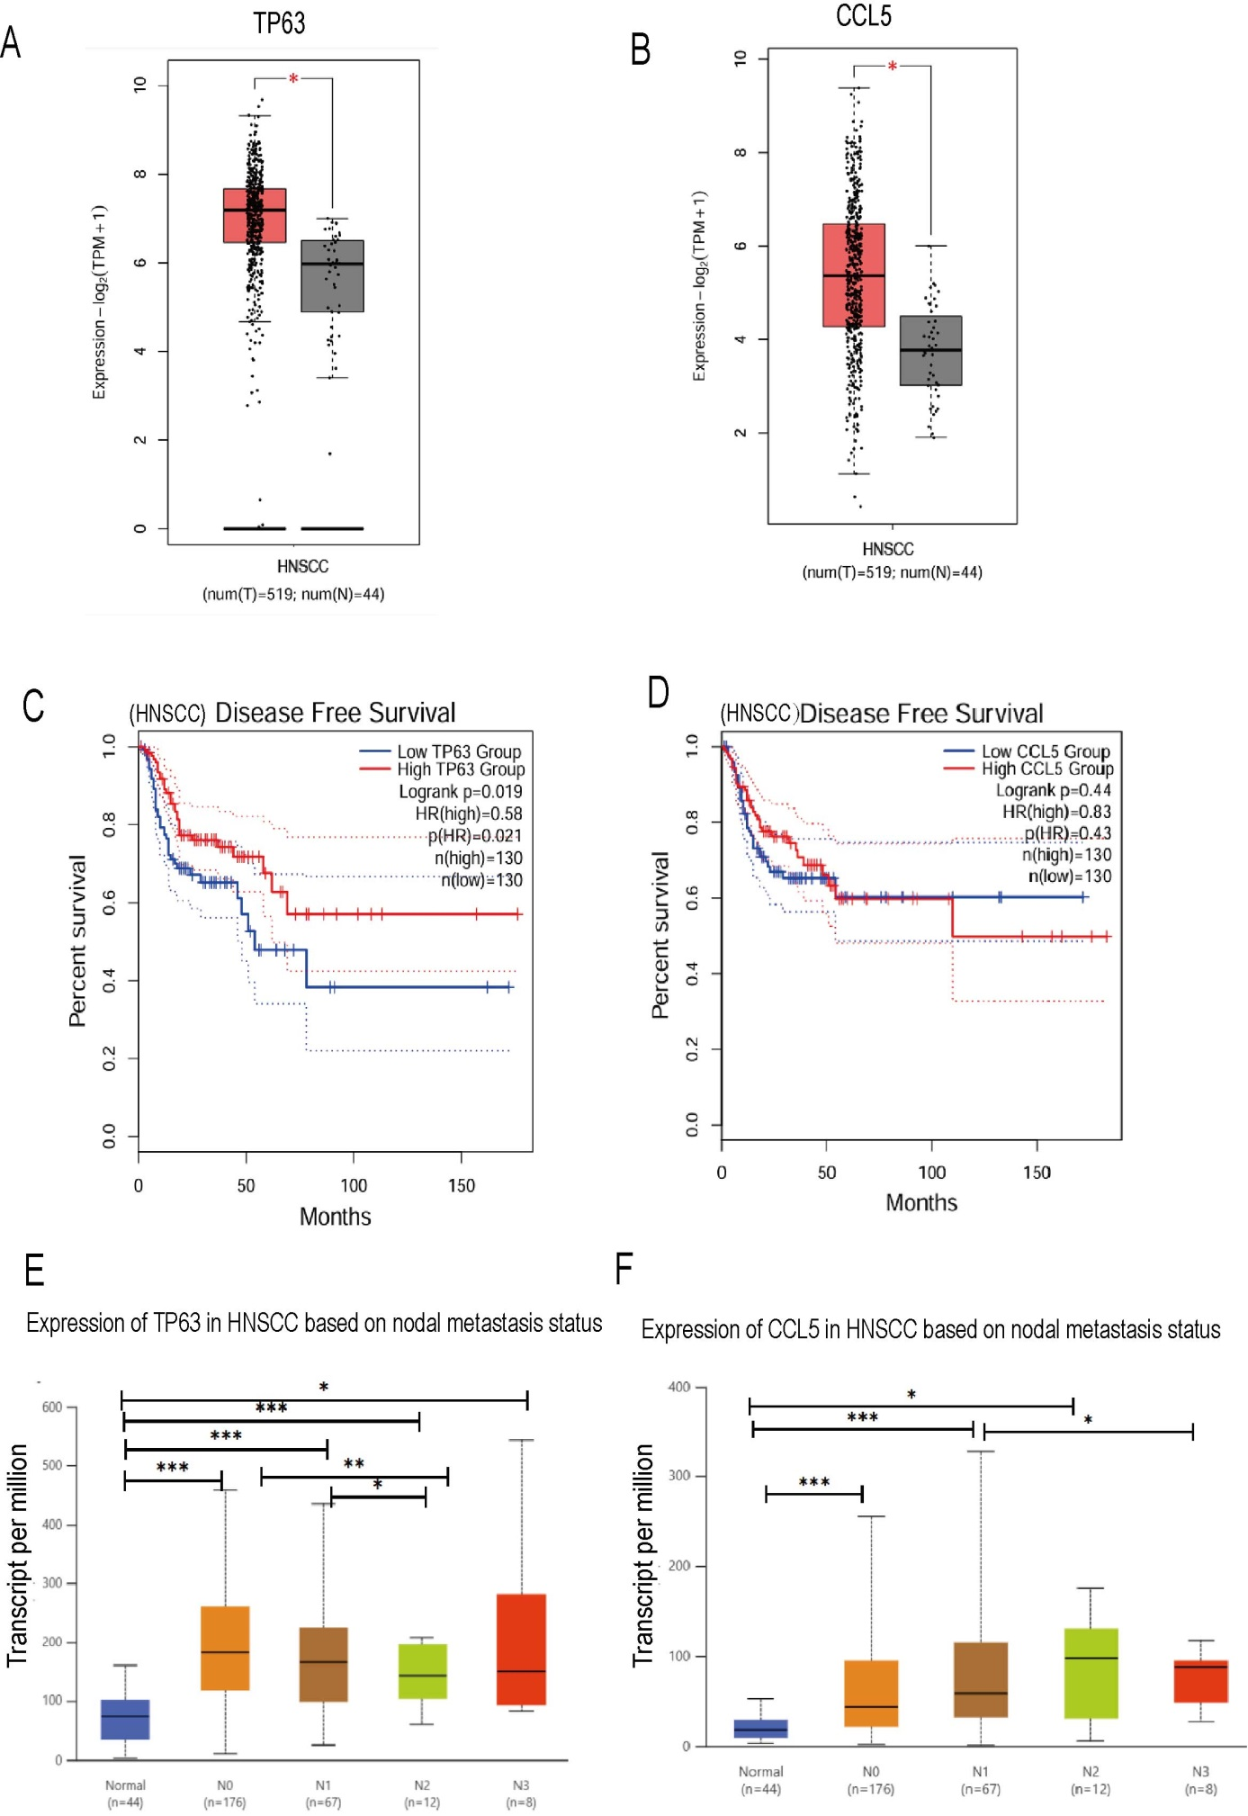

Figure S3. CCL5’s effects on proliferation, EMT and migration of HNSCC cells.
A. With indicated stable CAL27 cell strains, CCL5 expression was measured by RT-qPCR, cell proliferation was assessed via MTT assay. B. Stable cell lines overexpressing CCL5 were established in CAL27 cells. RT-qPCR was used to detect the expression levels of EMT markers (N-cadherin, Slug, Sox4, Twist). C. Stable cell lines knocking down CCL5 were established in CAL27 cells , cell proliferation assessed via colony formation assay, scale bar=1 cm. D. Stable cell lines overexpressing or knocking down CCL5 were established in CAL27 cells, cell migration ability was assessed via transwell assays, scale bar=200 μm. Data are presented as mean ± SD and analyzed using Student’s t-test. *, p < 0.05; **, p < 0.01; ***, p< 0.001; ****, p< 0.0001.

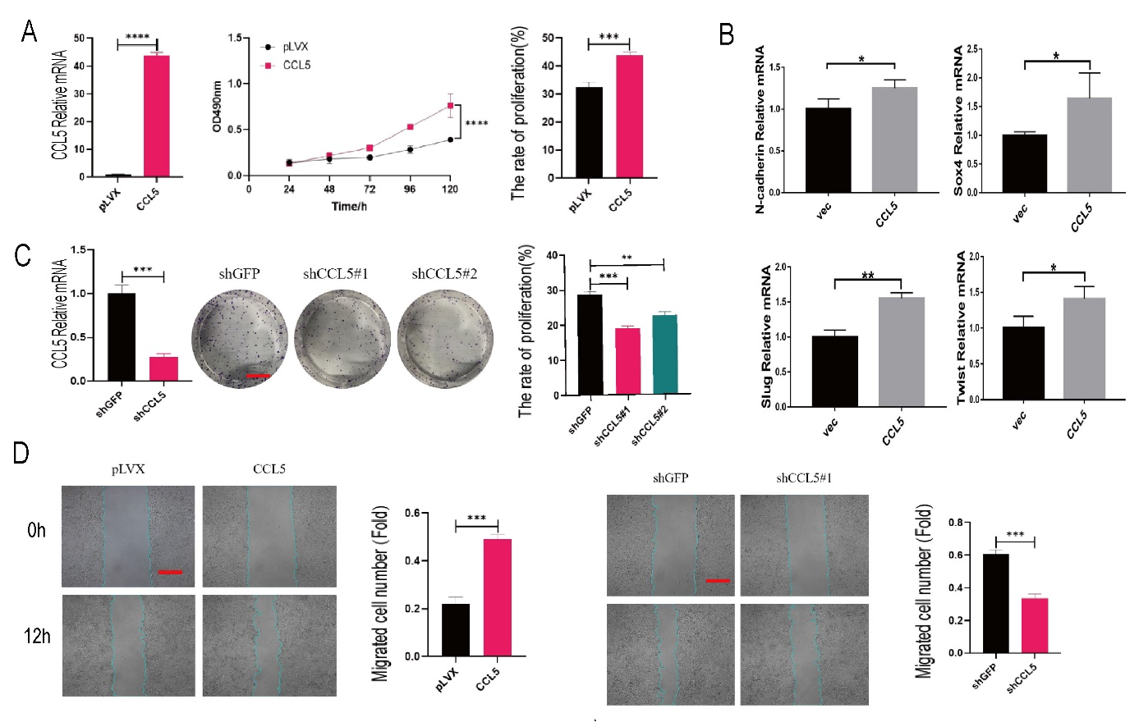

Figure S4. Supplemented or secreted CCL5 promotes proliferation and migration of HNSCC cells.
A. Seed SCC7 cells into a 96-well plate. Add CCL5 peptide solutions at varying concentrations (0–2 ng/mL) to the medium in each group. Measure absorbance values daily during cell culture and plot growth curves. B. Seed SCC7 cells at a density of 100,000 cells/well in the upper chamber of Transwell devices. Add 500 μL of medium containing 0, 0.5, 1, or 2 ng/mL CCL5 peptide to the lower chamber of each group. Transwell assay detects transmigrated cells. C. Conditioned medium from SCC7/UM1 cells under different CCL5 concentrations or following CCL5 knockdown or overexpression. Seeded in the lower layer to recruit HNSCC cells or co-cultured with HNSCC for growth curve analysis. D. Collect the conditioned medium from stable cell lines overexpressing or knocked out for CCL5 after 24 hours of culture. Seed SCC7 empty cells into a 96-well plate and culture them using five different conditioned media. Measure absorbance values daily to plot growth curves. E~G. After cell attachment, UM1-CCL5 and SCC7-CCL5/shCCL5 stable cell lines were cultured in serum-free medium for 24 h, and the supernatants were collected as conditioned media. Parental SCC7 or UM1 cells were seeded into the upper chambers, while 500 μL of conditioned medium was added to the lower chambers. Migrated cells were assessed after 24 h. Panels (B, E, F&G) are presented as mean ± SD and analyzed using Student’s t-test. Panel (A&D) was analyzed using two-way ANOVA.*P<0.05; ***P<0.001.

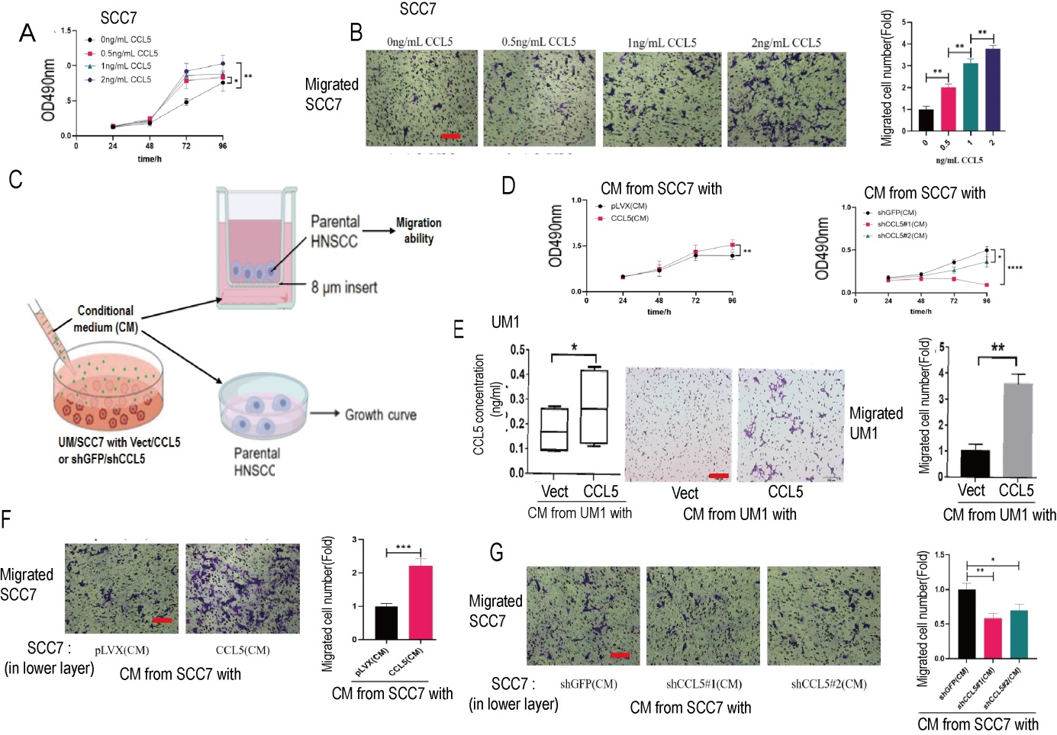
Figure S5. CCL5 mediates migration and liver metastasis of HNSCC cells induced by ΔNp63α depletion or inhibition
A~F. Stable cell lines overexpressing or knocking down ΔNp63α and/or CCL5 were established in CAL27 cells. CCL5 mRNA were measured by RT-qPCR, and indicated proteins were detected by IB analysis (A&D). RT-qPCR was used to detect the expression levels of EMT markers (N-cadherin, Slug) (B&E), and cell migration ability was assessed via transwell assays (C&F, scale bar=200 μm). G-I. Stable cell lines overexpressing or knocking down ΔNp63 and/or CCL5 were established in SCC7 cells, cell migration ability was assessed via transwell assays(H, scale bar=200 μm) J&K. Indicated SCC7 stable cell lines were injected into the tail veins of C3H mice. Liver metastasis was assessed by dissection 30 days post-injection (J, scale bar=1 cm). Quantitative analysis was performed (K). All panel data are analyzed using one-way ANOVA. *, p < 0.05; **, p < 0.01; ***, p< 0.001; ****, p< 0.0001.

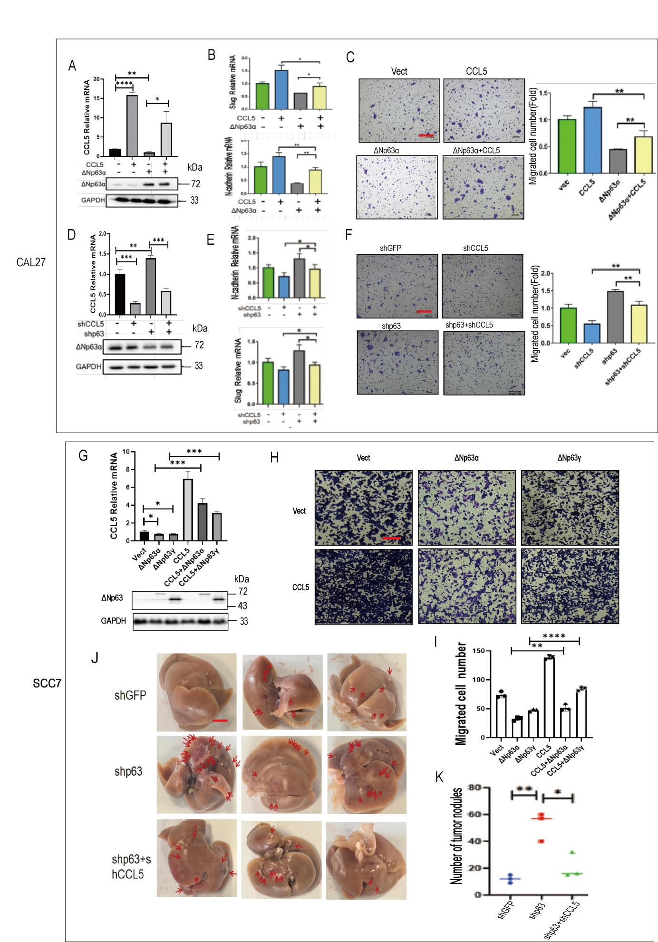
.
Figure S6. ΔNp63α/CCL5 axis affects cell migration mainly via modulating ERK pathway in CAL27 cell
A, B&G. CCL5-overexpressing, ΔNp63α- knockdown CAL27 cells, or their control groups, were treated with ERK inhibitor U0126; immunoblot analysis was employed to assess phosphorylated (P-ERK) and total ERK levels (A&G), while cell migration capacity was measured by transwell assay (A&B, scale bar=200 μm). C~F. CCL5-overexpressing, ΔNp63α- knockdown in CAL27 or UM1 cells, or their control groups, were treated with ERK inhibitor U0126 ; RT-qPCR detection of EMT markers (N-cadherin, Slug) expression. H. p63 knockdown in UM1 cells treated with CCR5 inhibitor Maraviroc: RT-qPCR detection of EMT markers (N-cadherin, Slug) expression. I&J. p63 knockdown in CAL27 cells treated with CCR5 inhibitor Maraviroc; immunoblot analysis was employed to assess phosphorylated (P-ERK) and total ERK levels(I); while cell migration capacity was measured by transwell assay (J, scale bar=200 μm). All panel data are analyzed using one-way ANOVA. *, p < 0.05; **, p < 0.01; ***, p< 0.001; ****, p< 0.0001.

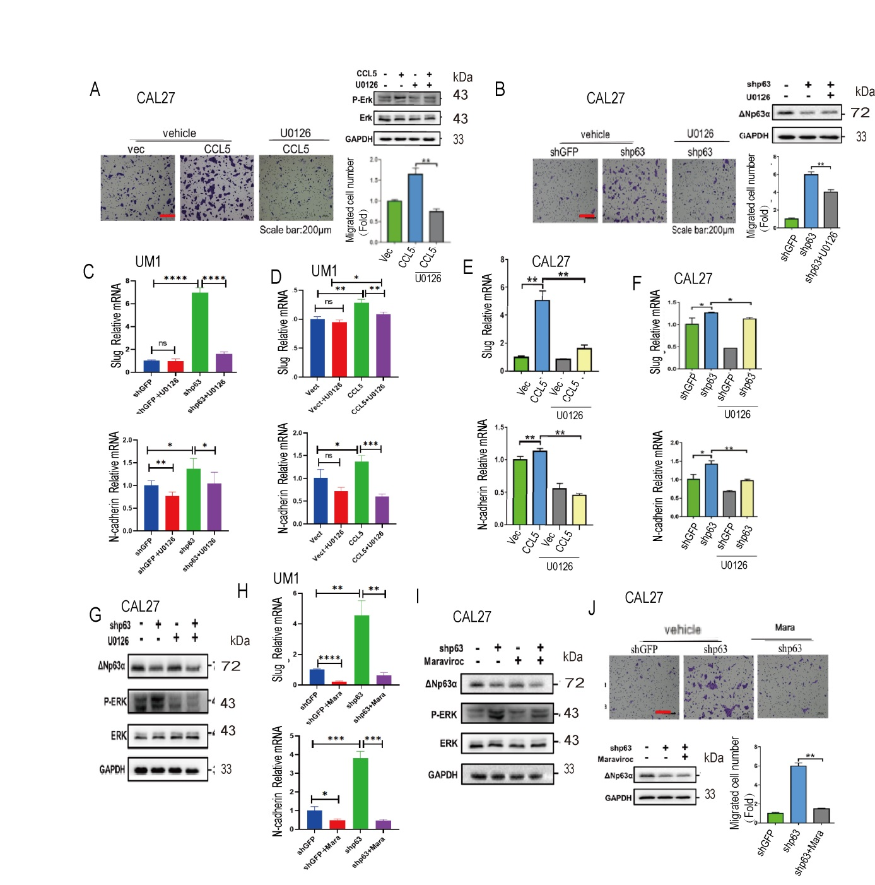

Figure S7. ΔNp63/CCL5 axis differentially regulates expression of CCND1 and CCNE2
A~D. Stable MOC1 cell lines overexpressing or knocking down p63 and/or CCL5 were established, RT-qPCR was used to detect the expression levels of CCND1 and CCNE2. E. Stable MOC1 cell lines overexpressing CCL5 were established, treat cells with mTOR inhibitor RAPA or controls, RT-qPCR was used to detect the expression levels of CCNE2. F~H. Stable MOC1 cells with CCL5/ΔNp63 knockdown were subcutaneously injected into the immunocompetent mice; Xenograft growth curves were assessed over 15 days (F); Xenografts were excised, photographed and weighted at this time point (G&H). Panels (A~E, H) are presented as mean ± SD and analyzed using one-way ANOVA. Panel (F) was analyzed using two-way ANOVA. *P<0.05; **P<0.001.
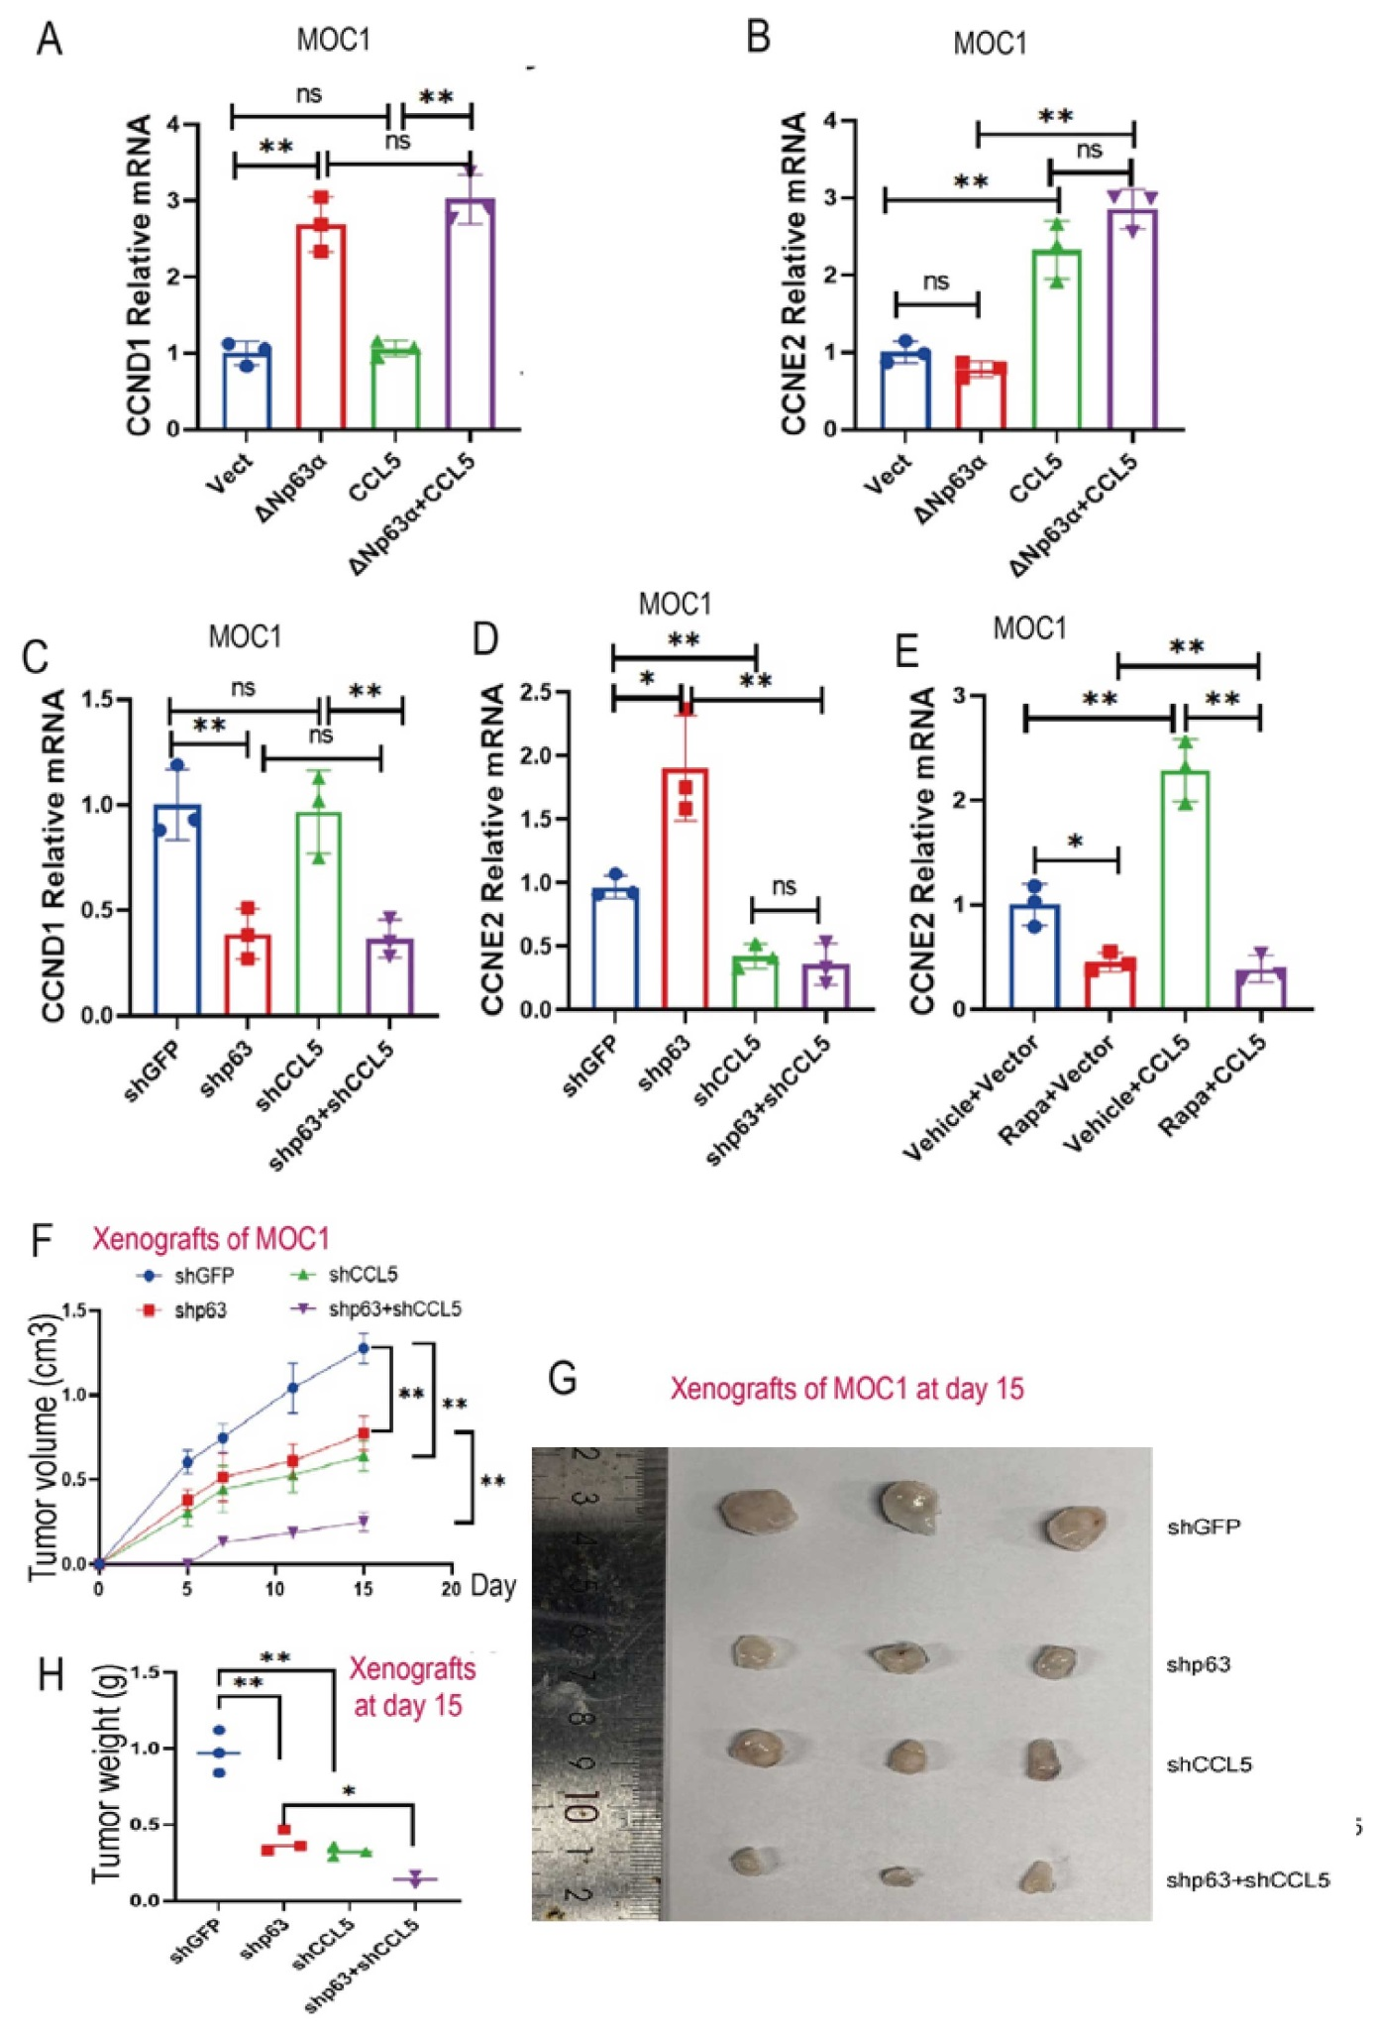
Figure S8. CCL5 promotes tumor growth and infiltration of M2 macrophages
Stable MOC1 cells with CCL5 overexpression were subcutaneously injected into the immunocompetent mice C57BL/6. Xenografts were excised, photographed and weighted over 15 days. The tumors were used for immunofluorescence analysis to detect macrophage recruitment (F4/80)(A, scale bar=100 um) and polarization (CD206 and CD86) (C, scale bar=50 um). Panel (B) are presented as mean ± SD and analyzed using Student’s t-test. Panel (D) was analyzed using two-way ANOVA. *, p < 0.05; **, p < 0.01; ***, p< 0.001.

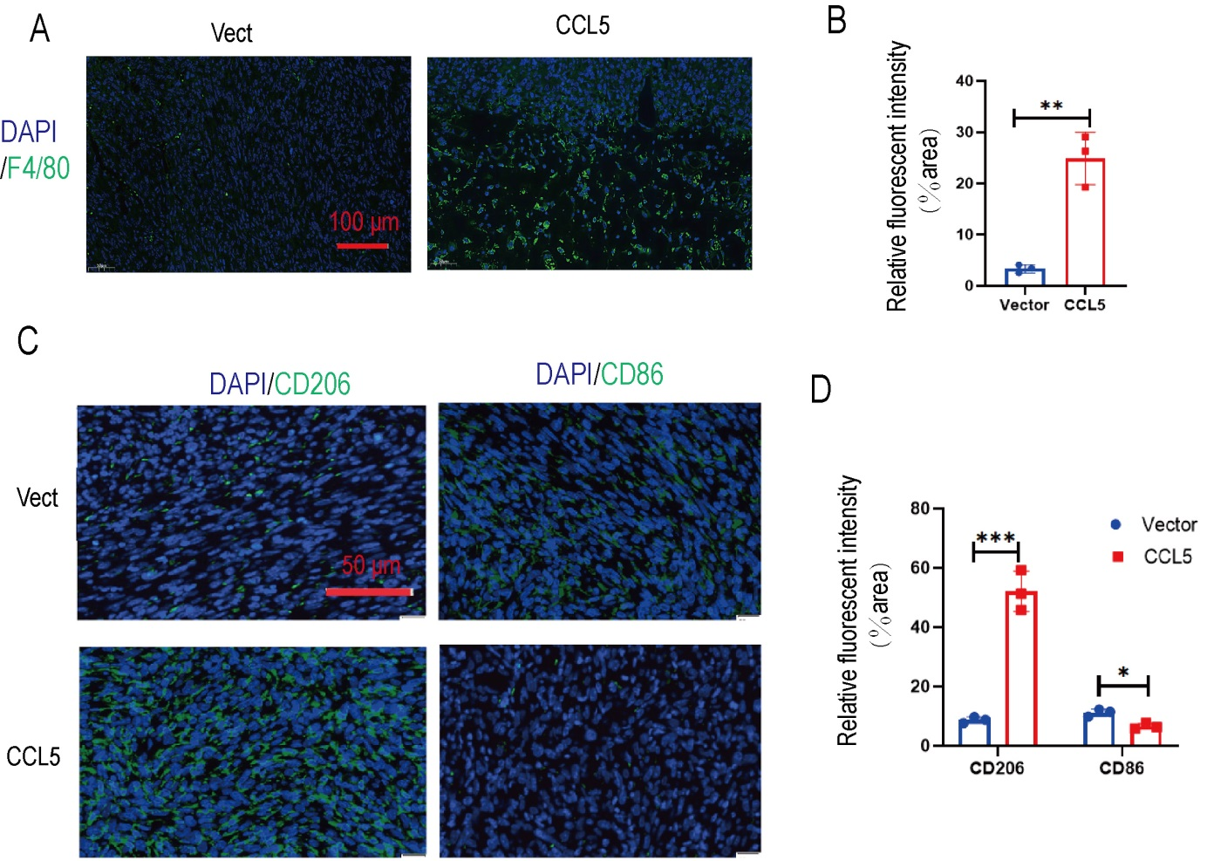

Table S1. The target sequences of shRNA

Name of shRNA | Sequences (5’→3’)
shGFP | GAAGCAGCACGACTTCTTC
shCCL5#1 | GTGTGTGCCAACCCAGAGA
shCCL5 #2 | GCTGGCTCAGTCACCTGAA
shp63#1 | GCAATGAAGACGAGATGGA
shp63#2 | GAGTGGAATGACTTCAACTTT

Table S2. Primer sequences for qPCR
Gene | Forward (5’→3’) | Reverse (5’→3’)
GAPDH-homo | GATTCCACCCATGGCAAATTC | CTGGAAGATGGTGATGGGATT
GAPDH-Mouse | GTGGACCTCATGGCCTACAT | TGTGAGGGAGATGCTCAGTG
SLUG-homo | AGCCGGAGGAGGAGATGT | ACAGTGATGGGGCTGTATGC
SLUG-Mouse | CACATTGCCTTGTGTCTGCAA | AAGAGAAAGGCTTTTCCCCAGT
N-Cadherin-homo | AGCCAACCTTAACTGAGGAGT | GGCAAGTTGATTGGAGGGATG
SOX4-homo | AGCCGGAGGAGGAGATGT | TTCTCGGGTCATTTCCTAGC
TWIST-homo | AGCTACGCCTTCTCGGTCT | CCTTCTCTGGAAACAATGACATC
TWIST-Mouse | GGCCGGAGACCTAGATGTCATT | ACGCCCTGATTCTTGTGAATTT
CCL5-homo | ATGACTCCCGGCTGAACAAG | GCCTCCCAAGCTAGGACAAG
CCL5-Mouse | CTCGCTGTCATCCTCATTGC | CTCTGGGTTGGCACACACTT
CD86 | CTTACGGAAGCACCCACGAT | TGTAAATGGGCACGGCAGAT
CD206 | GTCAGAACAGACTGCGTGGA | AGGGATCGCCTGTTTTCCAG
INOS | AACAGGGAGAAAGCGCAAAAC | TCCACTGCCCCAGTTTTTGA
ARG1 | CGGGAGGGTAACCATAAGCC | CTTGGGAGGAGAAGGCGTTT

