Supplementary Information

Supplementary Section 1. ICD codes for inclusion and exclusion criteria
This section provides the complete list of diagnosis codes used in this study to identify systemic hypertension and related subtypes for inclusion, as well as codes for excluded hypertension types. These codes were applied to the admission diagnosis records in the MIMIC-IV v3.1 database to define the study cohort.
Table S1. ICD-9 and ICD-10 codes for inclusion and exclusion criteria.
Criteria | Hypertension Type | ICD-9 Codes | ICD-10 Codes
Inclusion | Systemic Hypertension | 4019, 401, 4010, 4011, 40200, 40201, 40210, 40211, 40290, 40291 | I10, I11, I12, I13, I110, I119, I120, I129, I130, I131, I132, I139
Inclusion | Secondary Hypertension | 4050, 4051, 4052, 4053, 4054, 4055, 4056, 4057, 4058, 4059 | I15, I150, I151, I152, I158, I159
Inclusion | Hypertensive Complications | 40390, 40391, 40400, 40401, 40402, 40403, 40410, 40411, 40412, 40413 | I11, I12, I13
Exclusion | Non-systemic Hypertension (pulmonary, portal, intracranial, ocular) | 4160, 41611, 41619, 4168, 4169, 5723, 3482, 36504 | I27, I270, I271, I272, I278, I279, K766, G930, G932, H4000, H4001, H4002, H4003
Note:
- Inclusion codes define systemic hypertension and related conditions retained for the study cohort.
- Exclusion codes refer to non-systemic hypertension conditions. A hospitalization was excluded only if it contained exclusively exclusion codes without any inclusion code. If both inclusion and exclusion codes were present, the hospitalization was retained.
- This approach ensures that systemic hypertension is the defining condition of the final cohort.

Supplementary Section 2. Enhanced Semantic Analysis Approach for Postoperative ICU Transfer Identification
Figure S1. Two-Stage Workflow for Surgical and Postoperative ICU Identification.
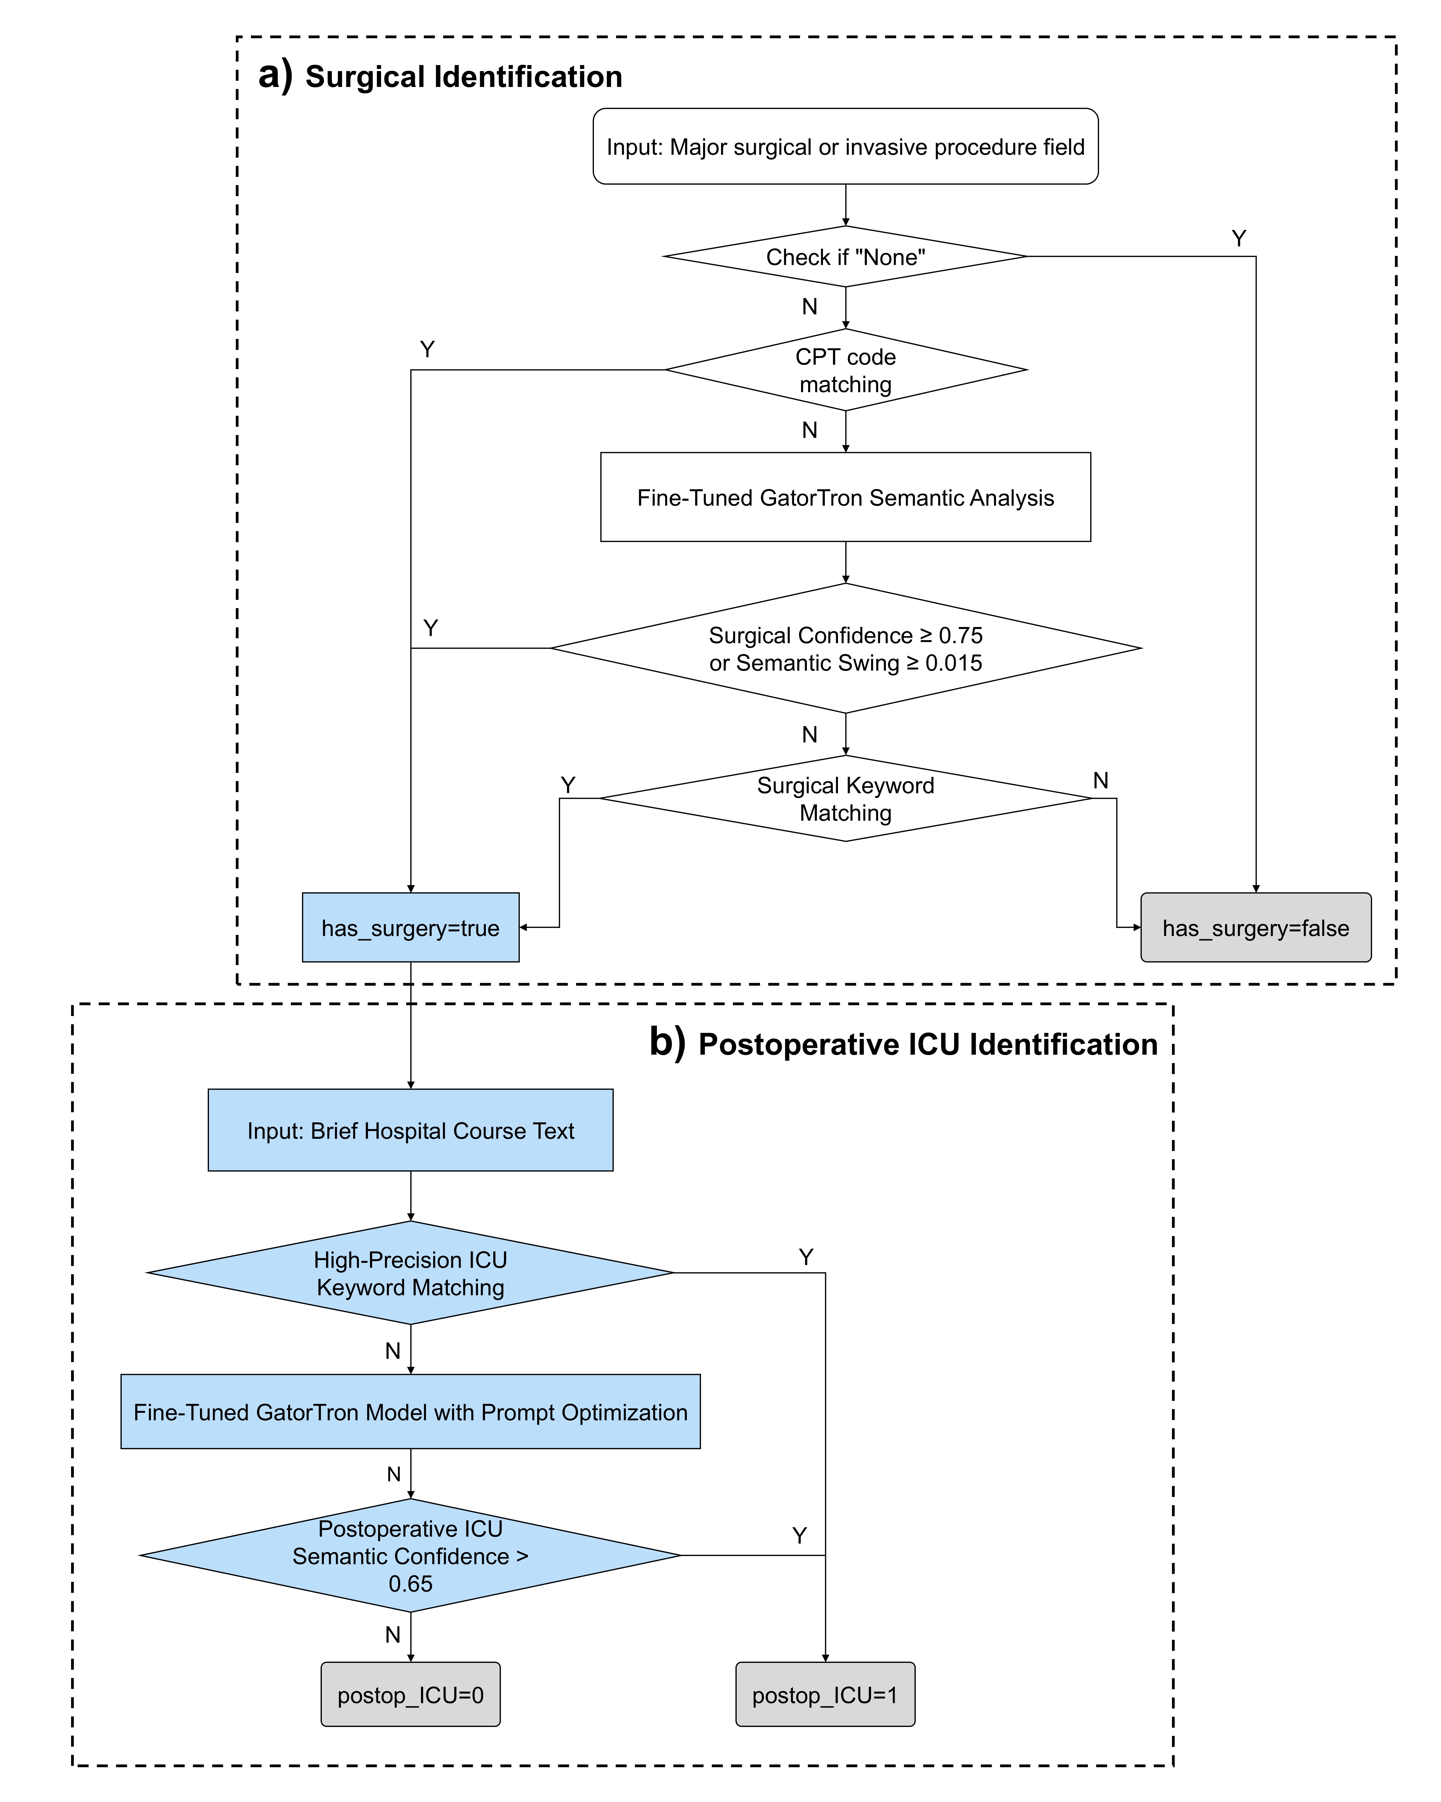
Note: This workflow illustrates the two-stage data-cleaning process for identifying and excluding postoperative ICU transfers, integrating structured procedure fields, CPT code matching, and fine-tuned semantic analysis of unstructured hospital course text.
To ensure that our cohort for ICU risk modeling reflects patients experiencing gradual clinical deterioration rather than surgery-driven events, we implemented a data-cleaning pipeline to identify and exclude postoperative ICU transfers. This approach integrates structured procedure codes from the “Major surgical or invasive procedure” field with clinical text from the “Brief Hospital Course”. Both surgical status and postoperative ICU events are determined through a combination of rule-based matching and semantic analysis using a GatorTron model pretrained on large-scale clinical corpora (including MIMIC-III) and fine-tuned with expert-labeled samples, with prompt optimization applied to enhance ICU identification accuracy. This integrated pipeline (see Figure S1) provides a reproducible, interpretable, and clinically grounded framework for refining the study cohort.

Supplementary Section 3. Laboratory Items Used for Feature Extraction
Laboratory data were extracted for 40 commonly measured items spanning chemistry, hematology, blood gas, and urinalysis panels. These items include routinely collected biomarkers such as white blood cell count, hemoglobin, creatinine, blood urea nitrogen, sodium, potassium, alanine aminotransferase, and international normalized ratio, among others. The complete list of laboratory items used in this study is provided in Supplementary Table S2.
Table S2. Laboratory Items for Feature Extraction.
Itemid | Label | Fluid | Category
50802 | Base Excess | Blood | Blood Gas
50804 | Calculated Total CO2 | Blood | Blood Gas
50813 | Lactate | Blood | Blood Gas
50817 | Oxygen Saturation | Blood | Blood Gas
50818 | pCO2 | Blood | Blood Gas
50820 | pH | Blood | Blood Gas
50821 | pO2 | Blood | Blood Gas
50861 | Alanine Aminotransferase (ALT) | Blood | Chemistry
50862 | Albumin | Blood | Chemistry
50863 | Alkaline Phosphatase | Blood | Chemistry
50878 | Asparate Aminotransferase (AST) | Blood | Chemistry
50882 | Bicarbonate | Blood | Chemistry
50885 | Bilirubin, Total | Blood | Chemistry
50889 | C-Reactive Protein | Blood | Chemistry
50893 | Calcium, Total | Blood | Chemistry
50902 | Chloride | Blood | Chemistry
50912 | Creatinine | Blood | Chemistry
50915 | D-Dimer | Blood | Chemistry
50931 | Glucose | Blood | Chemistry
50960 | Magnesium | Blood | Chemistry
50971 | Potassium | Blood | Chemistry
50983 | Sodium | Blood | Chemistry
51006 | Urea Nitrogen | Blood | Chemistry
51094 | pH | Urine | Chemistry
51221 | Hematocrit | Blood | Hematology
51222 | Hemoglobin | Blood | Hematology
51237 | INR(PT) | Blood | Hematology
51265 | Platelet Count | Blood | Hematology
51274 | PT | Blood | Hematology
51275 | PTT | Blood | Hematology
51279 | Red Blood Cells | Blood | Hematology
51301 | White Blood Cells | Blood | Hematology
51463 | Bacteria | Urine | Hematology
51466 | Blood | Urine | Hematology
51493 | RBC | Urine | Hematology
51516 | WBC | Urine | Hematology
51623 | Fibrinogen | Blood | Chemistry
51981 | Glucose | Urine | Chemistry
51984 | Ketone | Urine | Chemistry
51987 | Nitrite | Urine | Chemistry
51992 | Protein | Urine | Chemistry
51994 | Specific Gravity | Urine | Chemistry

Supplementary Section 4. Comprehensive Temporal Performance Data
This section provides the complete set of performance metrics for the baseline (structured data only) and multimodal (structured data + Qwen embeddings) models across all eleven 24-hour prediction windows. The detailed data supporting the primary temporal analysis of AUPRC and PPV presented in the main text are available in Supplementary Table S3, with Sensitivity (~0.8–0.9) and Negative Predictive Value (NPV; >0.98) remaining largely stable across windows, and Accuracy showing a progressive increase over time as later windows contain more strongly separable physiological patterns.
To further elucidate the temporal dynamics of other key metrics, supplementary figures are included below. Supplementary Figure S2(A–C) depicts the temporal trends for AUROC, Specificity, and Accuracy, respectively, offering additional insight into the models’ performance regarding false-alarm reduction and overall prediction reliability across the longitudinal course.

Table S3. Detailed Temporal Performance Metrics for Baseline and Multimodal Models.
Time Window (hours) | Model | AUPRC | AUROC | sensitivity | specificity | PPV | NPV | accuracy | Total Samples | Positive Samples | Training Total | Training Positive | Training Negative
24 | baseline | 0.2823 ± 0.0370 | 0.7752 ± 0.0160 | 0.8294 ± 0.0200 | 0.5626 ± 0.0058 | 0.1123 ± 0.0037 | 0.9802 ± 0.0025 | 0.5793 ± 0.0067 | 166,112 | 534 | 7,713 | 2,373 | 5,340
48 | baseline | 0.2918 ± 0.0220 | 0.8252 ± 0.0119 | 0.8578 ± 0.0128 | 0.6543 ± 0.0320 | 0.1427 ± 0.0096 | 0.9857 ± 0.0008 | 0.6670 ± 0.0293 | 165,578 | 409 | 5,907 | 1,817 | 4,090
72 | baseline | 0.3390 ± 0.0244 | 0.8542 ± 0.0162 | 0.8454 ± 0.0160 | 0.7237 ± 0.0319 | 0.1710 ± 0.0166 | 0.9859 ± 0.0015 | 0.7313 ± 0.0298 | 165,169 | 323 | 4,665 | 1,435 | 3,230
96 | baseline | 0.3460 ± 0.0651 | 0.8783 ± 0.0051 | 0.8182 ± 0.0107 | 0.7850 ± 0.0007 | 0.2024 ± 0.0018 | 0.9848 ± 0.0009 | 0.7871 ± 0.0005 | 164,846 | 241 | 3,481 | 1,071 | 2,410
120 | baseline | 0.3584 ± 0.0607 | 0.8810 ± 0.0224 | 0.8789 ± 0.0086 | 0.7531 ± 0.0608 | 0.1998 ± 0.0409 | 0.9894 ± 0.0008 | 0.7609 ± 0.0568 | 164,605 | 157 | 2,267 | 697 | 1,570
144 | baseline | 0.4352 ± 0.0792 | 0.9073 ± 0.0177 | 0.8352 ± 0.0296 | 0.8425 ± 0.0439 | 0.2706 ± 0.0438 | 0.9872 ± 0.0017 | 0.8420 ± 0.0393 | 164,448 | 128 | 1,849 | 569 | 1,280
168 | baseline | 0.4151 ± 0.0409 | 0.9233 ± 0.0039 | 0.8336 ± 0.0161 | 0.8609 ± 0.0179 | 0.2877 ± 0.0230 | 0.9873 ± 0.0010 | 0.8592 ± 0.0161 | 164,320 | 95 | 1,372 | 422 | 950
192 | baseline | 0.4138 ± 0.0401 | 0.9132 ± 0.0225 | 0.8672 ± 0.0109 | 0.8624 ± 0.0424 | 0.3130 ± 0.0787 | 0.9898 ± 0.0009 | 0.8627 ± 0.0396 | 164,225 | 74 | 1,161 | 343 | 818
216 | baseline | 0.4876 ± 0.0491 | 0.9291 ± 0.0173 | 0.8865 ± 0.0256 | 0.9108 ± 0.0115 | 0.4010 ± 0.0361 | 0.9918 ± 0.0019 | 0.9093 ± 0.0117 | 164,151 | 69 | 1,126 | 326 | 800
240 | baseline | 0.5567 ± 0.0679 | 0.9431 ± 0.0283 | 0.8528 ± 0.0313 | 0.9235 ± 0.0257 | 0.4414 ± 0.0832 | 0.9894 ± 0.0025 | 0.9191 ± 0.0258 | 164,082 | 55 | 1,083 | 283 | 800
264 | baseline | 0.6522 ± 0.0731 | 0.9596 ± 0.0125 | 0.8519 ± 0.0262 | 0.9456 ± 0.0189 | 0.5082 ± 0.0886 | 0.9904 ± 0.0013 | 0.9402 ± 0.0182 | 164,027 | 42 | 1,036 | 236 | 800
24 | Qwen | 0.3975 ± 0.0194 | 0.8448 ± 0.0085 | 0.8218 ± 0.0096 | 0.7069 ± 0.0459 | 0.1603 ± 0.0211 | 0.9835 ± 0.0002 | 0.7141 ± 0.0425 | 166,112 | 534 | 7,713 | 2,373 | 5,340
48 | Qwen | 0.3260 ± 0.0298 | 0.8520 ± 0.0134 | 0.8511 ± 0.0086 | 0.6863 ± 0.0218 | 0.1538 ± 0.0101 | 0.9857 ± 0.0012 | 0.6966 ± 0.0209 | 165,578 | 409 | 5,907 | 1,817 | 4,090
72 | Qwen | 0.3985 ± 0.0406 | 0.8779 ± 0.0135 | 0.8578 ± 0.0334 | 0.7395 ± 0.0225 | 0.1808 ± 0.0124 | 0.9874 ± 0.0028 | 0.7469 ± 0.0204 | 165,169 | 323 | 4,665 | 1,435 | 3,230
96 | Qwen | 0.4148 ± 0.0553 | 0.8974 ± 0.0107 | 0.8425 ± 0.0156 | 0.8055 ± 0.0118 | 0.2246 ± 0.0132 | 0.9871 ± 0.0014 | 0.8078 ± 0.0120 | 164,846 | 241 | 3,481 | 1,071 | 2,410
120 | Qwen | 0.4086 ± 0.0568 | 0.8974 ± 0.0182 | 0.8539 ± 0.0304 | 0.8158 ± 0.0316 | 0.2395 ± 0.0258 | 0.9882 ± 0.0021 | 0.8182 ± 0.0284 | 164,605 | 157 | 2,267 | 697 | 1,570
144 | Qwen | 0.4834 ± 0.0680 | 0.9267 ± 0.0136 | 0.8118 ± 0.0129 | 0.8879 ± 0.0140 | 0.3276 ± 0.0228 | 0.9861 ± 0.0007 | 0.8831 ± 0.0124 | 164,448 | 128 | 1,849 | 569 | 1,280
168 | Qwen | 0.4553 ± 0.0167 | 0.9255 ± 0.0103 | 0.8568 ± 0.0328 | 0.8474 ± 0.0378 | 0.2820 ± 0.0502 | 0.9890 ± 0.0020 | 0.8480 ± 0.0334 | 164,320 | 95 | 1,372 | 422 | 950
192 | Qwen | 0.4518 ± 0.0215 | 0.9172 ± 0.0219 | 0.8557 ± 0.0224 | 0.8519 ± 0.0432 | 0.2908 ± 0.0589 | 0.9889 ± 0.0012 | 0.8522 ± 0.0391 | 164,225 | 74 | 1,161 | 343 | 818
216 | Qwen | 0.5432 ± 0.0170 | 0.9370 ± 0.0170 | 0.8721 ± 0.0176 | 0.9109 ± 0.0094 | 0.3966 ± 0.0276 | 0.9907 ± 0.0013 | 0.9085 ± 0.0094 | 164,151 | 69 | 1,126 | 326 | 800
240 | Qwen | 0.6056 ± 0.1348 | 0.9486 ± 0.0304 | 0.8343 ± 0.0182 | 0.9167 ± 0.0349 | 0.4265 ± 0.1062 | 0.9881 ± 0.0016 | 0.9116 ± 0.0334 | 164,082 | 55 | 1,083 | 283 | 800
264 | Qwen | 0.6334 ± 0.0352 | 0.9616 ± 0.0060 | 0.8519 ± 0.0262 | 0.9373 ± 0.0111 | 0.4622 ± 0.0649 | 0.9903 ± 0.0014 | 0.9323 ± 0.0117 | 164,027 | 42 | 1,036 | 236 | 800

Figure S2. Temporal trends of auxiliary performance metrics.
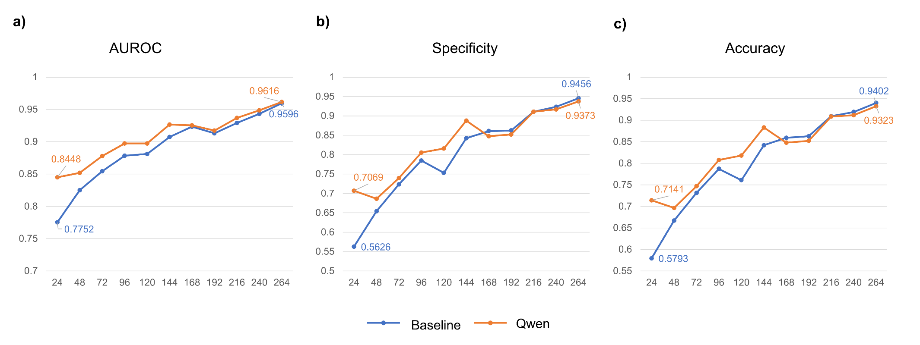
Note: (A) Area Under the Receiver Operating Characteristic Curve (AUROC). (B) Specificity. (C) Accuracy. Line plots compare the baseline and multimodal models across sequential 24-hour prediction windows.

