Supplementary
Figure S1: Symptoms of anxiety among women of reproductive age in Bangladesh
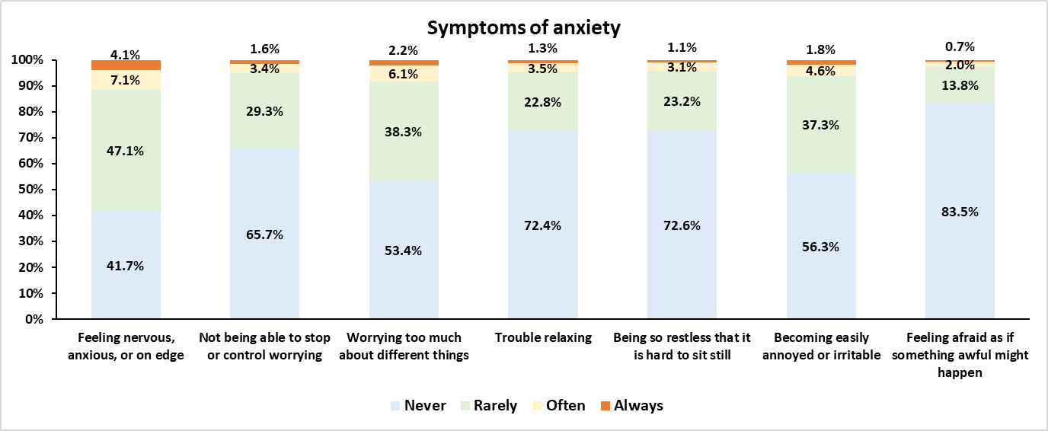

Figure S2: Symptoms of depression among women of reproductive age in Bangladesh
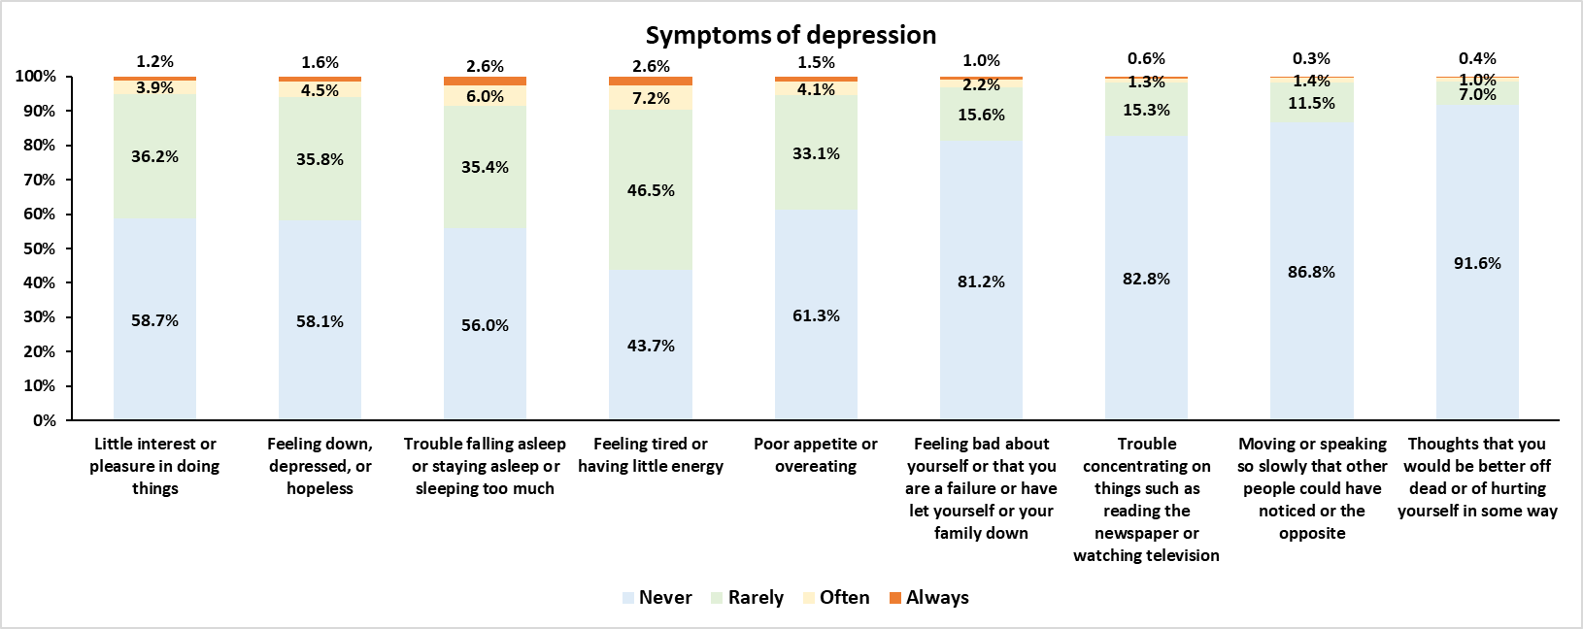

Figure S3: Prevalence of women sought care for mental health by level of women’s empowerment
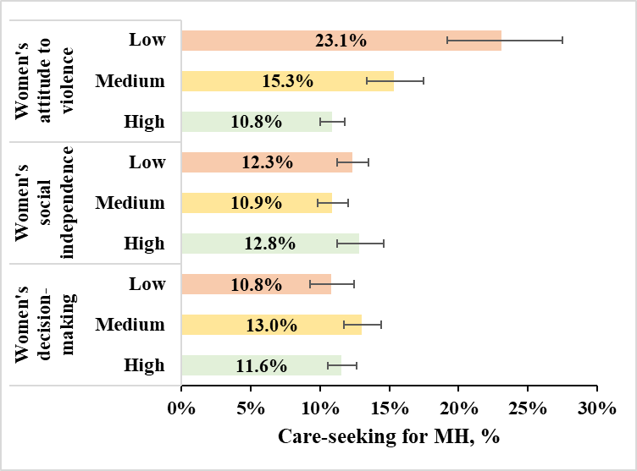

Table S1: Prevalence of anxiety, depression and associated care-seeking behaviors by background characteristics
 | % Anxiety | p-value | % Depression | p-value | % Any MH symptoms | p-value | % Co-occurrence of MH | p-value | % care-seeking for MH | p-value
Covariates
Women's age in years |  | 0.0000 |  | 0.0000 |  | 0.0000 |  | 0.0000 |  | 0.0019
15-19 | 12.9% |  | 3.7% |  | 15.0% |  | 2.5% |  | 9.1%
20-24 | 12.9% |  | 3.2% |  | 14.0% |  | 2.6% |  | 10.1%
25-29 | 17.0% |  | 4.6% |  | 18.5% |  | 3.8% |  | 11.6%
30-34 | 20.8% |  | 5.2% |  | 22.3% |  | 4.6% |  | 12.2%
35-39 | 23.5% |  | 5.4% |  | 25.2% |  | 4.8% |  | 13.2%
40-44 | 23.5% |  | 5.4% |  | 25.5% |  | 4.5% |  | 12.8%
45-49 | 25.9% |  | 7.3% |  | 27.9% |  | 6.3% |  | 13.3%
Current employment status |  | 0.0502 |  | 0.5427 |  | 0.0962 |  | 0.2994 |  | 0.0000
No | 19.0% |  | 4.8% |  | 20.7% |  | 4.0% |  | 10.9%
Yes | 20.6% |  | 5.1% |  | 22.1% |  | 4.4% |  | 13.9%
Media exposure |  | 0.0124 |  | 0.7949 |  | 0.0444 |  | 0.5634 |  | 0.0162
No | 20.6% |  | 4.9% |  | 22.1% |  | 4.3% |  | 11.0%
Yes | 18.6% |  | 5.0% |  | 20.4% |  | 4.1% |  | 12.6%
Wealth index |  | 0.0000 |  | 0.0602 |  | 0.0000 |  | 0.0558 |  | 0.3986
Poorest | 22.3% |  | 5.6% |  | 23.9% |  | 4.8% |  | 10.9%
Poorer | 21.6% |  | 5.1% |  | 23.2% |  | 4.3% |  | 11.4%
Middle | 19.1% |  | 5.4% |  | 20.8% |  | 4.6% |  | 12.7%
Richer | 18.9% |  | 4.6% |  | 20.4% |  | 3.9% |  | 12.0%
Richest | 16.0% |  | 4.0% |  | 17.8% |  | 3.3% |  | 12.3%
Residence |  | 0.0489 |  | 0.1823 |  | 0.0708 |  | 0.1798 |  | 0.2947
Urban | 17.9% |  | 4.4% |  | 19.6% |  | 3.7% |  | 11.2%
Rural | 20.1% |  | 5.1% |  | 21.7% |  | 4.4% |  | 12.2%
Division |  | 0.0000 |  | 0.0001 |  | 0.0001 |  | 0.0000 |  | 0.0000
Barishal | 18.9% |  | 4.7% |  | 21.4% |  | 3.4% |  | 6.0%
Chattogram | 21.4% |  | 4.2% |  | 23.1% |  | 3.6% |  | 13.9%
Dhaka | 16.6% |  | 4.2% |  | 18.3% |  | 3.4% |  | 10.6%
Khulna | 20.1% |  | 6.5% |  | 21.4% |  | 5.8% |  | 15.3%
Mymensingh | 17.1% |  | 3.8% |  | 18.9% |  | 2.9% |  | 9.6%
Rajshahi | 17.8% |  | 3.7% |  | 19.5% |  | 3.0% |  | 13.7%
Rangpur | 25.6% |  | 7.6% |  | 26.9% |  | 6.7% |  | 12.0%
Sylhet | 20.3% |  | 6.5% |  | 21.5% |  | 6.2% |  | 9.1%

