Supplemental Table 1. International Classification of Diseases (Ninth and Tenth Revisions) Clinical Modification (ICD-9-CM and ICD-10-CM) codes used to define comorbidities and clinical outcomes.
Outcome Definitions
Outcome | Definition
All cause mortality | Mortality status was defined according to the cause-of-death codes (ICD-9 or ICD-10) recorded in the Cause Of Death Data.
Cardiovascular death | Cardiovascular death was defined as death due to heart disease (ICD-9: 390-392,393-398,410-414,420-429; ICD-10: I01-I02.0, I05-I09, I20-I25, I27, I30-I52), cerebrovascular disease (ICD-9: 430-438; ICD-10: I60-I69), or hypertensive disease (ICD-9: 401-405; ICD-10: I10-I15), as recorded in the Cause Of Death Data.
Heart failure admission | ICD-9 codes of 428.x; ICD-10 codes of I50
Progressed renal function | Renal function progression was defined as a ≥50% reduction in eGFR, maintenance dialysis, kidney transplantation, or renal-related death.
Urinary tract infection | For outpatients, urinary tract infection was defined as the presence of abnormal white blood cells (WBCs) in urine sediment analysis accompanied by antibiotic prescription, while for inpatients, it was defined as a diagnosis of ICD-9 code 599.0 or ICD-10 code N39.0 with abnormal urinary WBC findings.

Supplemental Table 2. Biochemical tests
 | Unweighted cohort |  |  |  |  |  | ASMD | IPTW¹ cohort |  |  |  | ASMD
 | SGLT2i |  |  | Non- SGLT2i |  |  | ASMD | SGLT2i |  | Non- SGLT2i |  | ASMD
Laboratory data | Available N | mean | (SD) | Available N | mean | (SD) | ASMD | mean | (SD) | mean | (SD) | ASMD
ALT, U/L | 788 | 24.6 | (19.8) | 1499 | 22.3 | (18.0) | 0.123 | 24.8 | (19.9) | 22.0 | (17.5) | 0.150
HDL-C, mg/dL | 761 | 45.9 | (13.3) | 1358 | 46.3 | (13.0) | 0.027 | 46.1 | (13.1) | 46.1 | (12.9) | 0.003
LDL-C, mg/dL | 900 | 85.6 | (35.6) | 1627 | 88.8 | (33.0) | 0.092 | 85.1 | (33.3) | 88.8 | (35.4) | 0.107
Triglyceride, mg/dL | 815 | 147.0 | (96.1) | 1480 | 134.1 | (77.2) | 0.148 | 144.8 | (91.3) | 134.7 | (79.1) | 0.118
eGFR, mL/min/1.73m² | 1000 | 59.8 | (18.7) | 2000 | 59.2 | (19.2) | 0.034 | 59.8 | (19.1) | 59.0 | (19.2) | 0.043
Hb-A1c, % (baseline) | 1000 | 7.7 | (1.5) | 2000 | 7.6 | (1.5) | 0.074 | 7.7 | (1.5) | 7.6 | (1.5) | 0.089
Hb-A1c, % (6M) | 918 | 7.5 | (1.4) | 1838 | 7.4 | (1.3) | 0.121 | 7.6 | (1.4) | 7.4 | (1.3) | 0.146
Hb-A1c, % (1Y) | 856 | 7.4 | (1.3) | 1660 | 7.2 | (1.3) | 0.127 | 7.4 | (1.3) | 7.2 | (1.3) | 0.171
¹IPTW adjustment on age, gender, eGFR, Hb-A1c, comorbidities, medication.

Supplemental table 3. Hazard ratio for study outcomes between SGLT2i and non- SGLT2i groups by different analysis approaches.
 | Unweighted |  |  |  | Stabilized inverse probability weighting
 | Adjusted Analysis* |  | Competing Risk  Adjusted Analysis* |  | Adjusted Analysis* |  | Competing Risk  Adjusted Analysis*
 | HR (95% CI) | p Value | HR (95% CI) | p Value | HR (95% CI) | p Value | HR (95% CI) | p Value
All cause mortality | 0.50 (0.37-0.67) | <0.001 | – | – | 0.51 (0.38-0.68) | <0.001 | – | –
Cardiovascular death | 0.63 (0.35-1.13) | 0.121 | 0.66 (0.36-1.21) | 0.180 | 0.65 (0.37-1.16) | 0.144 | 0.69 (0.38-1.22) | 0.201
Heart failure admission | 0.95 (0.73-1.24) | 0.705 | 0.96 (0.73-1.27) | 0.786 | 0.96 (0.74-1.24) | 0.727 | 0.97 (0.75-1.26) | 0.812
Progressed renal function | 0.70 (0.57-0.87) | <0.001 | 0.72 (0.58-0.89) | 0.003 | 0.69 (0.57-0.85) | <0.001 | 0.71 (0.58-0.87) | <0.001
Urinary tract infection | 0.78 (0.56-1.08) | 0.133 | 0.81 (0.58-1.14) | 0.219 | 0.81 (0.59-1.11) | 0.199 | 0.84 (0.62-1.16) | 0.293
*Adjustment on age, gender, eGFR, Hb-A1c, comorbidities, and medication usage rate of 5% or more.

Supplemental Figure 1. Flowchart of Study Population Selection: The flowchart outlines the selection process for the study cohort. Patients aged 75 or older with diabetes treated with medications between 2012 and 2021 were identified. After excluding patients whose SGLT2i prescriptions occurred prior to diabetes diagnosis, diabetic patients were included and divided into two groups: diabetic patients with SGLT2i and without SGLT2i. After applying additional exclusion criteria, the final cohort of SGLT2i users was identified. Matching 1:2 by sex, age, heart failure diagnosis, eGFR group, and HbA1c group resulted in patients in the SGLT2i treatment group and in the non-SGLT2i treatment group.

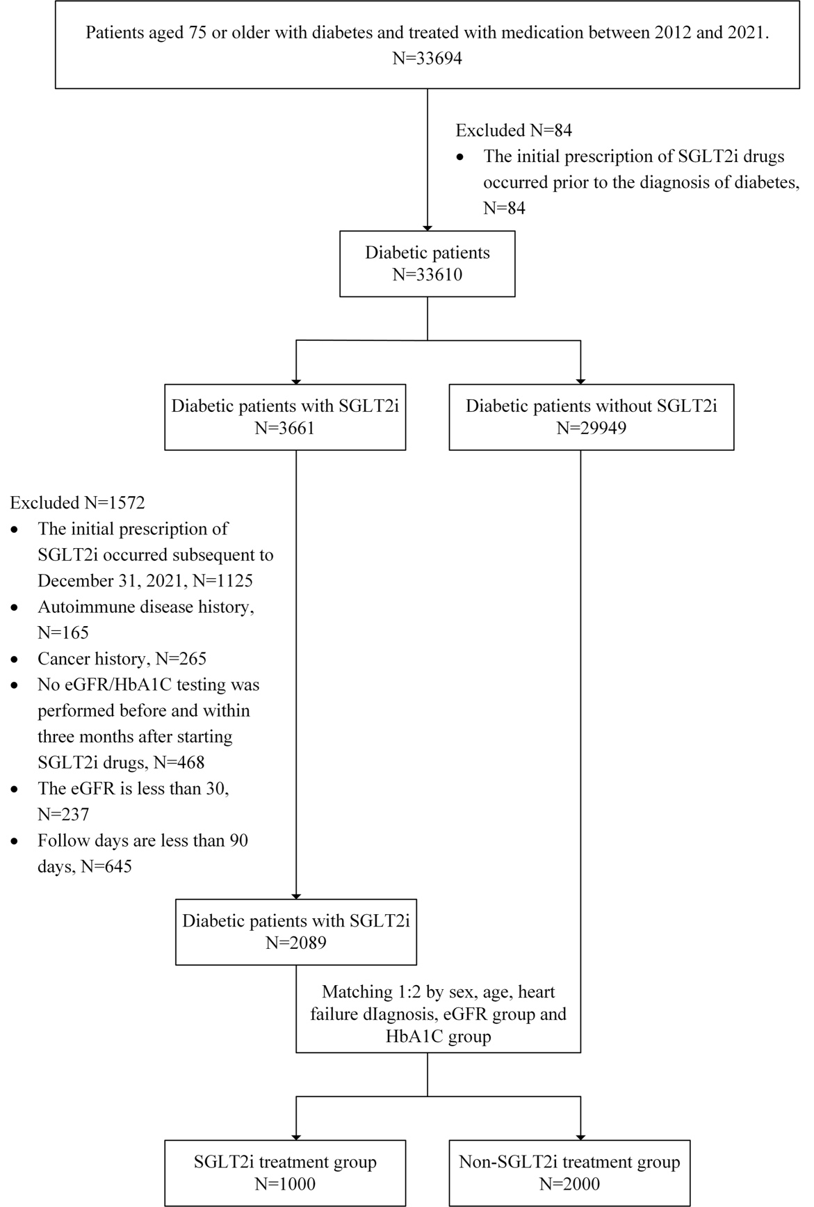
Supplemental Figure 2. Covariate balance before and after IPTW adjustment.
Love plot showing the absolute standardized mean differences (ASMD) of baseline covariates before (gray dots) and after (black dots) inverse probability of treatment weighting (IPTW). Several covariates exhibited imbalance (ASMD > 0.1) before weighting; after IPTW adjustment, all covariates achieved adequate balance with ASMD < 0.1.

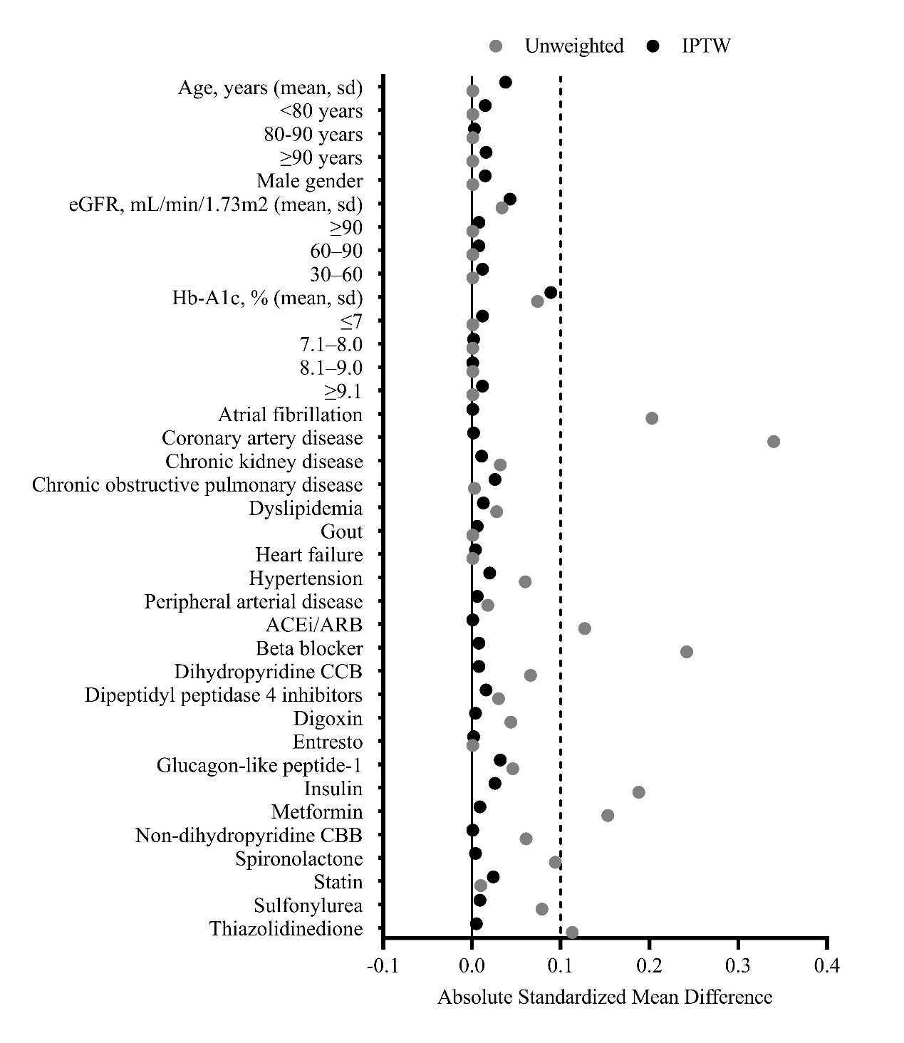

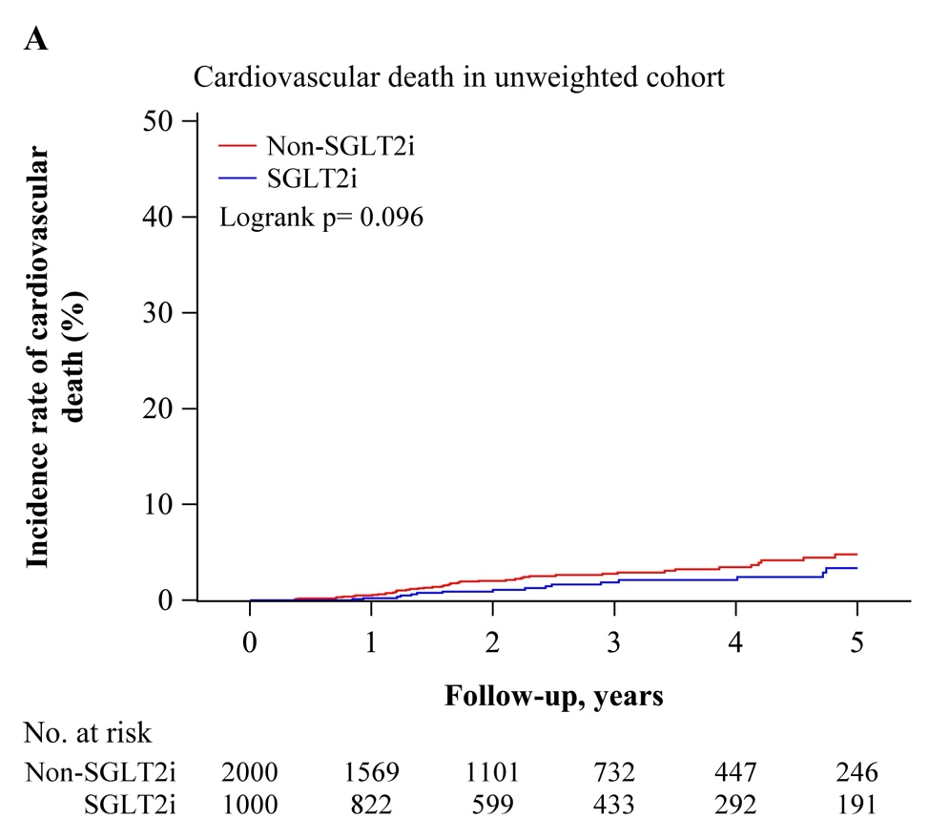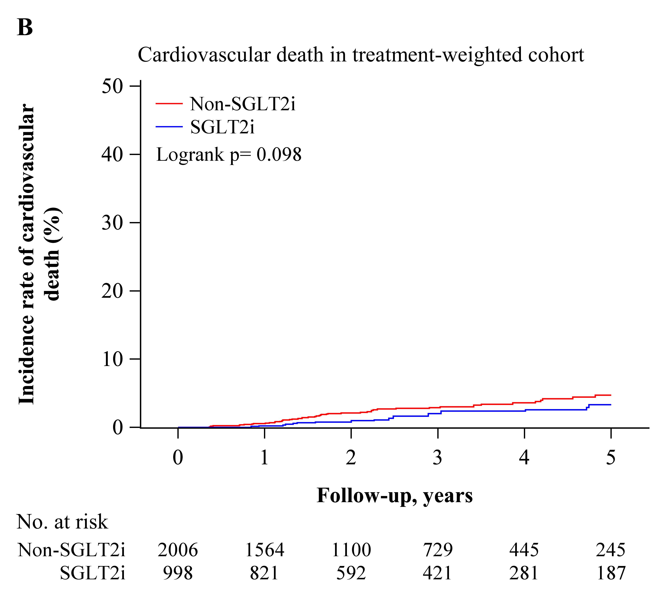Supplemental Figure 3. Cardiovascular Death in Diabetic Patients: (A) Cardiovascular death rates in the unweighted cohort comparing SGLT2i and non-SGLT2i users. The SGLT2i group exhibited fewer cardiovascular deaths compared to the non-SGLT2i group. (B) After IPTW adjustment, a trend towards reduced cardiovascular death with SGLT2i use remained evident.
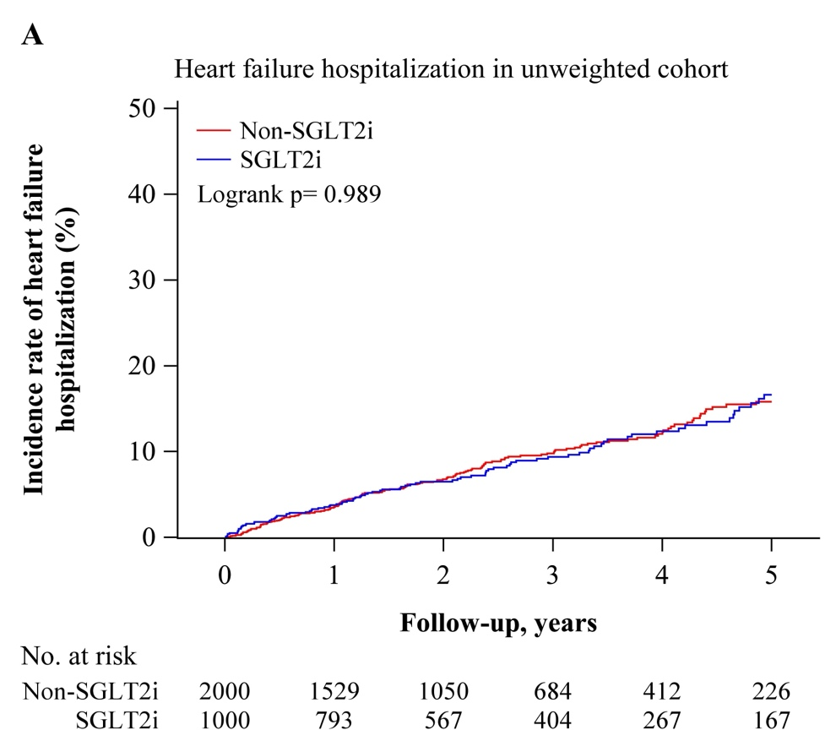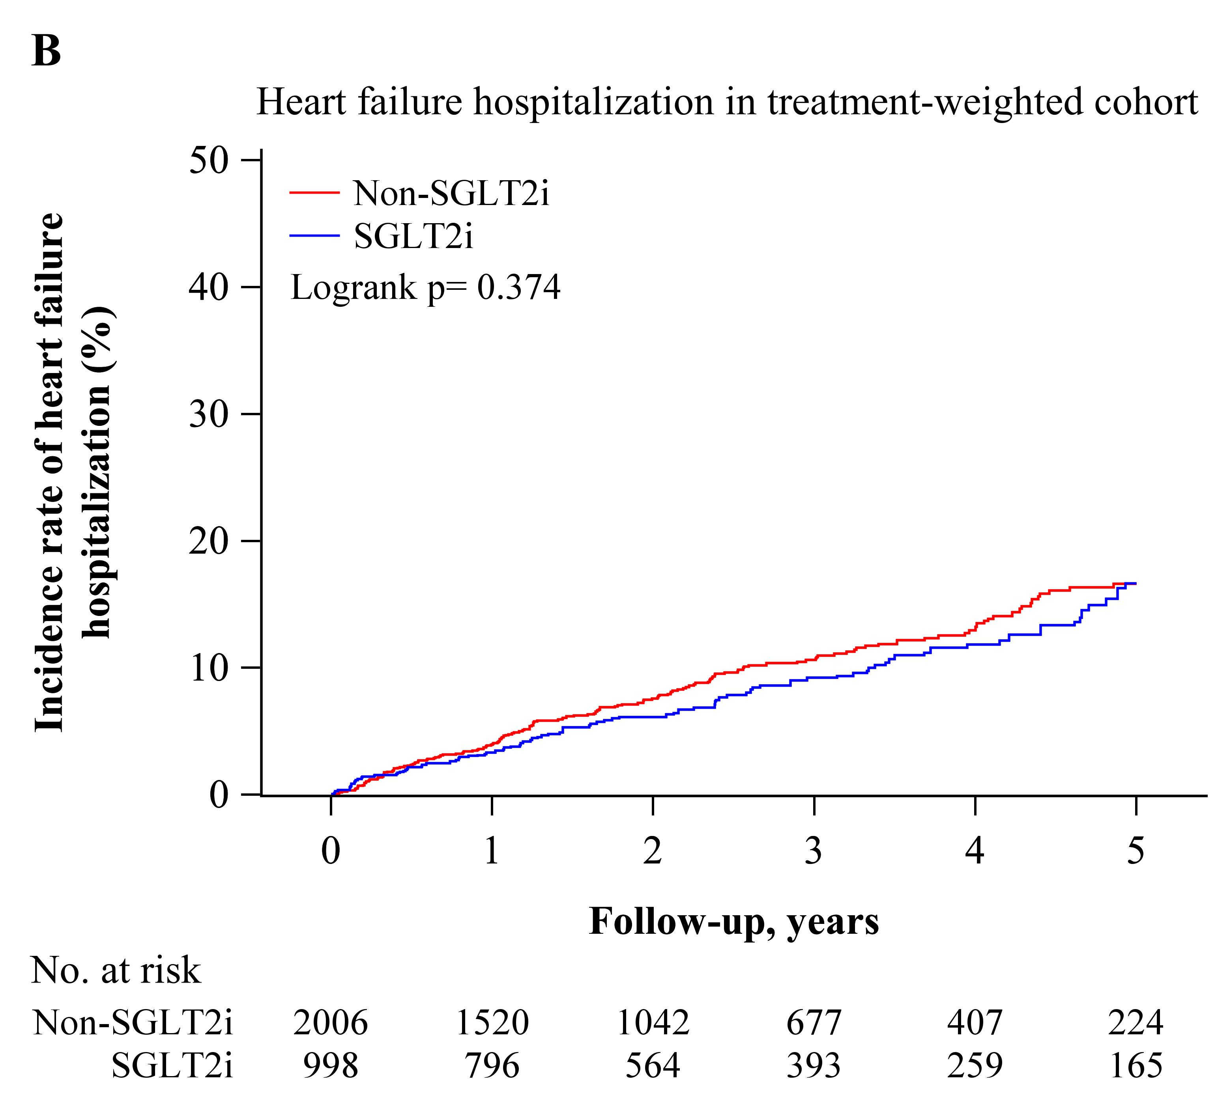Supplemental Figure 4. Heart Failure Hospitalization: (A) Incidence of heart failure hospitalization in the unweighted cohort comparing patients with and without SGLT2i treatment. Hospitalization for heart failure was similar between the SGLT2i and non-SGLT2i groups. (B) After IPTW adjustment, no significant difference in heart failure hospitalization was observed between the two groups.
Supplemental Figure 5. Incidence of Urinary Tract Infections (UTIs): (A) UTI occurrence in the unweighted cohort comparing SGLT2i and non-SGLT2i groups. The incidence of UTIs was slightly lower in the SGLT2i group compared to the non-SGLT2i group. (B) After IPTW adjustment, there was no significant difference in UTI risk between the two groups.
