Data for the Article — INFECTION FATALITY RATE OF COVID19 ( COMORBIDITIES ) — A LOGISTIC MODEL
( DATTA JAYDIP )

List of Data , Table & Figures ( Including Comorbities )

Data Source (REFERENCE. 2 ) — Mean of Age Vs IFR data = >

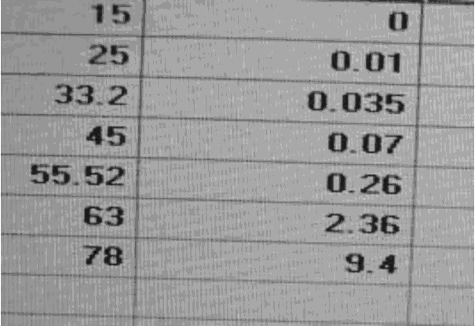

Figure 1

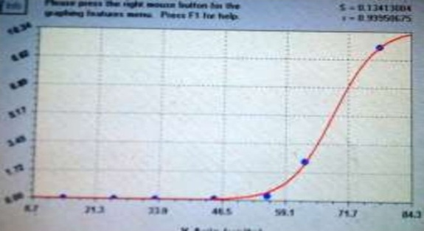

Figure4 ( Logistic Curve )

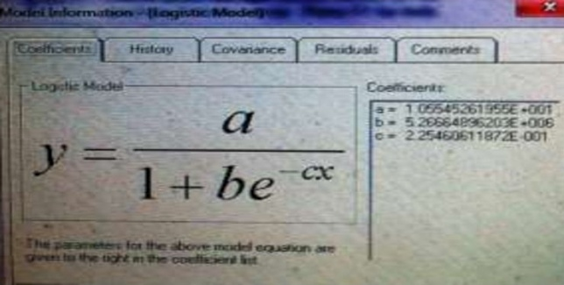

Figure 9 ( Sigmoid Function )

REFERENCE : (https://doi.org/10.31219/osf.io/wuqa6 )

JSON Coding - https://zenodo.org/record/4066767

JSON Coding ( Comorbities ) - https://zenodo.org/record/4553423

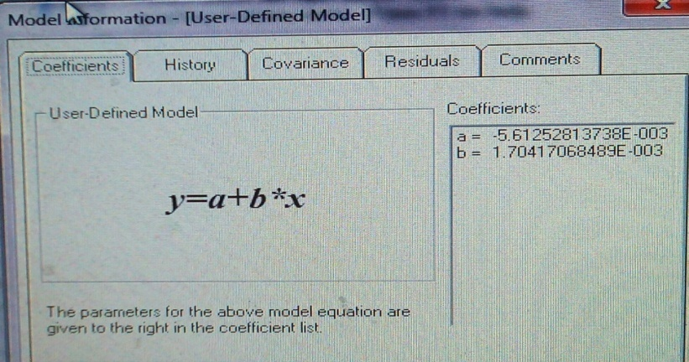

Figure 10 ( Linear regression )

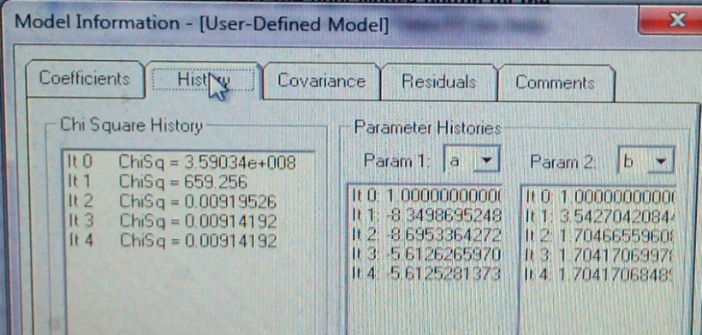

Figure 11 ( Chi-Sq Analysis )

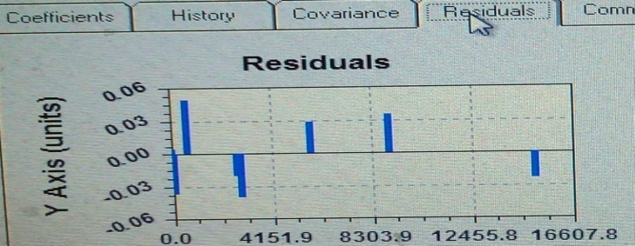
Figure 12— Cov [ Matrix ] representation with Residuals

