SUPPLIMENTARY INFORMATIONS:

Data Availability Study –Figure –I

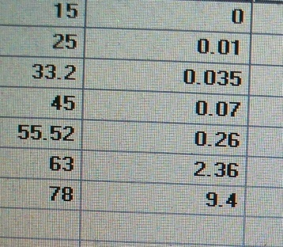

Results – Figure – II

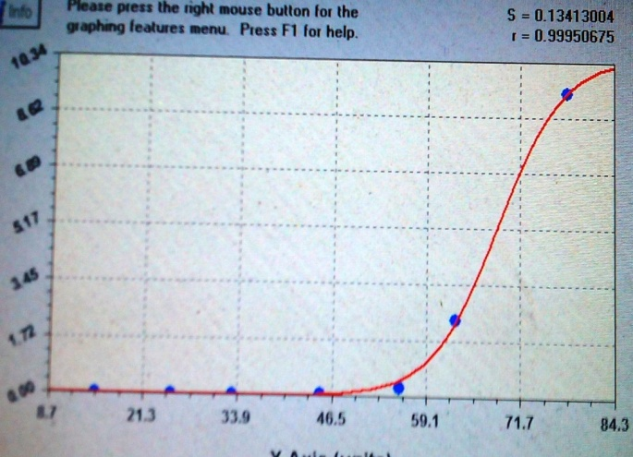

Code or Link available – ______________________________________________________________________________
- <resource xmlns="http://datacite.org/schema/kernel-3" xmlns:xsi="http://www.w3.org/2001/XMLSchema-instance" xsi:schemaLocation="http://datacite.org/schema/kernel-3 http://schema.datacite.org/meta/kernel-3/metadata.xsd">
<identifier identifierType="DOI">10.6084/m9.figshare.12979856.v1</identifier>
- <creators>
- <creator>
<creatorName>JAYDIP DATTA</creatorName>
</creator>
</creators>
- <titles>
<title>Data - INFECTION FATALITY RATE OF COVID19 — A LOGISTIC MODEL</title>
</titles>
<publicationYear>2020</publicationYear>
<publisher>figshare</publisher>
- <subjects>
<subject>Covid19</subject>
<subject>infection fatality rates</subject>
<subject>logistic-regression</subject>
<subject>sigmoid shape increase</subject>
<subject>data analysis.ResultsA</subject>
</subjects>
- <dates>
<date dateType="Issued">2020-09-19 14:40:12</date>
</dates>
<resourceType resourceTypeGeneral="Text">article</resourceType>
- <alternateIdentifiers>
<alternateIdentifier alternateIdentifierType="URL">https://figshare.com/articles/dataset/Data_-_INFECTION_FATALITY_RATE_OF_COVID19_A_LOGISTIC_MODEL/12979856</alternateIdentifier>
</alternateIdentifiers>
- <descriptions>
<description descriptionType="Abstract">Data for IFR vs Age of the Patients are analysed by Best fit analysis . The data of Logistics regression like Sigmoid equation coefficians , Variance matrix , Residual table are stored in this collection .</description>
</descriptions>
</resource>
________________________________________________________________________

