Entry for the Table of Contents
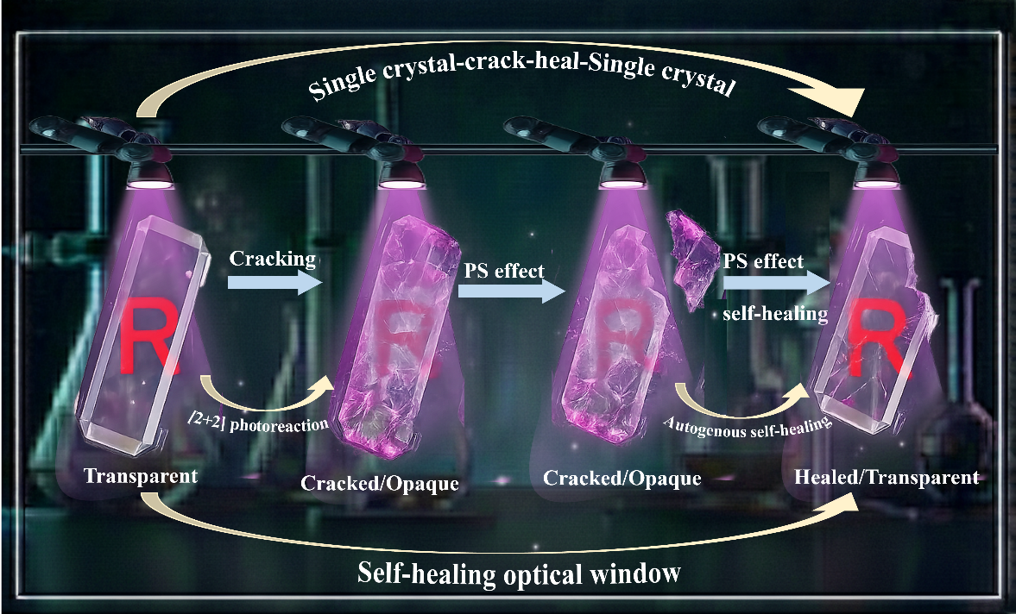
Light orchestrates a 2D → 3D MOF conversion that couples explosive photosalience with remarkable autogenous self-healing and functioning as a self-healing optical window. UV-induced [2+2] cycloaddition induces cracking and jumps, whereas dynamic covalent (S–S) chemistry mends almost 90% of the damage. Complete structural and optical restoration marks this as the first self-healing photosalient MOF and offers a design strategy for resilient, adaptive crystalline materials.

