Supplementary Materials for
Plasticizing aluminum by deformable and phase-transformable nitinol alloys
H. Ying et al.

Corresponding author: W. Zheng (cs-wangshu.zheng@ntu.edu.sg); L. Zhao (lzhao39@sjtu.edu.cn); Q. Guo (guoq@sjtu.edu.cn)

The PDF file includes:

Figs. S1 to S4

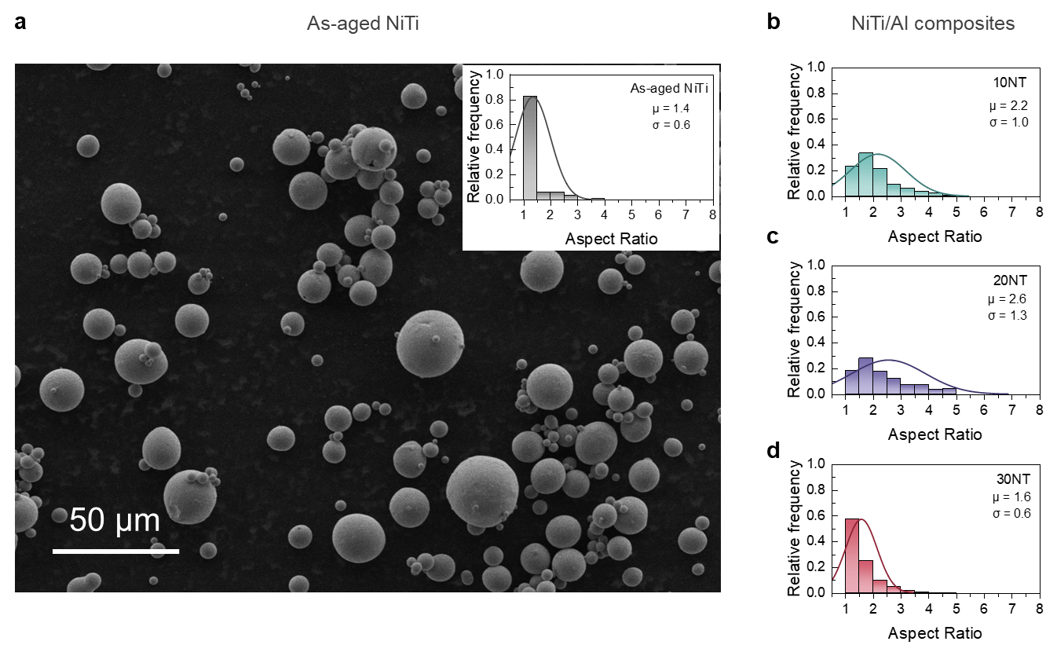
Fig. S1. Microstructures and aspect ratio statistics of as-aged NiTi particles and NiTi/Al composites. (a) Typical SEM image of the as-aged NiTi particles (near-sphere shape). The inset image statistically shows the relative frequency of the aspect ratio. (b-d) Statistical results of the aspect ratio of the three NiTi/Al composites, 10NT, 20NT and 30NT in sequence.

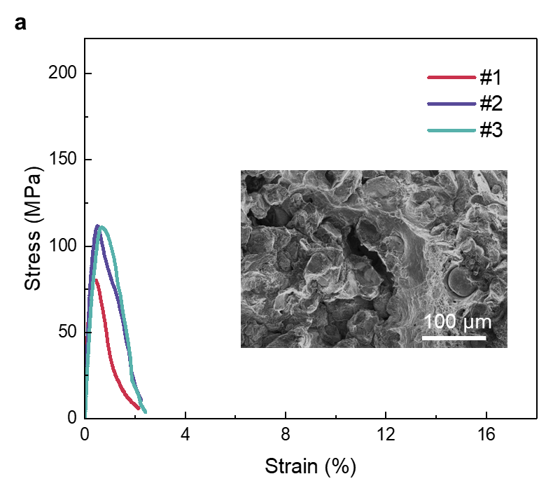
Fig. S2. Mechanical properties of the Al composites reinforced by as-aged NiTi powders (40 wt.%, denoted as 40NT). Engineering stress–strain curve of 40NT samples. The inset SEM image shows the probable filler agglomeration and cracks inside the composite. Excessive content can cause adverse effects on the mechanical properties. 40NT fractured at a very small strain value (< 3%) in all sets.

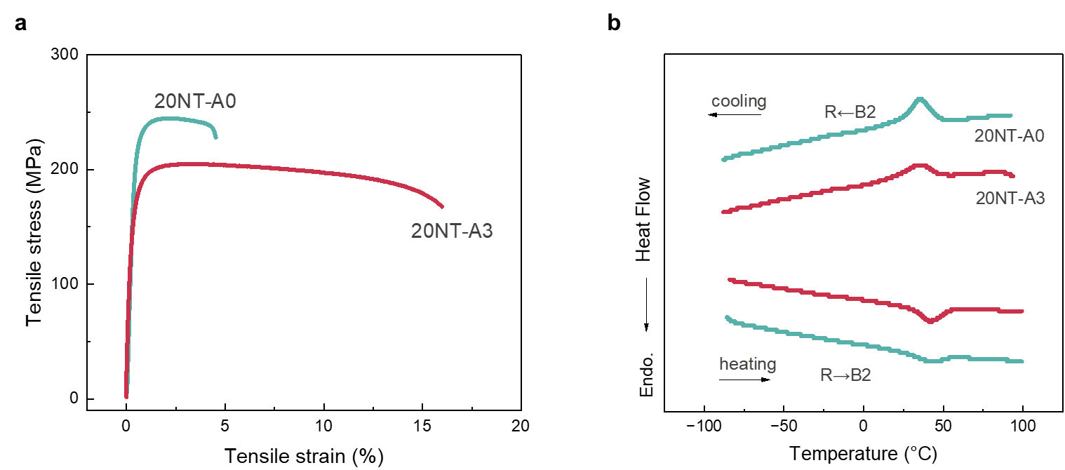
Fig. S3. Mechanical properties and thermally induced phase transformation of the unaged and aged NiTi/Al composites. (a) Engineering stress–strain curve of the un-aged 20NT and 3 h-aged 20NT. (b) DSC curves of the un-aged 20NT and 3 h-age d 20NT at the cooling segment. The yield strength and ultimate tensile strength of the un-aged 20NT (198 ± 25 MPa, 239 ± 12 MPa) are higher than those of 3 h-aged 20NT (156 ± 5 MPa, 207 ± 2 MPa), yet at the cost of the uniform elongation (un-aged 20NT-A0: 2.3 ± 0.1%, 3 h-aged 20NT: 3.7 ± 0.1%).
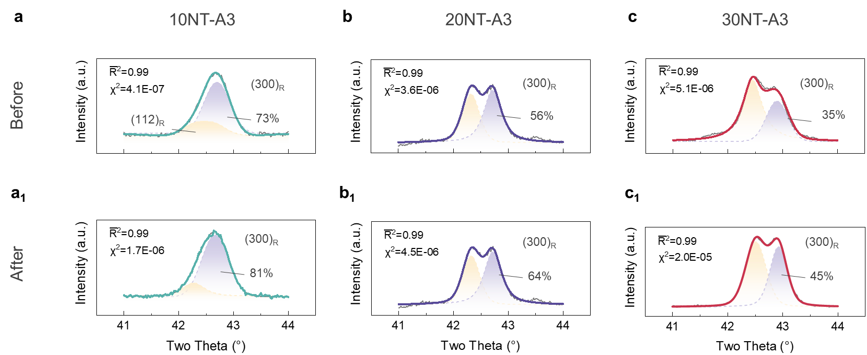
Fig. S4. Phase constituents of NiTi/Al composites before and after tension. Multi-peak fitting of (112) and (300) R phases of 10NT, 20NT and 30NT samples at the scanning range of 41-44°: (a-c) before tension, (a₁-c₁) after tension. ${\overline{R}}^{2}$ and $χ^{2}$ stand for Adjusted Coefficient of Determination and Chi-squared Statistic.

