Genomic characterisation of Mycoplasma genitalium in Victoria, Australia: exploring connections between lineages and epidemiological data
Supplementary
Azzato et al.

Supplementary Methods
Setting and data sources
Typically, the diagnosis of Mycoplasma genitalium infection involves identifying M.genitalium-specific DNA in clinical samples. The Victorian Infectious Disease Reference Laboratory (VIDRL) offers testing services for M.genitalium, which are utilized by multiple laboratories and sexual health clinics across Victoria. However, there's an exception at the MSHC, where they conduct on-site screening for M. genitalium. Where available we used clinical samples from individuals who tested positive for M.genitalium in routine PCR performed at VIDRL or the MSHC between 17 October 2014 and 22 November 2022.
Deidentified epidemiological information was provided by VIDRL and MSHC. M.genitalium is not subject to mandatory reporting in Victoria, which means that our access to epidemiological data was confined to the information provided by clinicians who made the requests. This dataset included demographic information such as gender and age, collected from both VIDRL and MSHC. Furthermore, for a specific subset of samples (n-113), details on sexual risk group (based on their sexual partners) and instances of treatment failure attributable to drug resistance were provided by MSHC. For a phylogenetic context, we included sequence reads from one other published genomic study of M.genitalium (1)

DNA extraction and whole genome sequencing
We utilized the Magbead Quick DNA/RNA kit (Zymo Research Irvine, CA, USA) to prepare genomic DNA (gDNA). The process was automated using the Freedom EVO 100 system (Tecan, Männedorf, Seestrasse, Switzerland). To assess the M. genitalium load in each sample, we performed an in-house real-time PCR assay targeting the Mg219 gene of M. genitalium, a method previously described by Chalker in 2009 (2). Samples with a cycle threshold (Ct) value less than or equal to 35 were selected for subsequent whole genome sequencing. Prior to library preparation, gDNA for each sample was concentrated to a volume of 50μl with the AMPure XP beads (Beckman Coulter, Brea, CA, USA). Library preparation was performed using Illumina® DNA Prep with Enrichment (Illumina, San Diego, CA, USA) and IDT® for Illumina Nextera DNA Unique Dual Indexes (IDT, San Diego, CA, USA). To optimise sequencing efficiency, libraries were pooled into predefined groups of 20. Samples were grouped based on the similarity of their Ct-values (± 1 cycle), to reduce variability in sequencing results. Subsequently pooled libraries underwent an enrichment step targeting M.genitalium. This enrichment step utilised a hybridization capture approach, based on 120 nucleotide RNA baits (SureSelect Target Enrichment System, Agilent, Santa Clara, CA, USA) following a previously described method (3). Enriched libraries were subsequently sequenced at VIDRL, where an Illumina NextSeq 1000 (Illumina, San Diego, CA, USA) was used to generate 150 bp paired end reads.
Quality control of sequence data
All samples included in this study were subject to a prefiltering process to specifically choose reads that aligned with the G37 reference genome of M. genitalium (NC_000908.2). The prefiltering was performed using Minimap2 (v. 2.24) (4) with default parameters, including semi-global alignment with a bandwidth of 500, gap opening penalty of 5, gap extension penalty of 2, mismatch penalty of 4, match score of 1, seed length of 19, and k-mer size of 15. The criteria for retention were sequence reads exhibiting at least 90% pairwise identity with the reference genome. Additionally, all sequence reads underwent adapter trimming using Trimmomatic (v 0.39) (5) prior to QC analysis. After prefiltering, sequence depth was assessed, with sequences passing quality control (QC) if the depth exceeded 50X. Species composition was then determined using the Kraken 2 Plus PF database (v2.12) (6). For this study, samples containing ≥50% M.genitalium were included in further downstream analysis (Supplementary Data 1, Supplementary Figure 1). Additionally, a further quality control step was carried out where the sequence reads generated in this study were aligned to the human reference genome (GRCh37, accession number: GCA_000001405-1) using Minimap2 (v2.24) (4) to confirm the absence of any residual human sequence data following the enrichment process (Supplementary Data 1; Figure 1). For subsequent analysis, only samples with 10% or fewer reads aligning to the human reference genome were retained. To maintain consistency in the dataset, sequence reads that were previously made publicly available were subjected to the same filtering and QC process as the samples used in this study. Finally, samples having ≥90% of the genome represented by 5 or more reads were retained for further analysis (Supplementary Data 1; Figure 1). This was determined by using snippy (v4.6.0, https://github.com/tseemann/snippy) and samtools (v 1.10.2) (7) and the genomecov function in bedtools (v. 2.30, https://github.com/arq5x/bedtools) (8). De novo assemblies were generated for each isolate from read data using Shovill (v1.1.0, https://github.com/tseemann/shovill), which incorporates SPAdes as the genome assembler(9). Assembly quality was assessed with QUAST (v5.3.0, https://github.com/ablab/quast)(10), evaluating key metrics such as N50, number of contigs, genome fraction, and total assembly length. Eighteen samples that had previously passed QC when mapped to a reference genome showed poor assembly quality and were therefore excluded from downstream analyses requiring assemblies.

Phylogenetic analyses of M.genitalium
A total of 220 M.genitalium genomes (Supplementary Data 1) were aligned to the G37 M.genitalium reference genome (NC_000908.2), variants were determined using snippy, (v. 4.6.0, https://github.com/tseemann/snippy). To be considered for inclusion, variants were required to have a minimum of 5 supporting reads and exhibit a variant frequency of 0.8 or greater. Furthermore, an alignment of all pseudogenes was created using the snippy core function (v. 4.6.0). Certain regions of alignment previously identified by Fookes, etal., as highly repetitive or recombinogenic were masked to N characters using bedtools maskfasta function (v. 2.30.0, https://github.com/ryanlayer/bedtools)(8) in addition to recombinant regions using Gubbins (v.3.2.1, https://github.com/nickjcroucher/gubbins) (Supplementary Table 10)(11). Previous studies reported high levels of recombination, affecting approximately 60% of the genome using Gubbins default parameters(1); we applied the same settings to maintain comparability. Additionally, we implemented a minimum SNP threshold of 40 to reduce overcalling and lower the proportion of the genome being masked, ensuring that only dense clusters of variants inconsistent with the phylogeny were masked while preserving true point mutations. The final processed alignment was generated by removing all invariant sites and filtering out positions where ≥5% of bases were ambiguous (N characters or missing data) using Core-SNP-filter(v.0.1.1, https://github.com/rrwick/Core-SNP-filter?tab=readme-ov-file)(12).
For the construction of phylogenetic tress IQ-Tree was used (v. 2·2·0·3)(13). The optimal model for the dataset was selected using the integrated ModelFinder feature (13, 14), followed by 1000 Ultrafast bootstraps (13, 15). The best fit model for the alignments, determined by Bayesian information criterion (BIC) was TVM+F+ASC+R3. To identify lineages rhierbaps (v. 1.1. 4)(16) was used, based on the hierBAPS algorithm using a maximum depth of three. Up to 50 populations were considered and assignment probabilities were taken into consideration (assigmment.probs =TRUE).
The stability of BAPS groups generated by rhierBAPS was assessed using two complementary statistical approaches: bootstrapping and stratified subsampling. The bootstrapping analysis involved generating 1000 resampled datasets. For the stratified subsampling analysis, datasets containing 90%, 70%, and 50% of the original data were constructed, with 10 replicates generated for each subset.

Phylodynamic analysis and Ancestral state reconstruction of M.genitalium
As an initial step in investigating evolutionary patterns in Mycoplasma genitalium, TempEST (v1.5.3) was employed to assess the strength of the temporal signal in our dataset. Root-to-tip distance analysis of the tree showed a correlation coefficient of 0.18 and R² of 0.033 (Supplementary Figure 7), suggesting that the sampling data had minimal temporal structure. Phylodynamic analyses were performed in triplicate for each population model using the final alignments of both global and local datasets with BEAST v 2.6.6 (17). The molecular clock was calibrated using the year of isolation for each genome. An HKY substitution model was employed alongside an uncorrelated lognormal relaxed molecular clock. A coalescent tree prior was used, evaluating three population size models: constant, exponential, and Bayesian Skyline (with four population size groups). Each analysis was run for 500 million MCMC generations, with sampling every 10,000 generations. Results were analysed using Tracer v1.7.2 (18). MCMC chains showed poor convergence across all population distribution models, with key model parameters exhibiting low ESS values below the recommended threshold of 200 (Supplementary Figure 7, p. 13). Due to insufficient temporal signal detected in BEAST, ancestral character state reconstruction was instead used to assess the evolutionary trajectory of M.genitalium. Ancestral state reconstruction was performed using the ape package (v4.3.3) in RStudio, applying a discrete framework under the equal rates (ER) model, to estimate transitions probabilities among BAPS defined character states across the phylogeny(19).
Core-genome MLST
The 220 samples, which successfully cleared Whole Genome Sequencing Quality Control (WGS QC) and were utilised in phylogenetic investigations, underwent preparation for core genome Multi-Locus Sequence Typing (cgMLST). Sequences were assembled de novo using Shovill (v.1.1.0, https://github.com/tseemann/shovill) which incorporates SPAdes as the genome assembler(9). The cgMLST scheme was developed using the Create Schema module in chewBBACA (version 3.3.2). Loci present in more than 95% of the dataset, as identified in the gene presence/absence output file, were considered core to M. genitalium. This threshold accounts for the possibility that up to 5% of loci may be undetected in any given strain due to issues such as low sequencing coverage, assembly errors, or limitations associated with draft genome assemblies(20) . Allele calling was conducted on 220 M. genitalium genome assemblies using chewBBACA, with a training file generated by Prodigal (v2.6.3) based on the reference genome G37 M. genitalium (NC_000908.2). Eighteen samples were excluded based on a distribution-based threshold, where the median number of alleles called across all samples was calculated and any sample with a value more than 20% below this median was removed. These samples also exhibited poor assembly quality. Gene annotation for the loci included in the schema was performed using the UniProtFinder module, which utilizes UniProt’s SPARQL endpoint and BLASTp alignment against UniProt’s reference proteomes for a selected set of taxa(20) (Supplementary Data 2).

In silico analysis of putative antimicrobial resistance determinants
Variants were identified through a mapping-based approach by aligning reads to the 23s rRNA gene sequence, ParC gene sequence, and the GyrA gene sequence from the G37 reference genome of M. genitalium using snippy (version 4.6.0, https://github.com/tseemann/snippy). Variant calling parameters required a minimum of 80% of sequencing reads to support a variant at a given position, with at least 5 reads covering that position for a SNP to be confidently identified. Alignments were then screened for known alleles associated with mutations in each of the three genes.
Statistical analysis and data visualisation
Adjusted Rand Index (ARI) was employed to assess the similarity between clustering results from both bootstrapping and stratified subsampling analyses and the original clustering. The relationship between mgpB genotypes and BAPS groups was evaluated using a chi-square test of independence. Pairwise SNP distances within each major lineage (Clade A and Clade B) were calculated using snp-dists (v0.8.2, https://github.com/tseemann/snp-dists) based on an alignment of all pseudogenes. The Wilcoxon test was used to compare pairwise SNP distances, to account for non-normal distributions. Linear regression analysis was used to assess the correlation between pairwise SNP distances calculated from an alignment of all pseudogenes and allelic pairwise distances obtained from cgMLST allele profiles for each sample. Logistic regression models were employed to evaluate associations between BAPS groups and demographic characteristics, antimicrobial resistance prevalence, and treatment outcomes. Statistical significance was assessed using the likelihood ratio test.
Data visualisation was carried out in RStudio (v4.2.0), with figures generated using ggplot2 (v3.3.6) and ggtree (v4.2.1). cgMLST and mgpB sequence type results were visualised using GrapeTree (v1.5.0) and additional figure annotation was completed in Adobe Illustrator (v27.9).

Supplementary Figures

Supplementary Figure1. Maximum likelihood tree showing quality control results for each sample included in the phylogenetic analysis.
Each bar graph shows a quality control (QC) metric for sequencing data. Coverage indicates the proportion of the reference genome with sequence data; samples with ≥90% of sites covered at ≥5× depth passed. Depth reflects the average sequencing depth per base, with a minimum threshold of >50. Kraken species match denotes the proportion of reads classified as M. genitalium; only samples with ≥50% identity were included. The Human metric measures reads mapped to the human genome; samples with <10% mapping were retained. Only samples meeting all four QC criteria were included in the phylogenetic analysis.

Supplementary Figure 2. Recombination blocks identified in alignment, mapped to the M. genitalium reference genome
Maximum-likelihood phylogenetic tree with BAPS groups highlighted. The heatmap indicates the number of independent recombination blocks detected at each genomic position, with colour intensity reflecting the number of SNPs within each block. Coding sequences (CDS) are displayed below the heatmap to indicate regions where they overlap with recombination blocks.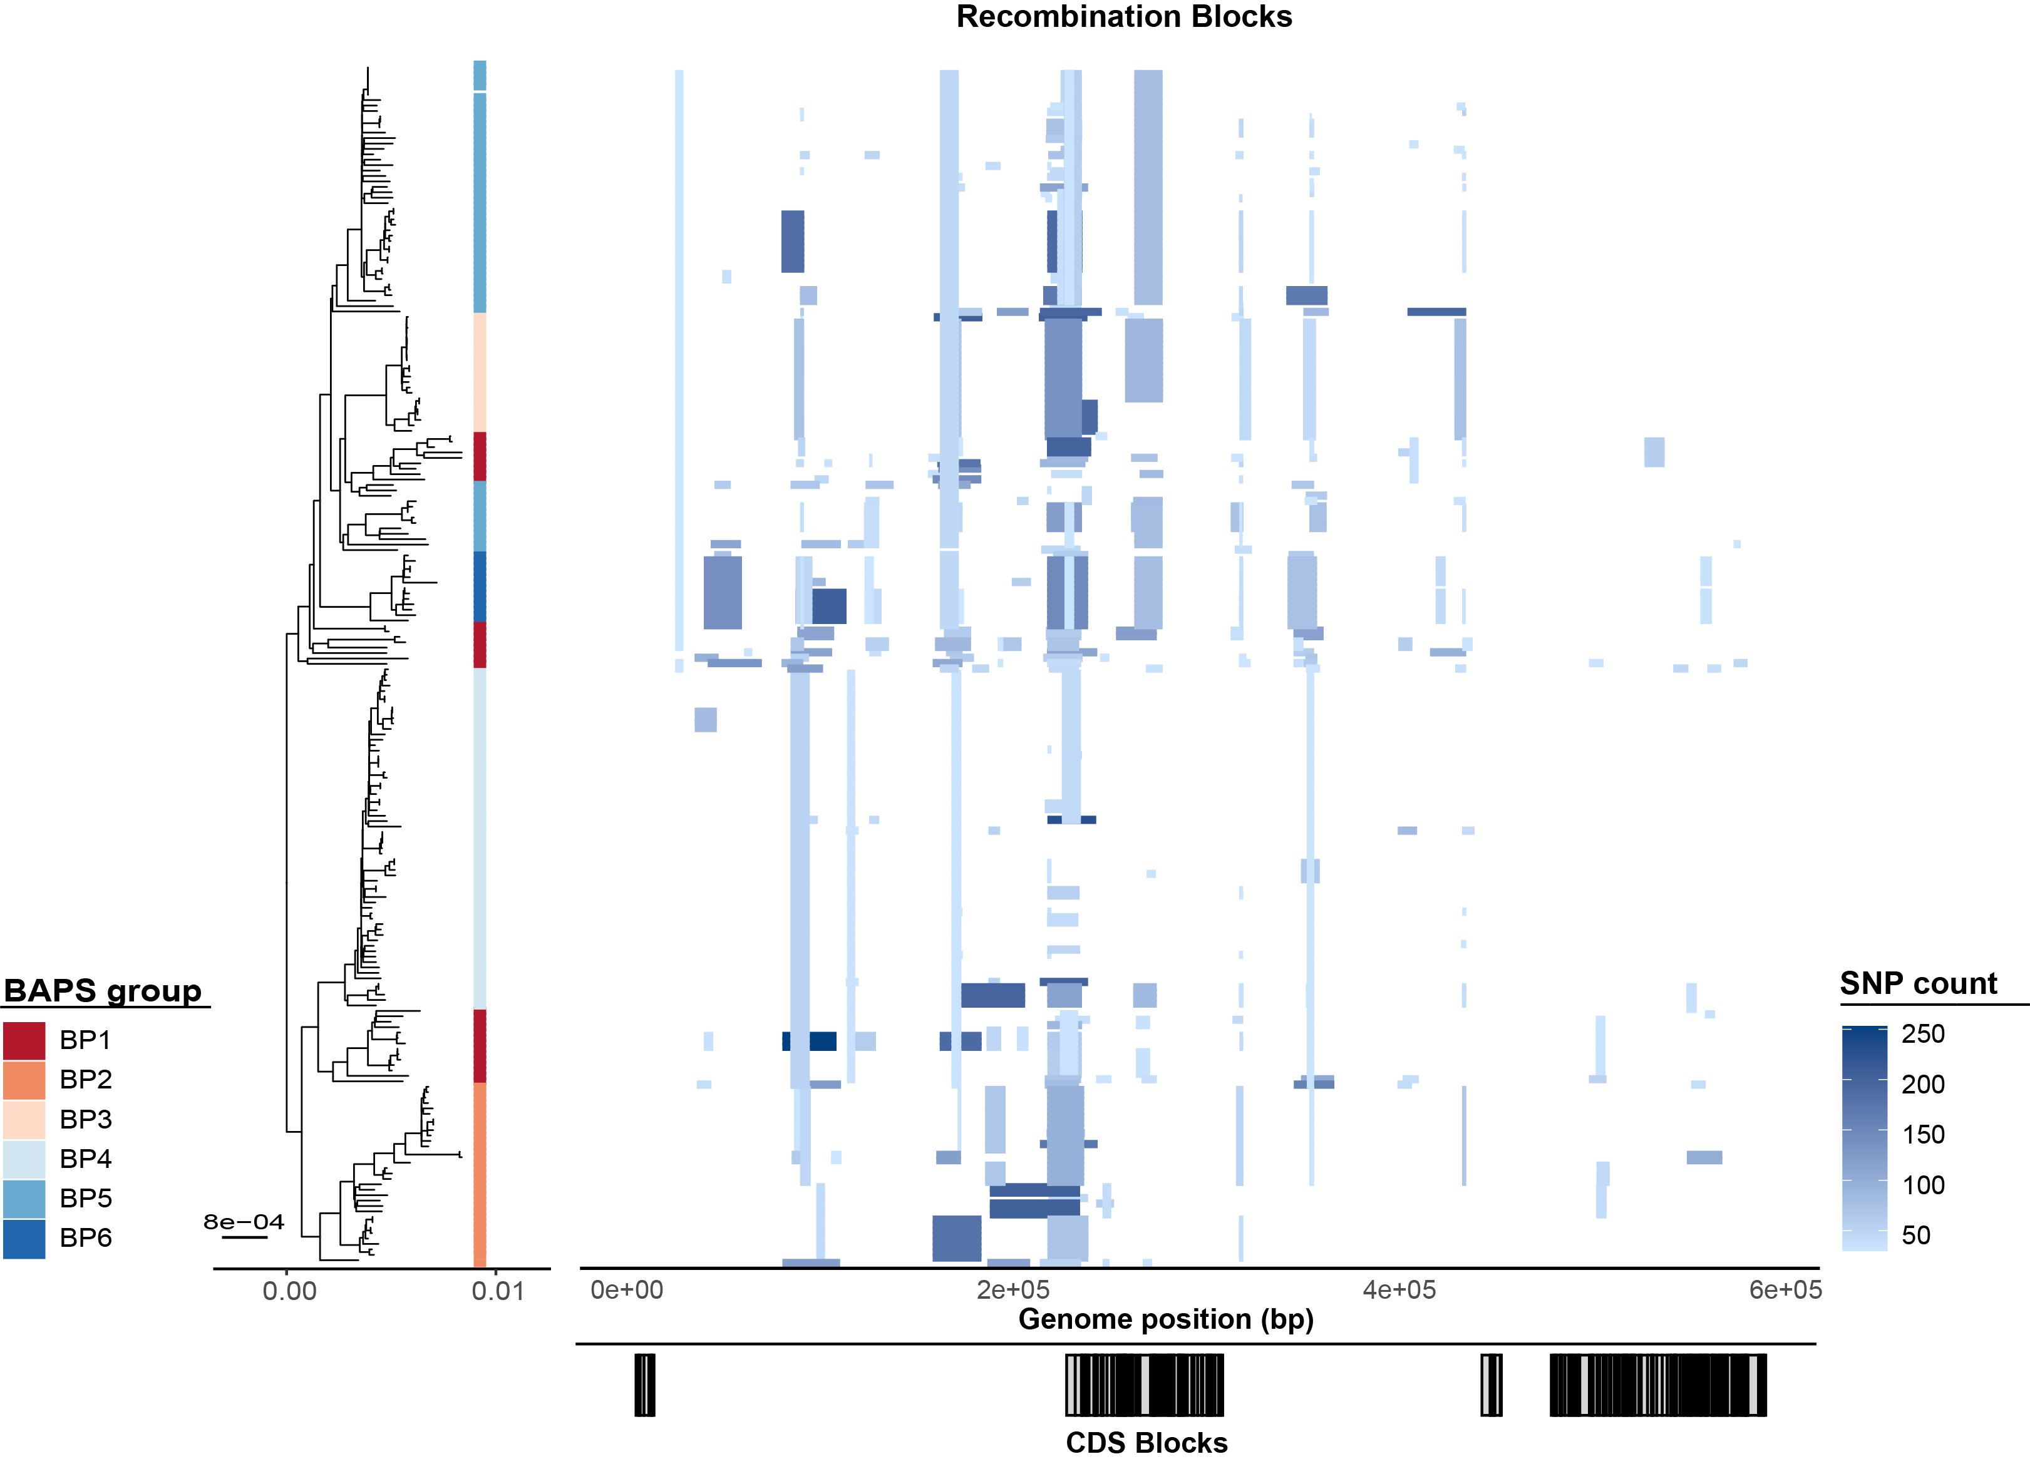
Supplementary Figure 3. Maximum-likelihood phylogenies of M. genitalium showing branch length changes before and after recombination masking.
The tree on the left depicts the maximum-likelihood phylogeny after recombination masking, while the tree on the right shows the phylogeny prior to masking. Connecting lines between the trees illustrate changes in branch lengths resulting from recombination masking.

Supplementary Figure 4 . Maximum Likelihood tree showing bootstrap support for each Clade.
Maximum likelihood phylogeny of the dataset. Clades are indicated by two coloured bars. Branch nodes with bootstrap support >70% are marked with a black dot.
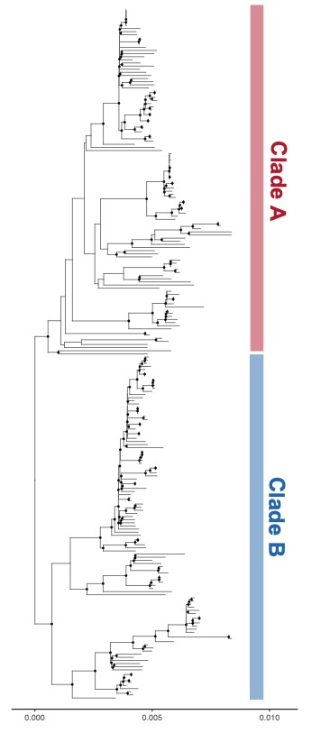

Supplementary Figure 5. Comparison of ARI Scores across bootstrap replicates and subsampling fractions.
A) The line plot shows the distribution of Adjusted Rand Index (ARI) scores from 1000 bootstrap iterations of the hierarchical Bayesian Analysis of Population Structure (BAPS) used to assess the stability of BAPS group assignments. Each point represents the ARI calculated from a single bootstrap replicate. The solid horizontal line represents the mean ARI (0.94), while the dashed lines mark the 95% confidence interval above and below the mean
B) Each boxplot displays the distribution of Adjusted Rand Index (ARI) scores for subsampling fractions of 50%, 70%, and 90% of samples analysed using the hierarchical Bayesian Analysis of Population Structure (BAPS) used to evaluate the stability group assignments. The median and interquartile range (IQR) for each subsampling level is indicated below the corresponding boxplot.

Supplementary Figure 6. Distribution of mgpA Paralogs Across Isolates.
Each barplot represents a single mgpB paralog, with the height indicating its presence (1 = 100%) or absence (0 = 0%) within each BAPS group, highlighting the diversity of mgpB paralogs among lineages.

Supplementary Figure 7. Assessment of molecular clock signal
A) Regression analysis of root-to-tip genetic distance over time was performed in TempEst using a maximum likelihood phylogeny. The root was optimized to minimize residual mean squared error, and the plot displays the coefficient of determination (R²) along with other statistical metrics. B) Each heatmap represents one model, showing ESS values for key parameters relevant to convergence. Higher ESS values indicate better sampling efficiency and more reliable posterior estimates.

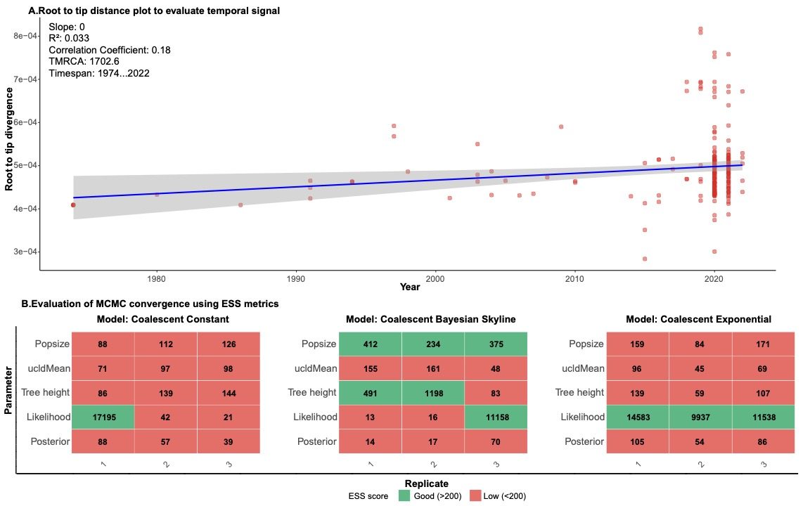

Supplementary Figure 8. Comparison between Grouping Methods
A) Linear regression analysis was performed to assess the relationship between pairwise SNP distances and pairwise allelic distances. The scatter plot displays the coefficient of determination (R²), highlighting the strength of correlation between the two metrics. B) Comparison of phylogenetic topologies generated using cgMLST and SNP based maximum likelihood (ML) methods. Dendrograms constructed from cgMLST profiles consistently reflected the topology observed in the SNP-based ML tree, supporting the concordance between both phylogenetic approaches.

Supplementary Figure 9. Performance of cgMLST and mgpB Typing Methods Relative to Genomic Structure Defined by BAPS Groups
(a) Dendrogram of mgpB sequence types. (b) Dendrogram of cgMLST clusters. In both dendrograms, BAPS group membership is indicated by the number shown at the tip of each branch, illustrating how each typing method aligns with broader genomic structure. Adjusted Rand Index showed strong agreement between BAPS and cgMLST (ARI 0.7) and weak agreement between BAPS and mgpB sequence type approach (ARI 0.3)

Supplementary Figure 10. M.genitalium sequences included in the final phylogenetic analysis.
Total number of sequences incorporated in the phylogenetic alignments for A) Victorian local samples and B) publicly available samples. Samples were eliminated from subsequent analysis if they did not pass any individual step in the quality control (QC) pipeline. Inclusion and exclusion criteria a described in detail in the Supplementary Methods.

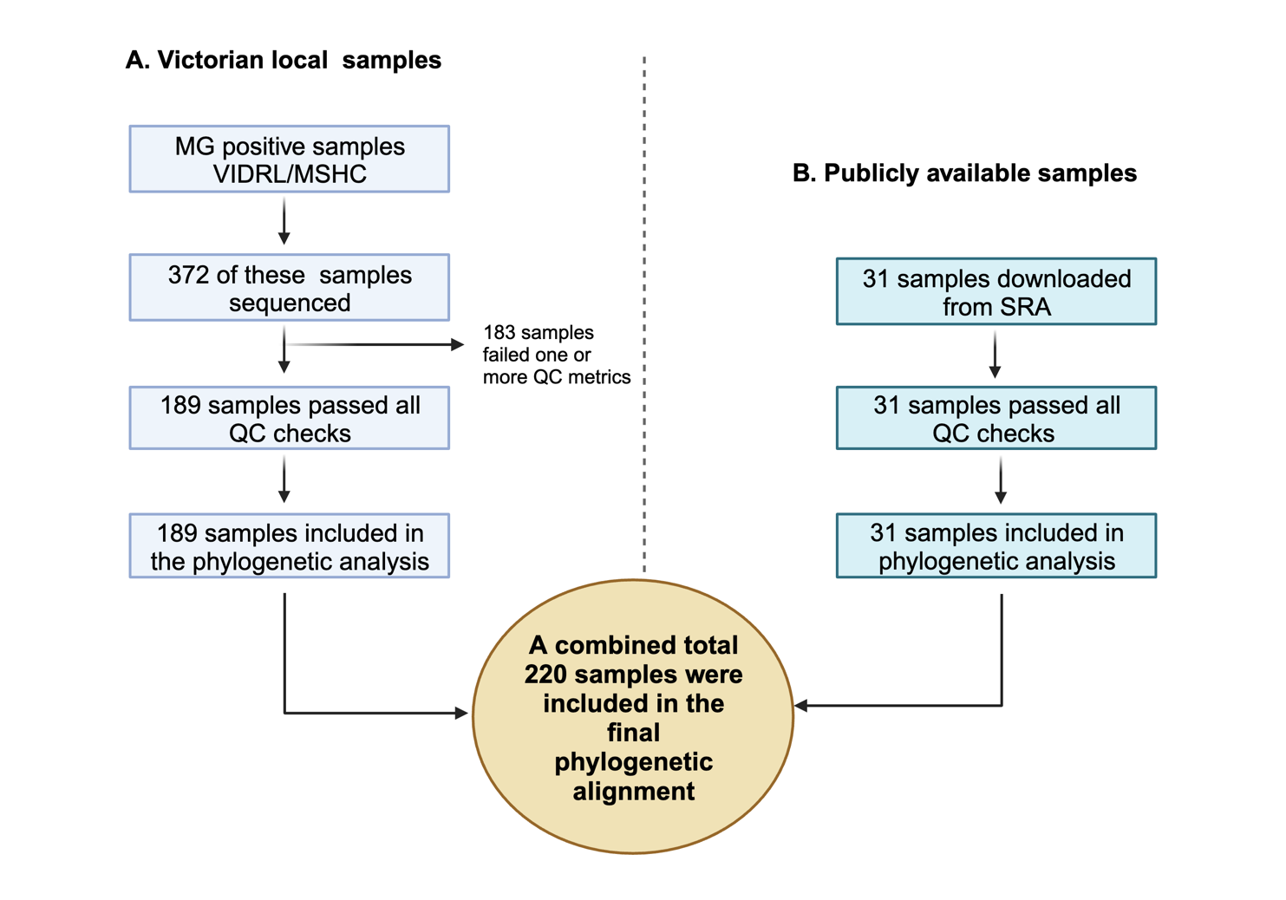
Supplementary Table. 1. Ancestral reconstruction posterior probability for each BAPS group.

BAPS Group | Probability (%) | Confidence Category
BP1 | 99 | High confidence
BP2 | 10 | Moderate confidence
BP3 | 0 | Moderate confidence
BP4 | 0 | Moderate confidence
BP5 | 0 | Moderate confidence
BP6 | 0 | Moderate confidence
Confidence categories were assigned based on the Shannon entropy measure, calculated as follows:
- High confidence: normalized entropy < 0.3
- Moderate confidence: 0.3 ≤ normalized entropy ≤ 0.6
- Low confidence: normalized entropy > 0.6

Supplementary Table 2. Association Between BAPS Groups and Sex or Sexual Risk Group.
Multinomial logistic regression model for each characteristic was used as the primary analysis to estimate the odds of BAPS group membership by sex and sexual risk group. Adjusted Odds ratios (aORs), 95% confidence intervals (CIs), were reported for each group. Likelihood ratio tests were conducted to determine p-values for each predictor across all BAPS groups.
BAPS Group | Characteristic | Category | Adjusted Odds Ratio (aOR) | 95% Confidence Interval (CI)
BP1  (Reference Group) | Sex | Male | - | -
BP1  (Reference Group) | Sex | Female | - | -
BP1  (Reference Group) | Sexual Risk Group | GBSM | - | -
BP1  (Reference Group) | Sexual Risk Group | MSW/WSM | - | -
BP2 | Sex | Male | 2.24 | 0.34-14.61
BP2 | Sex | Female | Reference | -
BP2 | Sexual Risk Group | GBSM | 8.26 | 1.33-51.38*
BP2 | Sexual Risk Group | MSW/WSM | Reference | -
BP3 | Sex | Male | - | -
BP3 | Sex | Female | Reference | -
BP3 | Sexual Risk Group | GBSM | - | -
BP3 | Sexual Risk Group | MSW/WSM | Reference | -
BP4 | Sex | Male | 0.39 | 0.1-1.48
BP4 | Sex | Female | Reference | -
BP4 | Sexual Risk Group | GBSM | 0.55 | 0.16-1.97
BP4 | Sexual Risk Group | MSW/WSM | Refence | -
BP5 | Sex | Male | 0.54 | 0.13-2.3
BP5 | Sex | Female | Reference | -
BP5 | Sexual Risk Group | GBSM | 0.90 | 0.24-3.47
BP5 | Sexual Risk Group | MSW/WSM | Reference | -
BP6 | Sex | Male | - | -
BP6 | Sex | Female | Reference | -
BP6 | Sexual Risk Group | GBSM | 7.52 | 0.69-81.6
BP6 | Sexual Risk Group | MSW/WSM | Reference | -
- Cases where the logistic regression model was unstable (e.g., perfect separation occurred, or the confidence interval was infinite/undefined).
*Denotes p-value from the multinomial regression analysis (Wald test) of <0.05.
LRT p-value across all BAP groups for each predictor: Sex <0.001 Sexual risk group <0.001
GBMSM: Gay bisexual men who have sex with men; MSW: Men who have sex with women; WSM: Women who have sex with men

Supplementary Table 3. Association Between BAPS Groups and Age Group.
Multinomial logistic regression model for each characteristic was used as the primary analysis to estimate the odds of BAPS group membership by sex and sexual risk group. Adjusted Odds ratios (aORs), 95% confidence intervals (CIs), were reported for each group. Likelihood ratio tests were conducted to determine p-values for each predictor across all BAPS groups.
BAPS Group | Age Group | Adjusted Odds Ratio (aOR) | 95% Confidence Interval (CI)
BP1  (Reference group) | 20-39 | - | -
BP1  (Reference group) | 40+ | - | -
BP2 | 20-39 | Reference | -
BP2 | 40-49 | 3.62 | 0.68 -19.22
BP2 | 50+ | 1.36 | 0.2-9.02
BP3 | 20-39 | Reference | -
BP3 | 40-49 | 1.06 | 0.13-8.31
BP3 | 50+ | 1.06 | 0.13-8.31
BP4 | 20-39 | Reference | -
BP4 | 40-49 | 0.16 | 0.01-1.91
BP4 | 50+ | 0.16 | 0.01-191
BP5 | 20-39 | Reference | -
BP5 | 40-49 | 0.27 | 0.02-3.19
BP5 | 50+ | - | -
BP6 | 20-39 | Reference | -
BP6 | 40-49 | 8.15 | 1.32-50.28*
BP6 | 50+ | - | -
- Cases where the logistic regression model was unstable (e.g., perfect separation occurred, or the confidence interval was infinite/undefined).
*Denotes p-value from the multinomial regression analysis (Wald test) of <0.05.
LRT p-value across all BAP groups for each predictor: Age <0.001

Supplementary Table 4. Association Between BAPS Groups and Macrolide Resistance (A2072G/A2071G Mutations).
Multinomial logistic regression model for each characteristic was used as the primary analysis to estimate the odds of BAPS group membership by sex and sexual risk group. Adjusted Odds ratios (aORs), 95% confidence intervals (CIs), were reported for each group. Likelihood ratio tests were conducted to determine p-values for each predictor across all BAPS groups.

BAPS Group | Macrolide Resistance | Adjusted Odds Ratio (aOR) | 95% Confidence Interval (CI)
BP1 | WT | - | -
BP1 | A2072G/A2071G | - | -
BP2 | WT | Reference | -
BP2 | A2072G/A2071G | 3.86 | 1.18-12.58*
BP3 | WT | Reference | -
BP3 | A2072G/A2071G | 11.06 | 1.75-69.78*
BP4 | WT | Reference | -
BP4 | A2072G/ A2071G | 2.63 | 1.03-6.73*
BP5 | WT | Reference | -
BP5 | A2072G/A2071G | 0.86 | 0.35-2.09
BP6 | WT | Reference | -
BP6 | A2072G/A2071G | - | -
*Denotes p-value from the multinomial regression analysis (Wald test) of <0.05.
LRT p-value across all BAP groups for the mutation predictor: A2072G/A2071G = <0.0001

Supplementary Table 5. Association Between BAPS Group and Fluoroquinolone Resistance Mutations.
A bias-reduced multinomial logistic regression model was used to estimate the odds of individual fluoroquinolone resistance mutations compared to wild type (WT, reference) across different BAPS groups. Adjusted odds ratios (aOR), 95% confidence intervals (CI), were reported for each group. Likelihood ratio test was used to calculate p-value across all BAPS groups for each mutation category.
BAPS Group | Fluoroquinolone Resistance | Adjusted Odds Ratio (aOR) | 95% Confidence Interval (CI)
BP1 | WT | - | -
BP1 | S83I | - | -
BP1 | S83I/M95I | - | -
BP1 | Single | - | -
BP1 | Dual | - | -
BP2 | WT | Reference | -
BP2 | S83I | 1.37 | 0.34-5.6
BP2 | S83I/M95I | 0.14 | 0-3.71
BP2 | Single | 1.12 | 0.29-4.39
BP2 | Dual | 2.85 | 0.03-275.39
BP3 | WT | Reference | -
BP3 | S83I | 10.33 | 2.52-42.34*
BP3 | S83I/M95I | 0.43 | 0.01-12.43
BP3 | Single | 0.82 | 0.1-6.84
BP3 | Dual | 3 | 0.01-824.24
BP4 | WT | Reference | -
BP4 | S83I | 1.67 | 0.48-5.83
BP4 | S83I/M95I | 2.14 | 0.52-8.84
BP4 | Single | 0.49 | 0.12-2.08
BP4 | Dual | 3 | 0.04-228.17
BP5 | WT | Reference | -
BP5 | S83I | 0.3 | 0.06-1.4
BP5 | S83I/M95I | 0..06 | 0-1.48
BP5 | Single | 0.39 | 0.1-1.51
BP5 | Dual | 0.39 | 0-101.22
BP6 | WT | Reference | -
BP6 | S83I | 0.17 | 0.01-3.9
BP6 | S83I/M95I | 0.22 | 0.01-6.19
BP6 | Single | 0.43 | 0.05-3.32
BP6 | Dual | 1.56 | 0.01-417.66
*Denotes p-value = < 0.05 from the multinomial regression analysis (Wald test).
LRT p-value across all BAP groups for each mutation predictor: S83I = < 0.001; S83I/M95I = <0.001; Single = 0.040; Dual = 0.41
Low frequency single mutations D87N and P62S have been grouped together into the single group and low frequency dual mutations S83I/D87N and S83I/P62S have been grouped together into dual group.

Supplementary Table 6. Association Between BAPS Group and Tetracycline Resistance Mutations.
A bias-reduced multinomial logistic regression model was used to estimate the odds of individual tetracycline resistance mutations compared to wild type (WT, reference) across different BAPS groups. Adjusted odds ratios (aOR), 95% confidence intervals (CI), were reported for each group. p-values Likelihood ratio test was used to calculate p-value across all BAPS groups for each mutation category.
BAPS Group | Tetracycline Resistance | Adjusted Odds Ratio (aOR) | 95% Confidence Interval (CI)
BP1  (Reference group) | WT | - | -
BP1  (Reference group) | A644T | - | -
BP1  (Reference group) | A742G | - | -
BP1  (Reference group) | C1435T | - | -
BP1  (Reference group) | C1435T/Dual | - | -
BP1  (Reference group) | C462T | - | -
BP1  (Reference group) | Other | - | -
BP2 | WT | Reference | -
BP2 | A644T | 0.45 | 0.01-143.15
BP2 | A742G | 19.55 | 0.68-567.1
BP2 | C1435T | 0.06 | 0.01-0.47
BP2 | C1435T/Dual | 0.06 | 0-2.21
BP2 | C462T | 0.45 | 0-43.46
BP2 | Other | 0.29 | 0.04-2.01
BP3 | WT | Reference | -
BP3 | A644T | 0.33 | 0-1.03.2
BP3 | A742G | 0.33 | 0-28.29
BP3 | C1435T | 0.01 | 0-0.22
BP3 | C1435T/Dual | 0.05 | 0-1.58
BP3 | C462T | 10.33 | 0.34-315.03
BP3 | Other | 0.02 | 0-0.6
BP4 | WT | Reference | -
BP4 | A644T | 5 | 0.03-2892.58
BP4 | A742G | 5 | 0.03-927.86
BP4 | C1435T | 14.73 | 0.62-348.56
BP4 | C1435T/Dual | 13.57 | 0.46-400.12
BP4 | C462T | 5 | 0.02-1008.55
BP4 | Other | 0.29 | 0-23.37
BP5 | WT | Reference | -
BP5 | A644T | 0.3 | 0-26.84
BP5 | A742G | 0.06 | 0-4.86
BP5 | C1435T | 0.03 | 0.01-0.14
BP5 | C1435T/Dual | 0.01 | 0-0.27
BP5 | C462T | 0.06 | 0-4.45
BP5 | Other | 0.05 | 0.01-0.25
BP6 | WT | Reference | -
BP6 | A644T | 15 | 0.06-3657.48
BP6 | A742G | 5 | 0.03-927.86
BP6 | C1435T | 1.22 | 0.03-32.63
BP6 | C1435T/Dual | 12.14 | 0.41-360.9
BP6 | C462T | 5 | 0.02-1008.55
BP6 | Other | 0.29 | 0-23.37
*Denotes p-value from the multinomial regression analysis (Wald test) of <0.05.
LRT p-value across all BAP groups for each mutation predictor: A644T = 0.20; A742G = <0.001; C1435T = <0.001; C1435T_dual = <0.001; C462T = <0.001; Other = 1

Supplementary Table 7. Association Between Treatment Outcomes and Fluoroquinolone Resistance Mutations in Patients Treated with Fluoroquinolones
Standard logistic regression was used to assess the association between resistance mutations and treatment outcomes. Odds ratios (ORs) with 95% confidence intervals (CIs) are reported for each genotype, and likelihood ratio tests were used to determine statistical significance (p-values).

Genotype | Treatment Outcome | Odds Ratio (OR) | 95% Confidence Interval (CI) | p-value
WT | Pass | - | - | -
WT | Fail | - | - | -
D87N | Pass | Reference | - | -
D87N | Fail | 11.33 | 0.38-344.37 | 0.54
P62S | Pass | Reference | - | -
P62S | Fail | - | - | -
S83I | Pass | Reference | - | -
S83I | Fail | 18.13 | 3.93-108.37 | <0.05
S83I_P62S | Pass | Reference | - | -
S83I_P62S | Fail | - | - | -
S83I_M95I | Pass | Reference | - | -
S83I_M95I | Fail | 22.67 | 4.08-168.4 | <0.05
S83I_D87N | Pass | Reference | - | -
S83I_D87N | Fail | - | - | -

Supplementary Table 8. Association Between Treatment Outcomes and Macrolide Resistance Mutations in Patients Treated with Macrolides.
Standard logistic regression was used to assess the association between resistance mutations and treatment outcomes. Odds ratios (ORs) with 95% confidence intervals (CIs) are reported for each genotype, and likelihood ratio tests were used to determine statistical significance (p-values).

Genotype | Method | Treatment Outcome | Adjusted Odds Ratio (aOR) | 95% Confidence Interval (CI) | p-value
WT | Logistic Regression (Reference group) | Pass | - | - | -
WT | Logistic Regression (Reference group) | Fail | - | - | -
A2071G | Logistic Regression | Pass | Reference | - | -
A2071G | Logistic Regression | Fail | 1 | 0-NA | 0.73
A2072G | Logistic Regression | Pass | Reference | - | -
A2072G | Logistic Regression | Fail | - | - | -

Supplementary Table 9. Association Between Treatment Outcomes and Tetracycline Resistance Mutations in Patients Treated with Tetracycline.
Standard logistic regression was used to assess the association between resistance mutations and treatment outcomes. Odds ratios (ORs) with 95% confidence intervals (CIs) are reported for each genotype, and likelihood ratio tests were used to determine statistical significance (p-values).

Genotype | Method | Treatment Outcome | Adjusted Odds Ratio (OR) | 95% Confidence Interval (CI) | p-value
WT | Logistic Regression (Reference group) | Pass | - | - | -
WT | Logistic Regression (Reference group) | Fail | - | - | -
A742G | Logistic Regression | Pass | Reference | - | -
A742G | Logistic Regression | Fail | 1 | 0.02-40.40 | 0.54
C1435T | Logistic Regression | Pass | Reference | - | -
C1435T | Logistic Regression | Fail | 0.38 | 0.01-5.92 | 0.77
C1435T_Dual | Logistic Regression | Pass | Reference | - | -
C1435T_Dual | Logistic Regression | Fail | 0.5 | 0.01-23.55 | 0.93
C462T | Logistic Regression | Pass | Reference | - | -
C462T | Logistic Regression | Fail | - | - | -

Supplementary Table. 10. Sites removed from the global and local alignments using G37
M.genitalium reference genome (accession NC_000908.2)
Recombination block | Genes encoded | Locus Tag | Start | End | Size of region (bp)
1 | - | - | 1 | 950 | 950
2 | - | MG_RS02995, MG_RS03000 | 85580 | 87780 | 2200
3 | - | MG_RS00760, MG_RS00765, MG_RS00770 | 167200 | 169800 | 2600
4 | - | MG_RS02960, MG_RS03005, MG_RS03010 | 174850 | 175750 | 900
5 | mgpA, pheS | MG_RS02915, MG_RS02855, MG_RS03015, MG_RS01050, MG_RS01055, MG_RS01060, MG_RS01065, MG_RS01070, MG_RS02880, MG_RS01075, MG_RS01080, MG_RS02980, MG_RS09275, MG_RS02855, MG_RS03025, MG_RS01100 | 213500 | 232800 | 19300
6 | - | MG_RS01335 | 273300 | 273800 | 500
7 | - | MG_RS01525, MG_RS01530, MG_RS03030 | 312800 | 315210 | 2410
8 | - | MG_RS02985, MG_RS02990, MG_RS01730 | 349200 | 351800 | 2600
9 | recA | MG_RS02065, MG_RS02070, MG_RS03035,  MG_RS02080 | 428000 | 430550 | 2550

References

1. Fookes MC, Hadfield J, Harris S, Parmar S, Unemo M, Jensen JS, Thomson NR. Mycoplasma genitalium: whole genome sequence analysis, recombination and population structure. BMC Genomics. 2017;18(1):993.
2. Chalker VJ, Jordan K, Ali T, Ison C. Real-time PCR detection of the mg219 gene of unknown function of Mycoplasma genitalium in men with and without non-gonococcal urethritis and their female partners in England. J Med Microbiol. 2009;58(Pt 7):895-9.
3. Taouk ML TG, Pasricha S, Herman S, Chow EPF, Azzatto F, Zhang B, Sia CM, Duchene S, Lee A, Higgins N, Prestedge J, Lee YW, Thomson NR, Graves B, Meumann E, Gunathilake M, Hocking JS, Bradshaw CS, Beale MA, Howden BP, Chen MY, Fairley CK, Ingle D. J, Williamson DA. Characterisation of Treponema pallidum lineages within the contemporary syphilis outbreak in Australia: a genomic epidemiological analysis. . The Lancet Microbe. 2022;3(6):417-26.
4. Li H. Minimap2: pairwise alignment for nucleotide sequences. Bioinformatics. 2018;34(18):3094-100.
5. Bolger AM, Lohse, M. & Usadel, B. Trimmomatic: a flexible trimmer for Illumina sequence data. Bioinformatics. 2014;30(15):2114-20.
6. Wood DE, Salzberg SL. Kraken: ultrafast metagenomic sequence classification using exact alignments. Genome Biol. 2014;15(3):R46.
7. Danecek P, Bonfield, J.K., Liddle, J., Marshall,J., Ohan, V., Pollard, M.O., Whitwham, A., Keane, T., McCarthy, S.A., Davies, R.M. & Li.H. Twelve years of SAMtools and BCFtools. GigaScience. 2021;10(2):1-4.
8. Quinlan ARaH, I.M,. BEDTools: a flexible suite of utilities for comparing genomic features. . Bioinformatics. 2010;26(6):841–2.
9. Prjibelski A, Antipov, D., Meleshko, D., Lapidus, A. & Korobeynikov, A. Using SPAdes De Novo Assembler. Current Protocols in Bioinformatics. 2020;70(1):e102.
10. Gurevich A, Saveliev V, Vyahhi N, Tesler G. QUAST: quality assessment tool for genome assemblies. Bioinformatics. 2013;29(8):1072-5.
11. Croucher NJP, A.J., Connor,T.R., Delaney. A.J., Keane. J.A, Bentley, S.D., Parkhill,J. & Harris, S.R. Rapid phylogenetic analysis of large samples of recombinant bacterial whole genome sequences using Gubbins. Nucleic Acids Research. 2015;43(3):3-13.
12. Taouk ML, Featherstone LA, Taiaroa G, Seemann T, Ingle DJ, Stinear TP, Wick RR. Exploring SNP filtering strategies: the influence of strict vs soft core. Microb Genom. 2025;11(1).
13. Minh BQ, Schmidt HA, Chernomor O, Schrempf D, Woodhams MD, von Haeseler A, Lanfear R. Corrigendum to: IQ-TREE 2: New Models and Efficient Methods for Phylogenetic Inference in the Genomic Era. Mol Biol Evol. 2020;37(8):2461.
14. Kalyaanamoorthy S, Minh BQ, Wong TKF, von Haeseler A, Jermiin LS. ModelFinder: fast model selection for accurate phylogenetic estimates. Nat Methods. 2017;14(6):587-9.
15. Hoang DT, Chernomor O, von Haeseler A, Minh BQ, Vinh LS. UFBoot2: Improving the Ultrafast Bootstrap Approximation. Mol Biol Evol. 2018;35(2):518-22.
16. Tonkin-Hill G, Lees JA, Bentley SD, Frost SDW, Corander J. RhierBAPS: An R implementation of the population clustering algorithm hierBAPS. Wellcome Open Res. 2018;3:93.
17. Drummond AJ, Rambaut A. BEAST: Bayesian evolutionary analysis by sampling trees. BMC Evol Biol. 2007;7:214.
18. Rambaut A DA, Xie D, Baele G, Suchard MA. . Posterior Summarization in Bayesian
485 Phylogenetics Using Tracer 1.7. Systematic Biology. 2018;67(5):901-4.
19. Paradis E, Claude J, Strimmer K. APE: Analyses of Phylogenetics and Evolution in R language. Bioinformatics. 2004;20(2):289-90.
20. Silva M, Machado MP, Silva DN, Rossi M, Moran-Gilad J, Santos S, et al. chewBBACA: A complete suite for gene-by-gene schema creation and strain identification. Microb Genom. 2018;4(3).

