Supplementary Materials

Mechanisms on the Combined Remediation of Sulfonylurea Herbicides Contaminated Soil by Chenggangzhangella sp. BI-1 and Cucumber

Lian-zheng Dong^{a,1}, Zi-wang Yuan^{a,1}, Xue Xiaª, Zi-yue Dingª, Yuan-yuan Zhaoª, Tie-jun Wang^{b}, Qiu-hong Niuª, Hao Zhang^{a, *}

ªCollege of Life Science, Nanyang Normal University, Nanyang, 473061, PR China.
^{b}Pet Engineering College, Nanyang Vocational College of Agriculture, Nanyang, 473000, PR China.

¹ These authors contribute equally to this manuscript
* Corresponding author: Hao Zhang
Email address: zhanghao660@nynu.edu.cn
Fig. S1 The chemotaxis of strain BI-1 to 4 kinds of amino acids, 4 kinds of vitamins and 8 kinds of organic acids. Different letters represent significant differences at the P<0.05
Fig. S2 Effects of different organic acids, amino acids and vitamins on the colonization of strain BI-1 on cucumber root surface. Different letters represent significant differences at the P<0.05 level
Fig. S3 Effects of root exudates on biofilm formation by strain BI-1

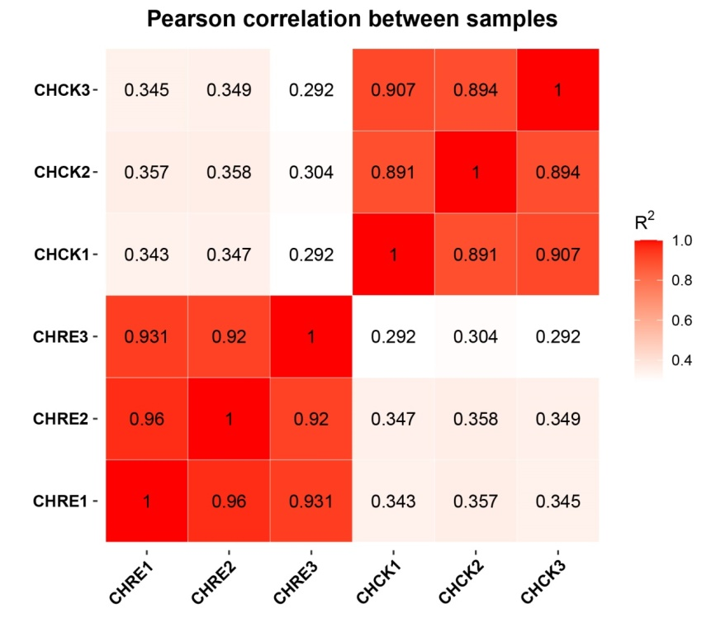
Fig. S4 RNA-Seq correlation check
The numbers in the figure represent the square of the correlation coefficient between the samples

Fig. S5 Effect of CMC concentration, proportion of herbicide and seeds, coating time on the colonization of strain BI-1
Fig. S6 Colonization dynamics of strain BI-1 in cucumber root with different herbicides

A

B

C

Fig. S7 UPGMA analysis of soil samples under different treatments.
(A, B, C are chlorimuron-ethyl, bensulfuron-methyl, tribenuron-methyl)

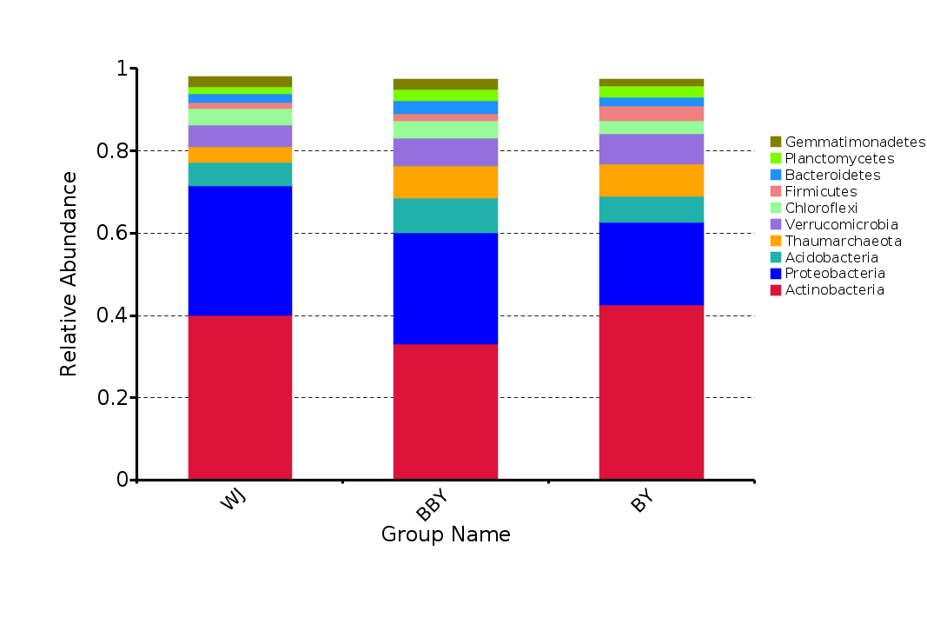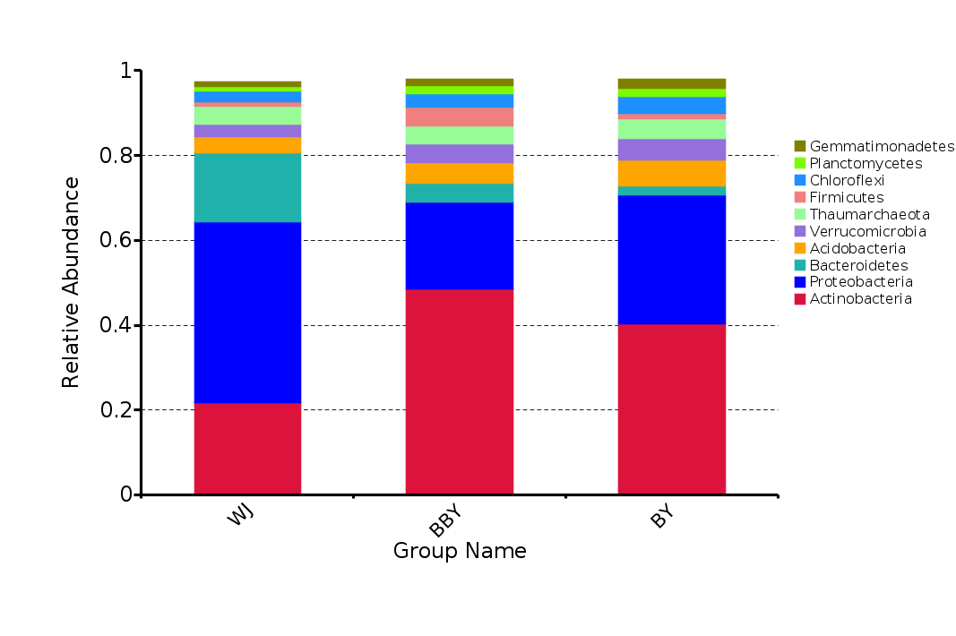
A
B
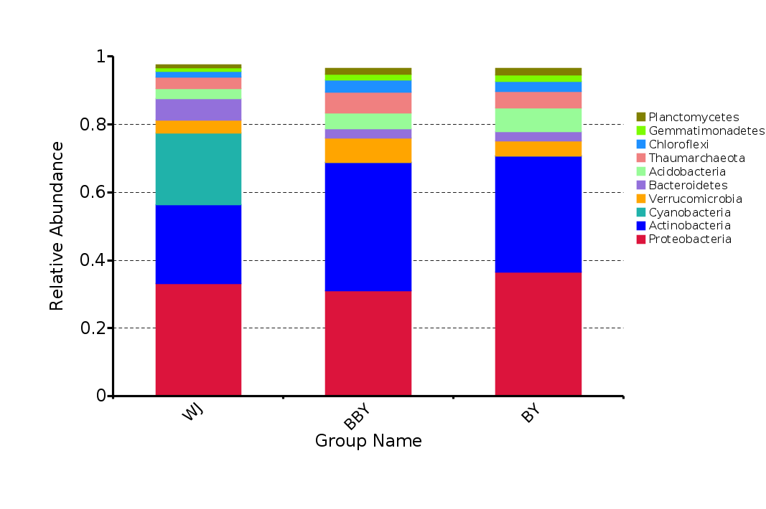
C
Fig.S8 Relative abundance of bacterial community at phylum level in soil with different treatments (A, B, C are chlorimuron-ethyl, bensulfuron-methyl, tribenuron-methyl)
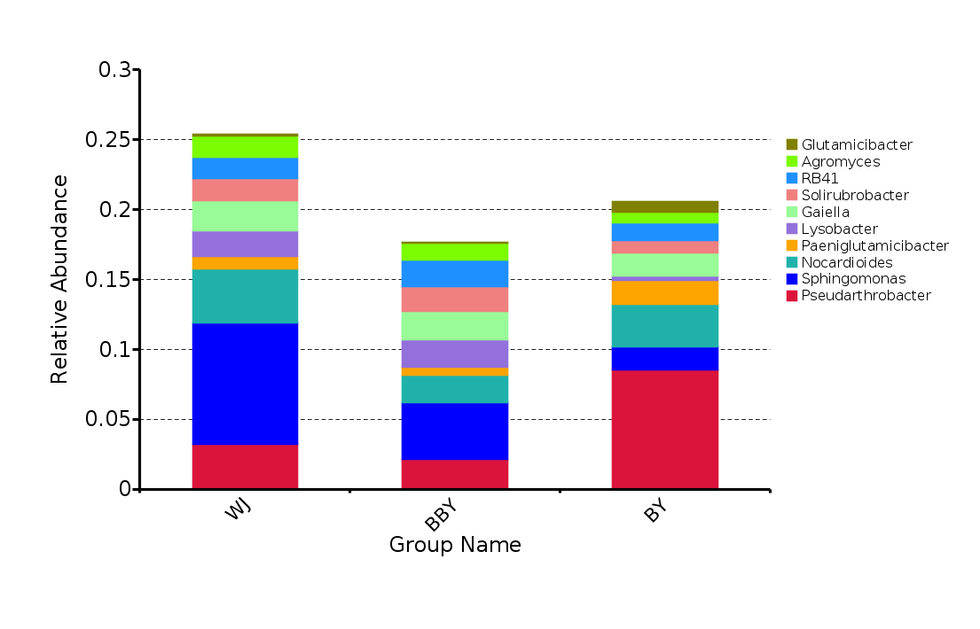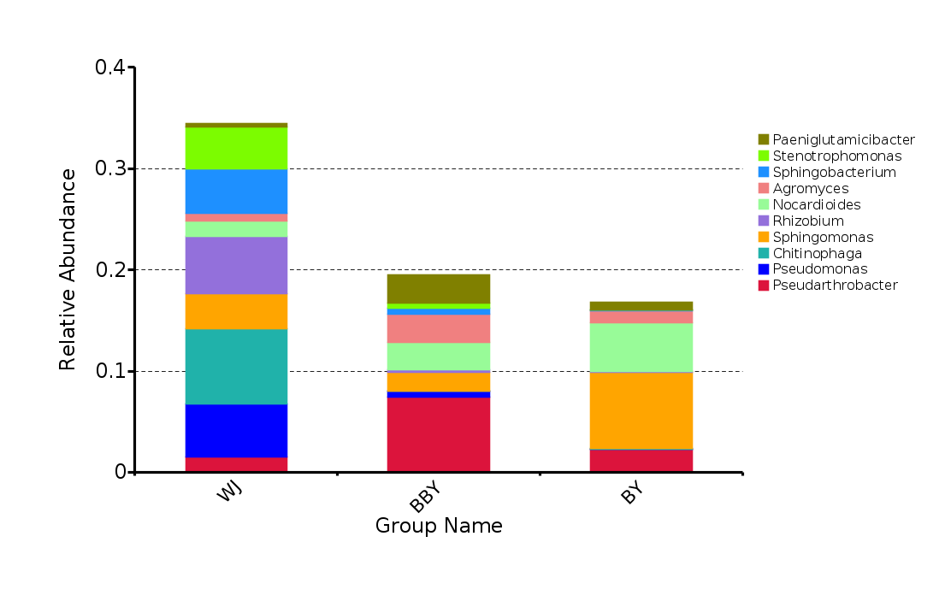
B
A
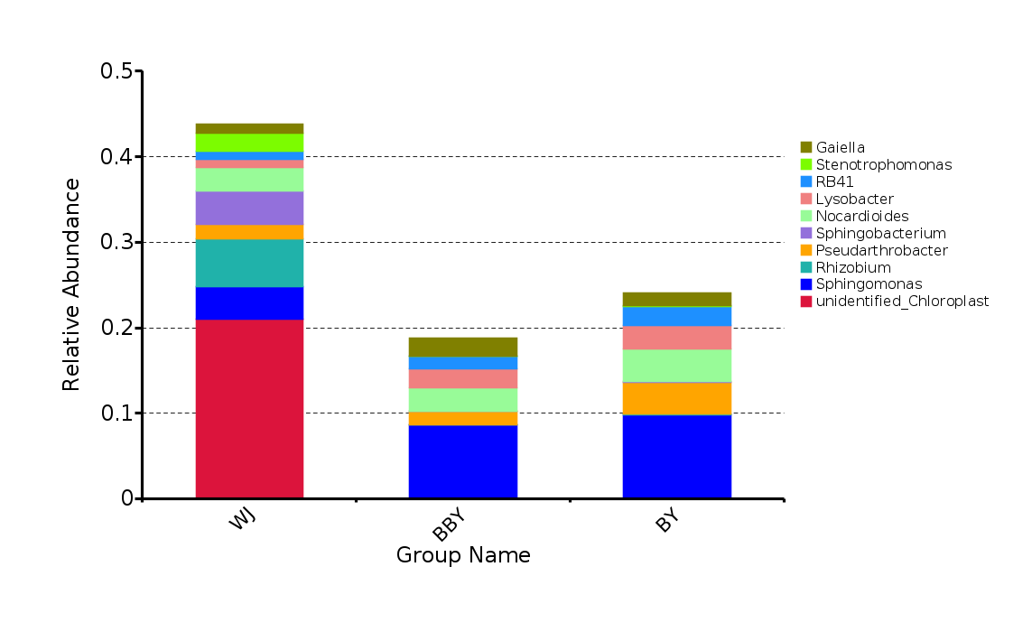
C

Fig. S9 Relative abundance of bacterial community at genus level in soil with different treatments
(A, B, C are chlorimuron-ethyl, bensulfuron-methyl, tribenuron-methyl)
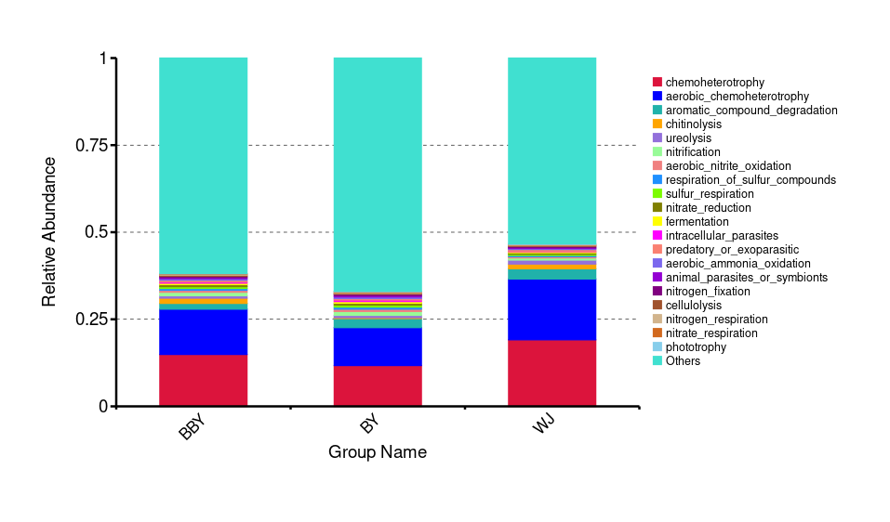
A
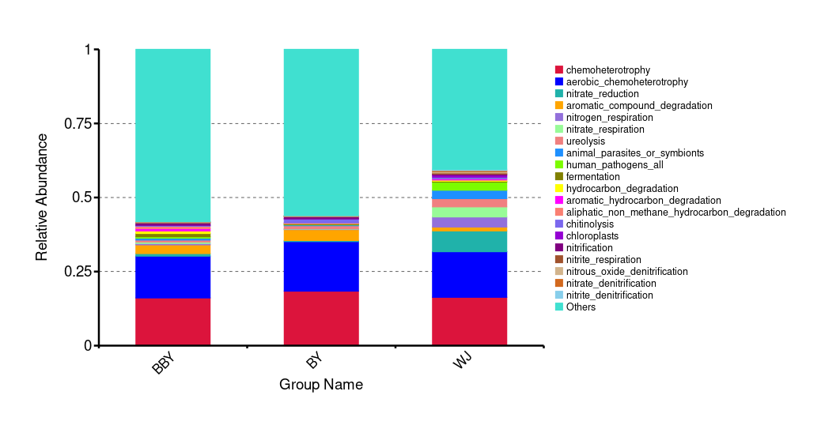
B
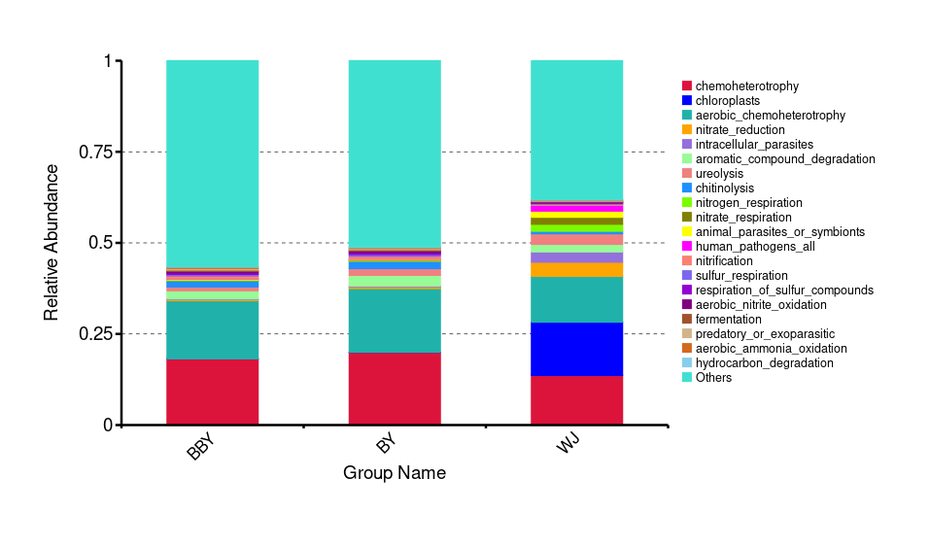
C
Fig. S10 Prediction of bacterial function in different soil samples
(A, B, C are chlorimuron-ethyl, bensulfuron-methyl, tribenuron-methyl）

Table S1 Statistics of the number of genes in different expression levels
FPKM Interval | CHRE1 | CHRE2 | CHRE3 | CHCK1 | CHCK2 | CHCK3
0~1 | 206(3.89%) | 227(4.29%) | 225(4.25%) | 368(6.95%) | 382(7.21%) | 343(6.48%)
1~3 | 30(0.57%) | 9(0.17%) | 35(0.66%) | 60(1.13%) | 34(0.64%) | 55(1.04%)
3~15 | 130(2.45%) | 147(2.78%) | 144(2.72%) | 717(13.54%) | 638(12.04%) | 692(13.06%)
15~60 | 446(8.42%) | 440(8.31%) | 462(8.72%) | 2270(42.85%) | 2339(44.16%) | 2271(42.87%)
>60 | 4485(84.67%) | 4474(84.46%) | 4431(83.65%) | 1882(35.53%) | 1904(35.94%) | 1936(36.55%)

Table S2 Differential expression analysis software and differential gene screening criteria
Type | Sofeware | Standardization method | P-value calculation model | FDR calculation method | Differential expression gene screening standard
Biological duplication. | DESeq | DESeq | Negative binomial distribution | BH | padj < 0.05

Table S3 Types and concentrations of amino acids in cucumber root exudates
Category | Ile | Asp | Lys | Ser | Met | Gln | Val | Pro | Ala | Glu
Concentration  (μg/mL) | Not detected | 2.84 | 1.34 | 0.55 | 0.12 | 0.55 | Not detected | Not detected | 0.49 | 1.29
Category | Leu | Gly | Arg | Cys | Trp | Tyr | Thr | His | Phe | Asn
Concentration  (μg/mL) | Not detected | 0.59 | 0.13 | 2.97 | 0.78 | 0.46 | 0.41 | 0.28 | Not detected | 0.35

Table S4 Types and concentrations of organic acids in cucumber root exudates (Top 10)
Category | lactic-acid | levulinic-acid | azelaic-acid | glutaric-acid | succinic-acid
Concentration  (ng/mL) | 335.51 | 181.78 | 100.01 | 62.21 | 56.55
Category | 3-hydroxyphenylacetic-acid | 3-hydroxyisovaleric-acid | tartaric-acid | adipic-acid | pantothenic-acid
Concentration  (ng/mL) | 49.43 | 45.27 | 34.71 | 32.70 | 31.61

Table S5 Types and concentrations of vitamins in cucumber root exudates
Category | VB1 | VB2 | VB3 | VB6 | VB7 | VC | VB5 | VB12
Concentration  (μg/mL) | 0.04 | Not detected | Not detected | 3.04 | 0.10 | 15405.56 | Not detected | Not detected

Table S6 Sequencing data statistics
Sample name | Raw reads | Raw bases | Clean reads | Clean bases | Error rate | Q20 | Q30 | GC content
CHRE1 | 23180530 | 2.90G | 19183312 | 2.90G | 0.03% | 97.94% | 94.35% | 67.15%
CHRE2 | 15301456 | 1.88G | 12434228 | 1.88G | 0.03% | 97.86% | 94.20% | 67.24%
CHRE3 | 21814488 | 2.76G | 18211100 | 2.75G | 0.03% | 97.68% | 93.82% | 67.90%
CHCK1 | 17417920 | 1.52G | 10094854 | 1.52G | 0.03% | 97.28% | 92.97% | 60.58%
CHCK2 | 14814322 | 1.25G | 8288904 | 1.25G | 0.03% | 97.28% | 93.05% | 59.59%
CHCK3 | 17660642 | 1.59G | 10539270 | 1.59G | 0.03% | 97.25% | 93.15% | 60.34%

Table S7 Functional classification of significant differential genes between samples
Functional category | CHRE vs CHCK （gene number） | The total number of genes
Metabolism
Sulfur metabolism | 46 | 52
Methane metabolism | 47 | 54
Citrate cycle (TCA cycle) | 22 | 23
Microbial metabolism in diverse environments | 182 | 263
Terpenoid backbone biosynthesis | 10 | 10
Tryptophan metabolism | 17 | 20
Cysteine and methionine metabolism | 24 | 30
Selenocompound metabolism | 9 | 9
One carbon pool by folate | 11 | 12
C5-Branched dibasic acid metabolism | 11 | 12
Biosynthesis of antibiotics | 149 | 222
Carbon metabolism | 85 | 128
Biosynthesis of secondary metabolites | 185 | 281
Valine, leucine and isoleucine degradation | 17 | 22
Genetic Information Processing
RNA degradation | 16 | 19
Ribosome | 51 | 59
Mismatch repair | 14 | 17
DNA replication | 13 | 15
Homologous recombination | 17 | 19
Environmental Information Processing
Two-component system | 64 | 85

Table S8 Experimental factors and levels
Level | Factors
Level | A： CMC concentration （g·10 mL⁻¹） | B：Proportion of herbicide and seeds  （mL/g） | C：Coating time  （min）
-1  0 | 0.50  0.75 | 20  30 | 40  50
1 | 1.00 | 40 | 60

Table S9 Results of response surface method
Number | Factors |  |  | BI-1 colonization
Number | A：CMC addition (g/10 mL) | B：inoculation-seeds ratio (mL/g) | C：coating time (min) |  | (10⁶ CFU/g)
1 | 0.50 | 30 | 40 |  | 2.38
2 | 1.00 | 30 | 40 |  | 1.96
3 | 0.50 | 30 | 60 |  | 2.25
4 | 1.00 | 30 | 60 |  | 2.69
5 | 0.50 | 20 | 50 |  | 2.75
6 | 1.00 | 20 | 50 |  | 2.42
7 | 0.50 | 40 | 50 |  | 2.38
8 | 1.00 | 40 | 50 |  | 2.85
9 | 0.75 | 20 | 40 |  | 2.53
10 | 0.75 | 20 | 60 |  | 2.74
11 | 0.75 | 40 | 40 |  | 2.45
12 | 0.75 | 40 | 60 |  | 2.85
13 | 0.75 | 30 | 50 |  | 2.85
14 | 0.75 | 30 | 50 |  | 2.71
15 | 0.75 | 30 | 50 |  | 2.88
16 | 0.75 | 30 | 50 |  | 2.71
17 | 0.75 | 30 | 50 |  | 2.78

Table S10 Analysis of variance results
Source | Sum of Squares | df | Mean Square | F-value | p-value | Significance
Model | 1.04E+12 | 9 | 1.15E+11 | 30.440 | < 0.0001 | **
A- the condition of CMC | 3.20E+09 | 1 | 3.20E+09 | 0.847 | 0.3880
B- coating time | 1.83E+11 | 1 | 1.83E+11 | 48.440 | 0.0002 | **
C-inoculation-seeds ratio | 1.01E+09 | 1 | 1.01E+09 | 0.268 | 0.6206
AB | 1.85E+11 | 1 | 1.85E+11 | 48.940 | 0.0002 | **
AC | 1.60E+11 | 1 | 1.60E+11 | 42.350 | 0.0003 | **
BC | 9.03E+09 | 1 | 9.03E+09 | 2.390 | 0.1661
A² | 2.72E+11 | 1 | 2.72E+11 | 72.050 | < 0.0001 | **
B² | 1.89E+11 | 1 | 1.89E+11 | 49.970 | 0.0002 | **
C² | 1.96E+10 | 1 | 1.96E+10 | 5.190 | 0.0568
Residual | 2.64E+10 | 7 | 3.78E+09
Lack of Fit | 1.93E+09 | 3 | 6.42E+08 | 0.105 | 0.9530
Pure Error | 2.45E+10 | 4 | 6.13E+09
Cor Total | 1.06E+12 | 16
Note: * indicates a significant difference (P < 0.05); ** indicates an extremely significant difference (P < 0.01).

