Supplementary Information for

Early-crystalized bridgmanite as a source of primitive noble gases
Yunguo Li et al.
Corresponding author: Yunguo Li, liyunguo@ustc.edu.cn

This PDF file includes:

Text S1. He and Ne at the interstitial site of bridgmanite
Text S2. Fractionation of He and Ne during magma ocean crystallization
Figs. S1-S4
Table S1-S4

Text S1. He and Ne at the interstitial site of bridgmanite

The interstitial sites in bridgmanite could also accommodate noble gases like He and Ne. There are several types of interstitial site in bridgmanite, and we considered two large interstitial sites: The first is the interstitial site between the triangle composed of two Si-O tetrahedrons and one Mg atom (Fig. S1d); the second one is the interstitial site of a polyhedron composed of two Si-O tetrahedrons and two Mg atoms (Fig. S1e). We then performed static calculations at 20, 50, and 135 GPa to determine which interstitial site is more preferred. We put one Ne atom in the interstitial sites and fully relaxed the supercell and atom positions under target pressures. We found that the enthalpies of Ne at the first type of interstitial site are lower than those of the second type by 1.43, 1.53, and 1.83 eV at 20, 50, and 135 Gpa, respectively. Therefore, the first interstitial site should be more preferred by noble gases.
We also calculated the enthalpies of Ne occupying oxygen vacancy (OV) in bridgmanite, compared that to those at the interstitial site in Fig. S2. As can be seen, the enthalpies of Ne at the interstitial site are much larger than those at the OV site, and the difference increases with the increasing pressure. The enthalpies of Ne at the interstitial site are even much larger than the sum of the enthalpies of Ne at the OV site and the formation enthalpies of OV from 20 Gpa to 135 Gpa, which suggests that Ne prefers the OV site over the interstitial site in bridgmanite.
To verify whether He and Ne prefer the OV site over the interstitial site at high temperatures, we performed thermodynamic integration and AIMD simulations to calculate their chemical potentials at 20 GPa (2800 K) and 135 GPa (4200 K). At 20 GPa and 2800 K, the chemical potential of He in the bridgmanite interstitial site is 3.77 eV, and the chemical potential of Ne in the bridgmanite interstitial site is 4.89 eV. At 135 GPa and 4200 K, the chemical potential of He in the bridgmanite interstitial site is 6.36 eV, and the chemical potential of Ne in the bridgmanite interstitial site is 7.62 eV. Using these chemical potentials, we determined the partition coefficients between bridgmanite with noble gases in the interstitial site and silicate melt as shown in Fig. S3, which are much lower compared to the partition coefficients between bridgmanite with noble gases in the OV site and silicate melt.

Text S2. Concentration and fractionation of He and Ne during magma ocean crystallization

To examine how the crystallization of magma ocean (MO) may fractionate He and Ne, we modelled the crystallization of lower mantle using our partition coefficients for He and Ne between bridgmanite and silicate melt. We investigated the behaviors of He and Ne during magma ocean crystallization under three scenarios: top-down, bottom-up or from an intermediate layer resulting in an isolated basal magma ocean.
We used values of 3 x 10¹⁵ moles of ³He and 1 x 10¹⁵ moles of ²²Ne in the initial magma ocean, which are within the bounds of estimates from OIB sample analyses and modeling. Moreira & Kurz estimated the mantle concentration of ³He to be ${1.76×10}^{13}-{1.76×10}^{15}$ moles using selected MORB and OIB samples⁸; Jaupart et al. studied the evolution of standard planetary embryos and found ${7.05×10}^{13}-{1.76×10}^{16}$ moles of ²²Ne could be captured from nebular ingassing for a typical embryo size of 0.2 M_{Earth} (Earth’s mass)⁹. The Ne solubility experiments also suggest a Ne budget of 1.4 x 10¹⁴ moles in MO by nebular gas ingassing¹⁰. We have also tested higher values of He and Ne budgets estimated from modeling of nebular ingassing, but the fractionation are almost independent of these initial concentrations.
The density of the lower mantle is from PREM¹¹. The simulation step was set to be less than 1 km in the progressive crystallization of lower mantle, which is well enough to converge the result. In each step the solidifying layer is assumed to reach equilibrium with the leftover magma ocean. In the bottom-up model, the concentrations of He and Ne in the magma ocean are kept constant as they are buffered by the atmosphere of nebular origin and we assume a fast equilibrium between the atmosphere and upper magma ocean. In the middle-out model, crystallization was set to start from 1870 km and again the upper magma ocean always has constant He and Ne concentrations, while in this case the lower magma ocean will concentrate He and Ne as crystallisation proceeds. In the top-down model, both He and Ne are continuously concentrated in the leftover basal magma ocean.
The concentration of He and Ne in bridgmanite in the fully crystallized lower mantle relative to initial MO concentration are plotted as a function of depth in Fig. S4. The common feature for all three scenarios is that the concentrations of He and Ne increase with depth. For the bottom-up scenario this is due entirely to the increased partition coefficient with depth, whereas the other two are enhanced by the increased concentration in the basal magma ocean as crystallization proceeds, which eventually leads to an abrupt rise close to the core-mantle boundary. But even for the bottom-up scenario which results in the lowest concentration of He and Ne in the lower mantle of the three scenarios, the relative concentrations are greater than 10⁻² for He and 10⁻¹ for Ne in the deepest and earliest crystalizing mantle. These concentrations are equilibrium profiles which are unlikely to have been maintained due to convection in the crystalised portion of the mantle. Nevetheless, integrating these to the surface and assuming essentially zero solubility of He and Ne in the upper mantle gives a reasonable estimate of final concentration of ³He and ²²Ne kept in bridgmanite after crystalisation. These are shown in Table S2.
For bottom-up crystallization only 0.6% of the original ³He would be left in the mantle and about 3% of the ²²Ne. Assuming an ³He abundance in the magma ocean of about 3 x 10¹⁵ moles, and a current day flux of 670 mols/year, then this could supply current OIB flux for about ~27 Gyrs. An alternative way of looking at it is that if <20% of the crystalized mantle avoided early post-crystalisation degassing, then enough ³He and ²²Ne would remain in those parts to supply plumes over the age of the Earth. However, this bottom up scenario seems to be unlikely, and a mantle growing from the middle of the magma ocean is probably inevitable¹². In this case, about 1/3 of the initial noble gas budget is stored in the initially crystalised bridgmanite and only 0.3% of that is required to be undegassed to supply the OIB flux through Earth’s history. For a top-down crystallization scenario, the conditions are even more favourable and only 0.1% of the mantle is required to be isolated. Moreover, there is no fractionation between He and Ne for the top-down and middle-out models, and the ³He/²²Ne ratio is the same as that of MO. There is a fractionation with the ³He/²²Ne ratio to be one fifth of that of MO for the bottom-up case. As shown in Tables S3 and S4, these behaviors are almost solely determined by the crystallization of the deepest part of MO beyond the depth of 2600 km, where both He and Ne show much higher partition coefficients between bridgmanite and silicate melt. As such, if bridgmanite crystalising deeper is isolated and undegassed, then only fractions of a percent of this are needed to supply current OIB fluxes through Earth’s history.

Figure S1: Supercells used for calculating chemical potentials of He and Ne in bridgmanite. a) Bridgmanite supercell with one oxygen vacancy; b) Bridgmanite supercell with one He occupying oxygen vacancy; c) Bridgmanite supercell with one interstitial He; d) He is located in the interstitial site between the triangles composed of two Si-O tetrahedra and one Mg atom; e) He is located in the interstitial site of a polyhedron composed of two Si-O tetrahedrons and two Mg atoms.

Figure S2: The calculated enthalpies for Ne at the oxygen vacancy site and at the interstitial site in bridgmanite under pressures.

Figure S3: Calculated partition coefficients between bridgmanite with noble gases in the interstitial site and silicate melt.

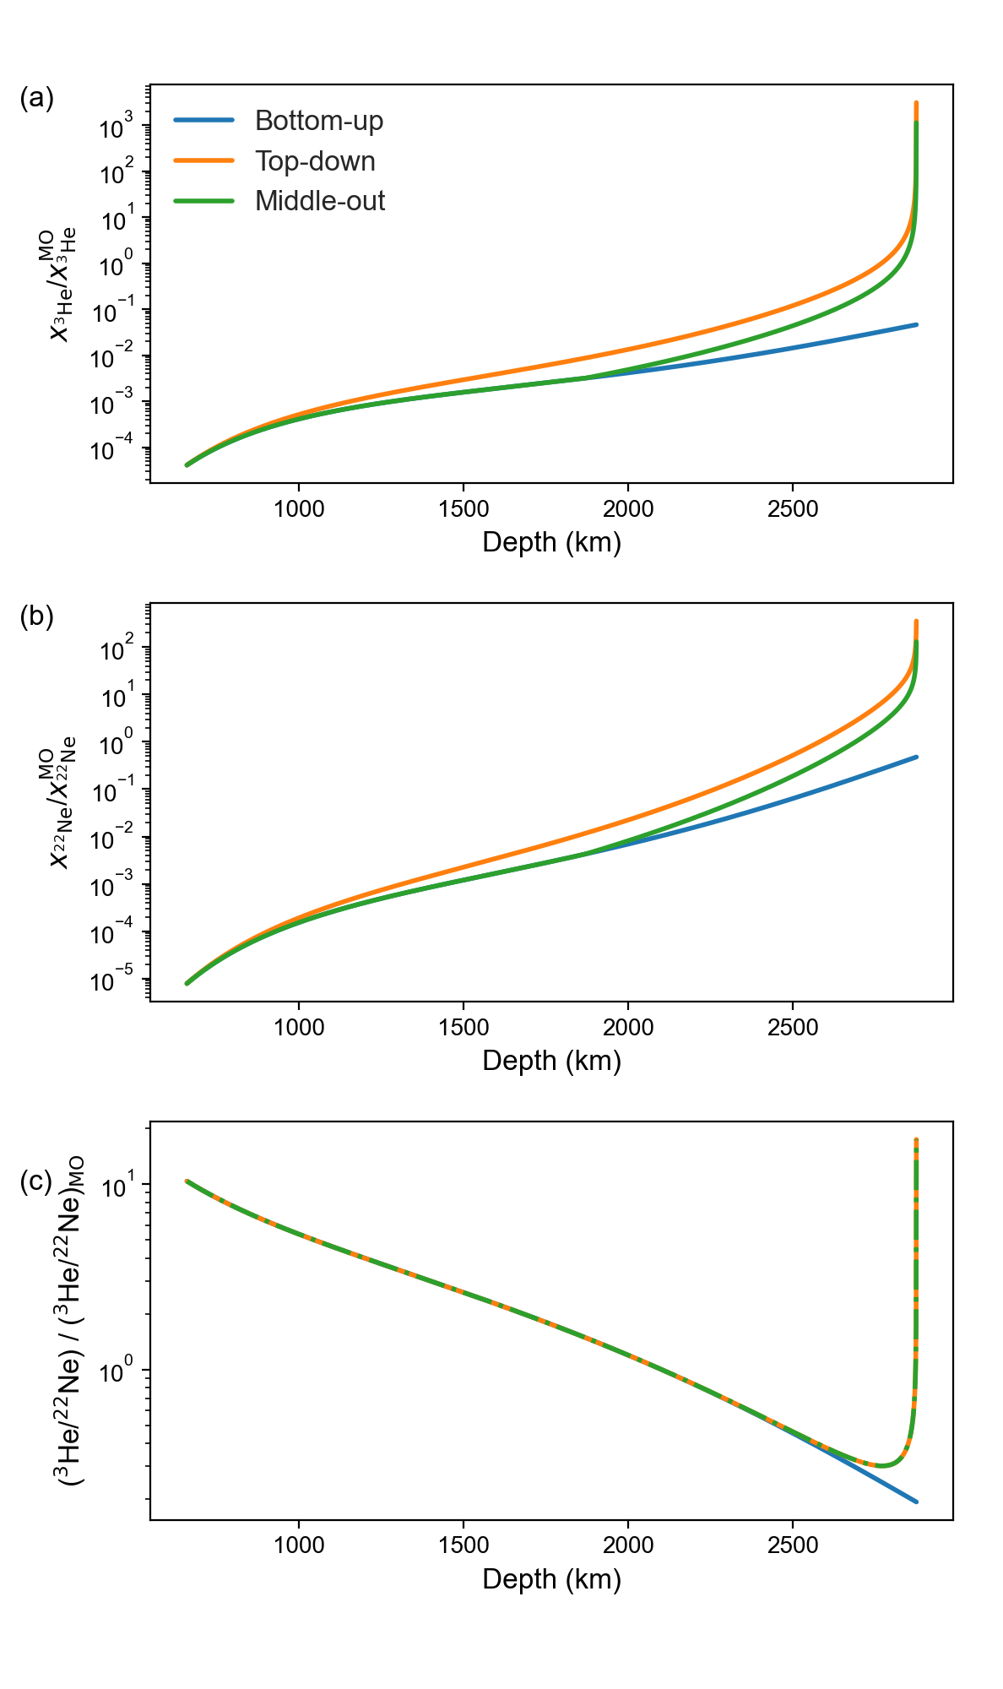
Figure S4: Concentrations of He and Ne in bridgmanite crystalizing in the lower mantle. a) ³He; b) ²²Ne; c) ³He/²²Ne. All values are normalized to the original concentration in the magma ocean. . Integrating these between the CMB and the surface would give the relative concentration in a well-mixed fully crystalized mantle. This is shown in Table S2.

Table S1: Calculated Gibbs free energies (in eV/atom).
Supercell | Pressure (GPa) | Temperature (K) | G (eV/atom)
Brg  (MgSiO₃)₃₀(Mg₂Al₂O₅) | 20 | 2800 | -7.026
Brg  (MgSiO₃)₃₀(Mg₂Al₂O₅)He | 20 | 2800 | -6.973
Brg  (MgSiO₃)₃₀(Mg₂Al₂O₅)Ne | 20 | 2800 | -6.969
Brg  (MgSiO₃)₃₂He | 20 | 2800 | -6.984
Brg  (MgSiO₃)₃₂Ne | 20 | 2800 | -6.978
Brg  (MgSiO₃)₃₀(Mg₂Al₂O₅) | 50 | 3500 | -5.978
Brg  (MgSiO₃)₃₀(Mg₂Al₂O₅)He | 50 | 3500 | -5.931
Brg  (MgSiO₃)₃₀(Mg₂Al₂O₅)Ne | 50 | 3500 | -5.922
Brg  (MgSiO₃)₃₀(Mg₂Al₂O₅) | 135 | 4200 | -2.700
Brg  (MgSiO₃)₃₀(Mg₂Al₂O₅)He | 135 | 4200 | -2.683
Brg  (MgSiO₃)₃₀(Mg₂Al₂O₅)Ne | 135 | 4200 | -2.669
Brg  (MgSiO₃)₃₂He | 135 | 4200 | -2.707
Brg  (MgSiO₃)₃₂Ne | 135 | 4200 | -2.699

Table S2: The budgets of ³He and ²²Ne in the crystallized lower mantle represented by bridgmanite divided by their original budgets in magma ocean, for the three MO crystallization models.
Model  Ratio | Top-down | Middle-out | Bottom-up
(³He)_{Brg}/(³He)_{MO} | 1.000 | 0.365 | 0.006
(²²Ne)_{Brg}/(²²Ne)_{MO} | 1.000 | 0.365 | 0.029
(³He/²²Ne)_{Brg}/(³He/²²Ne)_{MO} | 1.000 | 1.000 | 0.191

Table S3: The budgets of ³He and ²²Ne in the crystallized lower mantle from CMB to 300 km above divided by their original concentrations in magma ocean, for the three MO crystallization models.
Model  Ratio | Top-down | Middle-out | Bottom-up
(³He)_{Brg}/(³He)_{MO} | 0.359 | 0.98 | 0.003
(²²Ne)_{Brg}/(²²Ne)_{MO} | 0.342 | 0.94 | 0.020
(³He/²²Ne)_{Brg}/(³He/²²Ne)_{MO} | 1.049 | 1.049 | 0.124

Table S4: The budgets of ³He and ²²Ne in the crystallized lower mantle from CMB to 200 km above divided by their original concentrations in magma ocean, for the three MO crystallization models.
Model  Ratio | Top-down | Middle-out | Bottom-up
(³He)_{Brg}/(³He)_{MO} | 0.355 | 0.974 | 0.002
(²²Ne)_{Brg}/(²²Ne)_{MO} | 0.321 | 0.878 | 0.016
(³He/²²Ne)_{Brg}/(³He/²²Ne)_{MO} | 1.108 | 1.108 | 0.115

References
1 Li, Y., Vočadlo, L., Ballentine, C. & Brodholt, J. P. Primitive noble gases sampled from ocean island basalts cannot be from the Earth’s core. Nat. Commun. 13, 3770, (2022).
2 Li, Y., Vočadlo, L., Sun, T. & Brodholt, J. The Earth’s core as a reservoir of water. Nat. Geosci. 13, 10.1038/s41561-41020-40578-41561, (2020).
3 Kresse, G. & Furthmüller, J. Efficiency of ab-initio total energy calculations for metals and semiconductors using a plane-wave basis set. Computational Materials Science 6, 15-50, (1996).
4 Kresse, G. & Hafner, J. Ab initio molecular dynamics for open-shell transition metals. Physical Review B 48, 13115-13118, (1993).
5 Kresse, G. & Joubert, D. From ultrasoft pseudopotentials to the projector augmented-wave method. Physical Review B 59, 1758-1775, (1999).
6 Blöchl, P. E. Projector augmented-wave method. Physical Review B 50, 17953-17979, (1994).
7 Perdew, J. P., Burke, K. & Ernzerhof, M. Generalized gradient approximation made simple. Phys. Rev. Lett. 77, 3865-3868, (1996).
8 Moreira, M. A. & Kurz, M. D. in The Noble Gases as Geochemical Tracers (ed Pete Burnard) 371-391 (Springer Berlin Heidelberg, 2013).
9 Jaupart, E., Charnoz, S. & Moreira, M. Primordial atmosphere incorporation in planetary embryos and the origin of Neon in terrestrial planets. Icarus 293, 199-205, (2017).
10 Cardoso, C. D., Moreira, M. & Scaillet, B. Solar neon dissolution into an ultramafic magma ocean. Geochem. Perspect. Lett. 35, 31-35, (2025).
11 Dziewonski, A. M. & Anderson, D. L. Preliminary reference Earth model. Phys. Earth Planet Inter. 25, 297-356, (1981).
12 Boukaré, C.-É., Badro, J. & Samuel, H. Solidification of Earth’s mantle led inevitably to a basal magma ocean. Nature 640, 114-119, (2025).

