Supplementary Materials

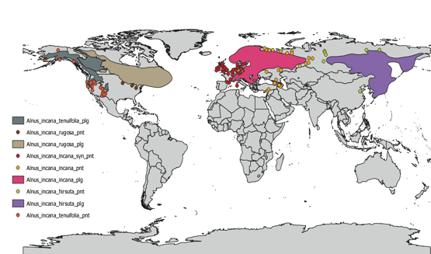

Figure S1. Global distribution of grey alder (Alnus incana (L.) Moench.) and its subspecies (adapted from Caudullo et al. 2017)¹⁴.

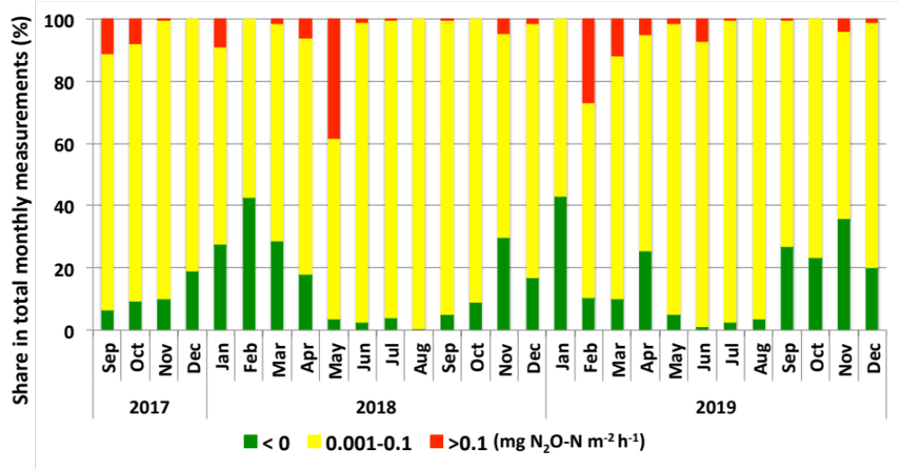
Figure S2. Temporal pattern of soil N₂O fluxes. Max possible number of measurements per month after quality checking was between 228 and 372.

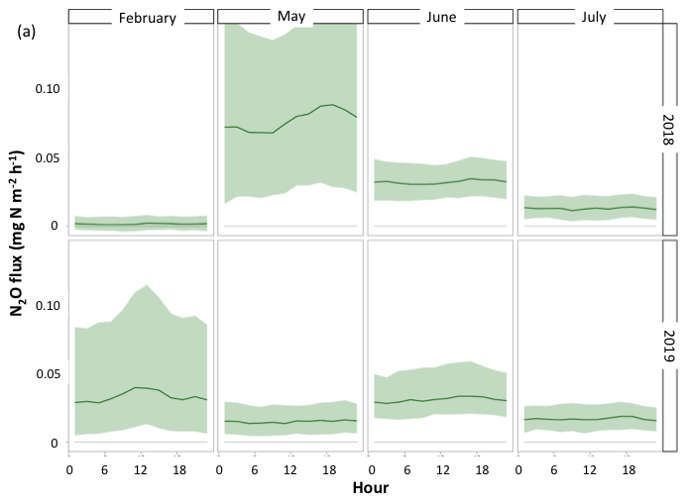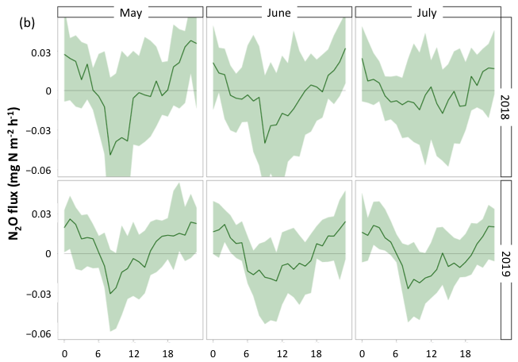

Figure S3. Diurnal pattern of soil and ecosystem (eddy covariance) of N₂O. (a) soil flux dynamics during the hot moments (Drought Onset in May 2018 and Freeze–Thaw in February 2019) and summer months (May, June and July, 2018 and 2019). (b) eddy covariance fluxes of N₂O during the three summer months 2018 and 2019. Daily average values and 95% confidential limits are shown.

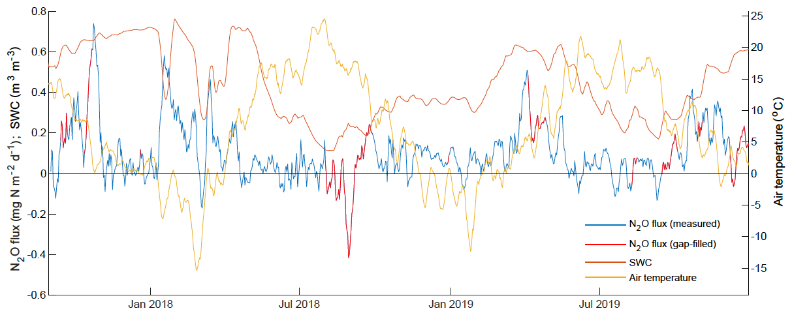
Figure S4. Temporal dynamics of ecosystem (EC) N₂O flux, soil water content and air temperature in the Agali riparian grey alder forest from September 2017 to December 2019. 7-day running means are shown.

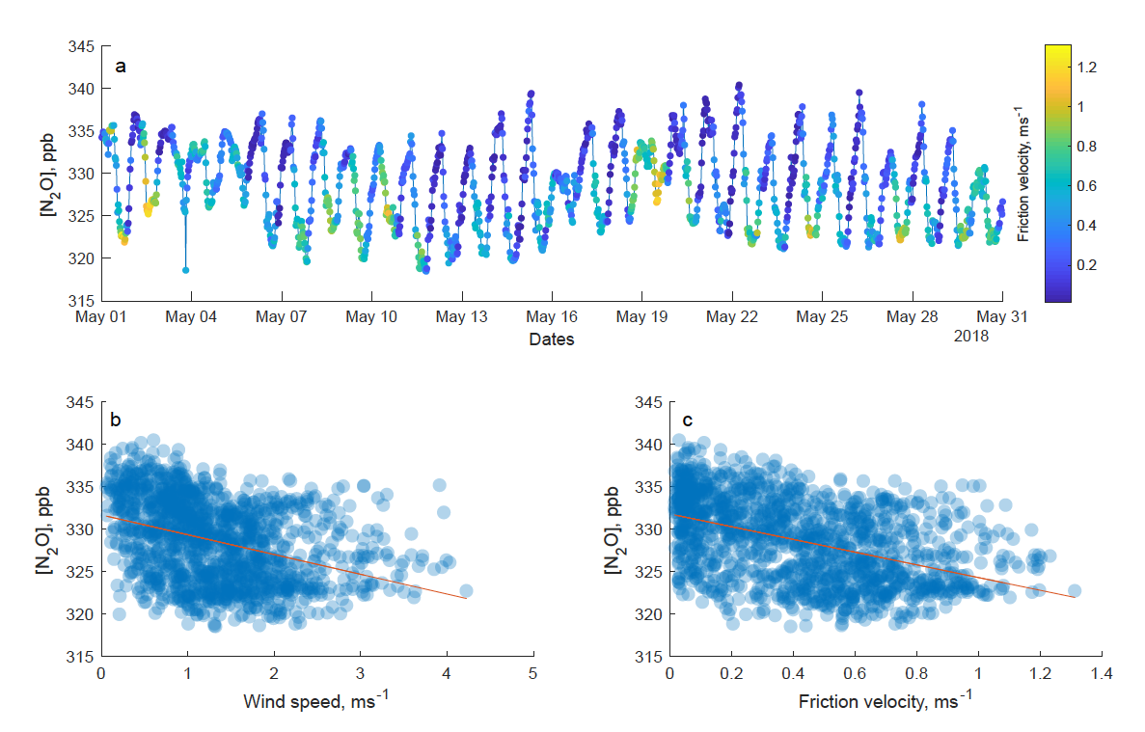
Figure S5. Example of the impact of friction velocity (u*) and wind speed on the N₂O concentrations during the Drought Onset episode in 2018. (a) Lower concentrations of N₂O tend to appear under low friction velocity. (b) correlation between the N₂O concentration vs the wind speed (left) and concentration vs u* (right). This is a possible explanation why hot moments of soil N₂O emission do not show in eddy covariance measurements.

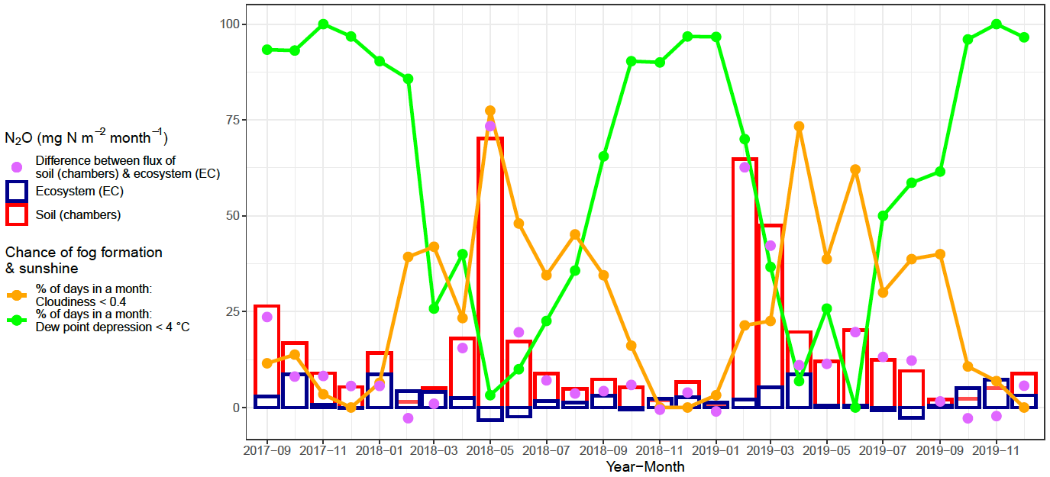

Figure S6. Relationship between the monthly sum of soil and EC fluxes of N₂O (mg N₂O-N m⁻² month⁻¹) with the percentage of days with high chance of sunshine (cloudiness ratio <0.4) and fog formation (dew point depression <4ºC). During Drought Onset (May 2018) and Dry minor period (June-July 2019) photochemical reactions might play the most important role in decreasing ecosystem (EC) flux of N₂O whereas during the Wet (September-November 2017) and Freeze–Thaw (February-March 2019) periods absorption on wet surfaces and water droplets could be reason for the decrease on EC N₂O flux. The difference between the soil and EC N₂O fluxes is negatively correlating with the percentage of days in a month with dew point depression <4ºC whereas a positive trend is observed between the soil and EC flux and the share of sunny days (cloudiness ratio < 0.4) in a month.

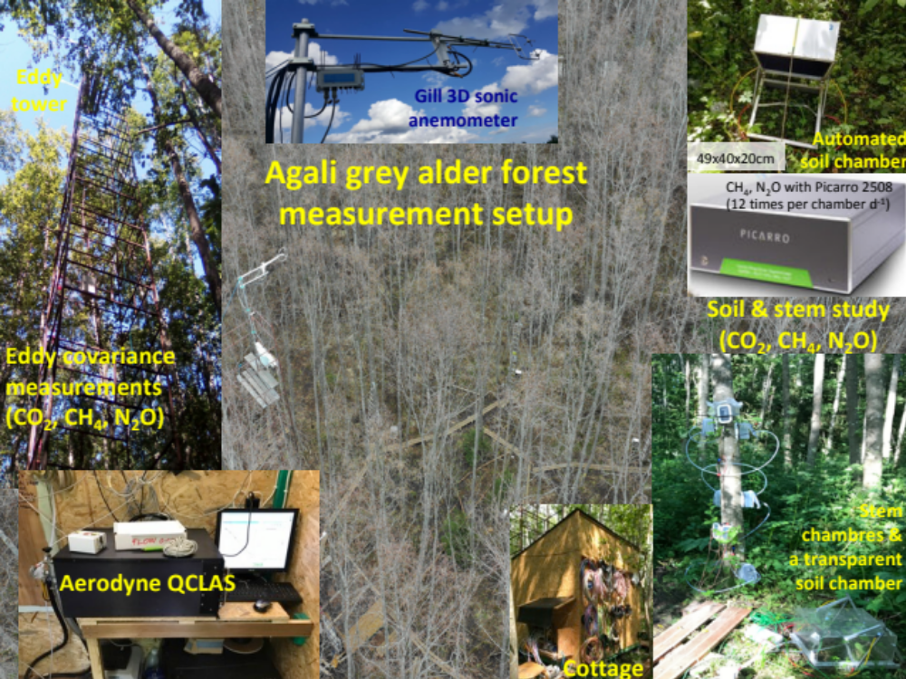

Figure S7. Instrumentation in the Agali grey alder forest.

Table S1. Fluxes of N₂O from all sources during the full years of study and full calendar years. Average ± standard deviation values are shown. EC – eddy covariance.

Period | Source | Flux (mg N₂O-N m⁻² y⁻¹)
Full year of study
Sept. 2017 – Sept. 2018 | Soil | 215.5 ± 7.7
 | Stems | 3.64 ± 0.18
 | Ecosystem (EC) | 28.8 ± 5.22
Sept. 2018 – Sept. 2019 | Soil | 221.4 ± 12.2
 | Stems | −
 | Ecosystem (EC) | 22.5 ± 2.8
Full calendar year
2018 | Soil | 196.3 ± 7.1
 | Stems | 1.97 ± 0.11
 | Ecosystem (EC) | 24.30 ± 4.07
2019 | Soil | 221.0 ± 12.4
 | Stems | −
 | Ecosystem (EC) | 31.1 ± 2.9

Table S2. Soil physical-chemical parameters in the Agali grey alder forest. Mean and standard error values (in parenthesis) are shown. DM – dry matter, SOM – soil organic matter, TC – total carbon, TN – total nitrogen.

Depth cm | pH_{KCl} | DM % | SOM % | TC  % | TN  % | C/N | NO₃-N mg/kg | NH₄-N mg/kg | P  mg/kg (AL) | K mg/kg | Ca mg/kg | Mg mg/kg
10 (n=72) | 5.30 (0.04) | 66.4 (0.5) | 6.5 (0.2) | 3.8 (0.1) | 0.33 (0.01) | 11.5 (0.1) | 2.42 (0.35) | 2.89 (0.23) | 14.8 (0.6) | 35.2 (0.9) | 1487 (48) | 283 (13)
20 (n=24) | 5.99 (0.05) | 84.0 (0.2) | 1.1 (0.1) | 0.6 (0.0) | 0.04 (0.00) | 15.0 (0.0) | 0.55 (0.08) | 0.80 (0.08) | 28.5 (2.6) | 21.4 (1.6) | 634 (27) | 144 (8)

