Appendix S1

How Hurricanes Drive Bird Displacement in Gulf Ecosystems Revealed by Deep Learning Species Distribution Model

Learned species-species and species-habitat relations
We pruned the species-environmental latent spaces based on the criterion of prediction precision, ensuring a value greater than 0.3, unless the species occurrence accuracy exceeded 0.97, to simplify the visualization of learned environment-species and species-species relations, also known as species embedding and environmental embedding, respectively. Each month, the list of species shortlisted is different. We plotted the interspecific embedding of the sampled species and their environmental (feature) embedding in Figures S1 and S2.
The correlation matrix in Figure S1 shows pairwise species relations. The species-species embedding (correlation values) has small variations across different pairs of species. Therefore, a Tahn-transform z-score normalization was applied to non-diagonal correlation values (correlation between different species). That is to apply tanh to bound values to (–1, 1) smoothly after values were standardized using Z-score (mean 0, std 1) to make correlation values have a clear contrast and comparable across months.
Figure S1. Clustered species-species correlation matrix (species embedding) for sampled bird species in different months in the Northern Gulf of Mexico
Environmental (feature) embedding of a species number by 512 dimensions was first reduced to 2D dimensions using t-SNE (Van Der Maaten & Hinton, 2008) and plotted in clusters based on pairwise dissimilarities (Figure 3). T-SNE is a nonlinear method that maps high-dimensional data into 2D or 3D using a t-distribution. If two points are close together in high-dimensional feature embedding space, they will be placed close to each other in Figure 3 using Kullback–Leibler (KL) divergence. Figure S2 illustrates the pairwise similarities among all sampled species within a month. In June, as species have relatively higher competition than in
Figure S2. Clustered species-environment correlation (feature embedding) after t-SNE dimensions reduction for sampled bird species in different months in the Northern Gulf of Mexico

Species level model performance evaluation
At the species level, AdaSTEM DRNets-MVPMs have higher F1 scores than static DRNets-MVPMs (Supplementary Information Figure S3, full description of metrics can be found in Supplementary Information S2). Because F1 combines sensitivity and precision, this indicates fewer missed presences and fewer false presences across species. AdaSTEM models have seasonal trending F1 scores, while static model doesn’t. The model has a better score in the summer for Laughing Gull, Royal Tern, and Black Skimmer, which are highly migratory and display strong seasonal habitat preferences. Blue Jay and Brown Pelican saw less seasonal variation in model performance than other species.
AdaSTEM DRNets-MVPMs captures timely appearances and environmental cues, leading to better precision and recall—and thus a higher F1 score when species are more abundant. For species like Laughing Gull, Royal Tern, and Black Skimmer, they shift in distribution and become more abundant during the summer breeding season. This leads to higher F1 scores.
On the other hand, the Blue Jay and Brown Pelican exhibit more stable, year-round distributions, with less dramatic seasonal movement. AdaSTEM DRNets-MVPM achieved a better F1 score for Great Egrets in the winter, while the osprey was predicted more accurately in the spring. The Great Egret tends to migrate southward in winter to the Gulf coast and warmer wetland habitats. More observation led to AdaSTEM’s adjustment to these season-specific habitat preferences. However, a static model doesn’t have the ability to identify wintering grounds; therefore, it doesn’t show a higher F1 score in the Winter.
Ospreys are long-distance migrants that return to breeding areas in spring, often near freshwater bodies with abundant fish. Their spring arrival creates this distinct seasonal signal in model performance, with better F1 scores generated by more observations. which AdaSTEM can leverage to refine predictions.

Figure S3. Examples of AdaSTEM DRNets-MVPM and static DRNets-MVPM F1 scores by species for predicting species presence/absence across 12 months of the year (black solid dots and violins represent the performance of AdaSTEM sub-models, and red hollow dots represent F1 score of the static model)
Community level model performance evaluation

At the richness level, richness dissimilarity is consistently lower for the static models, indicating that the AI model can reproduce the ranked spatial pattern of richness (which cells are hotspots or dips in diversity, and how that pattern changes across seasons) even without partitioning training into spatial and temporal blocks (Supplementary Materials Figure S4). However, richness calibration errors are generally smaller for the AdaSTEM models, showing that AdaSTEM better matches the magnitude of observed richness, while the static model is comparatively better at preserving rank order. Richness precision is also higher under AdaSTEM, meaning fewer spurious richness gains in inappropriate locations and better capture of when and where richness peaks (e.g., migratory waves and breeding concentrations). The static model, which lacks time-varying parameters, cannot simultaneously fit key ecological dynamics such as mixed breeding and migratory habitat use, migration timing, and patchy detection of rare species. As a result, it can approximate the broad spatial gradient in richness but struggles to reproduce the correct seasonal amplitudes and local richness peaks that the AdaSTEM framework captures more accurately.
Figure S4: AdaSTEM DRNets–MVPM and static DRNets–MVPM performance for predicting
species occurrence at richness and community levels across 12 months of the year. Boxplots
summarize the mean, quartiles, and distribution of metrics across AdaSTEM sub-models,
and red hollow circles denote the corresponding static-model metrics.
At the community level, AdaSTEM DRNets–MVPMs again outperform the static models in Sorensen calibration and Simpson precision, although the static model shows slightly lower Sorensen dissimilarity. Lower Sorensen calibration indicates that AdaSTEM more accurately reconstructs which species co-occur in which places and how these assemblages reorganize seasonally. Higher Simpson precision further shows that the dominant species and major features of community structure are better captured by the dynamic framework. In contrast, the static model’s lower dissimilarity largely reflects its ability to preserve broad community gradients with species information across large areas, while failing to match the detailed seasonal composition and dominance structure that AdaSTEM recovers.
Where species shelter and rebound after hurricanes
Based on presence/absence and produced maps, we identified where species may occur before and after hurricanes; Figure. 4). We applied the MDT criterion (see Methods) to convert occurrence probabilities of Blue Jay, Brown Pelican, Great Egret, and Osprey to binary presence and absence maps for these species that have highly distinctive morphology and high observation rates. Highlighting these species is very helpful to illustrate contrasting, well-supported bird displacement. The resulting maps revealed several clear patterns. We observed Blue Jays flying from inland to flooded areas. Their historical ranges concentrated inland but with storm surges increasing presence was observed in low-lying, surge-affected areas, consistent with a generalist that can exploit newly inundated or edge habitats.
In contrast, Brown Pelican range didn’t shift as apparently as other species in the low sea level rise scenario, but contract sharply under Intermediate–High SLR: pelicans were wiped out along the Gulf shorelines of Mississippi, Alabama, and Florida, with remaining presence concentrated along the Louisiana coast and in inland areas that lie outside the simulated storm-surge footprint. Great Egret and Osprey display a broadly similar contraction in their ranges, but are less coastal-resilient than Brown Pelican. Even under Low SLR, their coastal ranges are largely eliminated from the coast, persisting mainly in parts of coastal Louisiana and inland habitat refugee. Under Intermediate–High SLR, Great Egret and Osprey disappears almost entirely from surge-impacted cells, indicating a pronounced loss of suitable coastal habitat. Together, these examples show that storm surge interacting with sea-level rise produces strongly species-specific range responses, with some generalists tracking new flooded habitats and many coastal specialists losing large portions of their historical Gulf coastline ranges.
Richness maps before and after the hurricane

Under historical climate and sea level, a continuous band of high species richness hugs the northern Gulf of Mexico, especially along the southeastern parishes of Louisiana, the coastal counties of Mississippi and Alabama, and the western Florida Panhandle (Figure S5). Richness drops off rapidly inland: Once you leave the immediate coastal wetlands, estuaries, and barrier islands, colors become darker (lower richness), although bright spots persist along major estuaries and river channels.
Overall, September bird diversity is tightly packed into low-lying coastal habitats, with
inland richness largely confined to corridors that track tidal rivers and estuarine networks.
Under Low SLR with a September storm surge, the main impact zone is confined to a
thin coastal strip. Bright coastal pixels along the Mississippi, Alabama, and western Florida
Panhandle become slightly brighter overall (more active species). Along the shoreline of
Lake Pontchartrain in Louisiana, many species tracked surge-driven habitat changes. In
southern Louisiana, commonly known as the Atchafalaya Basin or Bayou Country, responses are
spatially heterogeneous: some areas darken while others brighten, reflecting the fact that
the simulated storms have specific, localized impact footprints. Notably, the southern tip of
the Atchafalaya Basin emerges as one of the hottest bird-diversity spots, sitting just outside
the main impacted areas by simulated storms and therefore concentrating species displaced
from elsewhere. Inland mostly remains bright, and in several places, coastal birds pushed off
inundated habitats are redistributed into slightly higher, just-inland areas, leading to local
inland brightening (small richness gains).
Under Intermediate–High SLR, with the same September hurricane, the impact footprint expands both inland and along the shore. Areas that were bright and relatively safe in the Low scenario—especially low coastal plains and inner estuary margins—become noticeably darker, indicating substantial richness losses. Instead of a broad inland band of high richness, the landscape breaks up into isolated bright “islands” of diversity, and the entire impact zone within the Atchafalaya Basin becomes dark. The refugee pattern shifts: in many stretches, only a very narrow strip right at the shoreline retains high richness (for example, along the crests of some barrier islands or slightly elevated coastal ridges), while the adjacent inland and shoreline cells are much darker.
Figure S5: Species richness maps in September based on 332 modeled species under (a)
historical climate and sea-level conditions in 2020, and maps of richness impacted by a
September storm surge under two sea-level rise scenarios: (b) Low, corresponding to SSP2-
4.5 climate with 0.2 m mean sea-level rise by 2100; and (c) Intermediate-High, corresponding
to SSP5-8.5 climate with 1.2 m mean sea-level rise by 2100.
Figure S6. Hurricane impacts on species habitat suitability (occurrence probability) in September at different climate and sea level rise scenarios (More species habitat suitability changes at other months, please see additional figures on figshare.com)
Storm surge simulation modeling boundaries
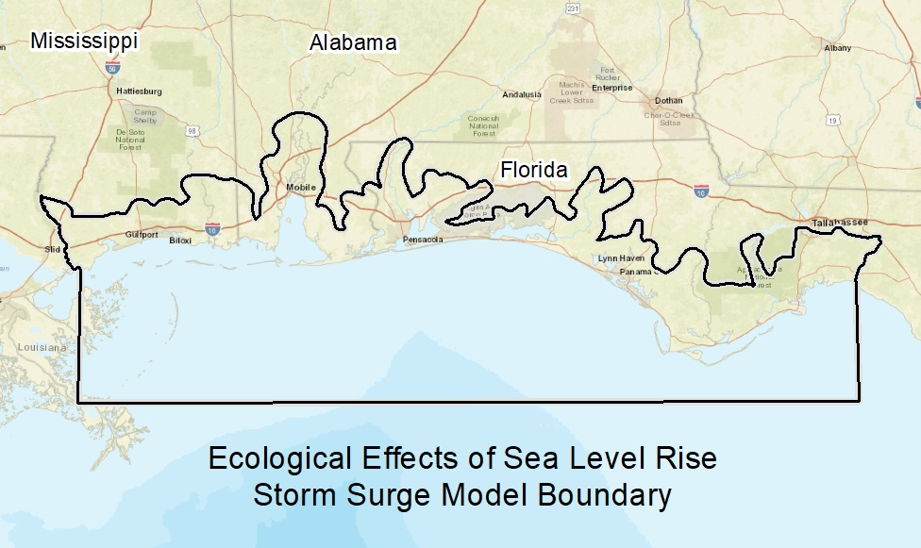
Figure S7. Storm surge model boundary (Bilskie et al., 2016)

