SUPPLEMENTARY FIGURES
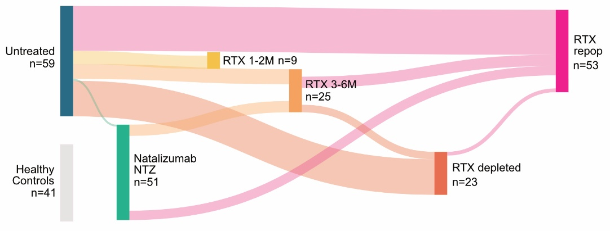
Supplementary Figure 1. Sankey plot of cohort designed and paired samples.
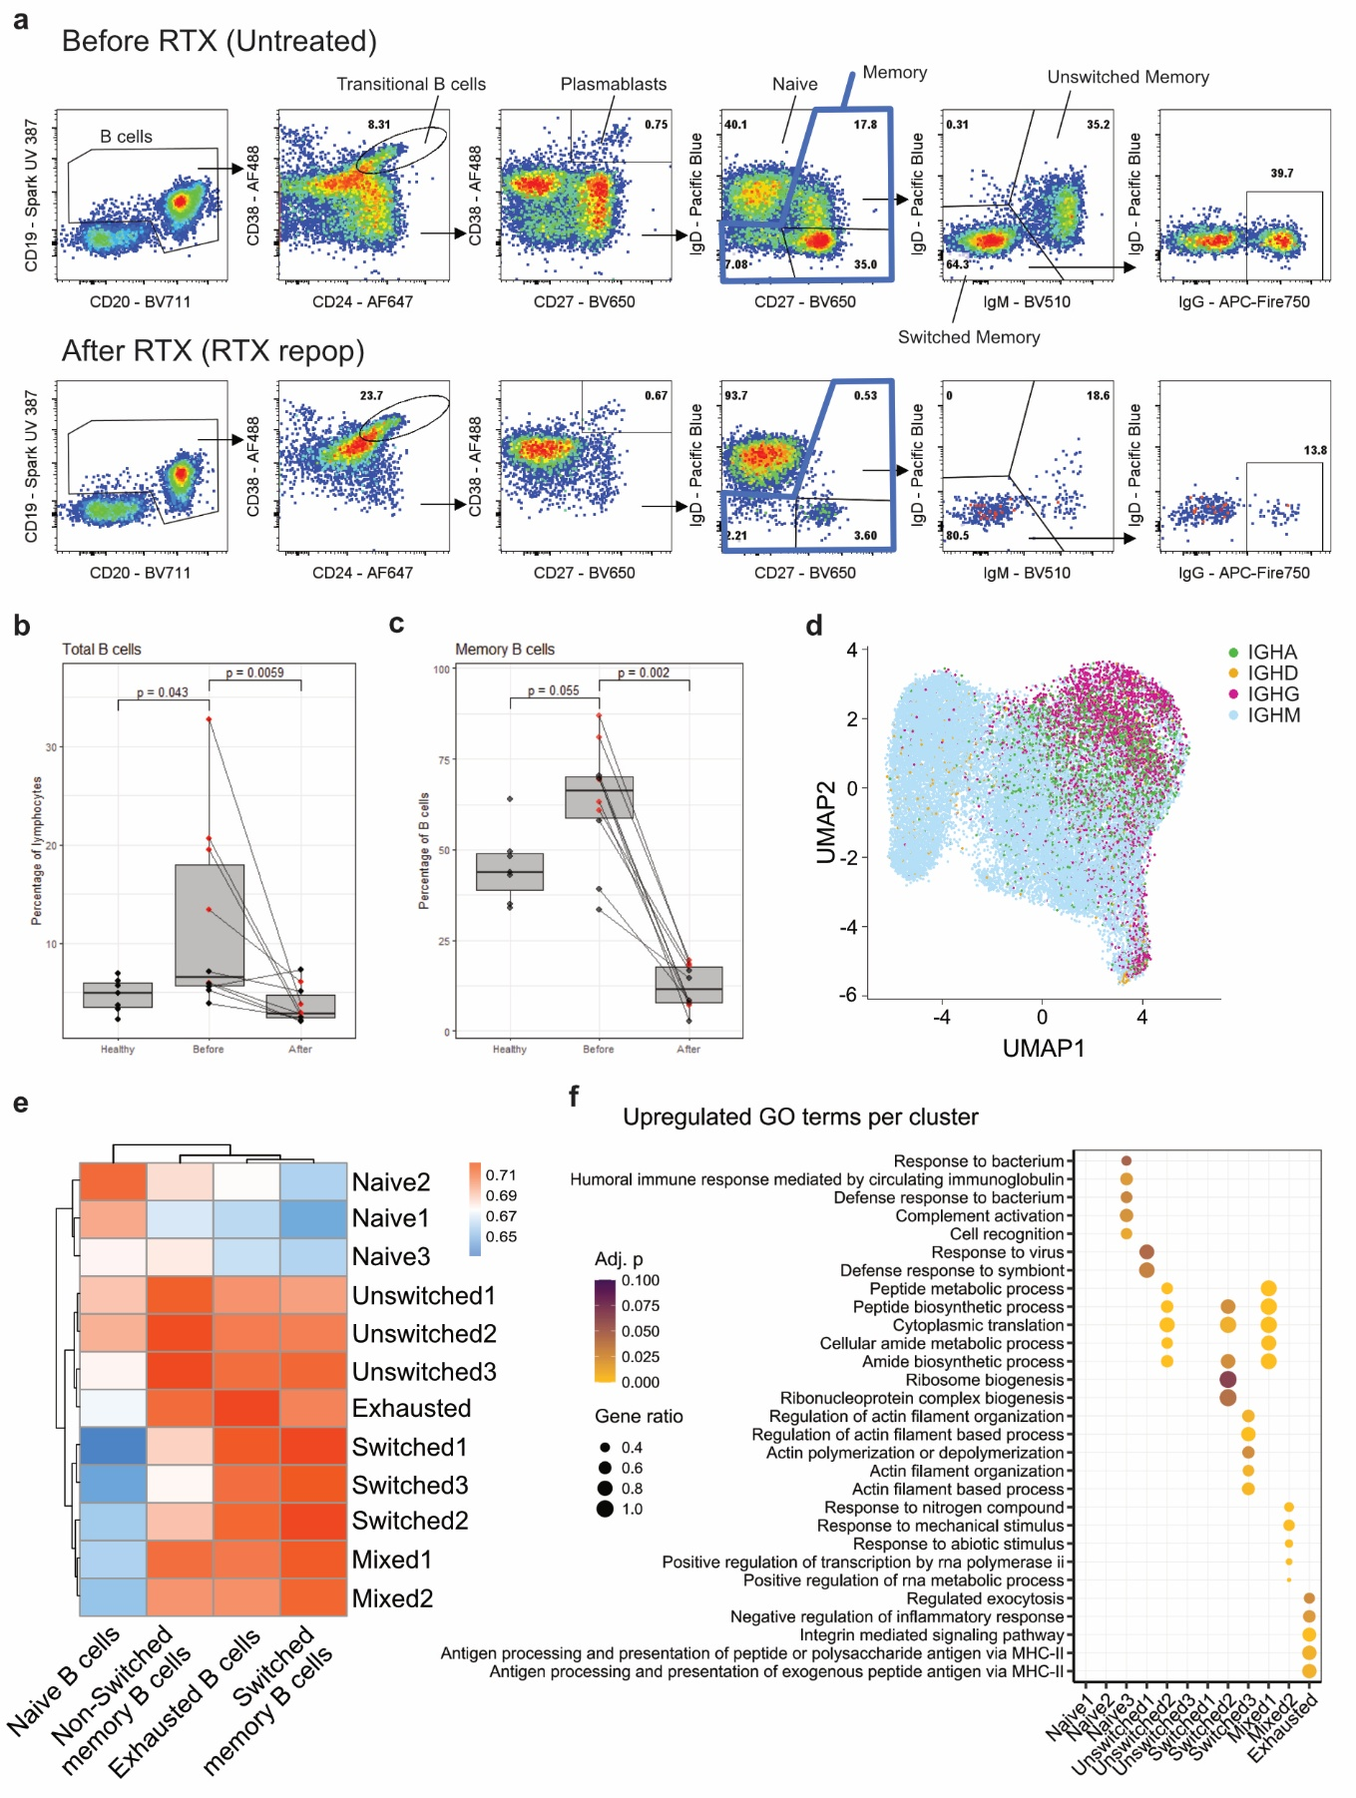
Supplementary Figure 2. B-cell sorting for single-cell transcriptomics and cluster annotation. a, FACS gating strategy and sorting of B cells for single-cell transcriptomics. Percentage of total B cells over total lymphocytes (b), memory B cells over total B cells (c) of samples used for single-cell transcriptomics. d, UMAP representation of B cells expressing different immunoglobulin heavy chains. e, Heatmap of Monaco annotation scores for B-cell subsets by cluster. f, GSEA for Gene Ontology (GO) terms of differentially expressed genes in individual clusters compared to the rest of the clusters.
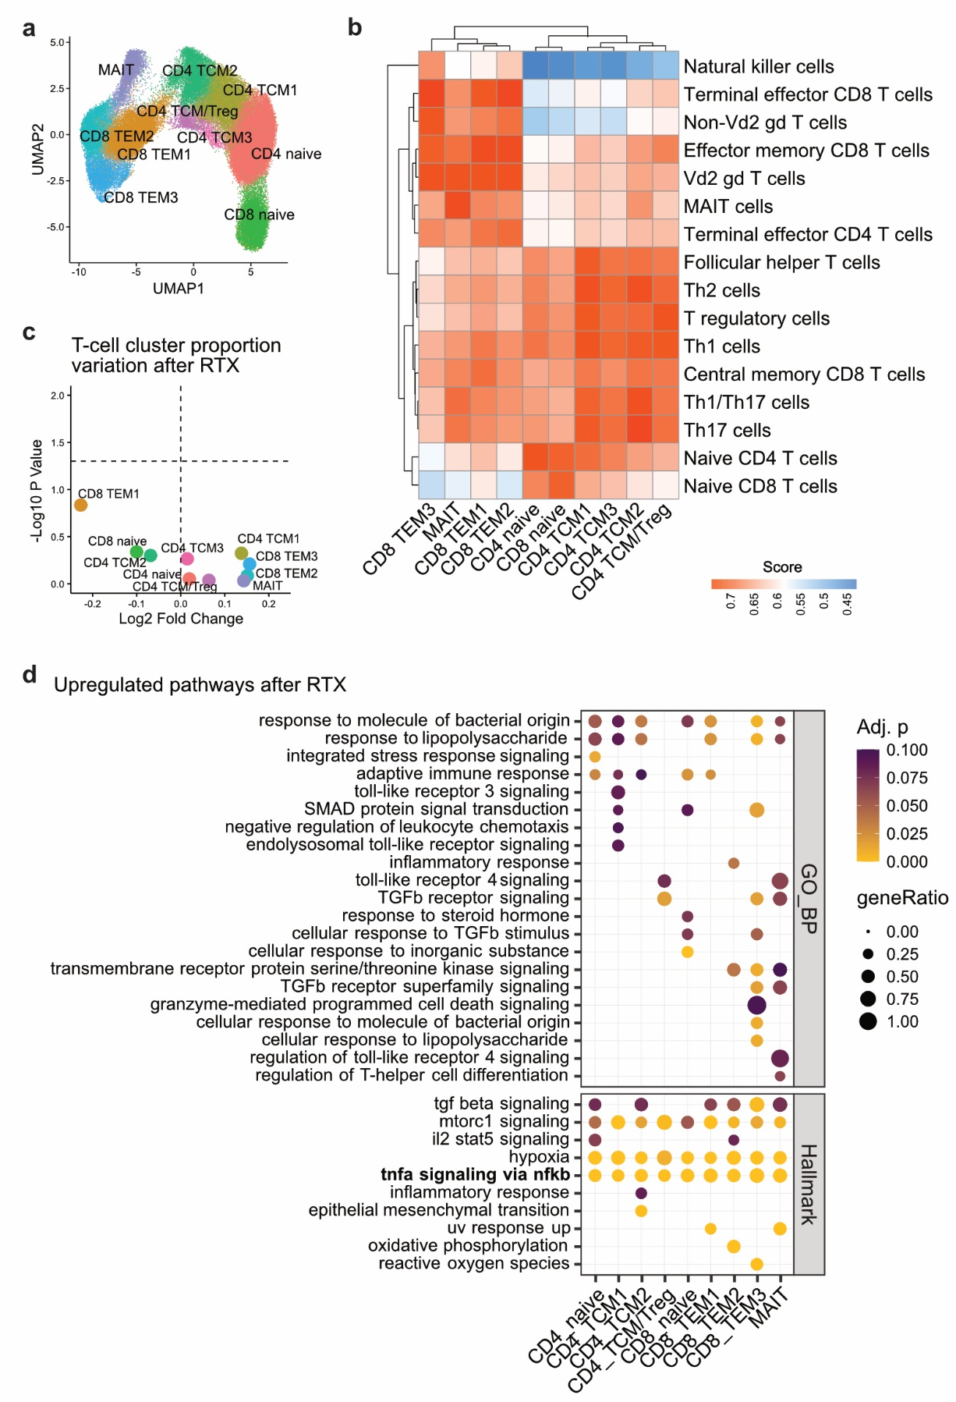
Supplementary Figure 3. Single-cell transcriptomic of T cells and cluster annotation. a, UMAP representation of clustered T cells. b, Heatmap of Monaco annotation score for T-cell subsets by cluster. c, Volcano plot of cluster proportion change in T cells at B-cell repopulation compared to baseline before RTX. d, Gene ontology/biological processes (GO_BP) and Hallmark terms upregulated in T-cell clusters after RTX according to GSEA performed on ranked logFC. Adj.p: false discovery rate (FDR)-adjusted p-value (FDR threshold 0.1); geneRatio: proportion of core enrichment genes on the total of pathway genes. Immune-related pathways in bold.
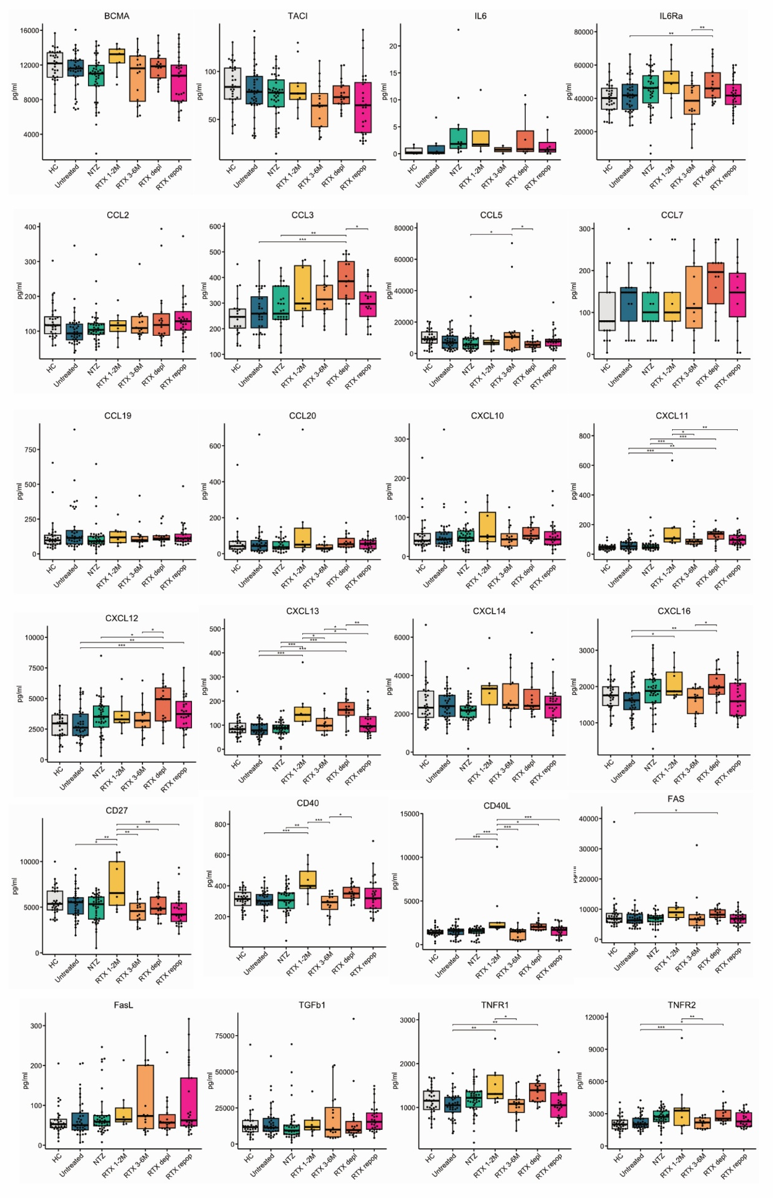
Supplementary Figure 4. Luminex analysis across sample groups for 27 analytes in plasma. Only significant pairwise comparison between RTX treated samples and untreated pwMS are reported on the graph for clarity reasons. P values are calculated using a mixed-effects model including individual ID to account for paired data. * p<0.05, **p<0.01, ***p<0.001.
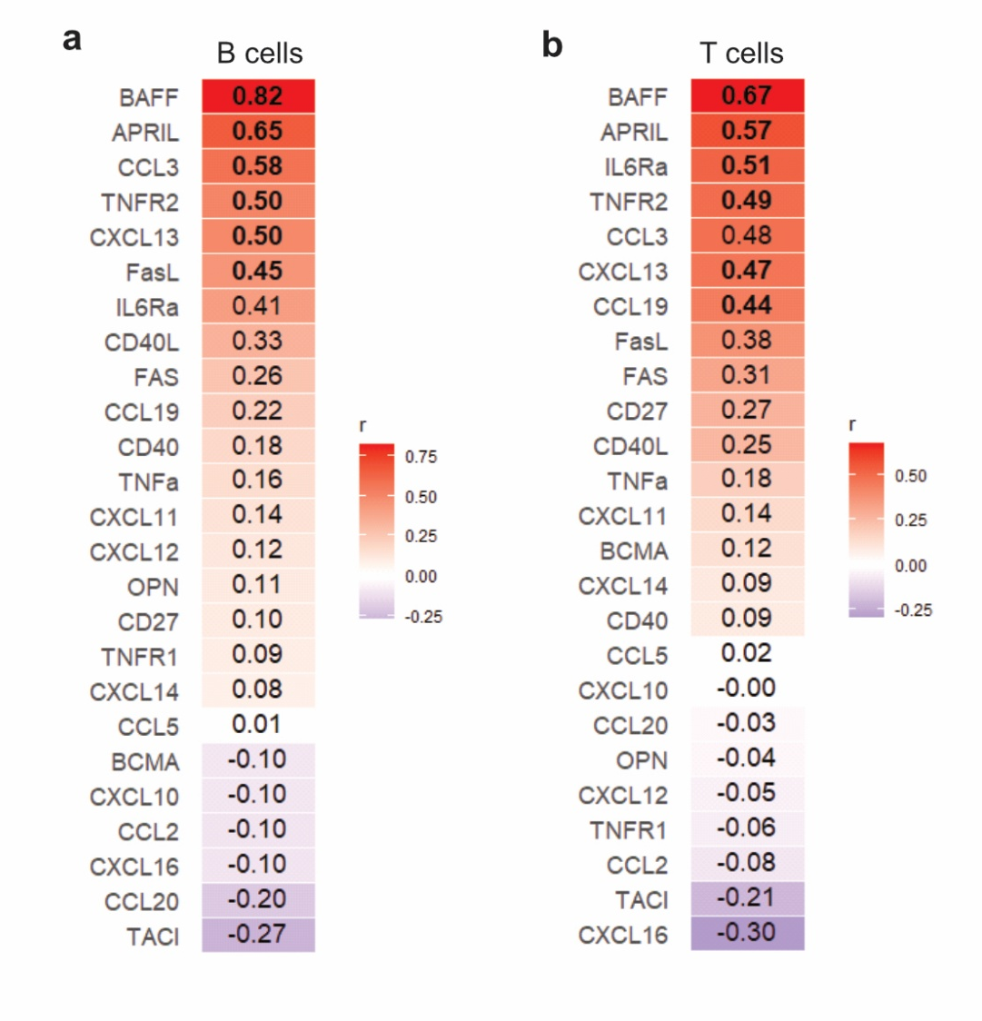
Supplementary Figure 5. Correlation between soluble plasma analyte and single-cell TNFα signaling via NF-κB gene signature. Pearson r coefficients for correlations between Luminex-assessed plasma soluble molecules levels and Hallmark’s “TNFα signaling via NF-κB” signature score, averaged across all the cell for each sample in single-cell analysis of sorted B- (a) and T- (b) cells. In bold coefficient corresponding to p values <0.05.
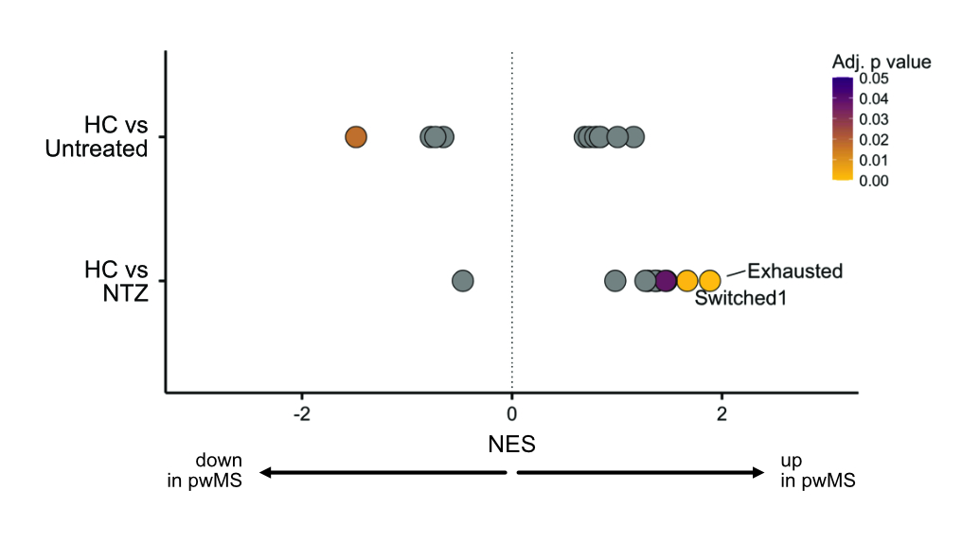
Supplementary Figure 6. Enrichment of EBV lytic signature in NTZ compared to HC. GSEA for EBV lytic gene signature on genes differentially expressed per B-cell cluster between untreated or NTZ-treated pwMS in comparison HC, with enrichment of the molecular signature in the Exhausted cluster in NTZ-treated pwMS.
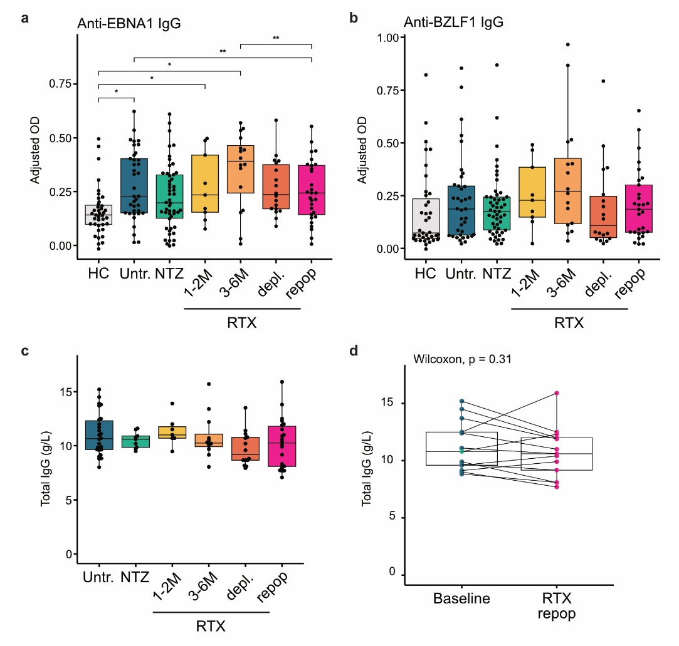
Supplementary Figure 7. Whole cohort anti-EBNA1 and anti-BZLF1 IgG, and total IgG levels at sampling. a-b, Whole cohort anti-EBNA1 (a) and anti-BZLF1 (b) IgG assessed by ELISA, significant pairwise differences post mixed-effects model are reported. * p<0.05, **p<0.01, ***p<0.001. c-d, Total IgG levels extracted from clinical data and considered at sampling if assessed within +/-90 days in the overall cohort (c, no significant pairwise differences as per mixed-effects model) and specifically in the paired baseline/RTX repop samples (d, Wilcoxon signed rank test).
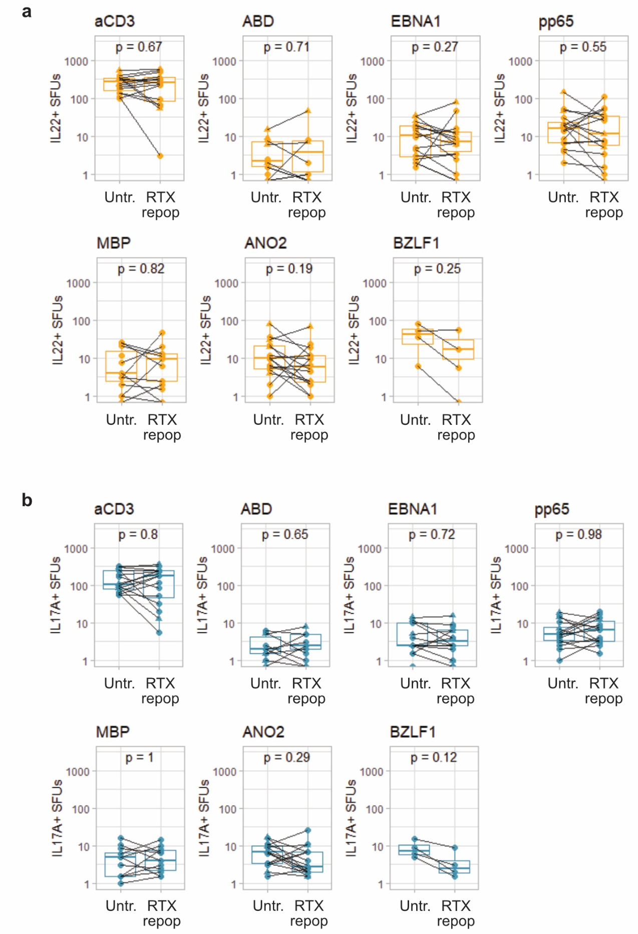
Supplementary Figure 8. IL-22- and IL-17A-positive response to EBV antigens and self-proteins assessed by Fluorospot. Counts of SFUs positive for IL-22 (a) or IL-17A (b) to ex vivo PBMC stimulation with anti-CD3, ABD, EBNA1, BZLF1, pp65, ANO2, MOG and MPB. Wilcoxon signed rank test p values are reported.
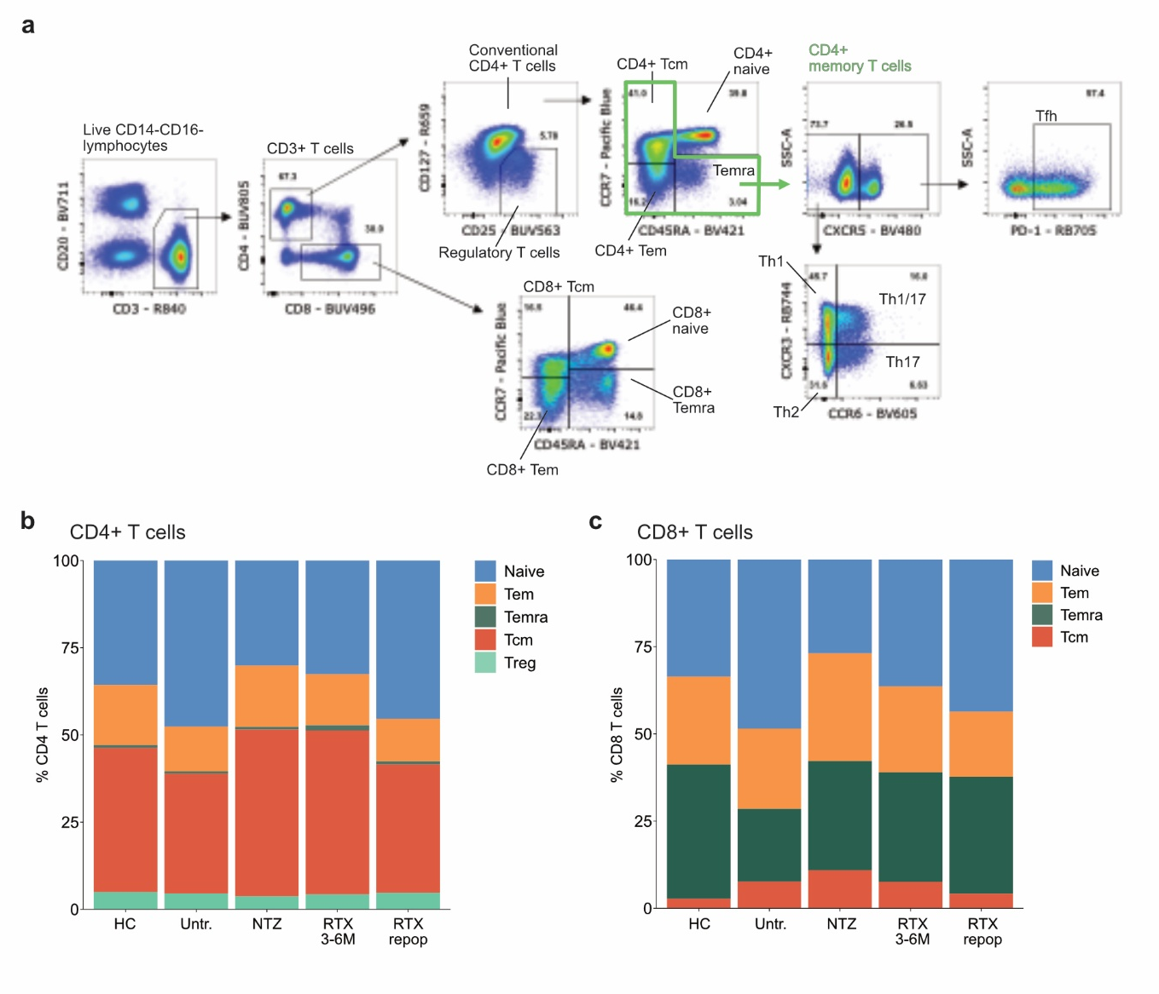
Supplementary Figure 9. T-cell phenotype. a, Gating strategy for T-cell immunophenotyping by FACS. b-c, Stacked bar plot of CD4+ (b) and CD8+ (c) T-cell subpopulation proportions across sampling groups.
SUPPLEMENTARY TABLES
Supplementary Table 1. Overview of sample overlap across groups.
Supplementary Table 2. List of genes in the EBV lytic signatures.
Supplementary Table 3. Antibody panel used for B- and T-cell immunophenotyping by FACS.
Supplementary Table 4. Antibody panel used for B- and T-cell sorting and library preparation for scRNA-seq.
Supplementary Table 5. List of analytes included in Luminex analysis.

