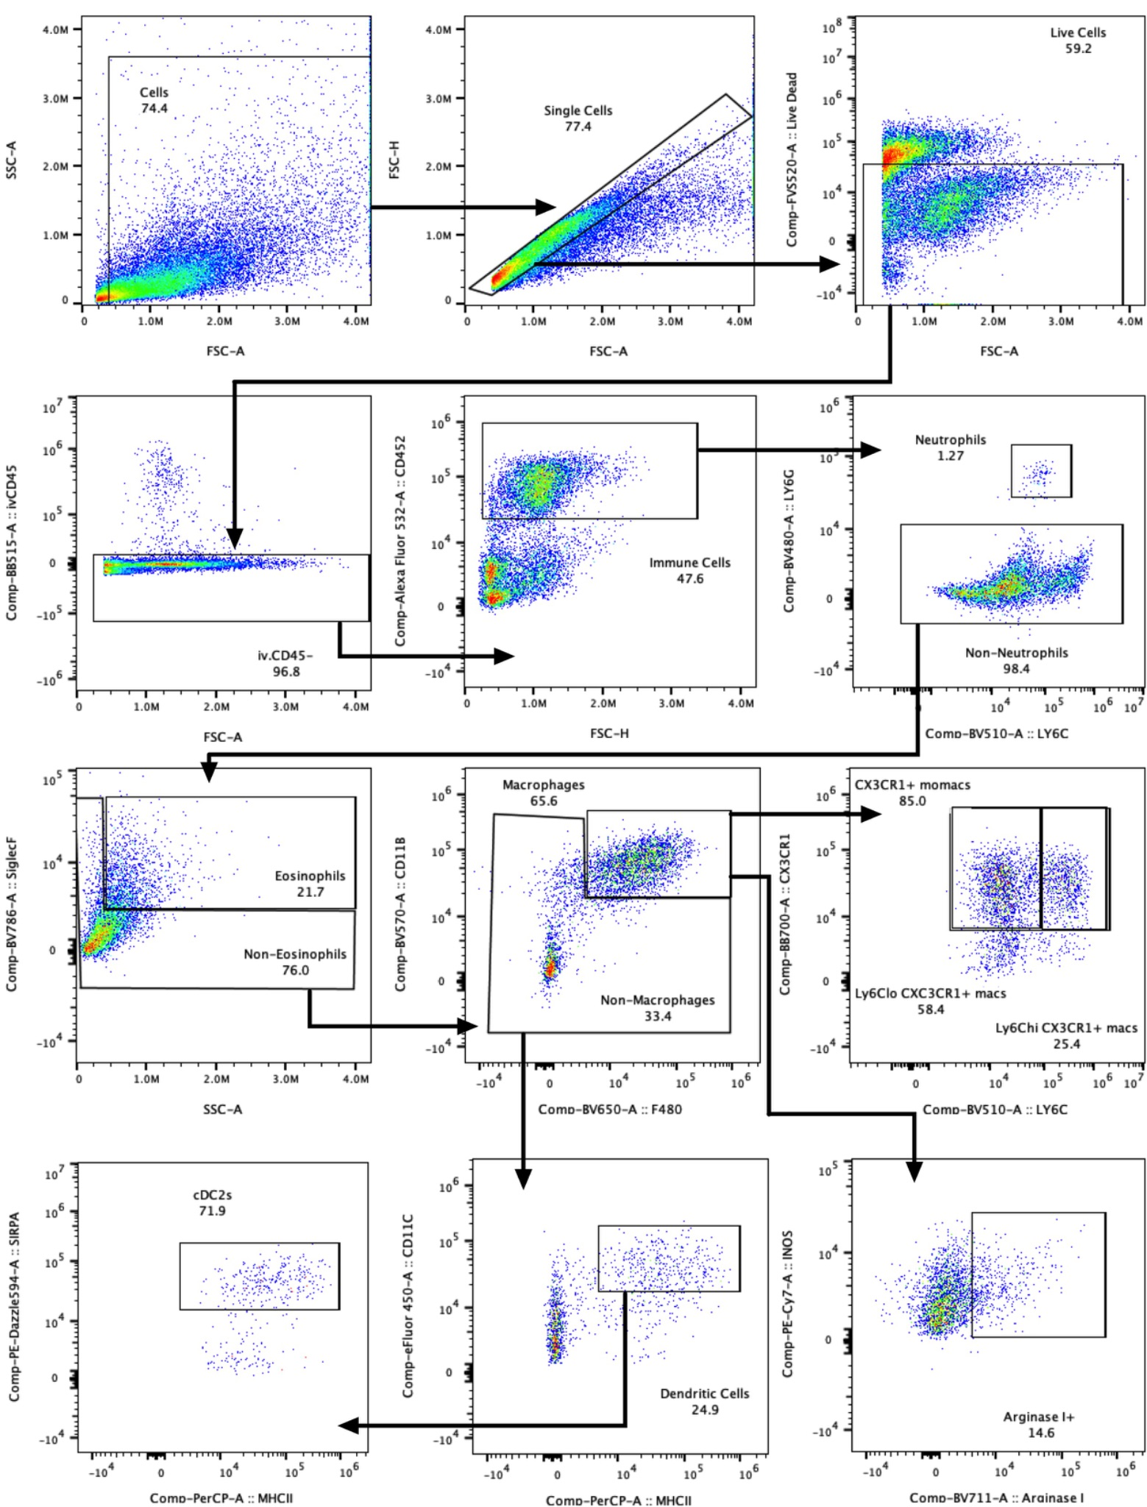
Supplementary Figure 1. Flow cytometry gating strategy used to quantify the myeloid population in the quadriceps muscles.

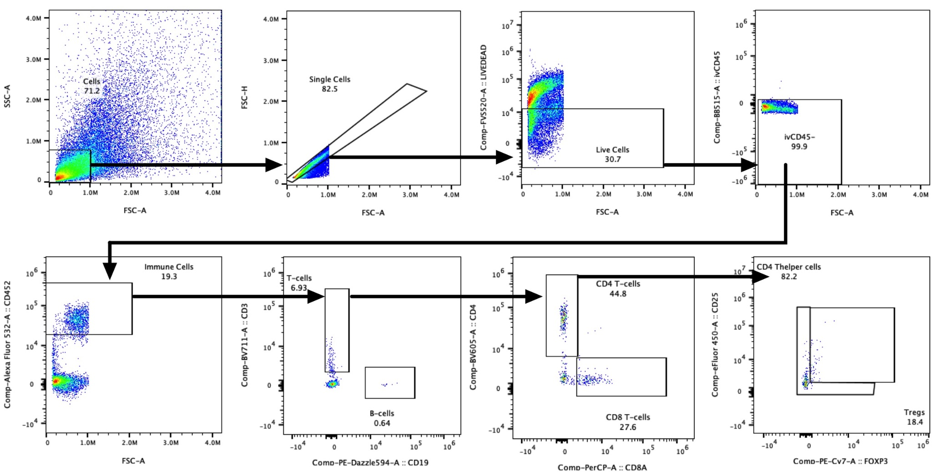
Supplementary Figure 2. Flow cytometry gating strategy used to quantify the lymphocyte populations in the quadriceps muscles.

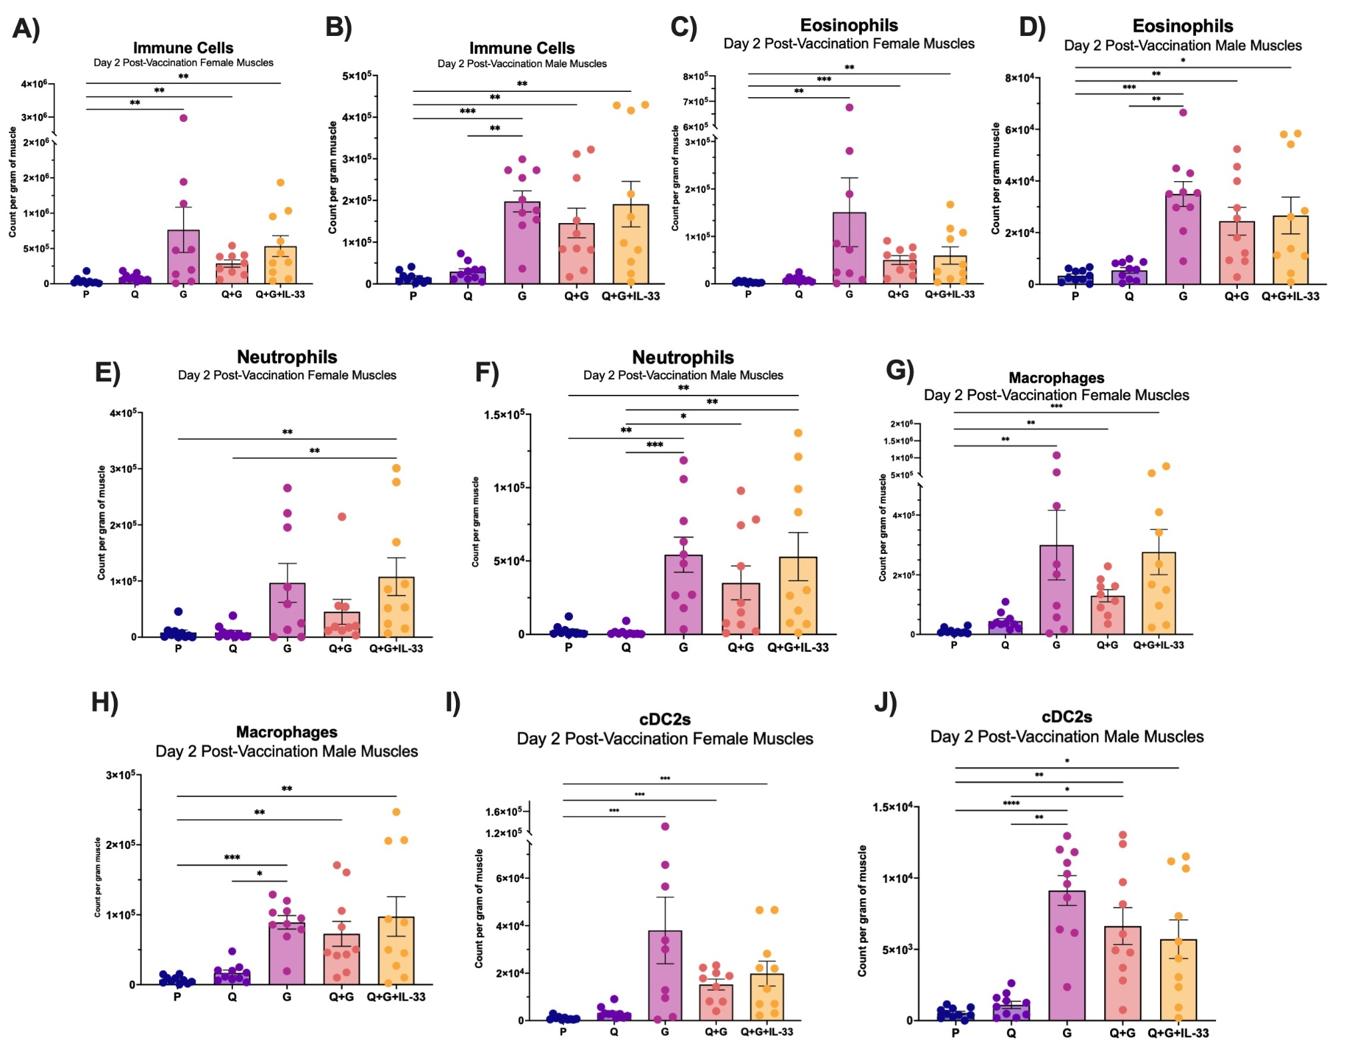
Supplementary Figure 3. Immune characterization of injected muscles using spectral flow cytometry on day 2. Count of non-circulating (A) total Immune cells in females, (B) total immune cells in males, (C) eosinophils in females, (D) eosinophils in males, (E) neutrophils in females, (F) neutrophils in males, (G) macrophages in females, (H) macrophages in males, (I) cDC2s in females, (J) cDC2s in males per gram of muscle 2 days after injection with PBS, Q, G, Q+G, and Q+G+IL-33. * P ≤ 0.05 ** P ≤ 0.01 *** P ≤ 0.001 **** P ≤ 0.0001 (Kruskall-Wallis followed by Dunn’s multiple comparisons test).

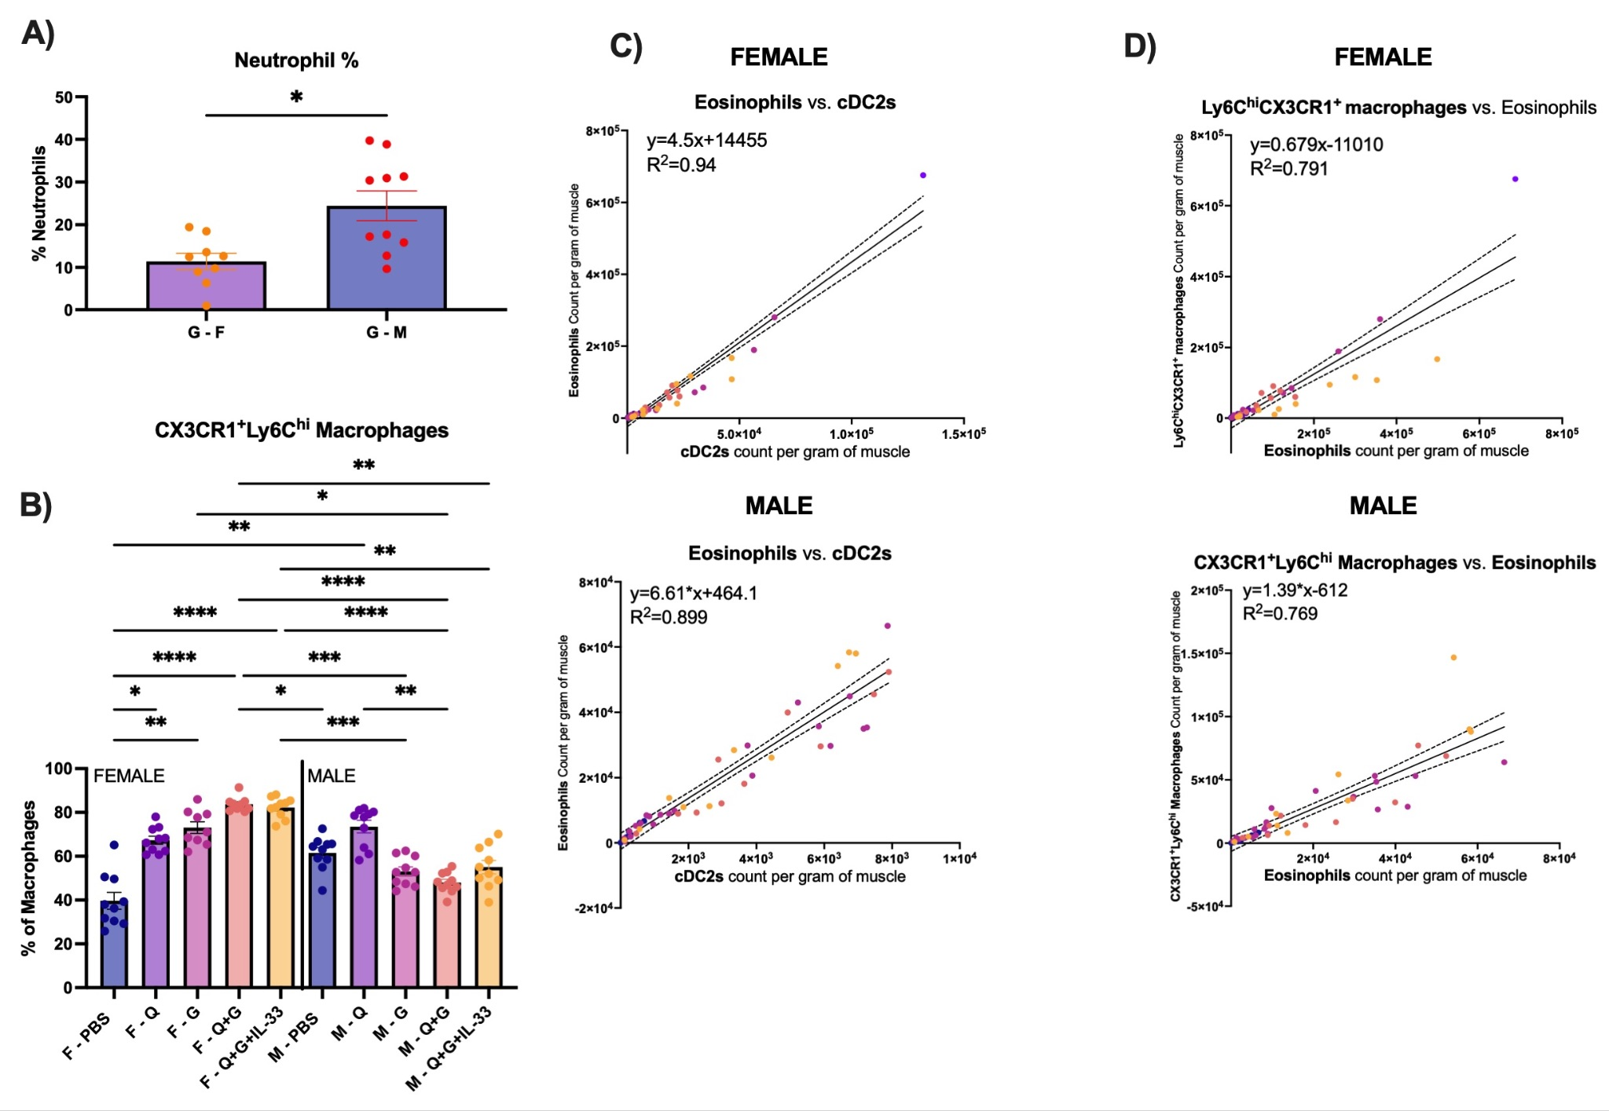
Supplementary Figure 4. Characterization of sex-dependent changes in immune compositions and correlation tests between immune populations in quadriceps on day 2. (A) counts of neutrophils per milligram in male and female G groups. (B) CX3CR1⁺Ly6C^{hi} macrophage percentages of total macrophages per group in male and female quadriceps 2 days after injection with P, Q, G, Q+G, or Q+G+IL-33. (C) Correlation of eosinophil cell count per milligram of muscle with cDC2 count per milligram of muscle in the quadriceps on day 2 in all groups. (D) Correlation of CX3CR1⁺Ly6C^{hi} macrophage cell count per milligram of muscle with eosinophils count per milligram of muscle in the quadriceps on day 2 in all groups. * P ≤ 0.05 ** P ≤ 0.01 *** P ≤ 0.001 **** P ≤ 0.0001 (Kruskall Wallis followed by Dunn’s multiple comparisons test).

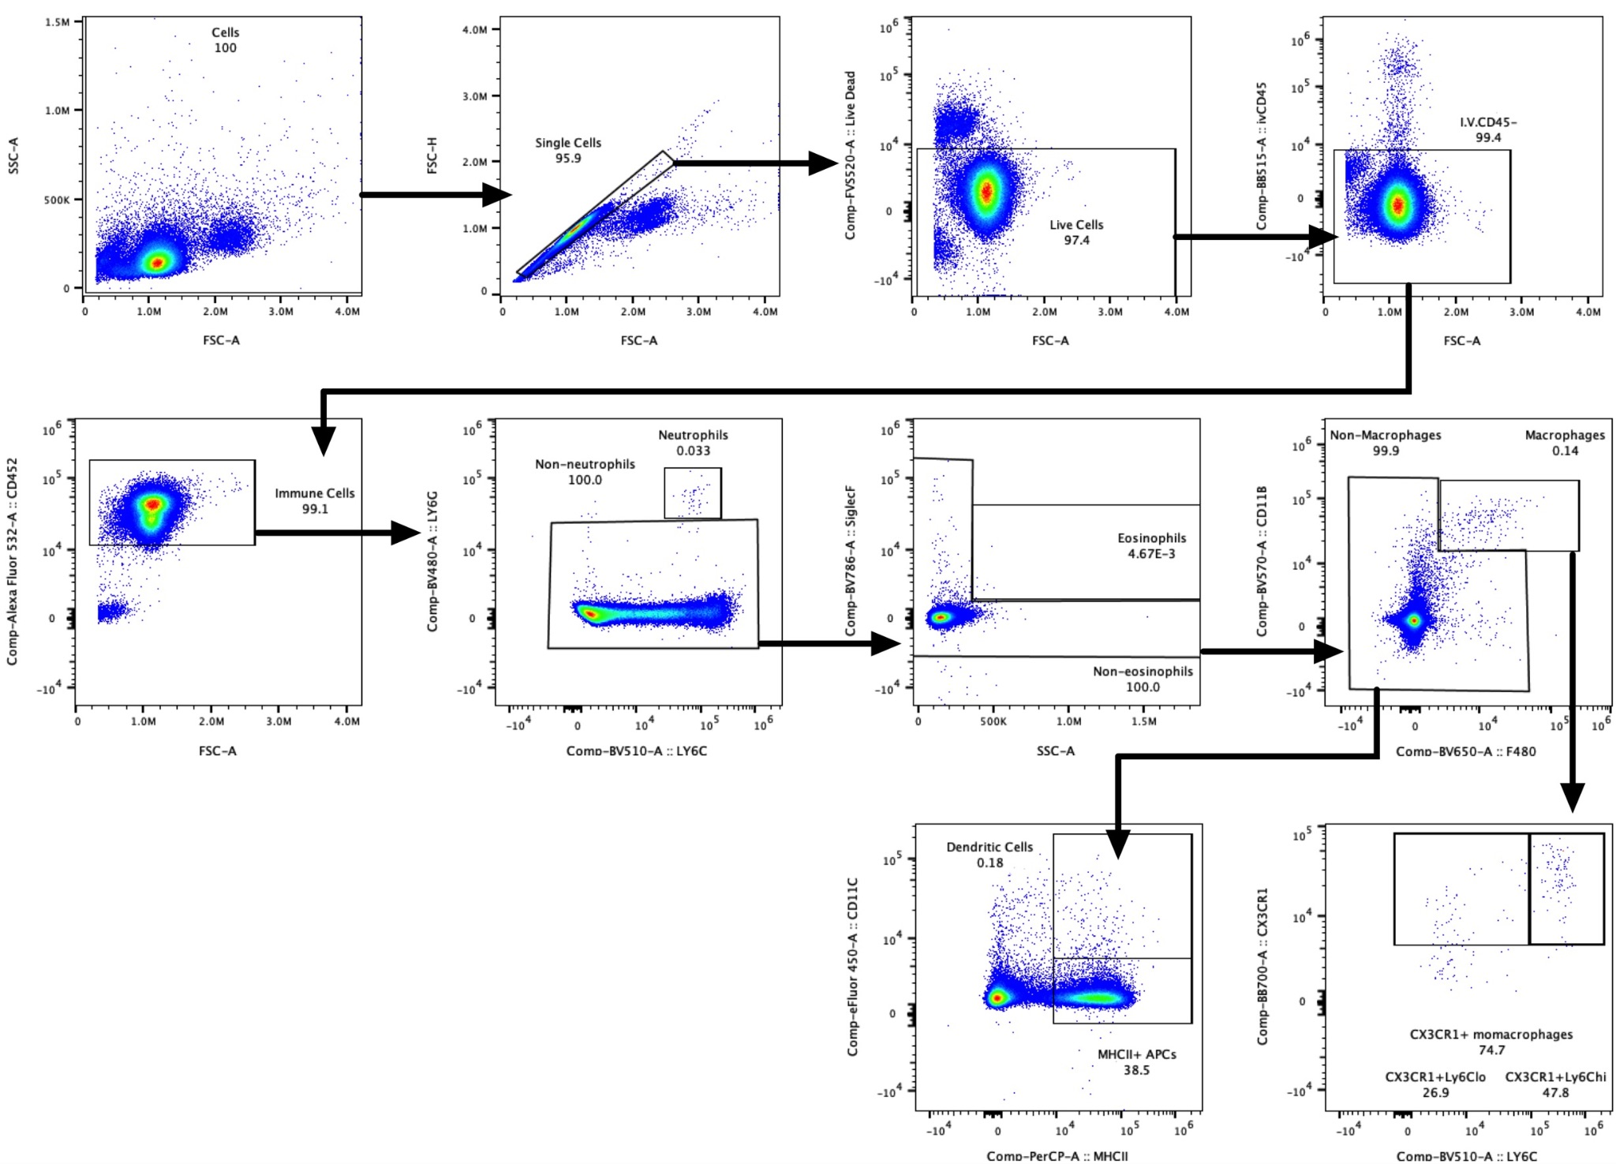
Supplementary Figure 5. Flow cytometry gating strategy used to quantify myeloid populations in the inguinal draining lymph nodes.

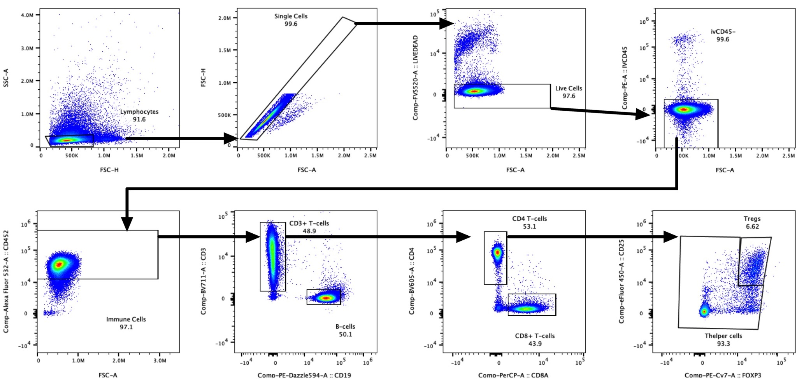
Supplementary Figure 6. Flow cytometry gating strategy used to quantify lymphocyte populations in the inguinal draining lymph nodes.

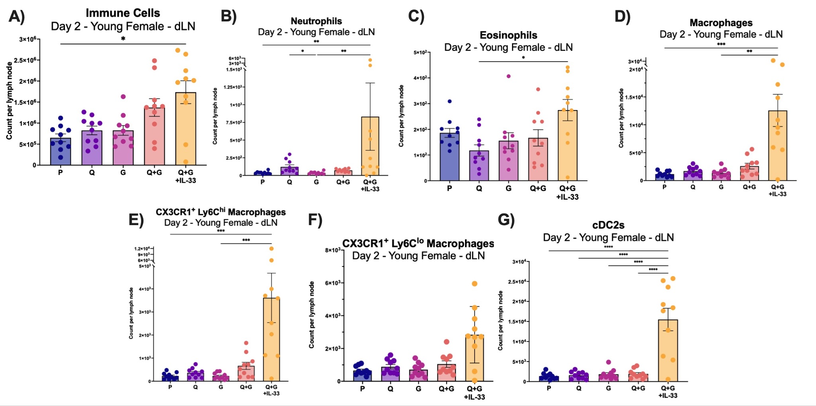

Supplementary Figure 7. Immune characterization of draining inguinal lymph nodes using spectral flow cytometry on day 2 in female mice. Count of non-circulating (A) total Immune cells, (B) neutrophils, (C) eosinophil, (D) macrophages, (E) CX3CR1⁺Ly6C^{hi} macrophages, (F) CX3CR1⁺Ly6C^{lo} macrophages, and (G) cDC2s in inguinal draining lymph nodes 2 days after injection with P, Q, G, Q+G, and Q+G+IL-33. * P ≤ 0.05 ** P ≤ 0.01 *** P ≤ 0.001 **** P ≤ 0.0001 (Kruskall-Wallis followed by Dunn’s multiple comparisons test).

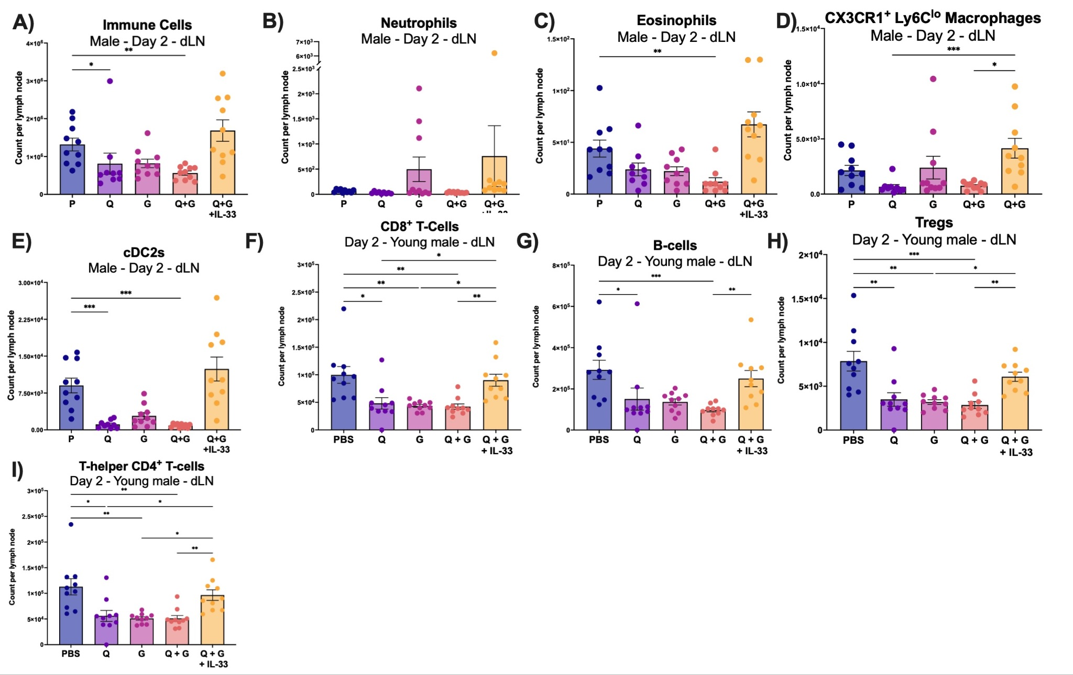

Supplementary Figure 8. Immune characterization of draining inguinal lymph nodes using spectral flow cytometry on day 2 in male mice. Count of non-circulating (A) total Immune cells, (B) neutrophils, (C) eosinophil, (D) CX3CR1⁺Ly6C^{lo} macrophages, (E) cDC2s, (F) CD8⁺ T-cells, (G) B-cells, (H) Tregs, and (I) CD4+ T-helper cells in inguinal draining lymph nodes 2 days after injection with P, Q, G, Q+G, and Q+G+IL-33. * P ≤ 0.05 ** P ≤ 0.01 *** P ≤ 0.001 **** P ≤ 0.0001 (Kruskall-Wallis followed by Dunn’s multiple comparisons test).
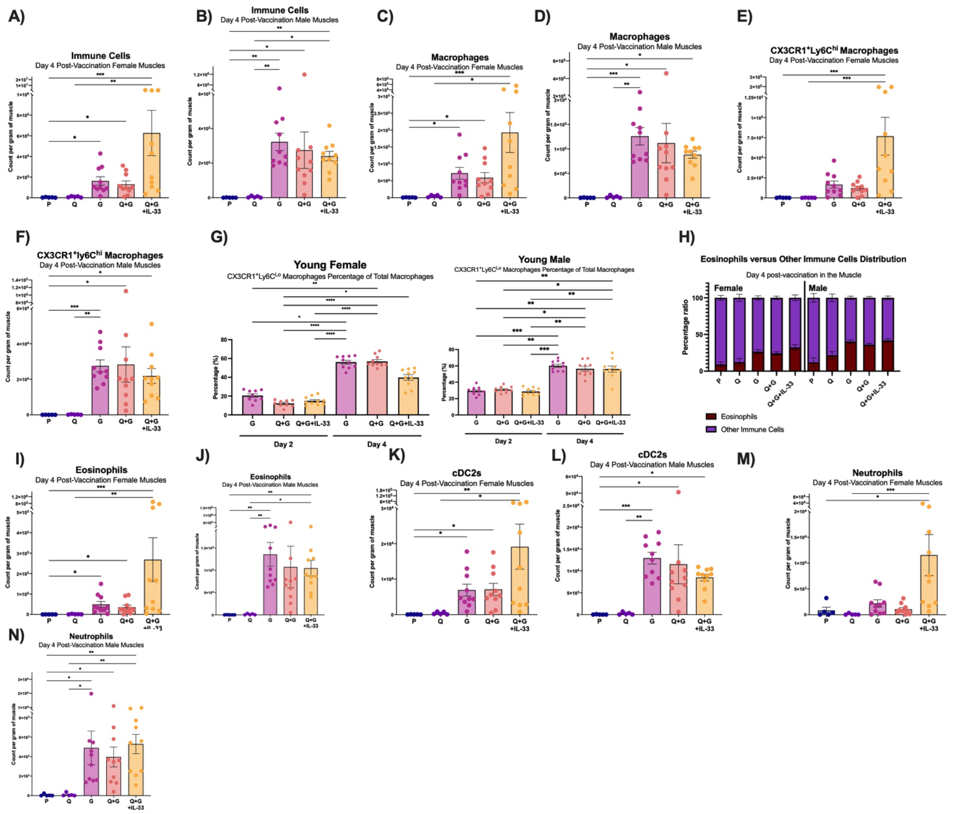

Supplementary Figure 9. Immune characterization of quadricep myeloid cells and granulocytes using spectral flow cytometry on day 4 in young male and female mice. Count of non-circulating (A) total immune cells in female quadriceps, (B) total immune cells in male quadriceps, (C) macrophages in female quadriceps, (D) macrophages in male quadriceps, (E) CX3CR1⁺Ly6C^{hi} macrophages in female quadriceps, (F) CX3CR1⁺Ly6C^{hi} macrophages in male quadriceps 4 days after injection with P, Q, G, Q+G, and Q+G+IL-33. (G) CX3CR1⁺Ly6C^{lo} macrophages percentage of total macrophages in young female and male mice on days 2 and 4 in the G, Q+G and Q+G+IL-33 groups. (H) eosinophil to non-eosinophil immune distributions in day 4 young male and female quadriceps from P, Q, G, Q+G, and Q+G+IL-33 groups. Count of non-circulating (I) eosinophils in female quadriceps, (J) eosinophils in male quadriceps, (K) cDC2s in female quadriceps, (L) cDC2s in male quadriceps, (M) neutrophils in female quadriceps, (N) neutrophils in male quadriceps 4 days after injection with P, Q, G, Q+G, and Q+G+IL-33. * P ≤ 0.05 ** P ≤ 0.01 *** P ≤ 0.001 **** P ≤ 0.0001 (Kruskall-Wallis followed by Dunn’s multiple comparisons test).

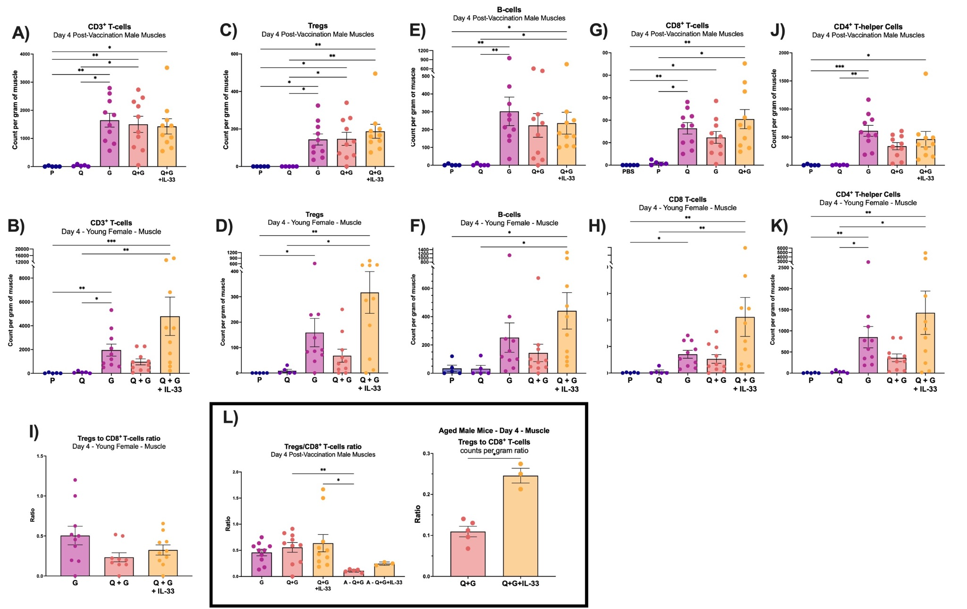

Supplementary Figure 10. Immune characterization of quadricep lymphocytes using spectral flow cytometry on day 4 in young male and female mice. Count of non-circulating (A) CD3⁺ T-cells, (C) Tregs, (E) B-cells, (I) CD8⁺ T-cells, (K) and CD4⁺ T-helper cells, in male quadriceps 4 days after injection with P, Q, G, Q+G, and Q+G+IL-33. Count of non-circulating (B) CD3⁺ T-cells, (D) Tregs, (F) B-cells, (H) CD8⁺ T-cells, (K) and CD4⁺ T-helper cells in young female quadriceps 4 days after injection with P, Q, G, Q+G, and Q+G+IL-33. (I) Treg:CD8⁺ T-cell ratio in day 4 female quadriceps from G, Q+G, and Q+G+IL-33 groups. (L) Tregs to CD8⁺ T-cells ratio in young and aged male mice on day 4 in the young G, Q+G and Q+G+IL-33 groups, and the aged Q+G and Q+G+IL-33 groups. * P ≤ 0.05 ** P ≤ 0.01 *** P ≤ 0.001 **** P ≤ 0.0001 (Kruskall-Wallis followed by Dunn’s multiple comparisons test).
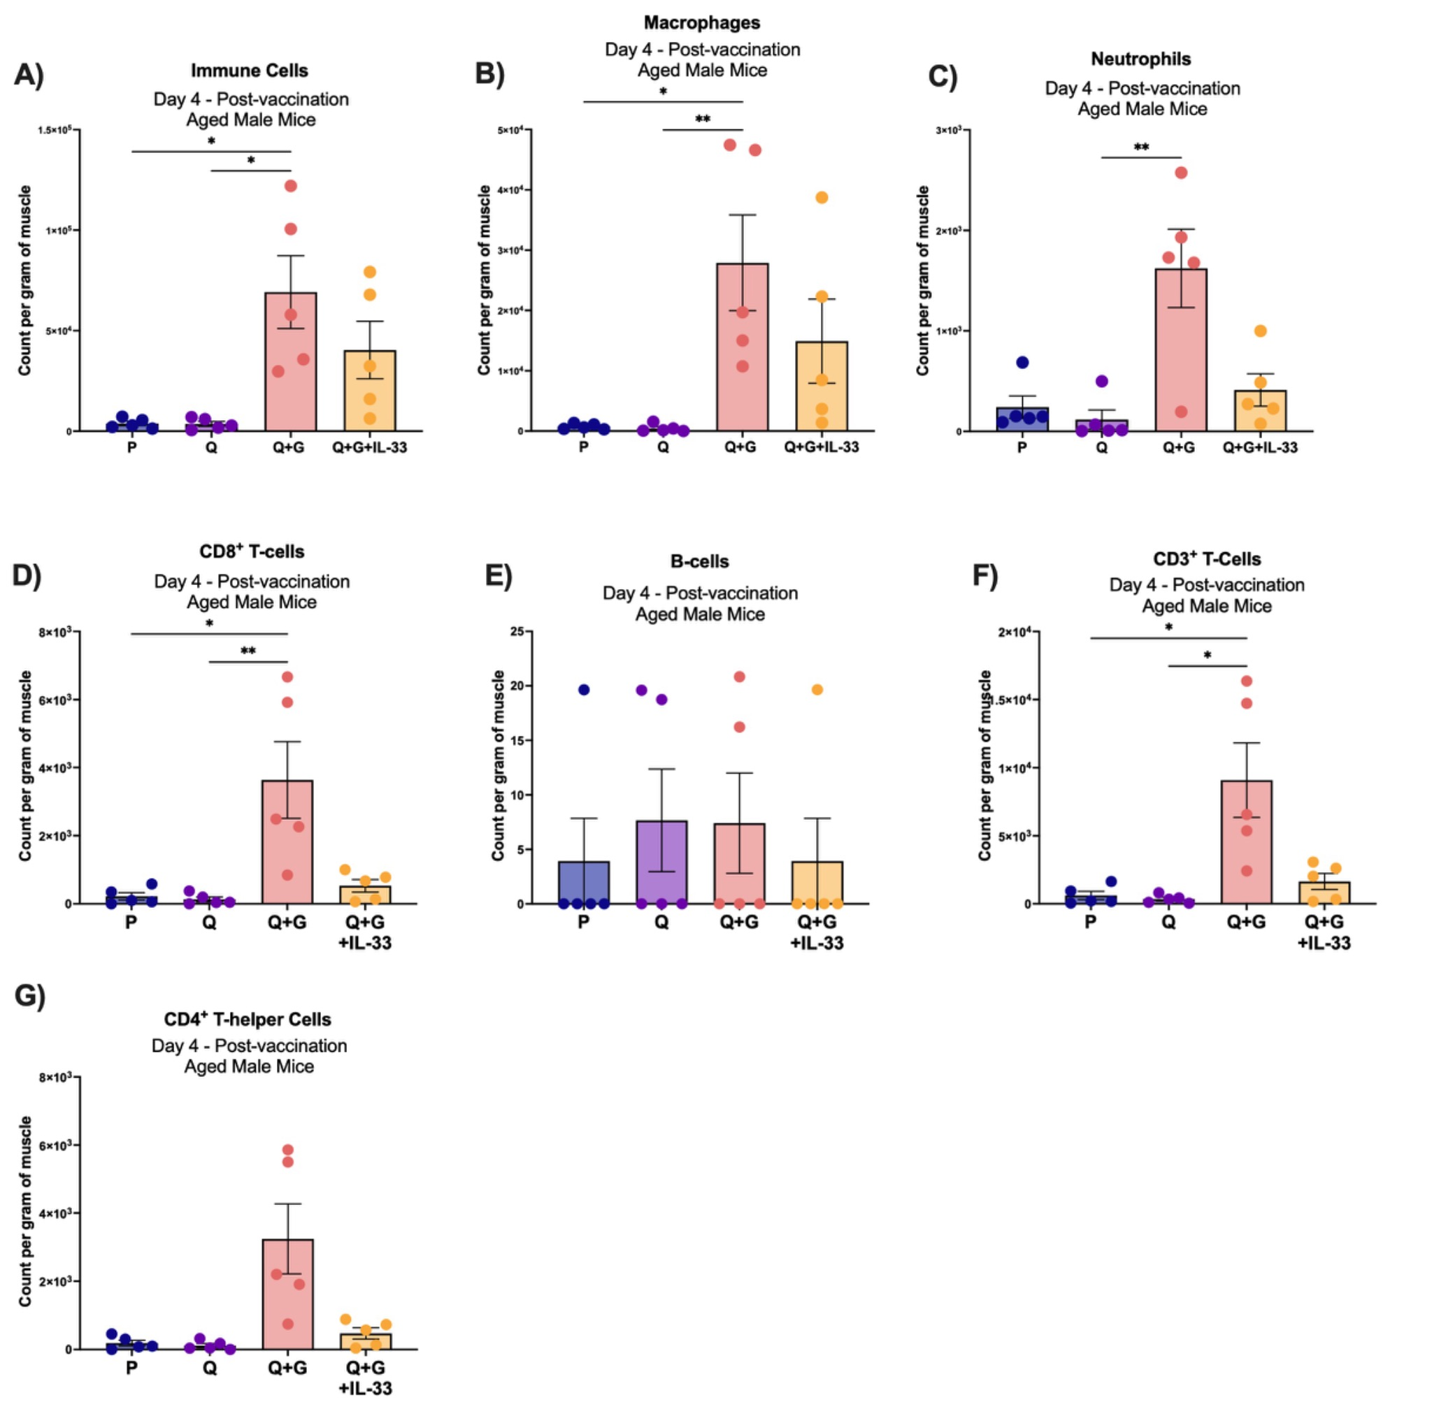
Supplementary Figure 11. Immune characterization of quadricep immune cells using spectral flow cytometry on day 4 in aged male mice. Count of non-circulating (A) Immune cells, (B) macrophages, (C) neutrophils, (D) CD8⁺ T-cells, (E) B-cells, (F) CD3⁺ T-cells, and (G) CD4⁺ T-helper cells in aged male quadriceps 4 days after injection with P, Q, G, Q+G, and Q+G+IL-33. * P ≤ 0.05 ** P ≤ 0.01 *** P ≤ 0.001 **** P ≤ 0.0001 (Kruskall-Wallis followed by Dunn’s multiple comparisons test).

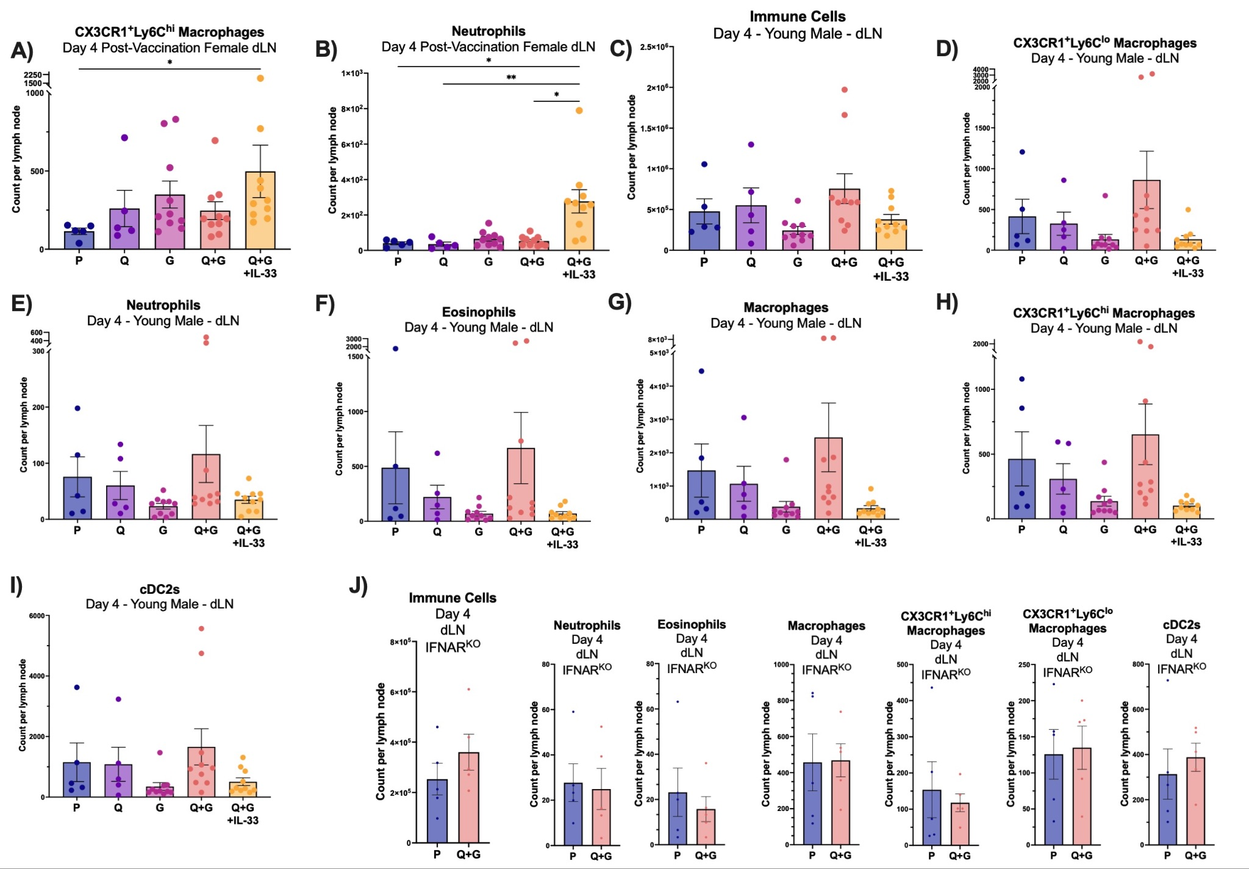
Supplementary Figure 12. Immune characterization of draining lymph node myeloid cells and granulocytes using spectral flow cytometry on day 4 in young male and female mice and IFNAR⁻/⁻ female mice. Count of non-circulating (A) CX3CR1⁺Ly6C^{hi} macrophages, and (B) neutrophils in young female mice draining lymph nodes 4 days after injection with P, Q, G, Q+G, and Q+G+IL-33. Count of non-circulating (C) Immune cells, (D) CX3CR1⁺Ly6C^{lo} macrophages, (E) neutrophils, (F) eosinophils, (G) macrophages, (H) CX3CR1⁺Ly6C^{hi} macrophages, and (I) cDC2s in young male draining lymph nodes 4 days after injection with P, Q, G, Q+G, and Q+G+IL-33. (J) Count of non-circulating immune cells, neutrophils, eosinophils, macrophages, CX3CR1⁺Ly6C^{hi} macrophages, CX3CR1⁺Ly6C^{lo} macrophages, and cDC2s in IFNAR⁻/⁻ female draining lymph nodes 4 days after P and Q+G. * P ≤ 0.05 ** P ≤ 0.01 *** P ≤ 0.001 **** P ≤ 0.0001 (Kruskall-Wallis followed by Dunn’s multiple comparisons test).

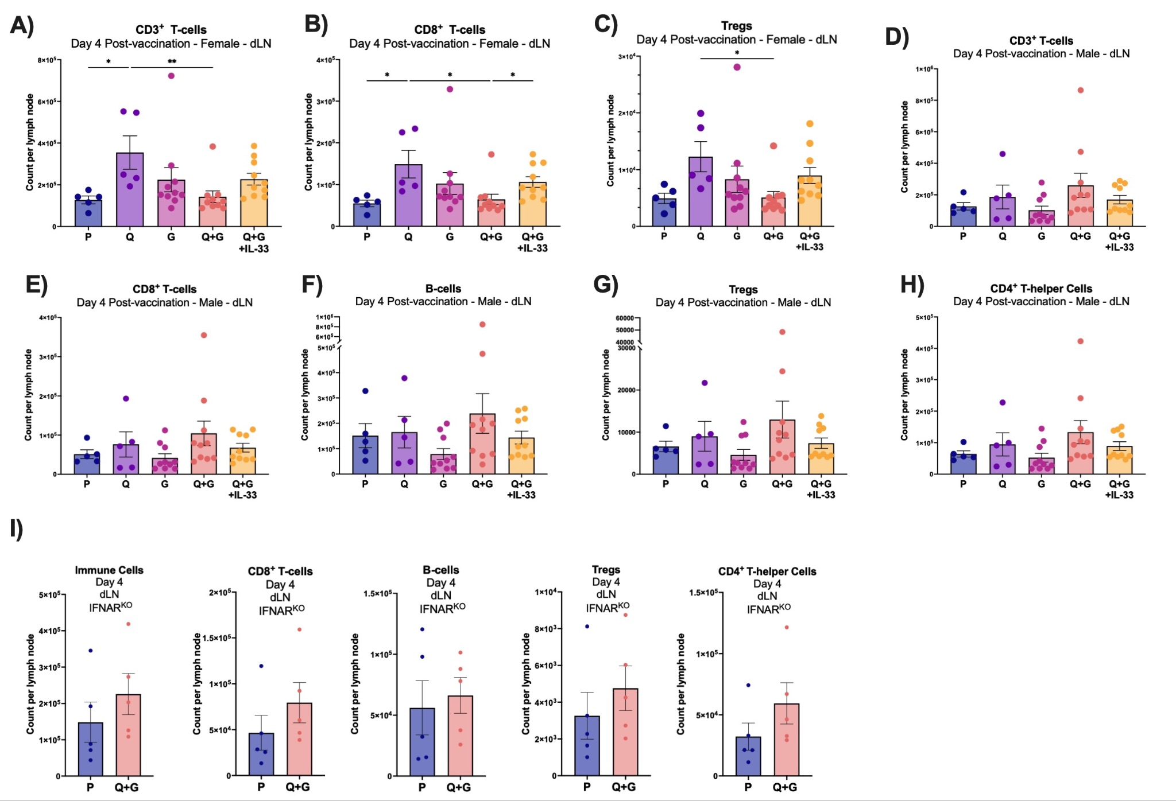
Supplementary Figure 13. Immune characterization of draining lymph node lymphocytes using spectral flow cytometry on day 4 in young male and female mice and IFNAR⁻/⁻ female mice. Count of non-circulating (A) CD3⁺ T-cells, (B) CD8⁺ T-cells, and (C) Tregs in young female mice draining lymph nodes 4 days after injection with P, Q, G, Q+G, and Q+G+IL-33. Count of non-circulating (D) CD3⁺ T-cells, (E) CD8⁺ T-cells, and (F) B-cells, (G) Tregs, and (H) CD4⁺ T-helper cells in young male draining lymph nodes 4 days after injection with P, Q, G, Q+G, and Q+G+IL-33. (J) Count of non-circulating immune cells, CD8⁺ T-cells, B-cells, Tregs, and CD4⁺ T-helper cells in IFNAR⁻/⁻ female draining lymph nodes 4 days after P and Q+G. * P ≤ 0.05 ** P ≤ 0.01 *** P ≤ 0.001 **** P ≤ 0.0001 (Kruskall-Wallis followed by Dunn’s multiple comparisons test).

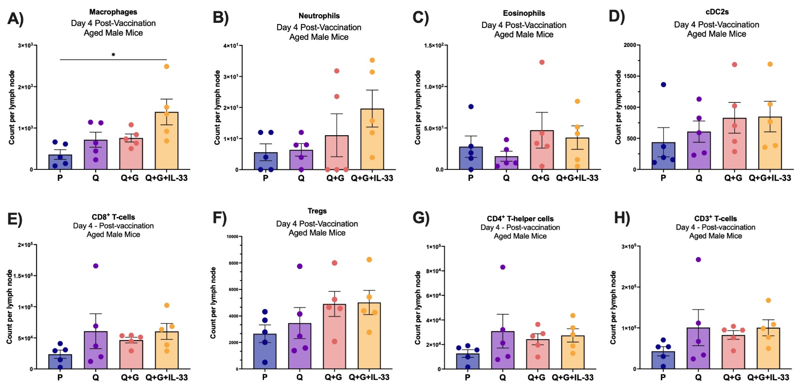
Supplementary Figure 14. Immune characterization of draining lymph nodes using spectral flow cytometry on day 4 in aged male mice. Count of non-circulating (A) macrophages, (B) neutrophils, (C) eosinophils, (D) cDC2s, (E) CD8⁺ T-cells, (F) Tregs,(G) CD4⁺ T-helper cells, and (H) CD3⁺ T-cells in aged male draining lymph nodes 4 days after injection with P, Q, G, Q+G, and Q+G+IL-33. * P ≤ 0.05 ** P ≤ 0.01 *** P ≤ 0.001 **** P ≤ 0.0001 (Kruskall-Wallis followed by Dunn’s multiple comparisons test).
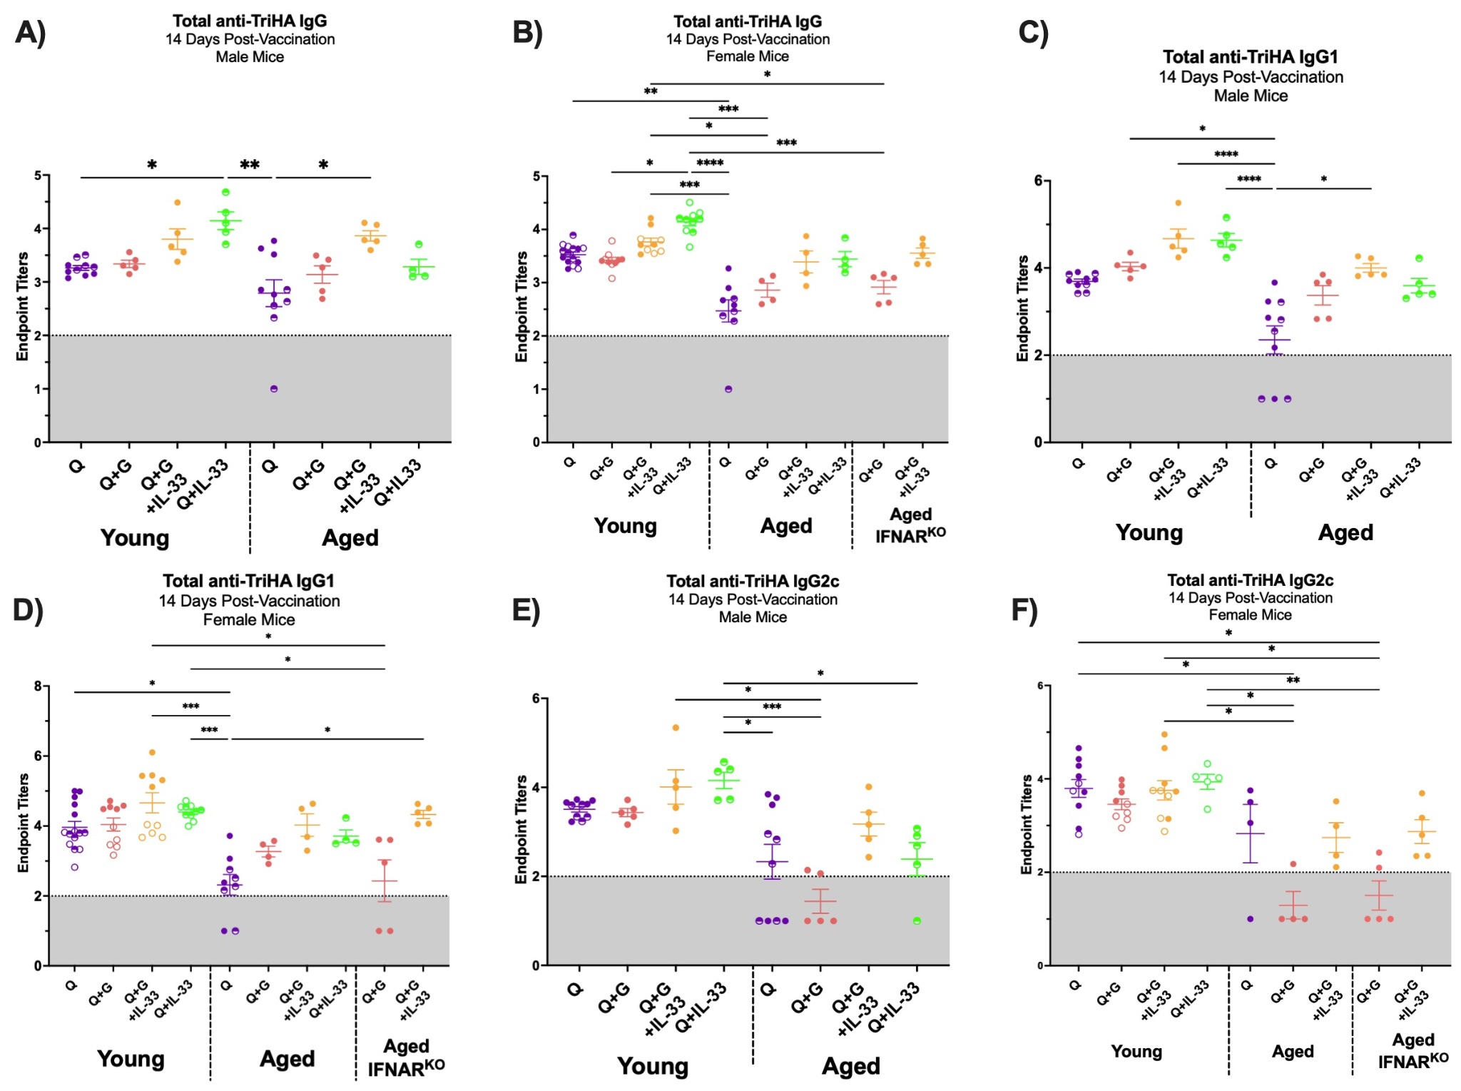
Supplementary Figure 15. Serological anti-TriHA log₁₀ Antibody titers of all mice 14 days following vaccination. (A) Quantification of anti-TriHA total IgG antibody endpoint titers on day 14 after vaccination in young and aged male mice; (B) in young, aged Wildtype, and aged IFNAR⁻/⁻ female mice; (C) Quantification of anti-TriHA total IgG1 antibody endpoint titers on day 14 after vaccination in young and aged male mice; (D) in young, aged Wildtype, and aged IFNAR⁻/⁻ female mice. (E) Quantification of anti-TriHA total IgG2c antibody endpoint titers on day 14 after vaccination in young and aged male mice; (F) in young, aged Wildtype, and aged IFNAR⁻/⁻ female mice. * P ≤ 0.05 ** P ≤ 0.01 *** P ≤ 0.001 **** P ≤ 0.0001 (Kruskall-Wallis followed by Dunn’s multiple comparisons test).
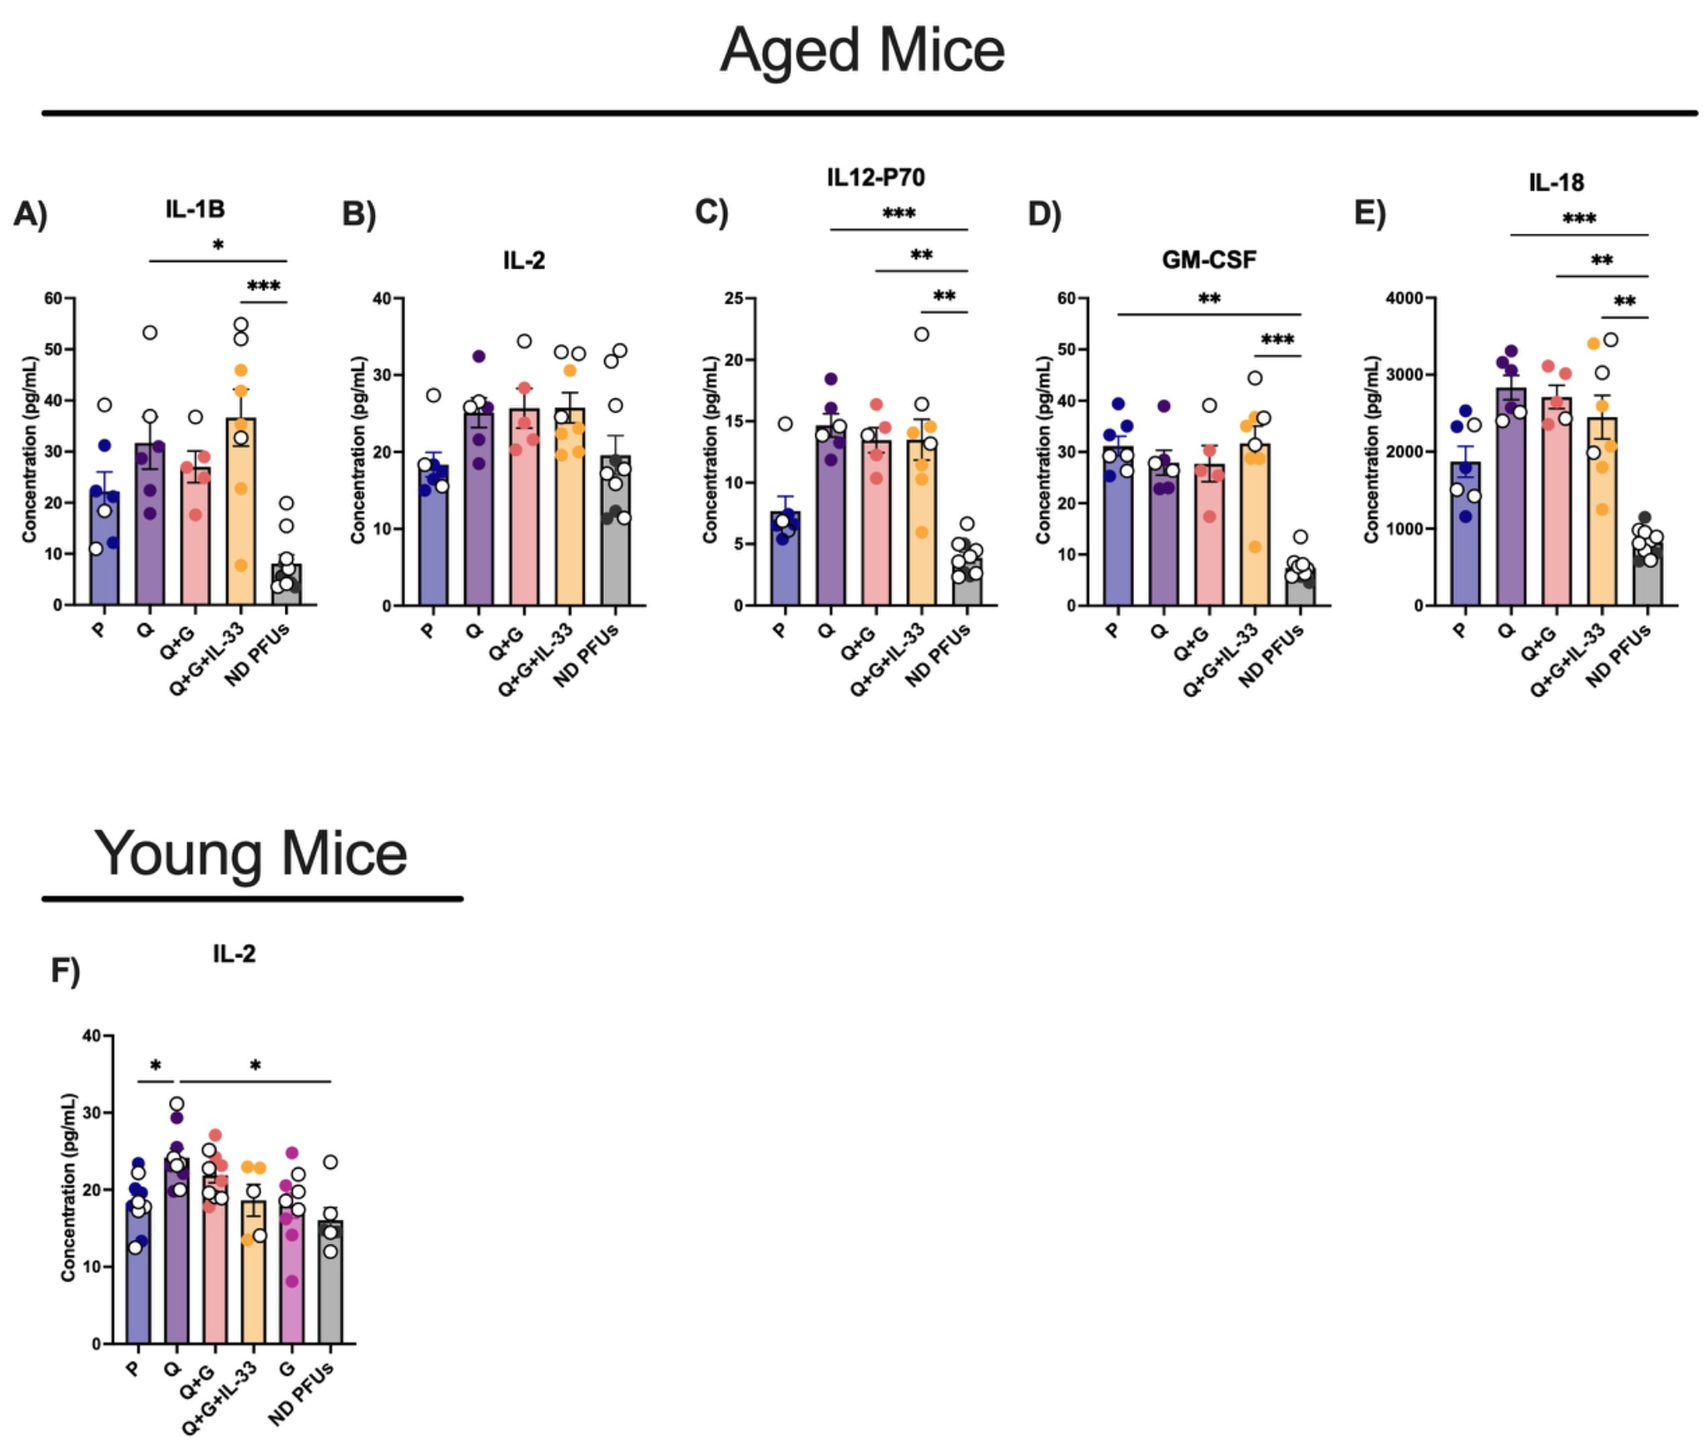
Supplementary Figure 16. Characterization of lung homogenate cytokine levels 6 days post-intranasal infection with 3LD₅₀ IVR-180 using cytokine multiplex assay. Lung homogenate concentrations (in pg/mL) of (A) IL-1β, (B) IL-2, (C) IL-12p70, (D) GM-CSF, (E) and IL-18 in aged mice lung homogenates 6 days post-infection with 3LD₅₀ IVR-180 of P, Q, Q+G, Q+G+IL-33, and ND PFUs groups. (F) Lung homogenate concentrations (in pg/mL) of IL-2 in young mice lung homogenates 6 days post-infection with 3LD₅₀ IVR-180 of P, Q, Q+G, Q+G+IL-33, G and ND PFUs groups. * P ≤ 0.05 ** P ≤ 0.01 *** P ≤ 0.001 **** P ≤ 0.0001 (Kruskall-Wallis followed by Dunn’s multiple comparisons test).

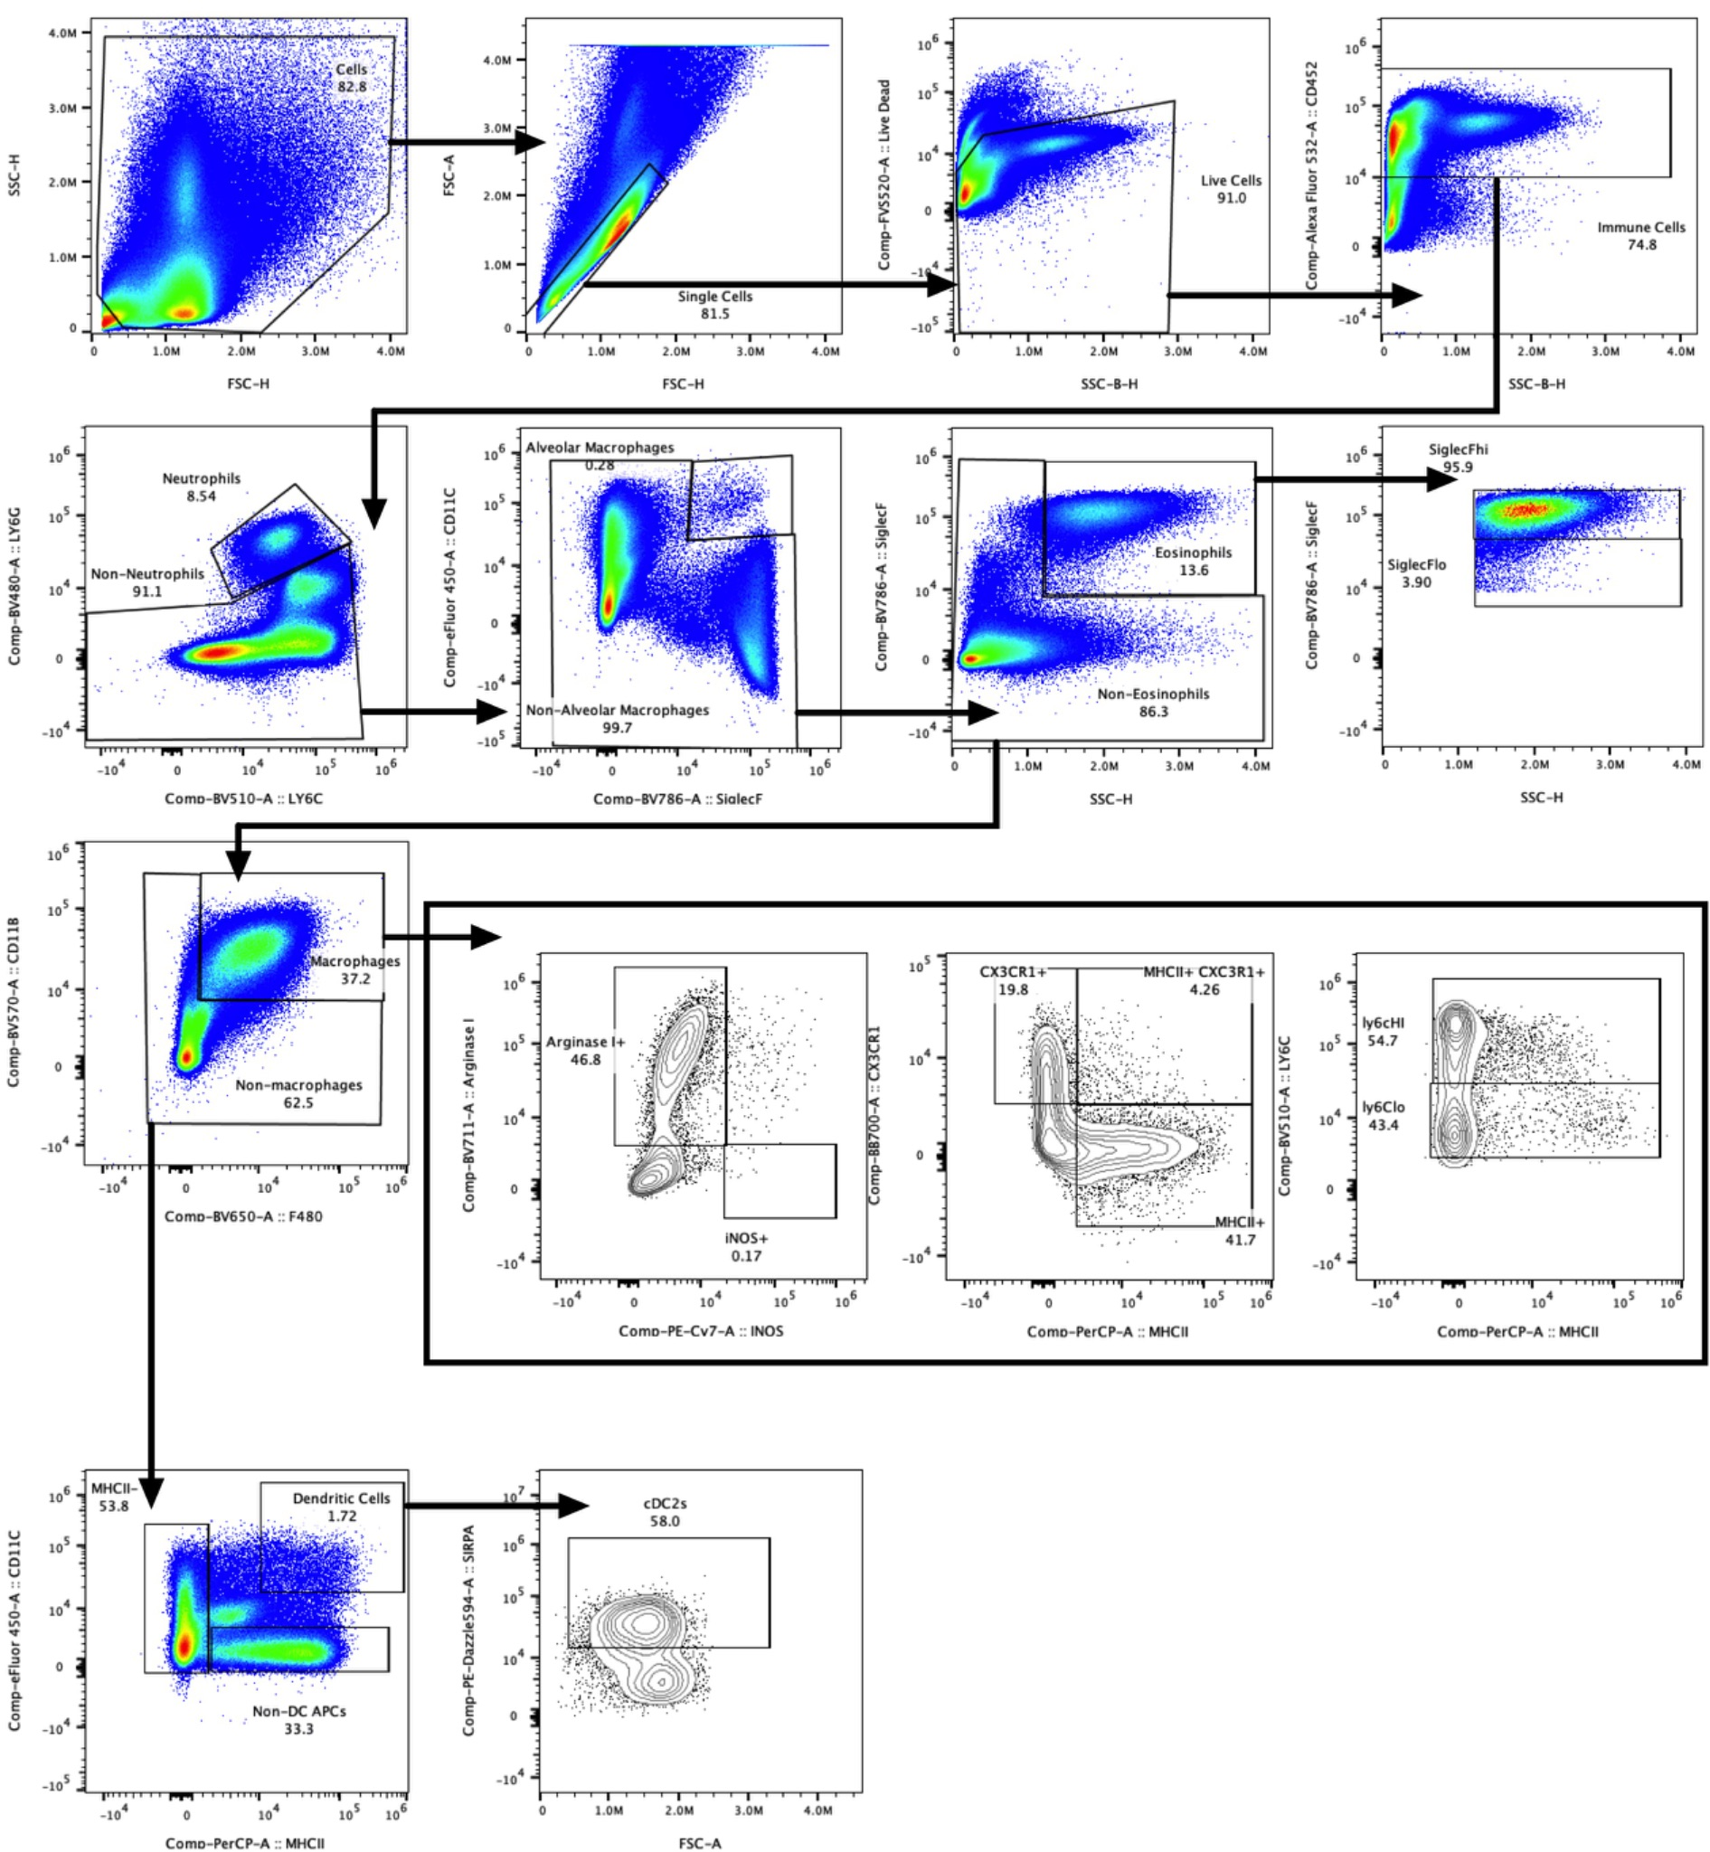
Supplementary Figure 17. Spectral flow cytometry gating strategy allows the characterization of myeloid cells and granulocytes in mouse lungs.

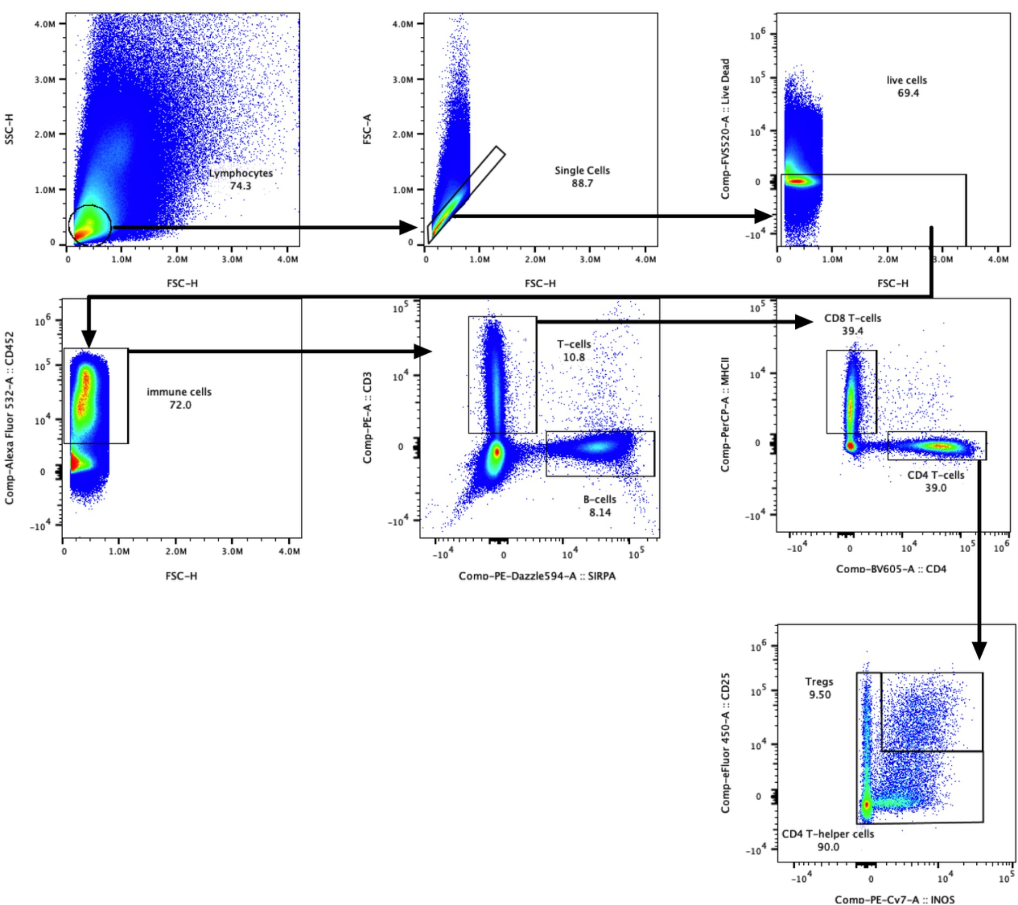
Supplementary Figure 18. Spectral flow cytometry gating strategy allows the characterization of lymphocytes in mouse lungs.

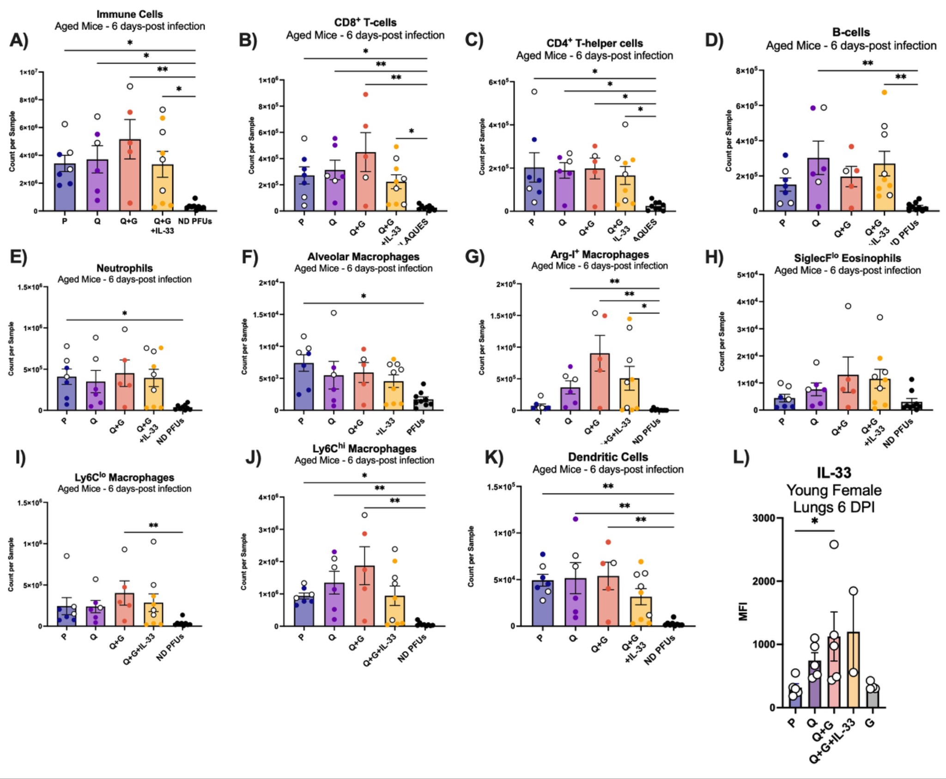
Supplementary Figure 19. Immune characterization of aged mice lungs using spectral flow cytometry 6 days post-infection. Count of (A) immune cells, (B) CD8⁺ T-cells, (C) CD4⁺ T-helper cells, (D) B-cells, (E) neutrophils, (F) alveolar macrophages, (G) Arginase I⁺ macrophages, (H) Siglec-F^{lo} eosinophils, (I) Ly6C^{lo} macrophages, (J) Ly6C^{hi} macrophages, and (K) dendritic cells in aged male lungs 6 days post-infection with IVR-180 of P, Q, Q+G, Q+G+IL-33, and ND PFUs groups. (L) Quantification of IL-33 MFIs 6 days post-infection with 3LD₅₀ (300 PFUs/mouse) dose IVR-180 (A/Michigan/25/2015, H1N1) in lungs of P, Q, Q+G, Q+G+IL-33, and G in young female mice. * P ≤ 0.05 ** P ≤ 0.01 *** P ≤ 0.001 **** P ≤ 0.0001 (Kruskall-Wallis followed by Dunn’s multiple comparisons test).

