Supplementary Material

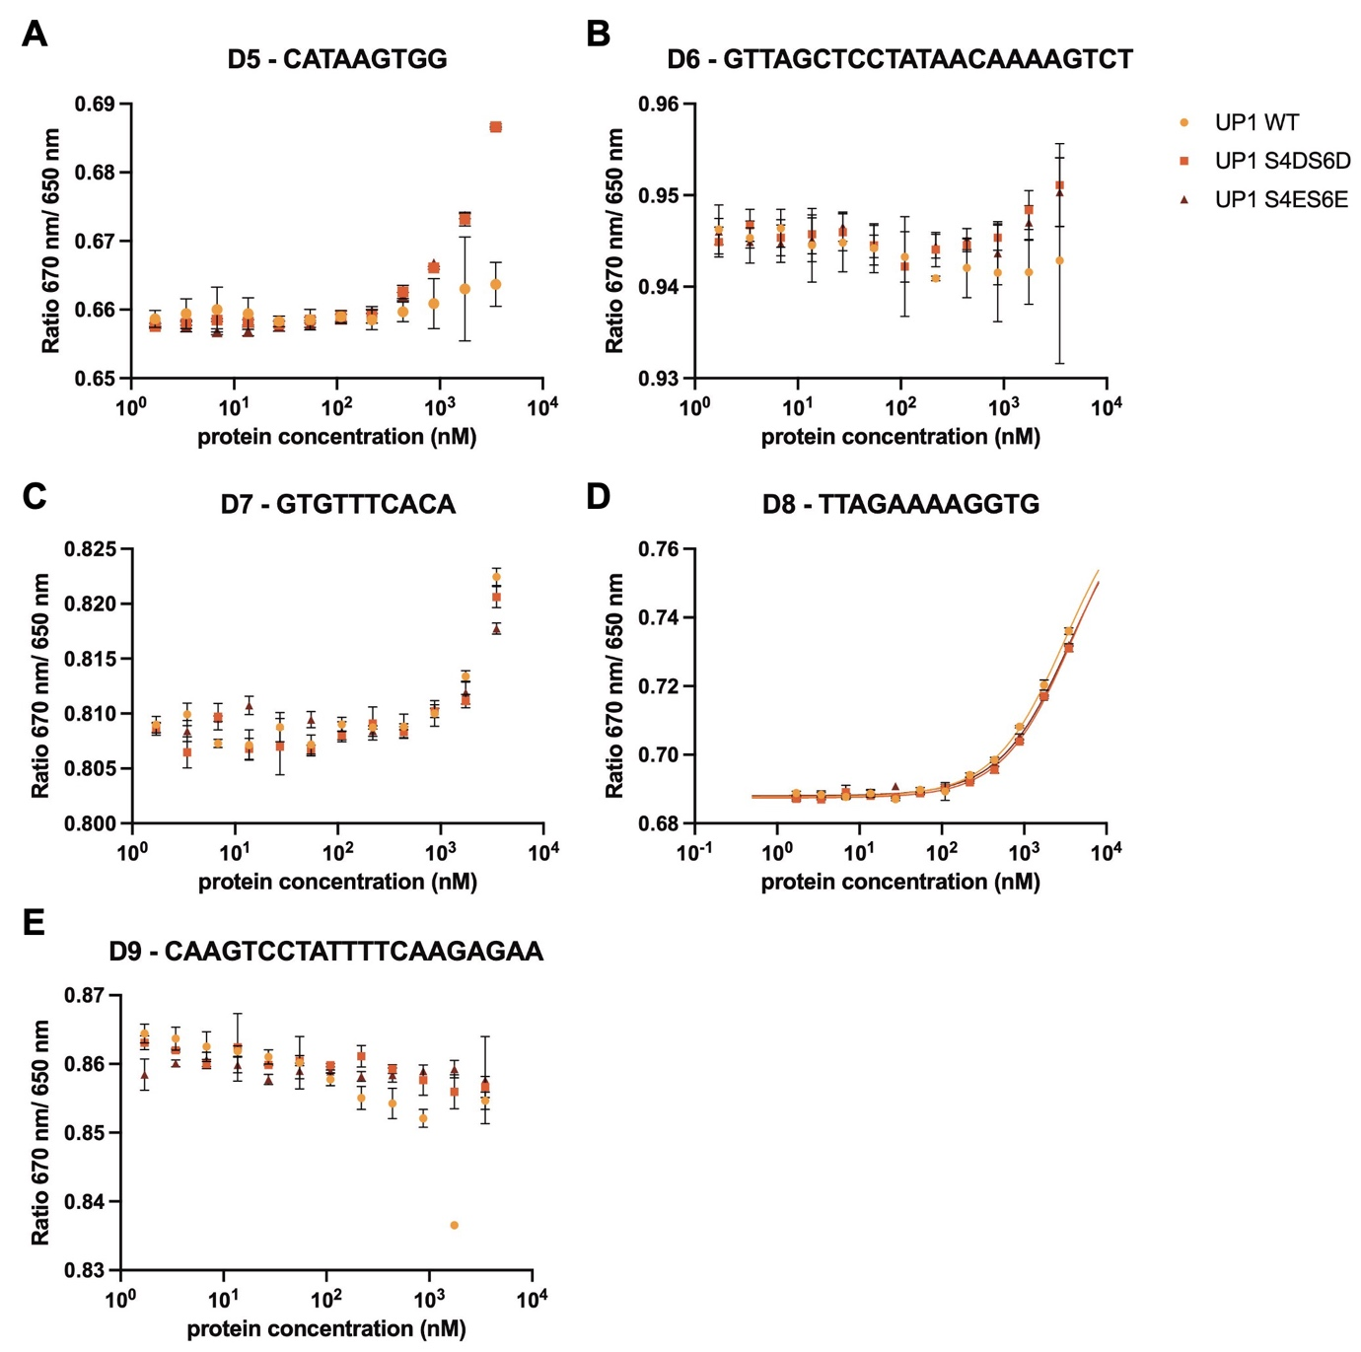
Figure S1 Spectral shift dose–response curves for UP1 wild type (yellow), UP1 S4D/S6D (orange), and UP1 S4E/S6E (brown) binding to (A) D5, (B) D6, (C) D7, (D) D8, (E) D9 DNA oligos.

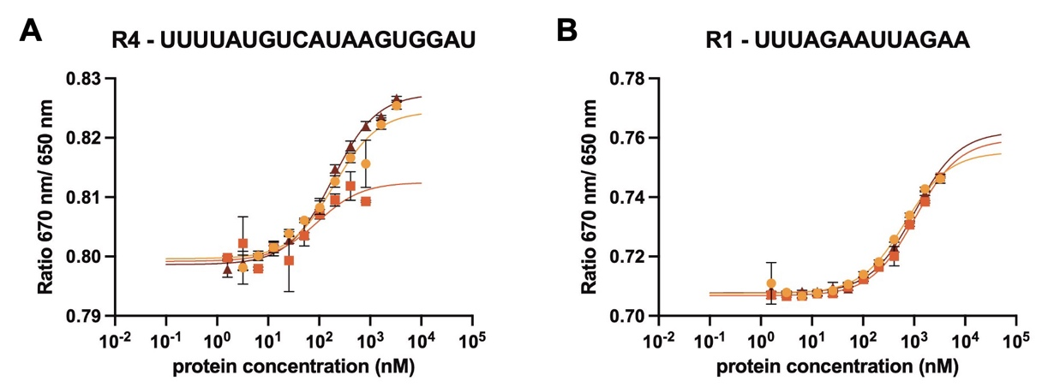
Figure S2 Spectral shift dose–response curves for UP1 wild type (yellow), UP1 S4D/S6D (orange), and UP1 S4E/S6E (brown) binding to (A) R4 and (B) R1 RNA oligos.

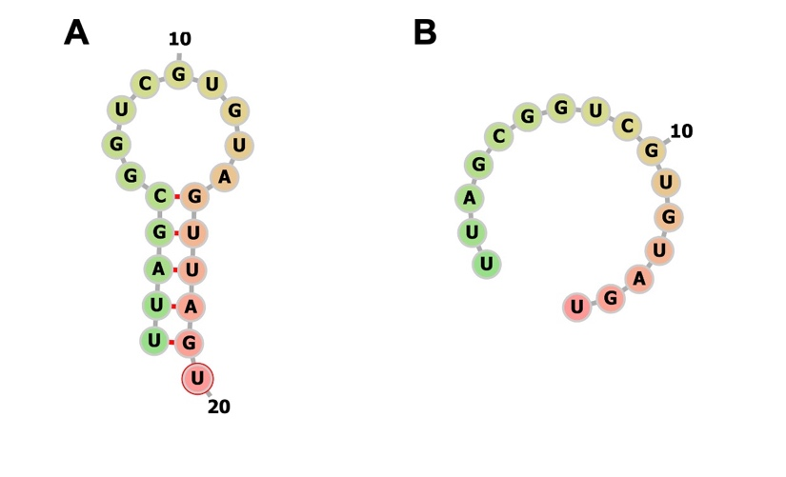
Figure S3: RNA oligos secondary structure. Visualization of predicted secondary structures of the (A) 20-mer and (B) 16-mer.

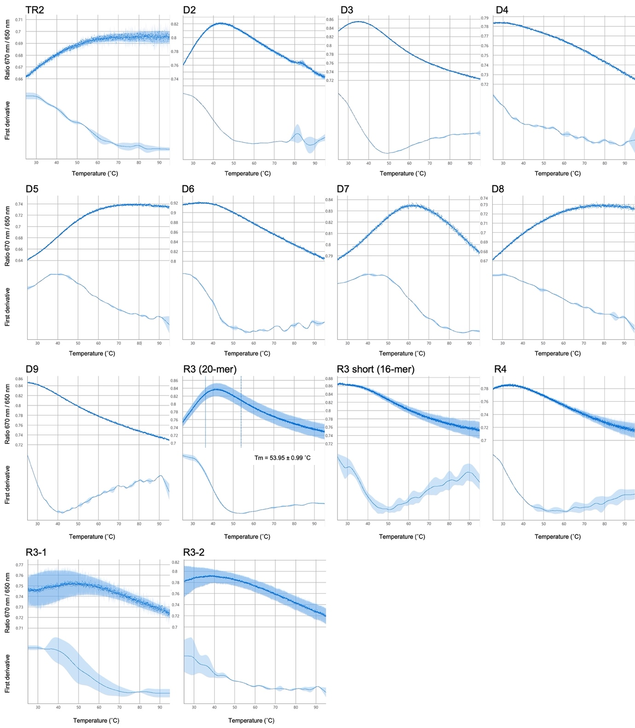
Figure S4: Thermal unfolding curves. Thermal unfolding curves of CY5-labelled oligonucleotides. Oligo names are shown above the plots. Upper and lower limits are shown as dotted lines in the R3 plot.

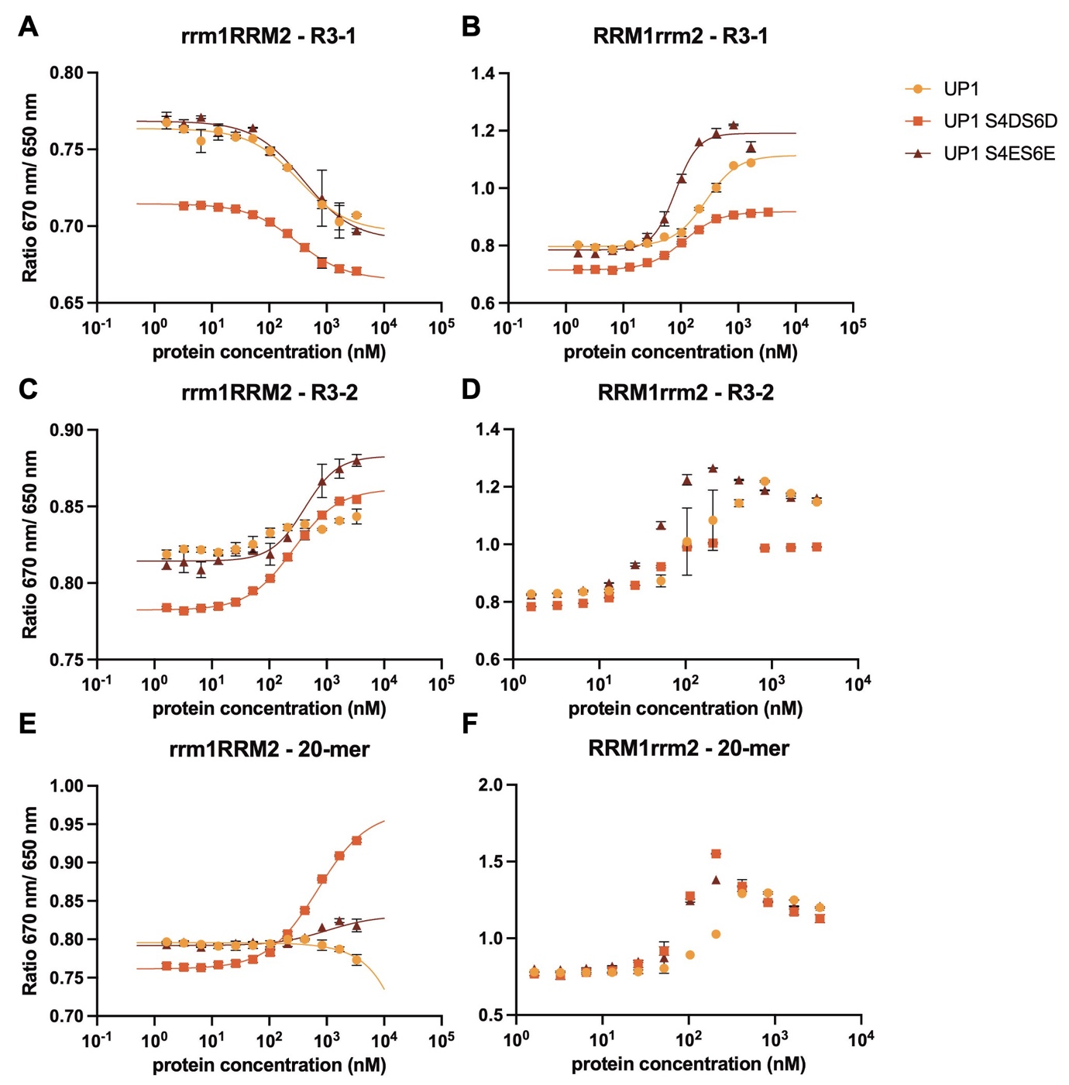
Figure S5 Spectral shift dose–response curves for UP1 wild type (yellow), UP1 S4D/S6D (orange), and UP1 S4E/S6E (brown) rrm1RRM2 binding to (A) R3-1, (C) R3-2, and (E) 20-mer RNA oligos. (B) UP1 wild type (yellow), UP1 S4D/S6D (orange), and UP1 S4E/S6E (brown) RRM1rrm2 binding to R3-1 RNA oligo. Biphasic binding curves for the (D) R3-2 and (F) 20-mer RNA oligos. RNA names are shown above the plots.

Figure S6: NMR of UP1. Superimposition of ¹H-¹⁵N HSQC spectra of ¹⁵N-labeled UP1 wt, S4DS6D (D), S4ES6E (E) in the free (red) and 16-mer and 20-mer bound form (blue). The amide cross-peaks fully disappeared upon increase of RNA during the titration.

Figure S7: N-tail interaction with RNA. Frequency of H-bond and VDW intramolecular contacts formed by residues 1–12 of the UP1 N-tail with 16-mer, calculated from 10-µs MD simulations of UP1 wt, and S4 and S6 phosphorylated UP1 (wt-Pi).

