Supplemental material 1 (SUP1). Spearman’s or Pearson’s correlation between psychometric instruments and other factors used in this study
 | 1 | 2 | 3 | 4 | 5 | 6 | 7 | 8 | 9 | 10 | 11 | 12 | 13 | 14 | 15 | 16 | 17 | 18 | 19
1. Suicidal ideation (SI)
2. Non-suicidal self-injury (NSSI) | 0.50***
3. Suicidal attempt (SA) | 0.42*** | 0.33***
4. Intentional self-harm (ISH) | 0.54*** | 0.97*** | 0.43***
5. Defeat | 0.48*** | 0.41*** | 0.26*** | 0.42***
6. Entrapment | 0.48*** | 0.44*** | 0.26*** | 0.45*** | 0.87***
7. Depression | 0.49*** | 0.42*** | 0.27*** | 0.43*** | 0.78*** | 0.79***
8. Rumination | 0.42*** | 0.43*** | 0.23*** | 0.44*** | 0.61*** | 0.66*** | 0.66***
9. Thwarted belongingness | 0.35*** | 0.28*** | 0.21*** | 0.29*** | 0.61*** | 0.60*** | 0.60*** | 0.45***
10. Perceived burdensomeness | 0.40*** | 0.31*** | 0.25*** | 0.33*** | 0.69*** | 0.69*** | 0.69*** | 0.49*** | 0.62***
11. Social support | -0.28*** | -0.19*** | -0.18*** | -0.21*** | -0.48*** | -0.46*** | -0.46*** | -0.30*** | -0.60*** | -0.49***
12. Resilience | -0.28*** | -0.28*** | -0.16*** | -0.28*** | -0.43*** | -0.40*** | -0.41*** | -0.35*** | -0.42*** | -0.38*** | 0.30***
13. Impulsivity | 0.17*** | 0.19*** | 0.16*** | 0.18*** | 0.15*** | 0.16*** | 0.21*** | 0.22*** | 0.04*** | 0.14*** | -0.10*** | 0.04
14. Exposure | 0.26*** | 0.28*** | 0.12*** | 0.27*** | 0.19*** | 0.21*** | 0.22*** | 0.30*** | 0.10*** | 0.16*** | -0.07** | -0.14*** | 0.13***
15. Fearlessness about death | 0.38*** | 0.23*** | 0.28*** | 0.25*** | 0.43*** | 0.43*** | 0.47*** | 0.29*** | 0.35*** | 0.48*** | -0.32*** | -0.22*** | 0.19*** | 0.11***
16. Pain tolerance | 0.21*** | 0.19*** | 0.15*** | 0.21*** | 0.16*** | 0.15*** | 0.19*** | 0.19*** | 0.10*** | 0.14*** | -0.09** | 0.17*** | 0.18*** | 0.13*** | 0.17***
17. Mental images | 0.49*** | 0.42*** | 0.29*** | 0.44*** | 0.57*** | 0.59*** | 0.62*** | 0.56*** | 0.41*** | 0.56*** | -0.33*** | -0.31*** | 0.22*** | 0.29*** | 0.49*** | 0.23***
18. Sex | -0.14*** | -0.26*** | -0.03 | -0.24*** | -0.20*** | -0.28*** | -0.23*** | -0.37*** | -0.09** | -0.13*** | -0.01 | 0.28*** | 0.07** | -0.30*** | 0.14*** | 0.06* | -0.22***
19. Age | -0.03 | 0.02 | -0.02 | 0.02 | -0.07** | -0.03 | 0.01 | 0.03 | -0.06* | -0.11*** | 0.11** | 0.10*** | -0.02 | 0.13*** | -0.14*** | 0.002 | -0.02 | -0.02
p<0.05, **p<0.01, ***p<0.001

Supplemental material 2 (SUP2). Pathway analysis with suicide attempt as outcome
The model fit with suicide attempts as the outcome can be seen in figure sup 3. It includes the paths from defeat to entrapment, entrapment to ideation, and ideation to self-harm, but also the paths from defeat to ideation and entrapment to suicide attempts, which are not hypothesised as direct paths in the IMV model. Model fit statistics are very good and only marginally worse than the model with self-harm as outcome. The GFI is 0.999, CFI is 1.000 and NFI is 0.999 and RMSEA is 0.006. The data is fitting the model very well.
Figure sup 3. Pathway analysis of suicide attempts.
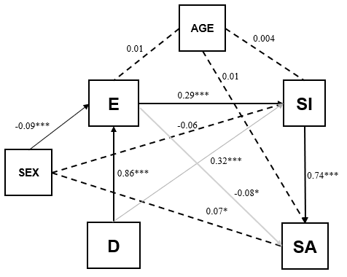
D: Defeat, E: Entrapment, SI: Suicide ideation, SA: Suicide attempt
* p<0.05, ***p<0.001
The standardized path coefficients were statistically significant and in the range of -0.08 to 0.86 with highest values in the paths from defeat to entrapment and suicidal ideation to suicide attempt. Consistent with the self-harm model, the lowest value was found for entrapment to suicide attempts. The negative path coefficients indicate some inverse relationship between entrapment and suicide attempts, after controlling for the direct effects of entrapment to ideation and ideation to suicide attempts. Not all confounders were significant in all the paths and the size and sign of the effects are not equal in all the paths (see figure sub 3 for more details).

Supplemental material 3 (SUP3). Analysis of moderators
Moderators in path from defeat to entrapment
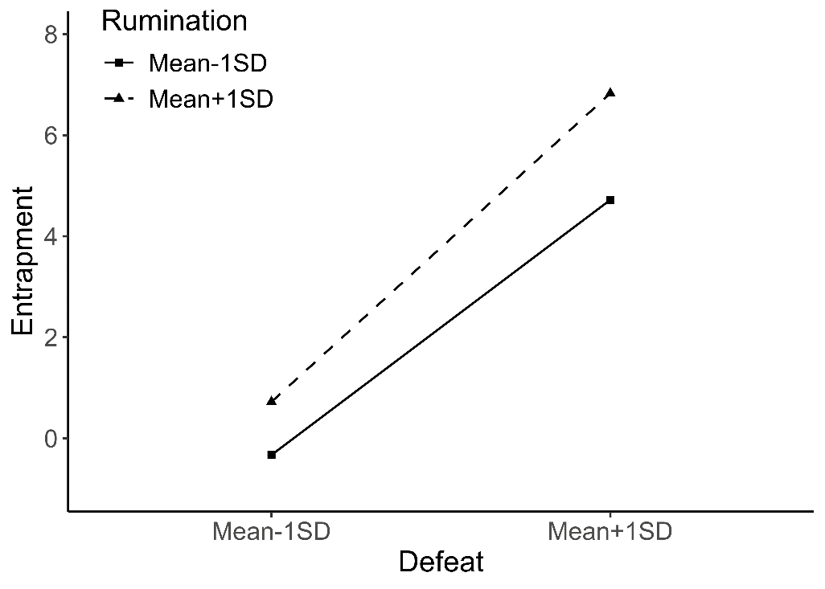 | 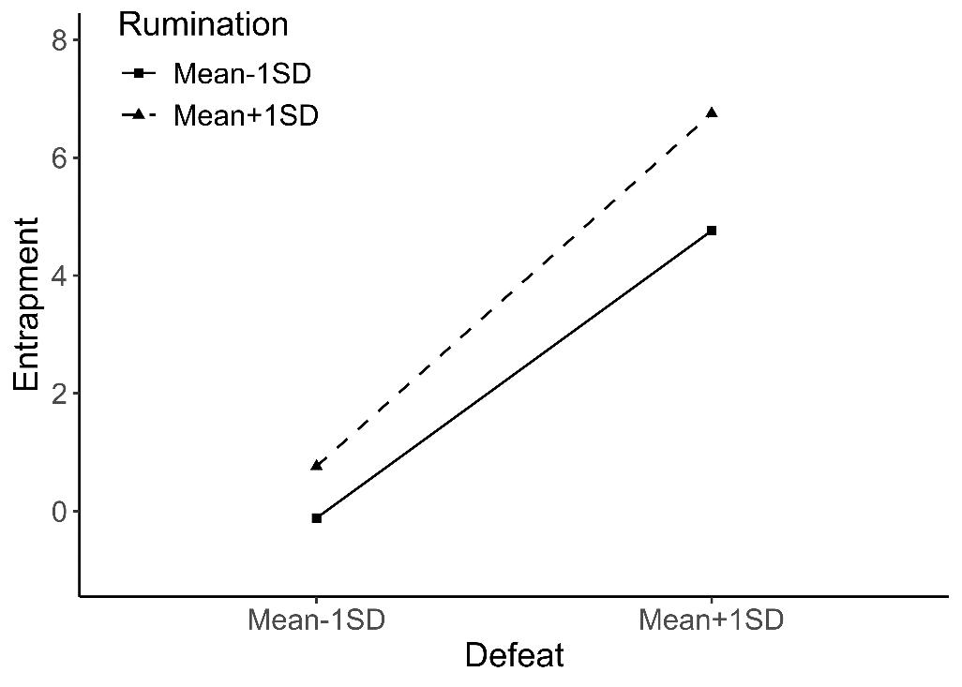
R²=0.79, AIC=2012 | R²=0.80, AIC=1997
  Name | Estimate | 95% CI
  Defeat | 0.51*** | 0.44 to 0.59
  Rumination | 0.14*** | 0.10 to 0.17
  Interaction | 0.29*** | 0.20 to 0.38
  Name | Estimate | 95% CI
  Defeat | 0.50*** | 0.42 to 0.57
  Rumination | 0.11*** | 0.07 to 0.15
  Interaction | 0.32*** | 0.23 to 0.41
  Confounder:
  Sex | -0.05*** | -0.08 to -0.03
  Age | -0.01 | -0.03 to 0.02
* p<0.05, ** p<0.01, ***p<0.001

Moderators in path from defeat to entrapment
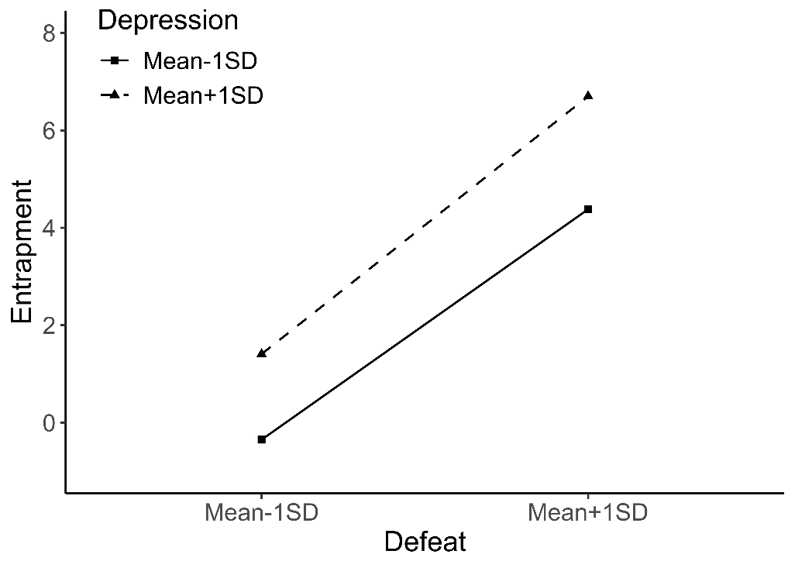 | 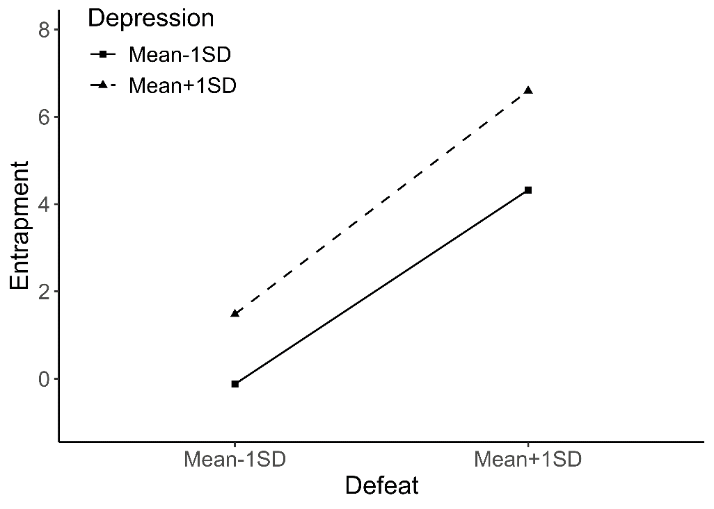
R²=0.79, AIC=2010 | R²=0.80, AIC=1959
  Name | Estimate | 95% CI
  Defeat | 0.54*** | 0.48 to 0.61
  Depression | 0.22*** | 0.18 to 0.27
  Interaction | 0.16*** | 0.08 to 0.25
  Name | Estimate | 95% CI
  Defeat | 0.51*** | 0.44 to 0.57
  Depression | 0.20*** | 0.15 to 0.25
  Interaction | 0.20*** | 0.12 to 0.29
  Confounder:
  Sex | -0.09*** | -0.11 to -0.06
  Age | -0.01 | -0.03 to 0.01
* p<0.05, ** p<0.01, ***p<0.001

Moderators in path from entrapment to suicide ideation
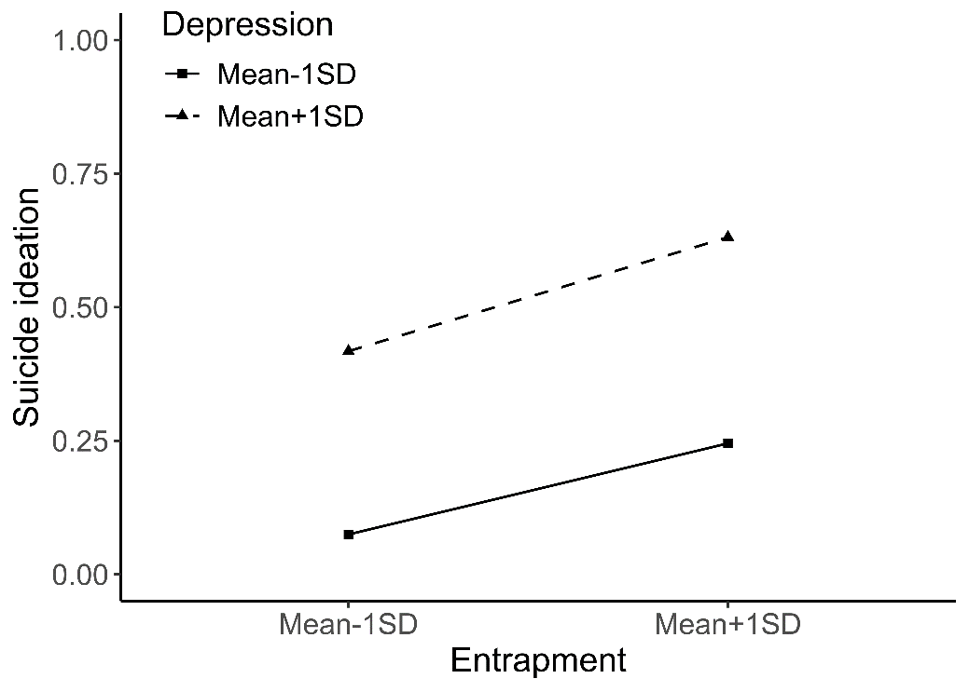 | 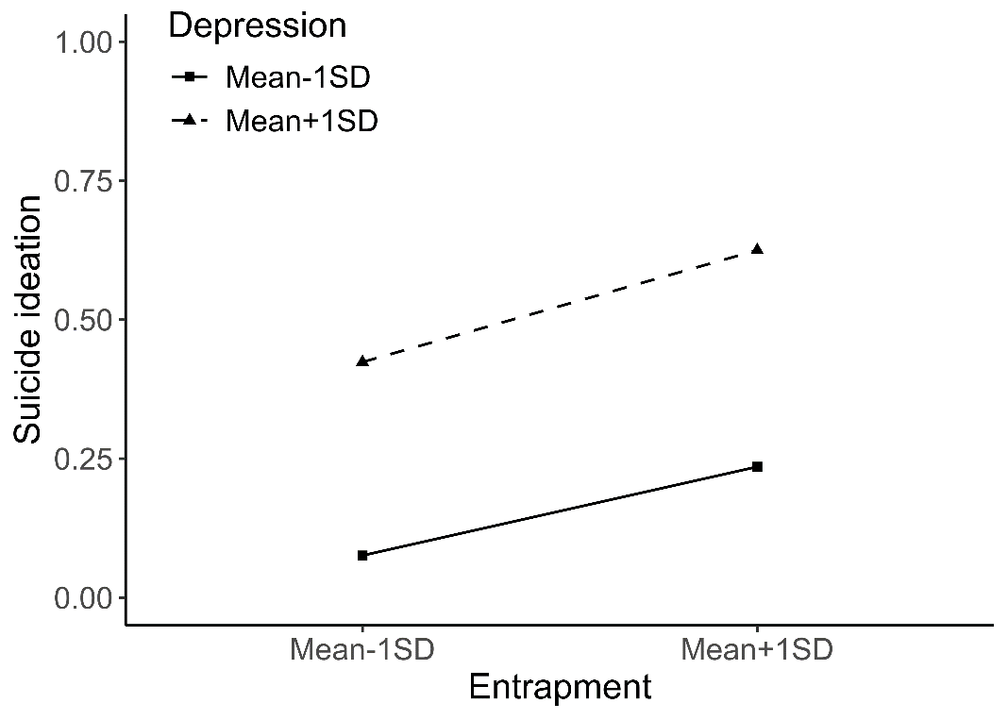
R²=0.30, AIC=1459 | R²=0.30, AIC=1461
  Name | Estimate | 95% CI
  Entrapment | 0.99*** | 0.54 to 1.42
  Depression | 1.09*** | 0.84 to 1.35
  Interaction | -0.67* | -1.23 to -0.05
  Name | Estimate | 95% CI
  Entrapment | 0.95*** | 0.50 to 1.38
  Depression | 1.10*** | 0.84 to 1.36
  Interaction | -0.64* | -1.21 to -0.02
  Confounder:
  Sex | -0.08 | -0.22to 0.05
  Age | -0.06 | -0.19 to 0.07
* p<0.05, ** p<0.01, ***p<0.001

Moderators in path from entrapment to suicide ideation
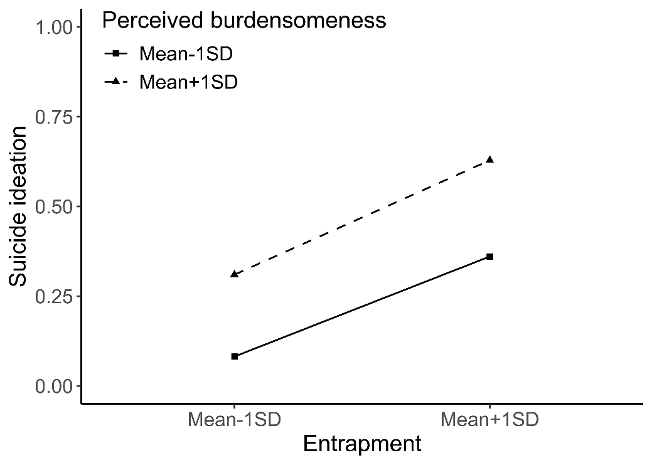 | 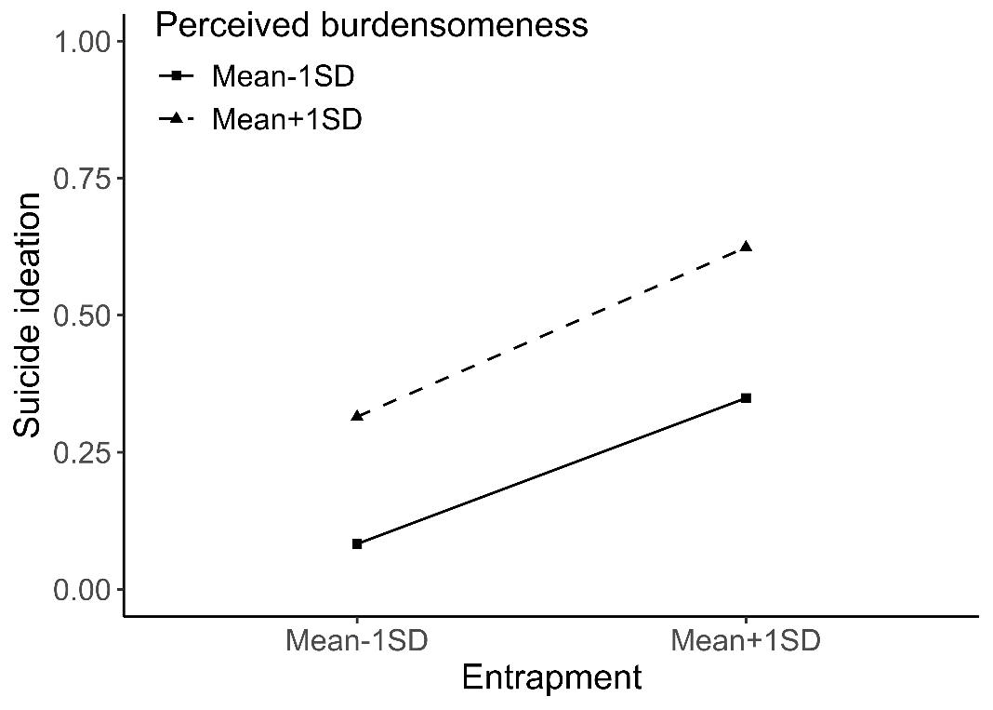
R²=0.28, AIC=1496 | AIC:0.28, R²=1497
  Name | Estimate | 95% CI
  Entrapment | 1,18*** | 0,82 to 1,54
  Perceived Burdensomeness | 0,81*** | 0,56 to 1,06
  Interaction | -0,60* | -1,10 to -0,05
  Name | Estimate | 95% CI
  Entrapment | 1.14*** | 0.77 to 1.50
  Perceived Burdensomeness | 0.81*** | 0.56 to 1.07
  Interaction | -0.57* | -1.07 to -0.02
  Confounder:
  Sex | -0.09 | -0.22to 0.04
  Age | 0.05 | -0.08 to 0.17
* p<0.05, ** p<0.01, ***p<0.001

Moderators in path from entrapment to suicide ideation
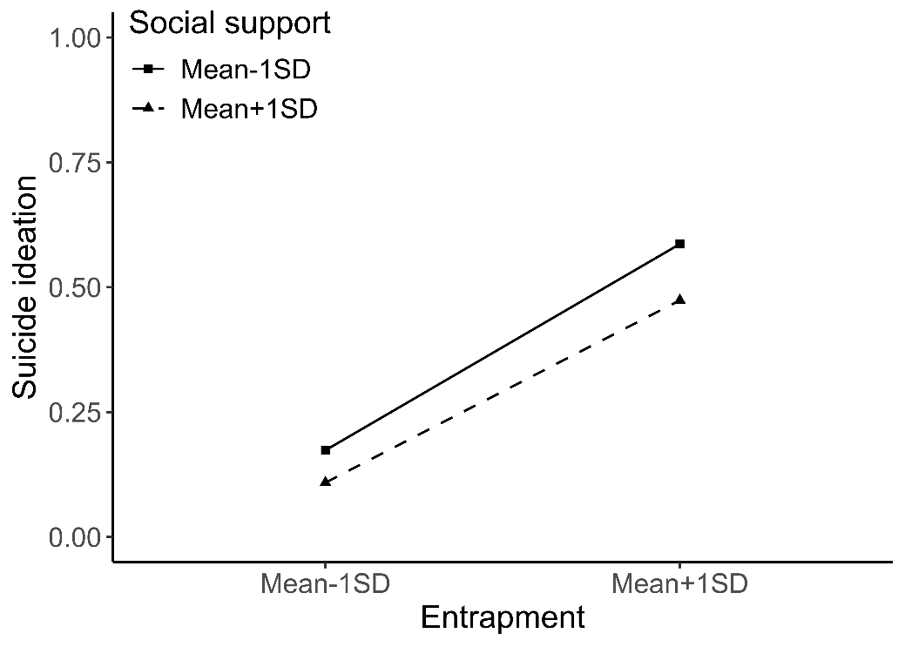 | 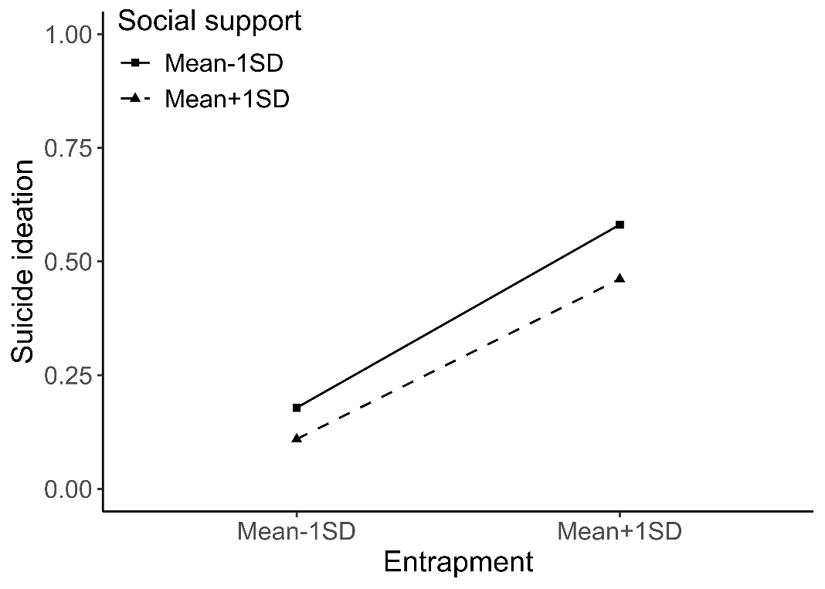
R²=0.26, AIC=1537 | R²=0.26, AIC=1538
  Name | Estimate | 95% CI
  Entrapment | 0,96* | 0,37 to 1,62
  Social support | -0,27* | -0,46 to -0,08
  Interaction | 0,11 | -0,47 to 0,65
  Name | Estimate | 95% CI
  Entrapment | 0.93* | 0.34 to 1.59
  Social support | -0.28* | -0.47 to -0.09
  Interaction | 0.11 | -0.47 to 0.65
  Confounder:
  Sex | -0.11 | -0.24 to 0.02
  Age | 0.005 | -0.12 to 0.13
* p<0.05, ** p<0.01, ***p<0.001

Moderators in path from entrapment to suicide ideation
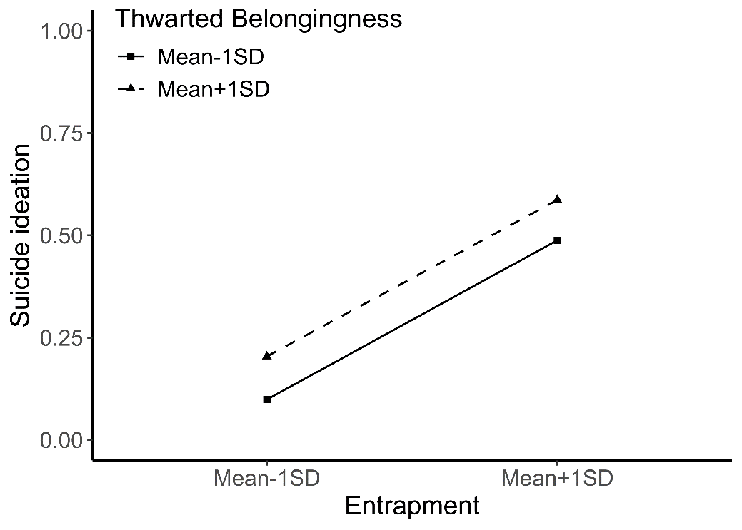 | 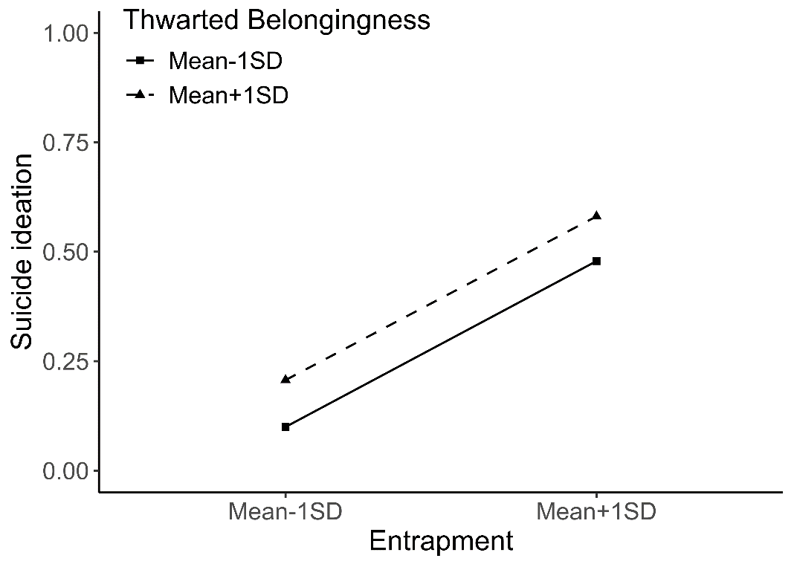
R²=0.26, AIC=1531 | R²=0.26, AIC=1533
  Name | Estimate | 95% CI
  Entrapment | 1.33*** | 0.96 to 1.70
  Thwarted Belongingness | 0.43*** | 0.23 to 0.62
  Interaction | -0.44 | -0.88 to 0.02
  Name | Estimate | 95% CI
  Entrapment | 1.30*** | 0.92 to 1.67
  Thwarted Belongingness | 0.43*** | 0.23 to 0.62
  Interaction | -0.43 | -0.87 to 0.03
  Confounder:
  Sex | -0.09 | -0.22 to 0.04
  Age | -0.0005 | -0.13 to 0.13
* p<0.05, ** p<0.01, ***p<0.001

Moderators in path from entrapment to suicide ideation
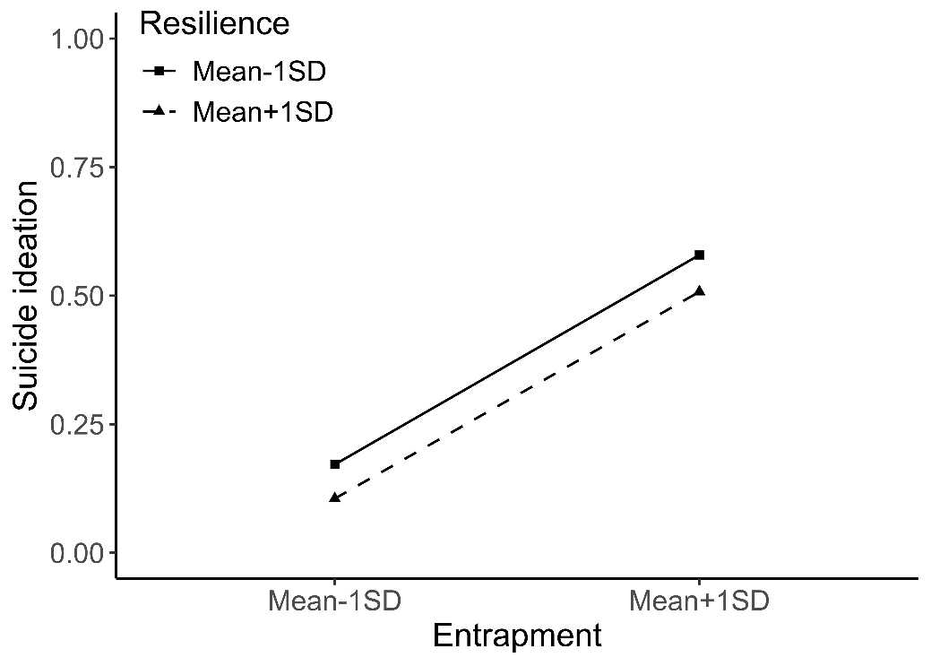 | 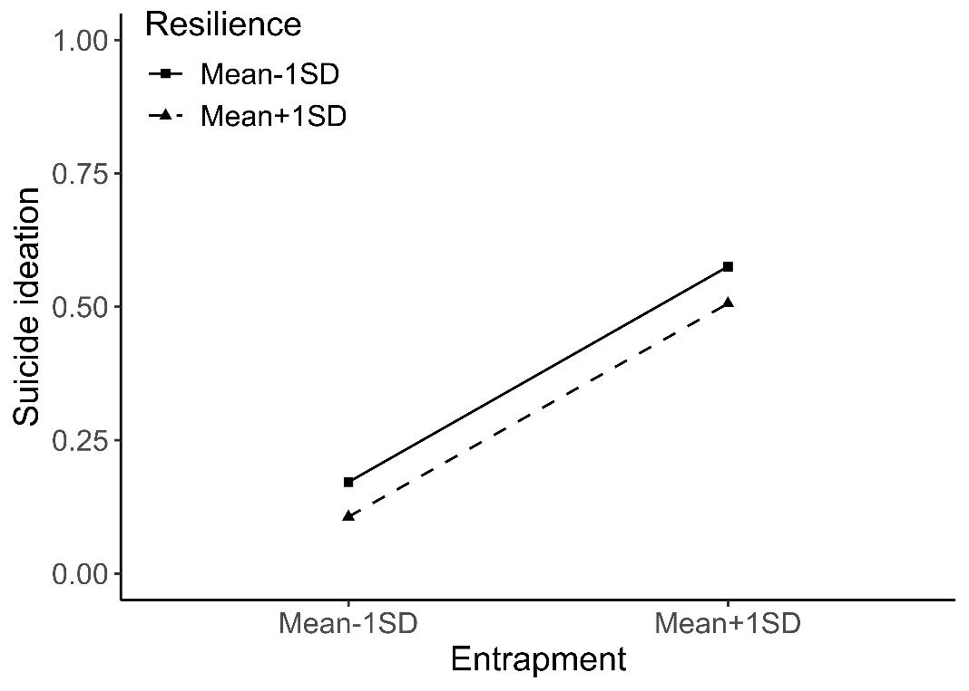
R²=0.26, AIC=1539 | R²=0.26, AIC=1543
  Name | Estimate | 95% CI
  Entrapment | 0,90*** | 0,53 to 1,29
  Resilience | -0,28* | -0.45 to -0,11
  Interaction | 0,20 | -0.15 to 0,54
  Name | Estimate | 95% CI
  Entrapment | 0.89*** | 0.53 to 1.28
  Resilience | -0.28* | -0.45 to -0.10
  Interaction | 0.19 | -0.16 to 0.53
  Confounder:
  Sex | -0.05 | -0.18 to 0.08
  Age | 0.01 | -0.12 to 0.14
* p<0.05, ** p<0.01, ***p<0.001

Moderators in path from suicide ideation to intentional self-harm
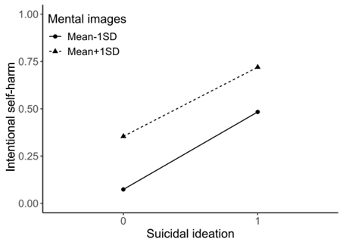 | 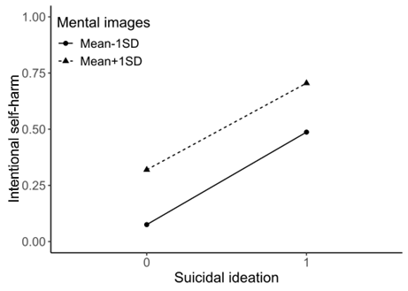
R²=0.33, AIC=1422 | R²=0.35, AIC=1384
  Name | Estimate | 95% CI
  Suicide ideation | 2.00*** | 1.72 to 2.29
  Mental images | 0.97*** | 0.72 to 1.22
  Interaction | -0.46** | -0.77 to -0.15
  Name | Estimate | 95% CI
  Suicide ideation | 2.04*** | 1.75 to 2.33
  Mental images | 0.88*** | 0.63 to 1.13
  Interaction | -0.41** | -0.73 to -0.10
  Confounder:
  Sex | -0.43*** | -0.57 to -0.30
  Age | 0.11 | -0.03 to 0.24
* p<0.05, ** p<0.01, ***p<0.001

Moderators in path from suicide ideation to intentional self-harm
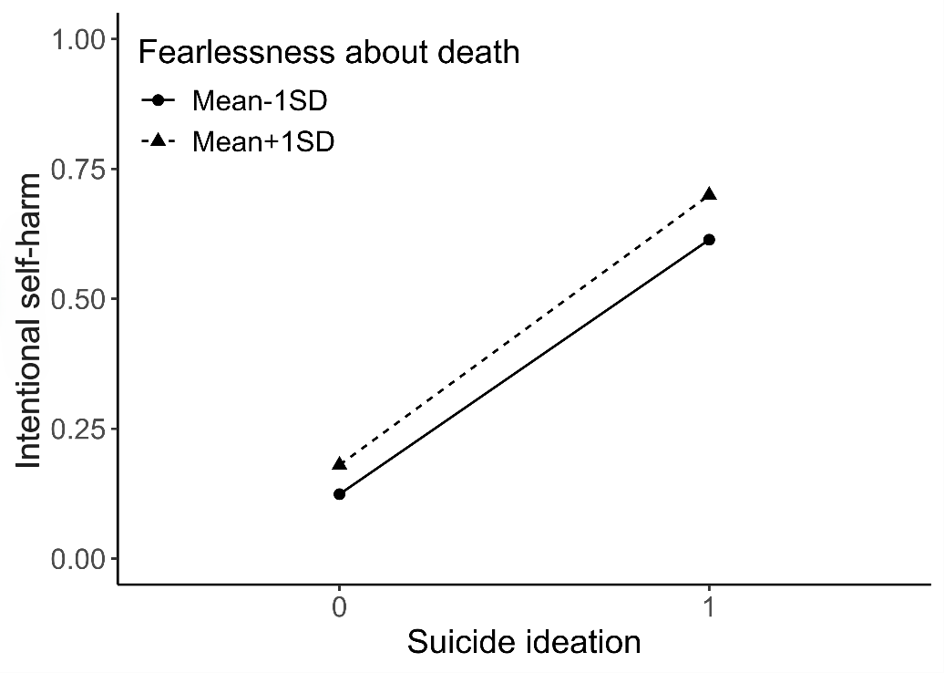 | 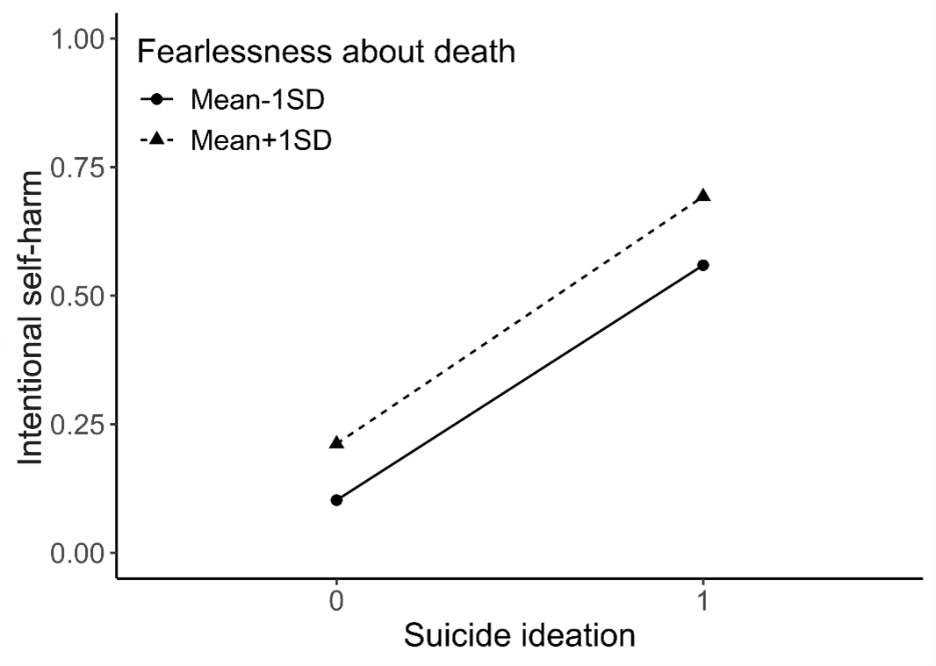
R²=0.29, AIC=1504 | R²=0.33, AIC=1443
  Name | Estimate | 95% CI
  Suicide ideation | 2.39*** | 2.12 to 2.67
  Fearlessness about death | 0.22* | 0.02 to 0.42
  Interaction | -0.03 | -0.30 to 0.24
  Name | Estimate | 95% CI
  Suicide ideation | 2.27*** | 1.99 to 2.56
  Fearlessness about death | 0.43*** | 0.22 to 0.64
  Interaction | -0.14 | -0.42 to 0.14
  Confounder:
  Sex | -0.58*** | -0.72 to -0.45
  Age | 0.13 | 0.00 to 0.26
* p<0.05, ** p<0.01, ***p<0.001

Moderators in path from suicide ideation to intentional self-harm
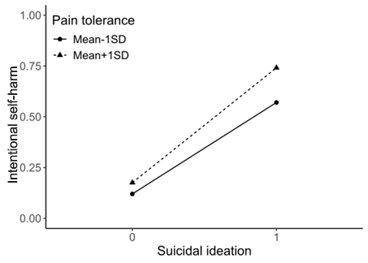 | 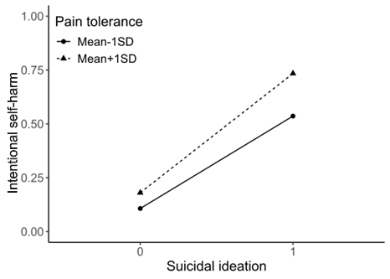
R²=0.30, AIC=1492 | R²=0.33, AIC=1429
  Name | Estimate | 95% CI
  Suicide ideation | 2.44** | 2.18 to 2.70
  Pain tolerance | 0.22** | 0.05 to 0.39
  Interaction | 0.16 | -0.10 to 0.43
  Name | Estimate | 95% CI
  Suicide ideation | 2.40*** | 2.13 to 2.67
  Pain tolerance | 0.30** | 0.13 to 0.48
  Interaction | 0.13 | -0.14 to 0.40
  Confounder:
  Sex | -0.55*** | -0.69 to -0.42
  Age | 0.08 | -0.05 to 0.21
* p<0.05, ** p<0.01, ***p<0.001

Moderators in path from suicide ideation to intentional self-harm
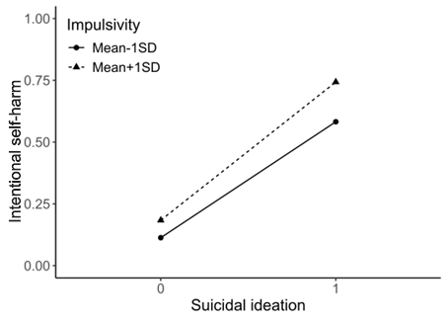 | 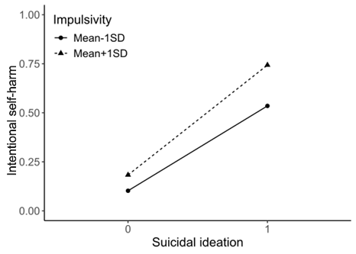
R²=0.30, AIC=1488 | R²=0.34, AIC=1422
  Name | Estimate | 95% CI
  Suicide ideation | 2.47*** | 2.22 to 2.74
  Impulsivity | 0.28** | 0.11 to 0.45
  Interaction | 0.08 | -0.18 to 0.34
  Name | Estimate | 95% CI
  Suicide ideation | 2.43*** | 2.17 to 2.71
  Impulsivity | 0.34*** | 0.16 to 0.51
  Interaction | 0.12 | -0.14 to 0.39
  Confounder:
  Sex | -0.56*** | -0.70 to -0.43
  Age | 0.10 | -0.04 to 0.23
* p<0.05, ** p<0.01, ***p<0.001

Moderators in path from suicide ideation to intentional self-harm
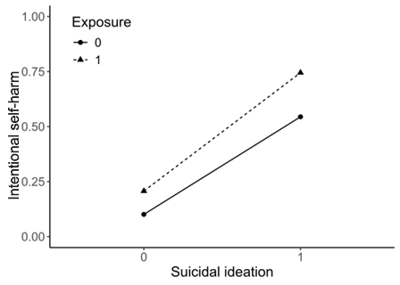

R²=0.31, AIC=1471 | R²=0.33, AIC=1436
  Name | Estimate | 95% CI
  Suicide ideation | 2.37*** | 1.96 to 2.78
  Exposure | 0.84*** | 0.50 to 1.19
  Interaction | 0.05 | -0.48 to 0.58
  Name | Estimate | 95% CI
  Suicide ideation | 2.34*** | 1.93 to 2.77
  Exposure | 0.59** | 0.24 to 0.95
  Interaction | 0.12 | -0.42 to 0.66
  Confounder:
  Sex | -0.43*** | -0.57 to -0.29
  Age | 0.04 | -0.09 to 0.18
* p<0.05, ** p<0.01, ***p<0.001

Moderators in path from suicide ideation to non-suicidal self-injury
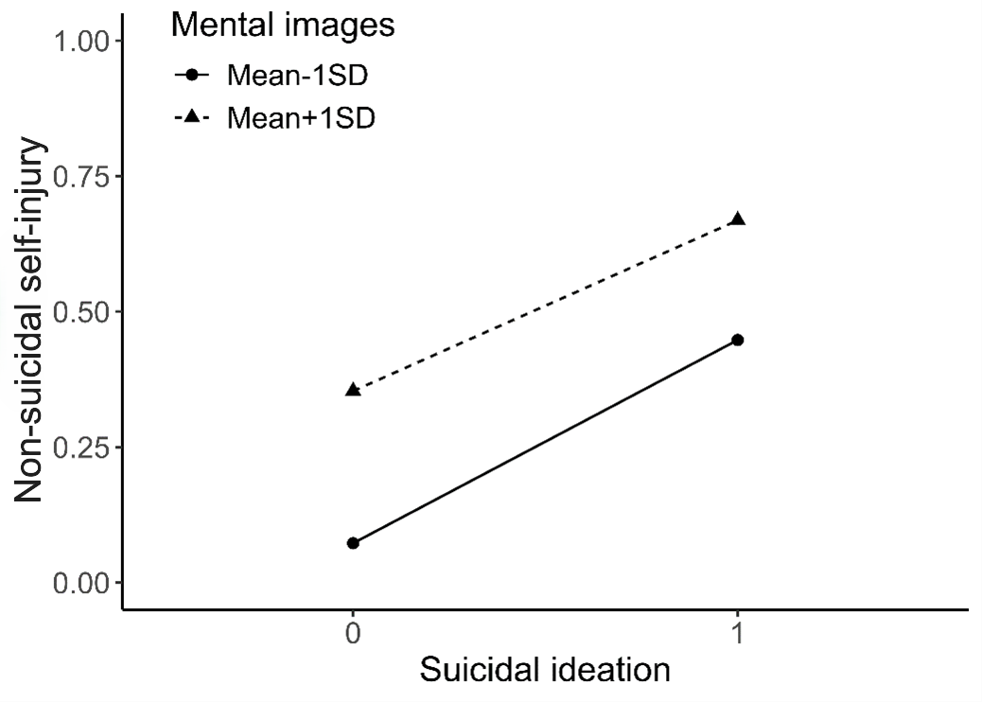 | 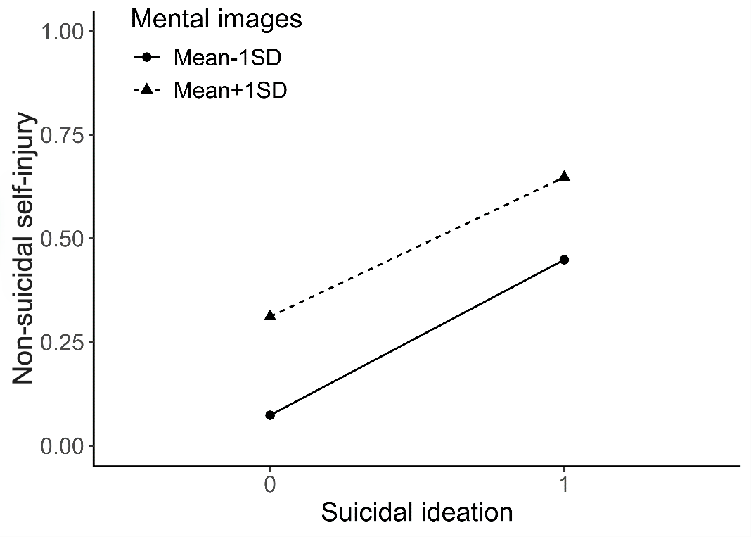
R²=0.30, AIC=1450 | R²=0.33, AIC=1396
  Name | Estimate | 95% CI
  Suicide ideation | 1,82*** | 1,54 to 2,10
  Mental images | 0,97*** | 0.72 to 1,22
  Interaction | -0.51** | -0,82 to -0,21
  Name | Estimate | 95% CI
  Suicide ideation | 1.86*** | 1.58 to 2.16
  Mental images | 0.87*** | 0.62 to 1.13
  Interaction | -0.46*** | -0.77 to -0.15
  Confounder:
  Sex | -0.52*** | -0.66 to -0.38
  Age | 0.10 | -0.03 to 0.24
* p<0.05, ** p<0.01, ***p<0.001

Moderators in path from suicide ideation to non-suicidal self-injury
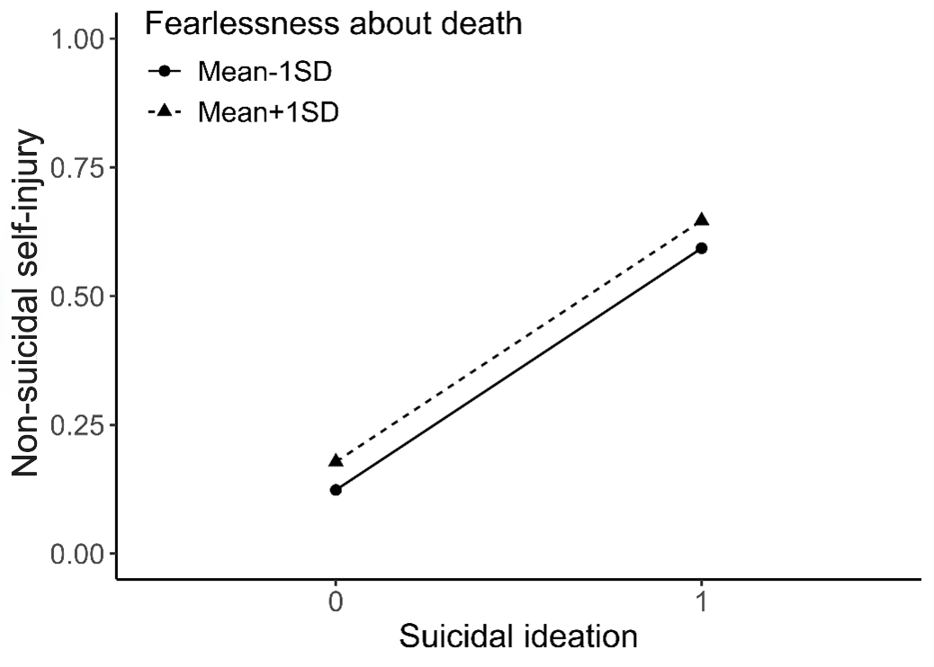 | 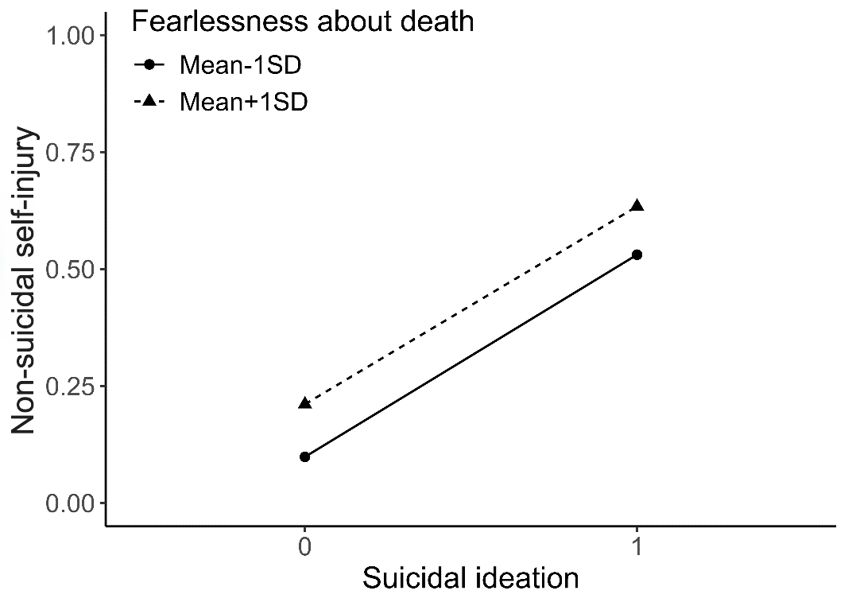
R²=0.25, AIC=1533 | R²=0.30, AIC=1442
  Name | Estimate | 95% CI
  Suicide ideation | 2.23*** | 1,96 to 2,51
  Fearlessness about death | 0.22* | 0,01 to 0,42
  Interaction | -0.10 | -0,37 to 0,16
  Name | Estimate | 95% CI
  Suicide ideation | 2.10*** | 1,82 to 2,39
  Fearlessness about death | 0.45*** | 0.23 to 0.66
  Interaction | -0.23 | -0.51 to 0.04
  Confounder:
  Sex | -0.66*** | -0.80 to -0.52
  Age | 0.12 | -0.01 to 0,25
* p<0.05, ** p<0.01, ***p<0.001

Moderators in path from suicide ideation to non-suicidal self-injury
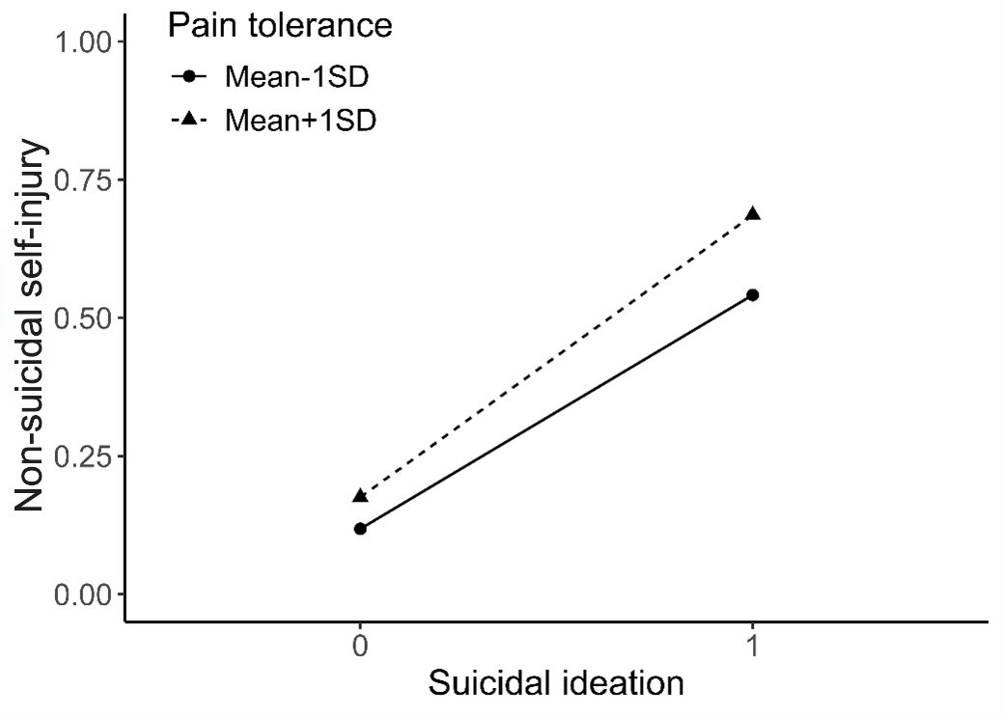 | 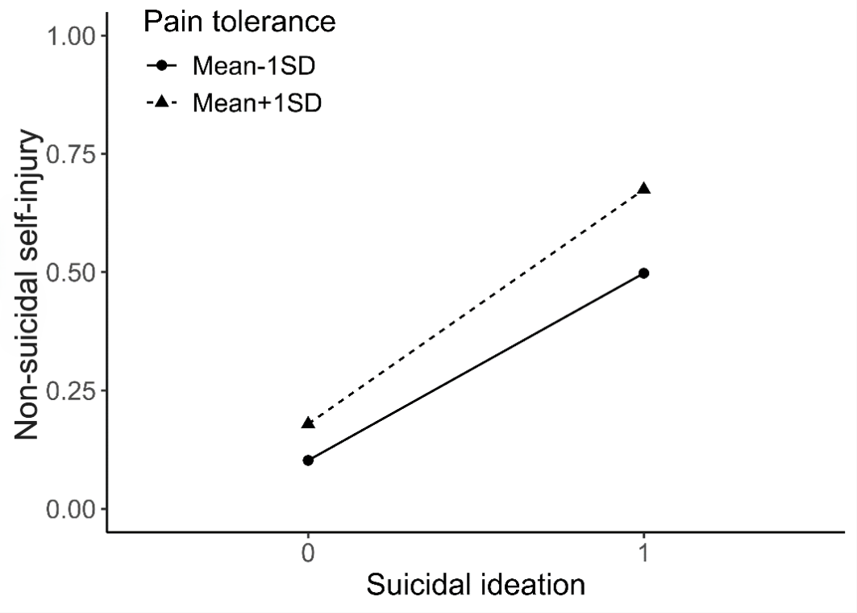
R²=0.26, AIC=1521 | R²=0.30, AIC=1438
  Name | Estimate | 95% CI
  Suicide ideation | 2.25*** | 1.99 to 2,51
  Pain tolerance | 0.23* | 0,06 to 0,40
  Interaction | 0.08 | -0,18 to 0,34
  Name | Estimate | 95% CI
  Suicide ideation | 2.21*** | 1,94 to 2,48
  Pain tolerance | 0,32** | 0.15 to 0.50
  Interaction | 0,04 | -0.22 to 0,31
  Confounder:
  Sex | -0,63*** | -0.77 to -0.49
  Age | 0.07 | -0.06 to 0.20
* p<0.05, ** p<0.01, ***p<0.001

Moderators in path from suicide ideation to non-suicidal self-injury
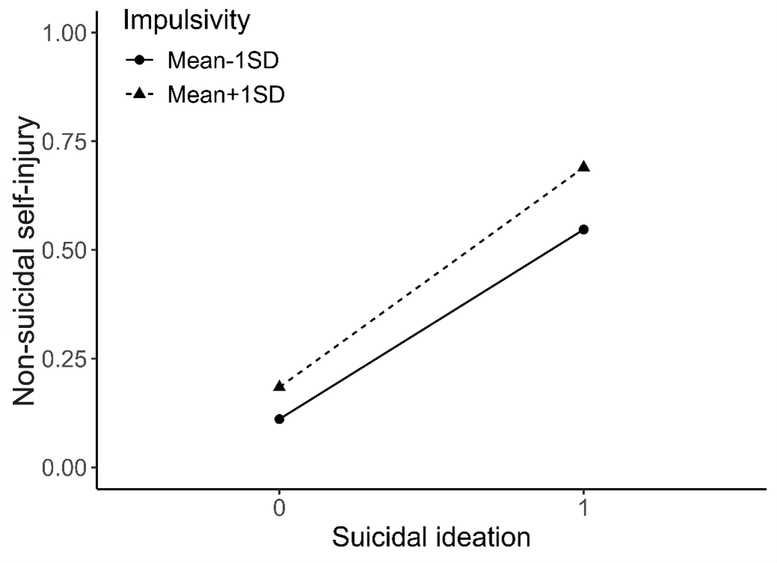 | 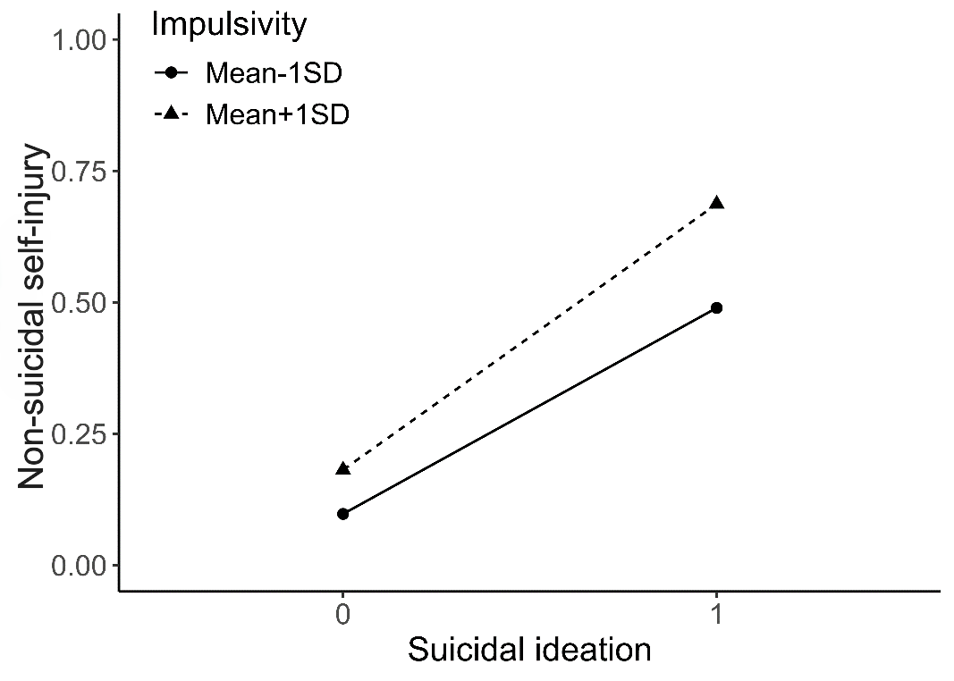
R²=0.26, AIC=1517 | R²=0.31, AIC=1430
  Name | Estimate | 95% CI
  Suicide ideation | 2.28*** | 2.02 to 2,54
  Impulsivity | 0.30** | 0,12 to 0,47
  Interaction | 0.01 | -0.24 to 0,26
  Name | Estimate | 95% CI
  Suicide ideation | 2.24*** | 1,97 to 2,51
  Impulsivity | 0,36*** | 0,18 to 0,53
  Interaction | 0,06 | -0,20 to 0,32
  Confounder:
  Sex | -0,64*** | -0,78 to -0,50
  Age | 0,09 | -0,04 to 0,22
* p<0.05, ** p<0.01, ***p<0.001

Moderators in path from suicide ideation to non-suicidal self-injury
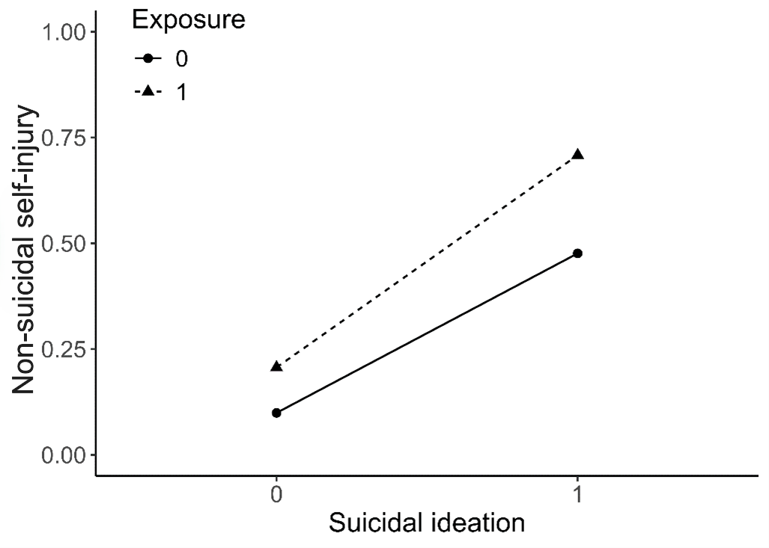 | 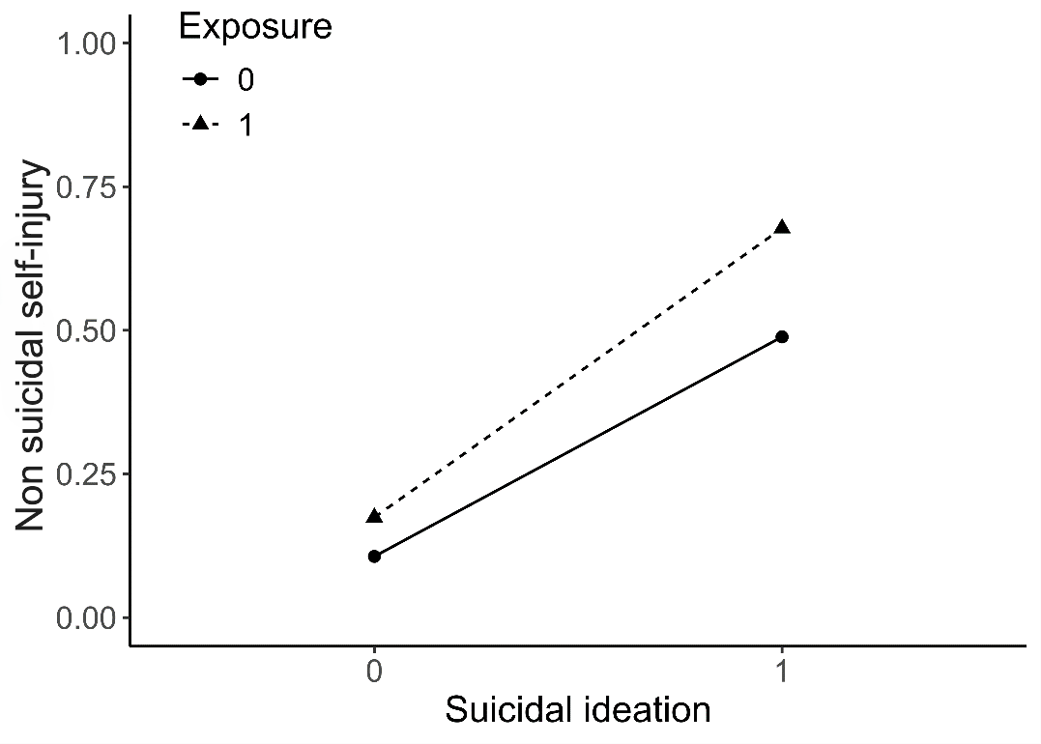
R²=0.27, AIC=1491 | R²=0.30, AIC=1441
  Name | Estimate | 95% CI
  Suicide ideation | 2.11*** | 1.70 to 2.53
  Exposure | 0.86*** | 0.52 to 1.21
  Interaction | 0.12 | -0.41 to 0.65
  Name | Estimate | 95% CI
  Suicide ideation | 2,08*** | 1,66 to 2,51
  Exposure | 0,57** | 0,22 to 0,93
  Interaction | 0,22 | -0,33 to 0,76
  Confounder:
  Sex | -0,51*** | -0,65 to -0,37
  Age | 0,04 | -0,09 to 0,17
* p<0.05, ** p<0.01, ***p<0.001

Moderators in path from suicide ideation to suicide attempt
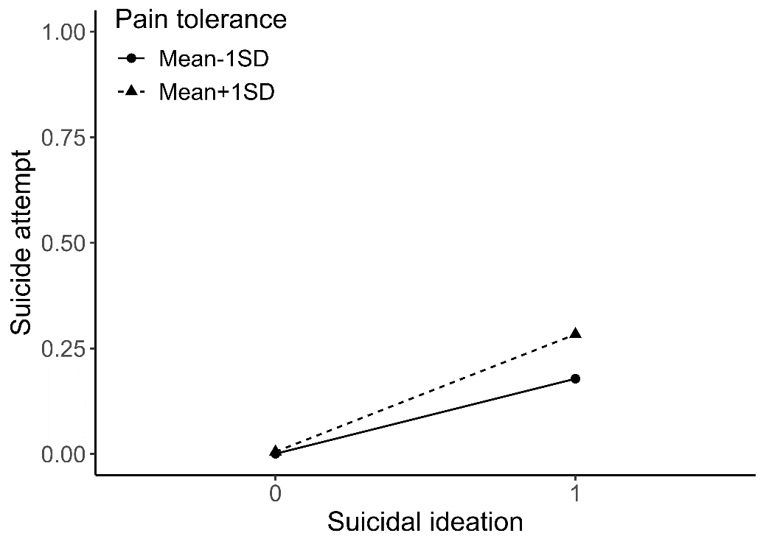 | 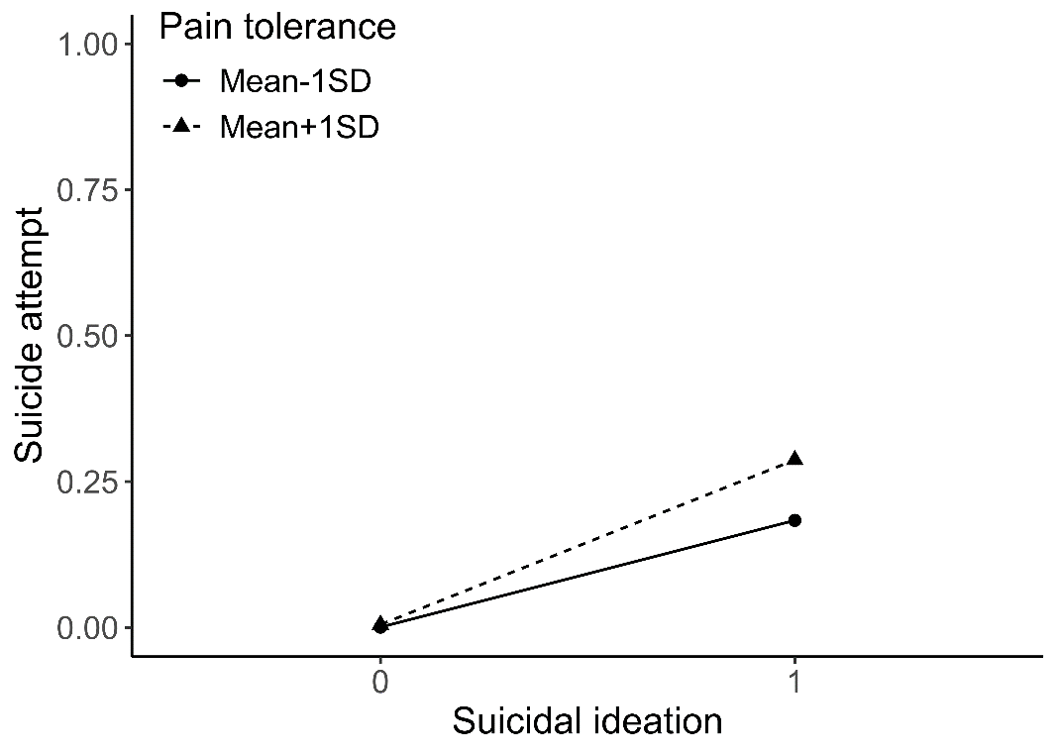
R²=0.19, AIC=572 | R²=0.19, AIC=574
  Name | Estimate | 95% CI
  Suicide ideation | 5,14** | 3,87 to 7,46
  Pain tolerance | 1,12 | -0,05 to 2,65
  Interaction | -0,82 | -2,36 to 0,38
  Name | Estimate | 95% CI
  Suicide ideation | 5.19** | 3.91 to 7.51
  Pain tolerance | 1.10 | -0.07 to 2.62
  Interaction | -0.81 | -2.34 to 0.39
  Confounder:
  Sex | 0.14 | -0.08 to 0.35
  Age | -0.04 | -0.25 to 0.17
* p<0.05, ** p<0.01, ***p<0.001
Moderators in path from suicide ideation to suicide attempt
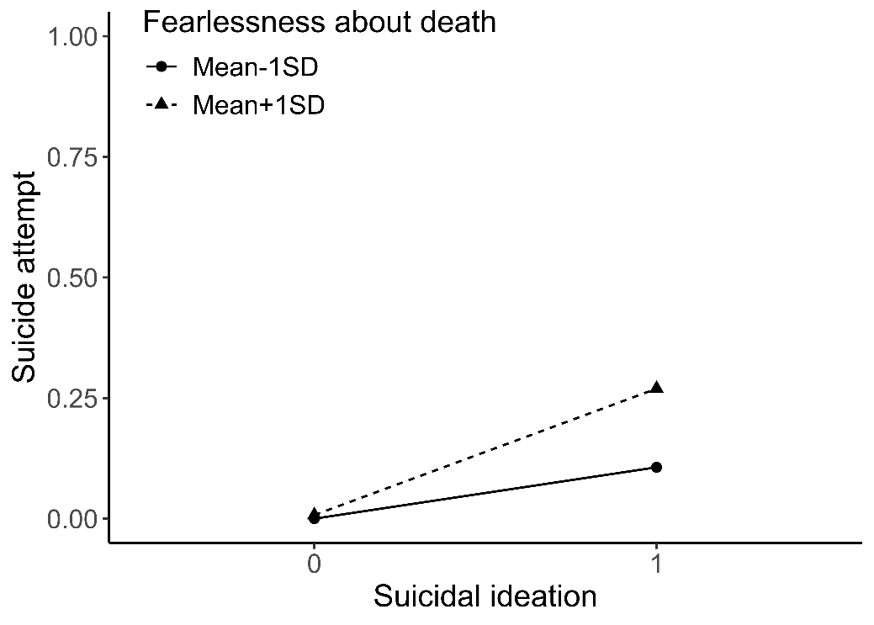 | 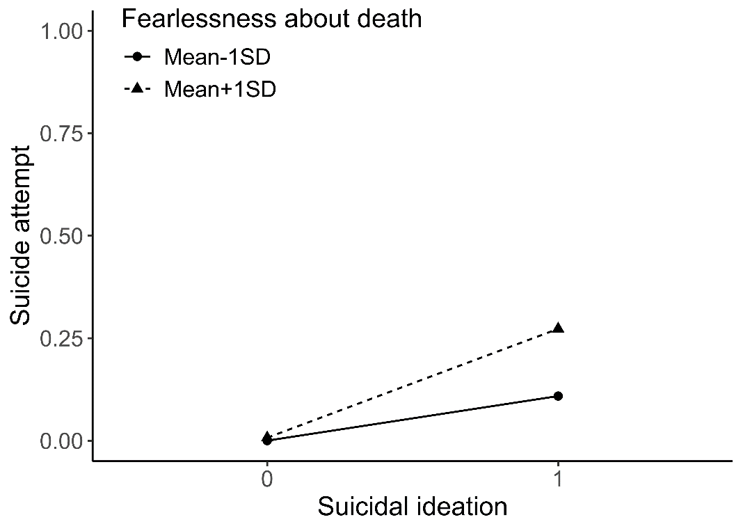
R²=0.23, AIC=543 | R²=0.24, AIC=546
  Name | Estimate | 95% CI
  Suicide ideation | 4,97*** | 3,59 to 7.26
  Fearlessness about death | 1,67* | 0,49 to 2,94
  Interaction | -1,10 | -2,39 to 0,09
  Name | Estimate | 95% CI
  Suicide ideation | 5.01*** | 3.63 to 7.31
  Fearlessness about death | 1.65* | 0.47 to 2.92
  Interaction | -1.09 | -2.38 to 0.11
  Confounder:
  Sex | 0.09 | -0.13 to 0.30
  Age | 0.03 | -0.18 to 0.24
* p<0.05, ** p<0.01, ***p<0.001

Moderators in path from suicide ideation to suicide attempt
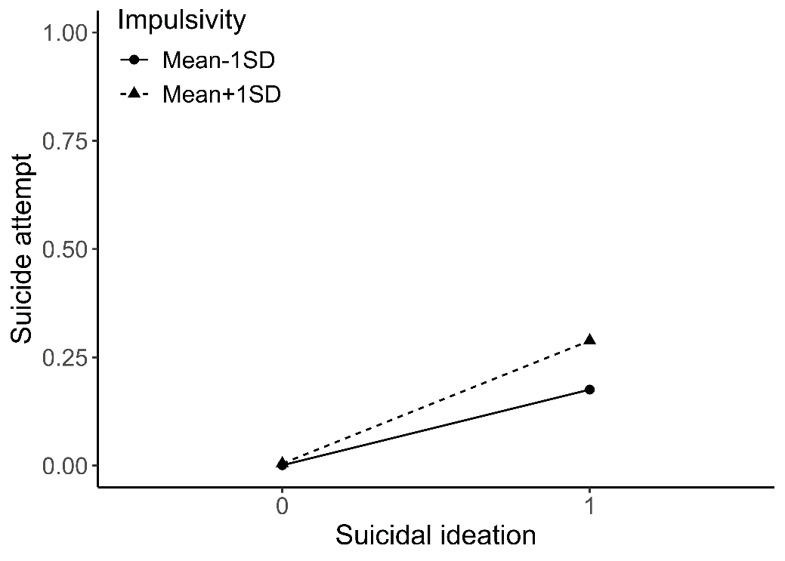 | 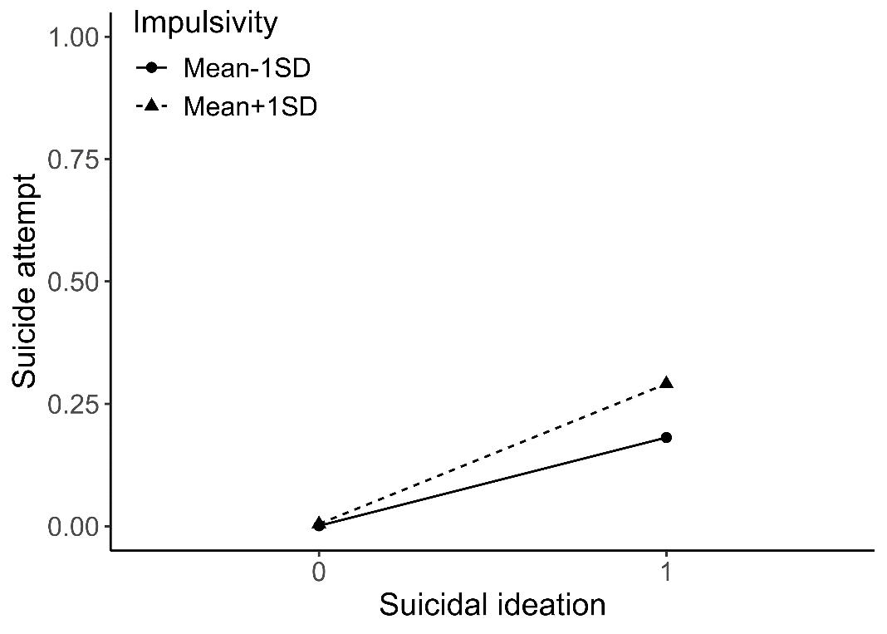
R²=0.20, AIC=570 | R²=0.20, AIC=573
  Name | Estimate | 95% CI
  Suicide ideation | 4,93** | 3,80 to 6,72
  Impulsivity | 0,81 | -0,25 to 1,79
  Interaction | -0,48 | -1,48 to 0,59
  Name | Estimate | 95% CI
  Suicide ideation | 4.97** | 3.84 to 6.77
  Impulsivity | 0.80 | -0.26 to 1.79
  Interaction | -0.49 | -1.50 to 0.58
  Confounder:
  Sex | 0.12 | -0.10 to 0.33
  Age | -0.02 | -0.23 to 0.19
* p<0.05, ** p<0.01, ***p<0.001
Moderators in path from suicide ideation to suicide attempt
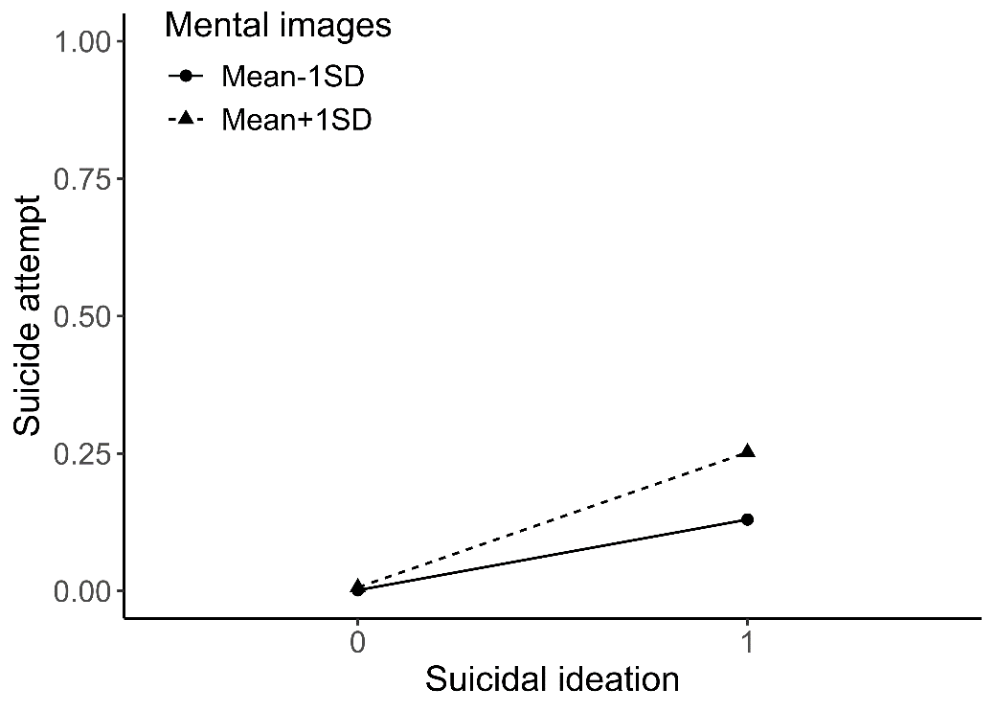 | 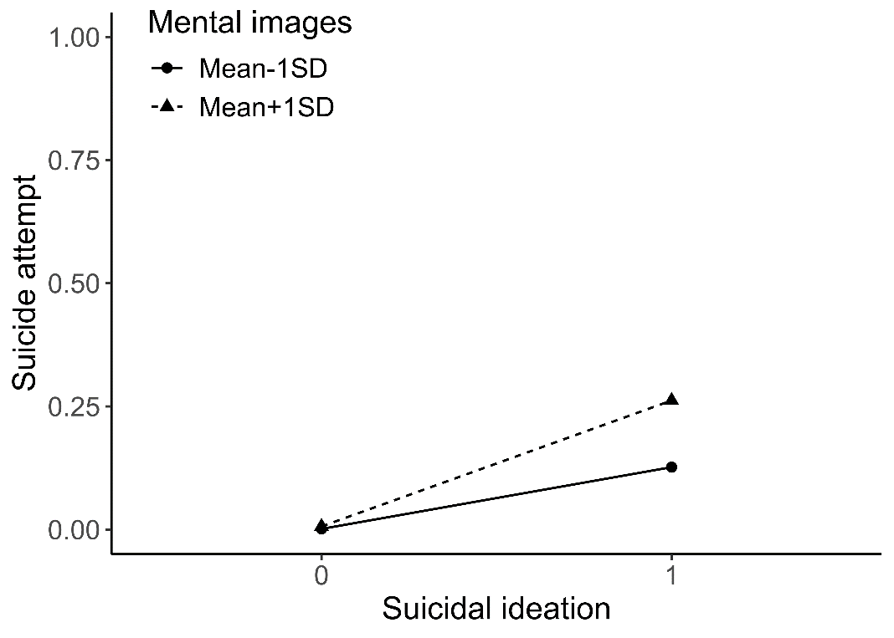
R²=0.22, AIC=557 | R²=0.23, AIC=555
  Name | Estimate | 95% CI
  Suicide ideation | 4,30*** | 3,29 to 5,73
  Mental images | 0.76 | -0,71 to 1,64
  Interaction | -0.35 | -1,25 to 1,12
  Name | Estimate | 95% CI
  Suicide ideation | 4.35*** | 3.34 to 5.79
  Mental images | 0.78 | -0.66 to 1.63
  Interaction | -0.33 | -1.20 to 1.11
  Confounder:
  Sex | 0.27* | 0.05 to 0.50
  Age | 0.01 | -0.20 to 0.22
* p<0.05, ** p<0.01, ***p<0.001
Moderators in path from suicide ideation to suicide attempt
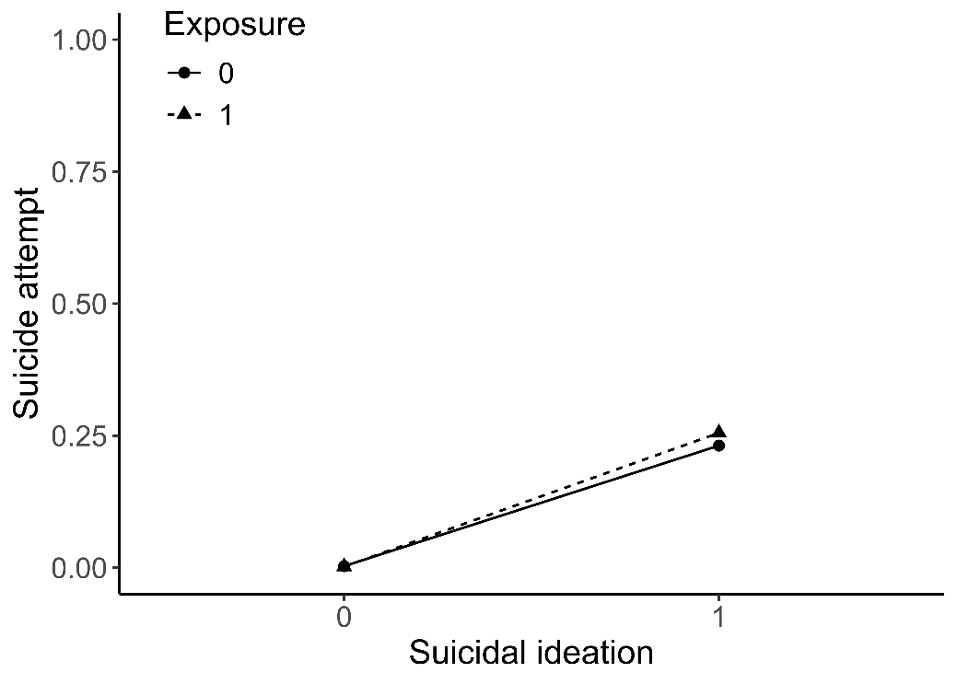 | 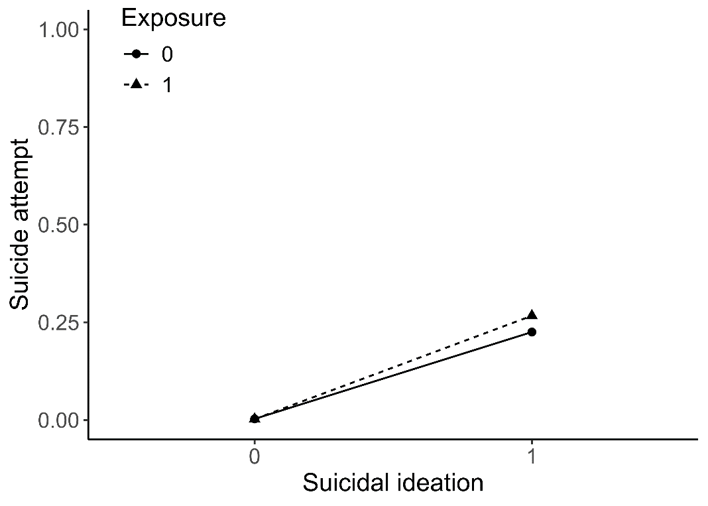
R²=0.18, AIC=582 | R²=0.18, AIC=583
  Name | Estimate | 95% CI
  Suicide ideation | 4.59*** | 3.38 to 6.41
  Exposure | -0.32 | -3,39 to 2,03
  Interaction | 0.45 | -1.94 to 3.55
  Name | Estimate | 95% CI
  Suicide ideation | 4.63*** | 3.42 to 6.46
  Exposure | -0.20 | -3.27 to 2.16
  Interaction | 0.42 | -1.97 to 3.52
  Confounder:
  Sex | 0.18 | -0.04 to 0.39
  Age | -0.04 | -1.97 to 3.52
* p<0.05, ** p<0.01, ***p<0.001

