Supplement

Table of Contents
Table 1 | Experimental dataset Summary. | Page 2
Table 2 | Ablation experiment of two types of features. | Page 3
Table 3 | The impact of dictionary size on model performance. | Page 3

Figure of Contents
Fgiure 1 | Glioma tissue-level dictionary containing 128 image patches. | Page 4
Fgiure 2 | Glioma cellular-level dictionary containing 1024 image patches. | Page 5
Fgiure 3 | Representative image patches obtained by clustering in the two dictionaries. | Page 6
Fgiure 4 | Histological annotations of the representative image patches from the two dictionaries. | Page 7
Fgiure 5 | Prognosis prediction results of PATH-SparseD on CUHK Glioma (Cohort 1), HHAFD Glioma (Cohort 2) and TCGA Glioma (Cohort 3). | Page 8
Fgiure 6 | Prognosis prediction results of PATH-SparseD on TCGA KRIC (Cohort 4), TCGA LIHC (Cohort 5) and TCGA STAD (Cohort 6). | Page 9
Fgiure 7 | Prognosis prediction results of PATH-SparseD on TCGA LUNG (Cohort7), TCGA BRCA (Cohort8), TCGA COAD (Cohort9) and TCGA READ (Cohort10). | Page 10
Fgiure 8-21 | Tissue-level and cellular-level dictionaries of TCGA KRIC, TCGA LIHC, TCGA STAD, TCGA LUNG, TCGA BRCA, TCGA COAD and TCGA READ, respectively. | Page 11-24

Table 1 Experimental dataset Summary. Ten datasets encompassing eight tumor types. 4997 cases of data were used for tumor classification tasks, and 5185 cases of data were used for tumor prognosis prediction tasks.
Dataset properties | Cohorts | Classification |  | Prognosis prediction
Private datasets | CUHK Glioma  (Cohort 1) | Genotyping  IDH1 Mutation  IDH1 Wildtype | 556  349  207 | 556
Private datasets | CUHK Glioma  (Cohort 1) | Grading  LGG  GBM | 556  399  157 | 556
Private datasets | HHAFD Glioma  (Cohort 2) | Genotyping  IDH1 Mutation  IDH1 Wildtype | 397  183  214 | 309
Private datasets | HHAFD Glioma  (Cohort 2) | Grading  LGG  GBM | 397  262  135 | 309
Public datasets | TCGA Glioma  (Cohort 3) | Genotyping  IDH1 Mutation  IDH1 Wildtype | 693  360  333 | 693
Public datasets | TCGA Glioma  (Cohort 3) | Grading  LGG  GBM | 693  414  279 | 693
Public datasets | TCGA KRIC  (Cohort 4) | TNM Grading  1,2  3,4 | 508  197  311 | 508
Public datasets | TCGA LIHC  (Cohort 5) | TNM Grading  1,2  3,4 | 318  158  160 | 318
Public datasets | TCGA STAD  (Cohort 6) | Tumor Differentiation  Yes  No | 282  108  174 | 400
Public datasets | TCGA LUNG  (Cohort 7) | Cellular origin identification  Squamous cell carcinoma  Adenocarcinoma | 1046  512  534 | 1006
Public datasets | TCGA BRCA  (Cohort 8) | Cellular origin identification  carcinoma  Infiltrating duct carcinoma | 893  714  179 | 893
Public datasets | TCGA COAD  (Cohort 9) | Organ origin identification  Cecum  Colon | 168  94  74 | 396
Public datasets | TCGA READ  (Cohort 10) | Organ origin identification  Rectum  Rectosigmoid junction | 136  77  59 | 136
Total Number |  | 4997 |  | 5185

Table 2 Ablation experiment of two types of features on IDH1 genotyping task. CHP: Quantification feature of canonical histopathological pattern. SPP: Quantification feature of spatial proximity phenotypes.
Experiment | Methods | AUC | ACC | SEN | SPE | PPV | NPV
Multi-GLIOMA | CHP | 0.869  [0.874 0.866] | 0.815  [0.824 0.809] | 0.838  [0.842 0.836] | 0.786  [0.809 0.774] | 0.831  [0.852 0.813] | 0.794  [0.810 0.783]
Multi-GLIOMA | CHP+SPP | 0.883  [0.882 0.883] | 0.827  [0.825 0.827] | 0.790  [0.788 0.791] | 0.872  [0.871 0.874] | 0.886  [0.885 0.887] | 0.768  [0.765 0.768]
CUHK-GLIOMA | Methods | AUC | ACC | SEN | SPE | PPV | NPV
CUHK-GLIOMA | CHP | 0.887  [0.886 0.891] | 0.855  [0.853 0.858] | 0.885  [0.882 0.887] | 0.808  [0.806 0.815] | 0.877  [0.875 0.881] | 0.819  [0.816 0.824]
CUHK-GLIOMA | CHP+SPP | 0.909  [0.907 0.911] | 0.860  [0.857 0.862] | 0.947  [0.943 0.947] | 0.726  [0.722 0.732] | 0.843  [0.840 0.846] | 0.898  [0.892 0.900]
HHAFD-GLIOMA | Methods | AUC | ACC | SEN | SPE | PPV | NPV
HHAFD-GLIOMA | CHP | 0.822  [0.818 0.825] | 0.812  [0.807 0.813] | 0.831  [0.825 0.834] | 0.797  [0.790 0.799] | 0.766  [0.759 0.769] | 0.855  [0.849 0.857]
HHAFD-GLIOMA | CHP+SPP | 0.871  [0.865 0.872] | 0.850  [0.844 0.850] | 0.831  [0.825 0.834] | 0.865  [0.858 0.865] | 0.831  [0.822 0.831] | 0.865  [0.860 0.867]
TCGA-GLIOMA | Methods | AUC | ACC | SEN | SPE | PPV | NPV
TCGA-GLIOMA | CHP | 0.907  [0.905 0.909] | 0.853  0.852 0.856] | 0.882  [0.881 0.887] | 0.826  [0.824 0.830] | 0.822  [0.819 0.826] | 0.885  [0.884 0.890]
TCGA-GLIOMA | CHP+SPP | 0.930  [0.930 0.933] | 0.866  [0.865 0.869] | 0.855  [0.854 0.859] | 0.876  [0.875 0.880] | 0.862  [0.861 0.867] | 0.869  [0.868 0.873]

Table 3 The impact of dictionary size on model performance (IDH1 genotyping task).
Dictionary | AUC | ACC | SEN | SPE | PPV | NPV
8× 32 | 0.869  [0.874 0.866] | 0.815  [0.824 0.809] | 0.838  [0.842 0.836] | 0.786  [0.809 0.774] | 0.831  [0.852 0.813] | 0.794  [0.810 0.783]
8× 64 | 0.883  [0.882 0.883] | 0.827  [0.825 0.827] | 0.790  [0.788 0.791] | 0.872  [0.871 0.874] | 0.886  [0.885 0.887] | 0.768  [0.765 0.768]
8× 128 | 0.883  [0.882 0.883] | 0.827  [0.825 0.827] | 0.790  [0.788 0.791] | 0.872  [0.871 0.874] | 0.886  [0.885 0.887] | 0.768  [0.765 0.768]
40× 512 | 0.904  [0.903 0.908] | 0.876  [0.875 0.880] | 0.912  [0.910 0.916] | 0.822  [0.818 0.826] | 0.888  [0.886 0.891] | 0.857  [0.855 0.864]
40× 1024 | 0.909  [0.907 0.911] | 0.860  [0.857 0.862] | 0.947  [0.943 0.947] | 0.726  [0.722 0.732] | 0.843  [0.840 0.846] | 0.898  [0.892 0.900]
40× 2048 | 0.888  [0.885 0.891] | 0.850  [0.845 0.851] | 0.797  [0.792 0.801] | 0.892  [0.885 0.892] | 0.855  [0.845 0.854] | 0.846  [0.843 0.850]

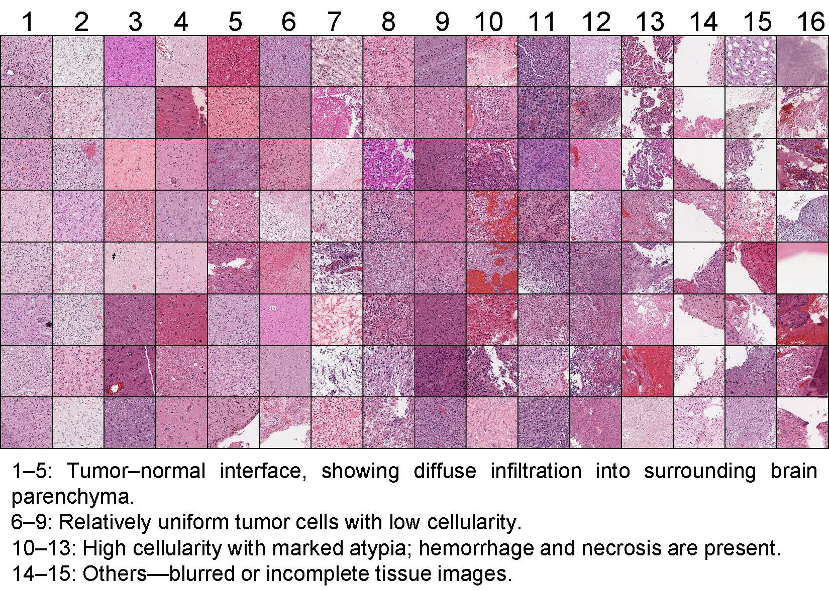
Figure 1 Tissue-level dictionary of GLIOMA containing 128 image patches.

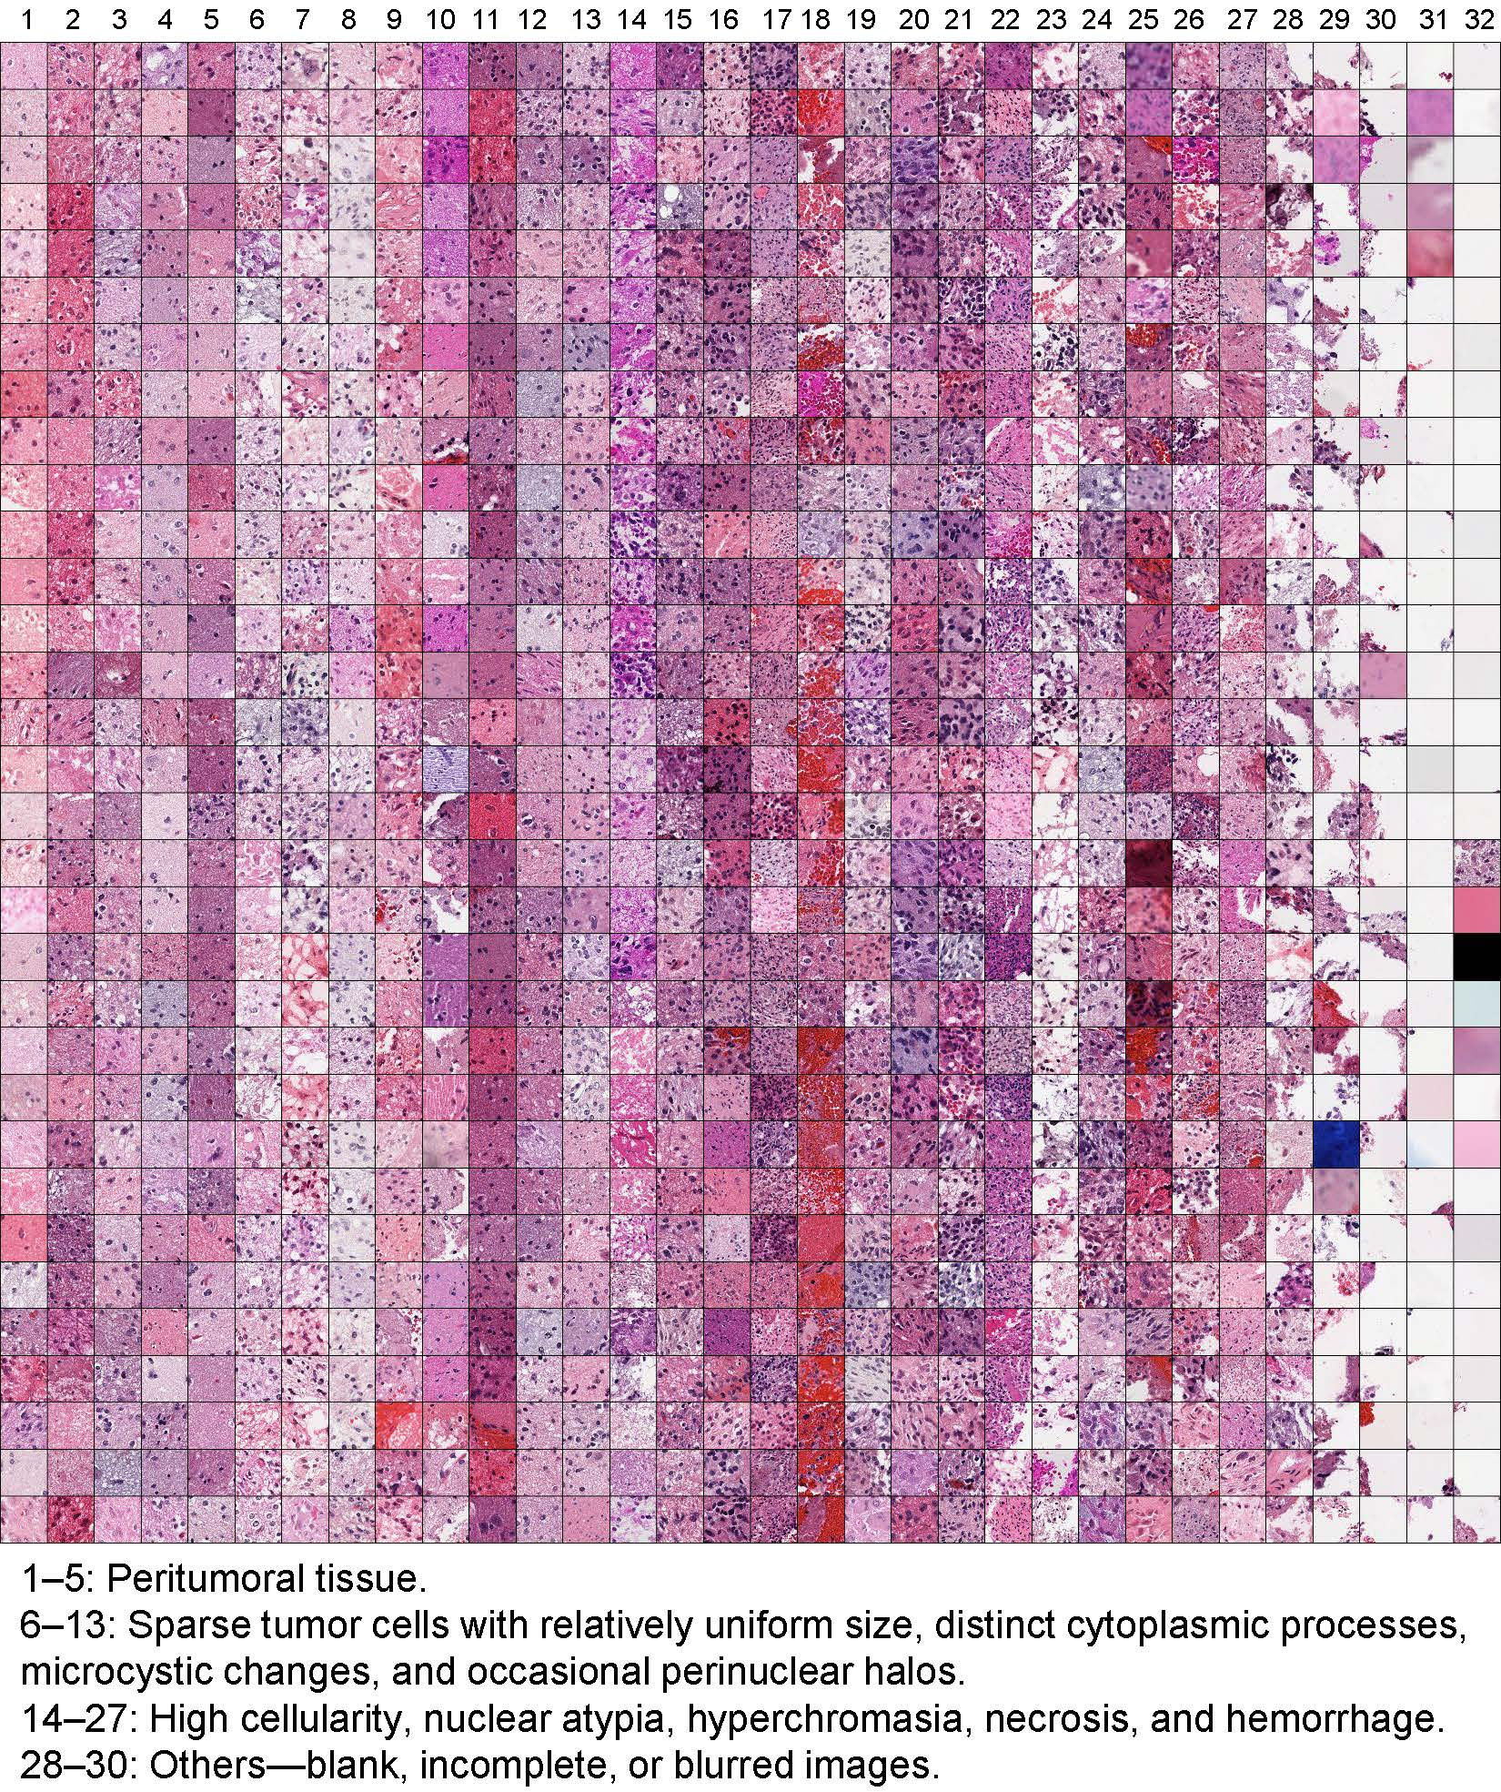
Figure 2 Cellular-level dictionary of GLIOMA containing 1024 image patches.

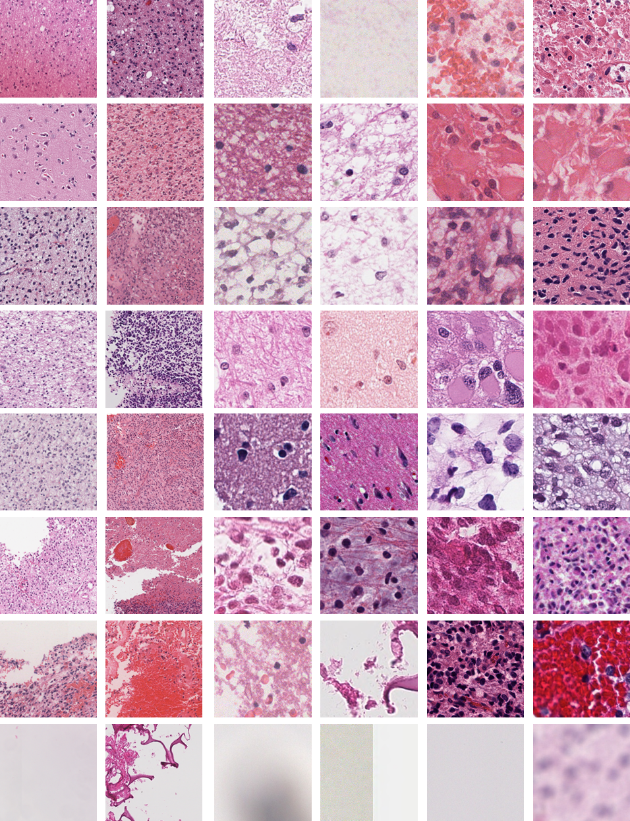
Figure 3 Representative image patches obtained by clustering in the two dictionaries, with 16 patches from the 8× dictionary and 32 the 40× dictionary.

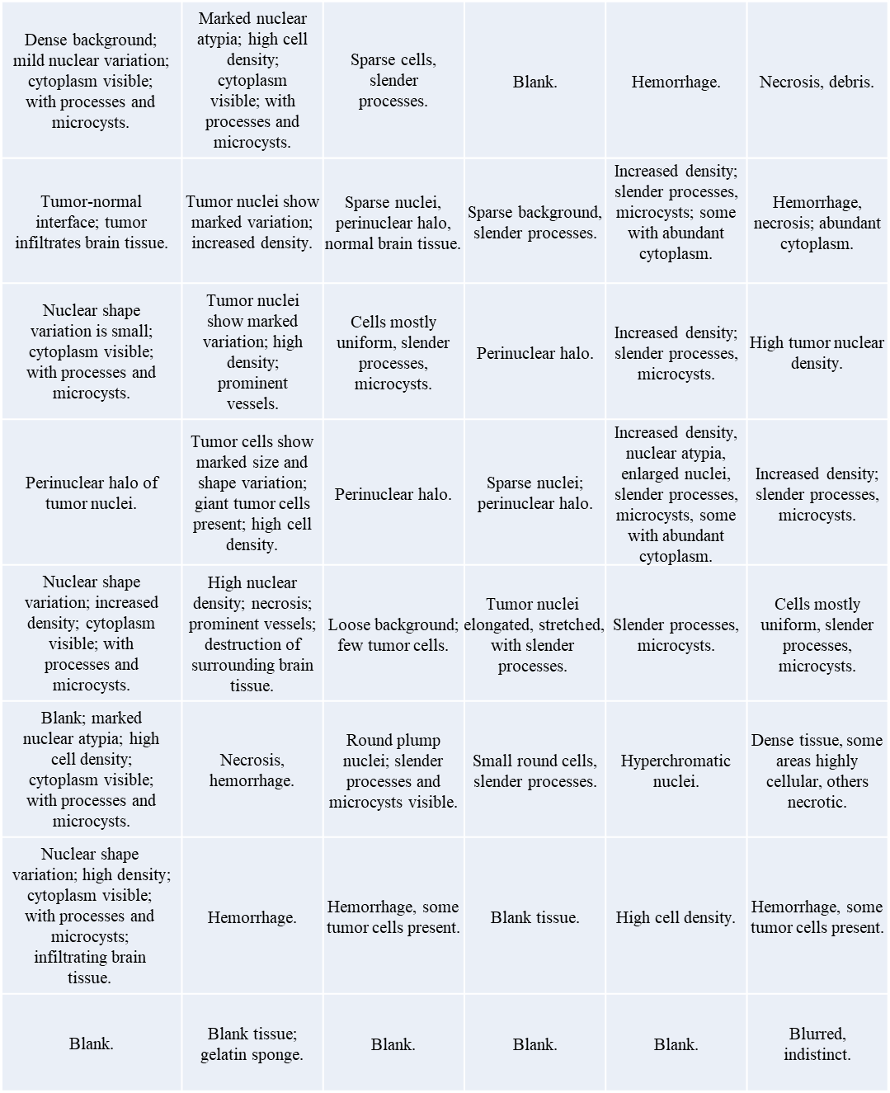
Figure 4 Histological annotations of the representative image patches from the two dictionaries.

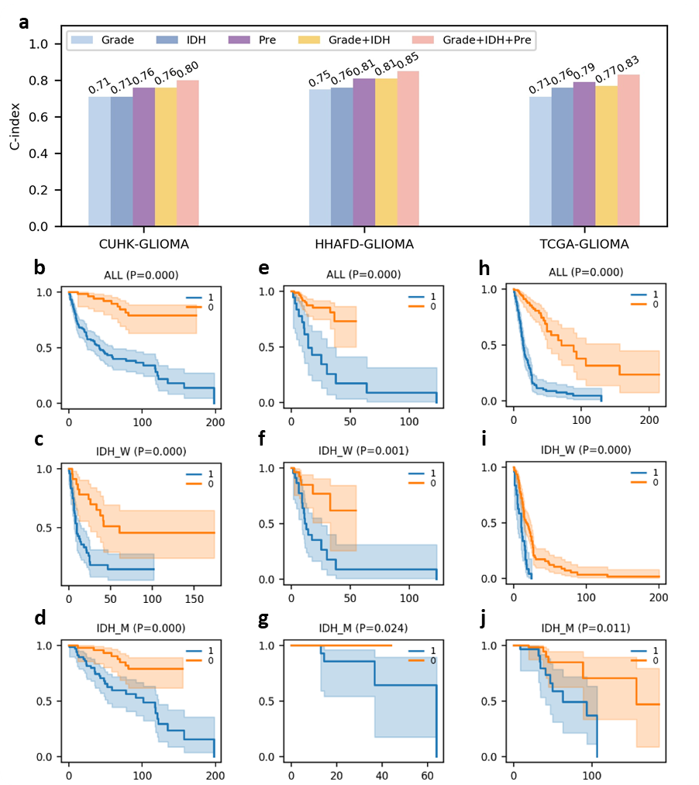
Figure 5 Prognosis prediction results of PATH-SparseD on glioma dataset. a. Comparison of the prognosis prediction c-index of PATH-SparseD and clinical indicators. b. c. and d. are the KM curves of PATH-SparseD for the high and low risk classification of all cases, IDH1 wild-type cases and IDH1 mutant cases in cohort 1, respectively. e. f. and g. are the KM curves of PATH-SparseD for the prognosis classification of each group of cases in cohort 2, respectively. h. i. and j. are the KM curves of PATH-SparseD for the prognosis classification of each group of cases in cohort 3, respectively.

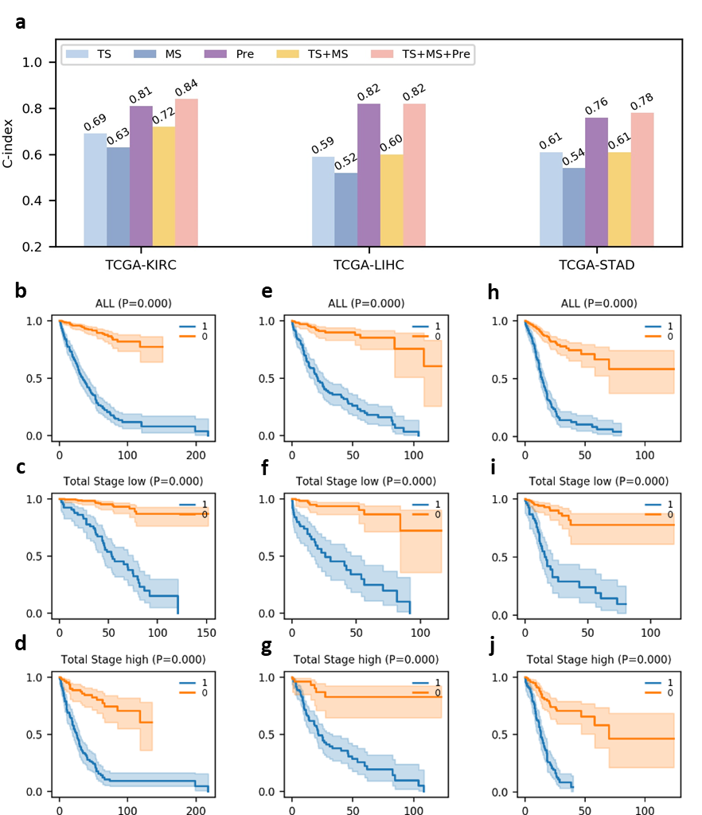
Figure 6 Prognosis prediction results of PATH-SparseD on TCGA KRIC (Cohort 4), TCGA LIHC (Cohort 5) and TCGA STAD (Cohort 6). a. Comparison of the prognosis prediction c-index of PATH-SparseD and clinical indicators. b. e. and h. are the KM curves for the high and low risk classification of all data of the three cohorts. c. f. and i. are the KM curves of cases with low TNM grade (1 and 2). d. g. and j. are the KM curves of cases with high TNM grade (3 and 4).

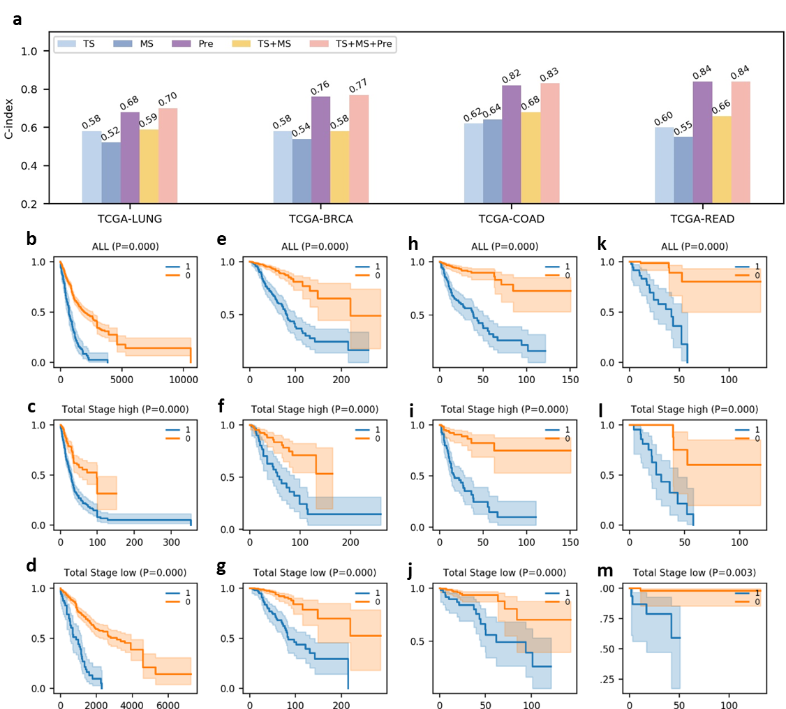
Figure 7 Prognosis prediction results of PATH-SparseD on TCGA LUNG (Cohort7), TCGA BRCA (Cohort8), TCGA COAD (Cohort9) and TCGA READ (Cohort10). a. Comparison of the prognosis prediction c-index of PATH-SparseD and clinical indicators. b. e. h. and k. are the KM curves for the high and low risk classification of all data of the three cohorts. c. f. i. and l. are the KM curves of cases with low TNM grade (1 and 2). d. g. j. and m. are the KM curves of cases with high TNM grade (3 and 4).

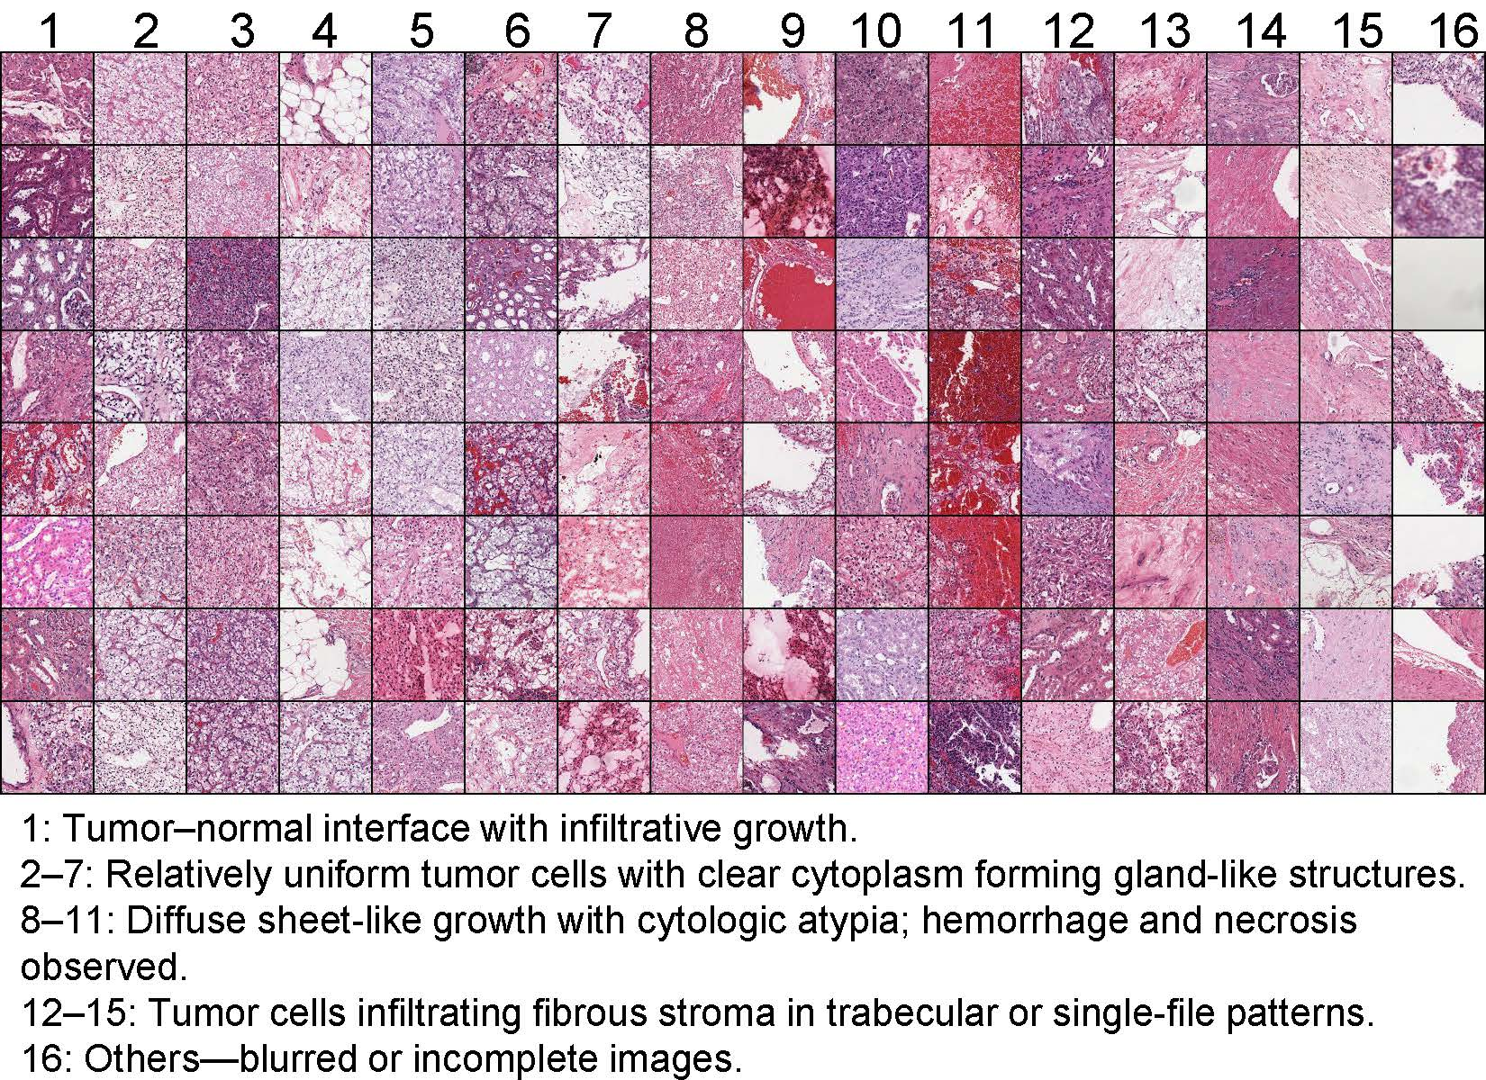
Figure 8 Tissue-level dictionary of TCGA-KIRC.
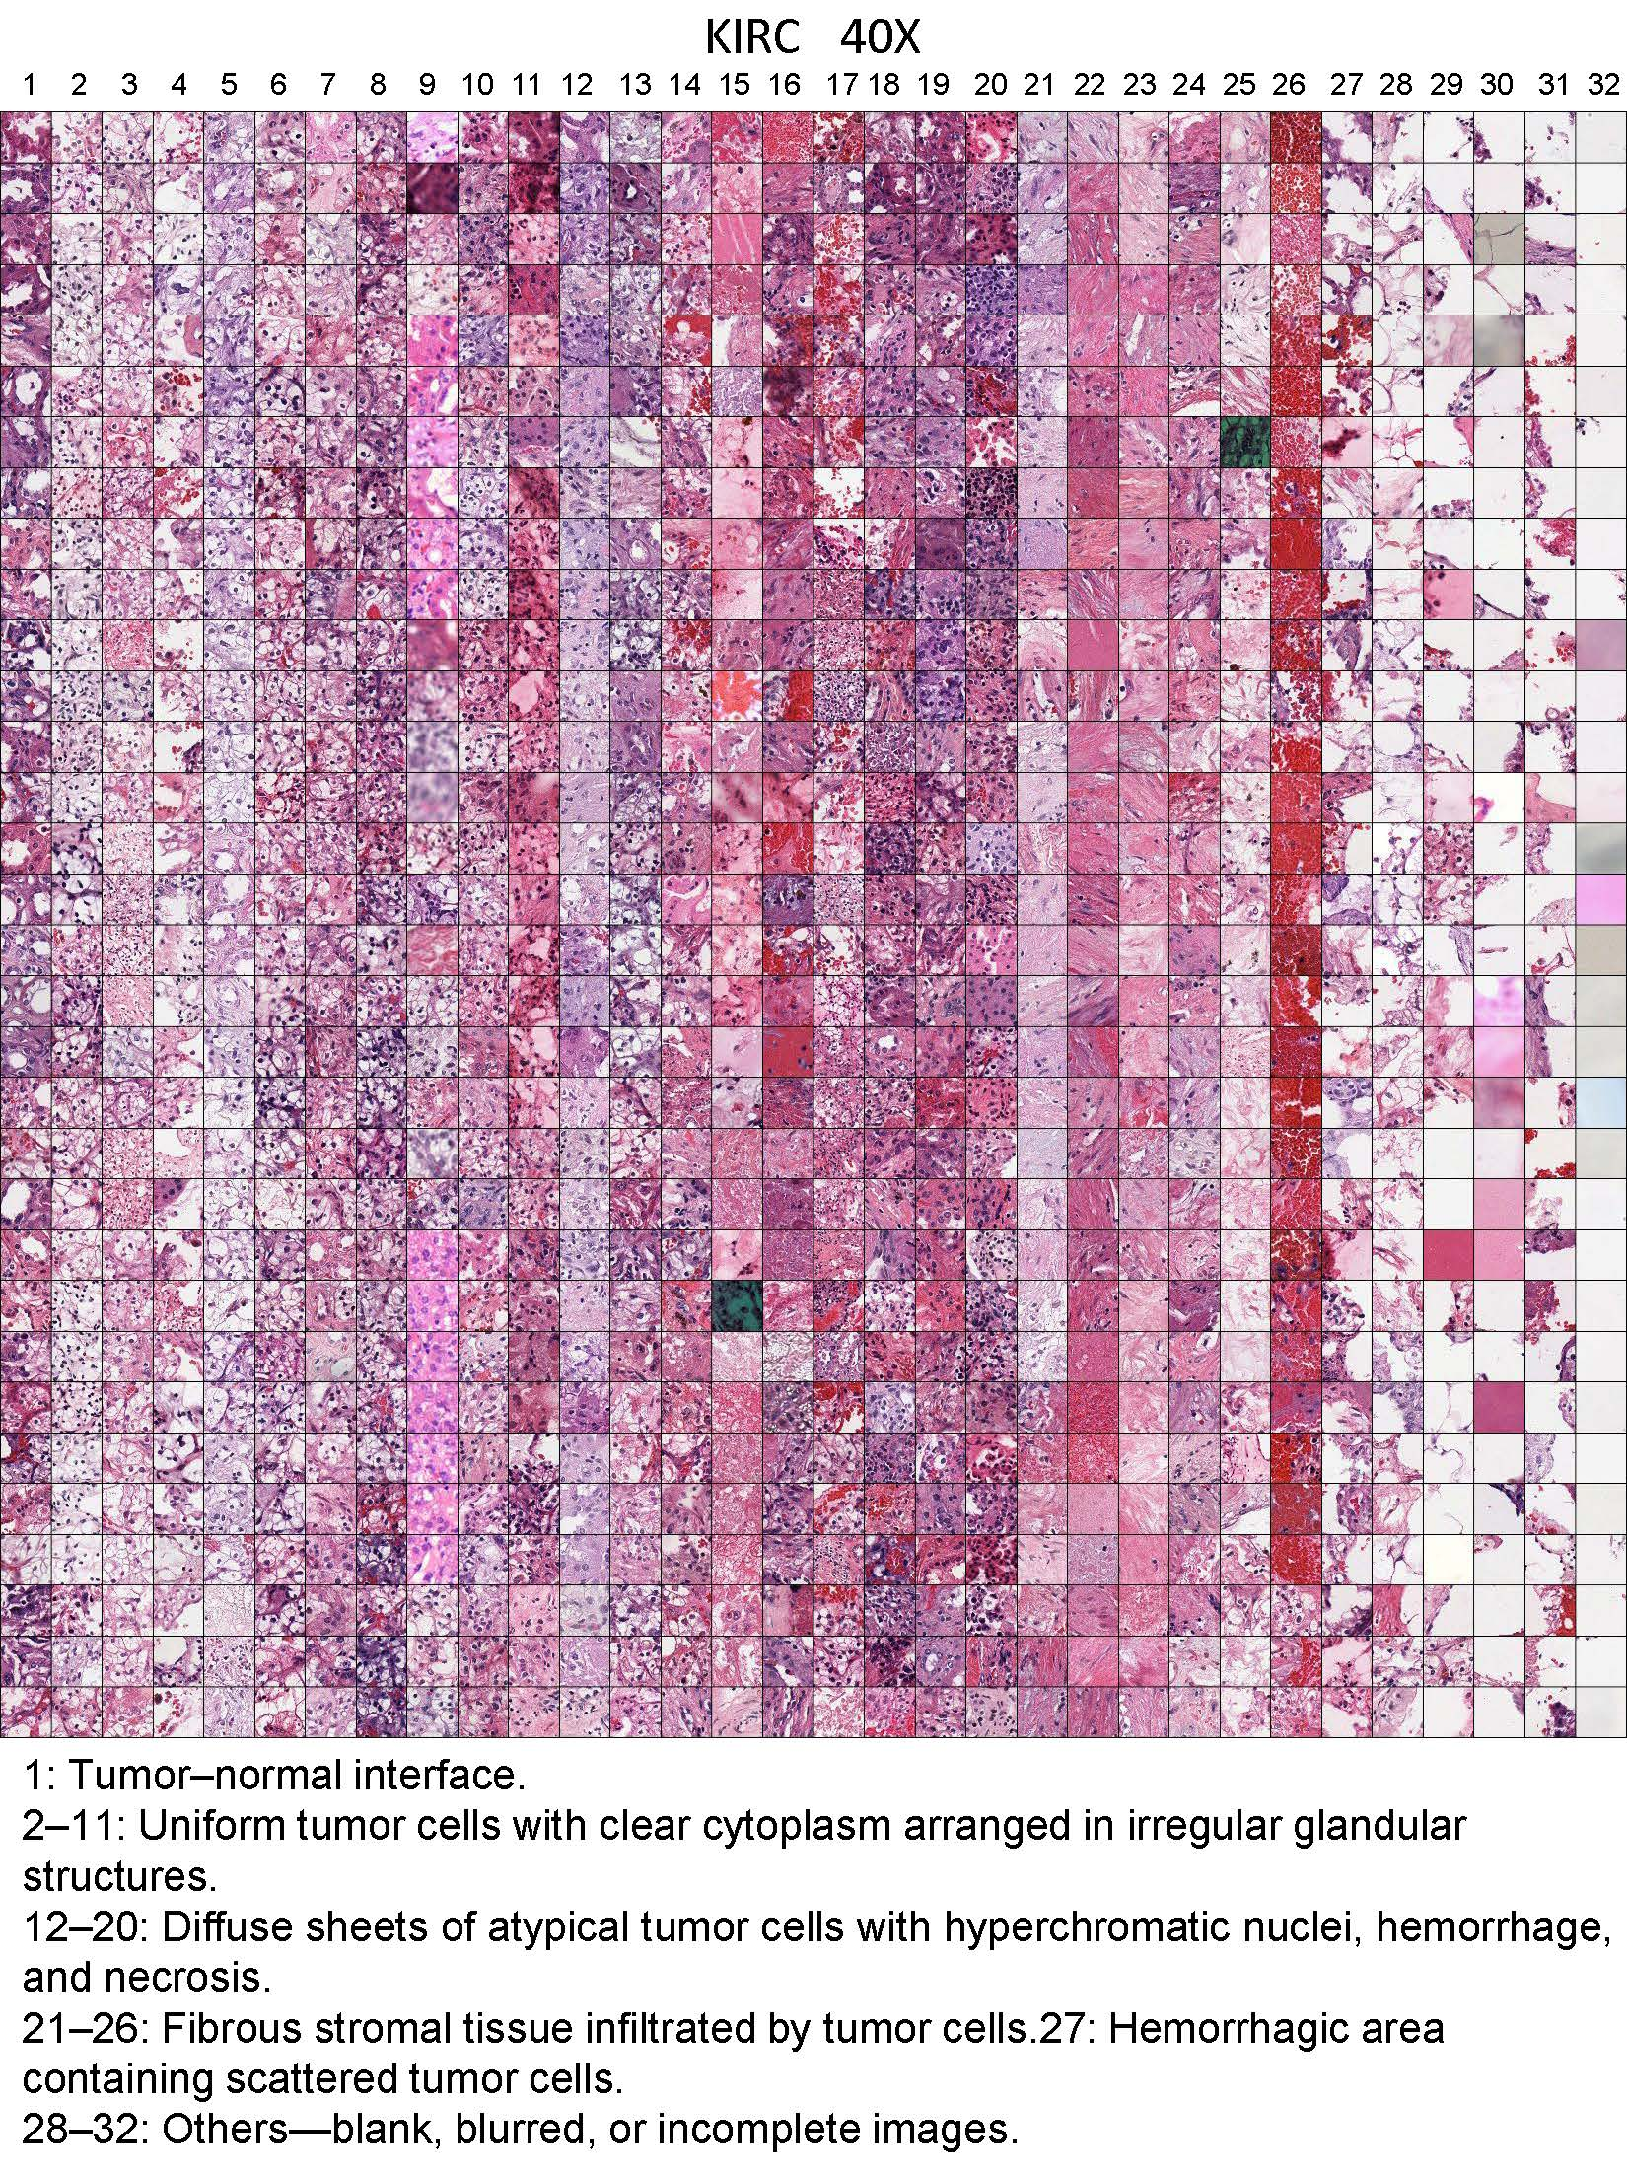
Figure 9 Cellular-level dictionary of TCGA-KIRC.
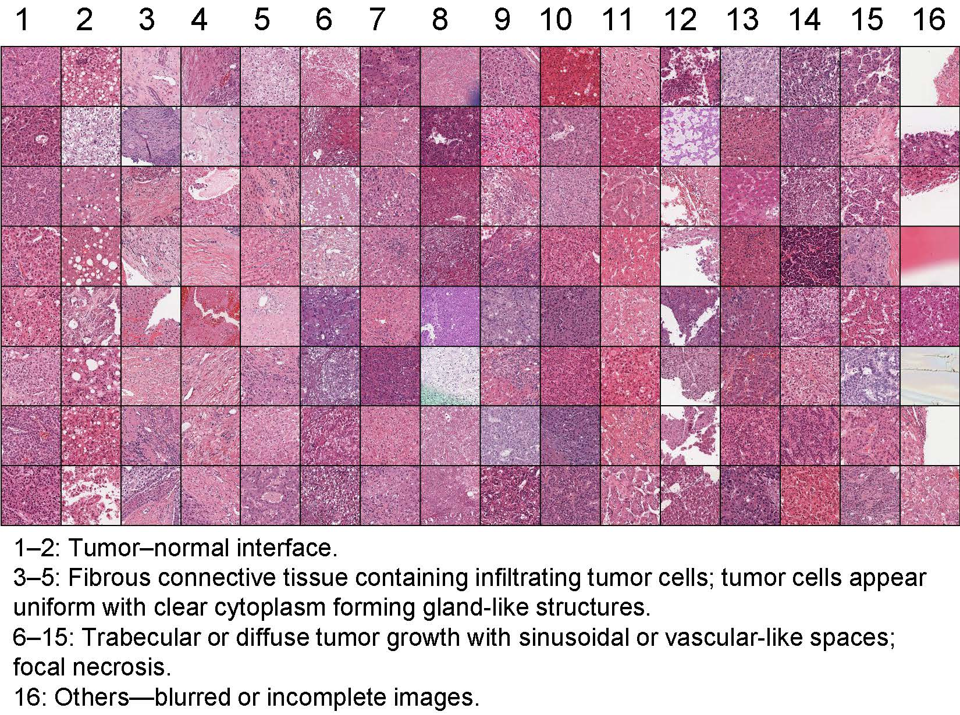
Figure 10 Tissue-level dictionary of TCGA-LIHC.
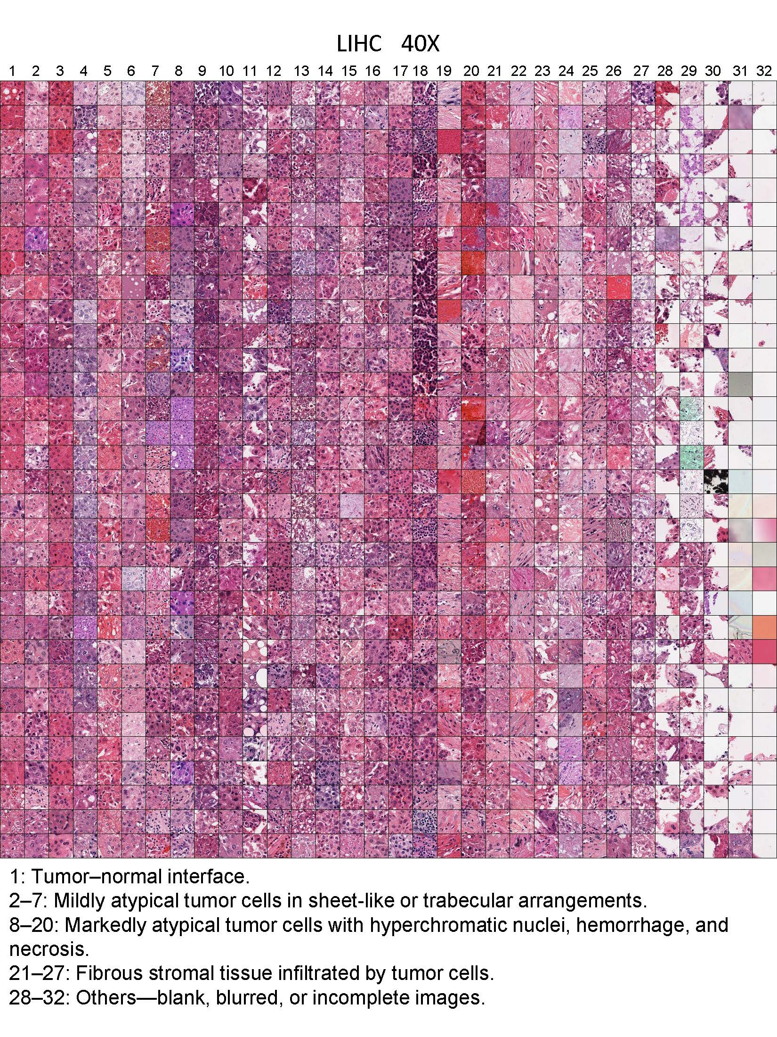
Figure 11 Tissue-level dictionary of TCGA-LIHC.
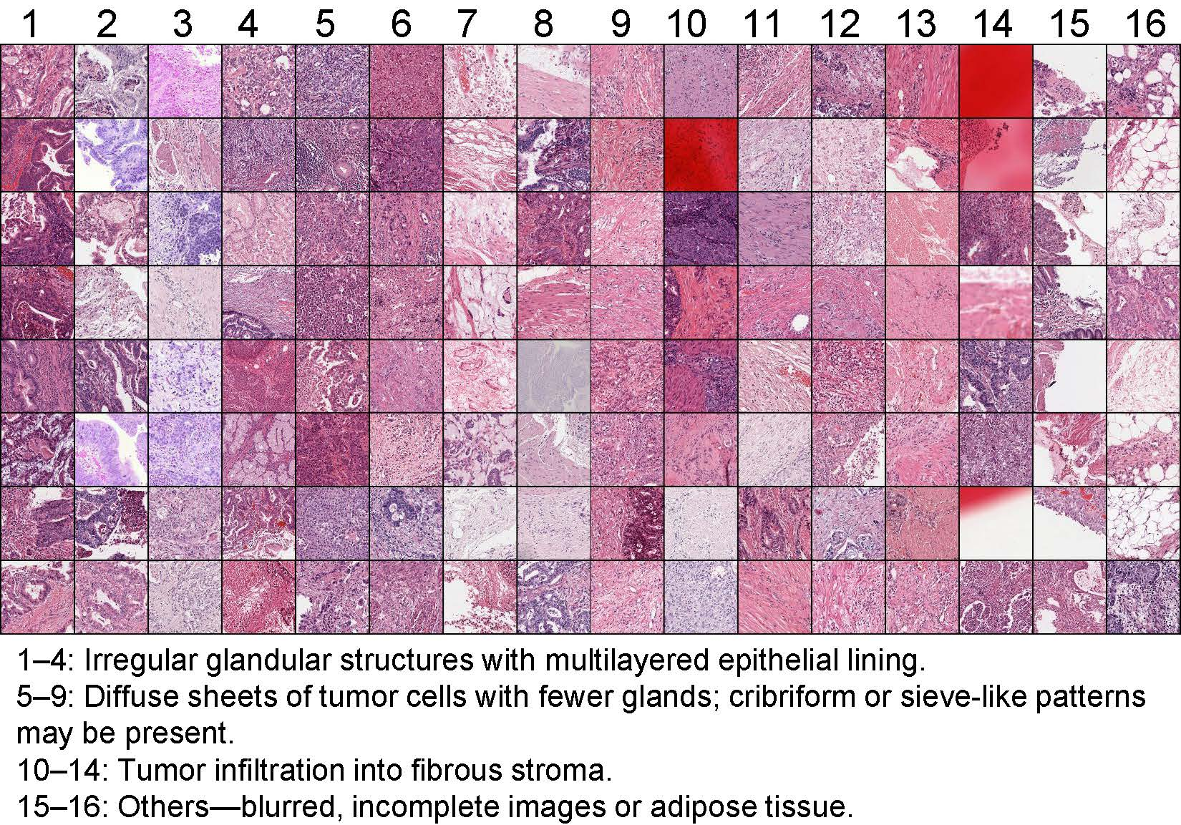
Figure 12 Tissue-level dictionary of TCGA-STAD.
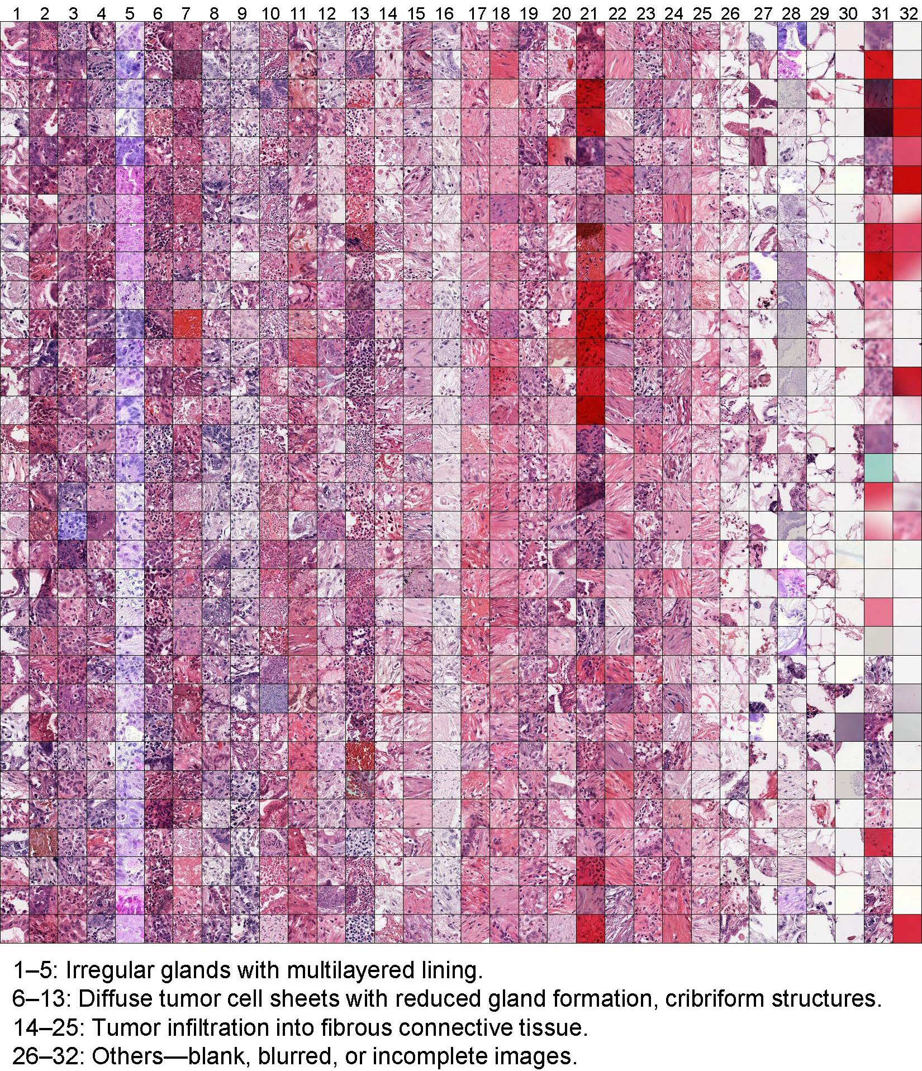
Figure 13 Cellular-level dictionary of TCGA-STAD.
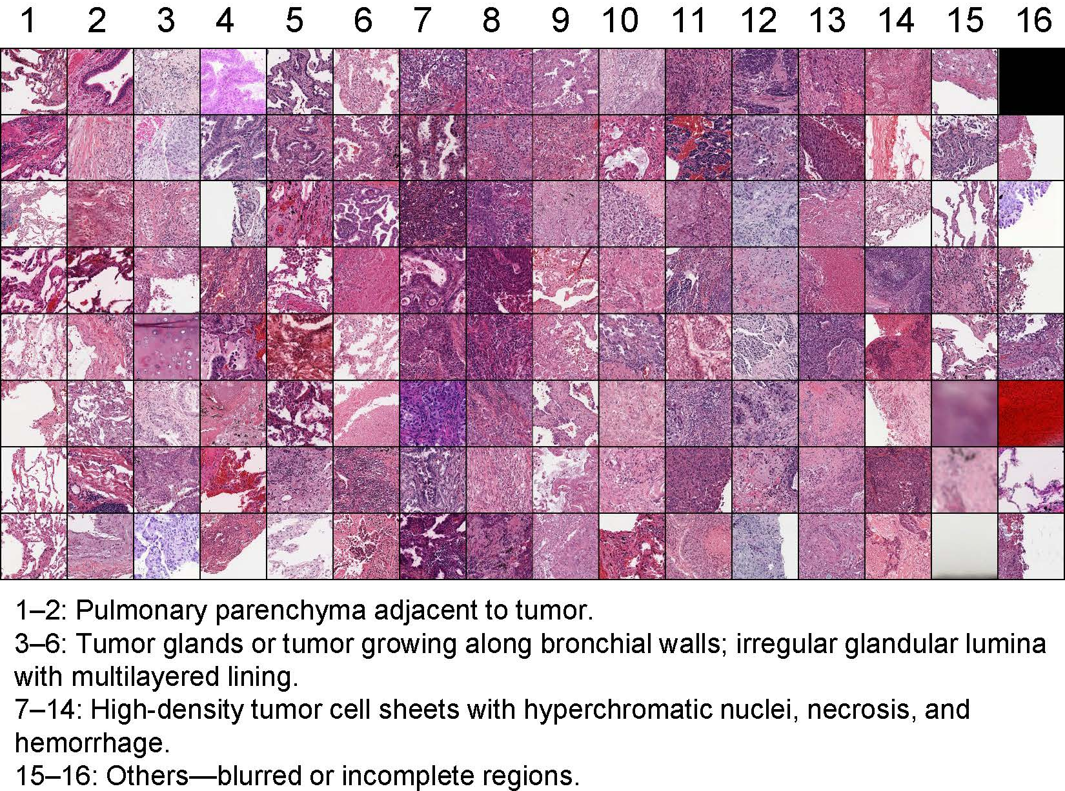
Figure 14 Tissue-level dictionary of TCGA-LUNG.
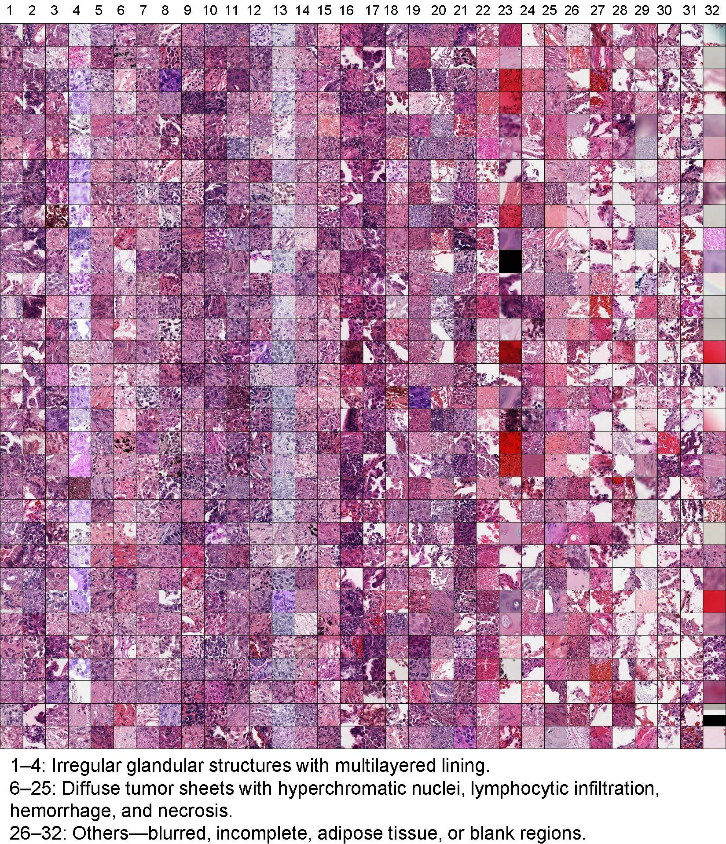
Figure 15 Cellular-level dictionary of TCGA-LUNG.
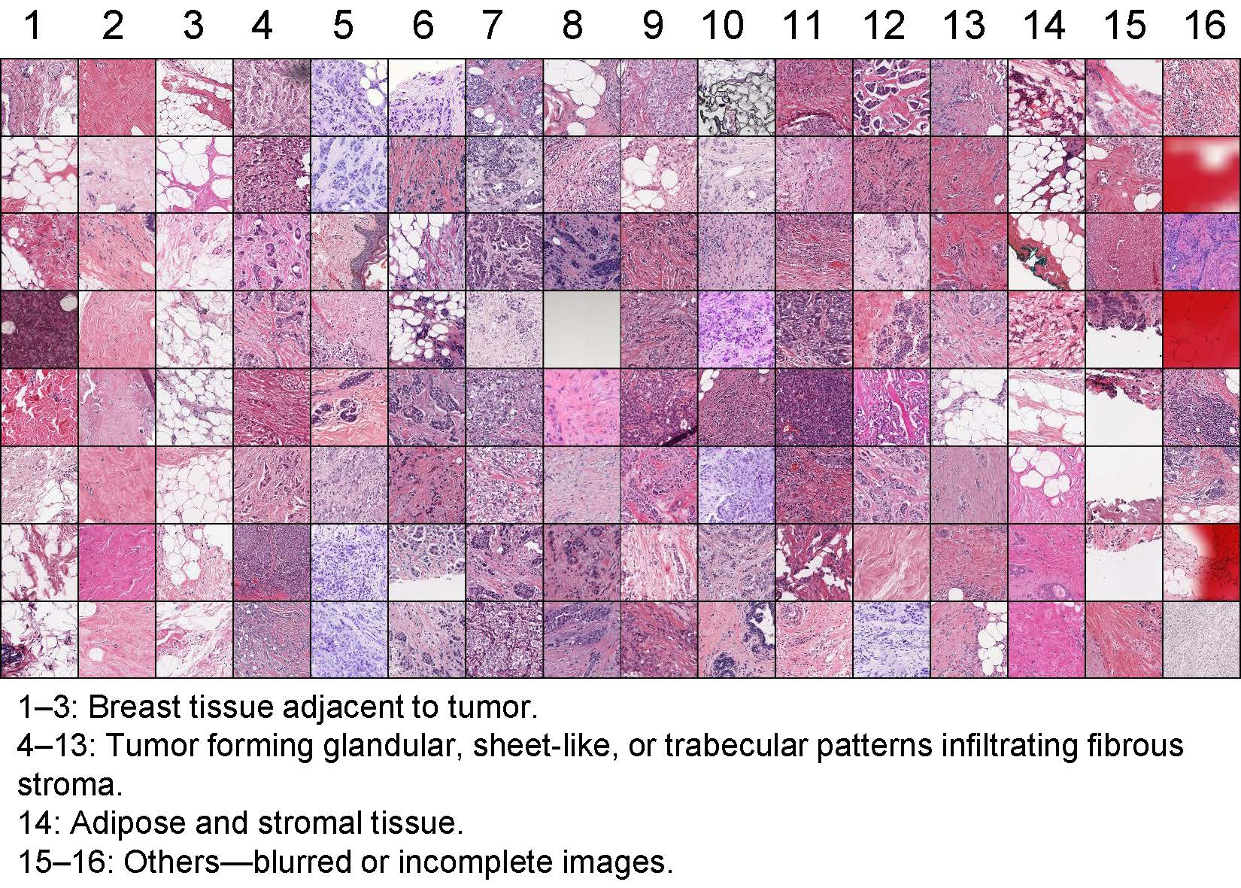
Figure 16 Tissue-level dictionary of TCGA-BRCA.
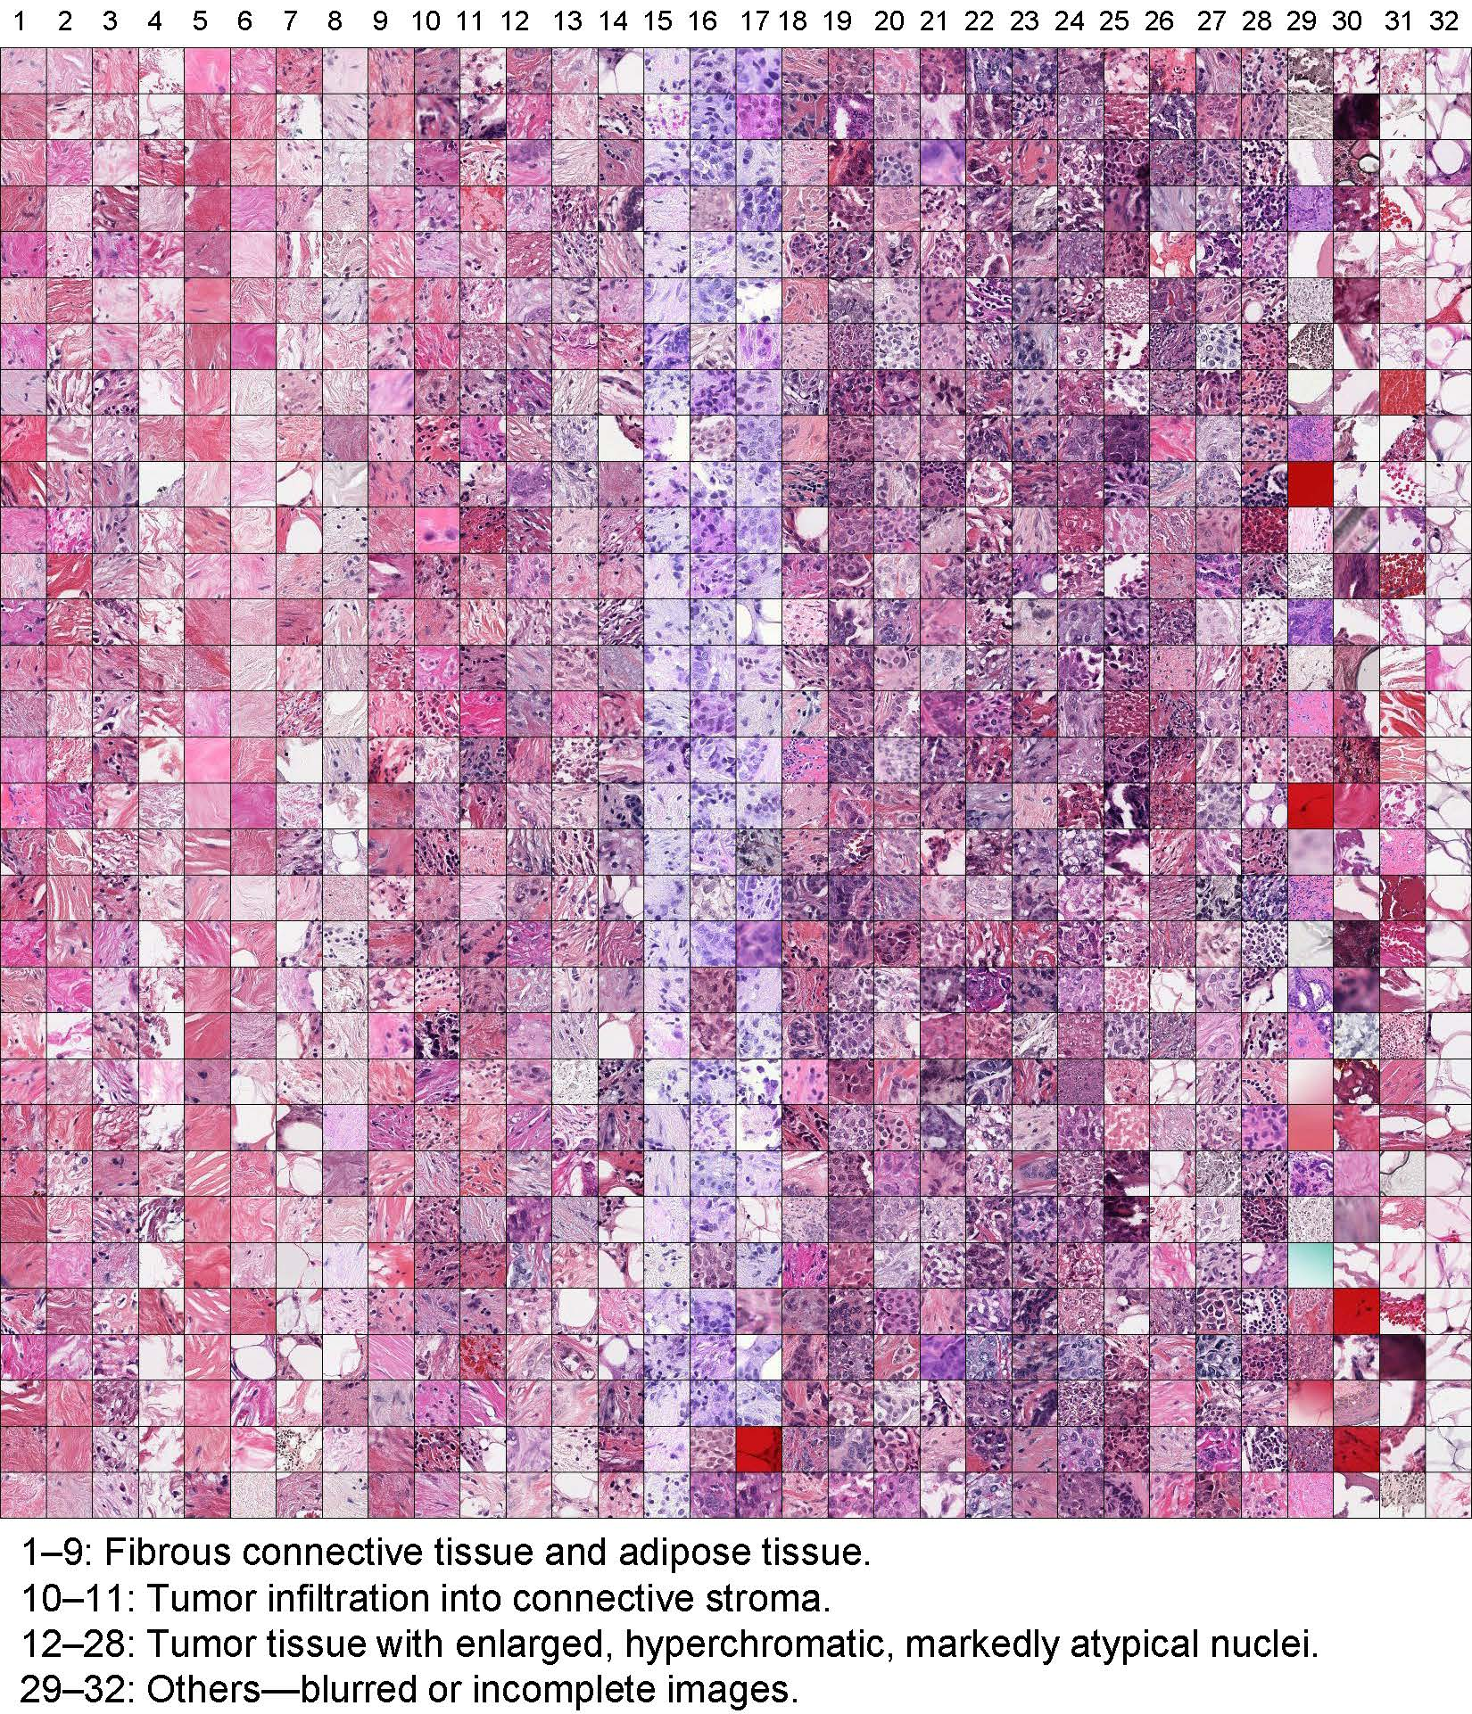
Figure 17 Cellular-level dictionary of TCGA-BRCA.
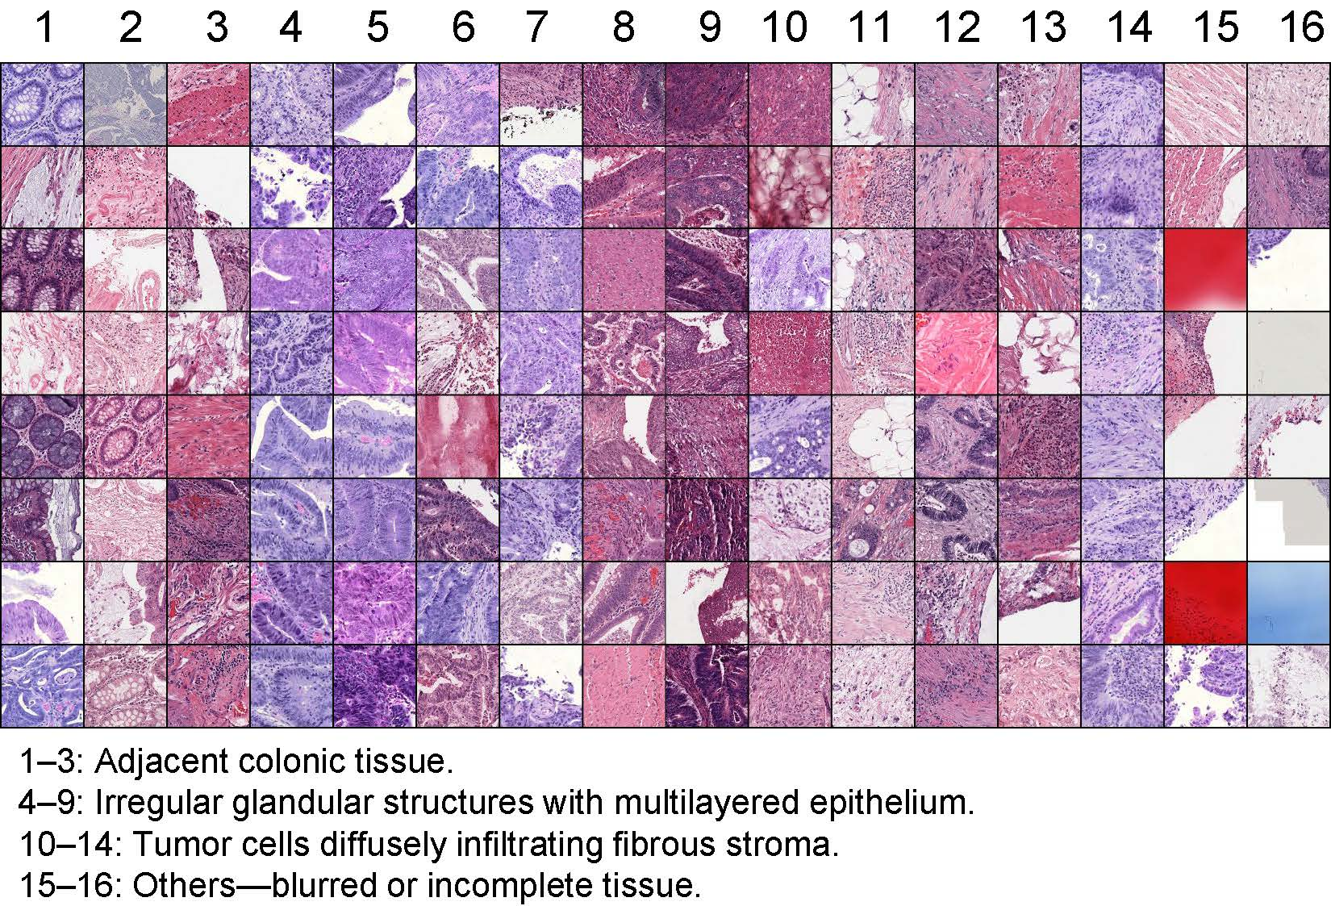
Figure 18 Tissue-level dictionary of TCGA-COAD.
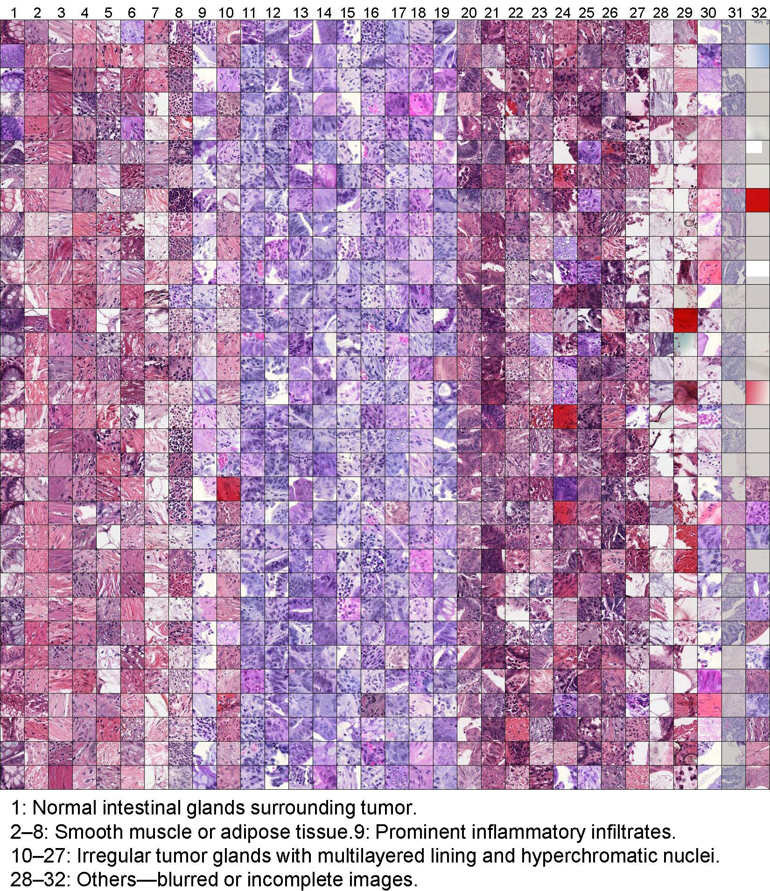
Figure 19 Cellular-level dictionary of TCGA-COAD.
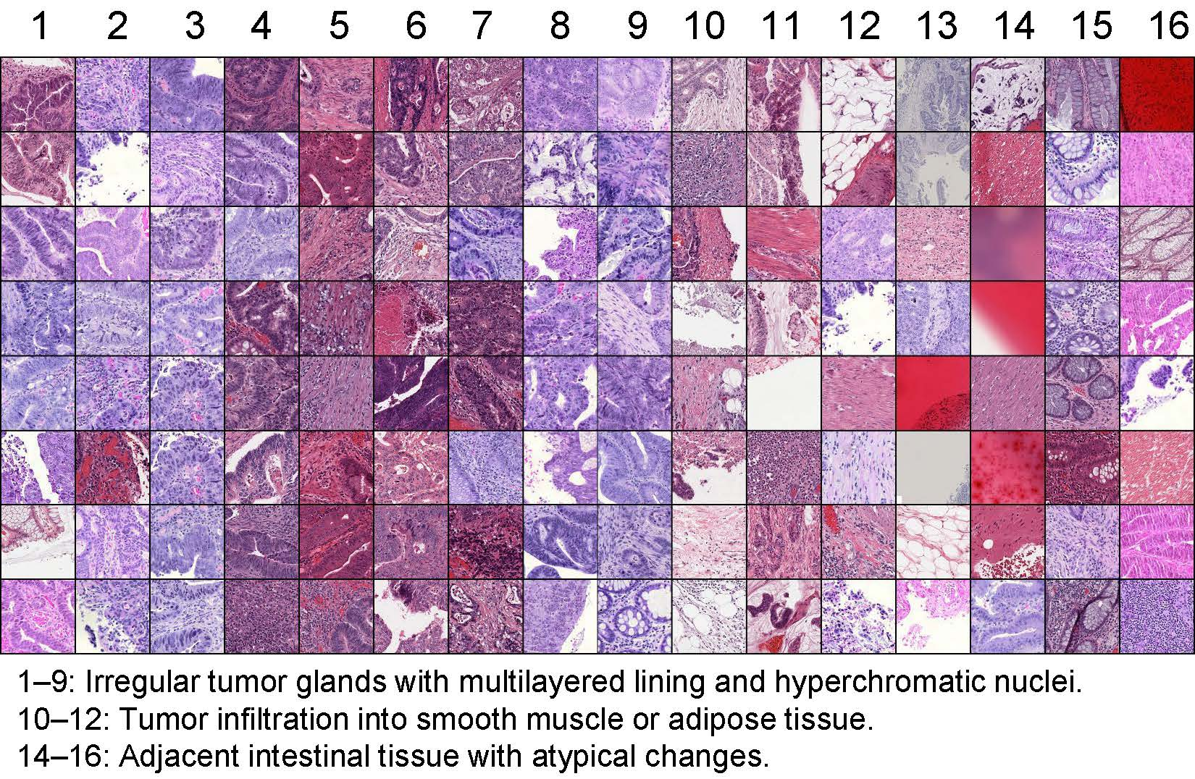
Figure 20 Tissue-level dictionary of TCGA-READ.

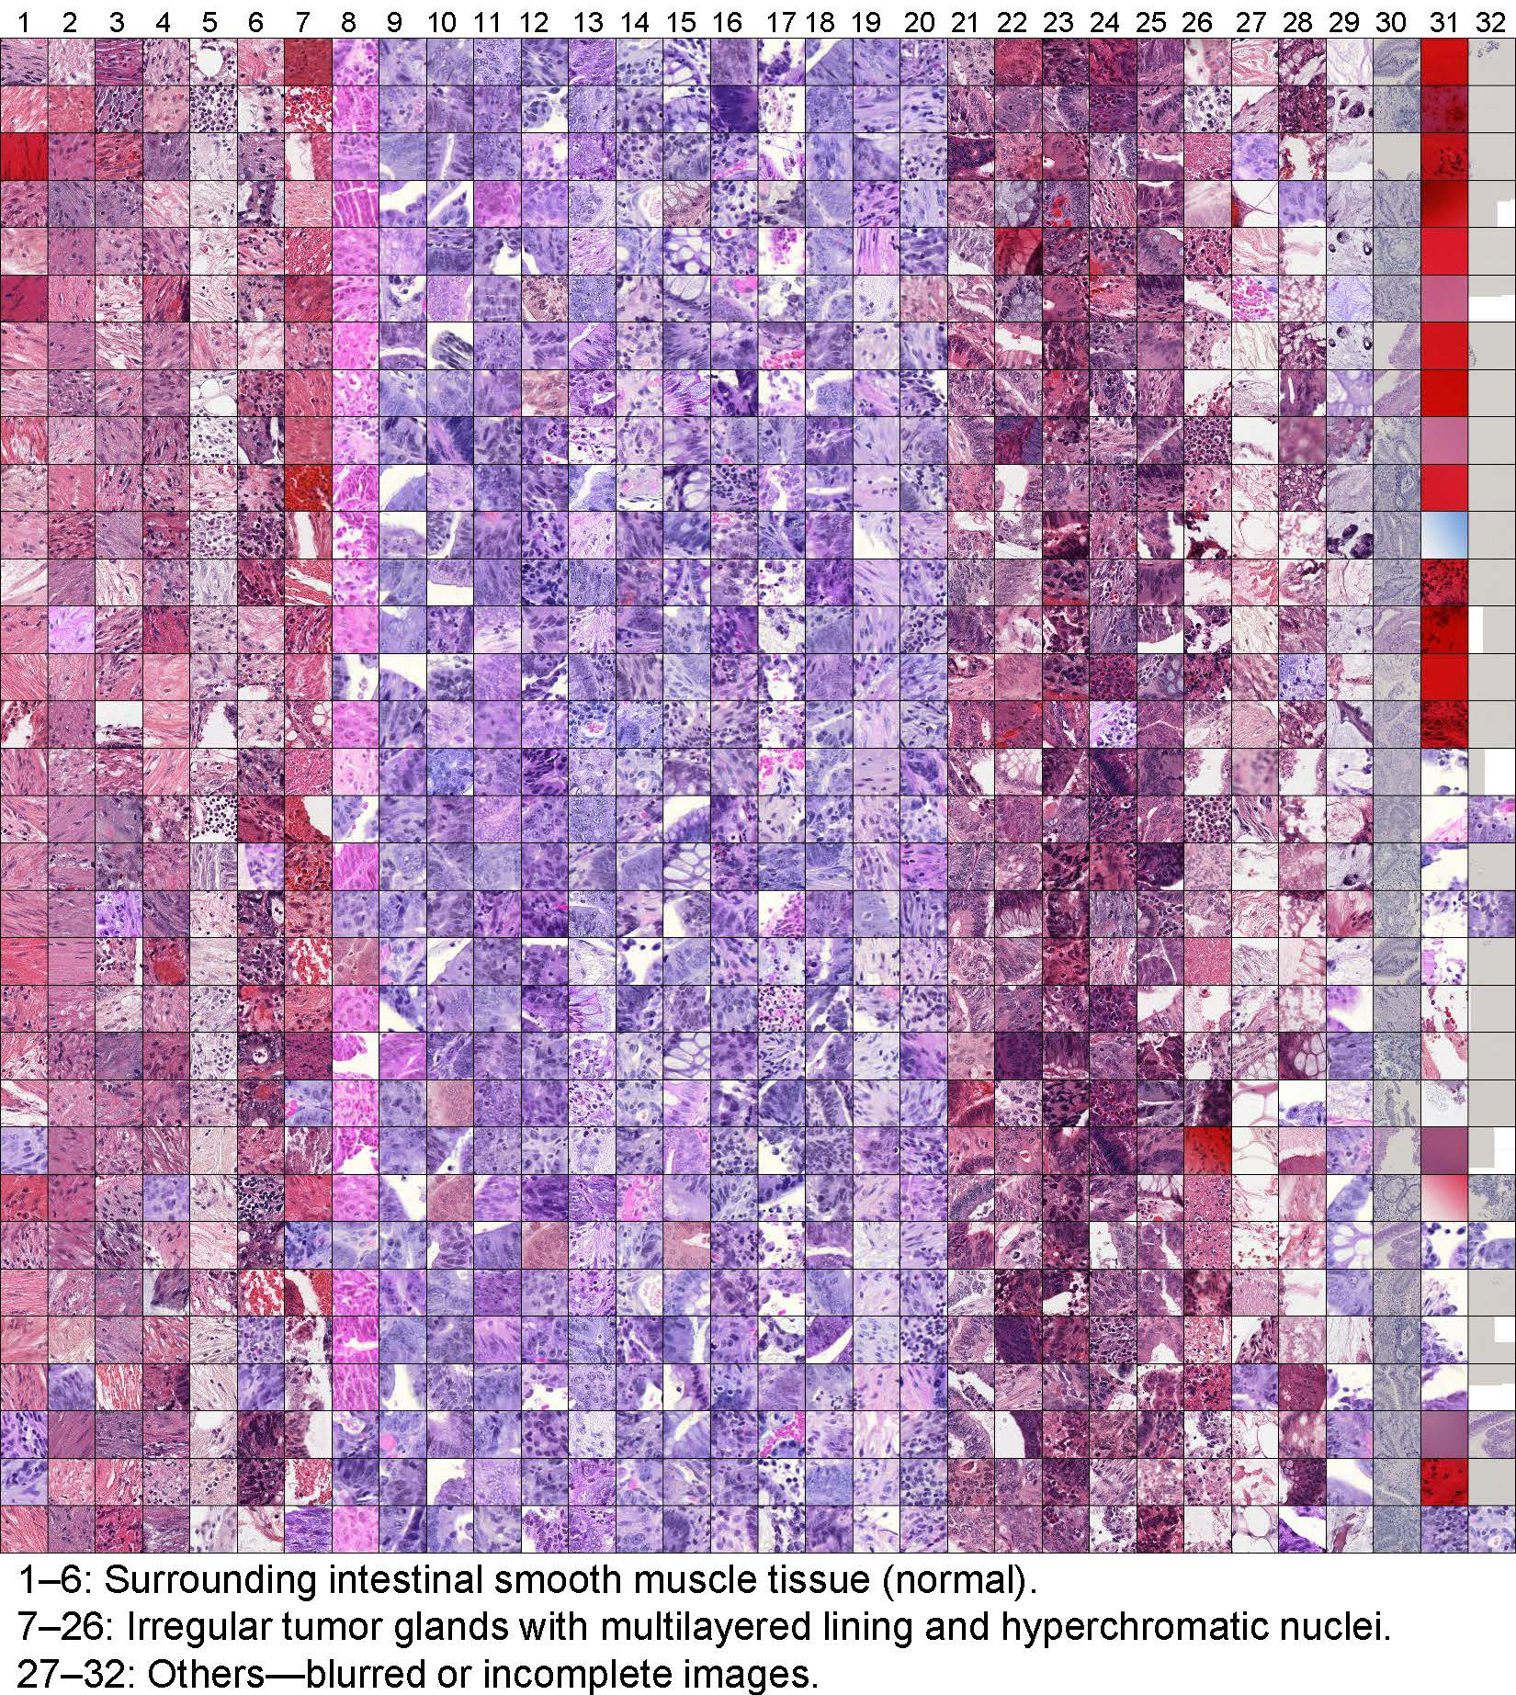
Figure 21 Cellular-level dictionary of TCGA-READ.

