Figure S1 Heat map of correlation. Positive correlation was painted in blue and negative correlation was painted in red. The darker the colour, the stronger the correlation intensity was. *** P < 0.01, ** P < 0.01, * P < 0.05
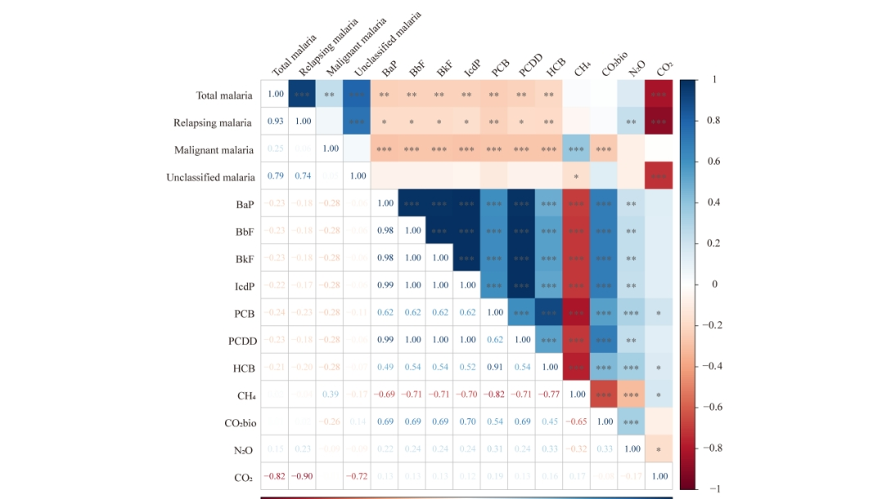

Figure S2 The relative risk (time lag) of total malaria using 3D plots (A, C) and heatmap (B, D).
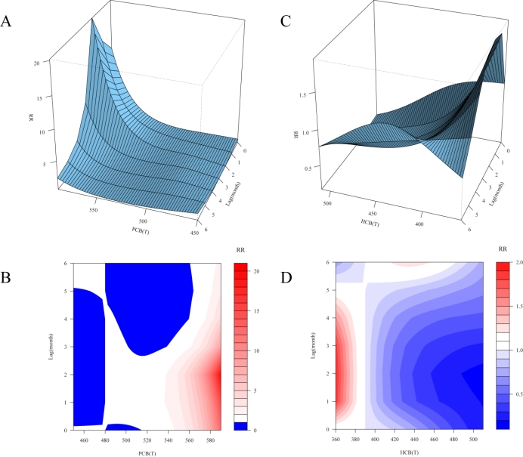

Table S1 The emissions of various POPs from different sources.
Field | PAH_BbF | PAH_BaP | PAH_BkF | PAH_IcdP | HCB | PCB | PCDD_F | Total
Other Sectors | 1.264662938 | 0.991711147 | 0.481852277 | 0.454929044 | 1.70058E-05 | 0.000578539 | 4.0022E-06 | 3.193754952
Manufacturing Industries and Construction | 0.877288174 | 0.646690351 | 0.3392443 | 0.26526776 | 3.86485E-05 | 0.002393565 | 2.91065E-06 | 2.130925709
Non-Specified | 0.167119291 | 0.164987939 | 0.066080777 | 0.057554365 | 5.28643E-07 | 0.000144951 | 3.88126E-07 | 0.455888239
Emissions from biomass burning | 0.011040191 | 0.016130609 | 0.00610528 | 0.006168432 | 0 | 0 | 3.68854E-09 | 0.039444516
Road Transportation no resuspension | 0.003136205 | 0.001388464 | 0.002946835 | 0.001721298 | 0 | 1.54305E-08 | 7.53299E-08 | 0.009192892
Main Activity Electricity and Heat Production | 0.001729787 | 0.001599835 | 0.001329284 | 0.000113734 | 0.000308221 | 5.04153E-06 | 5.20898E-07 | 0.005086423
Metal Industry | 0.000559232 | 0.000560176 | 0.000559232 | 0.000552203 | 3.37139E-08 | 3.95595E-06 | 7.4352E-09 | 0.00223484
Petroleum Refining - Manufacture of Solid Fuels and Other Energy Industries | 9.96837E-06 | 0.000394789 | 6.56746E-06 | 8.62142E-06 | 0 | 0 | 3.83995E-08 | 0.000419985
Railways | 0.000155496 | 9.32979E-05 | 0.000115689 | 2.67454E-05 | 0 | 0 | 0 | 0.000391228
Incineration and Open Burning of Waste | 3.06816E-10 | 1.9323E-10 | 1.75947E-10 | 2.10459E-10 | 1.43596E-09 | 2.05699E-09 | 9.29247E-13 | 4.38033E-09
Total | 2.325701281 | 1.823556609 | 0.898240241 | 0.786342202 | 0.000364439 | 0.00312607 | 7.94673E-06 | 5.83733879

Table S2 The emissions of various GHGs from different sources.
Field | CO₂ | CO₂bio | CH₄ | N₂O | F | Total
Main Activity Electricity and Heat Production | 5071184.82 | 132230.34 | 90.4496029 | 169.954273 | 0 | 5203675.57
Manufacturing Industries and Construction | 2790824.16 | 117105.408 | 170.425499 | 26.3137196 | 0 | 2908126.31
Residential and other sectors | 598961.122 | 323857.624 | 1605.8484 | 35.2803915 | 0 | 924459.875
Road Transportation no resuspension | 783676.736 | 6835.31513 | 165.153436 | 67.7967373 | 0 | 790745.002
Cement production | 750479.716 | 0 | 0 | 0 | 0 | 750479.716
Petroleum Refining - Manufacture of Solid Fuels and Other Energy Industries | 304758.169 | 0 | 7.20973532 | 2.59802857 | 0 | 304767.976
Solid Fuels | 285474.036 | 0 | 18915.3359 | 0 | 0 | 304389.372
Lime production | 225000 | 0 | 0 | 0 | 0 | 225000
Metal Industry | 214347.766 | 0 | 93.2311695 | 0 | 1.9186314 | 214442.916
Emissions from biomass burning | 0 | 211662.569 | 377.220421 | 9.77978869 | 0 | 212049.57
Chemical Industry | 193596.452 | 0 | 131.860924 | 36.6524883 | 7.641231 | 193772.607
Civil Aviation | 75630.343 | 0 | 0.52888352 | 2.11553407 | 0 | 75632.9874
Water-borne Navigation | 74882.5671 | 0 | 6.98887238 | 1.99682068 | 0 | 74891.5528
Non-Specified | 72081.9942 | 0 | 212.495896 | 3.05271114 | 0 | 72297.5428
Other Process Uses of Carbonates | 34343.6152 | 0 | 0 | 0 | 0 | 34343.6152
Fossil fuel fires | 28380 | 0 | 90 | 0.45 | 0 | 28470.45
Non-Energy Products from Fuels and Solvent Use | 22815.2711 | 0 | 0 | 0 | 0 | 22815.2711
Oil and Natural Gas | 9189.00194 | 6835.31513 | 849.749194 | 0.06400225 | 0 | 16874.1303
Rice cultivations | 0 | 0 | 14144.0586 | 0 | 0 | 14144.0586
Urea application | 11282.3837 | 0 | 0 | 0 | 0 | 11282.3837
Railways | 9569.90407 | 0 | 0.53596629 | 3.69364719 | 0 | 9574.13369
Other Transportation | 7196.59665 | 0 | 0.27020262 | 0.05238426 | 0 | 7196.91923
Enteric Fermentation | 0 | 0 | 7030.36221 | 0 | 0 | 7030.36221
Solid Waste Disposal | 0 | 0 | 5380.00373 | 0 | 0 | 5380.00373
Wastewater Treatment and Discharge | 0 | 0 | 5128.78211 | 93.5094083 | 0 | 5222.29152
Liming | 4095.5619 | 0 | 0 | 0 | 0 | 4095.5619
Incineration and Open Burning of Waste | 3258.78388 | 187.363013 | 399.29299 | 1.48687109 | 0 | 3846.92675
Manure Management | 0 | 0 | 1388.29489 | 84.0487406 | 0 | 1472.34363
Glass Production | 1387.37531 | 0 | 0 | 0 | 0 | 1387.37531
Direct N2O Emissions from managed soils | 0 | 0 | 0 | 669.693962 | 0 | 669.693962
Indirect N2O Emissions from managed soils | 0 | 0 | 0 | 155.420381 | 0 | 155.420381
Product Uses as Substitutes for Ozone Depleting Substances | 0 | 0 | 0 | 0 | 109.891012 | 109.891012
Indirect N2O emissions from the atmospheric deposition of nitrogen in NOx and NH3 | 0 | 0 | 0 | 101.991368 | 0 | 101.991368
Biological Treatment of Solid Waste | 0 | 0 | 9.02908053 | 0.67718104 | 0 | 9.70626157
Indirect N2O Emissions from manure management | 0 | 0 | 0 | 8.38544414 | 0 | 8.38544414
Other Product Manufacture and Use | 0 | 0 | 0 | 0.42640317 | 3.77828 | 4.20468317
Electronics Industry | 0 | 0 | 0 | 0 | 0.99202179 | 0.99202179
Total | 11572416.4 | 798713.934 | 56197.1277 | 1475.44029 | 124.221176 | 12428927.1

Table S3 Comparison of different time series models for the prediction in total malaria.
Time | Actual incidence | Holt-Winters | SARIMA | Kalman |  | Holt-Winters | SARIMA | Kalman
Time | Actual incidence | Forecasted incidence |  |  |  | Standard Error
January 2019 | 0.0191 | 0.0158 | 0.0176 | 0.0172 |  | 0.0033 | 0.0015 | 0.0019
February 2019 | 0.0139 | 0.0103 | 0.0140 | 0.0152 |  | 0.0036 | -0.0001 | -0.0013
March 2019 | 0.0113 | 0.0109 | 0.0140 | 0.0128 |  | 0.0004 | -0.0027 | -0.0015
April 2019 | 0.0122 | 0.0136 | 0.0162 | 0.0124 |  | -0.0014 | -0.0040 | -0.0002
May 2019 | 0.0138 | 0.0185 | 0.0201 | 0.0133 |  | -0.0047 | -0.0063 | 0.0005
June 2019 | 0.0167 | 0.0193 | 0.0213 | 0.0154 |  | -0.0026 | -0.0046 | 0.0013
July 2019 | 0.0169 | 0.0154 | 0.0189 | 0.0163 |  | 0.0015 | -0.0020 | 0.0006
August 2019 | 0.0151 | 0.0127 | 0.0166 | 0.0156 |  | 0.0024 | -0.0015 | -0.0005
September 2019 | 0.0141 | 0.0108 | 0.0147 | 0.0147 |  | 0.0033 | -0.0006 | -0.0006
October 2019 | 0.0140 | 0.0138 | 0.0162 | 0.0143 |  | 0.0002 | -0.0022 | -0.0003
November 2019 | 0.0171 | 0.0120 | 0.0151 | 0.0160 |  | 0.0051 | 0.0020 | 0.0011
December 2019 | 0.0149 | 0.0132 | 0.0162 | 0.0153 |  | 0.0017 | -0.0013 | -0.0004
January 2020 | 0.0222 | 0.0143 | 0.0183 | 0.0196 |  | 0.0079 | 0.0039 | 0.0026
February 2020 | 0.0068 | 0.0088 | 0.0153 | 0.0117 |  | -0.0020 | -0.0085 | -0.0049
March 2020 | 0.0064 | 0.0094 | 0.0153 | 0.0084 |  | -0.0030 | -0.0089 | -0.0020
April 2020 | 0.0030 | 0.0120 | 0.0171 | 0.0051 |  | -0.0090 | -0.0141 | -0.0021
May 2020 | 0.0027 | 0.0169 | 0.0202 | 0.0036 |  | -0.0142 | -0.0175 | -0.0009
June 2020 | 0.0049 | 0.0178 | 0.0212 | 0.0044 |  | -0.0129 | -0.0163 | 0.0005
July 2020 | 0.0038 | 0.0138 | 0.0192 | 0.0040 |  | -0.0100 | -0.0154 | -0.0002
August 2020 | 0.0041 | 0.0111 | 0.0174 | 0.0041 |  | -0.0070 | -0.0133 | 0.0000
September 2020 | 0.0045 | 0.0092 | 0.0158 | 0.0043 |  | -0.0047 | -0.0113 | 0.0002
October 2020 | 0.0053 | 0.0122 | 0.0171 | 0.0049 |  | -0.0069 | -0.0118 | 0.0004
November 2020 | 0.0042 | 0.0105 | 0.0162 | 0.0045 |  | -0.0063 | -0.0120 | -0.0003
December 2020 | 0.0044 | 0.0117 | 0.0171 | 0.0044 |  | -0.0073 | -0.0127 | 0.0000

Table S4 Comparison of different time series models for the prediction in relapsing malaria.
Time | Actual incidence | Holt-Winters | SARIMA | Kalman |  | Holt-Winters | SARIMA | Kalman
Time | Actual incidence | Forecasted incidence |  |  |  | Standard Error
January 2019 | 0.0025 | 0.0080 | 0.0065 | 0.0032 |  | -0.0055 | -0.0040 | -0.0007
February 2019 | 0.0012 | 0.0059 | 0.0064 | 0.0020 |  | -0.0047 | -0.0052 | -0.0008
March 2019 | 0.0012 | 0.0056 | 0.0082 | 0.0015 |  | -0.0044 | -0.0070 | -0.0003
April 2019 | 0.0010 | 0.0070 | 0.0113 | 0.0012 |  | -0.0060 | -0.0103 | -0.0002
May 2019 | 0.0019 | 0.0093 | 0.0158 | 0.0016 |  | -0.0074 | -0.0139 | 0.0003
June 2019 | 0.0025 | 0.0092 | 0.0180 | 0.0022 |  | -0.0067 | -0.0155 | 0.0003
July 2019 | 0.0033 | 0.0061 | 0.0170 | 0.0029 |  | -0.0028 | -0.0137 | 0.0004
August 2019 | 0.0017 | 0.0050 | 0.0157 | 0.0021 |  | -0.0033 | -0.0140 | -0.0004
September 2019 | 0.0012 | 0.0032 | 0.0131 | 0.0016 |  | -0.0020 | -0.0119 | -0.0004
October 2019 | 0.0008 | 0.0040 | 0.0116 | 0.0011 |  | -0.0032 | -0.0108 | -0.0003
November 2019 | 0.0025 | 0.0036 | 0.0089 | 0.0020 |  | -0.0011 | -0.0064 | 0.0005
December 2019 | 0.0016 | 0.0037 | 0.0075 | 0.0017 |  | -0.0021 | -0.0059 | -0.0001
January 2020 | 0.0012 | 0.0076 | 0.0094 | 0.0014 |  | -0.0064 | -0.0082 | -0.0002
February 2020 | 0.0013 | 0.0054 | 0.0089 | 0.0013 |  | -0.0041 | -0.0076 | 0.0000
March 2020 | 0.0009 | 0.0051 | 0.0105 | 0.0011 |  | -0.0042 | -0.0096 | -0.0002
April 2020 | 0.0015 | 0.0065 | 0.0135 | 0.0013 |  | -0.0050 | -0.0120 | 0.0002
May 2020 | 0.0016 | 0.0088 | 0.0180 | 0.0015 |  | -0.0072 | -0.0164 | 0.0001
June 2020 | 0.0035 | 0.0087 | 0.0203 | 0.0027 |  | -0.0052 | -0.0168 | 0.0008
July 2020 | 0.0028 | 0.0057 | 0.0194 | 0.0028 |  | -0.0029 | -0.0166 | 0.0000
August 2020 | 0.0006 | 0.0046 | 0.0182 | 0.0014 |  | -0.0040 | -0.0176 | -0.0008
September 2020 | 0.0008 | 0.0027 | 0.0158 | 0.0010 |  | -0.0019 | -0.0150 | -0.0002
October 2020 | 0.0014 | 0.0035 | 0.0144 | 0.0013 |  | -0.0021 | -0.0130 | 0.0001
November 2020 | 0.0006 | 0.0032 | 0.0118 | 0.0009 |  | -0.0026 | -0.0112 | -0.0003
December 2020 | 0.0008 | 0.0032 | 0.0103 | 0.0008 |  | -0.0024 | -0.0095 | 0.0000

Table S5 Comparison of different time series models for the prediction in malignant malaria.
Time | Actual incidence | Holt-Winters | SARIMA | Kalman |  | Holt-Winters | SARIMA | Kalman
Time | Actual incidence | Forecasted incidence |  |  |  | Standard Error
January 2019 | 0.0148 | 0.0102 | 0.0103 | 0.0128 |  | 0.0046 | 0.0045 | 0.0020
February 2019 | 0.0099 | 0.0067 | 0.0075 | 0.0110 |  | 0.0032 | 0.0024 | -0.0011
March 2019 | 0.0075 | 0.0057 | 0.0064 | 0.0088 |  | 0.0018 | 0.0011 | -0.0013
April 2019 | 0.0095 | 0.0070 | 0.0076 | 0.0092 |  | 0.0025 | 0.0019 | 0.0003
May 2019 | 0.0095 | 0.0099 | 0.0093 | 0.0094 |  | -0.0004 | 0.0002 | 0.0001
June 2019 | 0.0117 | 0.0109 | 0.0097 | 0.0108 |  | 0.0008 | 0.0020 | 0.0009
July 2019 | 0.0115 | 0.0108 | 0.0090 | 0.0112 |  | 0.0007 | 0.0025 | 0.0003
August 2019 | 0.0108 | 0.0093 | 0.0078 | 0.0110 |  | 0.0015 | 0.0030 | -0.0002
September 2019 | 0.0106 | 0.0084 | 0.0073 | 0.0107 |  | 0.0022 | 0.0033 | -0.0001
October 2019 | 0.0109 | 0.0091 | 0.0083 | 0.0108 |  | 0.0018 | 0.0026 | 0.0001
November 2019 | 0.0120 | 0.0075 | 0.0076 | 0.0116 |  | 0.0045 | 0.0044 | 0.0004
December 2019 | 0.0119 | 0.0082 | 0.0087 | 0.0118 |  | 0.0037 | 0.0032 | 0.0001
January 2020 | 0.0188 | 0.0089 | 0.0093 | 0.0161 |  | 0.0099 | 0.0095 | 0.0027
February 2020 | 0.0037 | 0.0054 | 0.0069 | 0.0084 |  | -0.0017 | -0.0032 | -0.0047
March 2020 | 0.0033 | 0.0044 | 0.0063 | 0.0053 |  | -0.0011 | -0.0030 | -0.0020
April 2020 | 0.0004 | 0.0057 | 0.0072 | 0.0023 |  | -0.0053 | -0.0068 | -0.0019
May 2020 | 0.0000 | 0.0086 | 0.0087 | 0.0009 |  | -0.0086 | -0.0087 | -0.0009
June 2020 | 0.0004 | 0.0096 | 0.0090 | 0.0006 |  | -0.0092 | -0.0086 | -0.0002
July 2020 | 0.0002 | 0.0095 | 0.0085 | 0.0003 |  | -0.0093 | -0.0083 | -0.0001
August 2020 | 0.0026 | 0.0080 | 0.0074 | 0.0017 |  | -0.0054 | -0.0048 | 0.0009
September 2020 | 0.0032 | 0.0071 | 0.0070 | 0.0026 |  | -0.0039 | -0.0038 | 0.0006
October 2020 | 0.0034 | 0.0078 | 0.0078 | 0.0031 |  | -0.0044 | -0.0044 | 0.0003
November 2020 | 0.0027 | 0.0062 | 0.0073 | 0.0029 |  | -0.0035 | -0.0046 | -0.0002
December 2020 | 0.0024 | 0.0069 | 0.0082 | 0.0026 |  | -0.0045 | -0.0058 | -0.0002

Table S6 Comparison of different time series models for the prediction in unclassified malaria.
Time | Actual incidence | Holt-Winters | SARIMA | Kalman |  | Holt-Winters | SARIMA | Kalman
Time | Actual incidence | Forecasted incidence |  |  |  | Standard Error
January 2019 | 0.0018 | -0.0019 | -0.0001 | 0.0012 |  | 0.0037 | 0.0019 | 0.0006
February 2019 | 0.0027 | -0.0015 | 0.0002 | 0.0021 |  | 0.0042 | 0.0025 | 0.0006
March 2019 | 0.0025 | -0.0010 | 0.0002 | 0.0024 |  | 0.0035 | 0.0023 | 0.0001
April 2019 | 0.0016 | 0.0001 | 0.0008 | 0.0019 |  | 0.0015 | 0.0008 | -0.0003
May 2019 | 0.0023 | 0.0001 | 0.0004 | 0.0021 |  | 0.0022 | 0.0019 | 0.0002
June 2019 | 0.0025 | 0.0008 | 0.0006 | 0.0024 |  | 0.0017 | 0.0019 | 0.0001
July 2019 | 0.0020 | 0.0015 | 0.0008 | 0.0021 |  | 0.0005 | 0.0012 | -0.0001
August 2019 | 0.0024 | 0.0010 | 0.0005 | 0.0023 |  | 0.0014 | 0.0019 | 0.0001
September 2019 | 0.0021 | 0.0011 | 0.0004 | 0.0022 |  | 0.0010 | 0.0017 | -0.0001
October 2019 | 0.0022 | 0.0010 | 0.0005 | 0.0022 |  | 0.0012 | 0.0017 | 0.0000
November 2019 | 0.0026 | 0.0004 | 0.0004 | 0.0024 |  | 0.0022 | 0.0022 | 0.0002
December 2019 | 0.0013 | 0.0000 | 0.0004 | 0.0017 |  | 0.0013 | 0.0009 | -0.0004
January 2020 | 0.0022 | -0.0023 | -0.0003 | 0.0020 |  | 0.0045 | 0.0025 | 0.0002
February 2020 | 0.0017 | -0.0019 | -0.0002 | 0.0018 |  | 0.0036 | 0.0019 | -0.0001
March 2020 | 0.0020 | -0.0014 | -0.0002 | 0.0019 |  | 0.0034 | 0.0022 | 0.0001
April 2020 | 0.0010 | -0.0003 | 0.0003 | 0.0014 |  | 0.0013 | 0.0007 | -0.0004
May 2020 | 0.0009 | -0.0003 | -0.0001 | 0.0011 |  | 0.0012 | 0.0010 | -0.0002
June 2020 | 0.0009 | 0.0005 | 0.0001 | 0.0010 |  | 0.0004 | 0.0008 | -0.0001
July 2020 | 0.0007 | 0.0011 | 0.0003 | 0.0008 |  | -0.0004 | 0.0004 | -0.0001
August 2020 | 0.0008 | 0.0007 | -0.0001 | 0.0008 |  | 0.0001 | 0.0009 | 0.0000
September 2020 | 0.0004 | 0.0007 | -0.0001 | 0.0006 |  | -0.0003 | 0.0005 | -0.0002
October 2020 | 0.0004 | 0.0006 | 0.0000 | 0.0005 |  | -0.0002 | 0.0004 | -0.0001
November 2020 | 0.0008 | 0.0001 | -0.0001 | 0.0007 |  | 0.0007 | 0.0009 | 0.0001
December 2020 | 0.0012 | -0.0004 | -0.0001 | 0.0010 |  | 0.0016 | 0.0013 | 0.0002

Table S7 Cumulative effects of organic compounds PCB and HCB in all lag months (6 months).
Series | Cumulative effects(95%CI)
Series | low PCB effect | High PCB effect | low HCB effect | High HCB effect
Total malaria | 0.328 (0.042, 2.546)  0.328 (0.042, 2.546) | 0.839 (0.001, 505.306)  3.673e+4 (41.930, 3.217e+7) | 4.148 (0.667, 25.790)  2.033 (0.837, 4.938) | 0.017 (0.001, 0.393)  0.001 (0.000, 0.100)
Relapsing malaria | 0.078 (0.008, 0.759)  0.078 (0.008, 0.759) | 20.131 (0.027, 1.478e+4)  6.385e+5 (340.063, 1.199e+9) | 9.462 (1.087, 82.341)  2.889 (1.005, 8.310) | 0.113 (0.000, 230.546)  0.003 (0.000, 12.814)
Malignant malaria | 2.171e+6 (0.079, 5.970e+13)  2.171e+6 (0.079, 5.970e+13) | 0.000 (0.000, 0.000)  0.000 (0.000, 0.091) | 0.006 (0.000, 1.419e+6)  0.001 (0.000, 13.816) | 3.307e+46 (11.764, 9.296e+91)  9.150e+32 (0.000, 1.569e+73)
Unclassified malaria | 0.026 (0.004, 0.176)  0.026 (0.004, 0.176) | 1.700e+3 (81.703, 3.536e+4)  1.245e+5 (629.074, 2.465e+7) | 5.584 (1.113, 28.021)  2.322 (1.059, 5.094) | 0.034 (0.002, 0.648)  0.027 (0.000, 2.234)
Bold font indicates statistical significance at the 0.05 level.

