Supplementary Information/Online Resource
Supplementary information contains further details on the camera trap surveys; habitats of the camera sites; activity schedules of European rabbits, brown rats, wood mice, and muntjacs; breakpoint analysis determining low and high visit sites; activity schedules of humans and dogs; results of linear regression between human and dog relative abundances and, results of temporal displacement analysis.
Table 1 Summary showing the coordinates of the 26 camera sites used in the study, the camera models used, the start and end dates of the survey at each camera site and the number of days recorded at each camera site (Total Survey Length). Camera site 77 had two distinct survey periods. The Total Survey Length does not always match the number of days between the start and end dates due to battery failures, memory cards filling up, or camera failures.
Camera Site | Latitude | Longitude | Camera Model | Start Date | End Date | Total Survey Length
29 | 51.56084837 | -0.167436 | Reconyx Hyperfire HC500 | 18/04/2018 | 02/05/2018 | 15
30 | 51.56084837 | -0.165318 | Browning Strike Force Pro | 18/04/2018 | 02/05/2018 | 15
33 | 51.5611396 | -0.159331 | Reconyx Hyperfire PC800 | 18/04/2018 | 01/05/2018 | 11
41 | 51.56216468 | -0.173791 | Reconyx Hyperfire HC500 | 19/04/2018 | 02/05/2018 | 14
42 | 51.56216468 | -0.171672 | Reconyx Hyperfire PC800 | 19/04/2018 | 02/05/2018 | 14
43 | 51.56216468 | -0.169554 | Browning Strike Force Pro | 19/04/2018 | 02/05/2018 | 11
57 | 51.563481 | -0.171672 | Browning Strike Force Pro | 19/04/2018 | 03/05/2018 | 15
58 | 51.563481 | -0.169554 | Browning Strike Force Pro | 19/04/2018 | 03/05/2018 | 15
59 | 51.563481 | -0.165318 | Browning Strike Force Pro | 19/04/2018 | 02/05/2018 | 14
65 | 51.5647973 | -0.188618 | Reconyx Hyperfire PC800 | 03/05/2018 | 22/05/2018 | 20
71 | 51.5649 | -0.1759 | Browning Strike Force Pro | 02/05/2018 | 31/05/2018 | 24
75 | 51.56479731 | -0.167436 | Browning Strike Force Pro | 18/04/2018 | 02/05/2018 | 15
77 | 51.56479731 | -0.163199 | Browning Strike Force Pro | 19/04/2018 | 02/05/2018 | 14
77 | 51.56479731 | -0.163199 | Browning Strike Force Pro | 16/05/2018 | 31/05/2018 | 16
82 | 51.5661136 | -0.1865 | Reconyx Hyperfire HC600 | 03/05/2018 | 22/05/2018 | 20
83 | 51.56611362 | -0.184382 | Reconyx Hyperfire PC800 | 03/05/2018 | 22/05/2018 | 20
85 | 51.56611362 | -0.180145 | Browning Strike Force Pro | 03/05/2018 | 16/05/2018 | 14
90 | 51.56611362 | -0.169554 | Reconyx Hyperfire PC800 | 17/05/2018 | 31/05/2018 | 15
100 | 51.56742994 | -0.180145 | Browning Strike Force Pro | 03/05/2018 | 16/05/2018 | 14
106 | 51.56742994 | -0.167436 | Reconyx Hyperfire HC600 | 17/05/2018 | 31/05/2018 | 15
107 | 51.56742994 | -0.165318 | Reconyx Hyperfire HC500 | 17/05/2018 | 31/05/2018 | 15
109 | 51.56742994 | -0.161081 | Browning Strike Force Pro | 16/05/2018 | 31/05/2018 | 16
111 | 51.56874625 | -0.178027 | Reconyx Hyperfire PC800 | 02/05/2018 | 17/05/2018 | 16
116 | 51.56874625 | -0.165318 | Browning Strike Force Pro | 17/05/2018 | 31/05/2018 | 15
127 | 51.5700626 | -0.158952 | Reconyx Hyperfire HC500 | 10/05/2018 | 31/05/2018 | 22
129 | 51.57137 | -0.18014 | Browning Strike Force Pro | 02/05/2018 | 17/05/2018 | 16
138 | 51.57269519 | -0.169554 | Browning Strike Force Pro | 02/05/2018 | 16/05/2018 | 15

Table 2 Summary of Phase 1 Habitat survey on Hampstead Heath commissioned by the City of London and conducted by Scott Wilson in 2009. For each of the 26 sites, percentage of each habitat type and description noted at time of survey is shown. Woodland with understory forms part of broadleaved woodland (native or non-native).
Camera Site | Native broadleaved woodland (%) | Woodland with understory (%) | Other Habitat Types (%) | Description
29 | 84 | 20 | Scrub 8% Neutral semi-improved grassland 8% | Linear compartment located between surfaced path and swimming pool boundary fence. Closest to path is bend of poor semi improved grassland which includes Dactylis glomerata, Holcus lanatus and Agrostis capillaris. Grassland grades into area of Rubus fruticosus and, at south end, Prunus spinosa. Lolium perenne and Hedera hibernaca also identified. Behind this is Quercus robur dominated broadleaved woodland.
30 | 100 | 5 | NA | Native in character but bolstered with non-native plantings and bird sown saplings e.g. Fagus sylvatica, Malva spp., Tilia platyphyllos and Acer pseudoplatanus. Canopy: Quercus robur, Fraxinus excelsior, and Tilia platyphyllos. Shrub layer: Sambucus nigra and occasionally Crataegus monogyna. Ground layer: Hedera hibernaca (Dominant) and sparse Rubus fruticosus.
33 | 90 | 50 | Scrub 10% | Tree line/linear woodland with scrub to west/east margins. Species include Quercus robur, Crataegus monogyna, Fraxinus excelsior, Hedera hibernaca, Rubus fruticosus, Acer campestre and Sambucus nigra.
41 | 100 | 75 | NA | Broadleaved woodland. Canopy layer: Quercus robur, Quercus petraea, Fagus sylvatica (Occasional), Tilia platyphyllos (Frequent), Aesculus hippocastanum, Salix fragilis, Taxus baccata (Rare). Shrub layer: Rubus fruticosus (Abundant), Hedera helix (Frequent), Urtica dioica (Occasional), Ilex aquifolium, and Sambucus nigra (Rare).
42 | 50 | 50 | Non Native Broadleaved Woodland 35%  Scrub 10% Bare soil and rock 5% | Broadleaved woodland. Species present Quercus robur, Fagus sylvatica, Rubus fruticosus and Betula pendula.
43 | 97 | 55 | Tall Herbs 3% | Woodland block which grades to tall herb (Urtica dioica) at North and West margins. Woodland slopes to south. Species includes Quercus robur, Fraxinus excelsior, Acer pseudoplatanus, Betula pendula, Alnus glutinosa, Urtica dioica, Hedera helix, Fagus slyvatica, and Ilex aquifolium.
57 | 90 | 90 | Non Native Broadleaved Woodland 10% | Broadleaved woodland dominated by Quercus robur with a Rubus fruticosus understorey.
58 | 100 | 0 | NA | Stand of Fagus sylvatica, with very little ground flora, apparently due to heavy footfall and also cycling. Others species present are Quercus robur, Acer pseudoplatanus, Ilex aquifolium, Impatiens parviflora, Rubus fruticosus and Betula pendula. There is also a veteran Platanus hybrida in this area.
59 | 0 | 0 | Neutral semi-improved grassland 94% Bare soil and rock 4% Scattered trees 2% | Large open meadow with scattered trees  N.B Camera trap was located at site 59 in a copse of broadleaved woodland to the north of this meadow.
65 | 98 | 30 | Tall Herb 2% | Woodland with poor ground flora due to high level of trampling. Species: Betula pendula, Quercus spp., Fagus sylvatica, Tilia spp., Sorbus aucuparia, Ilex aquifolium and Crataegus monogyna. Some large laying and standing dead wood. Rubus fruticosus and Hedera helix in understory. Patches of Urtica dioica and Impatiens parviflora. Some Prunus spinosa, Alnus glutinosa and Corylus avellana too, but none dominate.
71 | 100 | 50 | NA | Woodland block with veteran trees - being encroached by Acer pseudoplatanus. Canopy includes Quercus spp., Betula pendula, and Fagus sylvatica. Much Rubus fruticosus in understorey. Some Ilex aquifolium.
75 | 90 | 5 | Improved reseeded grassland 9.9% Ditches filled with water 0.1% | Broadleaved woodland good age/structure/patch dynamic. Northern edge compartment demarcated by spring line/ephemeral stream. Species includes Quercus robur, Rubus fruticosus, Ilex aquifolium, Betula pendula, Holcus lanatus and Impatiens parviflora.
77 | 90 | 5 | Improved reseeded grassland 9.9% Ditches filled with water 0.1% | Broadleaved woodland good age/structure/patch dynamic. Northern edge compartment demarcated by spring line/ephemeral stream. Species includes Quercus robur, Rubus fruticosus, Ilex aquifolium, Betula pendula, Holcus lanatus and Impatiens parviflora.
82 | 100 | 10 | NA | Cohesive large broadleaved woodland block, south boundary defined by stream/ditch. Canopy: Fagus sylvatica, Betula pendula, Quercus robur, Sorbus aucuparia, and Betula pubescens. Shrub layer: Malva sylvestris, Ilex aquifolium, Rubus fruticosus (Abundant), and Ilex x altaclarensis (Rare). Ground layer: Pteridium aquilinum, Poa nemoralis, and Holcus lanatus.
83 | 100 | 10 | NA | Cohesive large broadleaved woodland block, south boundary defined by stream/ditch. Canopy: Fagus sylvatica, Betula pendula, Quercus robur, Sorbus aucuparia, and Betula pubescens. Shrub layer: Malva sylvestris, Ilex aquifolium, Rubus fruticosus (Abundant), and Ilex x altaclarensis (Rare). Ground layer: Pteridium aquilinum, Poa nemoralis, and Holcus lanatus.
85 | 85 | 90 | Bracken 14% Bare soil and rock 1% | Woodland block with understory predominantly of bracken (Pteridium aquilinum). Canopy: Fagus sylvaticus and Quercus robur. Shrub: Rubus fruticosus, Ilex aquifolium, Hedera helix, and Acer pseudoplatanus.
90 | SSSI designated for ancient woodland |  |  | “Hampstead Heath Woods are examples of long-established high forest woodlands… comprising North Wood and the much larger Ken Wood to the south. The canopy of both woods is heavily dominated by sessile oak Quercus petraea and beech Fagus sylvatica, although pedunculate oak Quercus robur occurs occasionally and wild service tree Sorbus torminalis. The shrub layer is dominated by holly Ilex aquifolium with rowan Sorbus aucuparia, hazel Corylus avellana, and the locally abundant introduced shrubs rhododendron Rhododendron ponticum and cherry laurel Prunus laurocerasus. This frequently dense understorey coupled with the acidic soils produces a typically limited ground flora which is dominated by bramble Rubus fruticosus and bracken Pteridium aquilinum. Other species recorded include bluebell Hyacinthoides non-scripta and species indicating long-established woodland such as wood anemone Anemone nemorosa and pignut Conopodium majus.” (Natural England, 1990)
100 | 90 | 60 | Tall Herbs 5% Bracken 5% | Large, but homogenous woodland block with some veteran oak trees (Quercus robur). Other species include Fagus sylvaticus, Rubus fruticosus, Betula pendula and Pteridium aquilinum.
106 | SSSI designated for ancient woodland (Natural England, 1990) |  |  | See description for site 90
107 | SSSI designated for ancient woodland (Natural England, 1990) |  |  | See description for site 90
109 | 99.9 | 50 | Other 0.1% | Broad-leaved woodland includes a small garden near changing rooms. Alnus glutinosa, Salix alba and Salix fragilis frequent along pond margin giving way to Quercus robur and Ilex quercifolia on drier ground. Occasional Quercus cerris and Tilia x europaea present. Hedera helix in understorey.
111 | 89 | 40 | Gorse 5% Bare soil and rock 6% | Large, but homogenous woodland block with some veteran oak trees (Quercus spp.). Canopy species include Quercus spp. and Betula Pendula. Shrub species include Ilex aquifolium, Pteridium aquinilum, Rubus fructicosus, and Impatiens parviflora. Bluebells (Hyacinthoides non-scripta) present, but gone over by time of survey. Dense stand of japanese knotweed (Reynoutria japonica).
116 | SSSI designated for ancient woodland (Natural England, 1990) |  |  | See description for site 90
127 | 100 | 0 | NA | Woodland area with potential value for bat species. Species include Quercus robur, Ilex aquifolium, Rubus fruticosus and Carpinus betulus.
129 | 95 | 95 | Bare Soil and Rock 5% | False acacia (Robinia pseudoacacia) on east side of compartment occasionally. Avenue mature hornbeam (Carpinus betulus) runs adjacent to road on east side. Occasional rowan (Sorbus aucuparia) and yew (Taxus baccata) understorey, some ash (Fraxinus excelsior) and silver birch (Betula pendula).
138 | SSSI designated for ancient woodland (Natural England, 1990) |  |  | See description for site 90

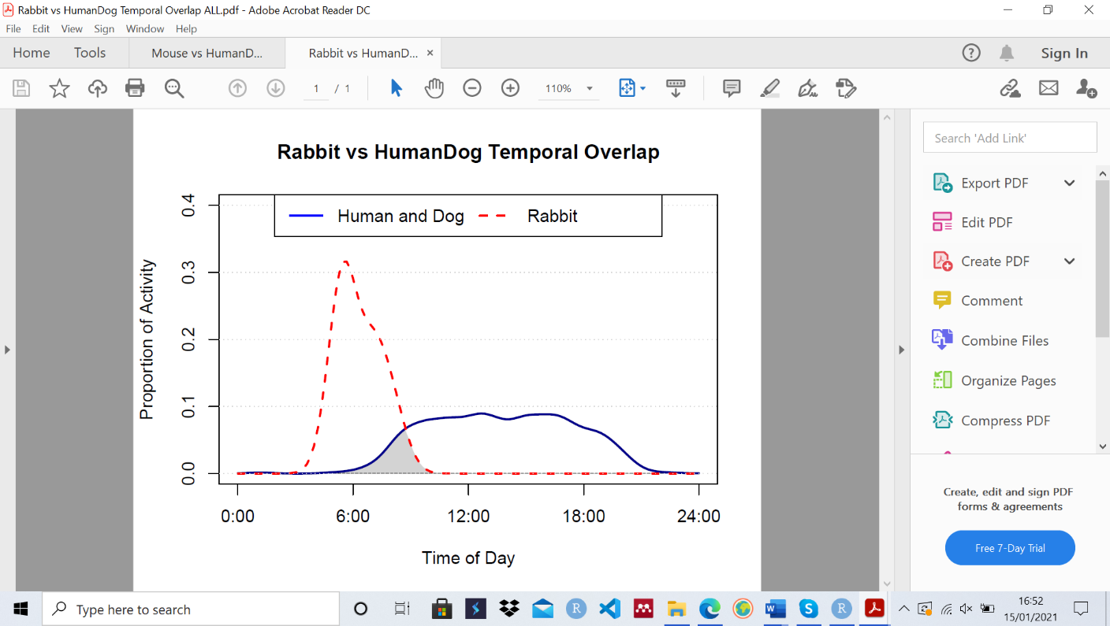
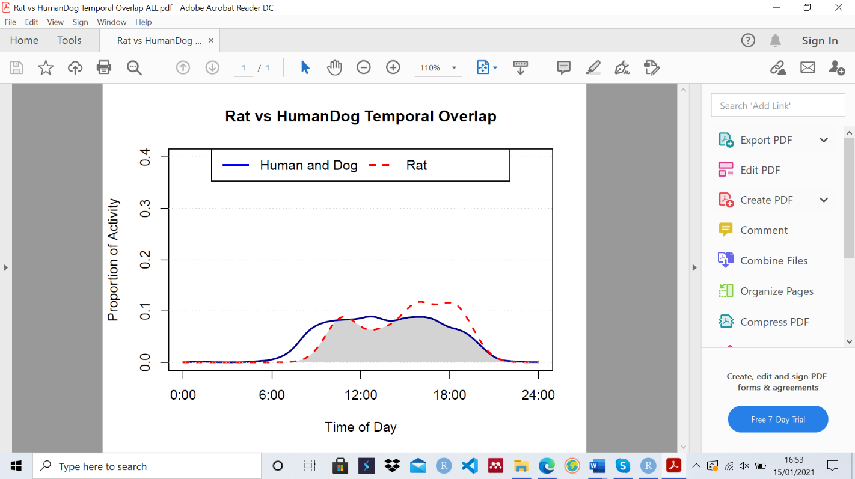
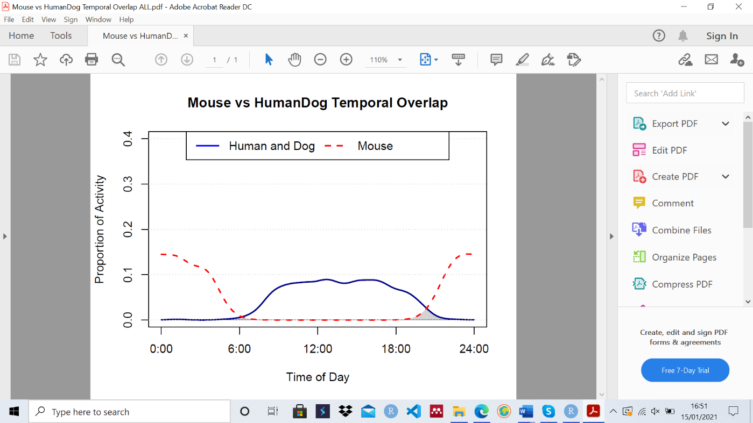
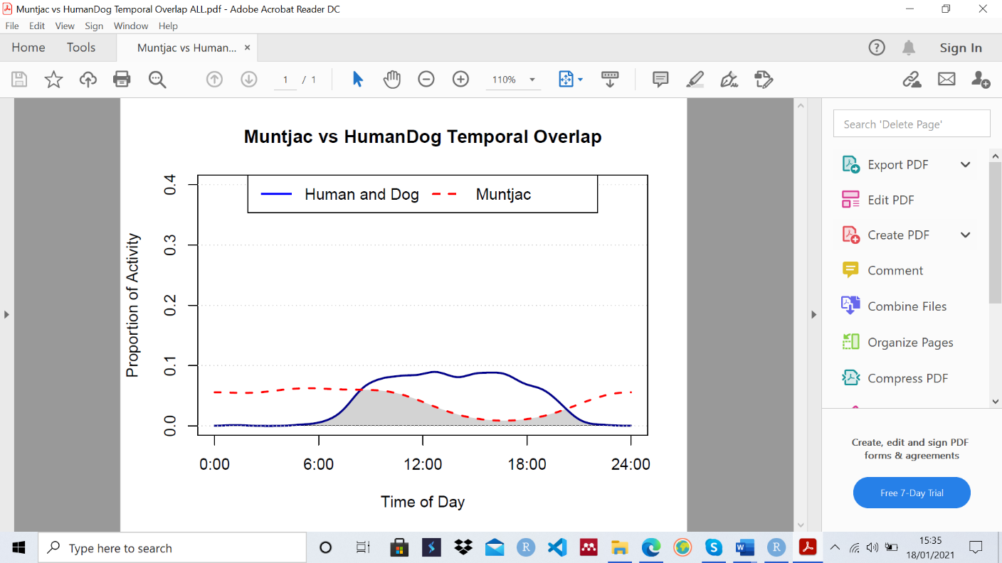
a)
b)
c)
d)

Fig. 1 Graphs showing the activity schedules of and the temporal overlap between human + dogs (blue solid) and a) European Rabbits (Oryctolagus cuniculus), b) Brown Rats (Rattus norvegicus), c) Wood Mice (Apodemus spp.) and d) Muntjacs (Muntiacus reevesi) (red dashed) across 26 woodland sites on Hampstead Heath. The number of detections for each species is as follows: European Rabbit=7, Brown Rats=29, Wood Mice=74, and Muntjacs=3. Note that the activity schedules of European Rabbits and Muntjacs were generated with less than ten detections so have low reliability. Figure made in in R v.3.6.2 (R Core Team, 2019)

Figure 2 Graphs showing the temporal overlap between human and dogs and a) Corvids, b) Squirrels, c) Thrushes, d) Foxes and e) Hedgehogs in Low Human/Dog Sites (left column) and High Human/Dog Sites (right column)

Sites Analysed | b estimate | p value | R²
All Sites | 0.67 | <0.01 | 0.70
Low Visits | 0.64 | <0.01 | 0.38
High Visits | 0.64 | 0.08 | 0.38
Table 3 Results of simple linear regressions between logged human and dog relative abundances across all sites, sites of low human and dog visits and sites of high human and dog visits.

Figure 3 Activity schedules of humans (blue) and dogs (red) a) across all sites, b) sites of low human and dog visits and c) sites of high human and dog visits. Number of detections used to generate the activity schedules: a) All Sites: Humans-1,570, Dogs-1,365; b) Low Sites: Humans-118, Dogs-222; c) High Sites: Humans-1,452, Dogs-1,143.

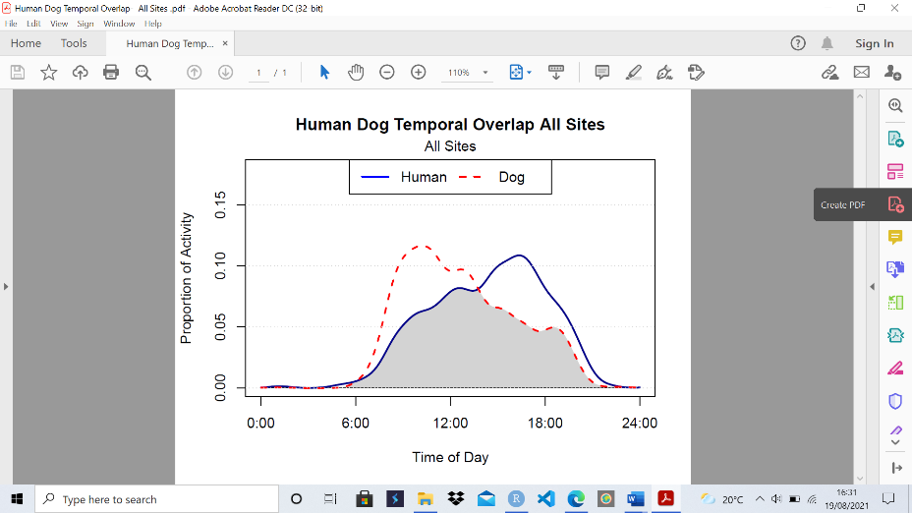
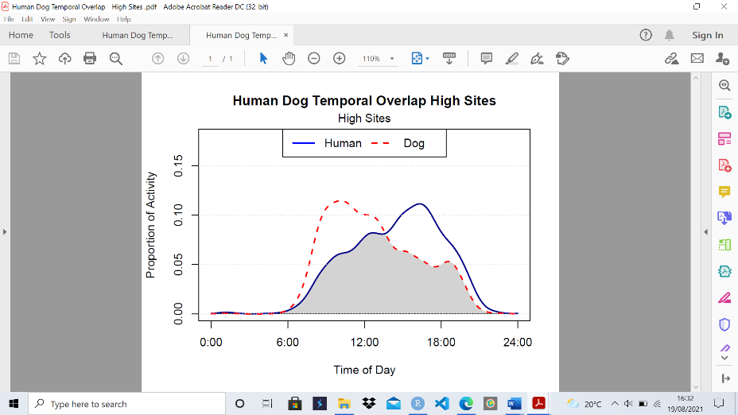
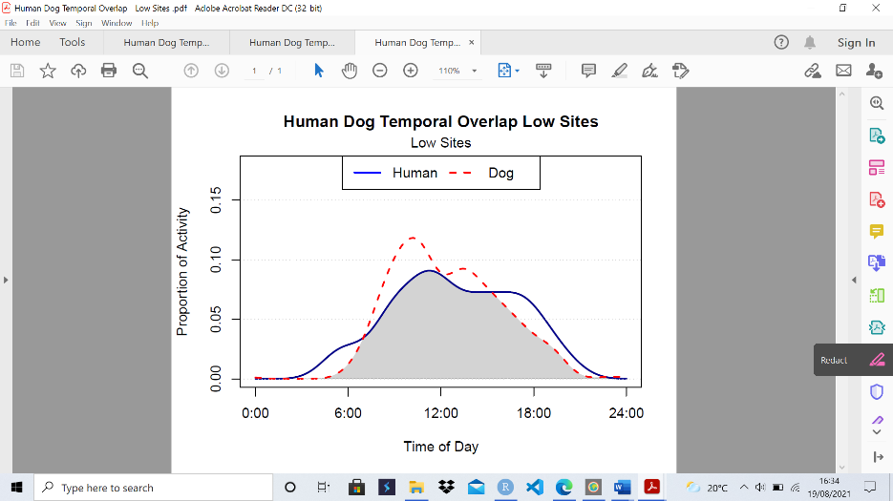
a)
b)
c)

Fig. 2 Activity schedules of humans (blue solid) and dogs (red dashed) a) across all sites, b) sites of low human and dog visits and c) sites of high human and dog visits. Number of detections used to generate the activity schedules: a) All Sites: Humans-1,570, Dogs-1,365; b) Low Sites: Humans-118, Dogs-222; c) High Sites: Humans-1,452, Dogs-1,143. Figures made in R v.3.6.2 (R Core Team, 2019)
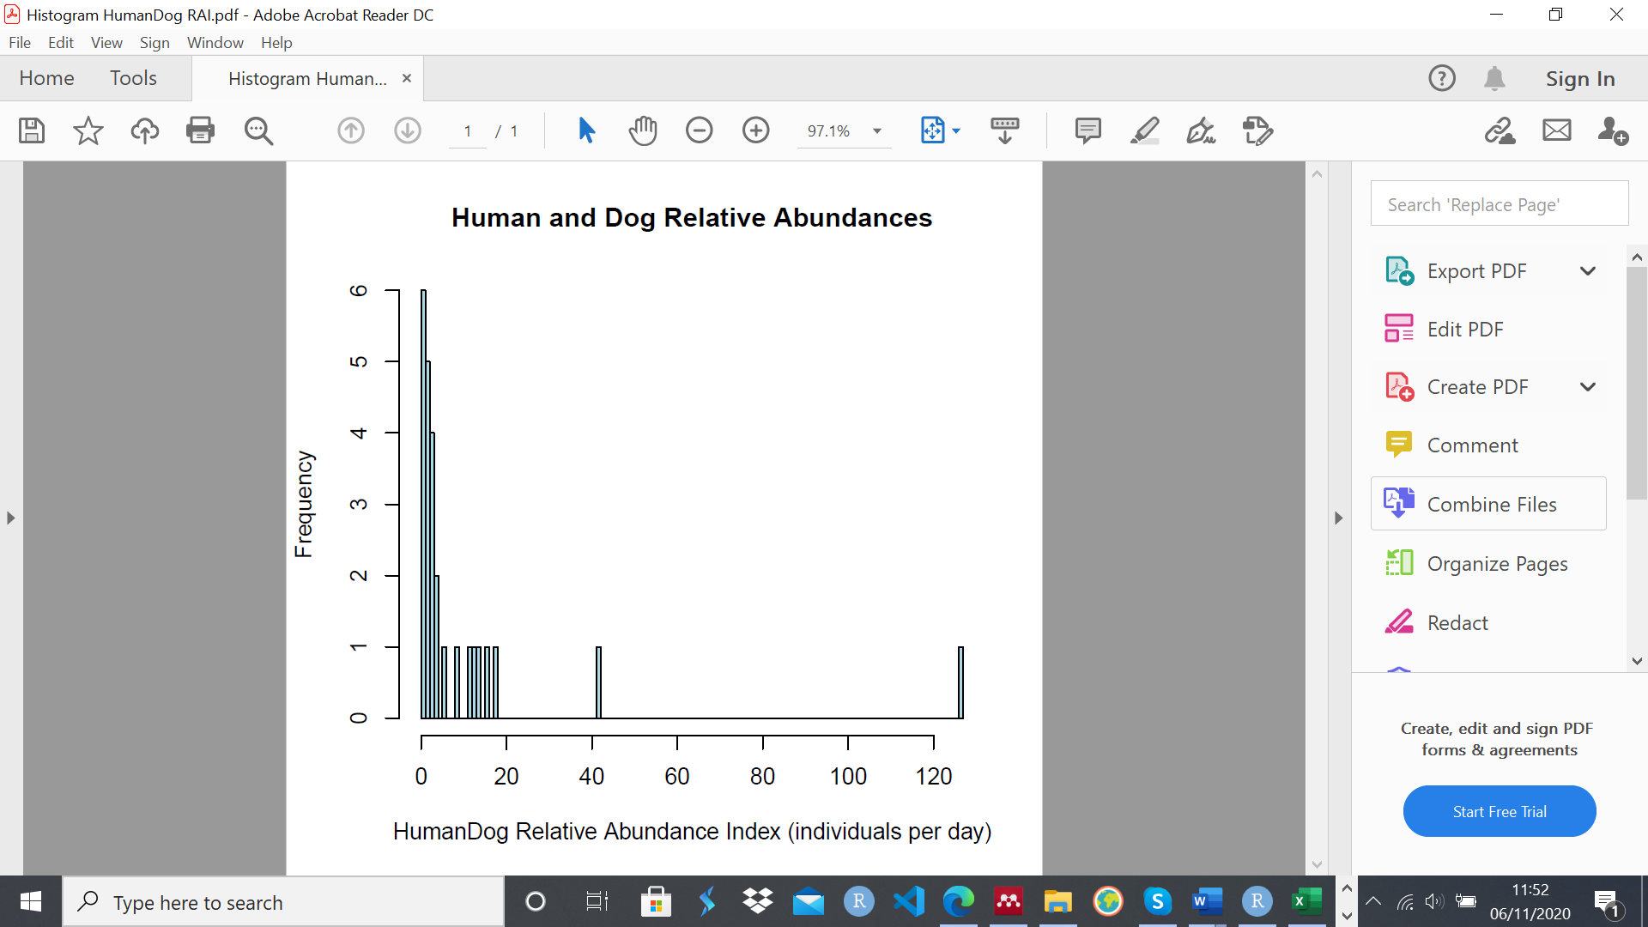
Fig. 3 Histogram showing the distribution of the combined Human + Dog Relative Abundance Indices (RAIs) across the 26 camera sites. The natural breakpoint between sites of low and high human and dog visits was determined to be at five Human + Dogs per day, due to the decrease in the frequency of higher RAIs values past this threshold. Figure made in R v.3.6.2 (R Core Team, 2019)

Human + Dog Visits | Species | Temporal Overlap | Lower CI | Upper CI | Total Detections
Low | All Birds | 0.93 | 0.88 | 0.96 | 591
High | All Birds | 0.73 | 0.67 | 0.79 | 184
Low | Blackbird | 0.92 | 0.87 | 0.96 | 269
High | Blackbird | 0.72 | 0.56 | 0.86 | 24
Low | Magpie | 0.76 | 0.65 | 0.86 | 72
High | Magpie | 0.68 | 0.60 | 0.76 | 117
Low | Song Thrush | 0.75 | 0.65 | 0.85 | 83
High | Song Thrush | 0.72 | 0.54 | 0.87 | 17
Low | Wood Pigeon | 0.89 | 0.80 | 0.96 | 65
High | Wood Pigeon | 0.73 | 0.54 | 0.88 | 17
Low | Non-Diurnal Mammals | 0.10 | 0.06 | 0.14 | 255
High | Non-Diurnal Mammals | 0.08 | 0.05 | 0.10 | 233
Low | European Hedgehog | 0.07 | 0.02 | 0.12 | 46
High | European Hedgehog | 0.06 | 0.01 | 0.12 | 32
Low | Grey Squirrel | 0.85 | 0.80 | 0.90 | 702
High | Grey Squirrel | 0.63 | 0.58 | 0.69 | 245
Low | Red Fox | 0.12 | 0.07 | 0.17 | 129
High | Red Fox | 0.08 | 0.05 | 0.11 | 196
Table 4 Results of temporal displacement analysis: Temporal overlap estimates between humans + dogs and each wildlife species by low and high visit sites, alongside their confidence intervals and the total number of detections of the wildlife species/groups used to generate the activity schedules. CI=Confidence Interval

