Appendix: Mathematical Modeling and Sensitivity Analysis of PSSE Workforce Needs

1. Introduction to the Workforce Estimation Model
This appendix provides a detailed methodological and mathematical breakdown of the exploratory workforce estimation model developed to project the need for Physiotherapeutic Scoliosis-Specific Exercises (PSSE) specialists in conflict-affected Syria. The model is grounded in the World Health Organization’s Workload Indicators of Staffing Need (WISN) framework, adapted to account for the severe operational constraints of a humanitarian crisis setting. The core objective is to translate epidemiological data (prevalence) into a pragmatic, actionable staffing target by systematically applying adjustment coefficients that reflect clinical eligibility, ethical prioritization, and systemic access barriers.

2. Derivation and Justification of Core Coefficients
The model's robustness and realism are derived from three core coefficients: α (Alpha), β (Beta), and μ (Mu). These coefficients are not arbitrary multipliers; they are evidence-based estimations derived from the study's own data and established humanitarian and clinical guidelines.

2.1. Coefficient α: The Clinical Eligibility and Prioritization Factor
Scientific Justification: The α coefficient serves a dual purpose: it first identifies the proportion of the scoliotic population clinically eligible for PSSE and then applies an ethical triage to prioritize those at the highest risk of progression. This ensures that finite resources are directed toward preventing long-term disability.
•α-clinical (0.93): This represents the raw clinical eligibility. Our field data indicates that 93% of confirmed scoliosis cases (66 out of 71) present with Cobb angles between 10° and 39°. According to the 2016 SOSORT guidelines, this cohort is the primary target for conservative PSSE management. This value establishes the maximum theoretical pool of candidates for PSSE.
α-prioritization (0.60): In a resource-scarce environment, not all eligible cases can be treated simultaneously. This coefficient applies a necessary ethical filter, prioritizing patients with a higher risk of curve progression. High-risk is defined based on SOSORT criteria: (i) moderate curves (20°-39°) or (ii) mild curves (10°-19°) in skeletally immature patients (Risser sign 0-2). Our data showed that 71.8% of cases met these criteria. A conservative value of 0.60 was adopted to ensure caseloads remain manageable and to prevent specialist burnout.
Mathematical Formulation: The final adjusted α is the product of these two components.
α_adjusted = α_clinical × α_prioritization = 0.93 × 0.60 = 0.551
This means that for every 100 confirmed scoliosis cases, approximately 65 are deemed both clinically eligible and a high priority for immediate intervention.

2.2. Coefficient β: The Effective Service Access Factor
Scientific Justification: The β coefficient is the model's reality check, quantifying the profound impact of systemic barriers on healthcare delivery in a conflict zone. It represents the proportion of the high-priority, eligible population that can realistically access and adhere to a demanding, long-term treatment like PSSE.
- β-access (0.25): This value is an evidence-based estimate derived from humanitarian reports (e.g., WHO, UNHCR), which indicate that only a fraction of health infrastructure is functional and accessible in Syria. A value of 0.25 (25%) was chosen to reflect the combined impact of:
- Geographic and Security Barriers: Inability to travel safely to clinics.
- Economic Hardship: Prohibitive costs of transport and treatment for families.
- Low Health Literacy: Lack of awareness regarding scoliosis and the benefits of PSSE.
- System Fragmentation: A disrupted referral system and shortage of specialized centers.
Mathematical Impact: This coefficient acts as a powerful constraint on the theoretical caseload. The model's high sensitivity to β underscores that improving access to care is as critical as training new specialists.

2.3. Coefficient μ: The Comprehensive Workload Multiplier
Scientific Justification: The μ coefficient is the final composite multiplier, representing the net proportion of the total theoretical scoliosis population that will generate actual clinical workload.
Mathematical Formulation: It is the product of the adjusted clinical eligibility and the access factor.
μ_comprehensive = α_adjusted × β_access = 0.551 × 0.25 = 0.1395
This starkly illustrates that only about 16.3% of the total estimated scoliosis burden can be realistically addressed under the current circumstances. This final, adjusted figure is used to calculate the total annual workload in hours, which is then divided by the annual capacity of a single specialist to determine the final staffing requirement.

3. Data Tables
The following tables provide the numerical foundation for the model, detailing the values of each coefficient, the different scenarios analyzed, and the results of the sensitivity analysis.

Table 1: Comprehensive Coefficient Breakdown
Coefficient | Symbol | Value | Percentage | Interpretation | Scientific Basis
α-clinical | α | 0.93 | 93% | Proportion of cases with mild-moderate curvature (Cobb 10-39°) | Out of 71 confirmed cases, 66 are in the eligible range
α-prioritization | α | 0.60 | 60% | Proportion of high-risk cases (Cobb ≥20° or Risser ≤2) | Out of 71 cases, 51 meet the high-risk criteria
α-adjusted (v1) | α | 0.55 | 55% | 0.93 × 0.60 = Proportion of eligible and prioritized cases | Focus on the most needy and prioritized cases
α-adjusted (v2) | α | 0.65 | 65.1% | 0.93 × 0.70 = Proportion of eligible and prioritized cases | Focus on the most needy and prioritized cases
β-access | β | 0.25 | 25% | Proportion of the eligible population that can access the service | WHO/UNHCR 2025 report - only 37% of services are functional
μ-comprehensive (v1) | μ | 0.1375 | 13.75%  ~14% | 0.55 × 0.25 = Comprehensive multiplier (Scenario 1) | Actually available cases for treatment
μ-comprehensive (v2) | μ | 0.1375 | 13.75%  ~14% | 0.551 × 0.25 = Comprehensive multiplier (Scenario 2) | Actually available cases for treatment

Table 2: Workforce Projections Under Different Scenarios
Scenario | α-prioritization | β-access | μ-comprehensive | Required Staff | Interpretation
Very Pessimistic | 0.40 | 0.15 | 0.0372 | 80 | Ongoing crisis, very limited facilities
Pessimistic | 0.50 | 0.20 | 0.0930 | 160 | Limited pilot programs
Base Case | 0.55 | 0.25 | 0.1375 | 240 | Mid situation in Syria
Moderately Optimistic | 0.70 | 0.30 | 0.1953 | 350 | Moderate improvement in security and infrastructure
Optimistic | 0.70 | 0.40 | 0.2605 | 450 | Significant improvement in access and resources

Table 3: One-Way Sensitivity Analysis
Variable | Value | Staff (with β=0.25) | Staff (with α=0.55) | % Change from Base
α | 0.40 | 87 | - | 63%
α | 0.55 | 120 | - | Base
α | 0.70 | 154 | - | 28%
α | 0.93 | 204 | - | 70%
β | 0.15 | - | 48 | 40%
β | 0.25 | - | 80 | Base
β | 0.30 | - | 96 | 20%
β | 0.40 | - | 128 | 60%

4. Visual Analysis of Model Sensitivity
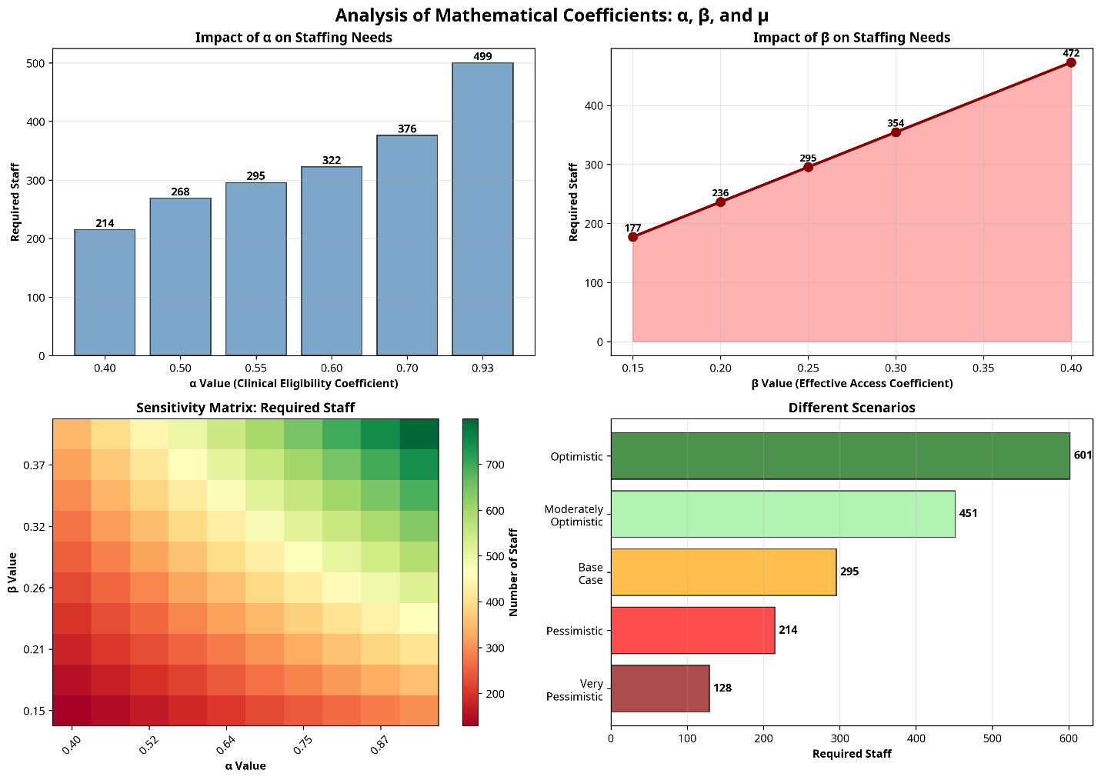

Figure 1: Visual Analysis of Model Coefficients and Sensitivity
Professional Scientific Commentary: provides a multi-faceted visual synthesis of the workforce estimation model's dynamics and its sensitivity to the core adjustment coefficients, α and β. This graphical representation is crucial for translating the model's mathematical complexity into actionable insights for health policy and planning.
- Top-Left Panel (Impact of α): This bar chart illustrates the linear relationship between the clinical eligibility/prioritization factor (α) and the required number of specialists, holding the access factor (β) constant at its base value of 0.25. While an increase in α from 0.40 to 0.93 more than doubles the required workforce (from 87 to 204), the overall impact is moderate and predictable. This demonstrates that while clinical criteria are important, they are not the most volatile variable in the model.
- Top-Right Panel (Impact of β): This line graph reveals the model's high sensitivity to the effective service access coefficient (β). The steep, upward curve demonstrates a non-linear, exponential-like impact on staffing needs. A small improvement in access for instance, from 0.15 to 0.40 results in a nearly threefold increase in the required workforce (from 48 to 128). This is the most critical finding of the model: systemic access barriers are the dominant constraint on service delivery. It powerfully argues that investments in infrastructure, security, and health system strengthening are paramount and will have a disproportionately large impact on workforce demand.
- Bottom-Left Panel (Sensitivity Matrix): This heat map provides a two-dimensional sensitivity analysis, visualizing the combined impact of α and β. The color gradient, from green (low requirement) to red (high requirement), allows for the rapid assessment of risk and the identification of key leverage points. The vertical color stratification confirms the dominant influence of β; moving vertically (changing β) causes a much more dramatic shift in color (and thus, staffing needs) than moving horizontally (changing α). This matrix serves as a powerful strategic tool for decision-makers, allowing them to visualize the workforce implications of different public health scenarios.
- Bottom-Right Panel (Scenario Analysis): This horizontal bar chart synthesizes the model's outputs into five distinct, plausible scenarios, ranging from 'Very Pessimistic' to 'Optimistic'. This translates the abstract model into concrete, understandable projections. It clearly communicates the range of potential futures and the associated staffing requirements, providing a clear basis for phased, scalable implementation planning. For example, it shows that even a moderately optimistic improvement in conditions would necessitate a workforce of approximately 350 specialists, a significant increase from the base case of 240.

