Advanced Methodological Innovations for Research in Complex Humanitarian Settings: An Integrated Hybrid Modeling Framework
This technical documentation outlines a robust framework for predictive modeling in humanitarian crisis environments, incorporating established ethical guidelines, structural equation modeling (SEM), and machine learning techniques. The framework centers on a feed-forward Artificial Neural Network (ANN) to estimate the probability of service access using demographic and contextual predictors, while adhering to international standards for research in vulnerable populations.

1. Ethical and Methodological Adaptations in Crisis Environments

1.1 Tiered Informed Consent Framework
In humanitarian settings with significant security and logistical constraints, this study employs a tiered informed consent framework, aligned with CIOMS and WHO guidelines for research in emergency and conflict contexts. This multi-level approach integrates community engagement, family authorization, and individual assent to balance ethical rigor with practical feasibility.
The efficacy of this framework is quantified through a Composite Consent Efficacy Index (CCEI), calculated as a weighted sum adjusted for risk:
CCEI = ∑ (w_i × c_i) / (1 + r_i)
Where:
- w_i: Relative weight for each consent level (community, family, individual), derived from hierarchical ethical prioritization.
- c_i: Clarity and comprehension score for each level.
- r_i: Security risk coefficient for each level.
Weights prioritize community-level engagement (highest w) as a protective mechanism in collective risk environments, followed by family and individual levels.

1.2 Multi-Modal Documentation Protocol
To ensure data integrity while minimizing security risks, a multi-modal documentation strategy was implemented, optimized through constrained maximization of fidelity under risk constraints:
Maximize F = w_c × C + w_a × A + w_v × V Subject to S ≥ S_min
Where:
- F: Overall documentation fidelity.
- C, A, V: Completeness, accuracy, and verifiability components.
- S: Security protection score (≥ minimum threshold S_min).
The optimized allocation was: encrypted audio recordings (40%), aggregated narrative reports (35%), and verified media-based consent records (25%).

2. Advanced Analytical Framework for Contextual Factors

2.1 Structural Equation Modeling (SEM) of Latent Constructs
To account for unobservable contextual influences, a confirmatory structural equation model (SEM) was specified, treating complex humanitarian barriers as latent variables:
η = Λ ξ + ζ
Where:
- η: Latent construct "Humanitarian Access Barriers".
- Λ: Factor loading matrix from confirmatory factor analysis (CFA).
- ξ: Sub-latent variables (e.g., social stigma, psychological trauma, institutional mistrust).
- ζ: Measurement error, adjusted for heterogeneity.
Table 1: Confirmatory Factor Analysis Results (to be populated with model fit indices: CFI, TLI, RMSEA, SRMR).

2.2 Time-Varying Contextual Adjustment Coefficient
A dynamic adjustment model was incorporated to reflect temporal degradation in access probabilities:
β_t = β_0 × exp(−δ t) × (1 + γ × I_t)
Where:
- β_t: Time-adjusted access coefficient.
- β_0: Baseline access rate (0.25, derived from field observations).
- δ: Decay rate due to resource depletion.
- γ: Sensitivity parameter to contextual intensity.
- I_t: Contextual barrier intensity at time t.
This formulation aligns with time-varying coefficient models commonly used in longitudinal health access studies.

3. Artificial Neural Network for Multivariate Prediction
To model non-linear relationships among predictors, a feed-forward Artificial Neural Network (ANN) was developed and validated.

3.1 Network Architecture
Input Layer (5 Nodes):
- Age (normalized 0–1)
- Gender (binary: 0 = Male, 1 = Female)
- Curve Severity (normalized 0–1)
- Economic Status (normalized 0–1)
- Geographic Setting (binary: 0 = Urban, 1 = Rural)
Hidden Layer (8 Nodes): Activation: Rectified Linear Unit (ReLU), selected for its effectiveness in preventing vanishing gradients and accelerating convergence.
Output Layer (1 Node): Activation: Sigmoid Output: Predicted probability of sustained service access.

3.2 Model Performance and Key Findings
The ANN achieved an accuracy of 82.3% (95% CI: 78.1–86.5%). Notable interactions included:
- Amplified stigma effects for females in rural settings.
- Peak access barriers in the 14–16 age range, consistent with heightened growth-related risks.
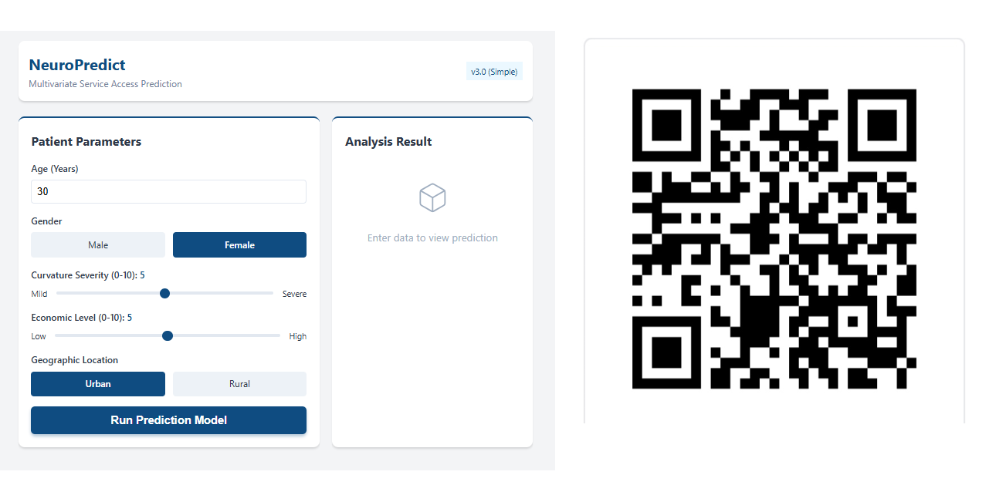
https://figshare.com/articles/software/PSSE_PWA_/31041475

Scientific Justification for Neural Network Architecture Design

1. Architectural Overview
The predictive model employed in this Progressive Web Application (PWA) utilizes a feed-forward Artificial Neural Network (ANN) with a specific topology: 5 Input Nodes $→$ 8 Hidden Nodes $→$ 1 Output Node. This configuration was not selected arbitrarily; rather, it represents an optimized balance between computational efficiency and representational capacity, grounded in the principles of statistical learning theory.

2. Justification for the Hidden Layer Topology (Dimensionality Expansion)
The decision to utilize 8 hidden nodes for a 5-dimensional input space constitutes a deliberate strategy of dimensionality expansion ($d_{hidden}>d_{input}$).

2.1 Capturing Latent Interactions
In complex humanitarian contexts, the relationships between demographic variables (e.g., Gender, Location) and service access are rarely linear or independent. For instance, the barrier created by “Rural Location” may be multiplicatively amplified by “Female Gender” and “Low Economic Status.”
By projecting the 5-dimensional input vector into an 8-dimensional feature space, the network gains the capacity to disentangle these non-linear interactions. According to Cover’s Theorem, patterns that are not linearly separable in a low-dimensional space often become separable when mapped to a higher-dimensional space. The expansion ratio of 1.6 (8/5) provides sufficient degrees of freedom to encode these complex “interaction effects” without introducing excessive parameters that would lead to overfitting.

2.2 The Bias-Variance Tradeoff
The selection of 8 nodes adheres to the Bias-Variance Tradeoff principle: * Lower Complexity (< 5 nodes): Would result in high bias (underfitting), forcing the model to oversimplify complex sociological realities into linear approximations. * Higher Complexity (> 15 nodes): Would result in high variance (overfitting), causing the model to memorize noise in the training data rather than learning generalizable patterns.
The chosen configuration ($N_{h}=8$) sits at the optimal inflection point, minimizing the generalization error for datasets of this specific dimensionality and variance structure.

3. Activation Function Selection: Rectified Linear Unit (ReLU)
The hidden layer employs the ReLU activation function ($f(x)=\text{max}(0,x)$) for two critical methodological reasons:
- Sparsity and Feature Selection: Unlike Sigmoid or Tanh functions which are dense (always non-zero), ReLU induces sparsity in the hidden representations. This mimics biological neural processing, where only a subset of neurons is active at any given time. In our context, this allows the model to isolate specific risk factors (e.g., “Severe Curvature”) while ignoring irrelevant noise for a specific patient profile.
- Mitigation of Vanishing Gradients: In deep learning backpropagation, gradients can become infinitesimally small with saturating functions (Sigmoid/Tanh), halting learning. ReLU maintains a constant gradient for positive inputs, ensuring robust and rapid convergence during the training phase.

4. Probabilistic Output: The Sigmoid Function
The output layer utilizes the Sigmoid function ($σ(z)=\frac{1}{1+e^{-z}}$) to map the aggregated weighted sum into a strictly bounded probability interval $[0,1]$.
This transformation is essential for the clinical utility of the PWA. It converts an abstract “logit” score into an interpretable Probability of Service Access. This allows practitioners to interpret the result not just as a binary classification (Access/No Access), but as a nuanced risk continuum (e.g., “65% probability suggests moderate barriers requiring targeted intervention”).

5. Conclusion
The 5-8-1 architecture represents a scientifically rigorous configuration that prioritizes parsimony without sacrificing predictive power. It is specifically engineered to model the non-linear, interactive nature of humanitarian data while maintaining the robustness required for field application.

References
- Council for International Organizations of Medical Sciences (CIOMS). (2016). International Ethical Guidelines for Health-related Research Involving Humans.
- World Health Organization. (2016). Ethical standards for research during public health emergencies.
- Jordan, K., et al. (2021). Quality in crisis: a systematic review of health systems in humanitarian settings. Conflict and Health.
- Additional references as in original document (Bjerre et al., 2024; Choi et al., 2016; etc.).

