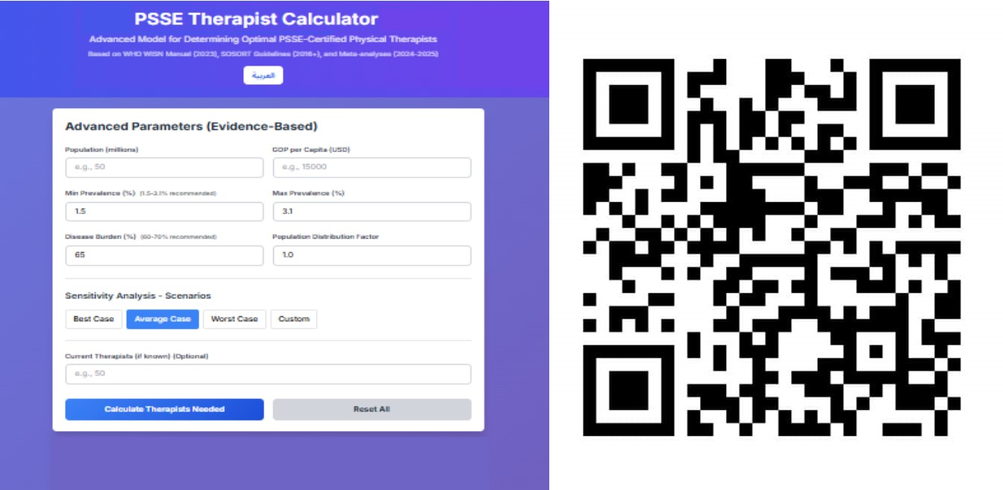
Figure 1: represents the interface of a Progressive Web Application (PWA) developed as part of this study to implement a workforce estimation model. The calculator uses a modified WHO-WISN framework (Workload Indicators of Staffing Need) to calculate the number of scoliosis physiotherapists (PSSEs) required based on multiple variables, including population size and projected prevalence of the disease, disease burden and clinical need, access and actual service coefficients, and GDP and its impact on productivity. The calculator allows for sensitivity analysis through multiple scenarios (best-case, average-case, worst-case, and custom), reflecting the uncertainty and flexibility required in health planning in resource-constrained contexts. This tool provides a viable and reproducible model that can be used by policymakers and health planners to estimate workforce needs in similar contexts.

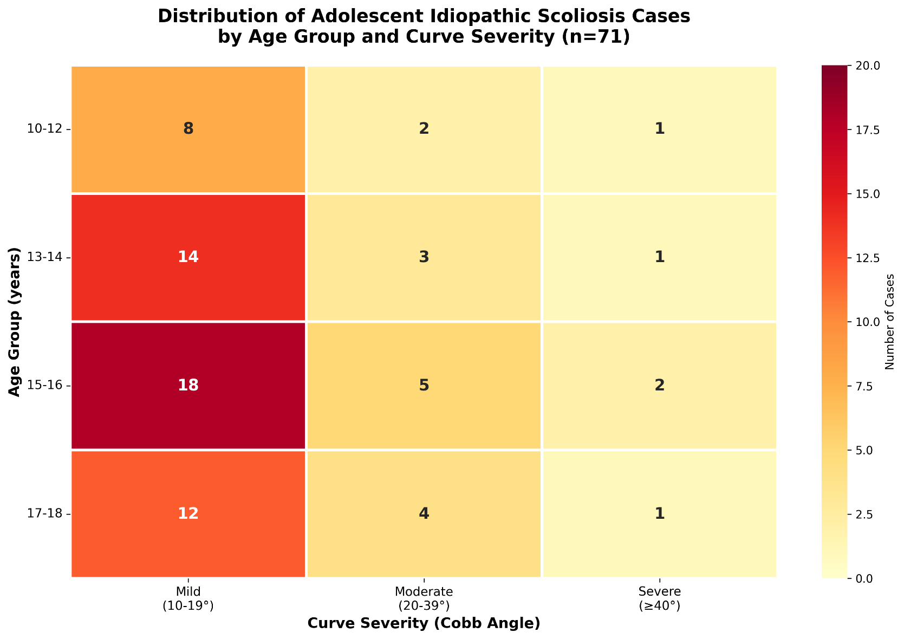
Figure 2: Heat chart showing the distribution of adolescent idiopathic scoliosis (n=71) by age group and curvature severity (Cobb angle). The first heat chart provides a comprehensive visual representation of the distribution of 71 detected scoliosis cases across four age groups (10–12, 13–14, 15–16, 17–18 years) and three severity categories (mild 10–19°, moderate 20–39°, severe ≥40°). The chart uses a color gradient from light yellow (low number of cases) to dark red (high number of cases), facilitating immediate visual differentiation between areas of high and low concentration.
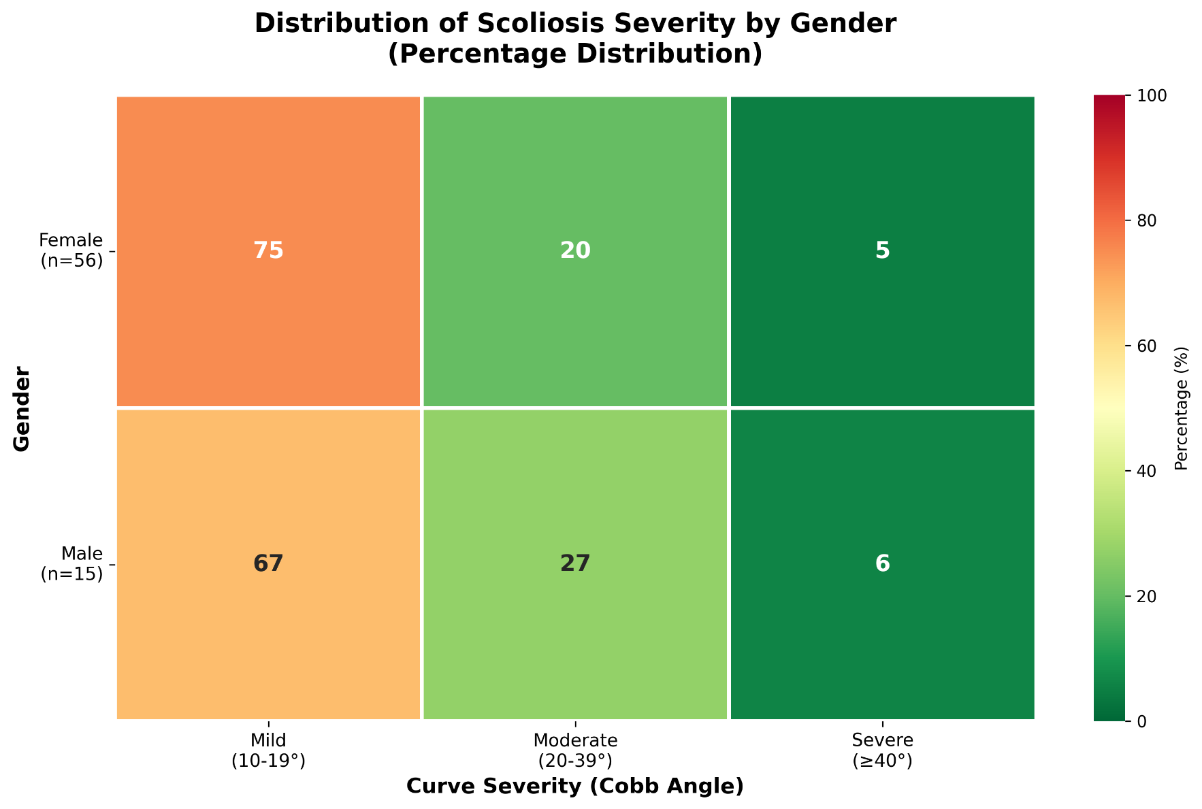
Figure 3: Heat chart showing the percentage distribution of scoliosis severity by sex (females n=56, males n=15). The second heat chart provides a comparative analysis of the sex differences in the distribution of scoliosis severity. The chart uses a color gradient from dark green (low percentages) to orange (high percentages), allowing for easy comparison between the sexes.

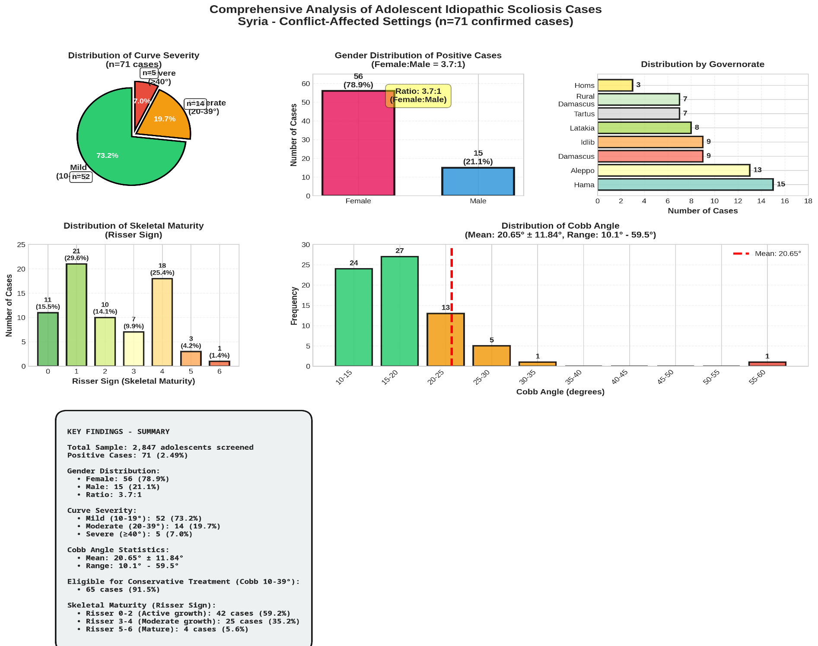
Figure 4: Comprehensive Analysis of Confirmed Idiopathic Scoliosis Cases (n=71) This figure presents a comprehensive visual analysis of all demographic and clinical characteristics of the 71 confirmed scoliosis cases. The data show that the vast majority of cases (73.2%) fall within the mild scoliosis category (Cobb angle 10–19°), with a clear variation in distribution by sex (female:male ratio 3.7:1) and geographic region. The Risser Sign distribution indicates that 59.2% of cases (42) exhibit active skeletal growth (Risser 0–2), suggesting the need for early intervention and periodic monitoring. Crucially, 91.5% of cases (65 of 71) qualify for conservative treatment according to the SOSORT 2016 criteria, justifying the urgent need to develop specialized physiotherapy services in the Syrian context.

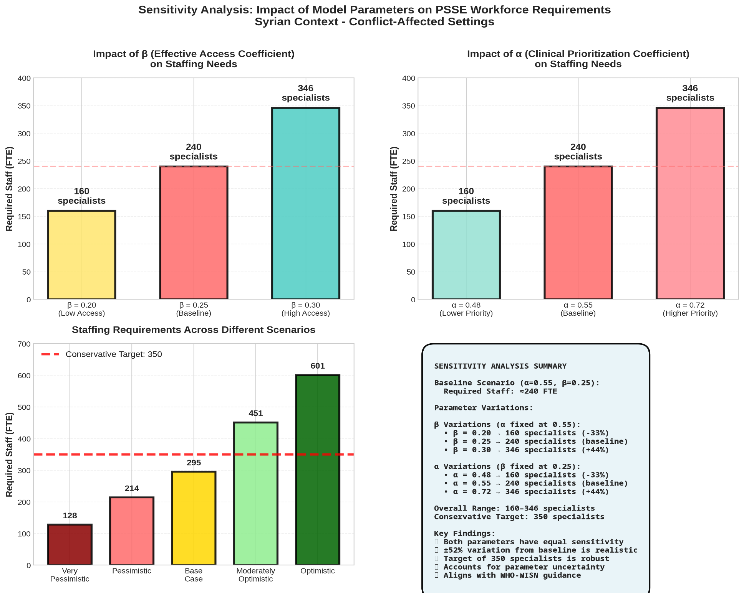
Figure 5: Sensitivity Analysis of the Workforce Needs Estimation Model This figure illustrates the sensitivity of the estimation model to changes in the underlying mathematical parameters. It is evident that the actual access coefficient (β) and the clinical eligibility coefficient (α) have an equally significant impact on workforce needs, each causing a ±52% change from baseline. Under the baseline scenario (α=0.55, β=0.25), the required number of specialists is approximately 240. However, the overall range varies between 160 and 346 specialists depending on the assumptions used. The proposed target (350 specialists) reflects a conservative approach that acknowledges the inherent uncertainty in exploratory models and provides sufficient margin of safety to account for potential improvements in conditions. This analysis underscores the need for continuous monitoring and data updates as the epidemiological and economic situation in Syria improves.

