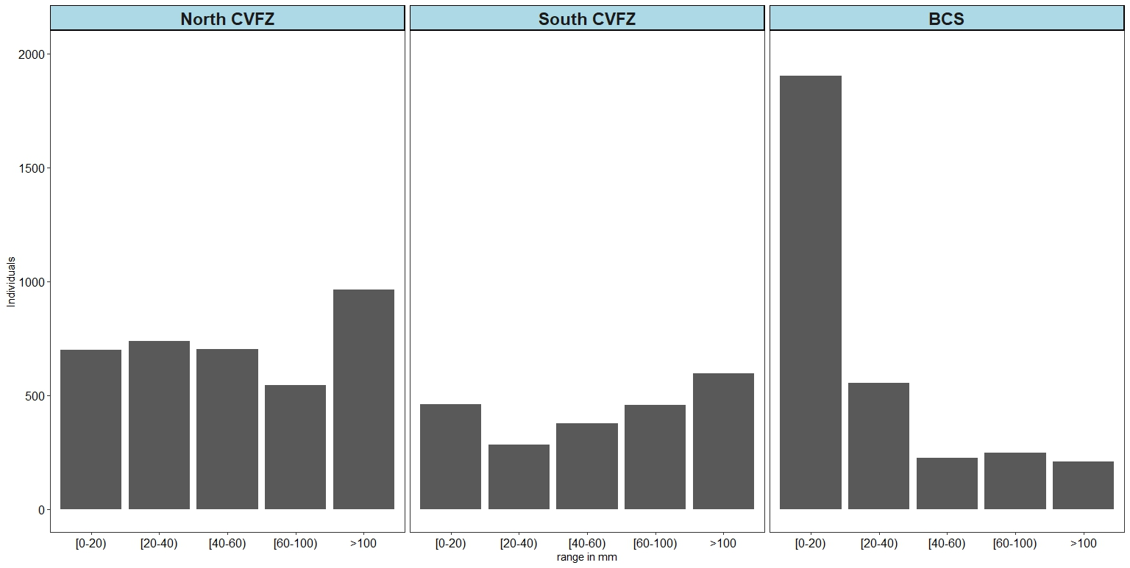
Supl. 1.Number of individuals for each area range throughout both sampling zones. The area range is given in mm²

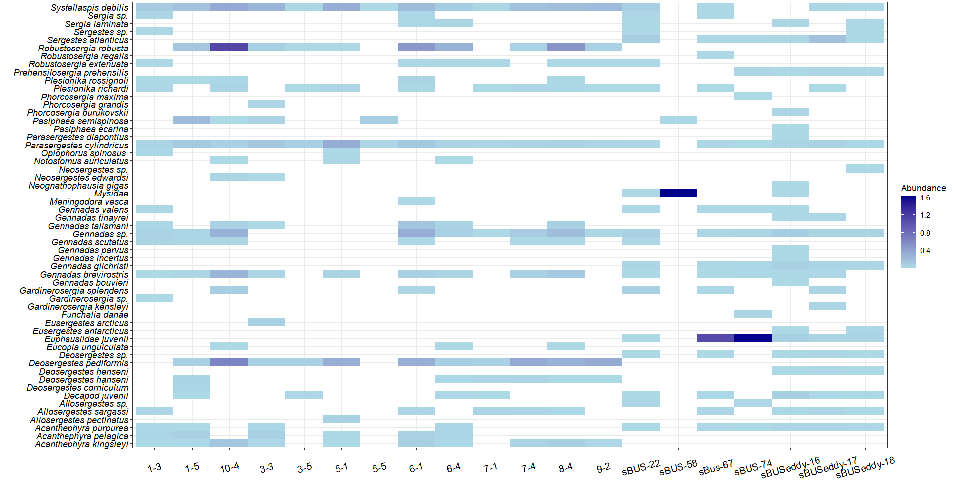
Supl. 2. Shade plot for decapods, lophogastrids, and mysids abundance distribution along the Mauritanian Upwelling (MU) and Benguela Upwelling System (BUS) sampling areas. Abundance data is given in individuals·m⁻².

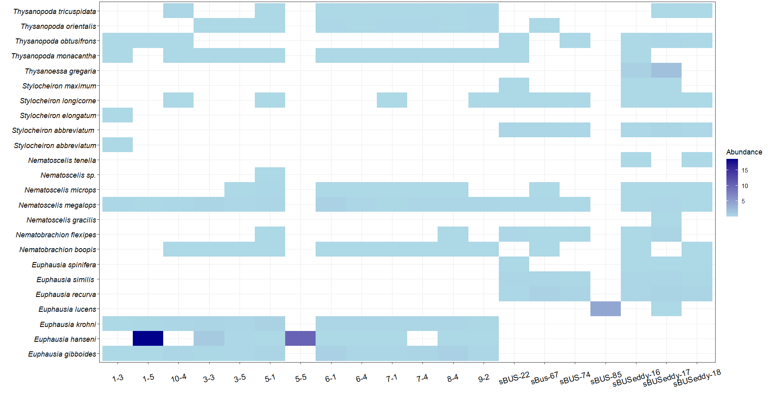
Supl. 3. Shade plot for euphausiids abundance distribution along the Mauritanian Upwelling (MU) and Benguela Upwelling System (BUS) sampling areas. Abundance data is given in ind·m⁻².

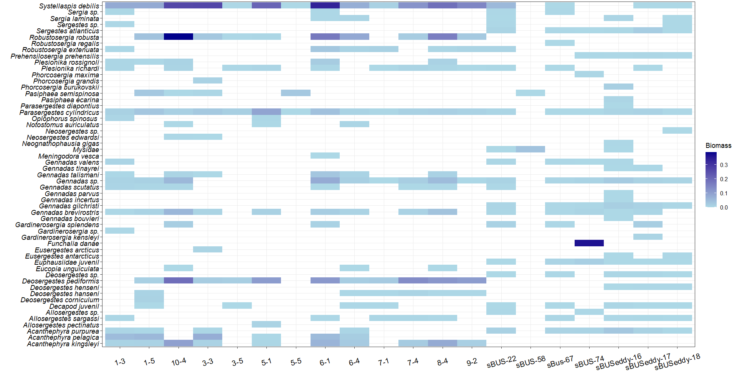
Supl. 4. Shade plot for decapods, lophogastrids, and mysids biomass distribution along the Mauritanian Upwelling (MU) and Benguela Upwelling System (BUS) sampling areas. Biomass data is given in grams of wet weight (gWW)·m⁻².

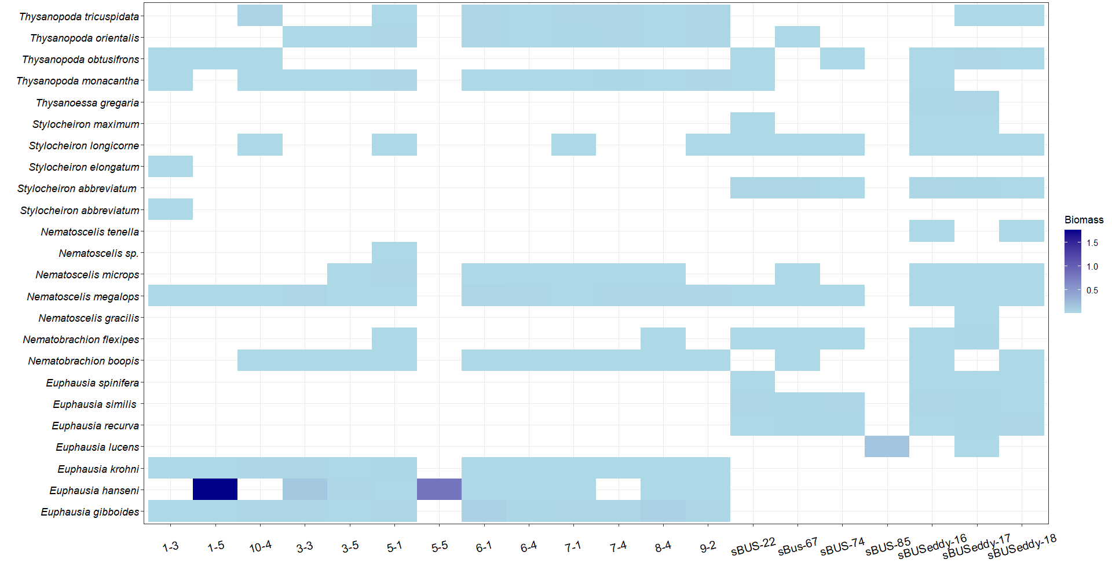
Supl. 5. Shade plot for euphausiids biomass distribution along the Mauritanian Upwelling (MU) and Benguela Upwelling System (BUS) sampling areas. Biomass data is given in grams of wet weight (gWW)·m⁻².

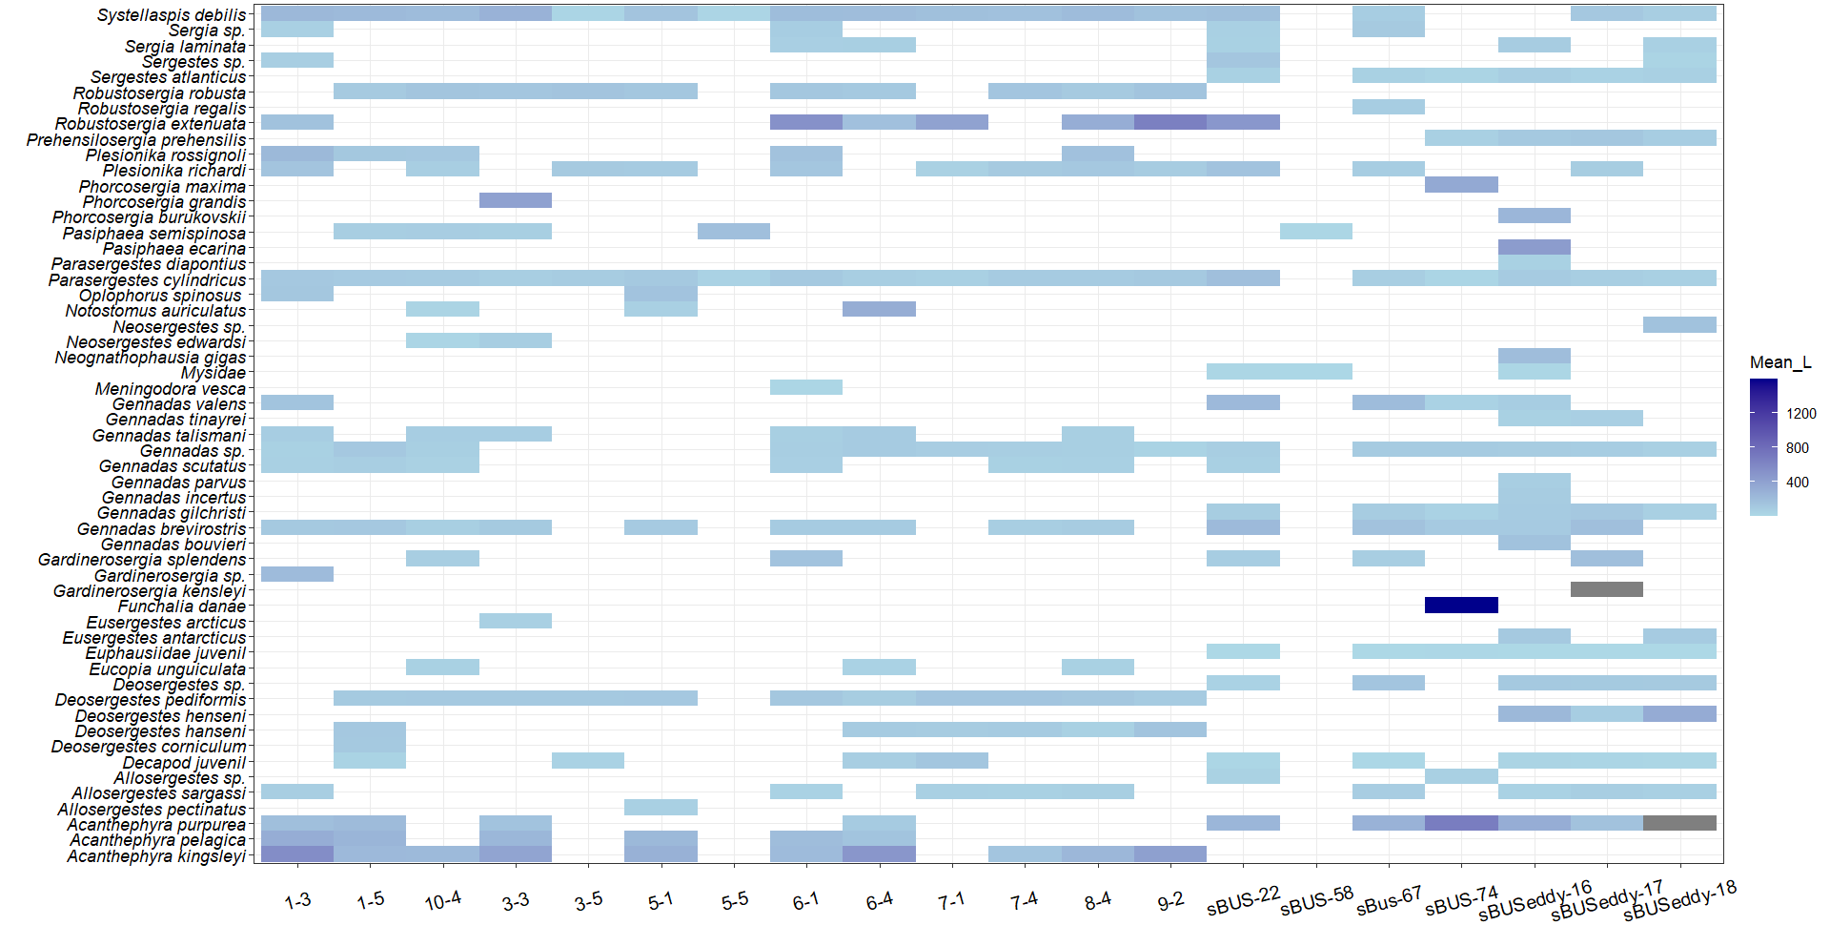
Supl. 6. Shade plot for decapods, lophogastrids, and mysids mean area along the Mauritanian Upwelling (MU) and Benguela Upwelling System (BUS) sampling areas. Mean area data is given in mm². Grey rectangles show NA values.

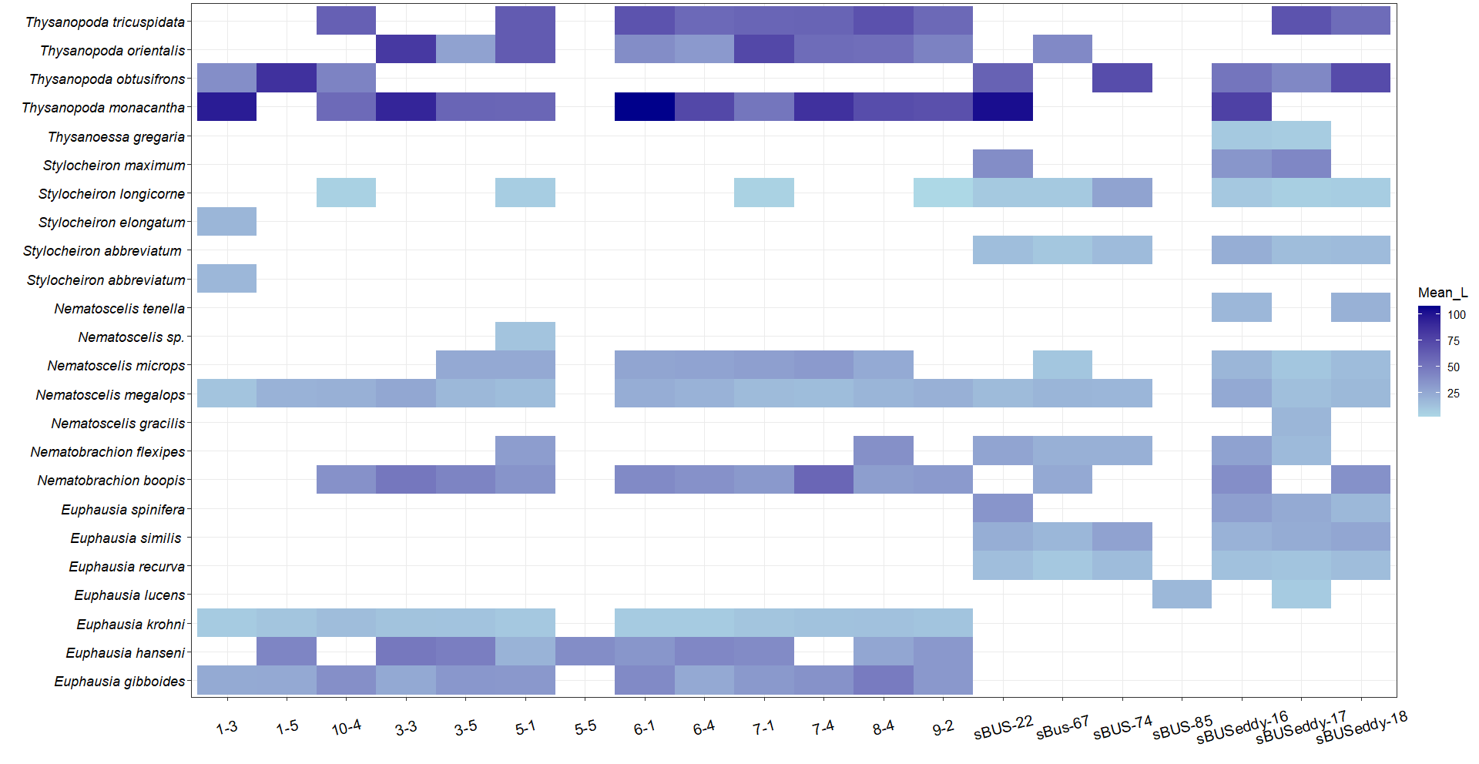
Supl. 7. Shade plot for euphausiids mean area distribution along the Mauritanian Upwelling (MU) and Benguela Upwelling System (BUS) sampling areas. Mean area data is given in mm².

