EXTENDED DATA FIGURES
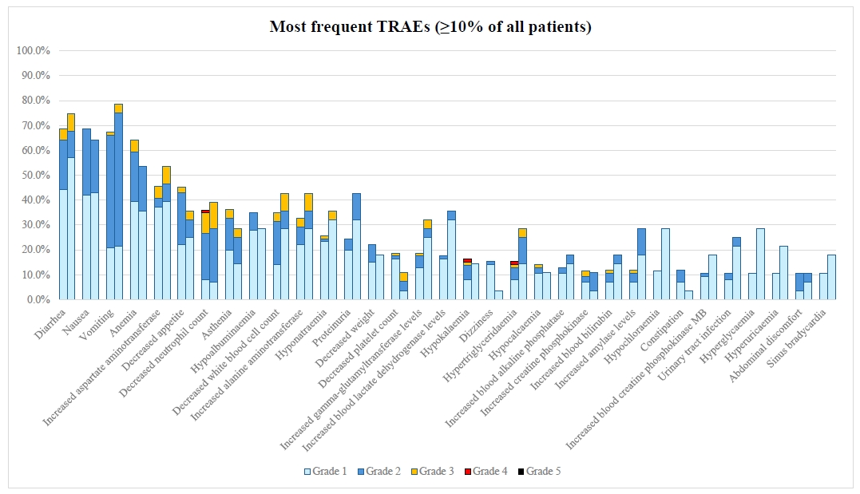
Extended Data Fig. 1. Most frequent TRAEs in the whole population (left bar) and in patients with NSCLC (right bar).
Extended Data Fig. 2. GFH375 mean plasma concentration–time curve at steady state.
The error bars represent the standard error. Abbreviations: BID: twice daily; QD, once daily.
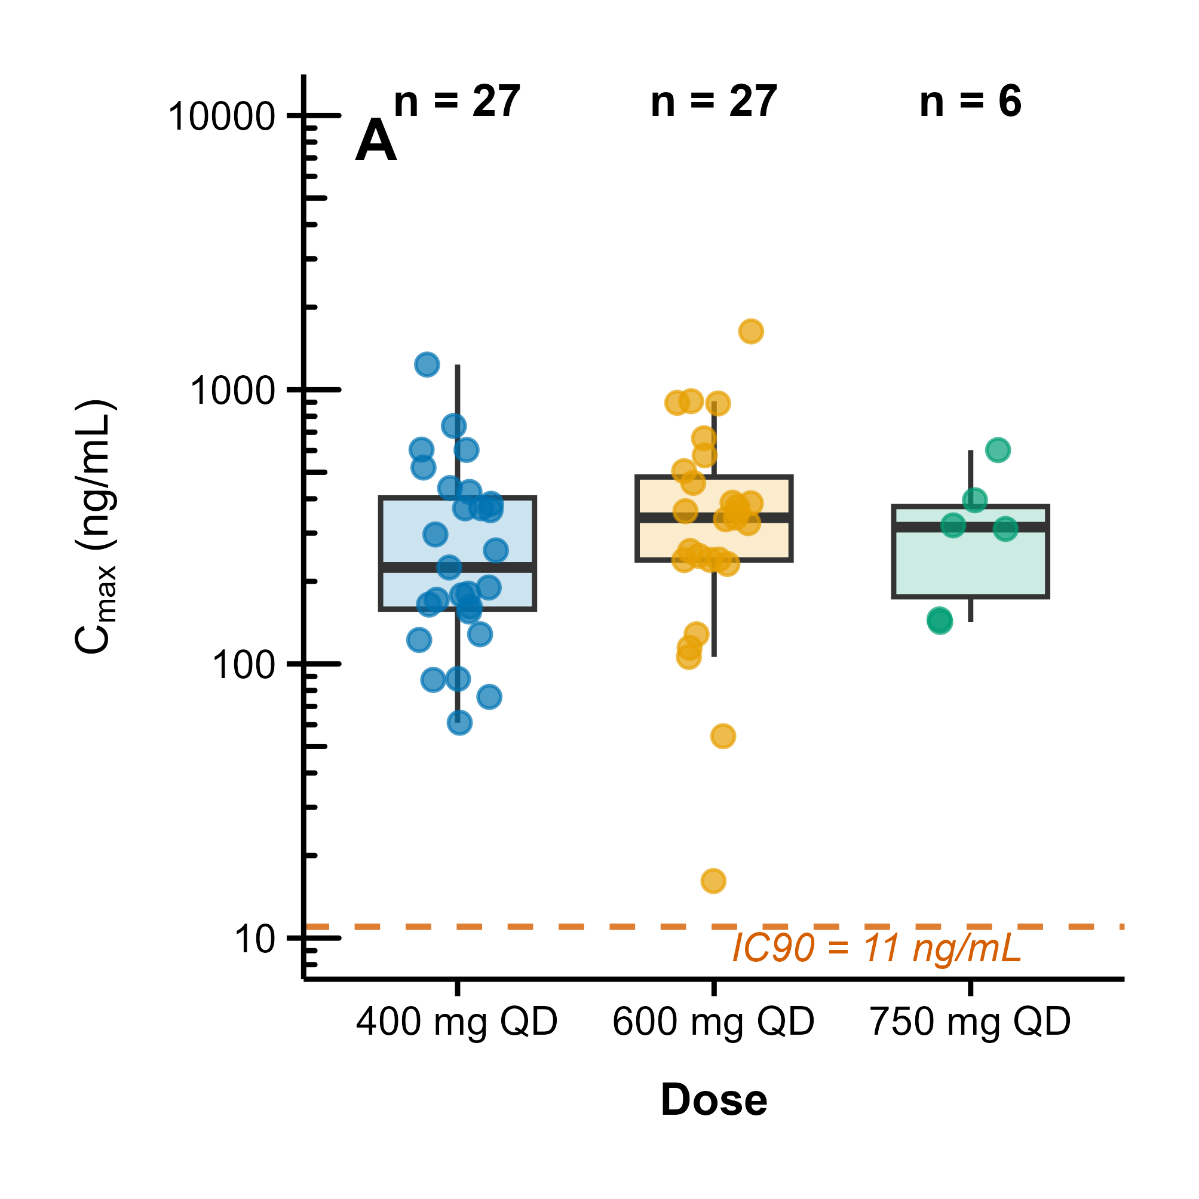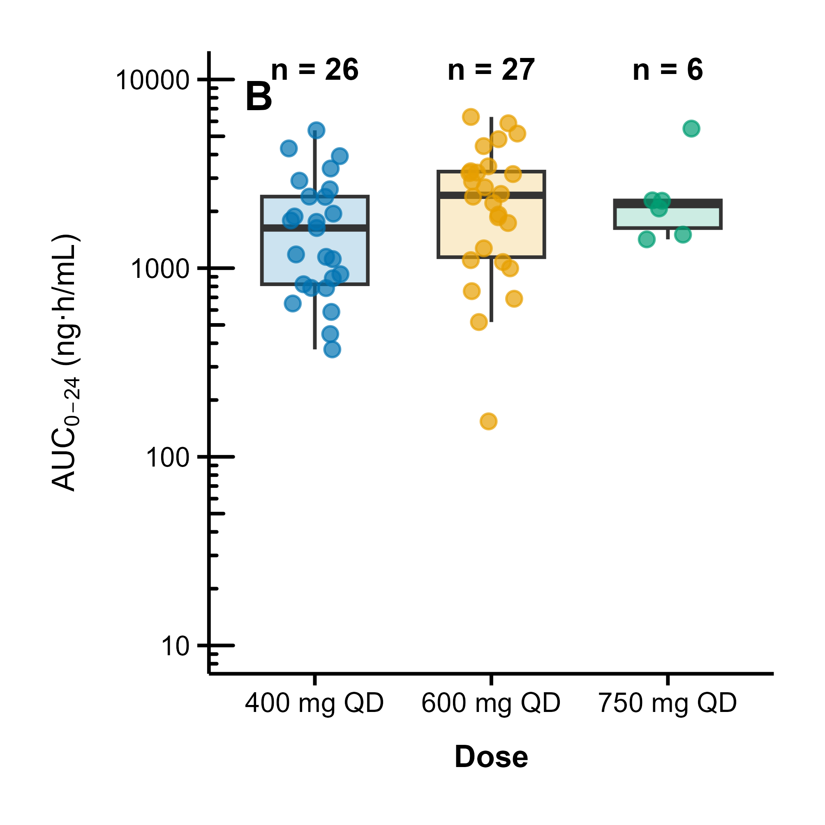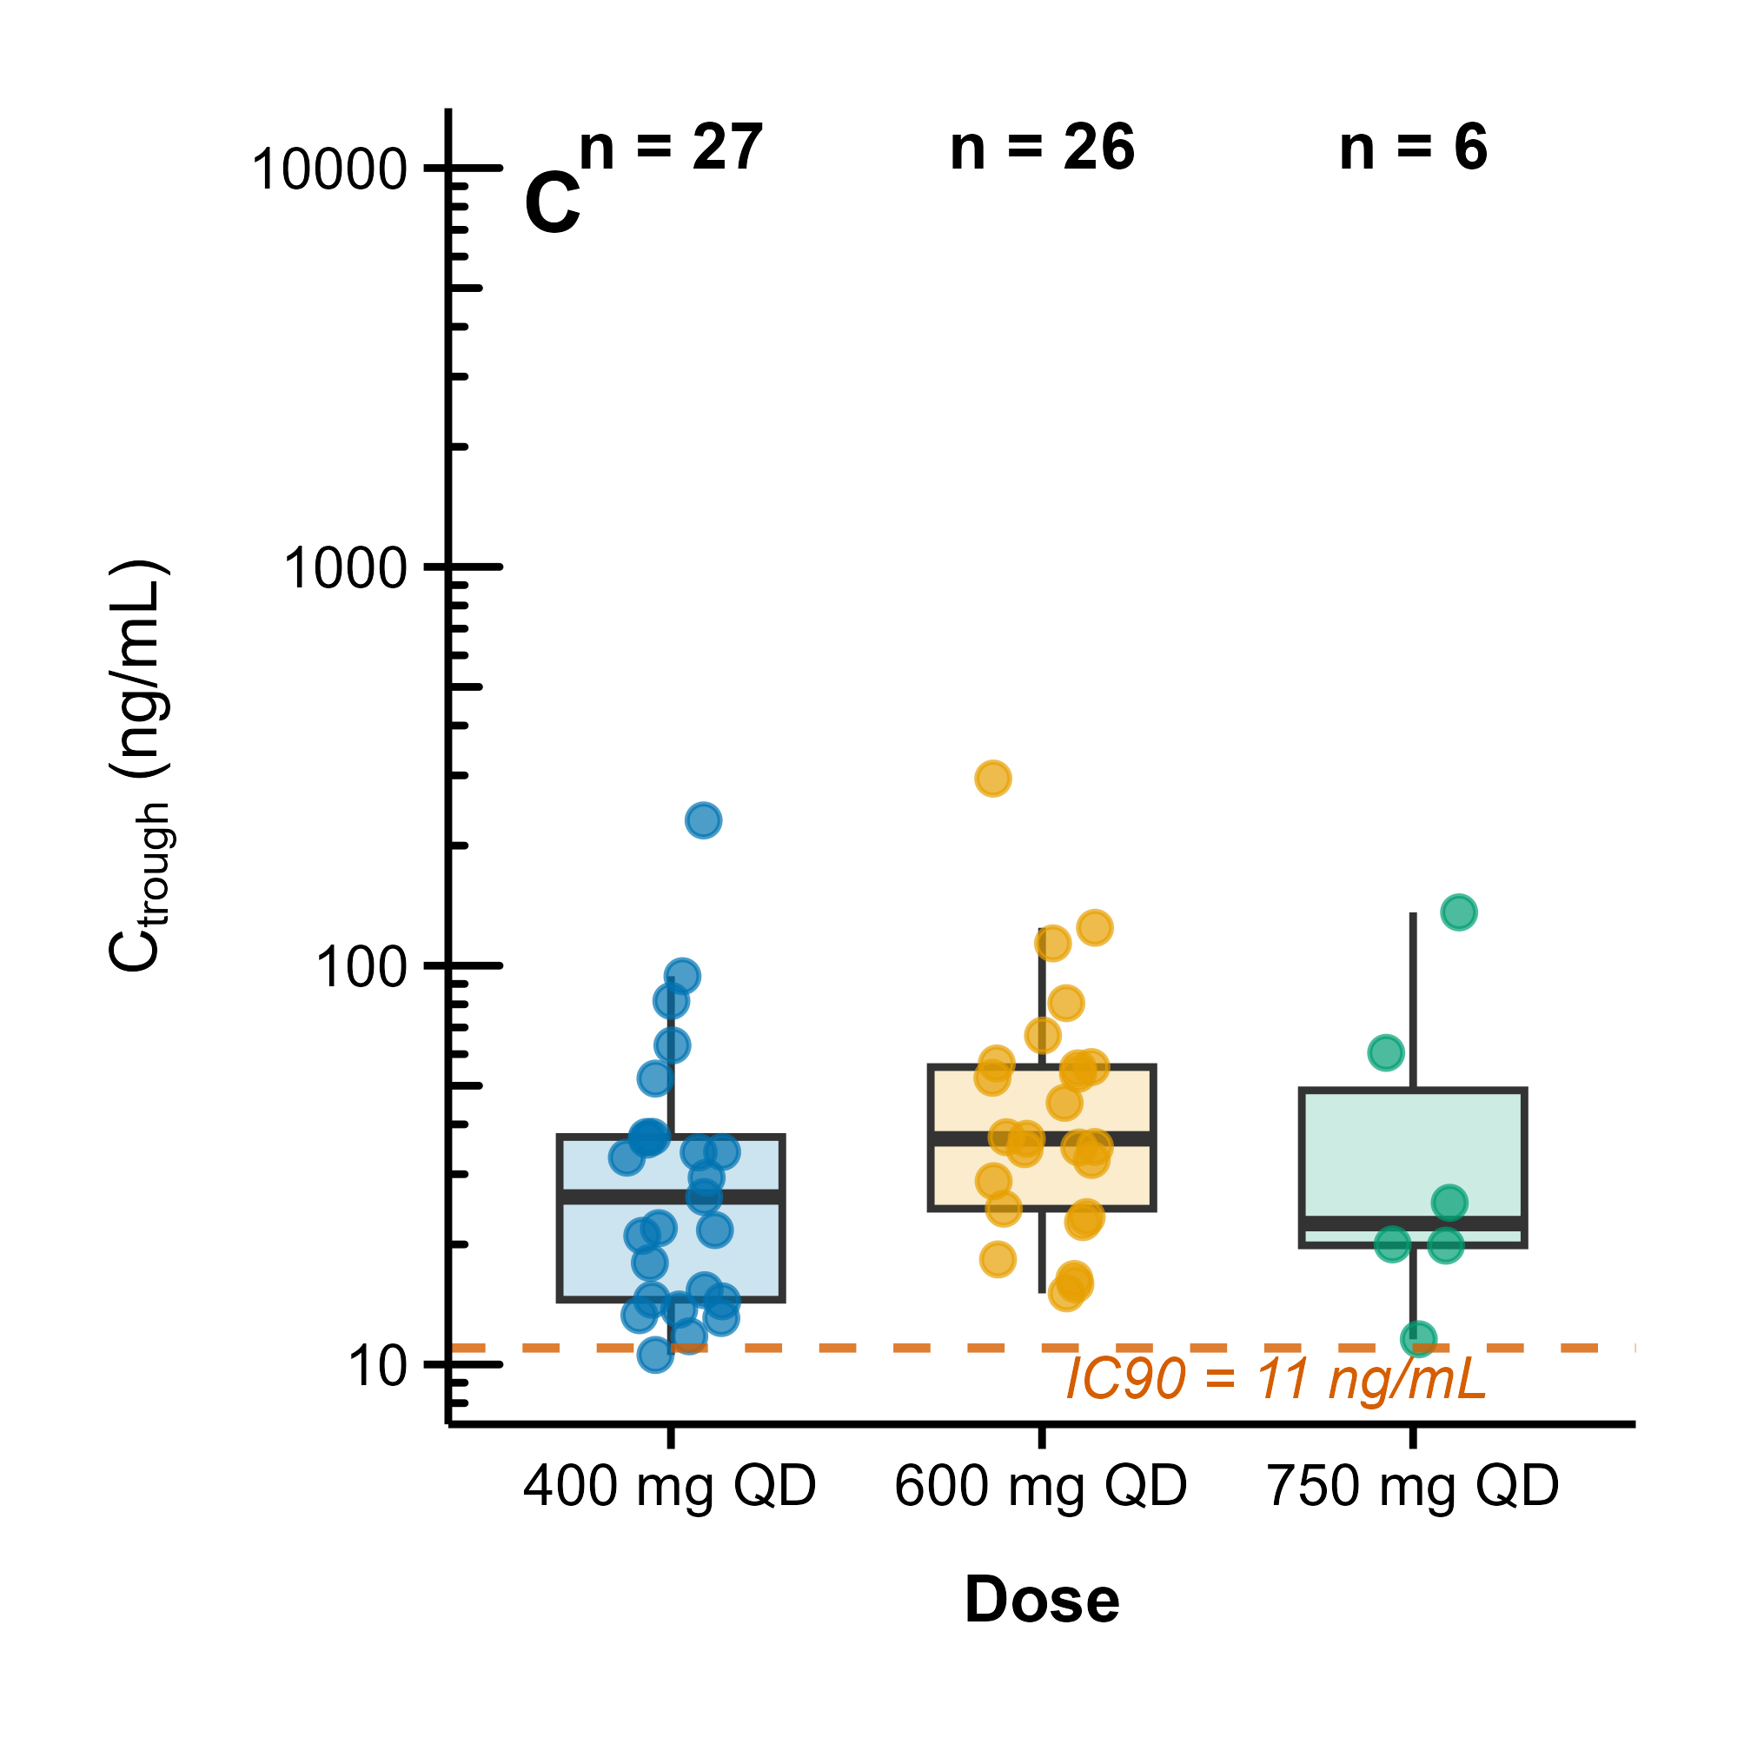
Extended Data Fig. 3. Distribution of GFH375 exposure parameters at steady state.
Boxplots show medians and interquartile ranges; points represent individual values. Abbreviations: AUC: area under the plasma concentration‒time curve from 0–24 hours; C_{max}: maximum concentration; Ctrough: trough concentration; IC₉₀: 90% inhibitory concentration; QD, once daily.

