Supplementary data
Appendix A. Quality control of raw reads-MultiQC Report
FastQC tool was used to carry out the QC of the raw reads. We further used MultiQC (Ewels et al. 2016) to aggregate the reports from FastQC into a single report with interactive plots for multiple bioinformatics analyses.

Table 1- The general statistics table. %Dups: duplicated reads, %GC: average GC content, Length: average sequence length (bp), %Failed: percent of modules failed in FastQC report, M Seqs: total sequences (millions).
Sample Name | % Dups | % GC | Length | % Failed | M Seqs
F0_Lymus1_root_split_1_fq_gz | 99.0% | 48% | 250 bp | 36% | 0.2
F0_Lymus1_root_split_2_fq_gz | 96.7% | 47% | 250 bp | 36% | 0.2
F0_Lymus1_soil_split_1_fq_gz | 97.9% | 45% | 250 bp | 36% | 0.2
F0_Lymus1_soil_split_2_fq_gz | 93.9% | 44% | 250 bp | 36% | 0.2
F0_Lymus2_root_split_1_fq_gz | 98.7% | 45% | 250 bp | 36% | 0.2
F0_Lymus2_root_split_2_fq_gz | 95.5% | 44% | 250 bp | 36% | 0.2
F0_Lymus2_soil_split_1_fq_gz | 98.1% | 45% | 250 bp | 36% | 0.2
F0_Lymus2_soil_split_2_fq_gz | 94.3% | 44% | 250 bp | 36% | 0.2
F0_Lymus3_root_split_1_fq_gz | 98.9% | 46% | 250 bp | 36% | 0.2
F0_Lymus3_root_split_2_fq_gz | 95.9% | 44% | 250 bp | 36% | 0.2
F0_Lymus3_soil_split_1_fq_gz | 98.2% | 47% | 250 bp | 36% | 0.1
F0_Lymus3_soil_split_2_fq_gz | 94.8% | 46% | 250 bp | 36% | 0.1
F0_Stipa1_root_split_1_fq_gz | 98.7% | 44% | 250 bp | 36% | 0.1
F0_Stipa1_root_split_2_fq_gz | 95.5% | 42% | 250 bp | 36% | 0.1
F0_Stipa1_soil_split_1_fq_gz | 98.1% | 43% | 250 bp | 36% | 0.1
F0_Stipa1_soil_split_2_fq_gz | 93.5% | 42% | 250 bp | 36% | 0.1
F0_Stipa2_root_split_1_fq_gz | 99.0% | 47% | 250 bp | 36% | 0.2
F0_Stipa2_root_split_2_fq_gz | 96.2% | 46% | 250 bp | 36% | 0.2
F0_Stipa3_root_split_1_fq_gz | 99.1% | 46% | 250 bp | 36% | 0.2
F0_Stipa3_root_split_2_fq_gz | 96.7% | 45% | 250 bp | 36% | 0.2
F0_Stipa3_soil_split_1_fq_gz | 98.1% | 43% | 250 bp | 36% | 0.1
F0_Stipa3_soil_split_2_fq_gz | 93.6% | 41% | 250 bp | 36% | 0.1
F1_5_Lymus1_root_split_1_fq_gz | 98.6% | 42% | 250 bp | 36% | 0.2
F1_5_Lymus1_root_split_2_fq_gz | 95.4% | 41% | 250 bp | 36% | 0.2
F1_5_Lymus1_soil_split_1_fq_gz | 98.3% | 42% | 250 bp | 36% | 0.1
F1_5_Lymus1_soil_split_2_fq_gz | 93.8% | 41% | 250 bp | 36% | 0.1
F1_5_Lymus2_root_split_1_fq_gz | 98.7% | 45% | 250 bp | 36% | 0.2
F1_5_Lymus2_root_split_2_fq_gz | 95.4% | 43% | 250 bp | 36% | 0.2
F1_5_Lymus3_root_split_1_fq_gz | 98.8% | 47% | 250 bp | 36% | 0.2
F1_5_Lymus3_root_split_2_fq_gz | 96.0% | 46% | 250 bp | 36% | 0.2
F1_5_Lymus3_soil_split_1_fq_gz | 98.3% | 44% | 250 bp | 36% | 0.1
F1_5_Lymus3_soil_split_2_fq_gz | 94.2% | 42% | 250 bp | 36% | 0.1
F1_5_Stipa1_root_split_1_fq_gz | 98.5% | 43% | 250 bp | 36% | 0.2
F1_5_Stipa1_root_split_2_fq_gz | 95.7% | 41% | 250 bp | 36% | 0.2
F1_5_Stipa2_root_split_1_fq_gz | 98.8% | 47% | 250 bp | 36% | 0.1
F1_5_Stipa2_root_split_2_fq_gz | 96.3% | 47% | 250 bp | 36% | 0.1
F1_5_Stipa2_soil_split_1_fq_gz | 98.0% | 43% | 250 bp | 36% | 0.1
F1_5_Stipa2_soil_split_2_fq_gz | 93.3% | 42% | 250 bp | 36% | 0.1
F1_5_Stipa3_root_split_1_fq_gz | 98.7% | 43% | 250 bp | 36% | 0.1
F1_5_Stipa3_root_split_2_fq_gz | 95.6% | 42% | 250 bp | 36% | 0.1
F1_5_Stipa3_soil_split_1_fq_gz | 97.9% | 43% | 250 bp | 36% | 0.1
F1_5_Stipa3_soil_split_2_fq_gz | 93.1% | 42% | 250 bp | 36% | 0.1
F3_Lymus1_root_split_1_fq_gz | 98.7% | 45% | 250 bp | 36% | 0.2
F3_Lymus1_root_split_2_fq_gz | 95.5% | 44% | 250 bp | 36% | 0.2
F3_Lymus1_soil_split_1_fq_gz | 98.3% | 44% | 250 bp | 36% | 0.2
F3_Lymus1_soil_split_2_fq_gz | 94.0% | 43% | 250 bp | 36% | 0.2
F3_Lymus2_root_split_1_fq_gz | 98.6% | 46% | 250 bp | 36% | 0.1
F3_Lymus2_root_split_2_fq_gz | 95.9% | 45% | 250 bp | 36% | 0.1
F3_Lymus2_soil_split_1_fq_gz | 98.4% | 43% | 250 bp | 36% | 0.1
F3_Lymus2_soil_split_2_fq_gz | 93.7% | 42% | 250 bp | 36% | 0.1
F3_Lymus3_root_split_1_fq_gz | 98.5% | 47% | 250 bp | 36% | 0.1
F3_Lymus3_root_split_2_fq_gz | 95.6% | 46% | 250 bp | 36% | 0.1
F3_Lymus3_soil_split_1_fq_gz | 98.3% | 44% | 250 bp | 36% | 0.2
F3_Lymus3_soil_split_2_fq_gz | 93.9% | 42% | 250 bp | 36% | 0.2
F3_Stipa1_root_split_1_fq_gz | 98.8% | 46% | 250 bp | 36% | 0.2
F3_Stipa1_root_split_2_fq_gz | 96.4% | 46% | 250 bp | 36% | 0.2
F3_Stipa1_soil_split_1_fq_gz | 98.2% | 42% | 250 bp | 36% | 0.1
F3_Stipa1_soil_split_2_fq_gz | 93.6% | 40% | 250 bp | 36% | 0.1
F3_Stipa2_root_split_1_fq_gz | 98.8% | 47% | 250 bp | 36% | 0.1
F3_Stipa2_root_split_2_fq_gz | 96.4% | 47% | 250 bp | 36% | 0.1
F3_Stipa2_soil_split_1_fq_gz | 98.3% | 43% | 250 bp | 36% | 0.2
F3_Stipa2_soil_split_2_fq_gz | 94.0% | 42% | 250 bp | 36% | 0.2
F3_Stipa3_root_split_1_fq_gz | 98.8% | 47% | 250 bp | 36% | 0.2
F3_Stipa3_root_split_2_fq_gz | 96.1% | 46% | 250 bp | 36% | 0.2
F3_Stipa3_soil_split_1_fq_gz | 98.3% | 42% | 250 bp | 36% | 0.1
F3_Stipa3_soil_split_2_fq_gz | 93.8% | 41% | 250 bp | 36% | 0.1
F4_5Lymus1_soil_split_1_fq_gz | 98.3% | 42% | 250 bp | 36% | 0.1
F4_5Lymus1_soil_split_2_fq_gz | 93.6% | 41% | 250 bp | 36% | 0.1
F4_5Lymus2_soil_split_2_fq_gz | 93.8% | 40% | 250 bp | 36% | 0.2
F4_5Lymus3_soil_split_1_fq_gz | 98.5% | 42% | 250 bp | 36% | 0.2
F4_5Lymus3_soil_split_2_fq_gz | 94.4% | 41% | 250 bp | 36% | 0.2
F4_5_Lymus1_root_split_1_fq_gz | 98.8% | 44% | 250 bp | 36% | 0.2
F4_5_Lymus1_root_split_2_fq_gz | 95.7% | 42% | 250 bp | 36% | 0.2
F4_5_Lymus2_root_split_1_fq_gz | 98.5% | 47% | 250 bp | 36% | 0.1
F4_5_Lymus2_root_split_2_fq_gz | 95.9% | 46% | 250 bp | 36% | 0.1
F4_5_Lymus3_root_split_1_fq_gz | 98.8% | 40% | 250 bp | 36% | 0.1
F4_5_Lymus3_root_split_2_fq_gz | 95.1% | 39% | 250 bp | 36% | 0.1
F4_5_Stipa1_root_split_1_fq_gz | 98.8% | 44% | 250 bp | 36% | 0.1
F4_5_Stipa1_root_split_2_fq_gz | 95.5% | 43% | 250 bp | 36% | 0.1
F4_5_Stipa1_soil_split_1_fq_gz | 98.0% | 43% | 250 bp | 36% | 0.2
F4_5_Stipa1_soil_split_2_fq_gz | 93.9% | 41% | 250 bp | 36% | 0.2
F4_5_Stipa2_root_split_1_fq_gz | 98.8% | 43% | 250 bp | 36% | 0.2
F4_5_Stipa2_root_split_2_fq_gz | 95.8% | 42% | 250 bp | 36% | 0.2
F4_5_Stipa2_soil_split_1_fq_gz | 98.5% | 41% | 250 bp | 36% | 0.2
F4_5_Stipa2_soil_split_2_fq_gz | 94.3% | 41% | 250 bp | 36% | 0.2
F4_5_Stipa3_root_split_1_fq_gz | 98.8% | 42% | 250 bp | 36% | 0.1
F4_5_Stipa3_root_split_2_fq_gz | 95.2% | 42% | 250 bp | 36% | 0.1
F4_5_Stipa3_soil_split_1_fq_gz | 98.4% | 42% | 250 bp | 36% | 0.1
F4_5_Stipa3_soil_split_2_fq_gz | 93.7% | 41% | 250 bp | 36% | 0.1
F6_Lymus1_root_split_1_fq_gz | 98.8% | 46% | 250 bp | 36% | 0.2
F6_Lymus1_root_split_2_fq_gz | 96.4% | 45% | 250 bp | 36% | 0.2
F6_Lymus2_root_split_1_fq_gz | 98.9% | 44% | 250 bp | 36% | 0.2
F6_Lymus2_root_split_2_fq_gz | 95.6% | 43% | 250 bp | 36% | 0.2
F6_Lymus2_soil_split_1_fq_gz | 98.2% | 43% | 250 bp | 36% | 0.2
F6_Lymus2_soil_split_2_fq_gz | 93.8% | 42% | 250 bp | 36% | 0.2
F6_Lymus3_root_split_1_fq_gz | 98.8% | 44% | 250 bp | 36% | 0.1
F6_Lymus3_root_split_2_fq_gz | 95.7% | 43% | 250 bp | 36% | 0.1
F6_Lymus3_soil_split_1_fq_gz | 98.6% | 43% | 250 bp | 36% | 0.2
F6_Lymus3_soil_split_2_fq_gz | 94.4% | 42% | 250 bp | 36% | 0.2
F6_Stipa1_root_split_1_fq_gz | 98.9% | 43% | 250 bp | 36% | 0.2
F6_Stipa1_root_split_2_fq_gz | 96.2% | 43% | 250 bp | 36% | 0.2
F6_Stipa2_root_split_1_fq_gz | 98.7% | 44% | 250 bp | 36% | 0.1
F6_Stipa2_root_split_2_fq_gz | 95.3% | 44% | 250 bp | 36% | 0.1
F6_Stipa3_root_split_1_fq_gz | 98.8% | 46% | 250 bp | 36% | 0.2
F6_Stipa3_root_split_2_fq_gz | 96.2% | 45% | 250 bp | 36% | 0.2
F6_Stipa3_soil_split_1_fq_gz | 98.3% | 44% | 250 bp | 36% | 0.1
F6_Stipa3_soil_split_2_fq_gz | 94.2% | 43% | 250 bp | 36% | 0.1
F7_5_Lymus1_root_split_1_fq_gz | 98.8% | 43% | 250 bp | 36% | 0.2
F7_5_Lymus1_root_split_2_fq_gz | 96.3% | 42% | 250 bp | 36% | 0.2
F7_5_Lymus1_soil_split_1_fq_gz | 98.0% | 44% | 250 bp | 36% | 0.1
F7_5_Lymus1_soil_split_2_fq_gz | 94.0% | 43% | 250 bp | 36% | 0.1
F7_5_Lymus2_root_split_1_fq_gz | 98.6% | 44% | 250 bp | 36% | 0.2
F7_5_Lymus2_root_split_2_fq_gz | 96.2% | 43% | 250 bp | 36% | 0.2
F7_5_Lymus2_soil_split_1_fq_gz | 98.1% | 43% | 250 bp | 36% | 0.2
F7_5_Lymus2_soil_split_2_fq_gz | 94.0% | 42% | 250 bp | 36% | 0.2
F7_5_Lymus3_root_split_1_fq_gz | 98.9% | 41% | 250 bp | 36% | 0.2
F7_5_Lymus3_root_split_2_fq_gz | 96.8% | 39% | 250 bp | 36% | 0.2
F7_5_Lymus3_soil_split_1_fq_gz | 97.8% | 44% | 250 bp | 36% | 0.1
F7_5_Lymus3_soil_split_2_fq_gz | 93.9% | 43% | 250 bp | 36% | 0.1
F7_5_Stipa1_root_split_1_fq_gz | 98.9% | 43% | 250 bp | 36% | 0.2
F7_5_Stipa1_root_split_2_fq_gz | 96.1% | 42% | 250 bp | 36% | 0.2
F7_5_Stipa1_soil_split_1_fq_gz | 97.9% | 43% | 250 bp | 36% | 0.1
F7_5_Stipa1_soil_split_2_fq_gz | 93.4% | 42% | 250 bp | 36% | 0.1
F7_5_Stipa2_root_split_1_fq_gz | 99.1% | 40% | 250 bp | 36% | 0.1
F7_5_Stipa2_root_split_2_fq_gz | 96.5% | 38% | 250 bp | 36% | 0.1
F7_5_Stipa2_soil_split_1_fq_gz | 98.2% | 43% | 250 bp | 36% | 0.2
F7_5_Stipa2_soil_split_2_fq_gz | 93.8% | 42% | 250 bp | 36% | 0.2
F7_5_Stipa3_root_split_1_fq_gz | 99.1% | 39% | 250 bp | 36% | 0.2
F7_5_Stipa3_root_split_2_fq_gz | 96.3% | 38% | 250 bp | 36% | 0.2
F7_5_Stipa3_soil_split_1_fq_gz | 98.0% | 42% | 250 bp | 36% | 0.2
F7_5_Stipa3_soil_split_2_fq_gz | 94.0% | 42% | 250 bp | 36% | 0.2
F9_Lymus1_soil_split_1_fq_gz | 98.3% | 41% | 250 bp | 36% | 0.2
F9_Lymus1_soil_split_2_fq_gz | 94.0% | 40% | 250 bp | 36% | 0.2
F9_Lymus2_soil_split_1_fq_gz | 98.2% | 42% | 250 bp | 36% | 0.2
F9_Lymus2_soil_split_2_fq_gz | 93.8% | 41% | 250 bp | 36% | 0.2
F9_Lymus3_soil_split_1_fq_gz | 98.3% | 43% | 250 bp | 36% | 0.2
F9_Lymus3_soil_split_2_fq_gz | 94.2% | 42% | 250 bp | 36% | 0.2
F9_Stipa1_root_split_1_fq_gz | 98.7% | 43% | 250 bp | 36% | 0.1
F9_Stipa1_root_split_2_fq_gz | 95.1% | 42% | 250 bp | 36% | 0.1
F9_Stipa1_soil_split_1_fq_gz | 98.5% | 41% | 250 bp | 36% | 0.2
F9_Stipa1_soil_split_2_fq_gz | 94.4% | 40% | 250 bp | 36% | 0.2
F9_Stipa2_root_split_1_fq_gz | 98.8% | 45% | 250 bp | 36% | 0.1
F9_Stipa2_root_split_2_fq_gz | 96.3% | 44% | 250 bp | 36% | 0.1
F9_Stipa2_soil_split_1_fq_gz | 98.3% | 42% | 250 bp | 36% | 0.1
F9_Stipa2_soil_split_2_fq_gz | 93.7% | 41% | 250 bp | 36% | 0.1
F9_Stipa3_root_split_1_fq_gz | 98.6% | 44% | 250 bp | 36% | 0.2
F9_Stipa3_root_split_2_fq_gz | 95.5% | 43% | 250 bp | 36% | 0.2
F9_Stipa3_soil_split_1_fq_gz | 98.3% | 42% | 250 bp | 36% | 0.2
F9_Stipa3_soil_split_2_fq_gz | 93.6% | 41% | 250 bp | 36% | 0.2
F_9_Lymus1_root_split_1_fq_gz | 98.9% | 44% | 250 bp | 36% | 0.2
F_9_Lymus1_root_split_2_fq_gz | 95.7% | 43% | 250 bp | 36% | 0.2
F_9_Lymus2_root_split_1_fq_gz | 98.9% | 45% | 250 bp | 36% | 0.2
F_9_Lymus2_root_split_2_fq_gz | 95.2% | 44% | 250 bp | 36% | 0.2
F_9_Lymus3_root_split_1_fq_gz | 98.8% | 45% | 250 bp | 36% | 0.2
F_9_Lymus3_root_split_2_fq_gz | 95.8% | 44% | 250 bp | 36% | 0.2

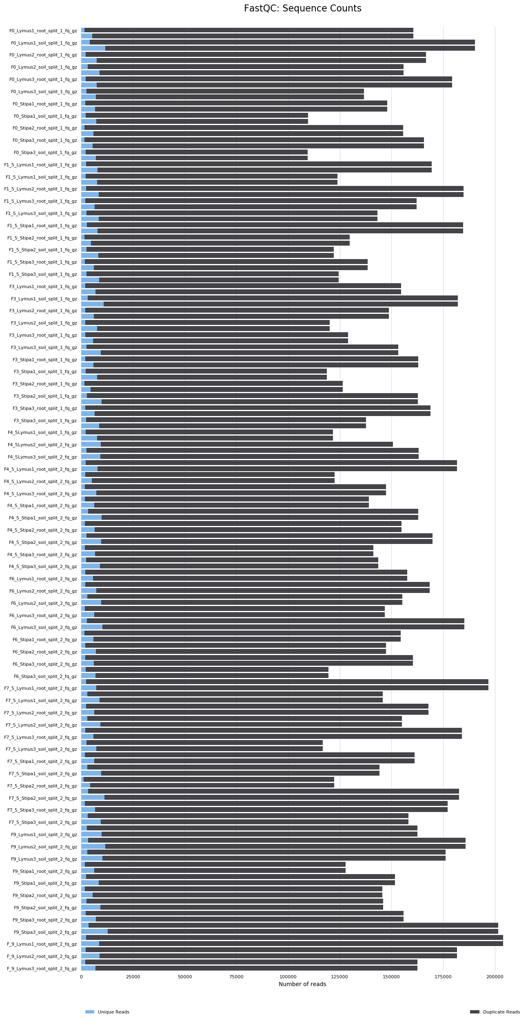
Figure 1. Sequence counts for each sample. Duplicate read counts are an estimate only. This plot shows the total number of reads, broken down into unique and duplicate reads. Only sequences which first appear in the first 100,000 sequences in each file were analysed. This should be enough to get a good impression for the duplication levels in the whole file. Each sequence is tracked to the end of the file to give a representative count of the overall duplication level. The duplication detection requires an exact sequence match over the whole length of the sequence. Any reads over 75bp in length are truncated to 50bp for this analysis.

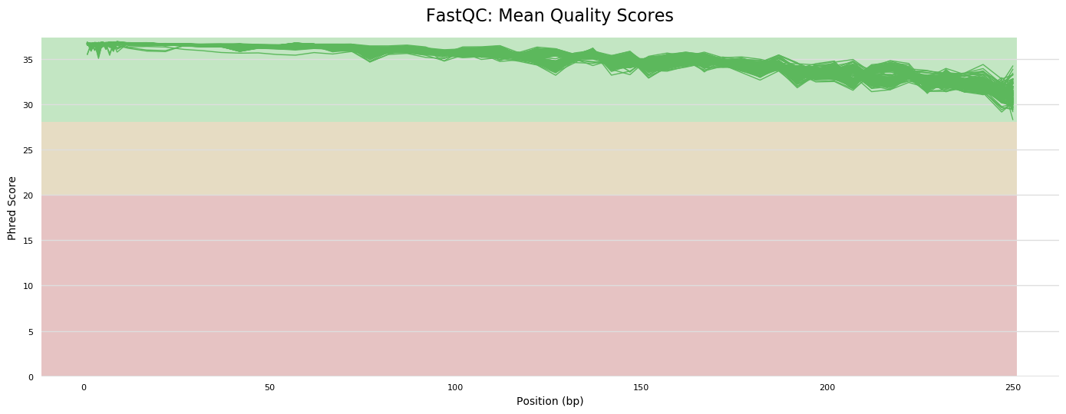
Figure 2. Sequence quality histograms. The mean quality value across each base position in the read. To enable multiple samples to be plotted on the same graph, only the mean quality scores are plotted. The y-axis on the graph shows the quality scores. The higher the score, the better the base call. The background of the graph divides the y axis into very good quality calls (green), calls of reasonable quality (orange), and calls of poor quality (red).
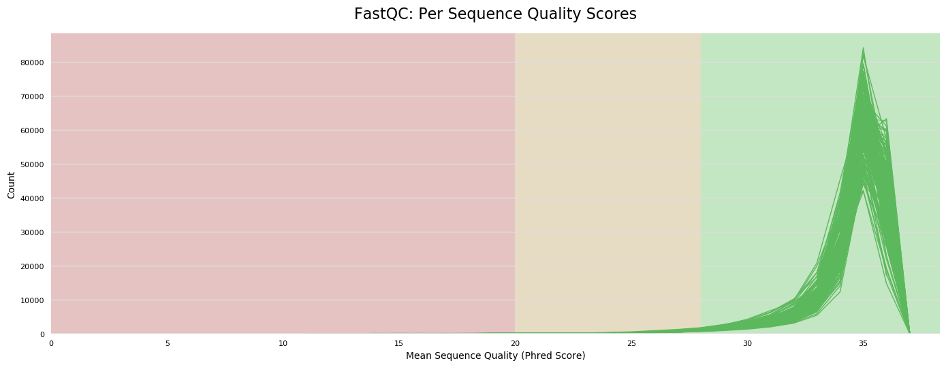
Figure 3.Per sequence quality scores. The graph shows the number of reads with average quality scores and a subset of reads with poor quality.
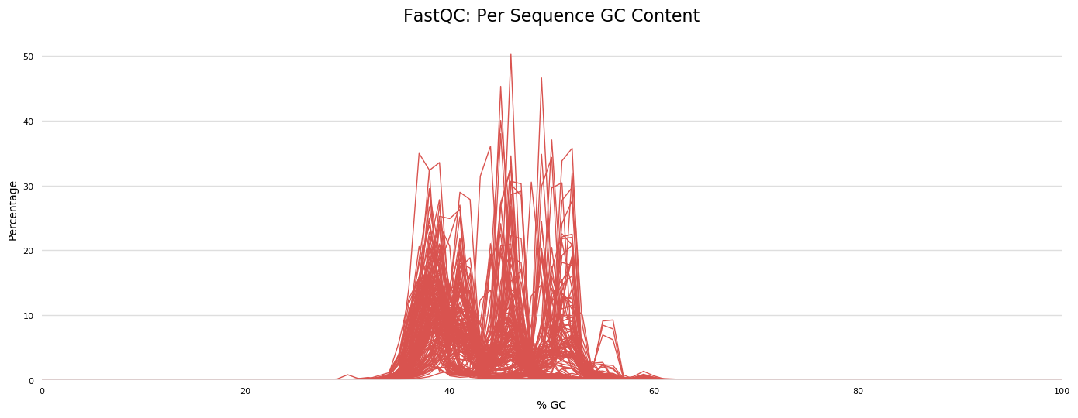
Figure 4.Per Sequence GC Content. The graph shows the average GC content of reads.
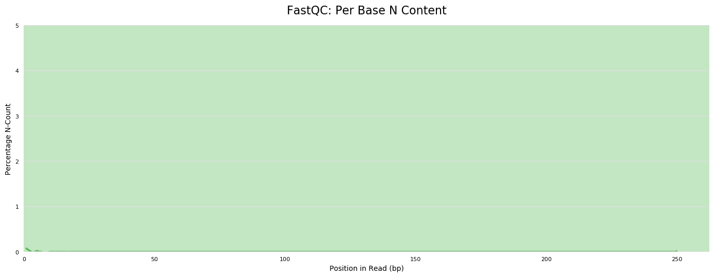
Figure 5. Per Base N Content. The graph shows the percentage of base calls at each position for which an N was called.

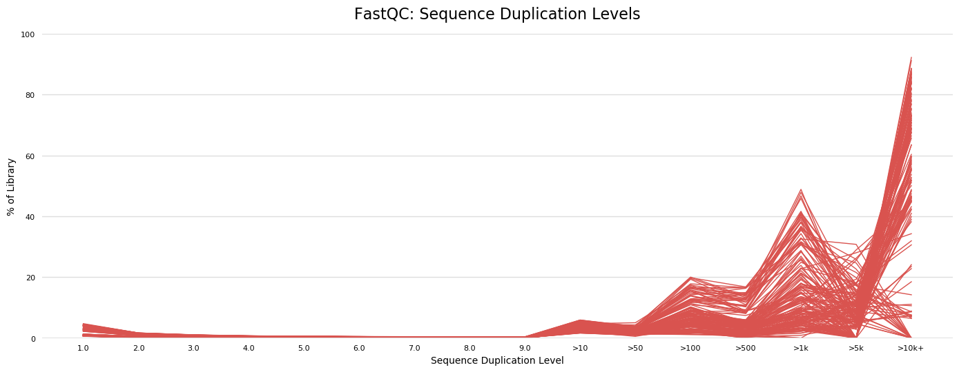
Figure 6. Sequence duplication levels. The relative level of duplication found for every sequence.
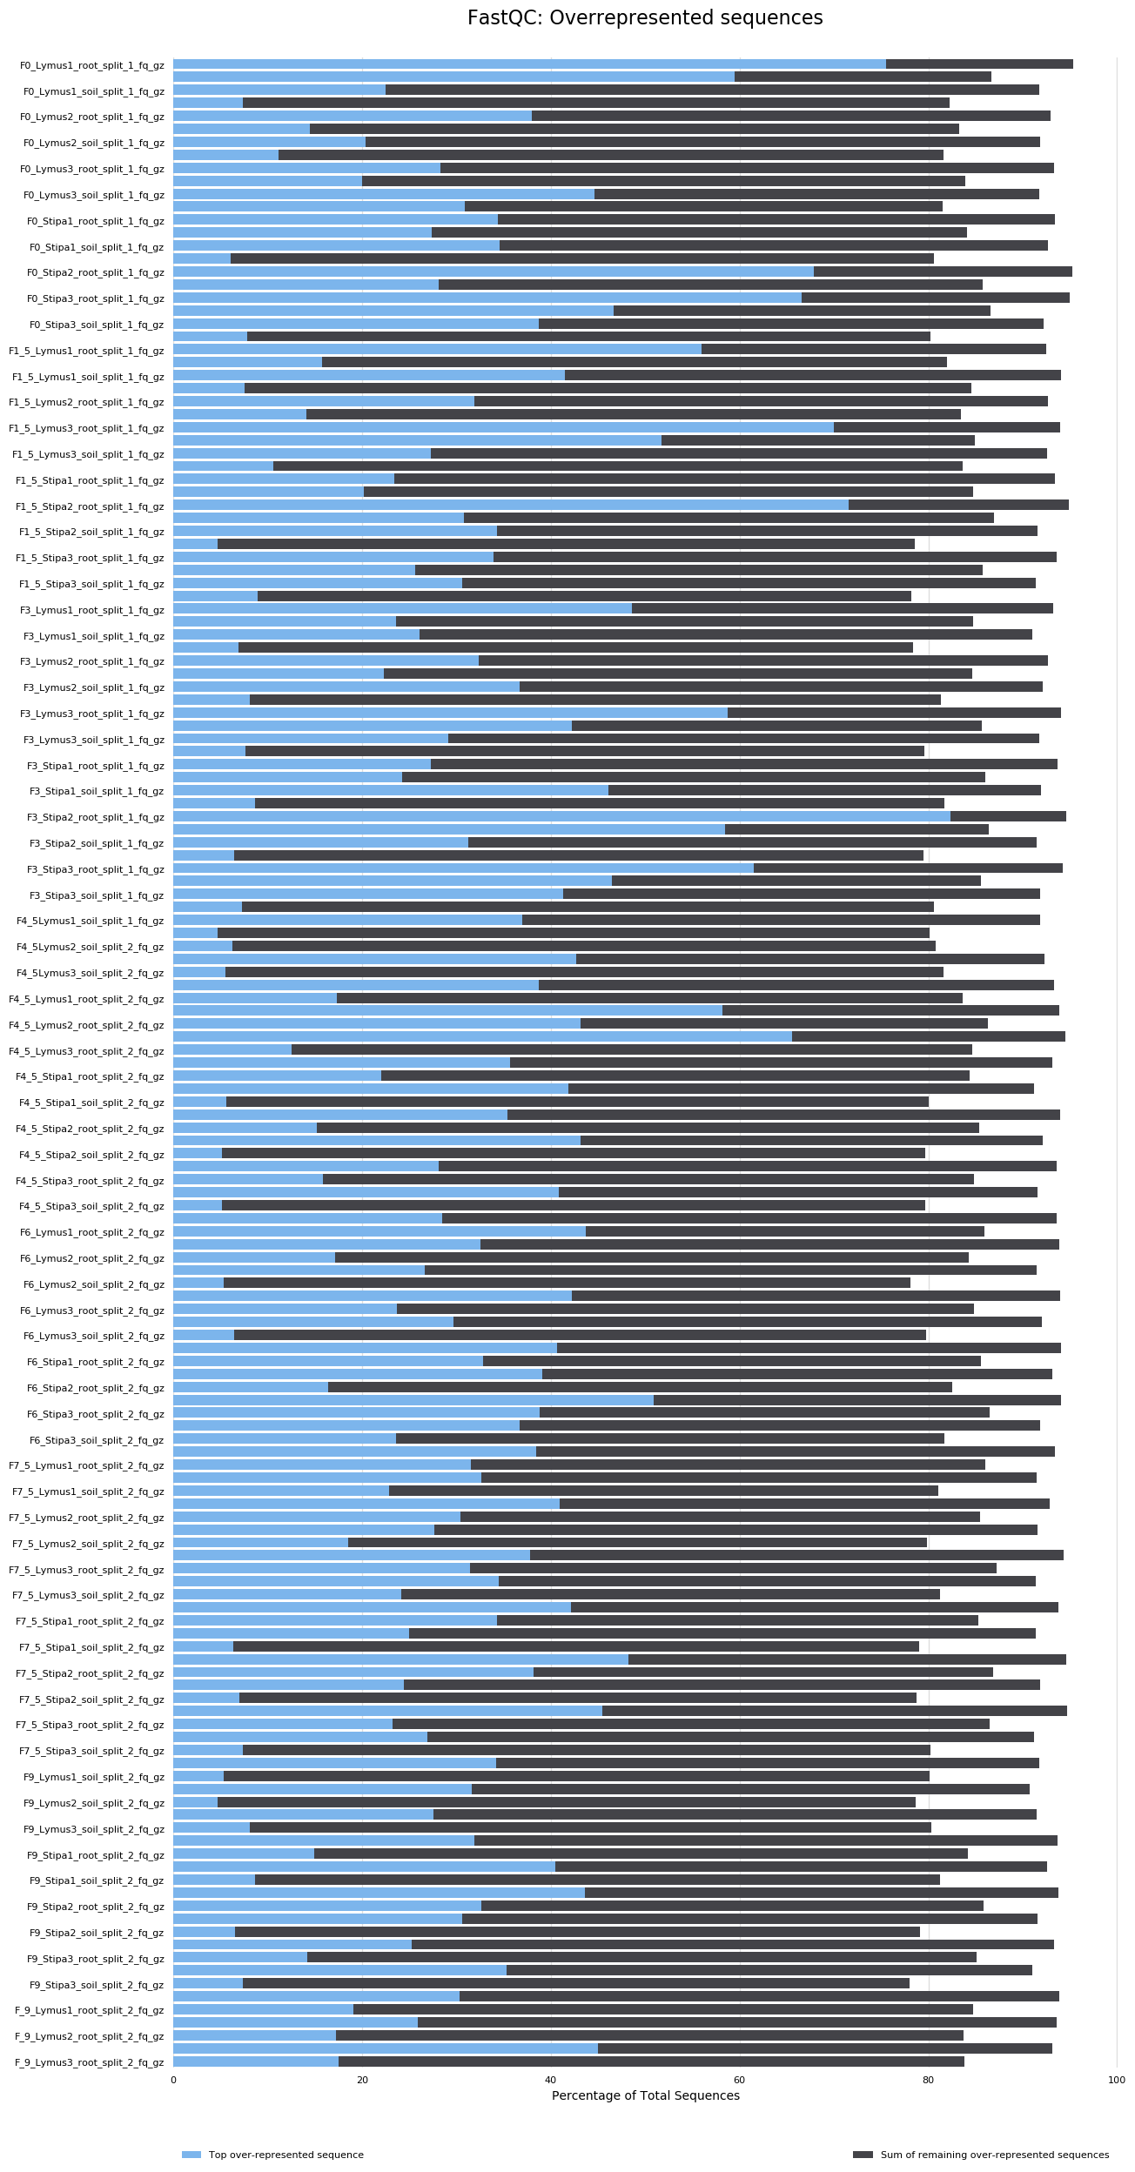
Figure 7. Over-represented sequences which is the total amount of overrepresented sequences found in each library. Sometimes, a single sequence may account for a large number of reads in a dataset. To show this, the bars are split into two: the first shows the overrepresented reads that come from the single most common sequence. The second shows the total count from all remaining overrepresented sequences.
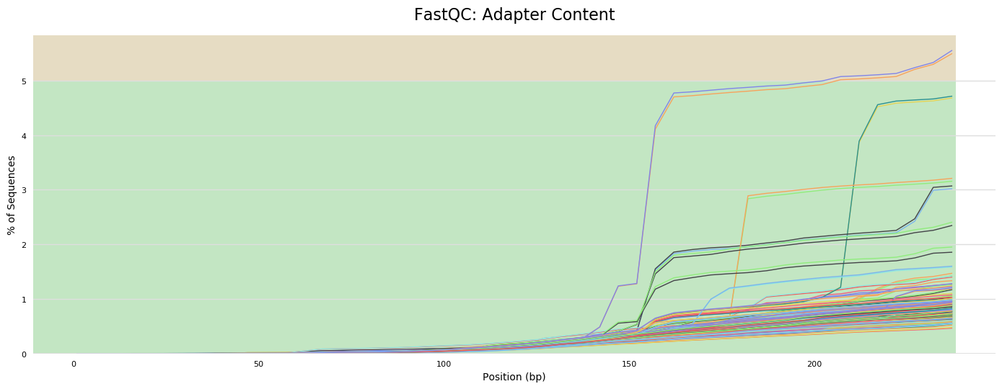
Figure 8. Adapter Content. The cumulative percentage count of the proportion of the library which has seen each of the adapter sequences at each position.

