Supplementary data
Appendix A.

A-1

Site description
This experiment was set up at the Sino-German grazing experimental site located in the Xilin River Basin of Inner Mongolia, China (longitude 116° 42′ E; latitude 43° 38′ N). The experimental site was established in 2005 and is ca. 128 ha, with an elevation of 1,200 m to 1,280 m asl. The area has a semi-arid, continental climate with a mean annual temperature of 0.9°C (1982–2010) and mean annual precipitation of 329 mm (1982–2010) with more than 70 % of the annual precipitation falling as rain during the growing season from April to September (Wan et al. 2011).
Two dominant plant species, Leymus chinensis (Trin.) Tzvel. and perennial bunchgrass Stipa grandis P. Smirn. together account for more than 75% of the total above-ground biomass (Li et al. 2017). Other species that commonly appeared in our experimental site are Cleistogenes squarrosa (Trin.) Keng, Agropyron cristatum (L.) Gaertn., Koeleria cristata (L.) Pers., Achnatherum sibiricum (L.) Keng, Carex korshinskyi Kom., Potentilla acaulis L., Allium bidentatum Fisch. ex Prokh., Allium tenuissimum L., Chenopodium aristatum L., Salsola collina Pall., and Chenopodium glaucum L. (Schönbach et al. 2011, Li et al. 2017). The total vegetation cover is about 30-40% in normal years and may reach 60-70% in wet years.
The soils are defined by a dark Ah horizon followed by an Ach horizon. The carbonate-free Ah horizon thickness ranges from 20 to more than 100 cm where L. chinensis dominates and from 5 to 45 cm where S. grandis is more abundant. The Ach horizon containing secondary calcium carbonate nodules is located bellow the Ah horizon (Wiesmeier et al. 2009).
We set up our experiment in 7 experimental plots. Each experimental plot, encompassed an area of 2 ha, was subjected to one of seven levels of grazing intensity (GI), from 0 to 9 ewes per ha with an interval increase of 1.5 ewes (35 kg live-weight female sheep). Hereafter, we represent GI by the number of grazers per hectare as 0 (no grazing), 1.5 (very light), 3 (light), 4.5 (light-moderate), 6 (moderate), 7.5 (heavy) and 9 (overgrazing). Ewes were put in plots for 90 days during the grazing season from June to September each year. When we sampled in 2019, the grazing experiment had been run continuously for 13 years.

A-2

Schematic illustration of experimental design
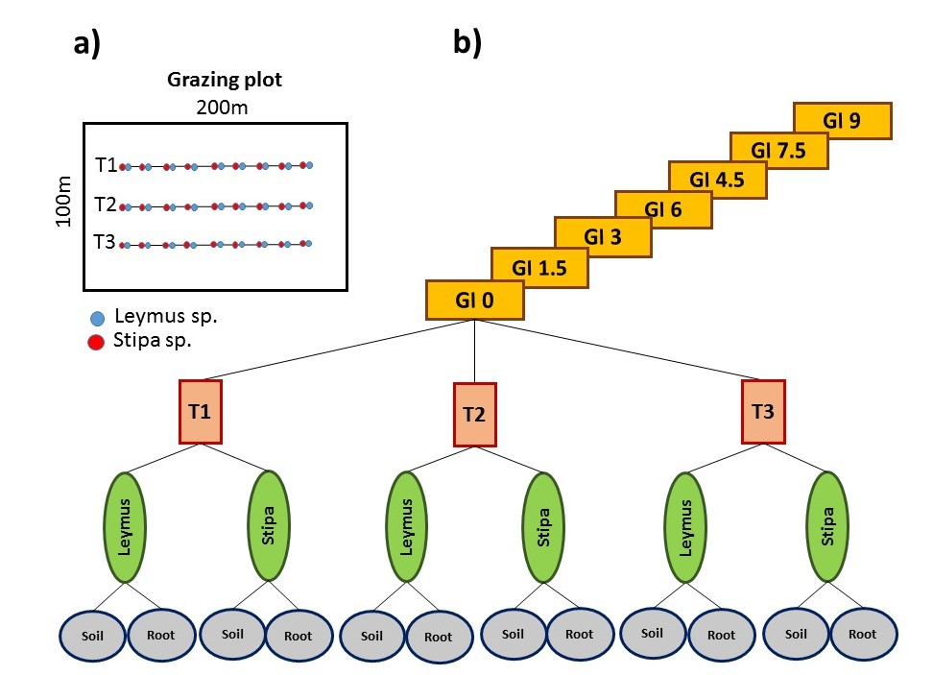

Figure S1. Schematic illustration of experimental design. a) Grazing plot and sample collection. Each grazing plot has an area of 2 ha. Three parallel transects, 50 m apart, were set up in each grazing plot. Transect lines were 150 m long and nine sampling points were placed at regular distance along each transect. Nine Stipa sp. and nine Leymus sp. with their roots and rhizosphere soil were collected along each transect and then root and soil samples of each plant species along each transect were mixed to give a composite soil and roots samples of each host plant. b) Experimental design. Samples were collected from seven plots, each with different levels of grazing intensities (GI); 0 (no grazing), 1.5 (very light), 3 (light), 4.5 (light-moderate), 6 (moderate), 7.5 (heavy) and 9 (overgrazing).

A-3
PCR amplification results
The results of PCR reaction are provided in Table. The DNA concentration of 6 out of 84 samples were not enough for subsequent analysis and removed from further analysis.
Table S1 - PCR amplification results
Sample number | Sample name | Concentration （ng/3μL) | Volume （μL） | Experimental results | Remarks
1 | F(0)-Lymus1-soil | 53.86 | 40 | B | qualified
2 | F(0)-Lymus2-soil | 45.75 | 40 | B | qualified
3 | F(0)-Lymus3-soil | 56.11 | 40 | B | qualified
4 | F(0)-Stipa1-soil | 25.1 | 40 | B | qualified
5 | F(0)-Stipa2-soil | 0 | 40 | D | non-target band
6 | F(0)-Stipa3-soil | 19.56 | 40 | C | Low concentration
7 | F(1.5)-Lymus1-soil | 21.52 | 40 | C | Low concentration
8 | F(1.5)-Lymus2-soil | 0 | 40 | D | non-target band
9 | F(1.5)-Lymus3-soil | 24.86 | 40 | C | Low concentration
10 | F(1.5)-Stipa1-soil | 0 | 40 | D | non-target band
11 | F(0)-Lymus1-root | 59.89 | 40 | B | qualified
12 | F(0)-Lymus2-root | 74.07 | 40 | A | qualified
13 | F(0)-Lymus3-root | 62.98 | 40 | A | qualified
14 | F(0)-Stipa1-root | 51.69 | 40 | B | qualified
15 | F(0)-Stipa2-root | 44.36 | 40 | B | qualified
16 | F(0)-Stipa3-root | 54.78 | 40 | B | qualified
17 | F(1.5)-Lymus1-root | 50.17 | 40 | B | qualified
18 | F(1.5)-Lymus2-root | 71.27 | 40 | A | qualified
19 | F(1.5)-Lymus3-root | 85.11 | 40 | A | qualified
20 | F(1.5)-Stipa1-root | 53.2 | 40 | B | qualified
21 | F(1.5)-Stipa2-soil | 32.5 | 40 | B | qualified
22 | F(1.5)-Stipa3-soil | 48.91 | 40 | B | qualified
23 | F(3)-Lymus1-soil | 37.55 | 40 | B | qualified
24 | F(3)-Lymus2-soil | 31.88 | 40 | B | qualified
25 | F(3)-Lymus3-soil | 38.83 | 40 | B | qualified
26 | F(3)-Stipa1-soil | 21.53 | 40 | C | Low concentration
27 | F(3)-Stipa2-soil | 39.38 | 40 | B | qualified
28 | F(3)-Stipa3-soil | 38.37 | 40 | B | qualified
29 | F(4.5)-Lymus1-soil | 28.97 | 40 | B | qualified
30 | F(4.5)-Lymus2-soil | 24.55 | 40 | C | Low concentration
31 | F(4.5)-Lymus3-soil | 24.99 | 40 | C | Low concentration
32 | F(4.5)-Stipa1-soil | 32.6 | 40 | B | qualified
33 | F(4.5)-Stipa2-soil | 33.68 | 40 | B | qualified
34 | F(4.5)-Stipa3-soil | 32.21 | 40 | B | qualified
35 | F(6)-Lymus1-soil | 0 | 40 | D | non-target band
36 | F(6)-Lymus2-soil | 29.9 | 40 | B | qualified
37 | F(6)-Lymus3-soil | 28.92 | 40 | B | qualified
38 | F(6)-Stipa1-soil | 0 | 40 | D | non-target band
39 | F(6)-Stipa2-soil | 0 | 40 | D | non-target band
40 | F(6)-Stipa3-soil | 38.68 | 40 | B | qualified
41 | F(1.5)-Stipa2-root | 50.24 | 40 | B | qualified
42 | F(1.5)-Stipa3-root | 35.31 | 40 | B | qualified
43 | F(3)-Lymus1-root | 80.63 | 40 | A | qualified
44 | F(3)-Lymus2-root | 64.01 | 40 | A | qualified
45 | F(3)-Lymus3-root | 69.37 | 40 | A | qualified
46 | F(3)-Stipa1-root | 100.72 | 40 | A | qualified
47 | F(3)-Stipa2-root | 61.29 | 40 | A | qualified
48 | F(3)-Stipa3-root | 75.32 | 40 | A | qualified
49 | F(4.5)-Lymus1-root | 60.7 | 40 | A | qualified
50 | F(4.5)-Lymus2-root | 26.89 | 40 | B | qualified
51 | F(4.5)-Lymus3-root | 61.45 | 40 | A | qualified
52 | F(4.5)-Stipa1-root | 76.94 | 40 | A | qualified
53 | F(4.5)-Stipa2-root | 64.73 | 40 | A | qualified
54 | F(4.5)-Stipa3-root | 68.23 | 40 | A | qualified
55 | F(6)-Lymus1-root | 75.8 | 40 | A | qualified
56 | F(6)-Lymus2-root | 57.11 | 40 | B | qualified
57 | F(6)-Lymus3-root | 65.23 | 40 | A | qualified
58 | F(6)-Stipa1-root | 71.91 | 40 | A | qualified
59 | F(6)-Stipa2-root | 69.59 | 40 | A | qualified
60 | F(6)-Stipa3-root | 69.74 | 40 | A | qualified
61 | F(7.5)-Lymus1-soil | 74.51 | 40 | A | qualified
62 | F(7.5)-Lymus2-soil | 75.94 | 40 | A | qualified
63 | F(7.5)-Lymus3-soil | 79.85 | 40 | A | qualified
64 | F(7.5)-Stipa1-soil | 67.64 | 40 | A | qualified
65 | F(7.5)-Stipa2-soil | 62.19 | 40 | A | qualified
66 | F(7.5)-Stipa3-soil | 40.79 | 40 | B | qualified
67 | F(9)-Lymus1-soil | 62.62 | 40 | A | qualified
68 | F(9)-Lymus2-soil | 66.11 | 40 | A | qualified
69 | F(9)-Lymus3-soil | 58.07 | 40 | B | qualified
70 | F(9)-Stipa1-soil | 83.36 | 40 | A | qualified
71 | F(9)-Stipa2-soil | 59.18 | 40 | B | qualified
72 | F(9)-Stipa3-soil | 58.99 | 40 | B | qualified
73 | F(7.5)-Lymus1-root | 89.13 | 40 | A | qualified
74 | F(7.5)-Lymus2-root | 69.07 | 40 | A | qualified
75 | F(7.5)-Lymus3-root | 108.32 | 40 | A | qualified
76 | F(7.5)-Stipa1-root | 82.74 | 40 | A | qualified
77 | F(7.5)-Stipa2-root | 92.43 | 40 | A | qualified
78 | F(7.5)-Stipa3-root | 89.86 | 40 | A | qualified
79 | F(9)-Lymus1-root | 56.05 | 40 | B | qualified
80 | F(9)-Lymus2-root | 58.6 | 40 | B | qualified
81 | F(9)-Lymus3-root | 71.63 | 40 | A | qualified
82 | F(9)-Stipa1-root | 56.01 | 40 | B | qualified
83 | F(9)-Stipa2-root | 72.88 | 40 | A | qualified
84 | F(9)-Stipa3-root | 71.81 | 40 | A | qualified
Note: Class A: The main band is clear, the PCR sample concentration is ≥ 60 ng / 3 μL, the total amount is ≥ 1000 ng, and can be used for more than 2 subsequent experiments; Class B: 25 ng / 3 μL ≤ PCR sample concentration < 60 ng / 3μL, 500 ng ≤ total amount <1000 ng, which can be used for 1 subsequent experiment; Class C: 10 ng / 3μL ≤ PCR sample concentration < 25ng / 3μL, 150 ng ≤ total amount < 500 ng, may be used for subsequent experiments at risk; Class D: DNA concentration < 10 ng / 3 μL, total amount < 150 ng.

A-4

a)
b)
Figure S2. Bar plot of relative abundance of observed AMF virtual taxa in a) two plant species and b) two mediums, root and soil.

A-5

Stress plot of relationship between NMDS ordination distance and original observed distance
Figure S3. Stress plot of relationship between NMDS ordination distance and original observed distance. The fit between the community distances (data dissimilarity) and ordination distances is indicated by the monotonic step line (red). Two stress values are provided: (1) Non-metric fit which is the modified Kruskal's stress value and is √1-R², (2) Linear fit which is the R² value of the correlation between the ordination values and the ordination values predicted from the (monotonic) regression line.

Figure S. Non-metric Multidimensional Scaling (NMDS, based on the Bray-Curtis dissimilarity index) of root and rhizosphere soil-associated AMF communities in two dominated plant species collected along a grazing gradient in a steppe grassland in Inner Mongolia.

References
Altschul, S. F., W. Gish, W. Miller, E. W. Myers, and D. J. Lipman. 1990. Basic local alignment search tool. Journal of molecular biology 215:403-410.
Bokulich, N. A., S. Subramanian, J. J. Faith, D. Gevers, J. I. Gordon, R. Knight, D. A. Mills, and J. G. Caporaso. 2013. Quality-filtering vastly improves diversity estimates from Illumina amplicon sequencing. Nature methods 10:57-59.
Callahan, B. J., P. J. McMurdie, M. J. Rosen, A. W. Han, A. J. A. Johnson, and S. P. J. N. m. Holmes. 2016. DADA2: high-resolution sample inference from Illumina amplicon data. 13:581-583.
Caporaso, J. G., J. Kuczynski, J. Stombaugh, K. Bittinger, F. D. Bushman, E. K. Costello, N. Fierer, A. G. Pena, J. K. Goodrich, and J. I. Gordon. 2010. QIIME allows analysis of high-throughput community sequencing data. Nature methods 7:335.
Edgar, R. 2010. Usearch. Lawrence Berkeley National Lab.(LBNL), Berkeley, CA (United States).
Ewels, P., M. Magnusson, S. Lundin, and M. Käller. 2016. MultiQC: summarize analysis results for multiple tools and samples in a single report. Bioinformatics 32:3047-3048.
Jalili, V., E. Afgan, Q. Gu, D. Clements, D. Blankenberg, J. Goecks, J. Taylor, and A. J. N. A. R. Nekrutenko. 2020. The Galaxy platform for accessible, reproducible and collaborative biomedical analyses: 2020 update.
Lee, J., S. Lee, and J. P. W. Young. 2008. Improved PCR primers for the detection and identification of arbuscular mycorrhizal fungi. FEMS microbiology ecology 65:339-349.
Sato, K., Y. Suyama, M. Saito, and K. Sugawara. 2005. A new primer for discrimination of arbuscular mycorrhizal fungi with polymerase chain reaction‐denature gradient gel electrophoresis. Grassland Science 51:179-181.
Wiesmeier, M., M. Steffens, A. Kölbl, and I. Kögel-Knabner. 2009. Degradation and small-scale spatial homogenization of topsoils in intensively-grazed steppes of Northern China. Soil and Tillage Research 104:299-310.

