Supplementary Information for:

Global exposure risk of timber production, carbon stocking, and biodiversity to forest pests

Yuxin Qiao^{1,2*}, Jianquan Liu^{1*}, David P. Edwards^{2,3*}

¹State Key Laboratory of Herbage Innovation and Grassland Agro-Ecosystem, College of Ecology, Lanzhou University, Lanzhou, China
²Department of Plant Sciences and Centre for Global Wood Security, University of Cambridge, Cambridge, UK.
³Conservation Research Institute, University of Cambridge, Cambridge, UK
*Correspondence: yq303@cam.ac.uk; liujq@nwipb.ac.cn; dpe29@cam.ac.uk

Supplementary Figures

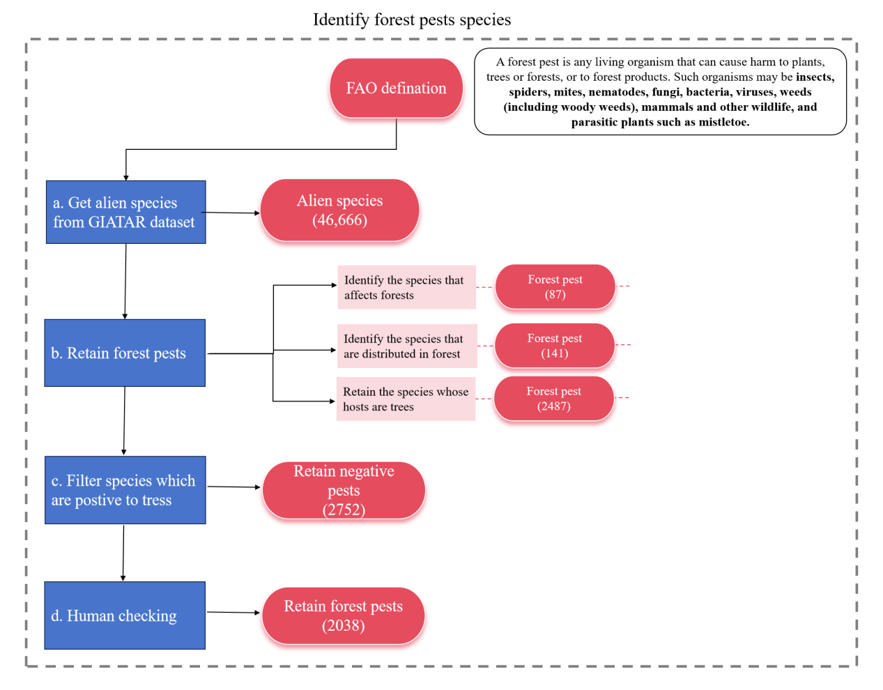
Supplementary Fig. 1 Workflow for identifying invasive forest pests lists. Summary of species filtering pipeline for forest pests spatial distribution pattern.

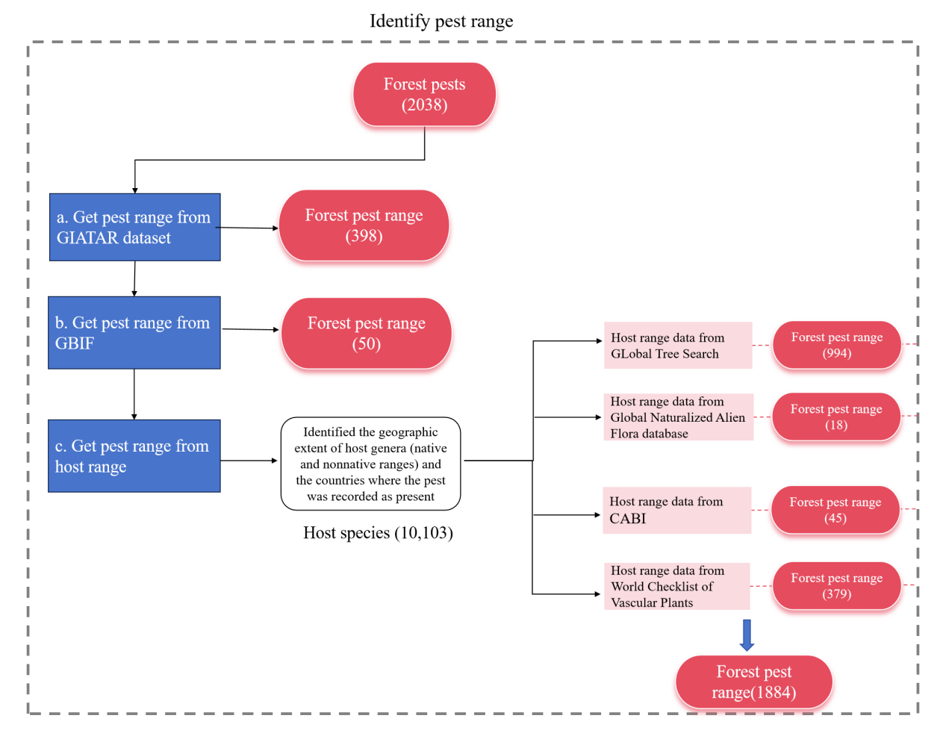
Supplementary Fig. 2 Workflow for determining geographic range of forest pests. The final analyses in the main text use 1,884 species with native and non-native ranges.

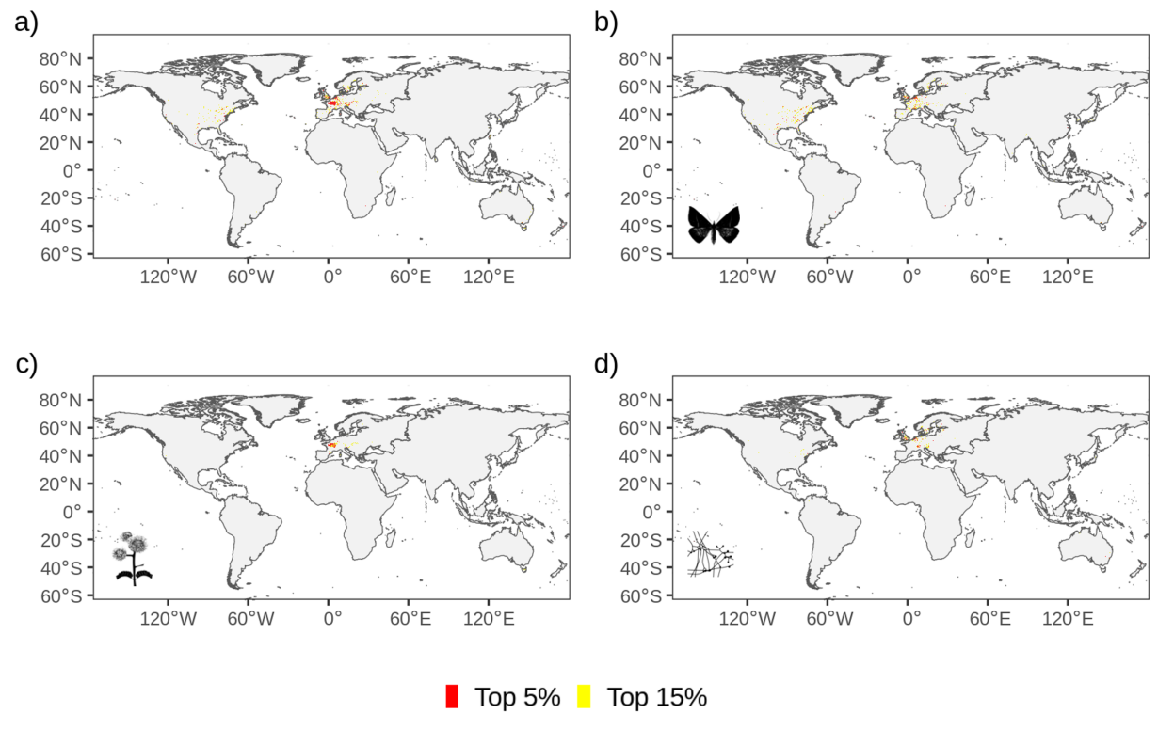
Supplementary Fig. 3 Global spatial pattern of forest pest richness. Spatial hotspots across all (a), fauna (b), flora (c), and pathogenic forest pests (d). Cells highlighted yellow represent the top 15% of grid cells and those in red represent the top 5%. To improve display, all maps have been resampled to 1° resolution.

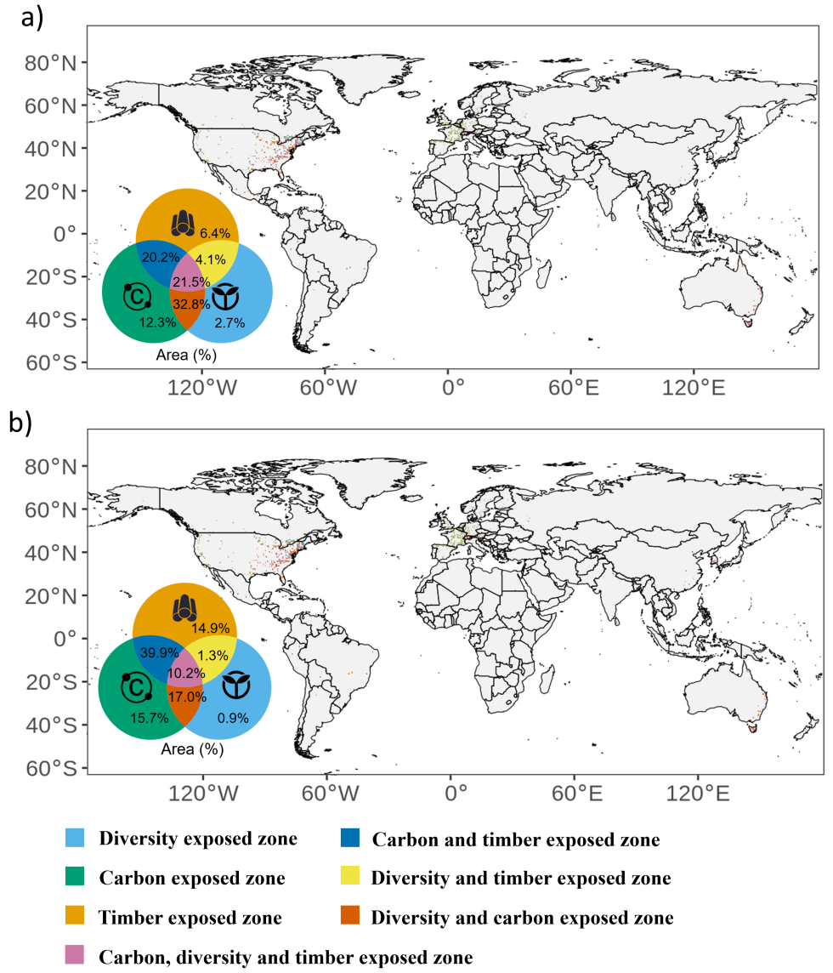

Supplementary Fig. 4 Global high-risk zones exposed to forest pests across different ecosystem services. The spatial map show high-risk zones of ecosystem services exposed to forest pests within (a) and outside (b) native ranges. The Veen map shows proportion of areas across different types of high-risk zones. The blue, green and orange colors represent high-risk zones exposed to forest pests across forest tree diversity, potential carbon stock, and timber-producing areas, respectively. The reddish-orange, deep blue, yellow and pink represent high-risk zones exposed to forest pests across intersection of timber area, forest diversity and potential carbon stock, respectively.

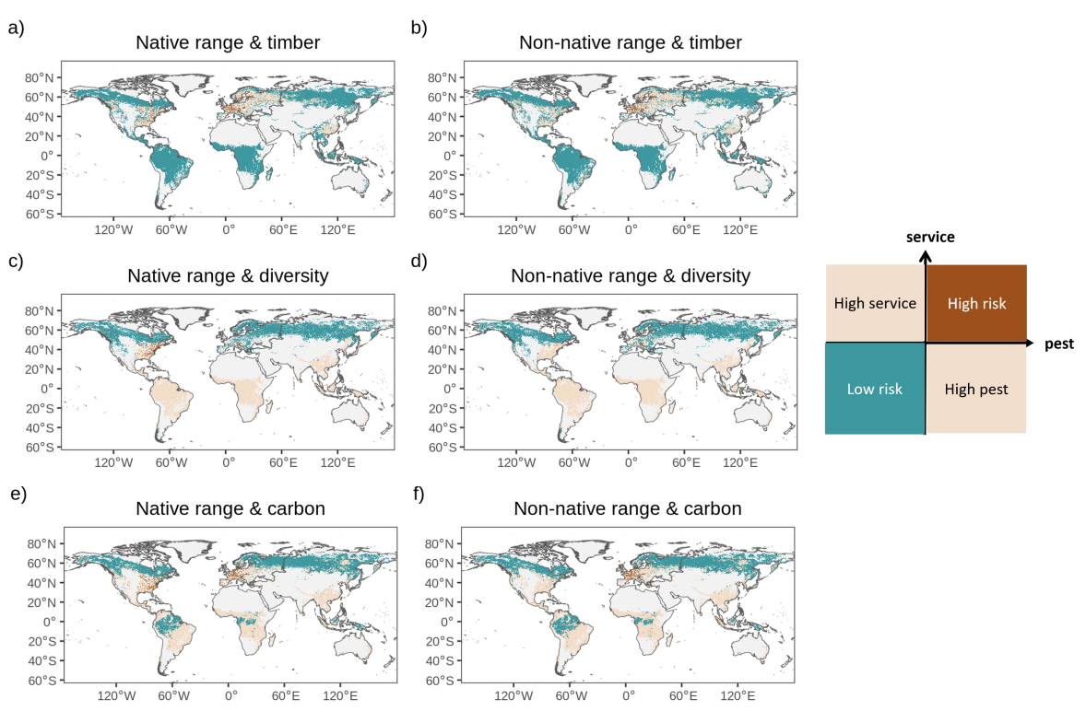

Supplementary Fig. 5 Spatial distribution overlap analysis between different geographic range of forest pests and ecosystem services. Spatial pattern of native range of forests pests with timber-producing area (a), forest diversity (c) and potential carbon stock (e). Spatial pattern of non-native range of forests pests with timber-producing area (b), forest diversity (d) and potential carbon stock (f). The brown color indicated the grid cell where has both high forest pests and ecosystem services, whereas blue indicated the grid cell where has both low forest pests and ecosystem services.

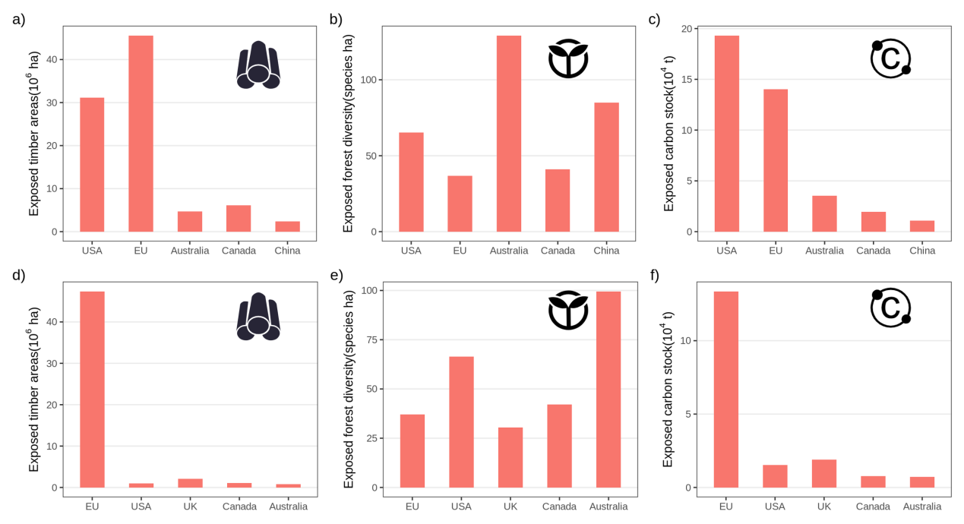

Supplementary Fig. 6 Statistics of exposed ecosystem services to forest pests in main exposure zones. Statistics of the timber-producing areas (a, d), forest diversity (b, e), and potential carbon stock (c, f) exposed to native and non-native range of forest pests, respectively.

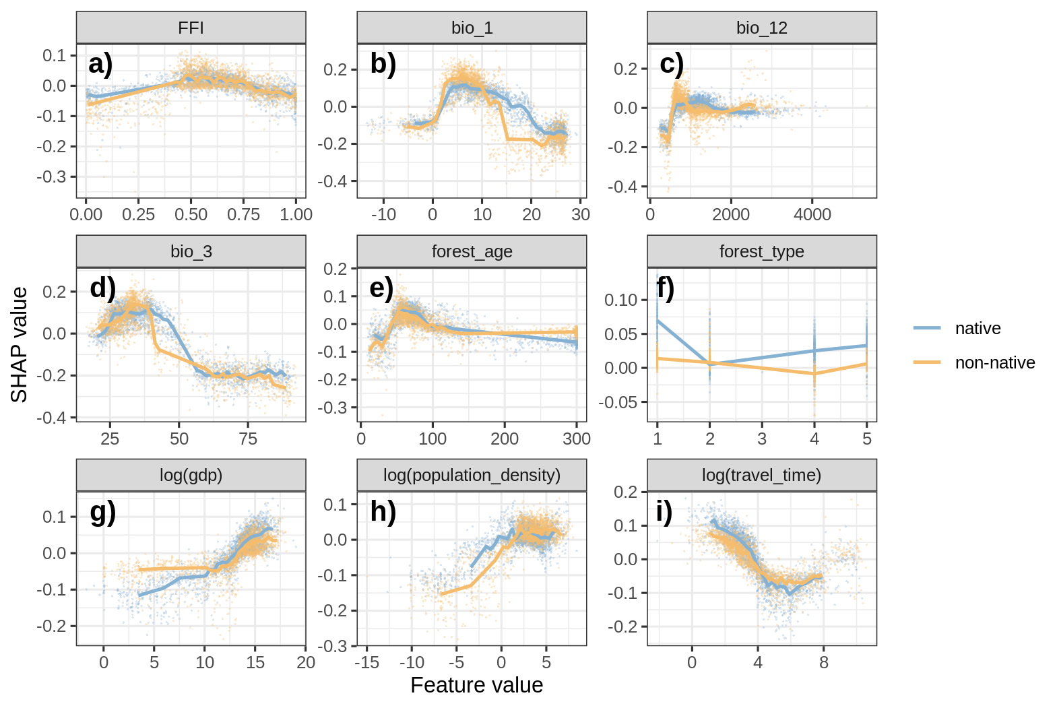

Supplementary Fig. 8 Partial dependence plots of the variables for native and non-native range of forest pests within high risk zones of timber-producing areas. Namely, forest fragment index (FFI) (a), bio_1 (mean temperature) (b), bio_12 (mean temperature) (c), bio_3 (Isothermality) (d), forest_age (e), forest_type (f), gdp (g), population_density (h) and travel_time (i). The Y-axis represents the SHAP value, while X-axis represents feature values with log transformed. The red and blue line indicates the median SHAP values across 50 bins of x-axis variables for native and non-native range of forest pest, respectively. The partial dependence plots illustrate how individual feature contribute to the high exposed zones.

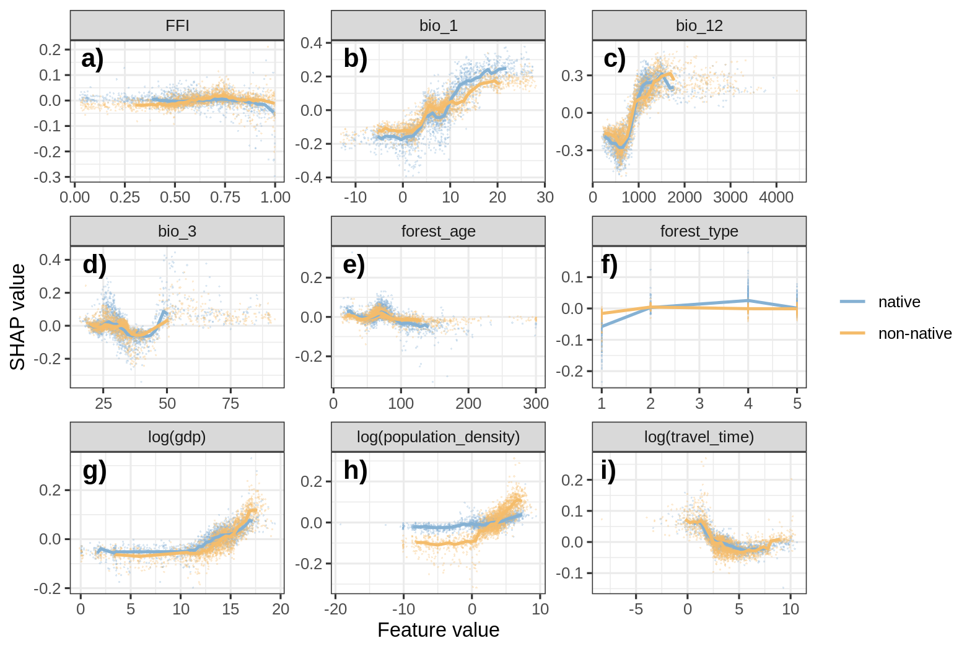

Supplementary Fig. 9 Partial dependence plots of the variables for native and non-native range of forest pests in high risk zones of forest diversity. Namely, forest fragment index (FFI) (a), bio_1 (mean temperature) (b), bio_12 (mean temperature) (c), bio_3 (Isothermality) (d), forest_age (e), forest_type (f), gdp (g), population_density (h) and travel_time (i). The Y-axis represents the SHAP value, while X-axis represents feature values with log transformed. The red and blue line indicates the median SHAP values across 50 bins of x-axis variables for native and non-native range of forest pest, respectively. The partial dependence plots illustrate how individual feature contribute to the high exposed zones.

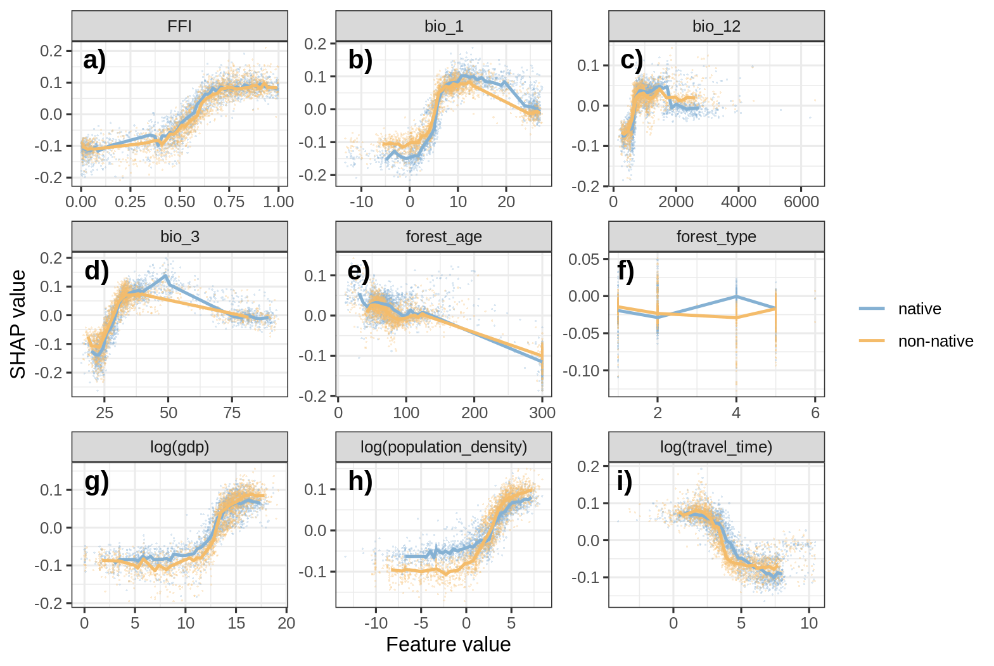

Supplementary Fig. 10 Partial dependence plots of the variables for native and non-native range of forest pests in high risk zones of potential carbon stock. Namely, forest fragment index (FFI) (a), bio_1 (mean temperature) (b), bio_12 (mean temperature) (c), bio_3 (Isothermality) (d), forest_age (e), forest_type (f), gdp (g), population_density (h) and travel_time (i). The Y-axis represents the SHAP value, while X-axis represents feature values with log transformed. The red and blue line indicates the median SHAP values across 50 bins of x-axis variables for native and non-native range of forest pest, respectively. The partial dependence plots illustrate how individual feature contribute to the high exposed zones..

Supplementary Tables
Supplementary Table 1 Spatial relationship between different functional groups forest pests and ecosystem services in main exposure zones.
Main exposure regions | Forest pests groups | Types | Timber areas |  | Forest diversity |  | Potential Carbon stock
Main exposure regions | Forest pests groups | Types | Moran’s I | P | Moran’s I | P | Moran’s I | P
USA | Fauna | Native | -0.08 | p<0.01 | 0.10 | p<0.01 | 0.01 | Not sig
USA | Fauna | Non-native | -0.07 | p<0.01 | -0.01 | p<0.05 | 0.01 | Not sig
USA | Flora | Native | 0.31 | p<0.01 | 0.14 | p<0.01 | 0.12 | p<0.01
USA | Flora | Non-native | -0.09 | p<0.01 | 0.04 | p<0.01 | 0.02 | p<0.05
USA | Pathogenic | Native | -0.10 | p<0.01 | -0.09 | p<0.01 | -0.08 | p<0.01
USA | Pathogenic | Non-native | 0.00 | Not sig | 0.12 | p<0.01 | -0.01 | Not sig
Canada | Fauna | Native | -0.10 | p<0.01 | 0.22 | p<0.01 | 0.17 | p<0.01
Canada | Fauna | Non-native | -0.16 | p<0.01 | 0.04 | p<0.01 | 0.25 | p<0.01
Canada | Flora | Native | 0.00 | Not sig | 0.03 | Not sig | 0.21 | p<0.01
Canada | Flora | Non-native | -0.15 | p<0.01 | -0.01 | p<0.05 | 0.22 | p<0.01
Canada | Pathogenic | Native | -0.09 | p<0.01 | -0.11 | p<0.01 | 0.14 | p<0.01
Canada | Pathogenic | Non-native | -0.08 | p<0.01 | 0.00 | Not sig | 0.09 | p<0.01
EU | Fauna | Native | -0.07 | p<0.01 | 0.26 | p<0.01 | 0.10 | p<0.01
EU | Fauna | Non-native | -0.03 | p<0.05 | -0.06 | p<0.01 | -0.09 | p<0.01
EU | Flora | Native | -0.04 | p<0.01 | 0.12 | p<0.01 | 0.22 | p<0.01
EU | Flora | Non-native | 0.01 | Not sig | 0.25 | p<0.01 | 0.22 | p<0.01
EU | Pathogenic | Native | 0.07 | p<0.01 | 0.17 | p<0.01 | 0.24 | p<0.01
EU | Pathogenic | Non-native | 0.11 | p<0.05 | -0.03 | p<0.01 | 0.02 | Not sig
UK | Fauna | Native | -0.03 | p<0.01 | 0.17 | p<0.01 | -0.09 | p<0.01
UK | Fauna | Non-native | -0.05 | p<0.01 | 0.23 | p<0.01 | -0.01 | p<0.01
UK | Flora | Native | -0.14 | p<0.01 | -0.12 | p<0.01 | 0.08 | p<0.01
UK | Flora | Non-native | -0.09 | p<0.01 | 0.11 | p<0.01 | -0.10 | p<0.01
UK | Pathogenic | Native | -0.08 | p<0.01 | 0.09 | p<0.01 | -0.04 | p<0.01
UK | Pathogenic | Non-native | -0.19 | p<0.01 | -0.21 | p<0.01 | 0.06 | p<0.01
China | Fauna | Native | -0.07 | p<0.01 | -0.07 | p<0.01 | -0.03 | p<0.01
China | Fauna | Non-native | -0.07 | p<0.01 | -0.07 | p<0.01 | 0.12 | p<0.01
China | Flora | Native | 0.04 | Not sig | 0.28 | p<0.01 | 0.03 | Not sig
China | Flora | Non-native | -0.14 | p<0.01 | -0.14 | p<0.01 | 0.06 | p<0.01
China | Pathogenic | Native | -0.08 | p<0.01 | -0.14 | p<0.01 | 0.08 | p<0.01
China | Pathogenic | Non-native | 0.01 | Not sig | 0.32 | p<0.01 | 0.02 | Not sig
Australia | Fauna | Native | -0.14 | p<0.01 | 0.20 | p<0.01 | 0.05 | p<0.01
Australia | Fauna | Non-native | -0.11 | p<0.01 | 0.09 | p<0.01 | -0.02 | p<0.01
Australia | Flora | Native | -0.07 | p<0.01 | 0.23 | p<0.01 | -0.10 | p<0.01
Australia | Flora | Non-native | -0.12 | p<0.01 | 0.09 | p<0.01 | -0.14 | p<0.01
Australia | Pathogenic | Native | -0.06 | p<0.01 | 0.03 | p<0.01 | 0.03 | p<0.01
Australia | Pathogenic | Non-native | -0.05 | p<0.01 | 0.02 | p<0.01 | -0.03 | p<0.01

