Strict norms and perceived cultural tightness have distinct societal consequences - Supplementary Materials
Contents:
Supplementary Figure 1
Supplementary Tables 1-6

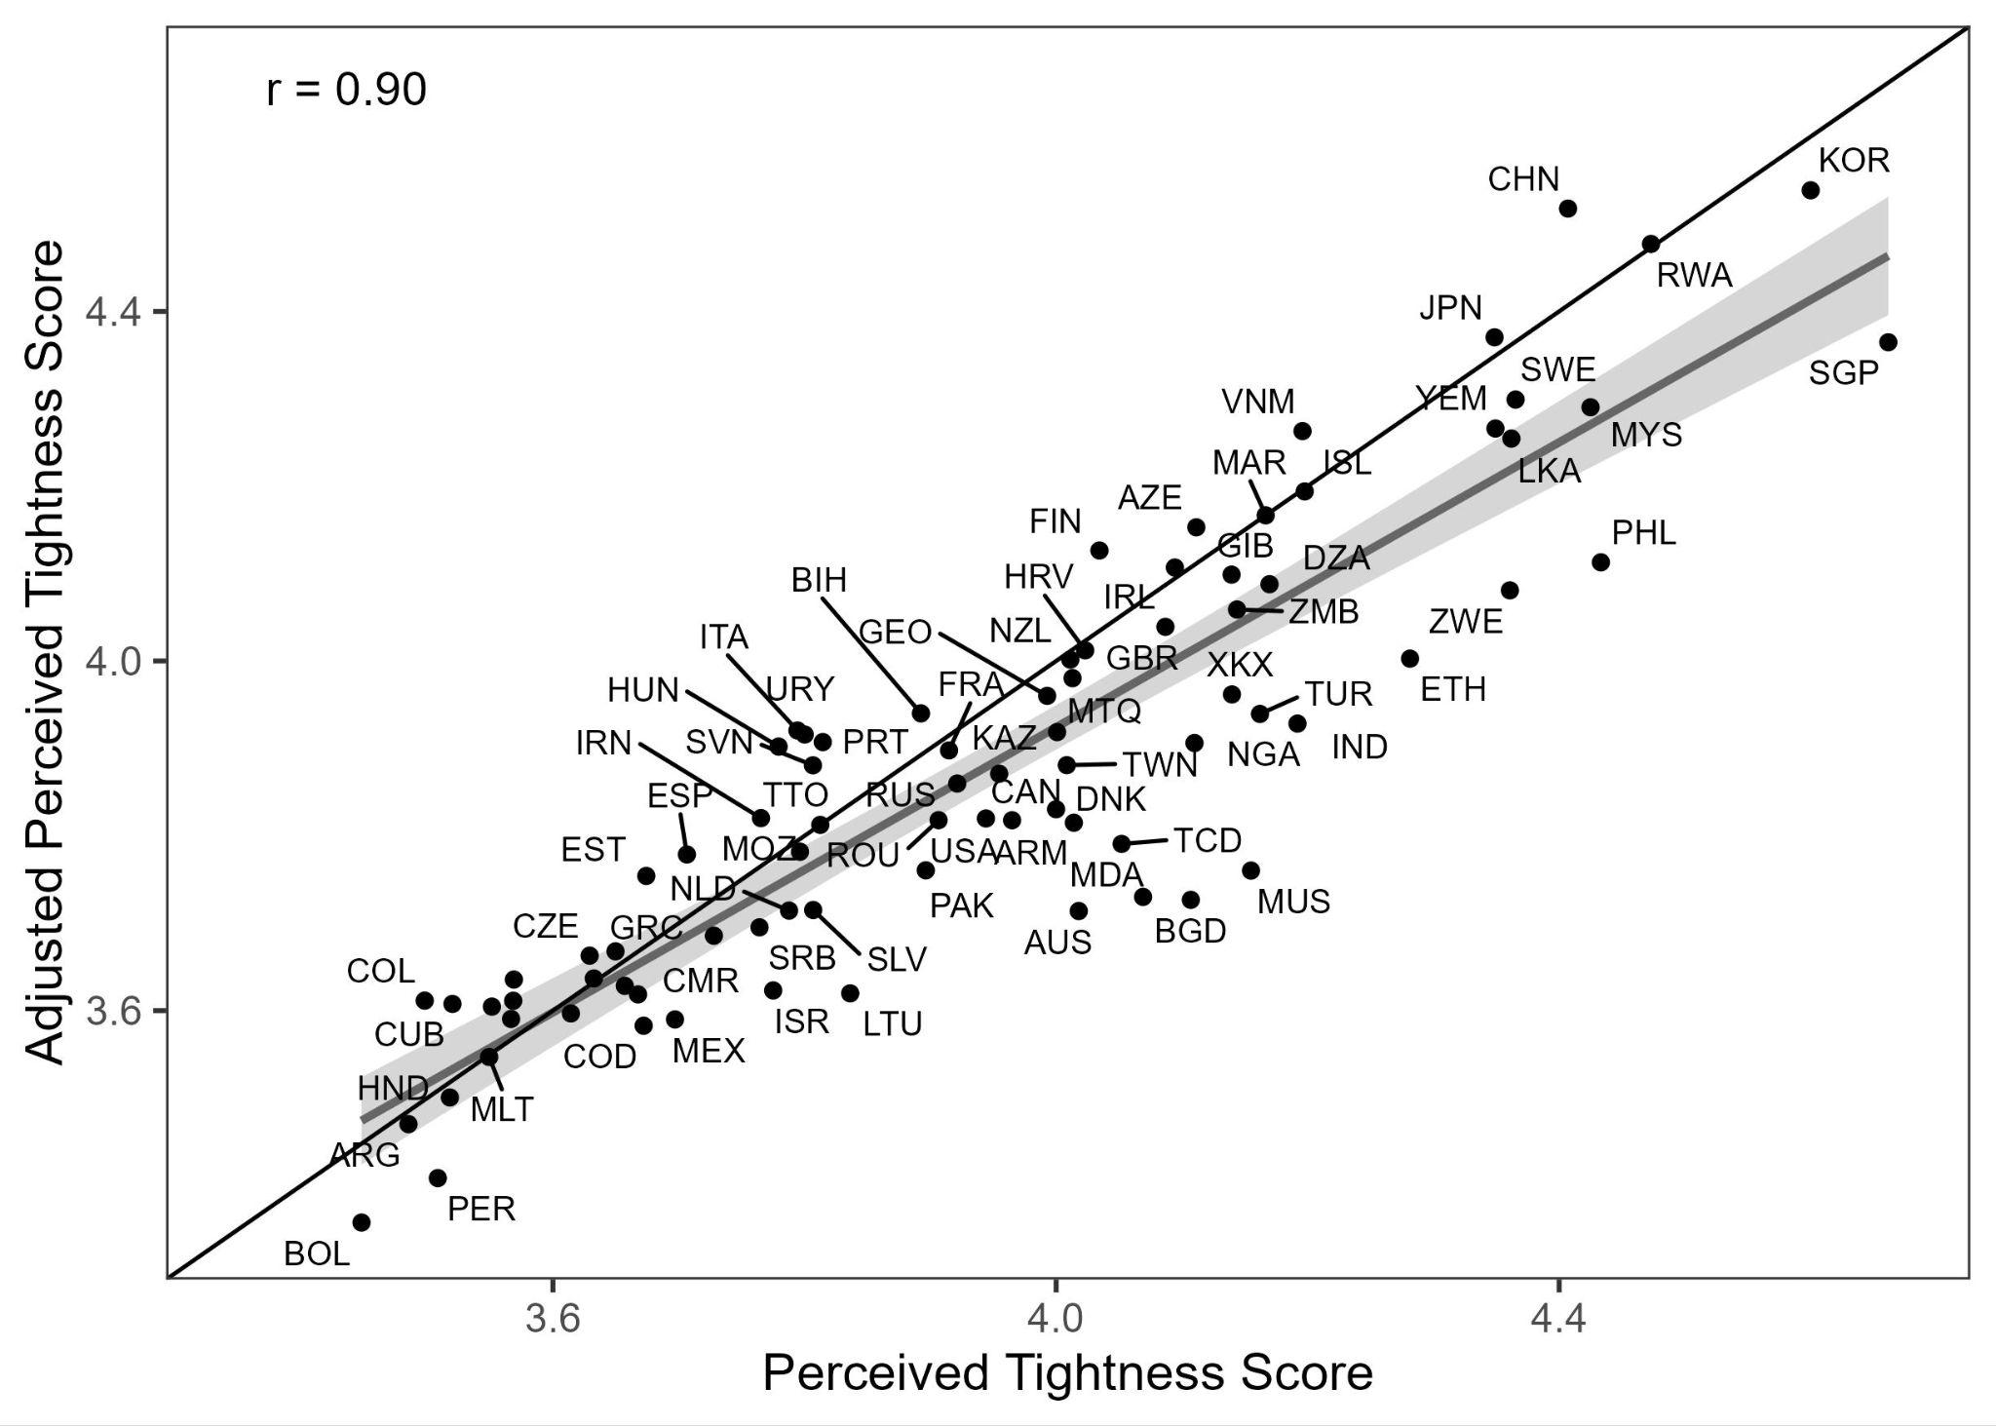 Supplementary Figure 1. Correlation between adjusted and unadjusted perceived tightness scores.

Supplementary Table 1. Perceived tightness (Perc), norm strictness (Stric), and sample size (N) for each society.
Country | PTL | Stric | N | Country | PTL | Stric | N | Country | PTL | Stric | N
Algeria | 4.17 | 1.03 | 55 | Germany | 3.95 | -0.08 | 221 | N. Macedonia | 3.66 | 0.39 | 184
Argentina | 3.49 | 0.02 | 277 | Gibraltar | 4.14 | 0.18 | 87 | Pakistan | 3.90 | 0.61 | 1029
Armenia | 3.97 | 0.51 | 475 | Greece | 3.65 | 0.04 | 448 | Peru | 3.51 | 0.43 | 434
Australia | 4.02 | 0.27 | 576 | Guatemala | 3.61 | 0.28 | 303 | Philippines | 4.43 | 0.11 | 222
Azerbaijan | 4.11 | 0.46 | 308 | Honduras | 3.52 | 0.34 | 274 | Poland | 3.67 | 0.24 | 370
Bangladesh | 4.11 | 0.68 | 466 | Hungary | 3.78 | 0.11 | 386 | Portugal | 3.81 | 0.31 | 124
Bolivia | 3.45 | 0.48 | 688 | Iceland | 4.20 | -0.06 | 289 | Romania | 3.91 | 0.04 | 248
Bosnia & Herz. | 3.89 | 0.27 | 254 | India | 4.19 | 0.23 | 286 | Russia | 3.92 | 0.09 | 536
Brazil | 3.57 | 0.51 | 928 | Iran | 3.77 | 0.72 | 268 | Rwanda | 4.47 | 1.03 | 257
Bulgaria | 3.57 | 0.33 | 110 | Ireland | 4.09 | -0.09 | 257 | Serbia | 3.76 | 0.35 | 665
Cameroon | 3.73 | 0.52 | 301 | Israel | 3.78 | 0.10 | 329 | Singapore | 4.66 | -0.05 | 202
Canada | 4.00 | 0.03 | 454 | Italy | 3.79 | 0.08 | 438 | Slovakia | 3.63 | 0.23 | 242
Chad | 4.05 | 0.63 | 49 | Japan | 4.35 | 0.51 | 417 | Slovenia | 3.81 | 0.10 | 258
Chile | 3.57 | 0.00 | 75 | Kazakhstan | 4.00 | -0.15 | 208 | South Korea | 4.60 | 0.15 | 548
China | 4.41 | 0.27 | 209 | Kosovo | 4.14 | 0.25 | 214 | Spain | 3.71 | 0.14 | 201
Colombia | 3.50 | 0.15 | 342 | Latvia | 3.89 | 0.46 | 215 | Sri Lanka | 4.36 | 0.08 | 109
Costa Rica | 3.55 | -0.10 | 101 | Lithuania | 3.84 | 0.21 | 226 | Sweden | 4.37 | -0.14 | 305
Croatia | 4.02 | 0.17 | 281 | Malaysia | 4.42 | 0.05 | 406 | Taiwan | 4.01 | 0.53 | 236
Cuba | 3.52 | 0.28 | 284 | Malta | 3.55 | 0.17 | 247 | Trinidad & T. | 3.81 | 0.20 | 49
Czechia | 3.63 | 0.09 | 227 | Martinique | 4.01 | 0.15 | 174 | Turkey | 4.16 | 0.45 | 256
D.R. Congo | 3.67 | 0.72 | 295 | Mauritius | 4.15 | 0.14 | 58 | United Kingdom | 4.09 | 0.07 | 210
Denmark | 4.01 | -0.09 | 242 | Mexico | 3.70 | 0.21 | 482 | United States | 3.94 | 0.16 | 832
El Salvador | 3.81 | 0.54 | 501 | Moldova | 4.07 | 0.26 | 329 | Uruguay | 3.80 | 0.02 | 226
Estonia | 3.67 | -0.03 | 261 | Morocco | 4.17 | 0.55 | 219 | Vietnam | 4.20 | 0.30 | 148
Ethiopia | 4.28 | 0.63 | 62 | Mozambique | 3.80 | 0.66 | 231 | Yemen | 4.35 | 0.79 | 219
Finland | 4.03 | -0.44 | 356 | Netherlands | 3.79 | -0.10 | 161 | Zambia | 4.14 | 0.73 | 315
France | 3.91 | 0.30 | 234 | New Zealand | 4.01 | -0.08 | 206 | Zimbabwe | 4.36 | 0.68 | 223
Georgia | 3.99 | 0.48 | 269 | Nigeria | 4.11 | 0.52 | 341

Supplementary Table 2. Reanalysis of Gelfand et al. (2011) raw data: Correlations between tightness dimensions and their associations with ecological threats and institutions.
Measure | Perceived Tightness | Norm Strictness
Intercorrelations
Perceived Tightness | — | 0.05, p = 0.80
Norm Strictness | 0.05, p = 0.80 | —
Ecological/Historical Threats
Child mortality, log | -0.04, p = 0.83 | 0.65, p < 0.001
Pathogen prevalence | -0.04, p = 0.82 | 0.64, p < 0.001
Societal Structure
Population density, log | 0.31, p = 0.08 | 0.20, p = 0.28
Ethnic fractionalization | -0.16, p = 0.38 | 0.39, p = 0.03
Institutions
Gender galitarian values | -0.21, p = 0.31 | -0.57, p = 0.002
Importance of religion | 0.09, p = 0.62 | 0.60, p < 0.001
Liberal democracy | 0.02, p = 0.90 | -0.66, p < 0.001
Choice values | -0.15, p = 0.46 | -0.68, p < 0.001
Note. N = 32 societies except for correlations with child mortality, which is not available in Hong Kong (n = 31). Correlations calculated from raw data without within-subject standardization. The intercorrelations are identical to those reported in the main text; external correlates demonstrate similar patterns of differential associations across tightness dimensions.

Supplementary Table 3. Intercorrelations between predictors of COVID-19 mortality.
Variable | Perceived Tightness | Norm Strictness | Median Age | Obesity Rate | Hypertension Rate
Norm Strictness | 0.10
Median Age | -0.13 | -0.58
Obesity Rate | -0.54 | -0.30 | 0.31
Hypertension Rate | -0.24 | -0.03 | 0.19 | 0.30
Gini Index | -0.01 | 0.44 | -0.65 | -0.13 | -0.13

Supplementary Table 4. Associations between tightness dimensions and homicide rates. Model 1 (N = 77) includes both tightness dimensions as predictors. Model 2 (N = 73) adds controls for national wealth (GDP per capita, log-transformed), liberal democracy, and poverty rate. Entries are standardized regression coefficients, boldfaced if p < .05.
 | Model 1 | Model 2
TL score | -0.33 (p = 0.003) | -0.34 (p < 0.001)
Strictness | 0.13 (p = 0.25) | -0.22 (p = 0.10)
GDP per capita, log |  | -0.68 (p = 0.003)
Liberal Democracy |  | 0.06 (p = 0.70)
Poverty Rate |  | -0.11 (p = 0.52)

Supplementary Table 5. Associations between tightness dimensions and obesity rates, controlling for Minkov cultural dimensions (Model 1, N = 79) or national wealth (Model 2, N = 65). Entries are standardized regression coefficients, boldfaced if p < .05.
 | Model 1 | Model 2
TL score | -0.41 (p < 0.001) | -0.53 (p < 0.001)
Strictness | -0.21 (p = 0.13) | 0.13 (p = 0.31)
Individualism | 0.18 (p = 0.24)
Flexibility | -0.35 (p = 0.02)
GDP per capita, log |  | 0.50 (p < 0.001)

Supplementary Table 6. Robustness to item sampling of the correlations in Table 1. Pearson correlations are presented with 95% confidence intervals derived from a double-bootstrap procedure (1,000 iterations) in which both societies (N=83) and norm strictness items (k=150) were resampled with replacement.
Variable | r [95% CI]
Child mortality, log | 0.75 [0.62, 0.85]
Pathogen prevalence | 0.59 [0.44, 0.70]
Population density, log | 0.04 [-0.21, 0.27]
Ethnic fractionalization | 0.39 [0.18, 0.58]
Gender egalitarian values | -0.70 [-0.82, -0.54]
Importance of religion | 0.56 [0.39, 0.69]
Liberal democracy | -0.62 [-0.75, -0.44]
Choice values | -0.84 [-0.90, -0.75]

