This supplementary Information contains
Supplementary Discussions 1−3
Supplementary Methods
Supplementary Figures 1−20
Supplementary Tables 1−8
Supplementary References

Supplementary Discussion 1
Low temperature specific heat capacity measurements
The temperature-dependent specific heat capacity (C_{p}) of pristine SnS and Na/Ag co-doped SnS (x = 0.03) single crystals was measured by Quantum Design PPMS and analyzed using a combined Debye–Einstein model¹, as shown in Supplementary Figure 21. The fits reproduced the experimental data (see Supplementary Table 8) with excellent agreement (R² > 0.9996), enabling separation of electronic, acoustic, and optical phonon contributions. For pristine SnS, the Sommerfeld coefficient was found to be (γ= 0.00234 Jmol⁻¹K⁻²), consistent with its semiconducting nature and negligible electronic density of states at the Fermi level. The Debye temperature was estimated as (θ_{D} =276 K), corresponding to ~0.024 eV or ~192 cm⁻¹, reflecting relatively stiff acoustic phonons in the orthorhombic lattice. Three Einstein modes were required to capture the optical phonon spectrum: θ_{E1} ≈ 25.7 K (~0.0022 eV, ~18 cm⁻¹), θ_{E2} ≈ 60.3 K (~0.0052 eV, ~42 cm⁻¹), and θ_{E3} ≈ 102.8 K (~0.0089 eV, ~71 cm⁻¹. The mid-energy Einstein mode aligns closely with the A_{g} Raman mode of SnS, confirming consistency between calorimetric and vibrational spectroscopy data.
Upon Na/Ag co-doping, the electronic contribution increased slightly γ= 0.00277 Jmol⁻¹K⁻², indicating enhanced carrier density or density of states near the Fermi level. The Debye temperature remained essentially unchanged θ_{D} =276 K (~0.024 eV, ~192 cm⁻¹), confirming that the long-wavelength acoustic phonon spectrum and elastic stiffness of the lattice were preserved. However, subtle modifications were observed in the optical phonon contributions: the lowest-energy Einstein mode stiffened slightly to θ_{E1} ≈ 26.4 K (~0.0023 eV, ~18.3 cm⁻¹) with increased weight, while the highest-energy mode showed a slight reduction in amplitude. These changes suggest that Na/Ag substitution perturbs local vibrational environments, introducing additional low-energy localized modes.
The (C_{p}/T³) vs T plots for both pristine and doped samples reveal pronounced boson-like features, indicative of excess vibrational density of states beyond the Debye acoustic contribution. These localized low-energy modes, strengthened upon doping, provide additional scattering channels that couple to acoustic phonons and to the A_{g} optical mode (~42 cm⁻¹). Although the overall heat capacity and Debye temperature remain nearly identical between pristine and doped samples, the lattice thermal conductivity of the doped crystals decreases significantly. This reduction is attributed to enhanced phonon scattering mechanisms introduced by Na/Ag substitution: (i) point-defect scattering from mass and strain-field fluctuations, (ii) hybridization of acoustic phonons with low-energy localized modes, and (iii) modestly stronger electron–phonon interactions due to increased γ. Collectively, these effects shorten phonon lifetimes and reduce the phonon mean free path without altering phonon velocities or heat capacity, thereby suppressing κ_{L} in the doped crystals.
To fit the C_{p}/T versus T² data for SnS crystal, we used a combined Debye-Einstein model¹. This approach captures both the acoustic and localized optical phonon contributions to the heat capacity, enabling an accurate description across low- and high-temperature regimes and providing deeper insight into the thermodynamic behavior of the alloy.
$\frac{C_{p}}{T}=γ+βT^{2}+\underset{n}{∑}\left(A_{n}{\left(Θ_{En}\right)}^{2}.{\left(T^{2}\right)}^{-\frac{3}{2}}.\frac{e^{\frac{Θ_{En}}{T}}}{{\left(e^{\frac{Θ_{En}}{T}}-1\right)}^{2}}\right)$ (1)
$β=C\left({12π^{4}N_{A}k_{B}}/5\right){\left(Θ_{D}\right)}^{-3}$ (2)
$C=1-∑_{n}{A_{n}}/{\left(3NR\right)}$ (3)
In the above equation, γ denotes the electronic contribution, and βT² corresponds to the Debye mode. In equation (2), N_{A}, k_{B,} and Θ_{D} are Avogadro number, Boltzmann constant, and Debye temperature, respectively. N is the number of atoms, and R is the gas constant in equation (3). In the third term of equation 1, A_{n} is the prefactor, and Θ_{En} is the Einstein temperature for the n^{th} mode.

Supplementary Discussion 2
Multiple parabolic band model calculation
The good thermoelectrics are considered to have a multiple band structure contribution for the transport properties, which is expected in the degenerate SnS. This electrical transport can be understood by observing the scattering mechanism from the measurement. In here, we consider the acoustic phonon scattering as the main mechanism for the transport phenomenon; therefore, we consider the deformation potential ($Ξ$) as the basic parameter for electron-phonon scattering. The mobility of the acoustic scattering (µ_{ph, i}) from each band or valley (i) can be defined as a function of the reduced Fermi level (η)^{2,3}:
$$μ_{AP}=\frac{\sqrt{2}πeℏ^{4}}{3{(k_{B}T)}^{\frac{3}{2}}}\frac{{v_{L}}^{2}ρ}{Ξ^{2}{m_{b}^{*}}^{\frac{3}{2}}m_{l}^{*}}\frac{F_{0}(η)}{F_{\frac{1}{2}}(η)}$$

(4)

where ℏ is the reduced Planck constant, k_{B} is the Boltzmann constant, υ_{L} is the longitudinal phonon velocity (3368 m s⁻¹), and ρ is the theoretical density (5.22 g cm⁻³). m_{b}* is the single valley effective mass, m_{b}* = (m_{x}*m_{y}*m_{z})^{1/3}, provided from the table S4. m_{l}* is conductivity effective mass, m_{l}* = 3/(1/m_{x}+1/m_{y}+1/m_{z}). The calculated $Ξ$ is provided in Supplementary Table 7.

The total carrier concentration for the multiple-band configuration with the total N valleys can be expressed as
$$n_{total}=\sum_{i=1}^{N}{n_{i}}$$

(5)

n_{i}​ is the carrier concentration of i-th valley. The relationship between VBM and i-th valley is η_{i} = η − ΔE/(k_{B}T), where ΔE is the energy difference between VBM and i-th valley. Therefore, the total mobility μ_{total} and Seebeck coefficient S_{total} can be expressed as:
$$μ_{total}=\frac{\sum_{i=1}^{N}{n_{i}μ_{i}}}{\sum_{i=1}^{N}{n_{i}}}$$

(6)
$$S_{total}=\frac{\sum_{i=1}^{N}{n_{i}μ_{i}S_{i}}}{\sum_{i=1}^{N}{{μ_{i}n}_{i}}}$$

(7)

This μ_{total} is used to predict different configurations of valence band structure in this system. Four valence band maxima were used for this mobility prediction. The band effective mass (m_{b}*) for the merging band is calculated from the ARPES experiment by using m_{b}*= ℏ(d²E/dk²)⁻¹.

Supplementary Methods
Single parabolic band calculation
The single parabolic band (SPB) model is widely used simplifying approach to analyze thermoelectric transport in semiconductors by single parabolic band. Key parameters in the model include the reduced Fermi level (η), an effective carrier mass (m*), a scattering factor (r) representing the dominant carrier scattering mechanism, and the relaxation time (τ) related to the carrier scattering.
The SPB model allows fundamental thermoelectric properties like Seebeck coefficient (S), which can be expressed in this relation:
$$S = \frac{k_{B}}{e} \left[\frac{(r+5/2)F_{r+3/2}(η)}{(r+3/2)F_{r+1/2}(η)}-η\right]$$
(8)

where k_{B} is the Boltzmann constant, e is the electric charge, and F_{x}(η) is the Fermi integral:
$$F_{x}(η) = \int_{0}^{∞}{\frac{ε^{i}dε}{1+exp⁡(ε-η)}}$$
(9)

The reduced Fermi level (η) is defined through equation (8) with S obtained from the measurement, with the consideration of acoustic phonon-dominated scattering (r = -1/2). To realize the Pisoranko plot, the Hall carrier concentration (n_{H}) is determined by the density of state (DOS) effective mass (m_{d}*) via this relation:
$$n_{H} =\frac{2{\left(2πm_{d}^{*}k_{B}T\right)}^{\frac{3}{2}}}{h^{3}}F_{1/2}(η)$$
(10)

Where m_{d}* = N_{v}^{2/3} m_{b}* and Hall factor (r_{H)} is expressed as:
$$r_{H} =\frac{3}{4}\frac{F_{1/2}(η)F_{-1/2}(η)}{{[F_{0}(η)]}^{2}}$$
(11)

h is the Planck’s constant, T is the temperature, N_{v} is the valence degeneracy, and m_{b}* is the band effective mass.

Thermal conductivity fitting using the Callaway model
The temperature-dependent lattice thermal conductivity was fitted using the Debye–Callaway formalism⁴, incorporating only phonon–phonon Umklapp scattering and dopant-induced point-defect scattering. The Debye temperature ($Θ_{D}$) of 270 K and average phonon velocity ($υ$) of 2422 m s⁻¹ were fixed to literature-reported values for single-crystalline SnS^{5,6}. The Umklapp term was fitted using the parameters A, which reflects the anharmonic scattering strength, while the coefficient D quantifies mass and strain-field fluctuations arising from Na/Ag substitution. With only these two scattering coefficients, the Callaway model reproduces both the magnitude and temperature dependence of κₗ with minimal fitting error, indicating that no additional scattering channels are required to describe heat transport in the doped crystals.
In this framework, the total phonon relaxation rate was expressed as:
$τ^{-1}(ω,T)=τ_{U}^{-1}(ω,T)+τ_{PD}^{-1}(ω)$ (12)

The Umklapp scattering term followed the standard Callaway form:
$τ_{U}^{-1}=Aω^{2}Texp⁡\left(-\frac{Θ_{D}}{3T}\right)$ (13)

The point-defect scattering contribution was described by:
$τ_{PD}^{-1}=Dω^{4}$ (14)

Band structure calculations with density functional theory (DFT)
First-principles calculations were carried out within the framework of periodic density-functional theory (DFT)^{7,8} using the Vienna Ab initio Simulation Package (VASP)⁹. The interaction between valence electrons and ionic cores was treated using the projector-augmented wave (PAW) formalism. Exchange–correlation effects were described within the generalized-gradient approximation¹⁰, employing the Perdew–Burke–Ernzerhof (PBE) functional¹¹. All total-energy and electronic-structure calculations were performed using a plane-wave basis set with an energy cutoff of 500 eV, which ensures convergence of the total energy for the systems considered. Structural optimizations were conducted using the quasi-Newton RMM-DIIS ionic relaxation scheme until the residual Hellmann–Feynman forces on all atoms were reduced below 5×10⁻³ eV Å⁻¹. The electronic self-consistency tolerance was set to 1×10⁻⁸ eV. For fixed-lattice calculations, lattice degrees of freedom were constrained along all three crystallographic directions. Brillouin-zone integrations were performed using k-point meshes generated according to the Monkhorst–Pack scheme¹². For geometry optimizations, a Γ-centered mesh was used, while denser grids were applied for static electronic calculations to ensure well-converged energies and densities of states. The tetrahedron method¹³ with Blöchl corrections was used for accurate total-energy evaluations, whereas Gaussian smearing (σ = 0.05 eV) was employed during relaxation steps when appropriate. To evaluate the influence of dilute Na and Ag substitution on the electronic structure of SnS, supercells were constructed corresponding to compositions Sn_{0.98}Na_{0.01}Ag_{0.01}S and Sn_{0.96}Na_{0.01}Ag_{0.03}S. These configurations were generated by substituting Sn atoms with Na and Ag in the following stoichiometry within the unit-cell representation: Ag: 1, Na: 1, S: 72, Sn: 70; Ag: 2, Na: 1, S: 72, Sn: 69. Band-structure unfolding was carried out to map the supercell electronic bands into the Brillouin zone of the primitive SnS unit cell¹⁴, enabling direct comparison between pristine and doped systems. We used easyunfold¹⁵ postprocessing tool to plot the unfolded band structure.

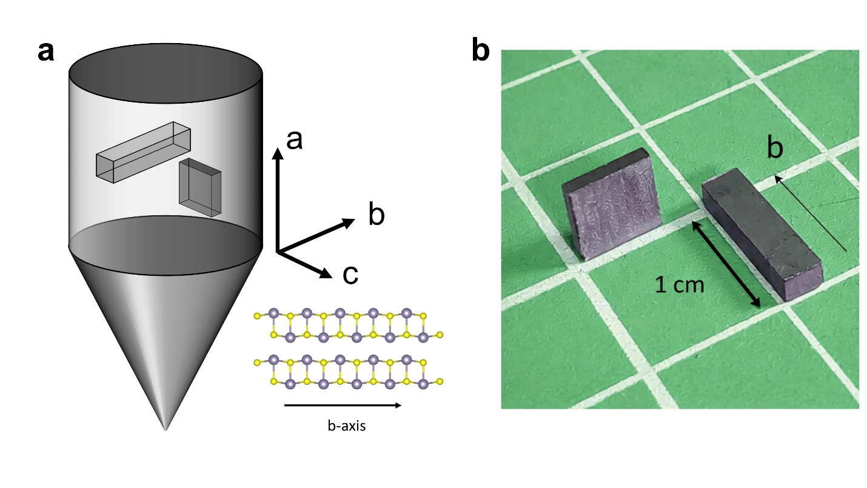
Supplementary Fig. 1 | SnS crystal orientation and sample geometry for anisotropic transport measurements. (a) Schematic illustration of the single-crystal ingot and the cutting orientation along b-axis, with the corresponding layered crystal structure. (b) Sn_{0.96}Na_{0.01}Ag_{0.03}S crystal single-crystal samples cut along b-axis, where the rectangular shape for the electrical transport measurements and the thin square-shape for the thermal transport measurements.
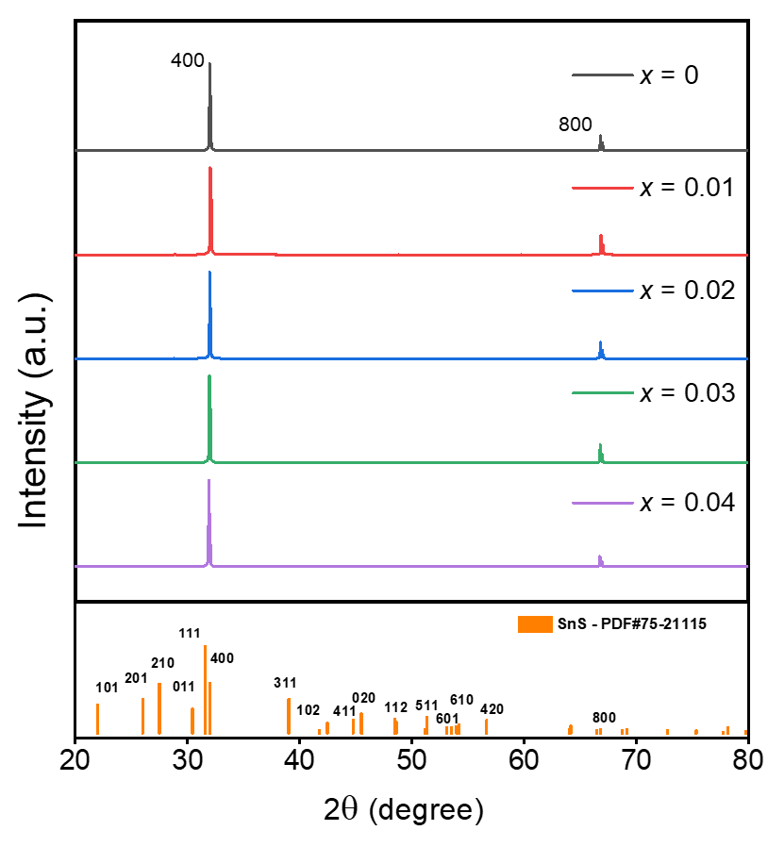
Supplementary Fig. 2 | X-ray diffraction (XRD) patterns of Sn_{0.99-x}Na_{0.01}Ag_{x}S single crystals (x = 0–0.04) were measured using a Bruker D2 instrument. The diffraction peaks correspond well with the orthorhombic SnS reference pattern (PDF#75-21115), confirming the phase purity of all samples. The sharp (400) and (800) reflections indicate the high crystallinity and preferred orientation along the b-axis direction.

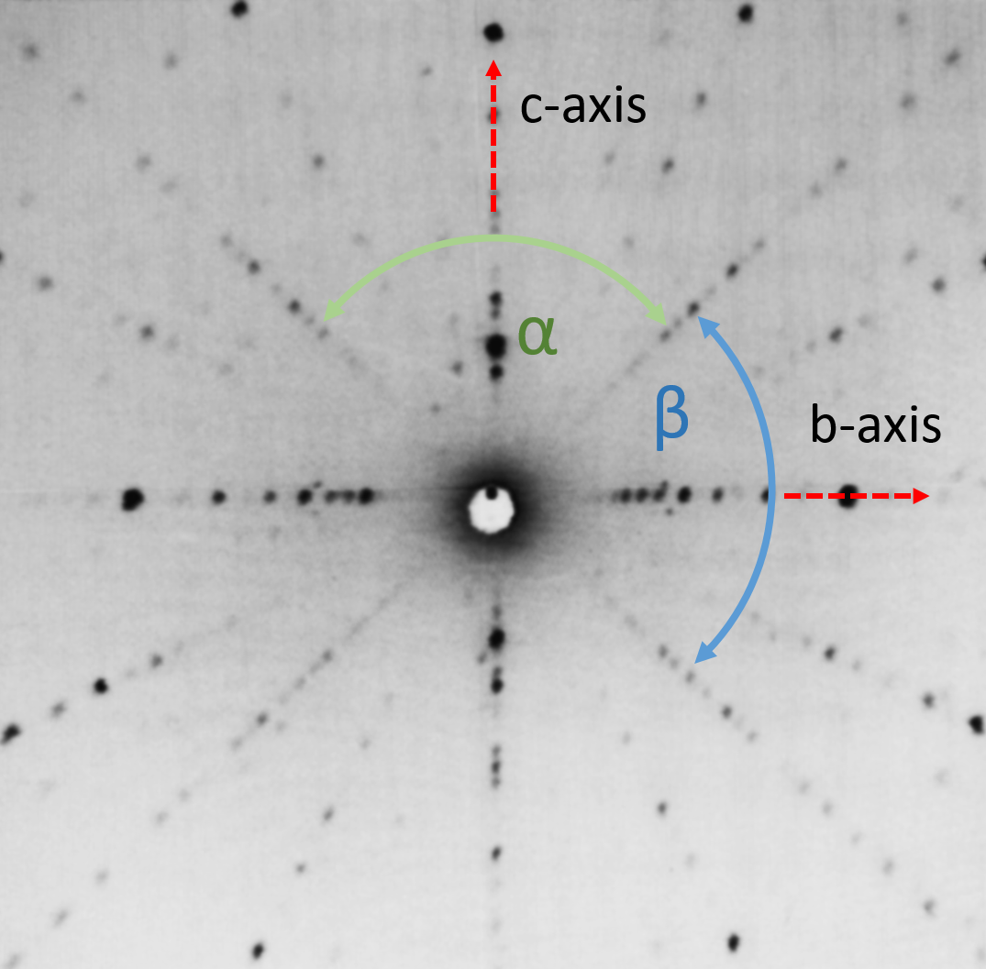
Supplementary Fig. 3 | Laue diffraction pattern at a-plane confirming the single crystal diffraction and orientation.

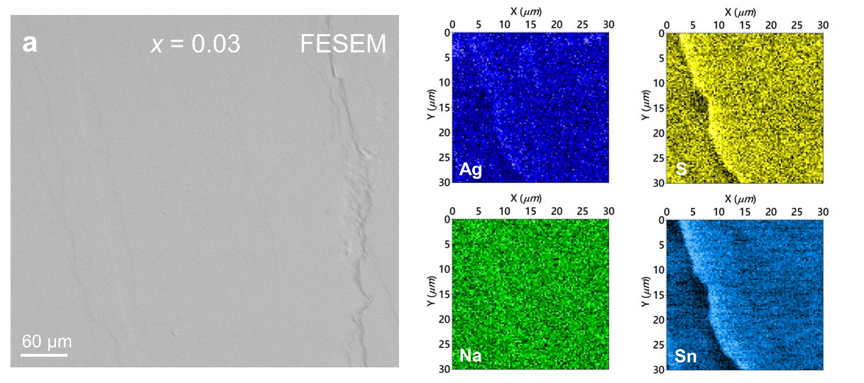
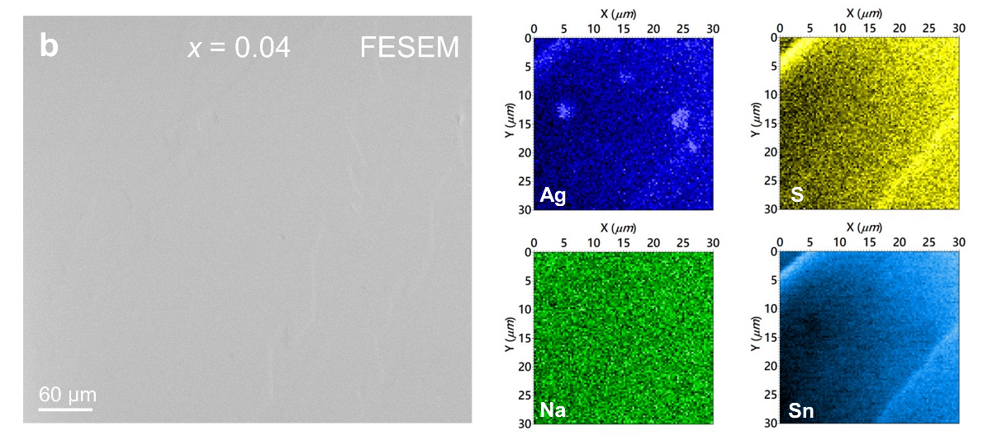
Supplementary Fig. 4 | Field-emission scanning electron microscopy (FESEM) images and X-ray fluorescence (XRF) elemental mapping of S, Sn, Na, and Ag. (a) Elemental distribution for the x = 0.03 sample. (b) Elemental distribution for the x = 0.04 sample. A significant difference is clearly observed in the Ag distribution.
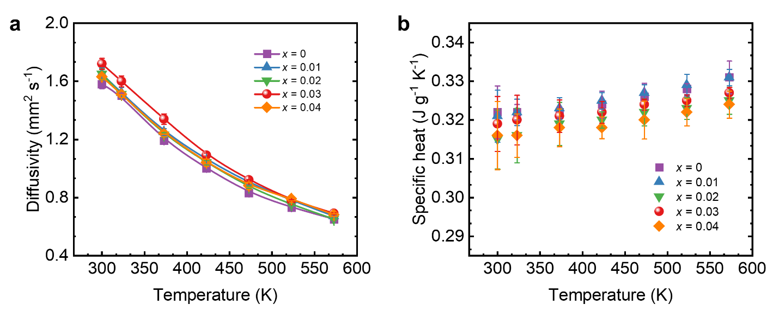
Supplementary Fig. 5 | LFA 457 thermal transport measurement of Sn_{0.99-x}Na_{0.01}Ag_{x}S single crystals (x = 0–0.04). (a) Thermal diffusivity and (b) specific heat.

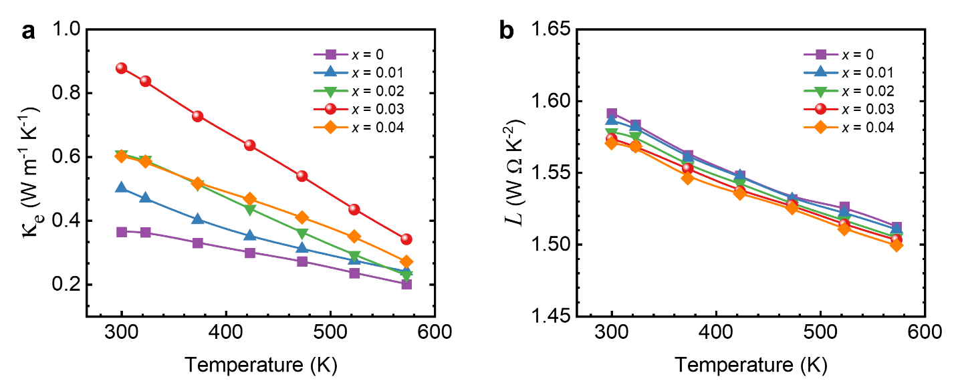
Supplementary Fig. S6 | Single parabolic band (SPB) model calculation for estimating lattice thermal conductivity of Sn_{0.99-x}Na_{0.01}Ag_{x}S single crystals (x = 0–0.04). (a) Lorenz number (L) and (b) electronic thermal.
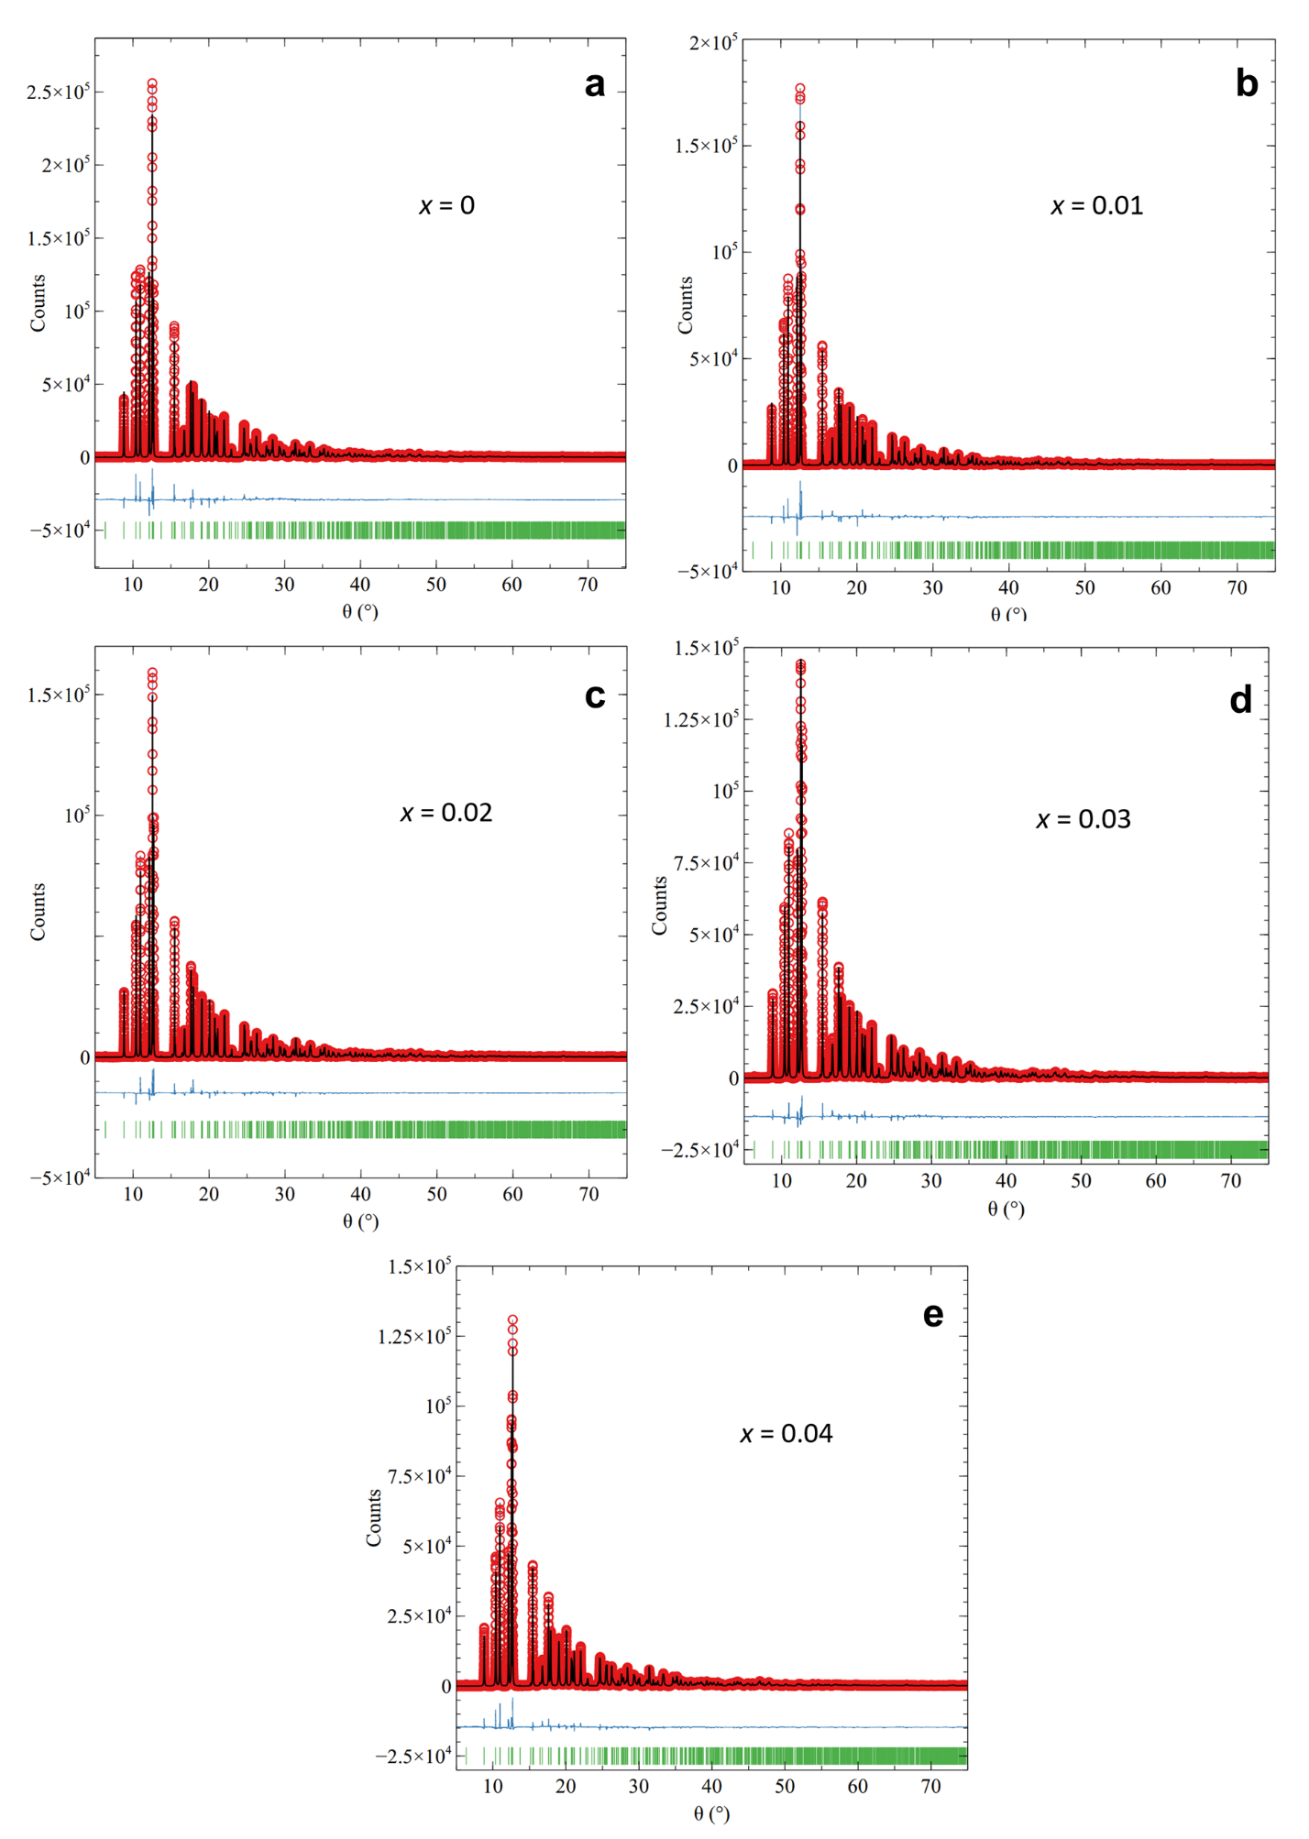
Supplementary Fig. 7 | High-resolution synchrotron radiation (SR) powder X-ray diffraction (XRD) patterns and Rietveld refinement for Sn_{0.99-x}Na_{0.01}Ag_{x}S powder. (a) x = 0, (b) x = 0.01, (c) x = 0.02, (d) x = 0.03, and (e) x = 0.04. The observed (red), calculated (black), and difference (blue) profiles demonstrate good agreement.

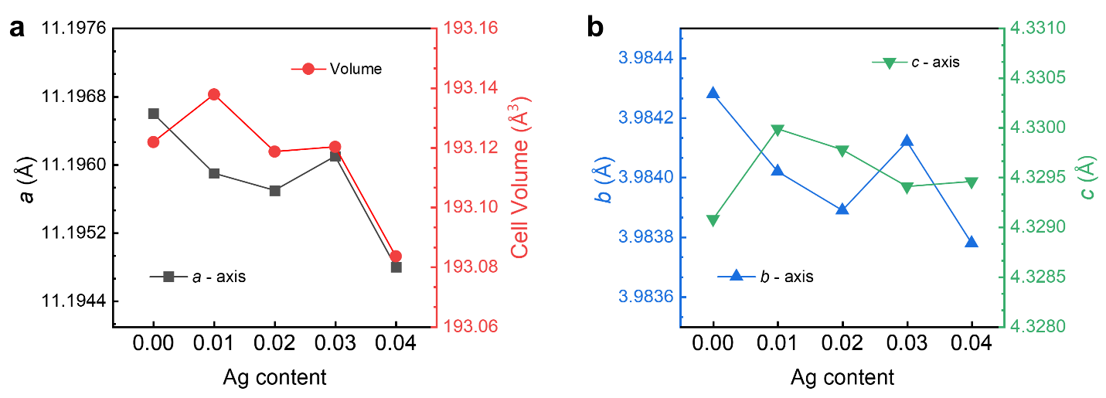
Supplementary Fig. 8 | The lattice parameters obtained from Le Bail refinement. (a) (a-axis) and unit cell volume with increasing Ag content. (b) b-axis and c-axis with increasing Ag content.

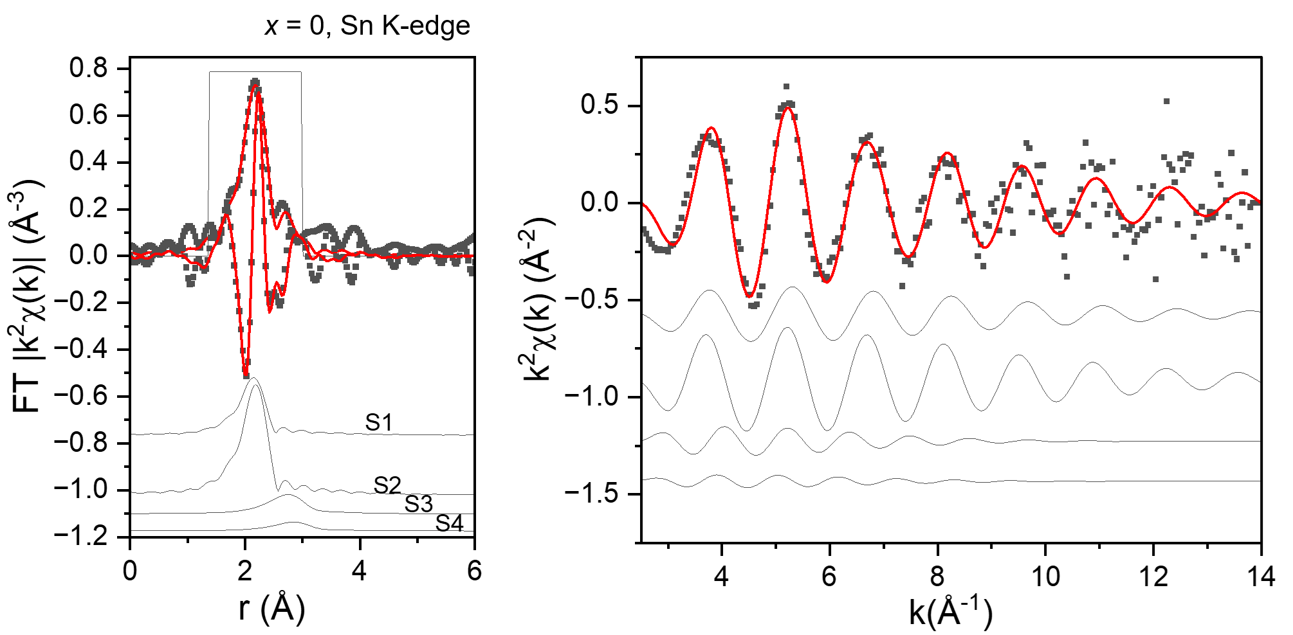
Supplementary Fig. 9 | Sn K-edge EXAFS analysis of Sn_{0.99-x}Na_{0.01}Ag_{x}S (x = 0). Left: Fourier-transformed k²-weighted EXAFS spectra in R-space (symbols) and the corresponding best fit (red line). Individual scattering paths (S1–S4) are shown offset for clarity. Right: k-space EXAFS oscillations (k²χ(k)) and their fitting results. The fitting confirms the local coordination environment of Sn and supports the presence of Sn–S bonding.

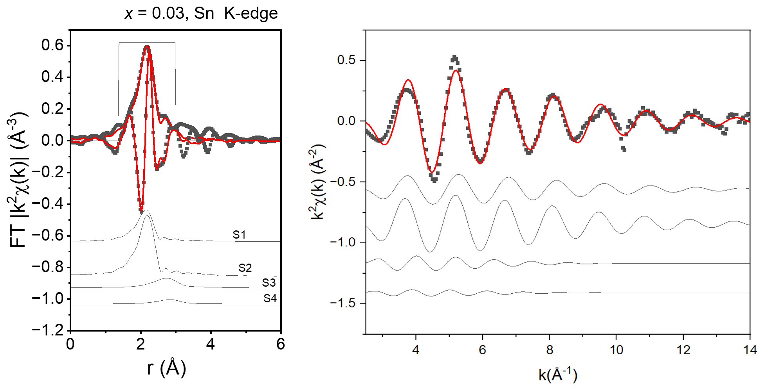
Supplementary Fig. 10 | Sn K-edge EXAFS analysis of Sn_{0.99-x}Na_{0.01}Ag_{x}S (x = 0.03). Left: Fourier-transformed k²-weighted EXAFS spectra in R-space (symbols) and the corresponding best fit (red line). Right: k-space EXAFS oscillations (k²χ(k)) and their fitting results.

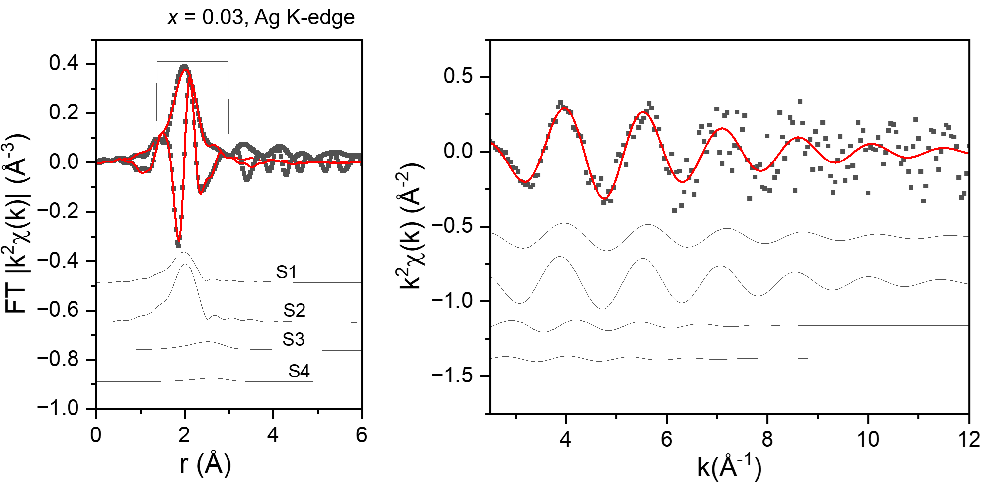
Supplementary Fig. 11 | Ag K-edge EXAFS analysis of Sn_{0.99-x}Na_{0.01}Ag_{x}S with x = 0.03. Left: Fourier-transformed k²-weighted EXAFS spectra in R-space (symbols) and the corresponding best fit (red line). Individual scattering paths (S1–S4) are shown offset for clarity. Right: k-space EXAFS oscillations (k²χ(k)) and their fitting results. The fitting confirms the local coordination environment of Ag and supports the presence of Ag–S bonding.

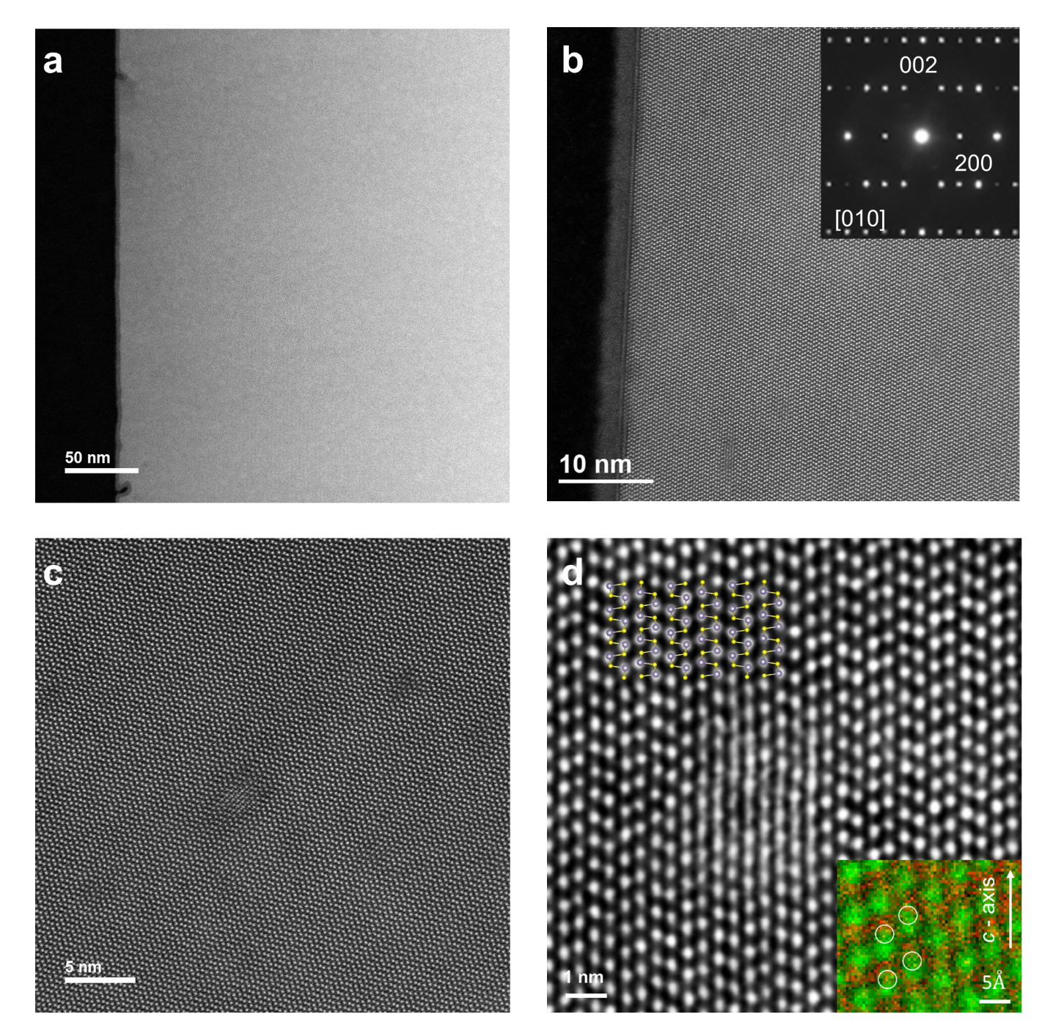
Supplementary Fig. 12 | Sn_{0.96}Na_{0.01}Ag_{0.03}S single crystals morphology. (a) Low-magnification HAADF-STEM image showing a cross-sectional view of the sample prepared by focused ion beam. (b) High-resolution HAADF-STEM image with an inset selected-area electron diffraction (SAED) pattern acquired along the [010] zone axis, confirming the orthorhombic SnS structure with indexed diffraction spots. (c) High-resolution HAADF-STEM image revealing local structural distortion. (d) Further magnified view of the distorted region, with an inset showing EELS elemental mapping of Sn (green) and S (red) overlaid with the structural model of SnS. The EELS mapping confirms the displacement of Sn atoms at the distorted sites.

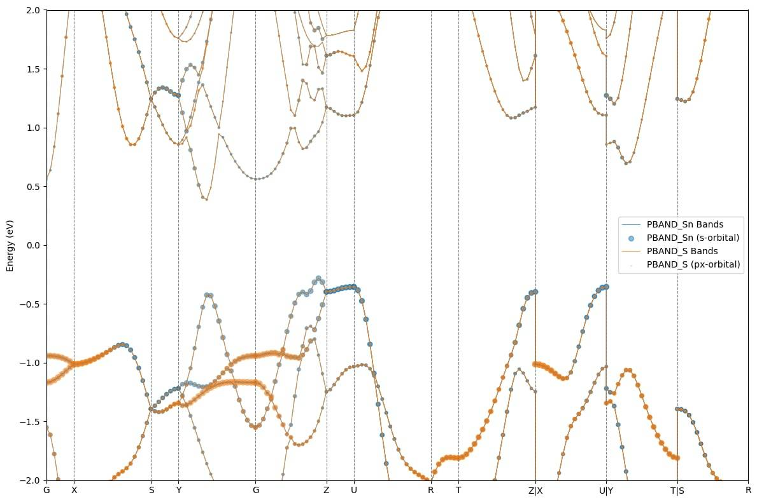
Supplementary Fig. 13 | The calculated band structures for Na-doped SnS (x = 0). The crystal information obtained from the Rietveld refinement was used for the calculation parameters.

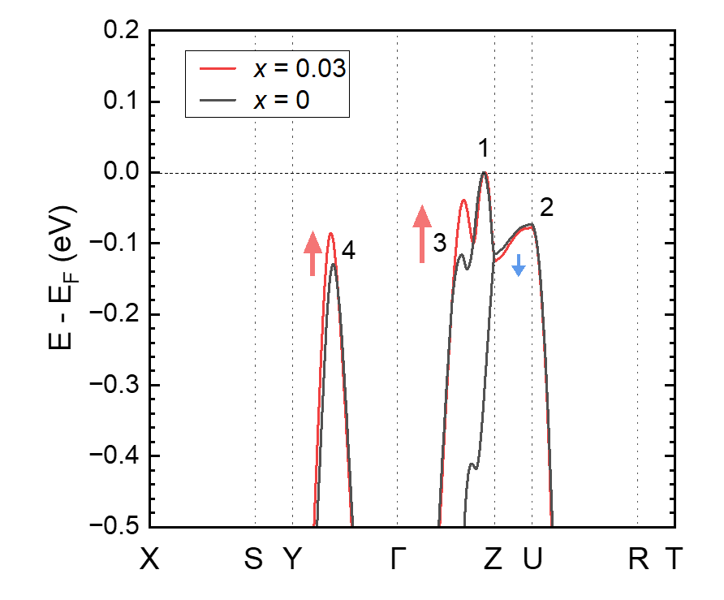
Supplementary Fig. 14 | Valence band structure of Na-doped SnS (x = 0), compared with Sn_{0.96}Na_{0.01}Ag_{0.03}S (x = 0.03), calculated by DFT using the crystal structure information from Rietveld refinement. The red arrow shows the convergence phenomena (VB3 and VB4), whereas the divergence is presented with the blue arrow (VB2).

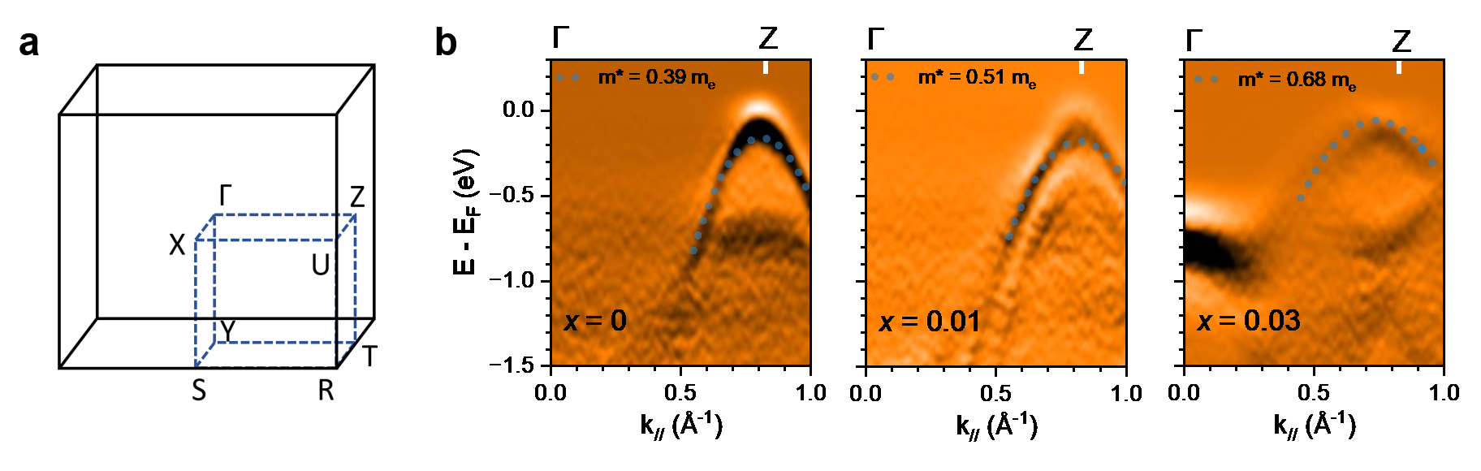
Supplementary Fig. 15 | ARPES band spectra of Sn_{0.99-x}Na_{0.01}Ag_{x}S single crystal. (a) The first Brillouin zone (Bz) of the orthorhombic lattice with high symmetry points. (b) The second derivative of ARPES band structure for Sn_{0.99-x}Na_{0.01}Ag_{x}S with selected Ag content (x = 0, 0.01, and 0.03). The overlay dotted parabolic curve represents the energy dispersion E(k) fitted to the experimental curvature of VB for effective mass (m*/m_{e}) calculation by using equation (1) in the main text.
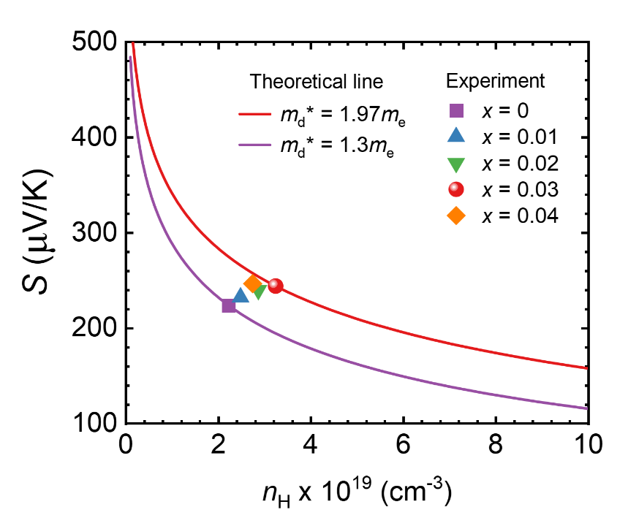
Supplementary Fig. 16 | Pisarenko plot of n_{H} vs S, compared with the theoretical plot from the single parabolic band (SPB) model. Samples with higher Ag content shift toward a higher DOS effective mass, reflecting the band flattening introduced by Ag.

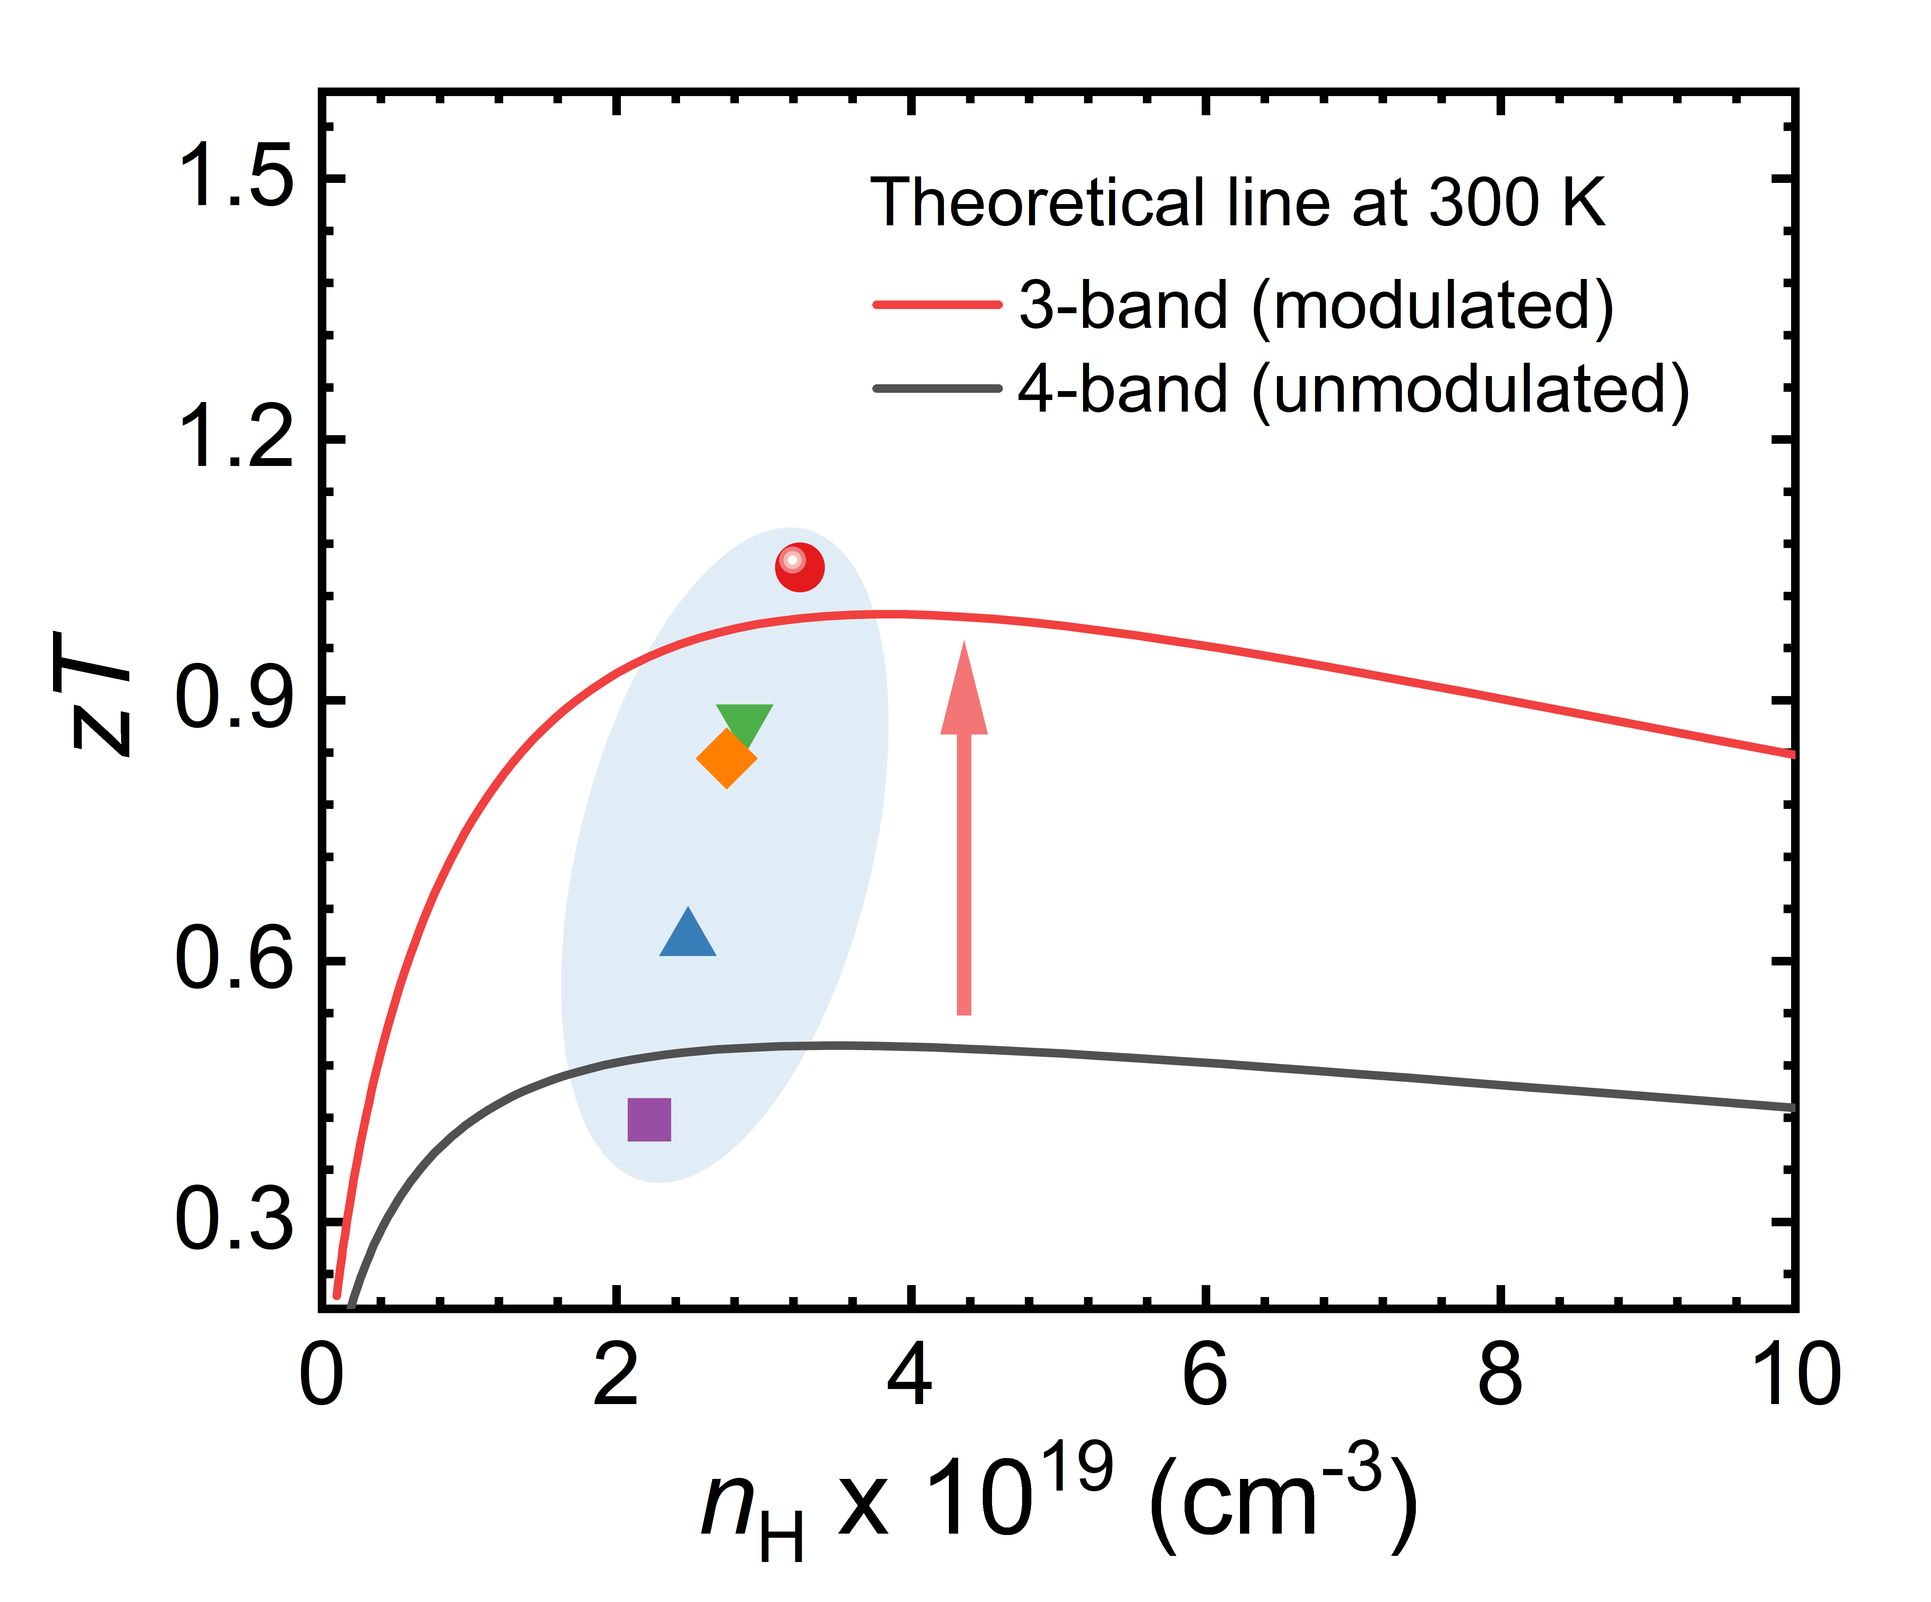
Supplementary Fig. 17 | The relation of n_{H} and zT at 300K, compared with theoretical zT values calculated for unmodulated 4-band and modulated 3-band structures.

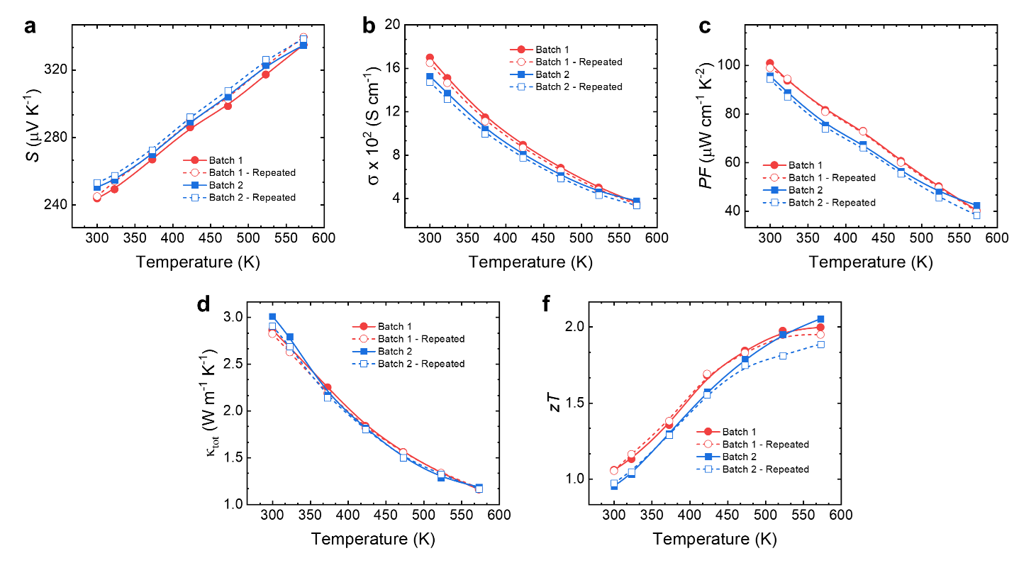
Supplementary Fig. 18 | Performance repeatability and reproducibility of Sn_{0.96}Na_{0.01}Ag_{0.03}S. (a) electrical conductivity. (b) Seebeck coefficient. (c) Power factor. (d) Total thermal conductivity.
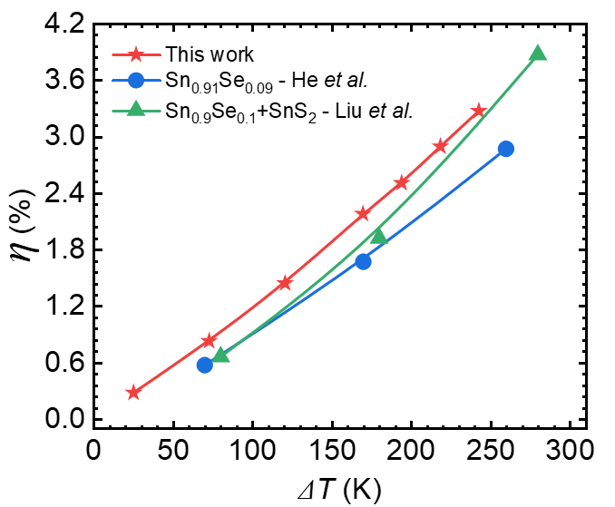
Supplementary Fig. 19 | Benchmark of thermoelectric conversion efficiency as a function of temperature gradient, compared with previously reported SnS-based thermoelectric devices^{6,16}.
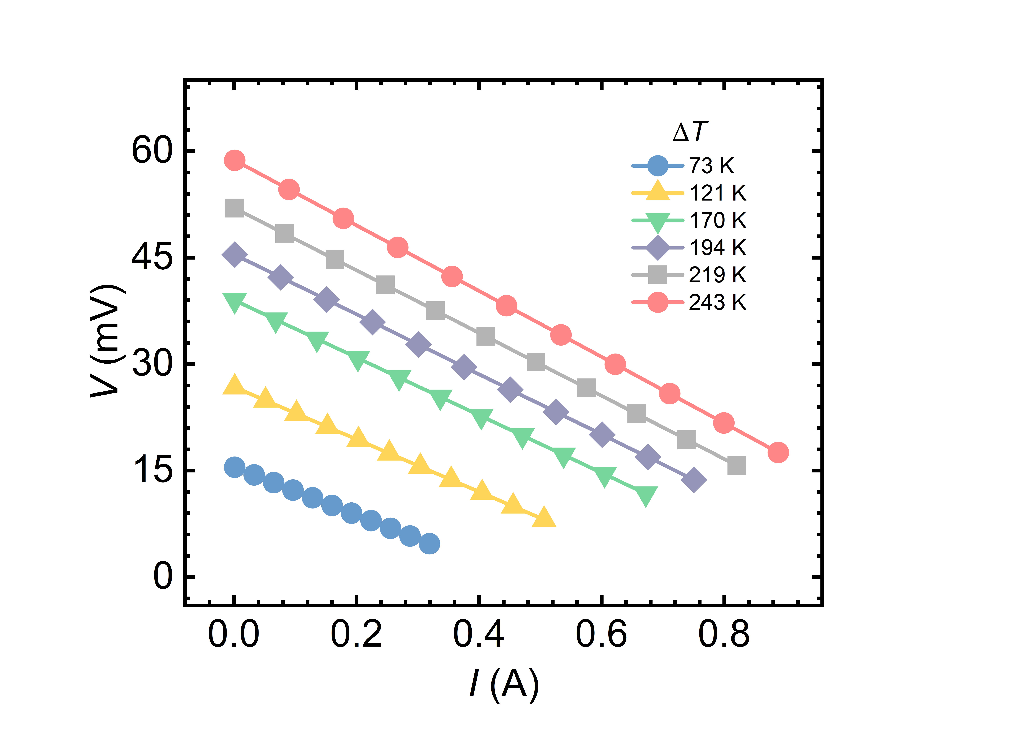
Supplementary Fig. 20 | V-I of the for different temperature gradients (ΔT) from the device measurements of fabricated single-leg module using miniPEM system.

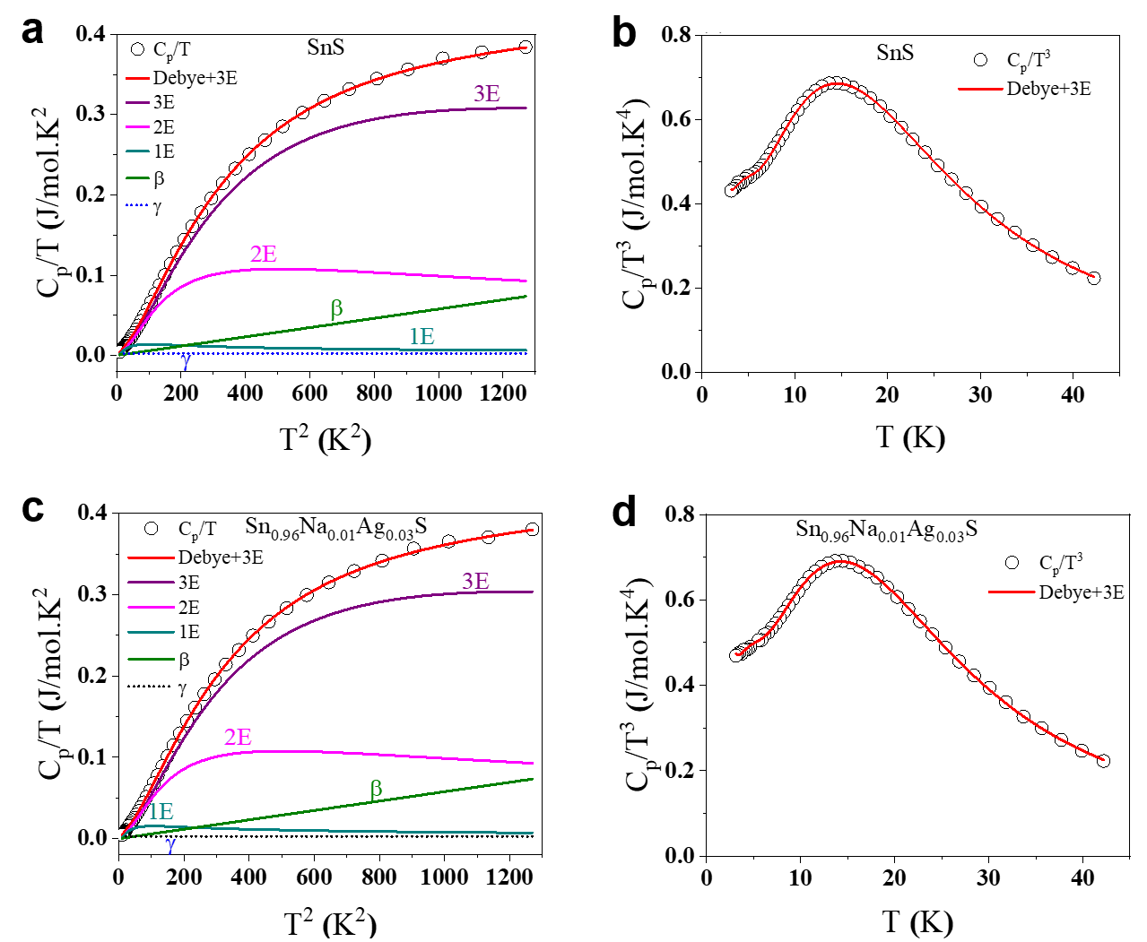
Supplementary Fig. 21 | Temperature dependence of the heat capacity of pristine and doped SnS single crystals. (a)&(c) C_{p}/T vs T² showing the low‑temperature fit using the Debye + 3 Einstein model. The intercept corresponds to the electronic Sommerfeld coefficient (γ), while the slope reflects the Debye contribution (β). The separate contributions from one, two, and three Einstein terms are shown to highlight the necessity of multiple optical modes. (b)&(d) C_{p}/T³ vs T representation, emphasizing deviations from the pure Debye law. The boson‑like excess density of states is evident as a peak, consistent with localized vibrational modes in the layered SnS lattice.

Supplementary Table 1 | The experimental density obtained by the conventional Archimedes method.
Sample | Density (g cm⁻³)
x = 0 | 5.15
x = 0.01 | 5.14
x = 0.02 | 5.17
x = 0.03 | 5.16
x = 0.04 | 5.19

Supplementary Table 2 | Lattice parameters (a, b, c) and unit cell volume of Ag-doped SnS single crystals obtained from Rietveld refinement.
Sample | Lattice parameters (Å) |  |  | Volume (Å³)
Sample | a | b | c | Volume (Å³)
x = 0 | 11.1966 | 3.98428 | 4.32908 | 193.1219
x = 0.01 | 11.1959 | 3.98402 | 4.32999 | 193.1379
x = 0.02 | 11.1957 | 3.98389 | 4.32978 | 193.1187
x = 0.03 | 11.1961 | 3.98412 | 4.32941 | 193.1203
x = 0.04 | 11.1948 | 3.98378 | 4.32946 | 193.0836

Supplementary Table 3 | Atomic positions of Sn and S in Ag-doped SnS single crystals obtained from Rietveld refinement, used for the symmetry clarification.
Sample | Sn atomic position |  |  | S atomic position
  θ (º)
Sample | X | Y | Z | X | Y | Z
x = 0 | 0.12031 | 0.25 | 0.11998 | 0.3528 | 0.25 | 0.015 | 9.9033
x = 0.01 | 0.11951 | 0.25 | 0.11911 | 0.35218 | 0.25 | 0.0163 | 9.6977
x = 0.02 | 0.1193 | 0.25 | 0.11783 | 0.35293 | 0.25 | 0.0209 | 9.1155
x = 0.03 | 0.11902 | 0.25 | 0.11784 | 0.3535 | 0.25 | 0.0232 | 8.8708
x = 0.04 | 0.11916 | 0.25 | 0.11637 | 0.353 | 0.25 | 0.0245 | 8.6394

Supplementary Table 4 | Fitted structural parameters from EXAFS analysis of the first coordination shells around the absorbing atom. The table lists the scattering path, coordination number (N), effective half-path length (R_{eff}), fitted bond distance (R), and Debye–Waller factor (σ²).
Sample, edge | Shell | Path | N | R_{eff} (Å) | R (Å) | σ² (Å²)
x = 0,  Sn K-edge | 1 | S1 | 1 | 2.627 | 2.610 | 4.66×10⁻³
x = 0,  Sn K-edge | 2 | S2 | 2 | 2.665 | 2.648 | 4.66×10⁻³
x = 0,  Sn K-edge | 3 | S3 | 2 | 3.291 | 3.269 | 1.76×10⁻²
x = 0,  Sn K-edge | 4 | S4 | 1 | 3.388 | 3.365 | 1.76×10⁻²
x = 0.03,  Sn K-edge | 1 | S1 | 1 | 2.627 | 2.618 | 6.0×10⁻³
x = 0.03,  Sn K-edge | 2 | S2 | 2 | 2.665 | 2.656 | 6.0×10⁻³
x = 0.03,  Sn K-edge | 3 | S3 | 2 | 3.291 | 3.279 | 2.14×10⁻²
x = 0.03,  Sn K-edge | 4 | S4 | 1 | 3.388 | 3.376 | 2.14×10⁻²
x = 0.03,  Ag K-edge | 1 | S1 | 1 | 2.627 | 2.518 | 8.94×10⁻³
x = 0.03,  Ag K-edge | 2 | S2 | 2 | 2.665 | 2.555 | 8.94×10⁻³
x = 0.03,  Ag K-edge | 3 | S3 | 2 | 3.291 | 3.154 | 2.84×10⁻²
x = 0.03,  Ag K-edge | 4 | S4 | 1 | 3.388 | 3.247 | 2.84×10⁻²

Supplementary Table 5 | Obtained energy offset (ΔE) relative to the first valence band maximum (VBM 1) and band gap (Eg) for the calculated band structure of pristine and Na, Ag co-doped SnS super cell through DFT calculation.
Composition | ΔE₁₋₃ (eV) | ΔE₁₋₄ (eV) | ΔE₁₋₂ (eV)
Pristine SnS | 0.111 | 0.142 | 0.071
Na 1 Ag 1 Sn 70 S 72 | 0.107 | 0.064 | -
Na 1 Ag 2 Sn 69 S 72 | 0.084 | 0.06 | -

Supplementary Table 6 | Obtained tensor effective mass (m_{x}, m_{y}, m_{z}) of SnS band structure from DFT calculation along with conductive effective mass (m_{l}* = 3/(1/m_{x} + 1/m_{y} + 1/m_{z}), band effective mass (m_{b}* = (m_{x}*m_{y}*m_{z})^{1/3}), and DOS effective mass (m_{d} =N_{v}^{2/3} m_{b}*).
Bands | m_{x}/m_{e} | m_{y}/m_{e} | m_{z}/m_{e} | m_{l}*/m_{e} | m_{b}*/m_{e} | m_{d}*/m_{e}
VB 1 (Γ-Z) | 2.532 | 0.252 | 0.172 | 0.295 | 0.479 | 0.76
VB 2 (Z-U) | 4.842 | 0.405 | 0.381 | 0.566 | 0.907 | 1.44
VB 3 (Γ-Z) | 1.201 | 0.609 | 0.178 | 0.371 | 0.507 | 0.805
VB 4 (Γ-Y) | 0.28 | 0.126 | 0.176 | 0.175 | 0.184 | 0.292

Supplementary Table 7 | The deformation potential ($Ξ$) for each valence band determined as ∂E/(∂(δx/x₀)), where x₀ is the equilibrium lattice constant along the b-axis. The calculation uses the series of lattice constants of 0.99x₀, 0.995x₀, 1.00x₀, 1.005x₀, 1.01x₀, and 1.015x₀.
Bands | $Ξ$ (eV)
VB 1 (Γ-Z) | 9.5
VB 2 (Z-U) | 9.8
VB 3 (Γ-Z) | 8.5
VB 4 (Γ-Y) | 3.9
Supplementary Table 8 | Fitted parameters to the specific heat capacity data (C_{p}/T versus T² data) using the Debye-Einstein model for pristine and doped SnS
Parameters | SnS | Sn_{0.96}Na_{0.01}Ag_{0.03}S
γ (Jmol⁻¹K⁻²) | 0.00234± 8.95E-5 | 0.00277± 9.58462E-5
β (Jmol⁻¹K⁻⁴) | 5.77E-5± 4.16E-6 | 5.773E-5± 4.69E-6
A1 (Jmol⁻¹K⁻¹) | 0.229± 0.012 | 0.264± 0.016
A2 (Jmol⁻¹K⁻¹) | 3.90± 0.284 | 3.853± 0.352
A3 (Jmol⁻¹K⁻¹) | 14.693± 0.293 | 14.348± 0.319
θE₁ (K) | 25.693± 0.392 | 26.390± 0.434
θE₂ (K) | 60.273± 0.962 | 60.368± 1.232
θE₃ (K) | 102.822±1.526 | 102.467±1.844
θ_{D} (K) | 275.63 | 276.73
Reduced Chi-Sqr | 5.015E-12 | 6.186E-12
Adj. R-Square | 99972 | 99967

Supplementary References
- Gopal, E. S. R. Specific Heats at Low Temperatures. (Plenum, 1966).
- Bhandari, C. M. & Rowe, D. M. Modern Thermoelectrics (Holt Saunders, London, 1983).
- Liu, X., Zhu, T., Wang, H., Hu, L., Xie, H., Jiang, G., Snyder, G. J. & Zhao, X. Low electron scattering potentials in high performance Mg₂Si₀.₄₅Sn₀.₅₅-based thermoelectric solid solutions with band convergence. Adv. Energy Mater. 3, 1238–1244 (2013).
- Callaway, J. & Von Baeyer, H. C. Effect of point imperfections on lattice thermal conductivity. Phys. Rev. 120, 1149–1154 (1960).
- Asfandiyar, Xue, W., Mao, J., Liu, K., Zhang, Q. & Li, J. Thermoelectric performance enhancement in SnS polycrystals owing to hole doping combined with textured microstructures. ACS Appl. Mater. Interfaces 16, 38073–38082 (2024).
- He, W., Wang, D., Wu, H., Xiao, Y., Zhang, Y., He, D., Feng, Y., Hao, Y.-J., Dong, J.-F., Chetty, R., Hao, L., Chen, D., Qin, J., Yang, Q., Li, X., Song, J.-M., Zhu, Y., Xu, W., Niu, C., Li, X., Wang, G., Liu, C., Ohta, M., Pennycook, S. J., He, J., Li, J.-F. & Zhao, L.-D. High thermoelectric performance in low-cost SnS_{0.91}Se_{0.09} crystals. Science 365, 1418–1424 (2019).
- Hohenberg, P. & Kohn, W. Inhomogeneous electron gas. Phys. Rev. 136, B864–B871 (1964).
- Kohn, W. & Sham, L. J. Self-consistent equations including exchange and correlation effects. Phys. Rev. 140, A1133–A1138 (1965).
- Kresse, G. & Hafner, J. Ab initio molecular dynamics for liquid metals. Phys. Rev. B 47, 558–561 (1993).
- Kresse, G. & Hafner, J. Ab initio molecular-dynamics simulation of the liquid-metal–amorphous-semiconductor transition in germanium. Phys. Rev. B 49, 14251–14269 (1994).
- Perdew, J. P., Burke, K. & Ernzerhof, M. Generalized gradient approximation made simple. Phys. Rev. Lett. 77, 3865–3868 (1996).
- Monkhorst, H. J. & Pack, J. D. Special points for Brillouin-zone integrations. Phys. Rev. B 13, 5188–5192 (1976).
- Dippel, O., Schmelcher, P. & Cederbaum, L. S. Charged anisotropic harmonic oscillator and the hydrogen atom in crossed fields. Phys. Rev. A 49, 4415–4429 (1994).
- Popescu, V. & Zunger, A. Effective band structure of random alloys. Phys. Rev. Lett. 104, 236403 (2010).
- Zhu, B., Kavanagh, S. R. & Scanlon, D. Easyunfold: A Python package for unfolding electronic band structures. J. Open Source Softw. 9, 5974 (2024).
- Liu, S., Bai, S., Wen, Y., Lou, J., Jiang, Y., Zhu, Y., Liu, D., Li, Y., Shi, H., Liu, S., Wang, L., Zheng, J., Zhao, Z., Qin, Y., Liu, Z., Gao, X., Qin, B., Chang, C., Chang, C. & Zhao, L.-D. Quadruple-band synglisis enables high thermoelectric efficiency in earth-abundant tin sulfide crystals. Science 387, 202–208 (2025).

