Supplementary Information (SI)
Biosynthesis of 3D/2D CeO₂/MoS₂ nanocomposites with enhanced photocatalytic activity to degrade organic dye in wastewater and statistical optimization of reaction parameters
Yogesh Sharma^{a,#}, Mohammad Ahmed Khan^{a,#}, Thangapandi Chellapandi^{b}, Magdum Tejas Sukumarª, Gunabalan Madhumitha^{b}, Md. Maksudur Rahman Khan^{c}, Mohammed Danish^{d}, Sagadevan Veluª, Selvaraj Mohana Roopan^{b,*}
ªSchool of Chemical Engineering, Vellore Institute of Technology, Vellore 632014, Tamilnadu, India
^{b}Chemistry of Heterocycles & Natural Research Laboratory, Department of Chemistry, School of Advanced Sciences, Vellore Institute of Technology, Vellore 632014, Tamilnadu, India
^{c}Department of Chemical Engineering, College of Engineering, Universiti Malaysia Pahang, Gambang 26300, Pahang, Malaysia.
^{d}School of Industrial Technology, Universi Sains Malaysia, Penang 11800, Malaysia
*Corresponding author E-mail address: mohanaroopan.s@vit.ac.in (S.M. Roopan)
#Equal contribution to this work

S1. Experimental Section
S1.1. Synthesis of 2D MoS₂ sheet
In this study, molybdenum disulphide nanosheets was prepared using analytical grade chemicals. The solution has been prepared by mixing 12 mL (10%) hydrazine hydrate, 5 mL (0.1M) tartaric acid, 10 mL (0.1M) of ammonium molybdate, and 15 mL ammonia in a beaker. Then 20 mL (0.1M) thiourea solution was added to the prepared solution. In order to make the volume of the reaction mixture 150 mL, distilled water was added. Then, the reaction vessel was heated indirectly using an oil bath at 90°C for 90 min. After heating, the solution was transferred to an autoclave and kept in a hot air oven at 120°C for 18 h. This process was known as hydrothermal. The solution was then taken out and centrifugation was done at 6000 rpm. The colloidal suspension was rinsed several times using organic solvent and water. Lastly, the obtained product was set to dry for 24 h using a vacuum oven at 60°C. The dried product thus obtained was exfoliated 2D MoS₂, which was black in colour.

S2. Results and discussion
S2.1. UV-Visible Diffuse Reflectance Spectra
Optical absorption properties of the synthesized MoS₂, CeO₂ and CeO₂/MoS₂ nanocomposites samples were analysed by observing UV-spectra. Fig. S1 displays the UV−Vis spectrum of MoS₂, CeO₂ and CeO₂/MoS₂. Pristine CeO₂ has a typical absorption peak of around 430 nm. Observationally, it is noted that weight of MoS₂ is increased (in nanocomposite), the absorption peak intensity of composite samples also increased significantly. The reason for this could be the blackish colour of original MoS₂ and the change in colour of the composite. As the weight percentage of MoS₂ in the composite increased, a change appeared in the composite’s absorbance intensity at the edge that corresponded with the colour change from greenish-yellow to light brown [1]. The absorption of light of CeO₂, in visible spectrum (440-800 nm), significantly rises after the addition of black MoS₂catalyst and therefore, the CeO₂/MoS₂ nanocomposites can absorb a higher number of photons for the photocatalytic reactions [2].
Moreover, the bandgap energies for the MoS₂, CeO₂ and CeO₂/MoS₂ nanocomposites were computed by the use of Tauc’s formula (ahv) = A(hv - Eg)^{n/2}, where “h” was the Planck’s constant,“Eg” was the band gap energy, “a” was the absorption coefficient, “v” is the frequency of light and “n” varies with the properties of the transition [3]. Subsequently, the values of Eg are assessed, i.e., 1.81, 2.66, 2.41, 2.50, 2.57 and 2.61 eV for MoS₂, CeO₂, CMS-2, CMS-4, CMS-6 and CMS-8 respectively (Fig. S2).
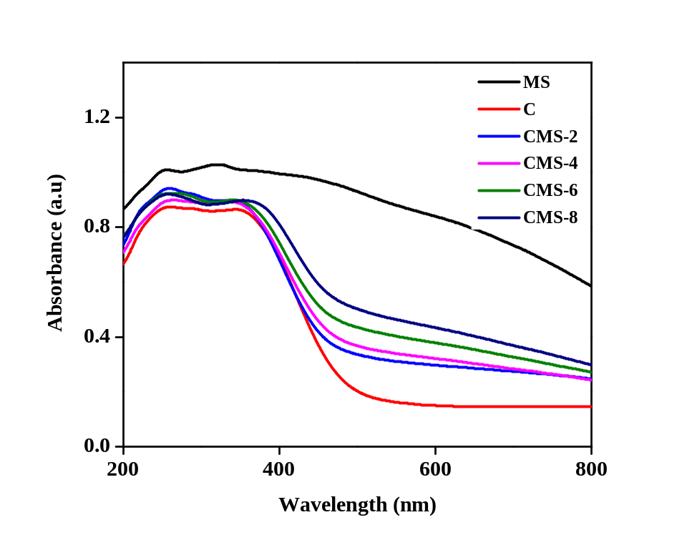
Fig. S1. UV-Vis DRS of MoS₂, CeO₂ and CMS (CeO₂/MoS₂ nanocomposites).

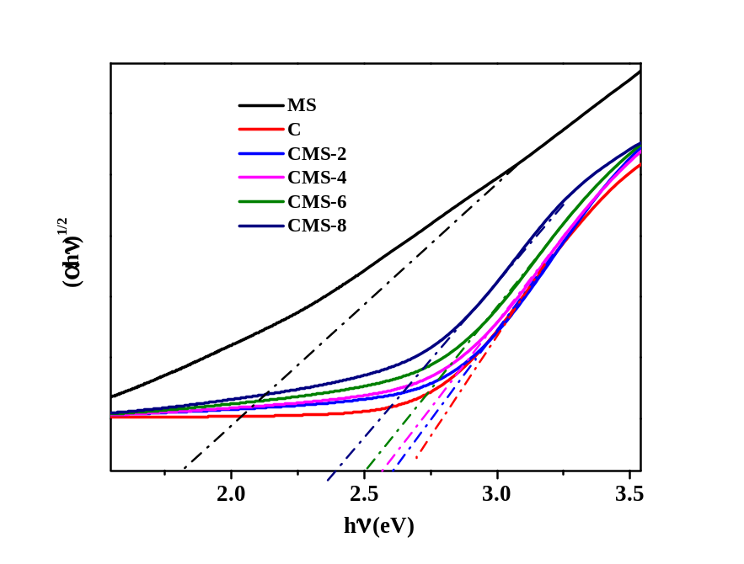
Fig. S2. Tauc’s plot photon energy of MoS₂, CeO₂ and CMS (CeO₂/MoS₂ nanocomposites).

S2.2. EDAX Analysis
The presences of all elements are identified from selected area EDAX studies and the presence MoS₂, CeO₂ and CMS-4 composite elements are shown in Fig. S3a-c respectively. The spectra obtained by the EDAX data shows peaks corresponding to elements making up the composition of the sample being analysed. The analysis disclosed the presence of Mo, S, Ce and O in the formed nanocomposite. No more other peak is present, and this shows that the green synthesized CeO₂ nanoparticles decorated MoS₂ is indeed a pure composite (Fig. S3c).
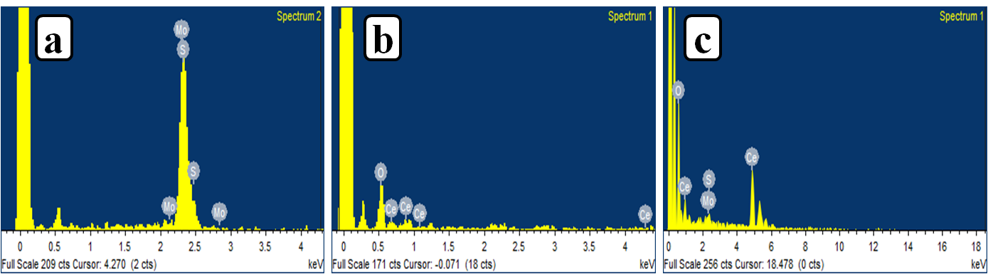
Fig. S3. EDAX Spectrum of a) MoS₂, b) CeO₂ c) CMS-4.

S2.3. Photoluminescence Spectra
The concept of Photoluminescence emission stems from the radiative recombination of photogenerated excitons (such as electron-hole pairs) which was employed to estimate the charge separation and transfer [4]. Fig. S4 depicts that CeO₂ indicates an intense photoluminescence signal with an emission band centred at 470 nm under 360 nm, which attributes to its prompt charge recombination. A solid blue emission peak noted at 470nm was because of the development of extra surface defect energy levels amongst band levels between O 2p and Ce 4f. As the percentage of CeO₂ in the composite decreases, the fall in the steadiness of peak was observed. Effective interfacial transfer of electron between excited MoS₂ and CeO₂ energy level was attributed to the removal of a photoluminescent peak in the CMS-4 photo catalyst. Based on the photoluminescence results, we can say CMS-4 nanocomposite has better charge separation compared with other samples. Due to the this it leaves more redox electrons hole pair, which is the responsible for enhances in degradation behavior.

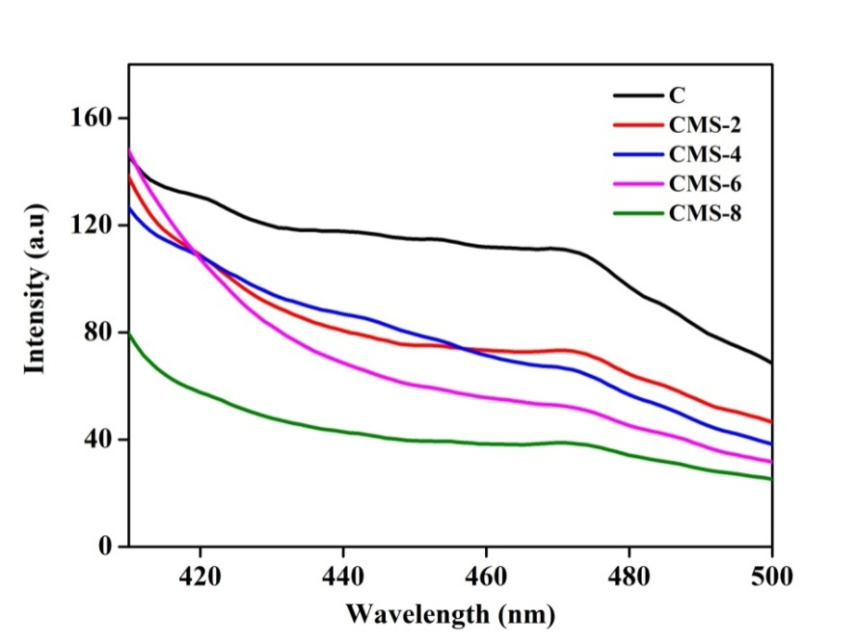
Fig. S4. Photoluminescence spectrum of MoS₂, CeO₂ and CeO₂/MoS₂ nanocomposites.

S2.4. Fourier Transform Infrared Spectroscopy (FT-IR Analysis)
In order to analyze the functional groups present on the surface, an FT-IR study was carried out. The MoS₂, CeO₂ and CeO₂/MoS₂ nanocomposite FT-IR spectrum is shown in Fig. S5. The O-Ce-O bonding character of the nanoparticles CeO₂ was a prominent peak at 841 cm⁻¹. The band at 1290 cm⁻¹ ultimately corresponds to the vibration of oxygen atom in N-O stretching which was present in the CeO₂ nanoparticles. The small bands formed at 710 and 431 cm⁻¹ corresponds to Ce-O straighten mode. According to the MoS₂ range, the band with its 450 cm⁻¹ vibration can be assigned to the Mo–S range. The band at 3413 cm⁻¹ which can be observed in CeO₂ and CeO₂/MoS₂ nanocomposites was mainly attributed to stretching vibrations of O-H bonds. Hence, the FT-IR spectra provide the evidence that CeO₂ nanoparticles were successfully composited with MoS₂ sheets [5].
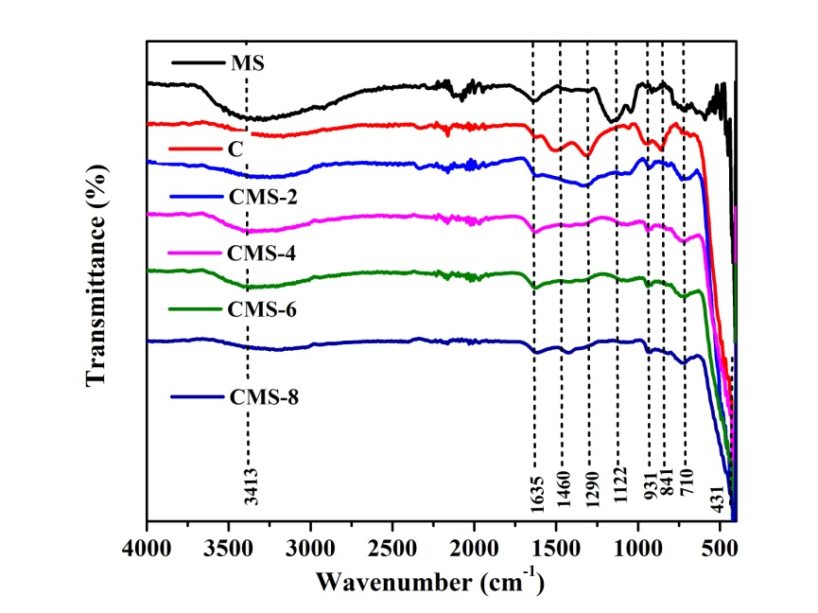
Fig. S5. FT-IR spectrum of MoS₂, CeO₂ and CMS (CeO₂/MoS₂ nanocomposites).

S2.5. Zeta Potential
The high zeta potential symbolizes that the nanocomposites prepared are stable. The zeta potential values for CMS-2, CMS-4, CMS-6 and CMS-8 nanocomposites are -34.7, -66.7, -52.7 and -43.3 mV respectively (illustrated in Fig. S6) and therefore suggests high stability. The nanocomposite of CMS-4 was remarkably stable. The values of zeta potential signify the establishment of a balanced system. Furthermore, negatively charged surfaces of the nanocomposites offer electrostatic repulsive forces and affords greater stability by restraining the nanocomposites from accumulating in the colloidal state [6].
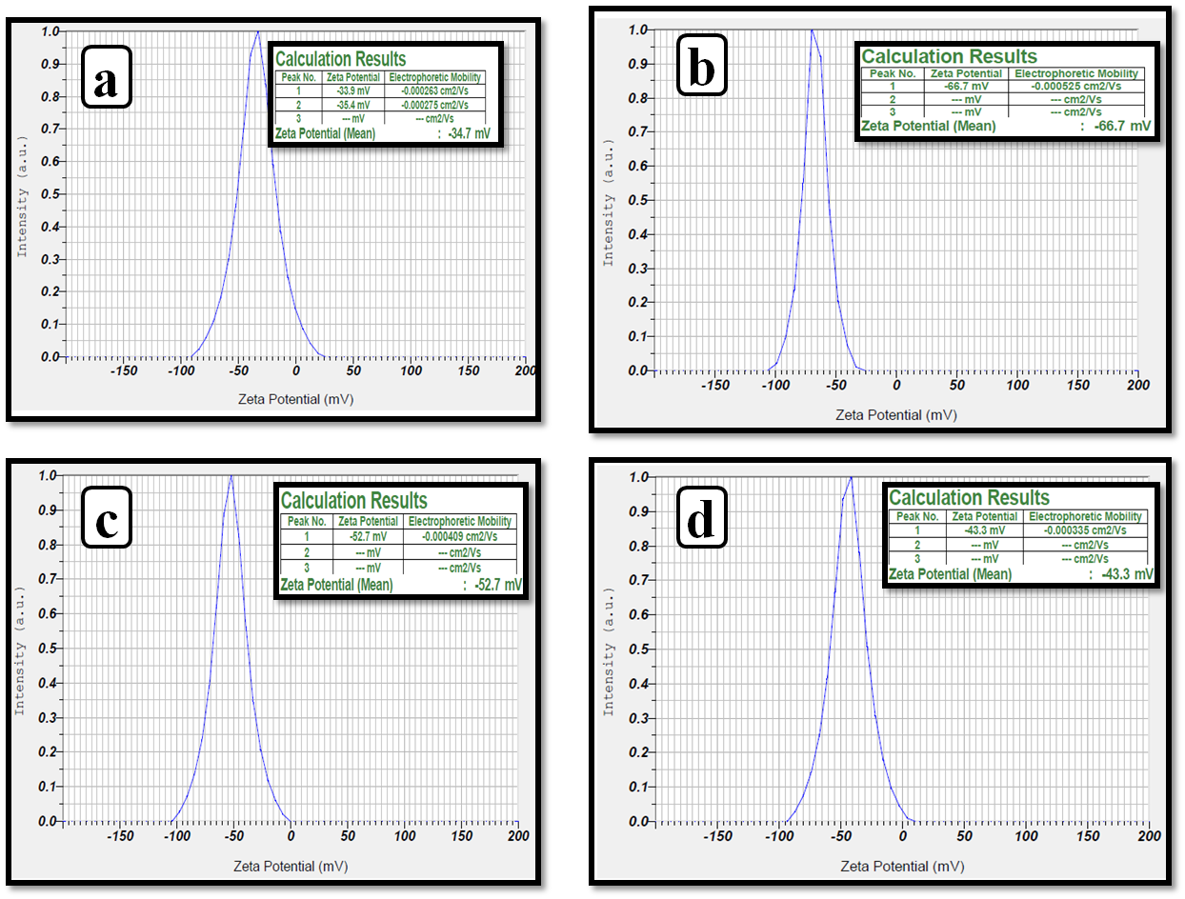
Fig. S6. Zeta potential of a) CMS-2, b) CMS-4, c) CMS-6 and d) CMS-8 nanocomposite.

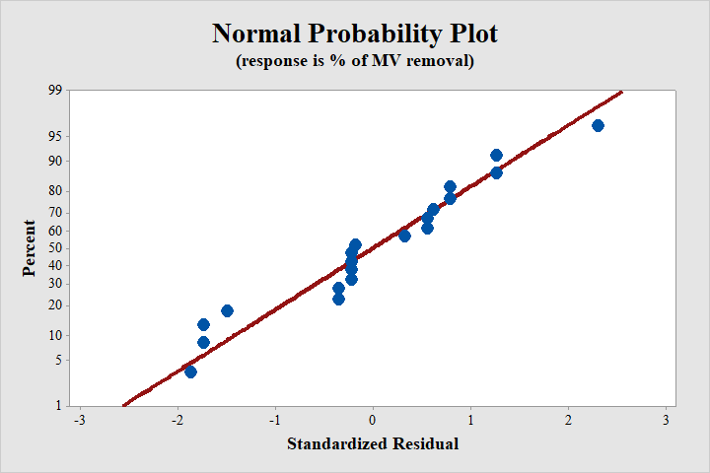
Fig. S7. The experimental data versus the predicted data for MV degradation (in %).

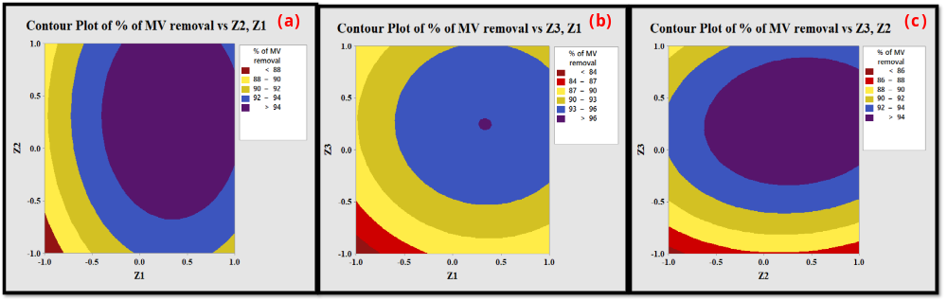
Fig. S8. Contour plot as a function of (a) amount of photocatalyst (Z1) and concentration of MV dye (Z2), (b) amount of photocatalyst (Z1) and time for degradation (Z3), (c) concentration of MV dye (Z2) and time for degradation (Z3)

Table S1. Performance of various photocatalysts for degrading methyl violet
Photocatalyst | Preparation method | Degradation Percentage | Amount of photocatalyst | Vol. and conc. of MV | Time for degradation (min) | Reference
ZnO | Precipitation method | 66.5 | 0.08 g | 40 mL of 7.1 mgL⁻¹ | 60 | [7]
TiO₂/Pt | Incipient wetness method | 78 | 0.02 g | 10 mL of 15 mgL⁻¹ | 20 | [8]
Fe⁰@Guar gum-crosslinked-soya lecithin nanocomposite hydrogel | Ultrasonication method | 81 | 30 mg | 100 mL of 30 mgL⁻¹ | 120 | [9]
TiSiW₁₂O₄₀/TiO₂ | - | 82.4 | 0.3 g | 20 mgL⁻¹ | 180 | [10]
Bi doped ZnO | Precipitation method | 82.5 | 0.08 g | 40 mL | 60 | [7]
Ho₂O₃  (Holmium oxide) | Precipitation method | 82.8 | 120 mg | 3 mg | 90 | [11]
Cation exchange membrane | - | 84-93 | 2.0 g/L | 20 mL of 15 mgL⁻¹ | 120 | [12]
SnO₂-activated carbon fiber hybrid catalyst | Pore-fabrication and self-assembly processes | 87 | 0.05 g | 150 mL | 12 | [13]
Activated charcoal supported bismuth doped ZnO nanocomposite | Precipitation method | 94.5 | 0.08 g | 40 mL of 7.1 mgL⁻¹ | 60 | [7]
TiO₂/Pd | Incipient wetness method | 95 | 0.02 g | 10 mL of 15 mgL⁻¹ | 20 | [8]
Pu-erh tea powder | - | 95 | 0.2 g | 100 mL of 100 mgL⁻¹ | 300 | [14]
Hybrid hydrogel | Suspension and heating–cooling cyclic processes | 95.7 | 0.5 mL | 4.5 mg of 1 mgL⁻¹ | 240 | [15]
Fertilizer plant waste carbon | - | 96 | 1.0 g/L | 100 mL of 20 mgL⁻¹ | 300 | [16]
CeO₂/MoS₂ nanocomposite  (4%) | Biosynthetic microwave assisted process | 96.25 | 20 mg | 100 mL of 20 mgL⁻¹ | 90 | Present Study

Table S2. The design factors and respective parameters with coded levels
Parameters | Units | Levels
Parameters | Units | -1 | 0 | +1
Amount of photocatalyst (Z1) | mg | 10 | 20 | 30
Concentration of MV dye (Z2) | mgL⁻¹ | 10 | 20 | 30
Time for degradation (Z3) | min | 75 | 90 | 105

Table S3. Analysis of Variance and multiple regression results
Source | DF | Adj SS | Adj MS | F-Value | P-Value
Model | 10 | 461.683 | 46.168 | 12.41 | 0.000
Blocks | 1 | 25.759 | 25.759 | 6.92 | 0.027
Linear | 3 | 133.814 | 44.605 | 11.99 | 0.002
Z1 | 1 | 54.943 | 54.943 | 14.76 | 0.004
Z2 | 1 | 14.811 | 14.811 | 3.98 | 0.077
Z3 | 1 | 64.060 | 64.060 | 17.21 | 0.002
Square | 3 | 311.558 | 103.853 | 27.91 | 0.000
Z1*Z1 | 1 | 31.731 | 31.731 | 8.53 | 0.017
Z2*Z2 | 1 | 10.241 | 10.241 | 2.75 | 0.132
Z3*Z3 | 1 | 65.590 | 65.590 | 17.62 | 0.002
2-Way Interaction | 3 | 2.912 | 0.971 | 0.26 | 0.852
Z1*Z2 | 1 | 0.031 | 0.031 | 0.01 | 0.929
Z1*Z3 | 1 | 0.281 | 0.281 | 0.08 | 0.790
Z2*Z3 | 1 | 2.599 | 2.599 | 0.70 | 0.425
Error | 9 | 33.493 | 3.721
Lack-of-Fit | 5 | 33.493 | 6.699 | * | *
Pure Error | 4 | 0.000 | 0.000
Total | 19 | 495.176

References
[1] Y. Song, Y. Lei, H. Xu, C. Wang, J. Yan, H. Zhao, Y. Xu, J. Xia, S. Yin, H. Li, Synthesis of few-layer MoS₂ nanosheet-loaded Ag₃PO₄ for enhanced photocatalytic activity, Dalton Trans. 44 (2015) 3057-3066, https://doi.org/10.1039/c4dt03242j.
[2] G. Swain, S. Sultana, B. Naik, K. Parida, Coupling of Crumpled-Type Novel MoS₂ with CeO₂ Nanoparticles: A Noble-Metal-Free p–n Heterojunction Composite for Visible Light Photocatalytic H₂ Production, ACS Omega 2 (2017) 3745-3753, https://doi.org/10.1021/acsomega.7b00492.
[3] Y. Li, Z. Wang, H. Zhao, X. Huang, M. Yang, 3D MoS₂@TiO₂@poly(methyl methacrylate) nanocomposite with enhanced photocatalytic activity, J. Colloid Interf. Sci. 557 (2019) 709-721, https://doi.org/10.1016/j.jcis.2019.09.074.
[4] S.R. Kande, U.G. Ghoshir, J.K. Khedkar, G.G. Muley, A.B. Gambhire, Nanocrystalline B/C/S-Doped ZnO-SnO₂ Photocatalysts: Preparation, Characterization and Photocatalytic Performance, Asian J. Chem. 31 (2019) 1971-1978, https://doi.org/10.14233/ajchem.2019.22047.
[5] S. Ding, P. He, W. Feng, L. Li, G. Zhang, J. Chen, F. Dong, H. He, Novel molybdenum disulfide nanosheets–decorated polyaniline: Preparation, characterization and enhanced electrocatalytic activity for hydrogen evolution reaction, J. Phys. Chem. Solids. 91 (2016) 41-47, https://doi.org/10.1016/j.jpcs.2015.12.009.
[6] P. Singh, H. Singh, V.C. Aceituno, S. Ahn, Y.J. Kim, D.C. Yang, Bovine serum albumin as a nanocarrier for the efficient delivery of ginsenoside compound K: preparation, physicochemical characterizations and in vitro biological studies, RSC Adv. 7 (2017) 15397-15407, https://doi.org/10.1039/C6RA25264H
[7] V.L. Chandraboss, J. Kamalakkannan, S. Prabha, S. Senthilvelan, An efficient removal of methyl violet from aqueous solution by an AC-Bi/ZnO nanocomposite material, RSC Adv. 5 (2015) 25857–25869, https://doi.org/10.1039/C4RA14463E.
[8] K. Saeed, I. Khan, T. Gul, M. Sadiq, Efficient photodegradation of methyl violet dye using TiO₂/Pt and TiO₂/Pd photocatalysts, Appl Water Sci. 7 (2017) 3841–3848, https://doi.org/10.1007/s13201-017-0535-3.
[9] G. Sharma, A. Kumar, S. Sharma, A.H. Al-Muhtaseb, Mu. Naushad, A.A. Ghfar, T. Ahamad, F.J. Stadler, Fabrication and characterization of novel Fe⁰@Guar gum-crosslinked-soya lecithin nanocomposite hydrogel for photocatalytic degradation of methyl violet dye, Sep. Purif. Technol. 211 (2019) 895–908, https://doi.org/10.1016/j.seppur.2018.10.028.
[10] S. Yang, Y. Xu, Y. Huang, G. Zhou, Z. Yang, Y. Yang, G. Wang, Photocatalytic Degradation of Methyl Violet with TiSiW₁₂O₄₀/TiO₂, Int. J. Photoenergy (2013) 1–5, https://doi.org/10.1155/2013/191340.
[11] S. Zinatloo-Ajabshir, S. Mortazavi-Derazkola, M. Salavati-Niasari, Preparation, characterization and photocatalytic degradation of methyl violet pollutant of holmium oxide nanostructures prepared through a facile precipitation method, J. Mol. Liq. 231 (2017) 306–313, https://doi.org/10.1016/j.molliq.2017.02.002.
[12] J.-S. Wu, C.H. Liu, K.H. Chu, S.Y. Suen, Removal of cationic dye methyl violet 2B from water by cation exchange membranes, J. Membr. Sci. 309 (2008) 239–245, https://doi.org/10.1016/j.memsci.2007.10.035.
[13] J. Li, D.H.L. Ng, P. Song, C. Kong, Y. Song, Synthesis of SnO₂-activated carbon fiber hybrid catalyst for the removal of methyl violet from wate, Mater. Sci. Eng. B. 194 (2015) 1–8, https://doi.org/10.1016/j.mseb.2014.12.007.
[14] P. Li, Y.J. Su, Y. Wang, B. Liu, L.M. Sun, Bioadsorption of methyl violet from aqueous solution onto Pu-erh tea powder, J. Hazard. Mater. 179 (2010) 43–48, https://doi.org/10.1016/j.jhazmat.2010.02.054.
[15] J. Wang, H. Wang, Z. Song, D. Kong, X. Chen, Z. Yang, A hybrid hydrogel for efficient removal of methyl violet from aqueous solutions, Colloids Surf. B. 80 (2010) 155–160, https://doi.org/10.1016/j.colsurfb.2010.05.042.
[16] I.D. Mall, V.C. Srivastava, G.V.A. Kumar, I.M. Mishra, Characterization and utilization of mesoporous fertilizer plant waste carbon for adsorptive removal of dyes from aqueous solution, Colloids Surf. A: Surf Physicochem Eng Aspect 278 (2006) 175–187, https://doi.org/10.1016/j.colsurfa.2005.12.017.

