Supplementary Material

Supplementary Figure and Table Legends

Figure S1 Crude funnel plot for the overall study

Figure S2 Crude funnel plot for the SSRI subgroup

Figure S3 Crude funnel plot for the SNRI subgroup

Figure S4 Crude funnel plot for the other disorders subgroup

Figure S5 Crude funnel plot for the depression subgroup

Figure S6 Crude funnel plot for the subgroup of patients with other disorders

Figure S7 Crude funnel plot for the subgroup of children/adolescents

Figure S8 Crude funnel plot for the subgroup of adults

Figure S9 Crude funnel plot for the subgroup of elderly individuals

Figure S10 Crude funnel plot for the subgroup of children/adolescents using SSRIs

Figure S11 Crude funnel plot for the subgroup of children/adolescents using SNRIs

Figure S12 Crude funnel plot for the subgroup of children/adolescents using duloxetine

Figure S13 Crude funnel plot for the subgroup of children/adolescents using paroxetine

Figure S14 Crude funnel plot for the subgroup of children/adolescents receiving venlafaxine

Table S1-a, b PRISMA_2020_Abstract Checklist

Table S2 Search strategy

Table S3 Detailed definitions of the subgroups

Table S4 CONSORT_Checklist

Table S5 Subgroup interactions

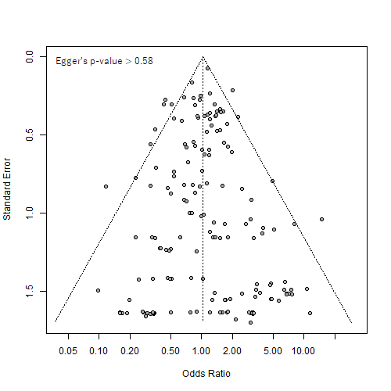
Fig_S1

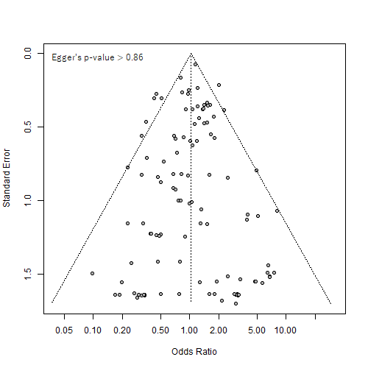
Fig_S2

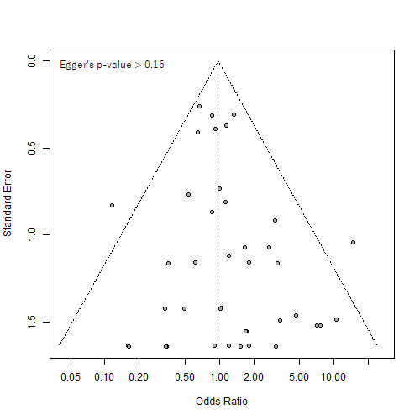
Fig_S3

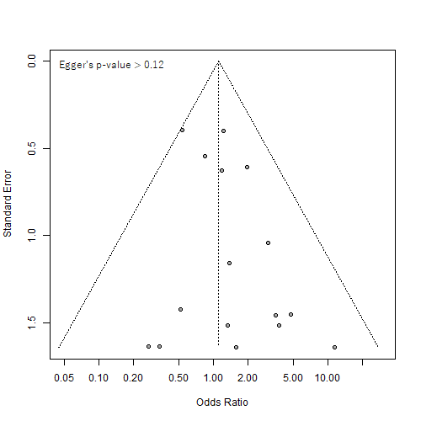
Fig_S4

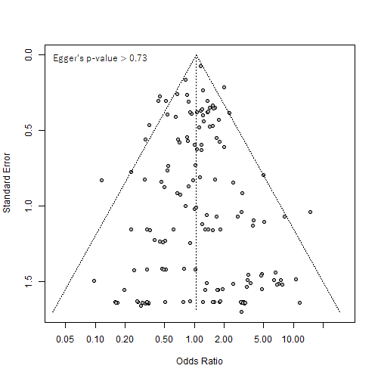
Fig_S5

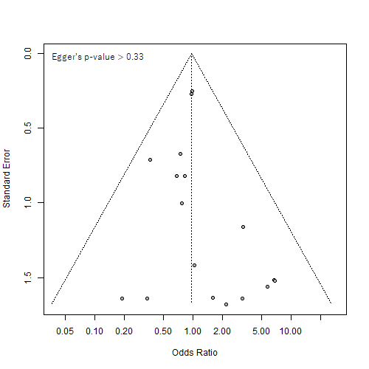
Fig_S6

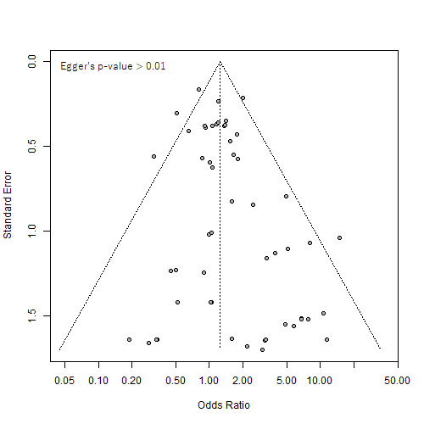
Fig_S7

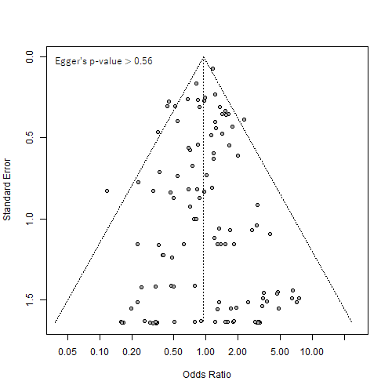
Fig_S8

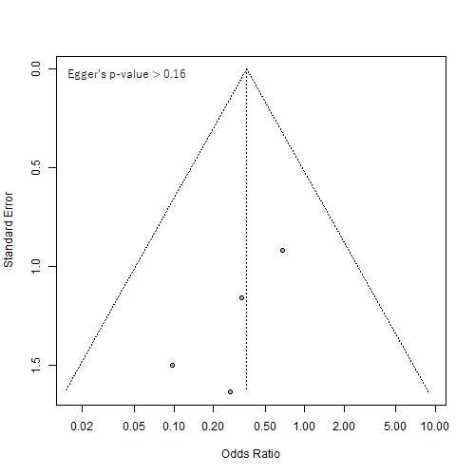
Fig_S9

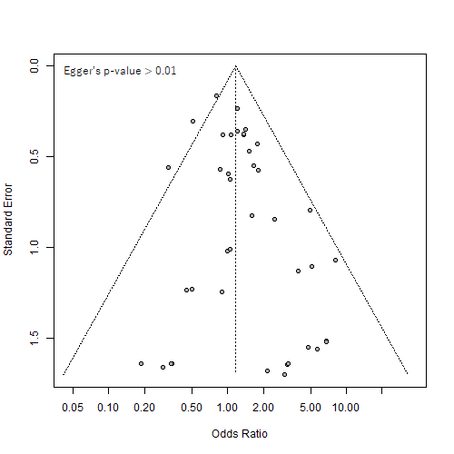
Fig_S10

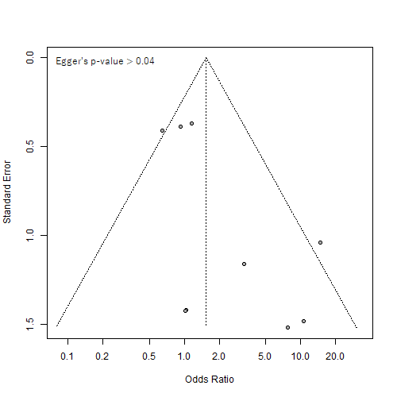
Fig_S11

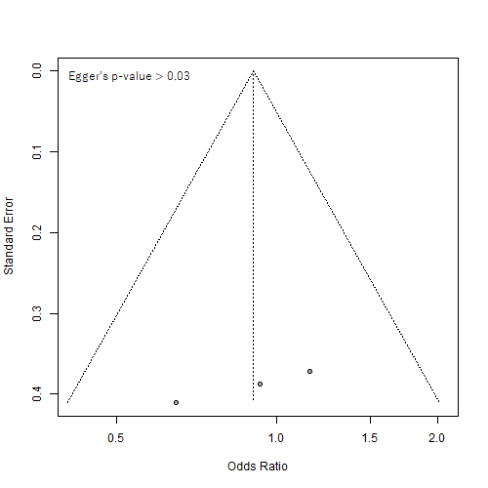
Fig_S12

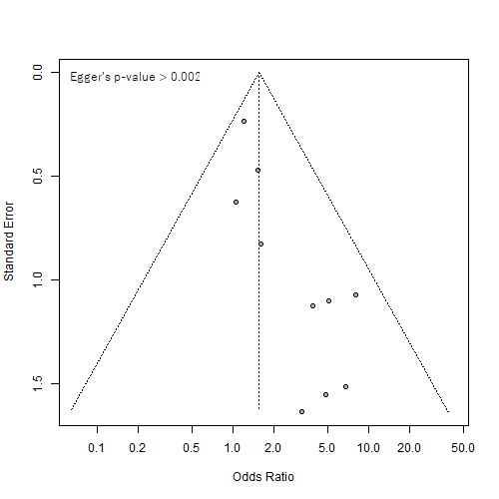
Fig_S13

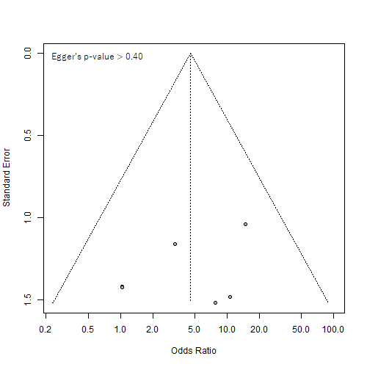
Fig_S14

Table S1a PRISMA_2020_abstract_checklist
Section and Topic | Item # | Checklist item | Location where item is reported
TITLE
Title | 1 | Identify the report as a systematic review. | Title
ABSTRACT
Abstract | 2 | See the PRISMA 2020 for Abstracts checklist. | Abstract
INTRODUCTION
Rationale | 3 | Describe the rationale for the review in the context of existing knowledge. | Background
Objectives | 4 | Provide an explicit statement of the objective(s) or question(s) the review addresses. | Background
METHODS
Eligibility criteria | 5 | Specify the inclusion and exclusion criteria for the review and how studies were grouped for the syntheses. | Study selection, Subgroup analysis
Information sources | 6 | Specify all databases, registers, websites, organisations, reference lists and other sources searched or consulted to identify studies. Specify the date when each source was last searched or consulted. | Data sources and search
Search strategy | 7 | Present the full search strategies for all databases, registers and websites, including any filters and limits used. | Data sources and search
Selection process | 8 | Specify the methods used to decide whether a study met the inclusion criteria of the review, including how many reviewers screened each record and each report retrieved, whether they worked independently, and if applicable, details of automation tools used in the process. | Materials and methods
Data collection process | 9 | Specify the methods used to collect data from reports, including how many reviewers collected data from each report, whether they worked independently, any processes for obtaining or confirming data from study investigators, and if applicable, details of automation tools used in the process. | Materials and methods, Study quality
Data items | 10a | List and define all outcomes for which data were sought. Specify whether all results that were compatible with each outcome domain in each study were sought (e.g. for all measures, time points, analyses), and if not, the methods used to decide which results to collect. | Study selection, Study quality
Data items | 10b | List and define all other variables for which data were sought (e.g. participant and intervention characteristics, funding sources). Describe any assumptions made about any missing or unclear information. | Not applied
Study risk of bias assessment | 11 | Specify the methods used to assess risk of bias in the included studies, including details of the tool(s) used, how many reviewers assessed each study and whether they worked independently, and if applicable, details of automation tools used in the process. | Study quality
Effect measures | 12 | Specify for each outcome the effect measure(s) (e.g. risk ratio, mean difference) used in the synthesis or presentation of results. | Data integration and statistical analysis
Synthesis methods | 13a | Describe the processes used to decide which studies were eligible for each synthesis (e.g. tabulating the study intervention characteristics and comparing against the planned groups for each synthesis (item #5)). | Study quality
Synthesis methods | 13b | Describe any methods required to prepare the data for presentation or synthesis, such as handling of missing summary statistics, or data conversions. | Not applied
Synthesis methods | 13c | Describe any methods used to tabulate or visually display results of individual studies and syntheses. | Data integration and statistical analysis
Synthesis methods | 13d | Describe any methods used to synthesize results and provide a rationale for the choice(s). If meta-analysis was performed, describe the model(s), method(s) to identify the presence and extent of statistical heterogeneity, and software package(s) used. | Data integration and statistical analysis
Synthesis methods | 13e | Describe any methods used to explore possible causes of heterogeneity among study results (e.g. subgroup analysis, meta-regression). | Data integration and statistical analysis
Synthesis methods | 13f | Describe any sensitivity analyses conducted to assess robustness of the synthesized results. | Not applied
Reporting bias assessment | 14 | Describe any methods used to assess risk of bias due to missing results in a synthesis (arising from reporting biases). | Data integration and statistical analysis
Certainty assessment | 15 | Describe any methods used to assess certainty (or confidence) in the body of evidence for an outcome. | Not applied
RESULTS
Study selection | 16a | Describe the results of the search and selection process, from the number of records identified in the search to the number of studies included in the review, ideally using a flow diagram. | (1) Search results
Study selection | 16b | Cite studies that might appear to meet the inclusion criteria, but which were excluded, and explain why they were excluded. | (1) Search results
Study characteristics | 17 | Cite each included study and present its characteristics. | (1) Search results
Risk of bias in studies | 18 | Present assessments of risk of bias for each included study. | (2) Summary and quality assessment of key meta-analyses
Results of individual studies | 19 | For all outcomes, present, for each study: (a) summary statistics for each group (where appropriate) and (b) an effect estimate and its precision (e.g. confidence/credible interval), ideally using structured tables or plots. | (1) Search results
Results of syntheses | 20a | For each synthesis, briefly summarize the characteristics and risk of bias among contributing studies. | (1) Search results, (2) Summary and quality assessment of key meta-analyses
Results of syntheses | 20b | Present results of all statistical syntheses conducted. If meta-analysis was done, present for each the summary estimate and its precision (e.g. confidence/credible interval) and measures of statistical heterogeneity. If comparing groups, describe the direction of the effect. | (3) Overall OR pool for suicide-related events～(7) Subgroup analysis of differences in antidepressants among children and adolescents
Results of syntheses | 20c | Present results of all investigations of possible causes of heterogeneity among study results. | (3) Overall OR pool for suicide-related events～(7) Subgroup analysis of differences in antidepressants among children and adolescents
Results of syntheses | 20d | Present results of all sensitivity analyses conducted to assess the robustness of the synthesized results. | Not applied
Reporting biases | 21 | Present assessments of risk of bias due to missing results (arising from reporting biases) for each synthesis assessed. | (3) Overall OR pool for suicide-related events～(7) Subgroup analysis of differences in antidepressants among children and adolescents
Certainty of evidence | 22 | Present assessments of certainty (or confidence) in the body of evidence for each outcome assessed. | Not applied
DISCUSSION
Discussion | 23a | Provide a general interpretation of the results in the context of other evidence. | Discussion
Discussion | 23b | Discuss any limitations of the evidence included in the review. | (2) Strengths and limitations of this study
Discussion | 23c | Discuss any limitations of the review processes used. | (2) Strengths and limitations of this study
Discussion | 23d | Discuss implications of the results for practice, policy, and future research. | Conclusion and future research
OTHER INFORMATION
Registration and protocol | 24a | Provide registration information for the review, including register name and registration number, or state that the review was not registered. | Data sources and search
Registration and protocol | 24b | Indicate where the review protocol can be accessed, or state that a protocol was not prepared. | Data sources and search
Registration and protocol | 24c | Describe and explain any amendments to information provided at registration or in the protocol. | Not applied
Support | 25 | Describe sources of financial or nonfinancial support for the review, and the role of the funders or sponsors in the review. | Funding Information
Competing interests | 26 | Declare any competing interests of review authors. | Conflict of interest
Availability of data, code and other materials | 27 | Report which of the following are publicly available and where they can be found: template data collection forms; data extracted from included studies; data used for all analyses; analytic code; any other materials used in the review. | Not applied
Page MJ, McKenzie JE, Bossuyt PM, Boutron I, Hoffmann TC, Mulrow CD, et al. The PRISMA 2020 statement: an updated guideline for reporting systematic reviews. BMJ 2021;372:n71. doi: 10.1136/bmj.n71
For more information, visit: http://www.prisma-statement.org/

Table S1b PRISMA_2020_abstract_checklist
Section and Topic | Item # | Checklist item | Reported (Yes/No)
TITLE
Title | 1 | Identify the report as a systematic review. | Yes
BACKGROUND
Objectives | 2 | Provide an explicit statement of the main objective(s) or question(s) the review addresses. | Yes
METHODS
Eligibility criteria | 3 | Specify the inclusion and exclusion criteria for the review. | Yes
Information sources | 4 | Specify the information sources (e.g. databases, registers) used to identify studies and the date when each was last searched. | Yes
Risk of bias | 5 | Specify the methods used to assess risk of bias in the included studies. | Yes
Synthesis of results | 6 | Specify the methods used to present and synthesize results. | Yes
RESULTS
Included studies | 7 | Give the total number of included studies and participants and summarize relevant characteristics of studies. | Yes
Synthesis of results | 8 | Present results for main outcomes, preferably indicating the number of included studies and participants for each. If meta-analysis was done, report the summary estimate and confidence/credible interval. If comparing groups, indicate the direction of the effect (i.e., which group is favored). | Yes
DISCUSSION
Limitations of evidence | 9 | Provide a brief summary of the limitations of the evidence included in the review (e.g. study risk of bias, inconsistency and imprecision). | Yes
Interpretation | 10 | Provide a general interpretation of the results and important implications. | Yes
OTHER
Funding | 11 | Specify the primary source of funding for the review. | Yes
Registration | 12 | Provide the register name and registration number. | Yes

Table S2 Search strategy
Database/No. | Querry
PubMed | suicide AND antidepressants AND ("meta-analysis" OR "meta-analyses" OR "systematic review" OR "database") in all fields
The Cochrane Library | ((suicide) AND (antidepressants) AND (meta-analysis OR meta-analyses OR systematic review OR database))

Table S3 Detailed definitions of the subgroups
Category/subgroup | Definition
Categories of antidepressants
SSRIs | Fluoxetine, Sertraline, Paroxetine, Citalopram, Escitalopram, Fluvoxamine
SNRIs | Duloxetine, Venlafaxine
Others | Not SSRI or SNRI (Bupropion, Mirtazapine, Nefazodone, Trazodone, Vilazodone, Vortioxetine)
Age
Children/adolescents | ≤ 18 years old
Adults | > 18 & < 65 years old
Elderly | ≥ 65 years old
Treatment indications
Depression | Depression and MDD
Others | GAD, IBD, OCD, PD, PTSD, and SAD,
Health | Healthy subjects
Abbreviations: FDA, Food and Drug Administration; GAD, generalized anxiety disorder; IBD, intermittent brief depression; MDD, major depressive disorder; OCD, obsessive‒compulsive disorder; PD, panic disorder; PTSD, posttraumatic stress disorder; SAD, social anxiety disorder; SSRIs, selective serotonin reuptake inhibitors; SNRIs, serotonin and noradrenaline reuptake inhibitors.

Table S4 CONSORT_checklist

Section/Topic | Item No | Checklist item
Title and abstract
 | 1a | Identification as a randomized trial in the title
 | 1b | Structured summary of trial design, methods, results, and conclusions (for specific guidance see CONSORT for abstracts)
Introduction
Background and objectives | 2a | Scientific background and explanation of rationale
Background and objectives | 2b | Specific objectives or hypotheses
Methods
Trial design | 3a | Description of trial design (such as parallel, factorial) including allocation ratio
Trial design | 3b | Important changes to methods after trial commencement (such as eligibility criteria), with reasons
Participants | 4a | Eligibility criteria for participants
Participants | 4b | Settings and locations where the data were collected
Interventions | 5 | The interventions for each group with sufficient details to allow replication, including how and when they were actually administered
Outcomes | 6a | Completely defined prespecified primary and secondary outcome measures, including how and when they were assessed
Outcomes | 6b | Any changes to trial outcomes after the trial commenced, with reasons
Sample size | 7a | How sample size was determined
Sample size | 7b | When applicable, explanation of any interim analyses and stopping guidelines
Randomization:
Sequence generation | 8a | Method used to generate the random allocation sequence
Sequence generation | 8b | Type of randomization; details of any restriction (such as blocking and block size)
Allocation concealment mechanism | 9 | Mechanism used to implement the random allocation sequence (such as sequentially numbered containers), describing any steps taken to conceal the sequence until interventions were assigned
Implementation | 10 | Who generated the random allocation sequence, who enrolled participants, and who assigned participants to interventions
Blinding | 11a | If done, who was blinded after assignment to interventions (for example, participants, care providers, those assessing outcomes) and how
Blinding | 11b | If relevant, description of the similarity of interventions
Statistical methods | 12a | Statistical methods used to compare groups for primary and secondary outcomes
Statistical methods | 12b | Methods for additional analyses, such as subgroup analyses and adjusted analyses
Results
Participant flow (a diagram is strongly recommended) | 13a | For each group, the numbers of participants who were randomly assigned, received intended treatment, and were analyzed for the primary outcome
Participant flow (a diagram is strongly recommended) | 13b | For each group, losses and exclusions after randomization, together with reasons
Recruitment | 14a | Dates defining the periods of recruitment and follow-up
Recruitment | 14b | Why the trial ended or was stopped
Baseline data | 15 | A table showing baseline demographic and clinical characteristics for each group
Numbers analyzed | 16 | For each group, number of participants (denominator) included in each analysis and whether the analysis was by original assigned groups
Outcomes and estimation | 17a | For each primary and secondary outcome, results for each group, and the estimated effect size and its precision (such as 95% confidence interval)
Outcomes and estimation | 17b | For binary outcomes, presentation of both absolute and relative effect sizes is recommended
Ancillary analyses | 18 | Results of any other analyses performed, including subgroup analyses and adjusted analyses, distinguishing prespecified from exploratory
Harms | 19 | All important harms or unintended effects in each group (for specific guidance see CONSORT for harms)
Discussion
Limitations | 20 | Trial limitations, addressing sources of potential bias, imprecision, and, if relevant, multiplicity of analyses
Generalisability | 21 | Generalisability (external validity, applicability) of the trial findings
Interpretation | 22 | Interpretation consistent with results, balancing benefits and harms, and considering other relevant evidence
Other information
Registration | 23 | Registration number and name of trial registry
Protocol | 24 | Where the full trial protocol can be accessed, if available
Funding | 25 | Sources of funding and other support (such as supply of drugs), role of funders
Citation: Schulz KF, Altman DG, Moher D, for the CONSORT Group. CONSORT 2010 Statement: updated guidelines for reporting parallel group randomized trials. BMC Medicine. 2010;8:18.
© 2010 Schulz et al. This is an open access article distributed under the terms of the Creative Commons Attribution License (http://creativecommons.org/licenses/by/2.0), which permits unrestricted use, distribution, and reproduction in any medium, provided that the original work is properly cited.
*We strongly recommend reading this statement in conjunction with the CONSORT 2010 Explanation and Elaboration for important clarifications on all the items. If relevant, we also recommend reading CONSORT extensions for cluster randomized trials, noninferiority and equivalence trials, nonpharmacological treatments, herbal interventions, and pragmatic trials. Additional extensions are forthcoming: for those and for up-to-date references relevant to this checklist, see www.consort-statement.org.

Table S5 Interactions among Subgroups
 | Odds-ratio difference | 95%CI lower | 95%CI upper | p- value
Children/adolescents vs. adults | 2.011126 | 1.935297 | 2.089927 | ≃0e+00
Children/adolescents vs. elderly patients | 5.343307 | 4.915416 | 5.808446 | 3.79E-03
Adults vs. elderly patients | 2.656873 | 2.54441 | 2.774306 | 9.08E-02

