Supplementary Information for

Microgravity experiments confirm densest stable hard sphere crystal is most symmetric
Qian Lei¹, Boris Khusid^{1*}, Andrew D. Hollingsworth², Paul M. Chaikin^{2*}, William V. Meyer³
¹ Otto H. York Department of Chemical and Materials Engineering, New Jersey Institute of Technology, 323 Dr Martin Luther King Jr Blvd, Newark, NJ 07102, USA
² Department of Physics, New York University, 726 Broadway, New York, NY 10003, USA
³ Universities Space Research Association, 425 3rd Street SW, Washington DC, 20024, USA

Correspondence to Boris Khusid khusid@njit.edu and Paul M. Chaikin chaikin@nyu.edu

Table of Content
No | Section | Page
1 | G-jitter effects | 1
2 | Distance between particle centers and particle sizes | 1
3 | Sample C3 | 6
3.1 | FCC structure of crystalline phase | 6
3.2 | Crystalline and disordered phases | 11
3.3 | Deformational of hexagonal lattice | 14
4 | Sample C2 | 16
4.1 | Crystalline and disordered phases | 16
4.2 | Thermophoresis | 18
5 | Sample C1 | 23

1. G-jitter effects
The Light Microscopy Module (LMM) housed in the International Space Station (ISS) Fluids Integrated Rack (FIR) (Method). Vibratory acceleration inside the FIR was monitored with a Space Acceleration Measurement System (SAMS) sensor within the frequency range $ν_{v}\sim 0.01-200 Hz.$ Magnitudes of the Power Spectral Density (PSD) g-jitter recorded over this frequency range, $\log_{10}\left\{{〈{\left[g\left(m/{s^{2}}\right)\right]}^{2}〉}/{Hz}\right\}$, lay below -8.5, jumping to -8 at 0.01Hz during the ISS maneuvers.
The PSD of the particle velocity caused by the ISS g-jitter can be estimated as
$〈u_{g}^{2}〉\sim {\left[{\left(ρ_{p}-ρ_{f}\right)v_{dr}}/{3πa_{dr}η_{f}}\right]}^{2}〈g^{2}〉<\sim {10}^{-12}{\left({{μm}^{2}}/{s^{2}}\right)}/{Hz}$, where the density mismatch between particles and the suspending fluid $ρ_{p}-ρ_{f}\sim 244{kg}/{m^{3}}$, the volume $v_{dr}={πa_{dr}^{3}}/6$ of a dry particle of diameter $a_{dr}=1.25±0.05 μm$, and the fluid viscosity $η_{f}\sim 0.0023Pa∙s.$
The particle Stokes-Einstein diffusion coefficient is $D_{Br}={k_{B}T}/{3πa_{dr}}η_{f}\sim 0.14{{μm}^{2}}/s$, where $k_{B}T=4∙{10}^{-21}J$ is the thermal energy at the cabin temperature. The g-jitter particle Péclet number is then
${Pe}_{g}={\sqrt{〈u_{g}^{2}〉}a_{dr}}/{D_{Br}}={\left(ρ_{p}-ρ_{f}\right)v_{dr}\sqrt{〈g^{2}〉}a_{dr}}/{k_{B}T}<\sim {{10}^{-5}}/{Hz}$
From this one sees that the ISS g-jitter effects on the particle motion over the
entire frequency range are insignificant compared to their thermal motion.

2. Distance between particle centers and particle sizes
Basic initial steps in digital image processing²⁵⁻²⁷ are performed with ImageJ software²⁴. We apply Gaussian smoothing filters to a grayscale confocal image to reduce noise. Measurements of the distance between centers of neighboring particles and particle diameters employ the open-source TrackMate plugin^{28,29} developed for processing of fluorescence bioimages. We use the Laplacian of Gaussian (LoG) filter to find with sub-pixel accuracy locations of local maxima of grayscale in an image which represent particle centers. Notice that the X and Y coordinates of a particle center can be measured even if the center is not located on the focal X-Y plane as they do not change while a spherical particle moves in the Z-direction.
Distances between centers of neighboring particles in a hexagonal array observed in our colloidal samples are found by computing a two-dimensional (2D) radial distribution function $g(r)$ (Method) of the particle centers in the X-Y plane:
C3: $L=1.38±0.02μm$, data on ~ 206,040 particles over 303 images.
C2: $L=1.33±0.02μm$, data on ~7,100 particles over 10 images.
C1: $L=1.32±0.02μm$, data on ~500 particles in dried regions over 10 images.
A measurement error of $L$ is attributed to a distance between locations of the particle center given by the software and found manually, which in turn is measured using a scale bar in an image.
The diameter of dry polymethyl methacrylate (PMMA)-based particles utilized in our samples (Methods) is $a_{dr}=1.25±0.05 μm$. It is well known that these particles swell in a decahydronaphthalene/tetrahydronaphthalene mixture that matches the particles and fluid refractive indices^{31,32}. Using algorithms provided in TrackMate^{28,29}, we estimate the particle diameter in an image by analyzing how the signal-to-noise ratio $S/N$ of a circular spot of diameter $d$ around the particle center varies with increasing $d$. Here
$S/N=\frac{G_{in}-G_{out}}{{STD}_{in}}$ , (1)
where $G_{in}$ is the mean grayscale of pixels within the spot of diameter $d$, $G_{out}$ is the mean grayscale of pixels in a complimentary ring ranging from the inner diameter $d$ to twice the outer diameter $2d$, and ${STD}_{in}$ is the standard deviation computed within the inner spot area of diameter $d$. A schematic in Fig.1 illustrates a set of spots with their complimentary rings around the center of a particle in a hexagonal array. If a spot and its ring are located entirely within a disk representing a particle in an image, variation of the $S/N$ magnitude with $d$ characterizes the grayscale nonuniformity across the disk caused by the unevenness of fluorescein dye distribution inside this particle (Methods). Once the outer boundary of diameter $2d$ of the ring that is complimentary to an inner spot of diameter $d$ expands over the disk boundary, the magnitude of the $S/N$ abruptly changes as the average grayscale of pixels outside of the disk is added to $G_{out}$ in Eq. (1). When the spot diameter $d$ rises to the disk diameter, the $S/N$ also abruptly changes as the mean grayscale of pixels inside the disk is not included in $G_{out}$ anymore. A diameter at which both abrupt changes match provides an estimate for the disk diameter.
An examination with ImageJ of a confocal image of a hexagonal lattice in our colloidal samples indicates variations in the grayscale of disks representing particles in this image, some of them appear brighter than others. We therefore select two disks, one bright and another dim, in the image of a hexagonal lattice in Sample C3 (Fig.2a) to illustrate the procedure of estimating the particle diameter using the signal-to-noise ratio $S/N$ given by Eq. (1). As the particle diameter is expected to be larger than $a_{dr}=1.25±0.05 μm$, we do not consider spots smaller than $0.6 μm$, that is half of the corresponding ring diameter $1.20 μm$, fully situated within a disk. Plots in Figs.2b and 2c show the variation of $G_{in}$ and $S/N$ with the spot diameter. As expected, magnitudes of $G_{in}$ and $S/N$ in the dim disk are lower. Datasets on $G_{in}$ in both disks indicate that the concentration of fluorescence dye in particles is decreasing away from the particle center. The estimated diameter of the bright disk is $1.32μm$ as two abrupt changes in the dataset on $S/N$ match at this value (Figs. 2b): one at the spot of this diameter and the other at the spot of diameter $0.66μm$ equal to half of its corresponding ring diameter. A similar estimate yields $1.26μm$ for the diameter of the dim disk (Fig.2c). The presented outcomes clarify a difference between these disks. The larger bright disk is the image of a particle with its center close to the focal $X-Y$ plane of the confocal image in Fig.2a. The smaller dim disk is the image of a particle of the same size with its center $0.2μm$ away from the focal plane.
Fig.3 presents datasets on the mean grayscale of pixels $G_{in}$ and the signal-to-noise ratio $S/N$ for spots of diameter $d$ around each center of 374 disks in the image shown in Fig.2a. The Gaussian curves fit well the probability density distribution of $G_{in}$ and $S/N$ at every spot diameter. Plots in Fig.4 demonstrate the variation with the spot diameter of the mean values of $G_{in}$, $S/N$ over all particles in these histograms as well as their standard deviations. The bright and dim particles shown in Fig.2 have respectively $G_{in}\sim 140$ and $G_{in}\sim 123.$ These values fall within one standard deviation (1-sigma) for the bright particle and beyond two standard deviations (2-sigma) for the dim particle from the mean in Fig.4, thereby representing respectively within 68% and beyond 2.3% of the total data points in the Gaussian distributions in histograms in Fig.3. Plots in Fig.4 show that the range of $G_{in}$ and $S/N$ of spots with diameters from the dry particle radius, ${a_{dr}}/2\sim 0.62 μm$, to half of the distance between centers of two particles, $L/2\sim 0.69 μm$, fall within the 1-sigma range from the mean of $G_{in}$ and $S/N$. Similarly, these plots show that the range of $G_{in}$ and $S/N$ of spots with diameters from $1.24 μm$ to $1.38 μm$ also fall within the 1-sigma range from the mean of $G_{in}$ and $S/N$. Thereby, they represent 68% of the total data points within their ranges in histograms in Fig.3. As seen in Fig.4, there is only one abrupt change in the dataset on $S/N$ in each of these intervals. They match at $1.32μm$ for the disk diameter that is the bright disk diameter in Fig.2b, thereby indicating that centers of these particles are close to the focal $X-Y$ plane of the confocal image. The plateau of the lowest values of $G_{in}$ and $S/N$ within the range $1.32μm-1.38μm$ in Figs.2b and 4, is consistent with the appearance of the gap between two particles in the hexagonal lattice.
We use this method with ImageJ and TrackMate to measure the particle diameter in confocal images taken at various locations for samples C1, C2 and C3:
C3: $a=1.32±0.02μm$, data on ~ 11,400 particles over 30 images.
C2: $a=1.30±0.02μm$, data on ~3,800 particles over 10 images.
C1: $a=1.32±0.02μm$, data on ~1,900 particles over 10 images.
Measurement errors in the particle size are attributed to the accuracy of measuring the distance between centers of neighboring particles.
In sample C1, we also manually measure the particle size on ten images of a thin dried region formed under the capillary top. In this region, particles arrange in a hexagonal array touching one another. To find the particle size, we draw a line across the line of particle centers and estimate its length using the image scale bar (Fig.5). The particle diameter is then calculated by dividing the length of a line segment by the number of centers. The outcome of a histogram constructed from measurements of over 200 lines is consistent with the software prediction (Fig.5).
Estimates of particle swelling by 5.6% in samples C3 and C1, and by 4% in sample C2 are consistent with measurements^{31,32}. Swelling of particles was estimated in these papers by measuring the colloid density, sedimentation time, and particle hydrodynamic diameter, and then confirmed by comparison with the volume fractions for hard spheres at freezing and melting. A slightly smaller change in the particle diameter in sample C2 which leaked solvent is likely caused by particle deswelling because of evaporation of some amount of tetrahydronaphthalene having a higher vapor pressure than decahydronaphthalene.^{31,32}

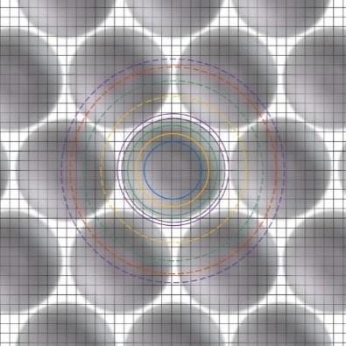
Fig.1. Arrangement of particles in a hexagonal lattice. A set of spots around the particle center with complimentary rings for computing the signal-to-noise ratio. The same color is used to show the spot boundary (solid line) and the outer boundary of its complimentary ring (dashed line). A dashed blue line with red dots illustrates the case when diameters of the blue ring and red spot coincide. A pixel grid is shown in the background.

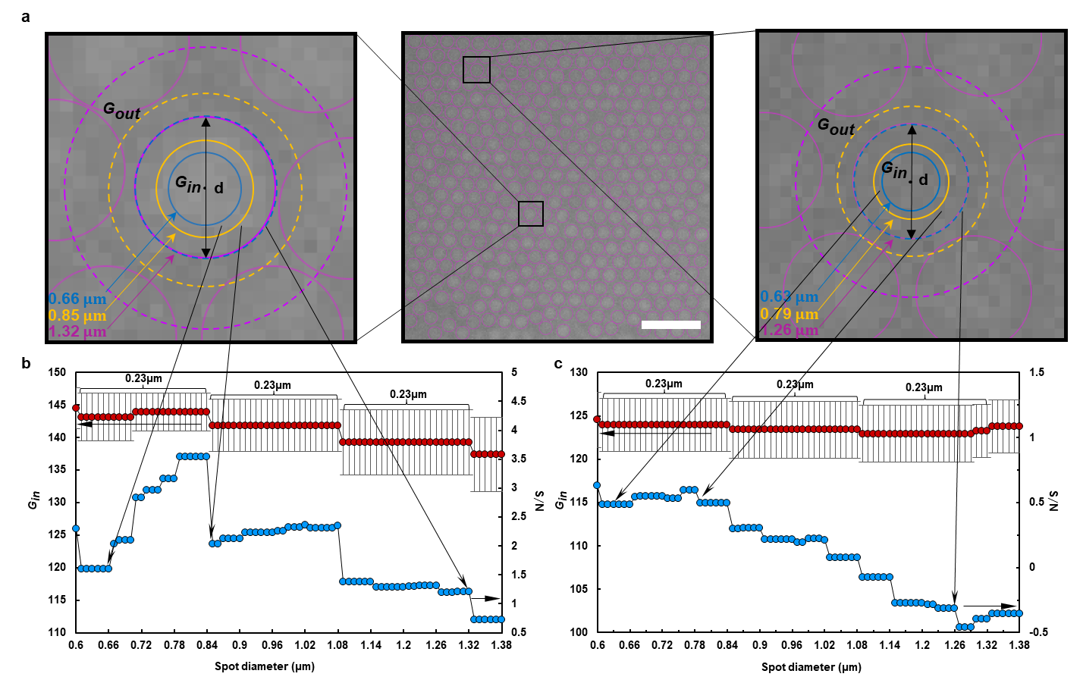
Fig.2. Grayscale variation across a single particle. a, Image of a hexagonal lattice in Sample C3 (middle) with selected bright (left) and dim (right) disks. Image 25.4$μm×$25.4 $μm$ centered at X = 0$μm$, Y = 0$μm$, Z = 5$μm$presents 374 particles, particles at the image boundary are not included; image pixel size 0.12$μm$ (Methods); white scale bar 5 $μm.$ Illustrated are circular spots and their complementary rings around the disk center of diameters 0.66$μm$, 0.85$μm$ and 1.32$μm$ in bright (left), and 0.63$μm$ , 0.79$μm$ and 1.26 $μm$ in dim (right) disks. b (bright disk) and c (dim disk), Plots show variation with the spot diameter $d$ of $G_{in}$ (top, red circles with error bars computed from datasets on individual pixels within a spot) and $S/N$ (bottom, blue circles).

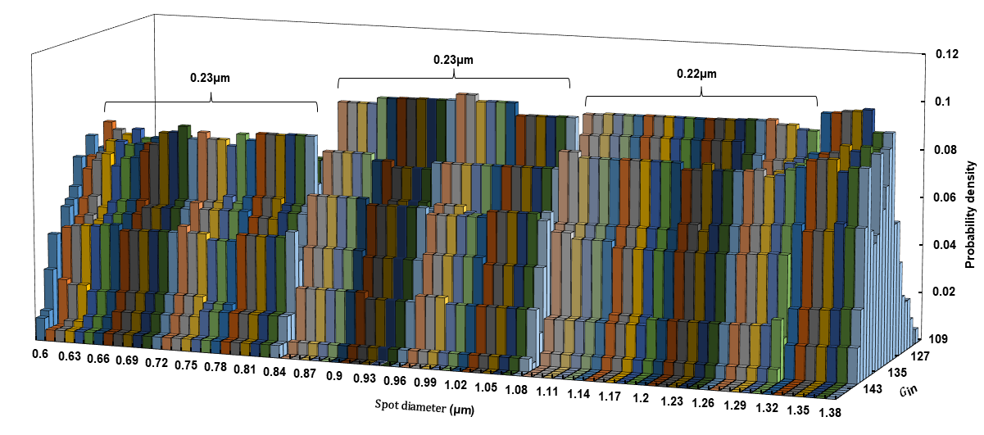
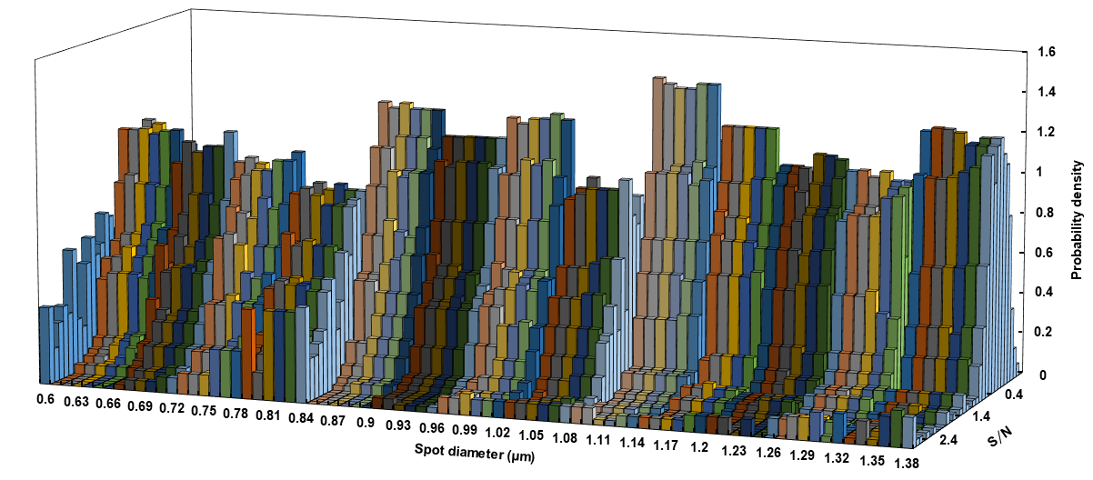
Fig.3. Sample C3. Probability distribution histograms of (top) the mean grayscale of pixels $G_{in}$, taken with bin size 1, and of (bottom) signal-to-noise ratio $S/N$, taken with bin size 0.1, for spots of diameter $d$ around each center of the 374 disks in the image presented in Fig.2a (middle). Color illustrates datasets within a slice $∆d=0.01μm$. The Gaussian curves fit well the probability density distribution of $G_{in}$ (with $R^{2} >0.88)$ and $S/N$ (with $R^{2}>0.97)$ at every spot diameter $d$.

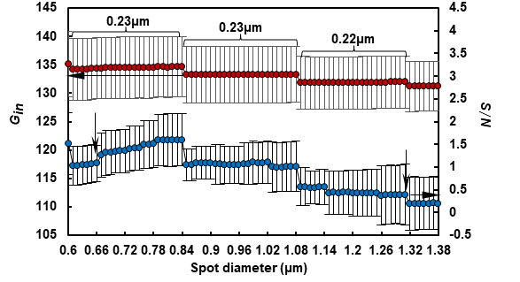
Fig.4. Sample C3. Plots show variation with the spot diameter of $G_{in}$ (top, red circles), $S/N$ (bottom, blue circles) averaged over all disks as well as their standard deviations (error bars) for datasets in the histograms presented in Fig.3. Vertical arrows show that abrupt changes of $S/N$ at the spot of $1.32μm$ diameter and at the outer boundary of the ring corresponding to the spot of $0.66μm$ diameter match.

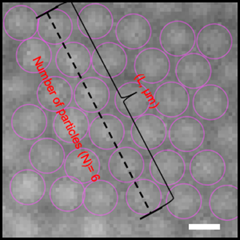 | 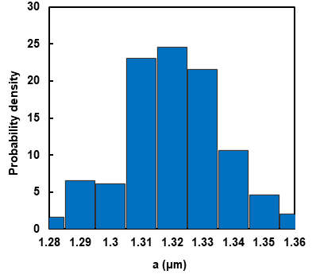
Fig.5. Sample C1. Left: Dry particles form a hexagonal array touching one another. Image centered at $X =-1,315μm, Y = 200μm, Z = 0μm$; a line across centers of six particles; white scale bar 1μm. The particle diameter is calculated by dividing the length of a line segment by the number of centers. Right: The histogram of measurements of the particle diameter over 200 lines in different locations; particle diameter $a=1.32±0.02μm$.

3. Sample 3
3.1. FCC structure of crystalline phase
Schematics of the face centered cubic (FCC) and hexagonal closest packed (HCP) structures with hexagonal arrays arranged in the X-Y plane are shown in Fig. 6a. The FCC unit cell contains three hexagonal layers of particles: top in yellow, middle in red and bottom in blue; 8 lattice points at cube corners and 6 at centers of each face square. Here A, D, and E are the lattice points in the hexagonal plane and exactly above them is the next hexagonal plane at the distance $d_{111}={\sqrt{6}L}/3$, where $L$ is the distance between two neighboring particle centers. Projections of the particle centers on the X-Y plane are shown in the bottom: 1 denotes the yellow particles from the first layer, 2 the red particles from the second layer, 3 the blue particles from the third layer, and 1/4 indicates that projections of particle centers in layers in the 1 and 4 overlay. The HCP unit cell contains two hexagonal layers of particles: top in blue, middle in red and bottom in blue; $c$ is the height of the unit cell of the HCP structure. Here A, B, and O are the lattice points in the hexagonal particle plane and exactly above them is the next hexagonal plane at the same distance $c/2={\sqrt{6}L}/3$ as that in the FCC structure. Projections of the particle centers on the X-Y plane are shown in the bottom of the structure schematics (Fig. 6b): As can be seen in this figure, a difference between the FCC and HCP structures appears if we consider a separation $δ$ between projections on the X-Y plane of particle centers taken from four successive hexagonal planes.
In the Z-stack of confocal images, images with large values of the average hexatic order parameter $〈\left|φ_{6}\right|〉$ (Methods) are centered in hexagonal planes, whereas images with lower values of $〈\left|φ_{6}\right|〉$ are situated in the space between them (Fig.6b). Out of total of 376 Z-stacks taken in sample C3 with a $0.2μm$ step in the Z-direction, only 101 listed in Supplementary File 3 appear to be conducive to a quantitative characterization of four successive hexagonal planes. In each of these Z-stacks, we analyze 20-25 images (total ~2,648 particles) to find four successive images with peak values of $⟨|φ_{6}|⟩$, number them sequentially 1-4, and project particle centers from these images on the X-Y plane as shown in Fig. 6b. We then took two different images in the same Z-stack and cropped them down to acquire a region $\sim 34.68μm×34.68μm$ free of bleaching for processing. Next, for each particle center projection in one image away from its border, we measure its minimum separation $δ$ from projections of particle centers in the other image, also away from the border. For each Z-stack, these measurements are conducted for paired mages: 1&2, 2&3, 3&4, 1&3, 2&4, 1&4. The order of taking images within a pair does not change a histogram displaying how frequently different values of $δ$ occur within a dataset. Once we identify and link every two nearest particle projections in a pair of selected images, say $i$ in one image and $j$ in the other, we then compute coordinates of their midpoint in the X-Y plane $r_{m,ij}={\left(r_{i}+r_{j}\right)}/2$. To characterize how far apart these midpoints are in the X-Y plane, we calculate the minimum separation $∆$ between them.
Measurements of $δ$ for over $2.7∙{10}^{5}$ particles in 101 Z-stacks are reported in Fig.7 and Supplementary File 3. They demonstrate that datasets of paired images1&2, 2&3, 3&4, 1&3, and 2&4 are similar and differ significantly from the dataset of pair 1&4. This outcome is incompatible with an HCP structure for which datasets of pairs 1&2, 2&3, 3&4 and 1&4 should be similar but significantly differ from datasets of pairs 1&3 and 2&4, also be similar. The mean values of $δ$ for pairs 1&2, 2&3, 3&4, 1&3, and 2&4 averaged over all Z-stacks are close to the value $δ^{*}= L/{√3}=0.80μm$ of an ideal FCC crystal with the lattice constant $L$. The value of $δ$ for pairs of images 1&4 averaged over all Z-stacks is respectively: $0.25±0.19μm$, whereas $δ= 0$ for an ideal FCC crystal. The reason that the measured values are not perfect is because of the particles Brownian motion, plus a 3.36s-time lag between scanning successive images in the Z-stack (Method). In fact, these values are consistent with the range $0.15-0.20μm$ reported in the main paper for the root mean square of Brownian displacements of particle centers away from their lattice nodes. Histograms of datasets on $δ$ for image pairs 1&2, 2&3, 3&4, 1&3, 2&4 are presented in Fig.7 are well fit with Gaussian curves. This means that the projections on the X-Y plane of most particle centers in the hexagonal planes 1-4 are located within the distance $δ±∆δ$ from one another. A set of radii $δ±∆δ$ drawn in Fig.8 for four nearby projections of particle centers in these planes demonstrates that planes 2 and 3 are shifted in opposite directions from planes 1 and 4. We can therefore identify hexagonal planes 1 and 4 as C and planes 2 and 3 as B and A, shifted in opposite directions from layer C illustrated in Fig.6a. We point out that this FCC structure is found in all 101 Z-stacks taken at different locations of sample C3.
We now explore the arrangement of projections of particle centers whose separation in the X-Y plane lays within tails of the Gaussian curves in Fig.7. We call these particles individual stacking faults at the particle level since they disrupt the regular stacking sequence of the particle arrangement in four successive hexagonal planes of the FCC structure. For each of 101 Z-stacks, we link neighboring projections of particle centers on the X-Y plane in pairs of images 1&2, 2&3, 3&4, 1&3, 2&4, and 1&4 for which $δ$ lays within ranges $0-0.25μm$ and $1-1.4μm$. The former range is comparable with the root-mean-square random displacements of two particle centers away from their lattice nodes. The latter is comparable with the lattice side $L=1.38±0.02μm$. We then compute the minimum separation $∆$ between the midpoints of these linked projections of particle centers to estimate how far they are from each other in the X-Y plane. The mean value and standard deviation of the minimum separation $∆$ between midpoints of the linked projections of particle centers in different image pairs are reported in Supplementary File 4. Images presented in Fig.9 illustrate locations of these stacking faults. The number of individual stacking faults in images of two different planes in pairs 1&2, 2&3, 3&4, 1&3, and 2&4 is less than 6% of the total number of particles in an image. They are randomly arranged in a plane with the average separation $∆$ twice as large as the lattice side $L$. Notice that $δ=0$ for the pair 1&4 in an ideal FCC crystal. About 58% of projections of particle centers in an image of this pair fall within the range $0≤δ≤0.25μm$ with the average separation $∆=1.28±0.38μm$ smaller than the lattice side $L$.

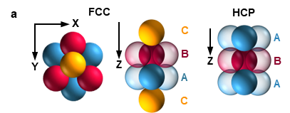
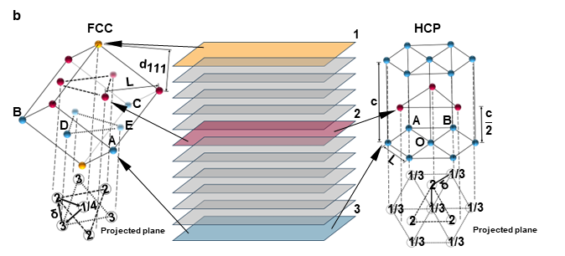
Fig.6. Projection on the X-Y plane of particle centers in FCC and HCP crystals whose hexagonal arrays are arranged in the X-Y plane. a, Packing of spheres in four layers in FCC (left) and three layers in HCP (right) crystals. b, Left: FCC unit cell. Middle: Stack of confocal images 1 (yellow), 2 (red), and 3 (blue), with large $〈\left|φ_{6}\right|〉$ centered in the hexagonal particle planes, images with lower values of $〈\left|φ_{6}\right|〉$ are situated in the space between them. Right: HCP unit cell. Projections of particle centers on the X-Y plane for both structures are shown at the bottom. FCC (left): 1 denotes yellow particles from the first layer, 2 red particles from the second layer, 3 blue particles from the third layer, 1/4 indicates that projections of particle centers in layers 1 and 4 overlay. HCP (right), 2 denotes red particles from the second layer, 3 blue particles from the third layer, 1/3 indicates that projections of particle centers in layers 1 and 3 overlay.

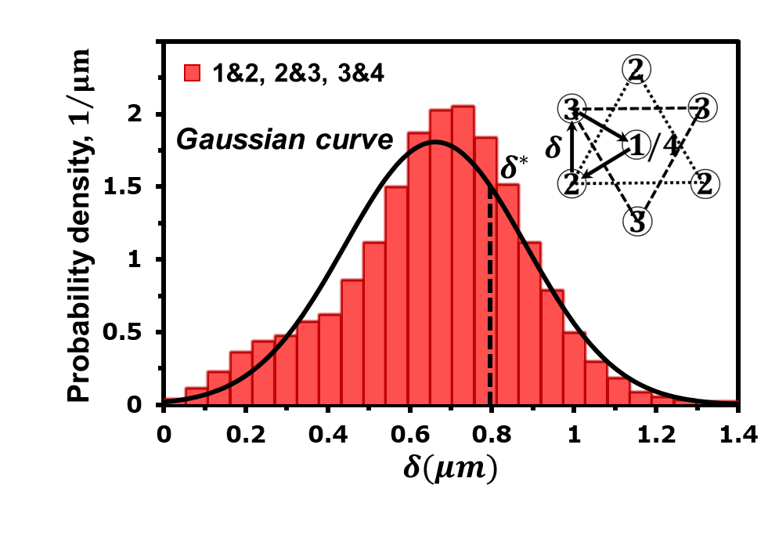 | 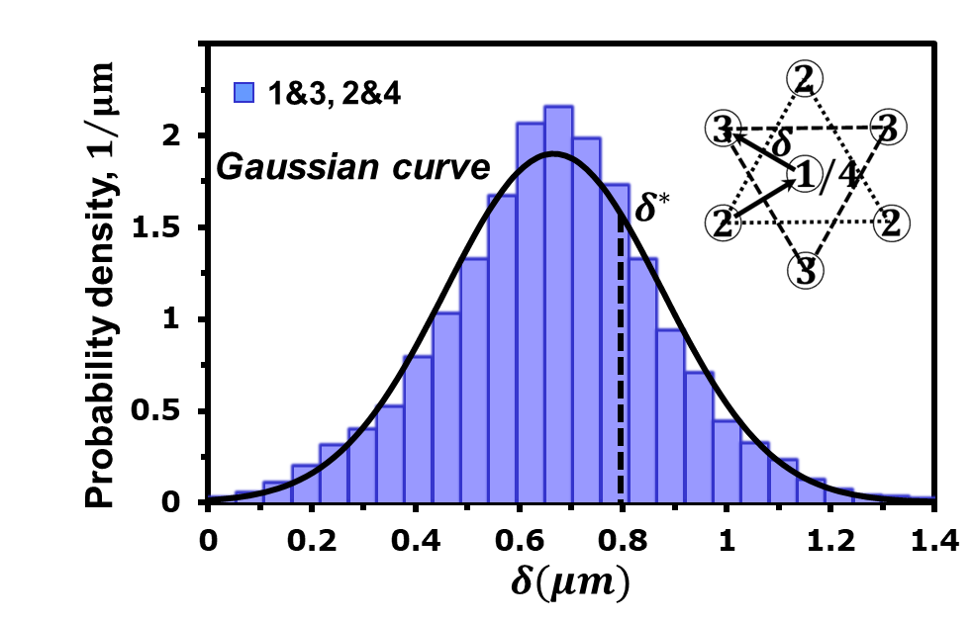 | 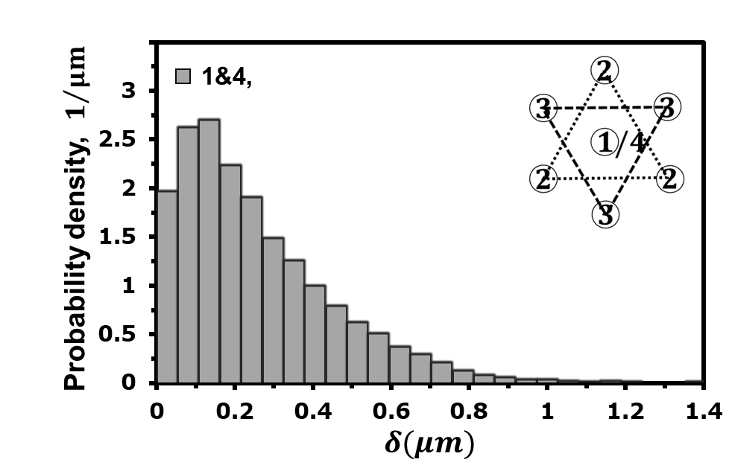
Fig.7. Sample C3. A probability distribution histogram with a bin size of $0.05μm$ for separation 𝛿 between nearby projections of particle centers in pairs of images in Z-stacks listed in Supplementary File 3. Left: 1&2, 2&3, 3&4. Middle: 1&3, 2&4. Right: 1&4. Averaged over all Z-stacks, the mean and standard deviation for $δ$ are: Left: $0.65±0.21μm;$ Middle: $0.65±0.21μm$s; Right: $0.25±0.19μm.$ $δ^{*}= L/{√3}=0.80μm$ for ideal FCC crystal with $L=1.38±0.02μm$. The left and middle histograms are well fitted by the Gaussian curves.

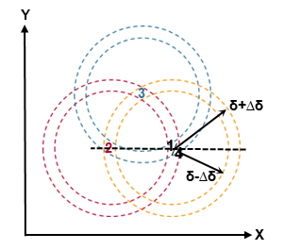
Fig.8. Relative orientation in the X-Y plane of four hexagonal planes in Z-stack. Projections of four nearby particle centers in hexagonal planes 1, 2, 3 and 4 on the X-Y plane are located within the distance $δ±∆δ$ from one another. The set of circles of radii $δ±∆δ$ shows the shift between these planes in the X-Y plane.

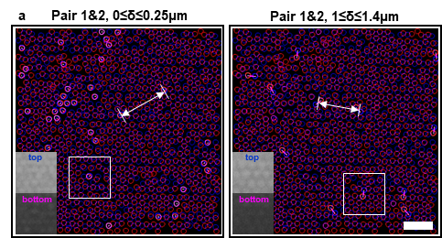 | 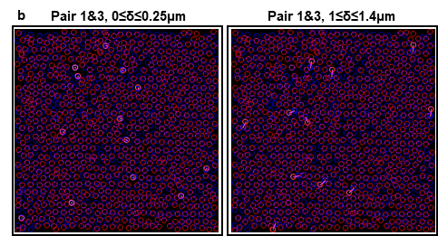
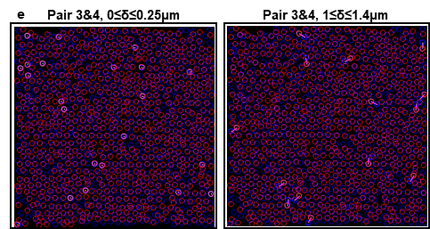 | 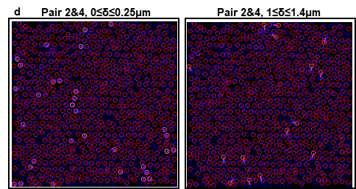
 | 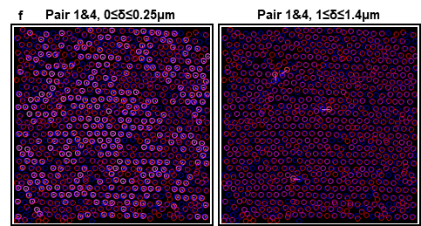
Fig9. Sample C3. Arrangement of neighboring particle centers for which separation $δ$ between projections on the X-Y plane lays within the tails of the Gaussian curves in Fig.7. 34.68μm x 34.68μm images of four hexagonal images taken from Z-stack #1 in Supplementary File 4. Listed are the paired images 1&2, 1&3, 2&3, 2&4, 3&4 and 1&4 and the range of $δ.$ The original images are shown in the background: particles are illustrated by circles. Blue indicates the first image in the pair and red indicates the other image. The length between the linked pair of particle centers represents the value of δ. Linked particle centers from the total particles in the image: a, 37 from 682 are within $0≤δ≤0.25μm$ (left) and 14 from 682 are within $1≤δ≤1.4μm$ (right). A confocal image of the region is shown in the insert as a white square. The white arrow illustrates a separation $∆$ between midpoints of the linked particle centers. b, 13 from 681 within $0≤δ≤0.25μm$ (left) and 11 from 681 within $1≤δ≤1.4μm$ (right). c, 37 from 688 within $0≤δ≤0.25μm$ (left) and 19 from 688 within $1≤δ≤1.4μm$ (right). d, 32 from 667 within $0≤δ≤0.25μm$ (left) and 15 from 667 within $1≤δ≤1.4μm$ (right). e, 22 from 662 within $0≤δ≤0.25μm$ (left) and 14 from 662 within $1≤δ≤1.4μm$ (right). f, 328 from 663 within $0≤δ≤0.25μm$ (left) and 4 from 663 within $1≤δ≤1.4μm$ (right). Particles at the image boundary are not included. Measurements for 101 Z-stacks are summarized in Supplementary File 4. Scale bar $5 μm.$Note that the only pair with substantial overlaps is 1&4 in ‘f’, corresponding to FCC stacking. The absence of substantial overlaps for other pairs indicates the low level of individual stacking faults.

3.2. Crystalline and disordered phases
To quantify the difference between the packing of individual particles in crystalline and disordered phases, we present the local hexatic order parameter (or six-bond orientational parameter) for each particle center $\left|φ_{6}\right|$ in an image and its average $〈\left|φ_{6}\right|〉$ (Methods) over the image (Figs.10-15). In the crystalline domain, images with $〈\left|φ_{6}\right|〉>\sim 0.74$ represent hexagonal particle planes of the FCC structure. Images in the disordered domain exhibit $〈\left|φ_{6}\right|〉\sim <0.68$. The appearance of low values of $\left|φ_{6}\right|$ in both phases is caused by fluctuations of the number of nearby particles (Figs.11, 14). Plots of the ratio ${{<φ}_{m}>}/{{<φ}_{6}>}$ between the $m$-bond and six-bond orientational parameters for $m = 4-8$ (Methods) show that the crystalline and disordered phases exhibit a similar intensity of fluctuations in the number of the particle neighbors. Datasets on the 2D radial distribution function $g(r)$ and bond-orientational correlation function $g_{6}\left(r\right)$ of particle centers (Methods) demonstrate that these local fluctuations of $\left|φ_{6}\right|$ for individual particles do not destroy the particle spatial and orientational order on the image scale (Figs.12, 15). The first minimum of $g(r)$ for the disordered state is achieved at $r/a=1.44$. Ref²⁰ provides an equation for the dependence of the location of the first minimum of the 3D radial distribution function in the hard sphere liquid on the particle volume fraction $φ$. Extrapolation of this equation²⁰ beyond the freezing point, $φ=0.494$, to $r/a=1.44$ predicts the particle volume fraction $φ\sim 0.55$ for the disordered state in sample C3.
A chief difference found between the crystalline and disordered phases is the probability distribution functions $f\left(\left|φ_{6}\right|\right)$ over the possible values of $\left|φ_{6}\right|$ for individual particles. Datasets taken from images of hexagonal planes in 101 Z-stacks listed in Supplementary File 3 demonstrate the exponential dependence $f\left(\left|φ_{6}\right|\right)=0.0704e^{4.1\left|φ_{6}\right|}$ with R² = 0.9743 for the FCC structure (Fig.10b). For the disordered phase, we have the power law expression $f\left(\left|φ_{6}\right|\right)=1.9{\left|φ_{6}\right|}^{0.94}$ with R² = 0.93 (Fig.13b). Notice that integrals of both functions over the interval $0≤\left|φ_{6}\right|≤1$ are slightly different from unity due to deviation near the endpoints. The average values of $\left|φ_{6}\right|$ calculated from these probability distribution functions for the crystalline and disordered phases are respectively 0.77 and 0.66.
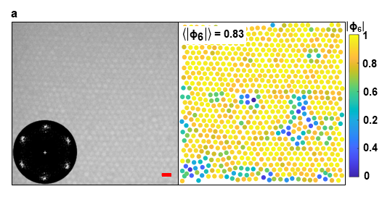 |  |  | 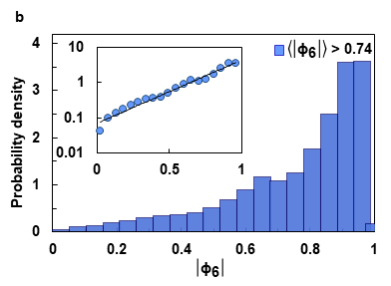
Fig.10. Crystalline structure in sample C3. a, Left: Confocal image 32.64μm x 32.00μm centered at $X=0mm, Y=0mm, Z=2μm,$red scale bar 2$μm$. Placed in the corner, the 2DFFT spectrum of the image grayscale (Methods) shows the 6 Bragg spots of a hexagonal lattice. Right: Map shows the local hexatic order parameter for each particle center $\left|φ_{6}\right|$ and the average $〈\left|φ_{6}\right|〉$ over the entire image (Methods), particles illustrated by filled circles, particles at the image boundary not included. b, A probability distribution histogram of $\left|φ_{6}\right|$ for individual particles, bin size $0.052.$ Datasets taken from images in 101 Z-stacks listed in Supplementary File 3 for which $〈\left|φ_{6}\right|〉>0.74;$ there are four such images in every stack. The insert shows a log-linear-plot of points in the histogram.
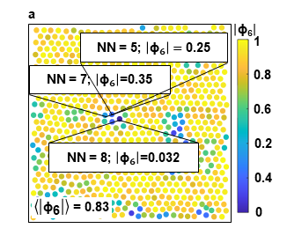 | 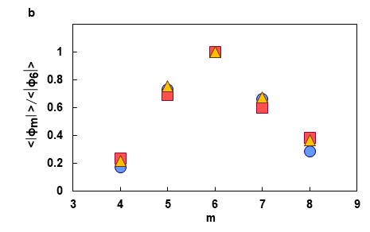
Fig.11. Crystalline structure in sample C3. a, Map for confocal image 32.64μm x32.00 μm centered at $X=0mm, Y=0mm, Z=2μm$ shows the local hexatic order parameter (or six-bond orientational parameter) for each particle center $\left|φ_{6}\right|$ and the average $〈\left|φ_{6}\right|〉$ over the entire image (Methods), particles illustrated by filled circles, particles at the image boundary are not included. Three particles with labeled low value $\left|φ_{6}\right|$ show the number of neighbors (NN). b, Plots for three images of the ratio ${{<φ}_{m}>}/{{<φ}_{6}>}$ between the $m$-bond and six-bond orientational parameters (Methods), $m = 4-8,$ averaging $〈∙〉$ over the entire image. Image center location and point labels: $X=0mm,Y=0mm,Z=2μm,$ blue circles; $X=9mm,Y=0.3mm,Z=5μm,$red squares; $X=0.097mm,Y=0mm,Z=5μm$, orange triangles.
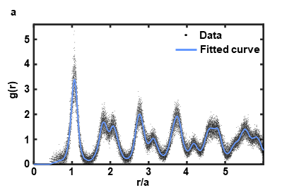 |  | 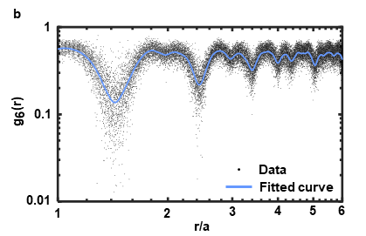
Fig.12. Crystalline structure in sample C3. Datasets taken from all images in 101 Z-stacks listed in Supplementary File 3 for which $〈\left|φ_{6}\right|〉>0.74$. Particle diameter: $a=1.32 μm$. a, 2D radial distribution function $g(r)$(Methods) of the particle centers. The smooth spline curve ($p = 1$) fits data with $R^{2}=0.93$. b, 2D bond-orientational correlation function of particle centers $g_{6}\left(r\right)$ in log-log scale. The smooth spline curve ($p = 1$) fits data with $R^{2}=0.91.$

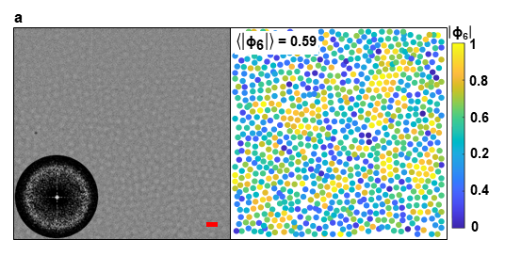 |  |  | 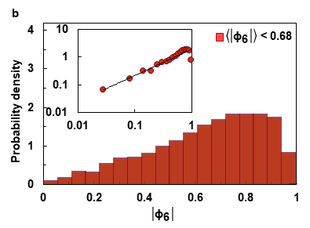
Fig.13. Disordered structure in sample C3. a, Left: Confocal image 41.51μm x 40.66μm centered at $X=-11,640μm, Y=-610μm,Z=1.0μm$ $,$red scale bar 2$μm$. Placed in the corner, 2DFFT spectrum of the image grayscale (Methods) shows the Bragg halo. Right: Map shows the local hexatic order parameter for each particle center $\left|φ_{6}\right|$ and the average $〈\left|φ_{6}\right|〉$ over the entire image (Methods), particles illustrated by filled circles, particles at the image boundary not included. b, A probability distribution histogram of $\left|φ_{6}\right|$ for individual particles, bin size $0.055$. Datasets taken from 10 images in different locations within the region: X = -11,617 $μm$ to -12,105 $μm$, Y = -610 $μm$ to + 610 $μm$, Z = 0 to 120 $μm.$The insert shows a log-log plot of points in the histogram.
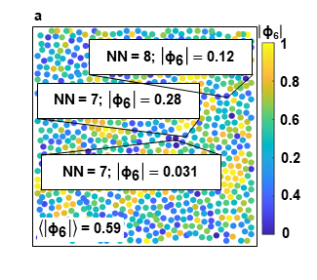 |  | 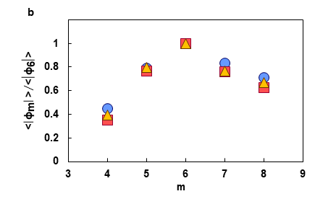
Fig.14. Disordered structure in sample C3. a, Map for confocal image 41.51μm x40.66μm centered at $X=-11,640μm, Y=-610μm,Z=1.0μm$ shows the local hexatic order parameter (or six-bond orientational parameter) for each particle center $\left|φ_{6}\right|$ and the average $〈\left|φ_{6}\right|〉$ over the entire image (Methods), particles are illustrated by filled circles, particles at the image boundary not included. Three particles with labeled low value $\left|φ_{6}\right|$ show the number of neighbors (NN). b, Plots for three images of ratio ${{<φ}_{m}>}/{{<φ}_{6}>}$ between the $m$-bond and six-bond orientational parameters (Methods), $m = 4-8,$ averaging $〈∙〉$over the entire image. Image center location and point labels: $X=-11,840μm,Y=-610μm,Z=1.0μm ,$ blue circles; $X=-11,640μm,Y=-610μm, Z=1.0μm ,$red squares; $X=-11,640μm, Y=-610μm,Z=2.6μm,$orange triangles.

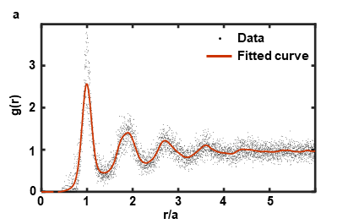 | 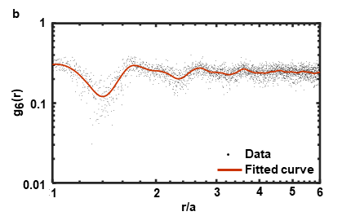
Fig.15. Disordered structure in sample C3. Datasets taken from 10 images in different locations within the region: X = -11617 $μm$ to -12105 $μm$, Y = -610 $μm$ to + 610 $μm$, Z = 0 to 120 $μm.$ Particle diameter: $a=1.32 μm$. a, 2D radial distribution function $g(r)$(Methods) of the particle centers. The smooth spline curve ($p = 1$) fits data with $R^{2}=0.91$. The first minimum of $g(r)$ is achieved at $r/a=1.44$. b, 2D bond-orientational correlation function of particle centers $g_{6}\left(r\right)$ in log-log scale. The smooth spline curve ($p = 1$) fits data with $R^{2}=0.91.$

3.3. Deformational of hexagonal lattice
Contiguous images shown in Supplementary File 1 demonstrate waviness in the X-Y plane of ordered particle rows in the central part of capillary C3. To quantify it, we measure angles between the Bragg spots in the 2DFFT spectrum in every image along 43 scans in the X and Y direction at different Z (Fig.16). A dataset on angles in a scan is then used to calculate crystal deformation along the scan (Methods). The estimated lattice deformation in the capillary is below ~15%. Small variation of the lattice deformation across the capillary gap with Z indicates that the crystal deforms in the X-Y plane in a homogeneous and uniform manner.
The observed crystal deformation may be caused by the formation of discrete domains of square lattices in a thin layer near the capillary sidewall close to the bubble (Fig.17). By measuring the positions of the Bragg spots in this region, we find that separation between particle centers in the square and hexagonal lattices is compatible. Hexagonal cells of the lattice close to the capillary sidewall are compressed up to ~17% while hexagonal cells adjacent to the square cells are not distorted. This suggests that these square cells form to accommodate elastic energy of the compressed surroundings. Because of a lack of Z stacks in this region, the 3D structure of the square lattice is not identified.

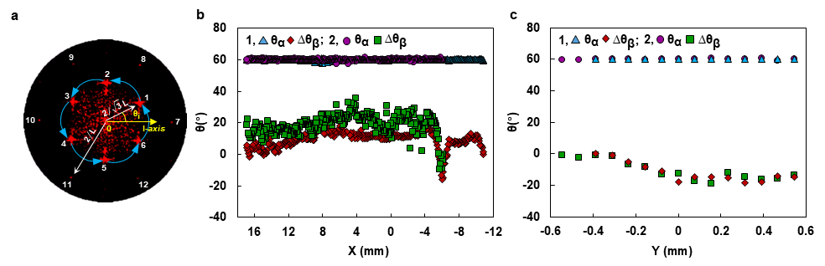
Fig.16. Waviness of ordered particle rows in sample C3. a, The 2DFFT spectrum of the grayscale over the image centered at $X=97μm,Y=-20μm,Z=5μm$ demonstrates 12 Bragg spots (Methods). Arrows represent the reciprocal vectors. Angles in the first sextet, $θ_{i},i=1,⋯6$, collected in every image in a scan in the X-Y plane are measured relative to the scan’s rightmost image. A dataset for angles in a scan is fitted by expression $θ_{i}=θ_{α}i+∆θ_{β};$ with $θ_{α}$ and $∆θ_{β}$ being used to estimate the crystal deformation along the scan (Methods). b, c: Variation of $θ_{α}$ and ${Δθ}_{β}$ along four scans: b, $X-$scans: 1 at $Y=-20μm, Z=20μm$ and 2 at $Y=-20μm,Z=120μm$. c, $Y-$scans: 1 at $X=-6mm,Z=5μm$; 2 at $X=-6mm,Z=60μm.$ Datasets on $θ_{α}$ and $∆θ_{β}$ acquired in 31 X-scans and 12 Y-scans at 14 Z locations lay in the range of the presented plots. Estimated lattice deformation is below ~15%.

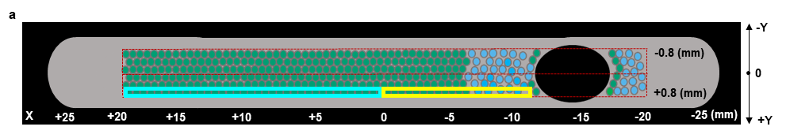
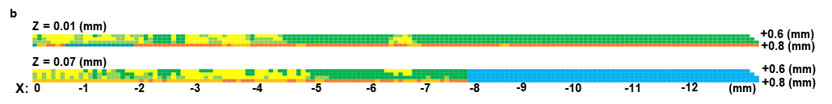
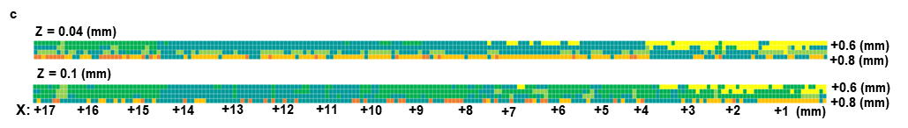
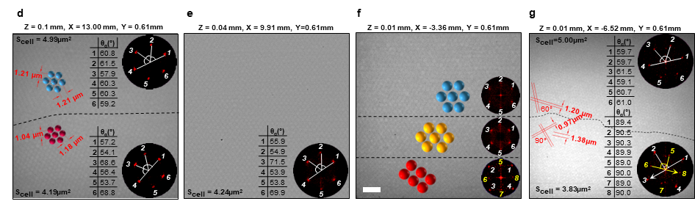
Fig.17. Particle arrangement in sample C3 close to capillary side wall. a, Red dashed lines show the area in the X-Y plane observed using a 100x oil immersion objective. Hexagonal lattice domains are indicated by green, yellow square lattice domains by yellow, and disordered particle arrangement by blue. b, c: Schematics illustrating structures formed in a thin layer, $0.6mm<Y<0.8mm,$along the capillary sidewall within two bounding boxes are shown in a, yellow border for b and cyan for c. Colored domains in b and c indicate the colloidal structure in this layer. d -g: Images of colloidal structures in this thin layer arranged in the direction towards the bubble, image center coordinates are posted, the white scale bar is 5μm long. Shown are 2DFFT spectra of the grayscale (Methods) with the Bragg spots. Tables list the counter clockwise angles between the Bragg spots, $s_{cell}$ lists the area with 6 particles in regions above and below the dashed line. d, Domains of nondeformed (top) and compressed (bottom) hexagonal lattice in the same image. e, Compressed hexagonal lattice. f, Gradual transition from hexagonal lattice (top) to square lattice (bottom) in the direction towards the capillary side wall. g, Above dashed line: nondeformed hexagonal lattice with 6 Bragg spots. Below dashed line: nondeformed square lattice with two quartets of Bragg spots, arrows with $L=1.38±0.02μm$ represent reciprocal vectors of the first and second quartets. Red schematics illustrate particle arrangement.

4. Sample C2
4.1. Crystalline and disordered phases
Sample C2 has two bubbles at either end of the capillary (Fig.18a). The left bubble grew slightly and migrated slowly to the right even during the ISS sessions, while the right bubble neither moved nor changed size during the entire experiment. Several domains with the ordered particle arrangement in the X-Y plane are seen in Fig.18a. Their area reduces rapidly with increasing Z and disappears below $25μm$ from the capillary top.
Measurements of the particle number area density using over ~3,400 images demonstrate a highly homogeneous particle distribution between two bubbles with the area density number of particle centers $ρ_{N}=0.64±0.04{μm}^{-2}$. We analyze the structure of domains with the ordered particle arrangement in sample C2 in a similar way to sample C3. Stitched images in Fig.18b show that particles form a hexagonal lattice in the X-Y plane with $L=1.33±0.02μm$ for the separation between particle centers. The planar density of particles in the lattice $2/{\sqrt{3}L^{2}}≈0.65{μm}^{-2}$ agrees well with direct measurements. A two-dimensional (2D) radial distribution function $g(r)$(Methods) demonstrates the particle ordering at the image scale (Fig.19a). A one-dimensional discrete Fourier Transform (1DFT) of the grayscale (Methods) was computed along the particle rows for over 30 stitched images and is presented in Fig.19b. The presence of two sharp peaks $k_{1}=1/L$ and $k_{2}=2/L$ with $L≈1.33μm$ confirms long-range particle ordering.
Fig.20a illustrates the local hexatic order parameter (or six-bond orientational parameter) of individual particles $\left|φ_{6}\right|$ in this image. $\left|φ_{6}\right|$ fluctuates within $\sim 0.1-0.9$, even though its average value over the image is $〈\left|φ_{6}\right|〉=0.79$ and the 2DFFT spectrum of the image grayscale (Methods) shows 12 Bragg spots. Fig.20b demonstrates oscillation of $⟨\left|φ_{6}\right|⟩$ in the Z-direction in consecutive images collected in Z-stacks taken at four different X, Y locations within a crystalline domain. Images with large $〈\left|φ_{6}\right|〉$ are centered in hexagonal particle planes, whereas images with a lower $〈\left|φ_{6}\right|〉$ are situated in the space between them. In Fig.20c, we take two triplets of images with the maxima values of $〈\left|φ_{6}\right|〉$ from the same stack and overlay $X$,Y positions of their particle centers. The similarity between images in this figure and Fig.3b demonstrates that the FCC structure also forms in sample C2.
Following the procedure for sample C3, we take 20-25 images (total ~2,648 particles) in each of three Z-stacks centered in different locations within crystalline domains to find four images with peak values of $⟨|φ_{6}|⟩,$ mark them 1-4, project particle centers from these images on the $X-Y$ plane and measure separation $δ$ between the nearby particle centers in two layers numbered: 1&2, 2&3, 3&4, 1&3, 2&4, and 1&4 (Fig.21). The similarity between histograms in this figure and Fig.7 confirms the FCC structure formation in sample C2. The FCC crystal constant is $A=L\sqrt{2}=1.88±0.03μm$. Expressions following from the FCC geometry yield $A/{\sqrt{3}}=1.09±0.02μm$ for the distance between (111) planes and $A/{\sqrt{6}}=0.77±0.02μm$ for the separation between the nearby particle centers in projection of closely packed spheres on the $X-Y$ plane. The former agrees well with the measured distance between planes with peak values of $\left\langle \left|φ_{6}\right|\right\rangle :$ $∆Z=1.09±0.03μm$ in Fig.20b. The latter marked as $δ^{*}$ is consistent with the datasets in histograms in Fig.21. The particle volume fraction computed for the FCC crystal in sample C2 is $φ=2{π{\left(a/A\right)}^{3}}/3=0.69±0.04$, where the particle diameter $a=1.30±0.02μm$.
We analyze waviness in the X-Y plane of ordered particle rows in crystalline domains in sample C2 similarly to sample C3 (Fig.22). The estimated lattice deformation, below ~3%, is significantly smaller than in sample C3.
Fig.23a shows a confocal image taken within the domain with a disordered arrangement of particles. The 2DFFT spectrum of the image grayscale (Methods) in the corner shows the Bragg halo. Figs.20a and 23a show that the crystalline and disordered phases exhibit a similar range of fluctuations for the local hexatic order parameter (or six-bond orientational parameter) of individual particles $\left|φ_{6}\right|\sim 0.1-0.9.$ Datasets on the 2D radial distribution function $g(r)$ of particle centers (Methods) demonstrate that these local fluctuations of $\left|φ_{6}\right|$ do not destroy the particle spatial and orientational order on the image scale (Figs 15a and Fig.23b). The first minimum of $g(r)$ for the disordered state is achieved at $r/a=1.36$. Extrapolation with the equation²⁰ predicts the particle volume fraction $φ\sim 0.63$ for this state.
The particle ordered arrangement away from the capillary top is likely suppressed by displacement and shear generated by the left bubble evolution. Images placed in Figs 24 and 25 demonstrate that a transition between regions with ordered and disordered particle arrangements in the $X-Y$ plane is smooth at the particle level. The 2DFFT spectra of the image grayscale (Methods) shown in these figures presented six Bragg spots for a hexagonal lattice in crystalline regions and the Bragg halo in disordered regions.

4.2. Thermophoresis
Capillaries with C1, C2, and C3 colloids were mounted in a sample module on a copper thermal bridge equipped with Peltier heaters on both ends (Methods) to explore effects of thermophoresis, such as, can one induce a density gradient along the capillary by imposing a temperature gradient. Sample C2 was chosen to initiate testing due to the presence of domains with ordered and disordered particle arrangements. In total, we conducted 4 scans along the X direction, 62 Z-stack scans, and 5 videos during the exposure of this sample to a temperature gradient.
We first created a temperature gradient of $0.4℃/{mm}$ along the channel (in the X-direction, Fig. 1a) by heating one of the bridge ends to 45°C (the maximum temperature available) and the set the other to 25°C. However, confocal imaging did not reveal any motion of both bubbles as well as of particles in either domain of the particle arrangement, even near the bubble surface.
We then heated both ends of the thermal bridge to 45° to create a temperature gradient of ${11℃}/{mm}$ across the channel (in the Z direction, Fig. 1a) between the thermal bridge and a 100x oil immersion objective maintained at a cabin temperature of 23°C. It took 20-30 min to stabilize the Peltier temperature. The sample was exposed to this temperature gradient for several hours while we collected confocal images. These images were compared to previously collected images in nearby locations. To quantify the particle displacement, we measured the area density number of particle centers within domains of the ordered and disordered particle arrangements before and after the test. To confirm results, we repeated this test in another ISS session. The exposure of sample C2 to the temperature gradient in the Z direction does not destroy the arrangement of particles in the FCC structure nor facilitates transition of the disordered particle arrangement to a more ordered state (Fig. 26). The area density number of particle centers measured after tests on over ~20 images for each type of particle arrangement falls within the range $ρ_{N}=0.64±0.04{μm}^{-2}$ found for ~3,400 images before conducting these tests (Fig.26).

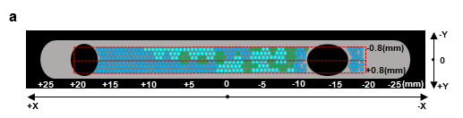
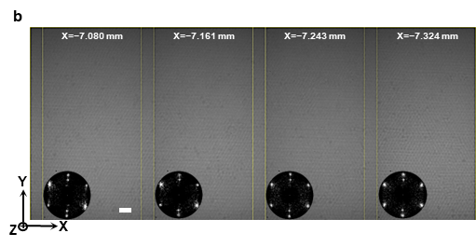
Fig.18. Sample C2. a, Particle arrangement in the X-Y plane at $Z=5μm$. Red dashed lines show the area observed with 100x oil immersion objective. Domains with the ordered particle arrangement indicated by green, with both ordered and disordered arrangements by cyan, and with disordered arrangement by blue. b, Four images, $51.84μm×77.88μm$, stitched along the $X$ axis at $Y=0.4mm,Z=5μm$ by ImageJ (Methods) with a ~10% overlap indicated by yellow lines; white scale bar $5μm.$ Placed in the corner, 2DFFT spectrum of the image grayscale (Methods) shows 6 Bragg spots of hexagonal lattice.
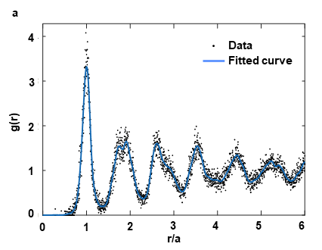 | 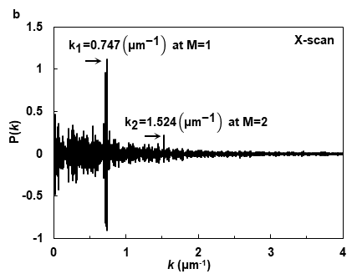
Fig.19. Particle arrangement in crystalline domain of sample C2. a, Black dots present the 2D radial distribution function $g(r)$ (Methods) of the particle centers in the hexagonal lattice, image centered at $X=-7,075μm,Y=0.3mm,Z=5μm;$ $X=-7,150μm,Y=0.3mm,Z=5μm$; $X=-9,000μm,Y=0.3mm,Z=0μm$. The smooth spline curve ($p=1$) fits the data with $R^{2}=0.94$, particle diameter $a=1.30μm$. b, The normalized 1DFT of the grayscale (Methods) through lines across the particle centers in the hexagonal lattice over 30 stitched images in the X scan at $Y=0.4mm,Z=5μm$ demonstrates two peaks $k_{1}=1/L$ and $k_{2}=2/L$ with $L≈1.33μm$.

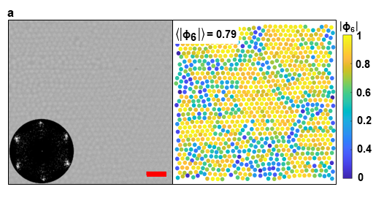 | 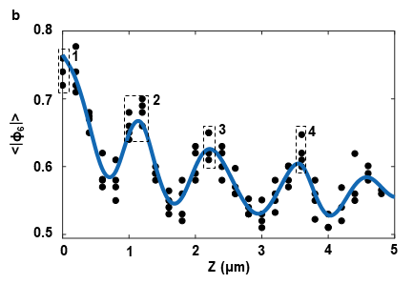
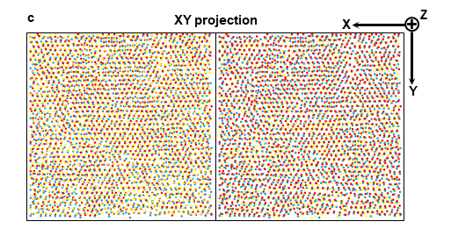
Fig.20. Particle arrangement in crystalline domain of sample C2. a, Left: Confocal Image $39.44μm×39.44μm$ centered at $X=-9.0mm,Y=0.3mm,Z=0μm,$ red scale bar $5μm$. 2DFFT spectrum of the image grayscale (Methods) in the corner shows 6 Bragg spots of the hexagonal lattice. Right: Map shows the local hexatic order parameter (or six-bond orientational parameter) for each particle center $\left|φ_{6}\right|$ and the average $〈\left|φ_{6}\right|〉$ over the entire image (Methods), particles illustrated by filled circles; particles at the image boundary were not included; $\left|φ_{6}\right|$ fluctuates within $\sim 0.1-0.9$. b, Oscillation of $⟨\left|φ_{6}\right|⟩$ in the Z-direction in consecutive images from stacks taken at four different X, Y location:$X=-7.0mm,Y=0.5mm,Z=5μm;$ $X=-7.075mm,Y=0.3mm,Z=5μm;$ $X=-7.150mm,Y=0.3mm,Z=0μm;$ $X=-9.0mm,Y=0.3mm,Z=5μm.$ Fitting data with a smoothing spline curves yields $∆Z=1.09±0.03μm$ for the separation between peaks of $\left\langle \left|φ_{6}\right|\right\rangle .$ c, An overlay in the $X-Y$ plane of particle centers (labeled in yellow, red and blue) is taken from a triplet of stacking images with peak values of $〈\left|φ_{6}\right|〉$ marked in b: 1,2,3 on the left and 2,3,4 on the right; stack at $X=-9.0mm, Y=0.3mm, Z=5μm$. The yellow lattice has its points surrounded by both a triangle of red points and a triangle of blue points in both overlay that demonstrates the signature of FCC crystal.

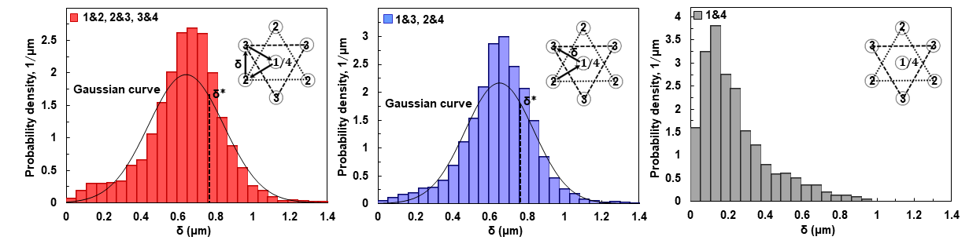
Fig.21. Sample C2. A probability distribution histogram with a bin size of $0.05μm$ for separation 𝛿 between nearby projections of particle centers in pairs of images in three Z-stacks centered at $X=-7.0mm,Y=0.5mm,Z=5μm;$ $X=-7.075mm,Y=0.3mm,Z=5μm;$ $X=-9.0mm,Y=0.3mm,Z=5μm.$ Left: 1&2, 2&3, 3&4. Middle: 1&3, 2&4. Right: 1&4. Averaged over all Z-stacks, the mean and standard deviation for $δ$ are: Left: $0.64±0.20μm;$ Middle: $0.65±0.18μm$; Right: $0.24±0.18μm.$ $δ^{*}= L/{√3}=0.77μm$ for ideal FCC crystal with $L=1.33±0.02μm$. Left and middle histograms are well fitted by the Gaussian curves.
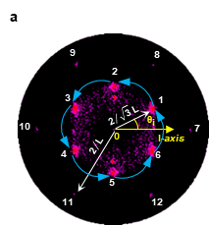 | 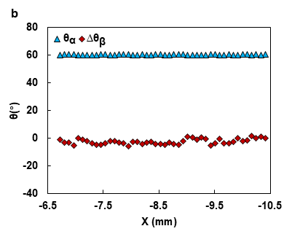 | 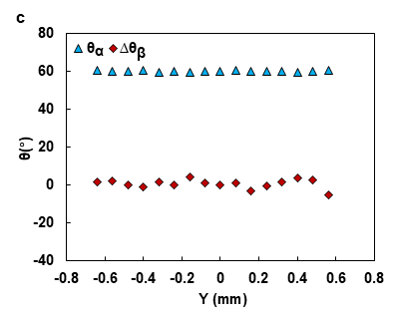
Fig.22. Waviness of ordered particle rows in sample C2. a, The 2DFFT spectrum (Methods) of the grayscale over this image in a crystalline domain centered at $X=-8.79mm,Y=0.4mm,Z=5μm$ demonstrates 12 Bragg spots of hexagonal lattice. Arrows represent the reciprocal vectors fitted with $L≈1.33μm$. Angles in the first sextet $θ_{i},i=1,⋯,6$ are measured in every image in a scan in the X-Y plane relative to the scan rightmost image. A dataset on angles in a scan are fitted by expression $θ_{i}=θ_{α}i+∆θ_{β};$ with $θ_{α}$ and $∆θ_{β}$ being used to estimate the crystal deformation along the scan (Methods). b, c: Variation of $θ_{α}$ and $∆θ_{β}$ in two scans within crystalline domains: b, X-scan at $Y=0.4mm,Z=5μm$. c, Y-scan at $X=-10.1mm,Z=5μm.$ Estimated lattice deformation is below ~3%.

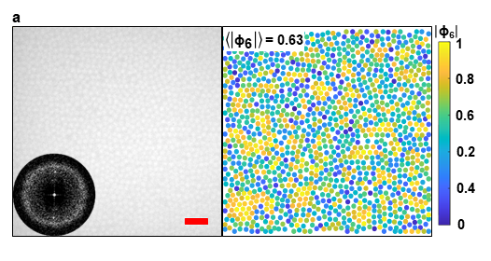 | 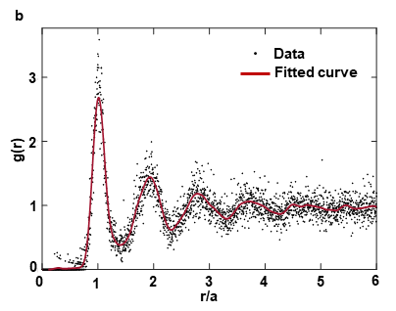
Fig.23. Disordered particle arrangement in sample C2. a, Left: Confocal image, $41.7μm×41.7μm$ , with $\left\langle \left|φ_{6}\right|\right\rangle =0.63$ centered at X = 0 mm, Y = 0 μm, Z = 16.5 μm, red scale bar $5μm.$2DFFT spectrum of the image grayscale (Methods) in the corner shows the Bragg halo. Right: Map shows the local hexatic order parameter (or six-bond orientational parameter) for each particle center $\left|φ_{6}\right|$ and the average $〈\left|φ_{6}\right|〉$ over the entire image (Methods), particles illustrated by filled circles; particles at the image boundary not included; $\left|φ_{6}\right|$ fluctuates within $\sim 0.1-0.9$. b, 2D radial distribution function $g(r)$(Methods) of the particle centers in three images centered at X = -10,046µm, Y = 100µm, Z = 5µm; X = -9,463µm, Y = 100µm, Z = 5µm; X = 0µm, Y = 0µm, Z = 16.5µm. The smooth spline curve ($p = 1$) fits the data with $R^{2}=0.91,$particle diameter $a=1.30μm.$ The first minimum of $g(r)$ is achieved at $r/a=1.36$.

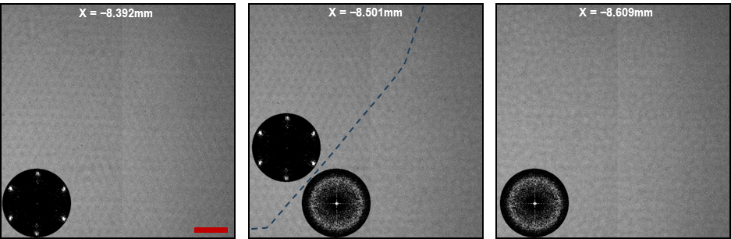
Fig.24. Order- disorder transition in sample C2. Particle arrangement in the X-Y plane in three images, 34$.68μm×34.68μm$ in the scan along the X direction at $Y=0, Z=10μm;$X coordinates listed, red scale bars $5μm$. 2DFFT spectra of the image grayscale (Methods) show 6 Bragg spots of hexagonal lattice in crystalline regions and the Bragg halo in disordered regions. A dashed line is drawn to indicate a boundary between these regions.
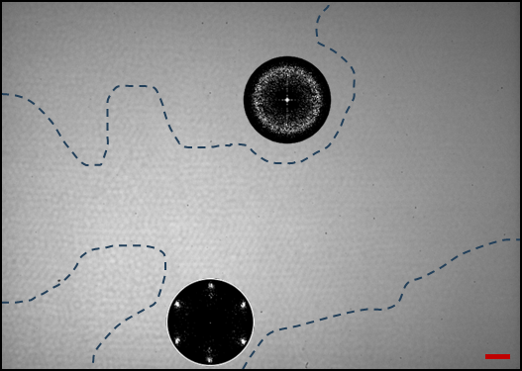
Fig.25. Order- disorder transition in sample C2. Left: Particle arrangement in the X-Y plane in image $103.20μm×73.08μm$ centered at $X=-4.280mm, Y=300μm, Z=5μm$, red scale bar $5μm$. Inserts show 2DFFT spectra of the image grayscale (Methods) with 6 Bragg spots in the region with the ordered particle arrangement and the Bragg halo in the region with the disordered particle arrangements. Dashed lines are drawn to indicate boundaries between these regions.

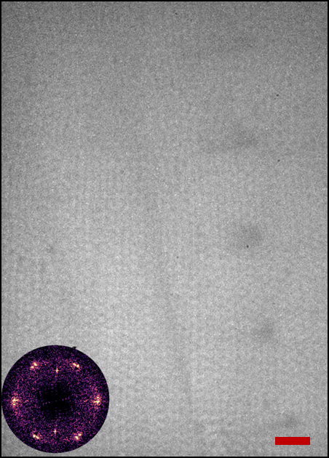 | 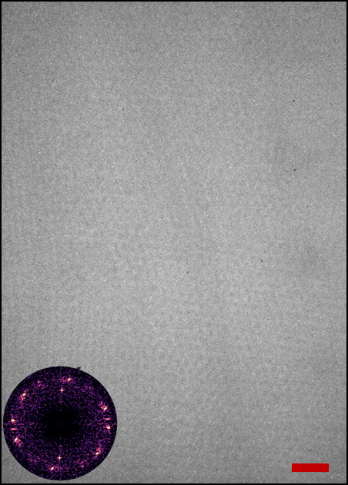
Fig. 26. Crystalline structure in sample C2 exposed to a temperature gradient of ${11℃}/{mm}$ across the channel. Left, before, and right, after the test. Image $8.64μm x 67.32μm$ centered at $X = -8,654 μm , Y=400 μm, Z = 5 μm$; red scale bar $5μm.$ 2DFFT spectra of the image grayscale (Methods) with inserts showing the 6 Bragg spots of a hexagonal lattice, reciprocal vectors fitted with $L≈1.33μm$. The area density number of particle centers, $ρ_{N}=0.64±0.04{μm}^{-2}$ does not change in the test$.$

5. Sample C1
Sample C1 dried out and lost transparency in the bulk. Images in a thin layer under the capillary top show irregular patches of dried particles arranged in a well-defined hexagonal lattice (Fig.27). Similar 2D honeycomb structures of touching particles were observed in the ISS experiments on polymer based colloids²².
Wet particles adjacent to and under ordered patches remain disordered. Fig.28a shows fluctuations of the local hexatic order parameter (or six-bond orientational parameter) of individual particles, $\left|φ_{6}\right|\sim 0.1-0.9,$ in this domain. Datasets on the 2D radial distribution function $g(r)$ of particle centers (Methods) demonstrate that these local fluctuations of $\left|φ_{6}\right|$ do not destroy the particle spatial arrangement on the image scale (Fig.28b). The first minimum of $g(r)$ is achieved at $r/a=1.38$. Extrapolation of the equation²⁰ predicts the particle volume fraction $φ\sim 0.61$ for this state.
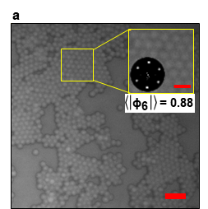 | 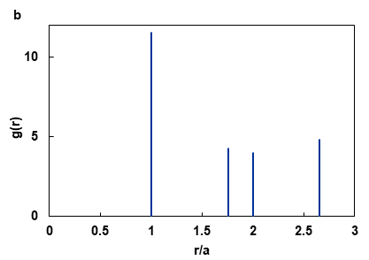
Fig.27. Ordered particle arrangement in sample C1. a, Image, 40.68µm X 40.68µm, centered at $X=-1.315mm,Y=200μm,Z=1μm,$ red scale bar $5μm$. Insert: Particles form a hexagonal lattice by touching one another; the 2DFFT spectrum of its grayscale (Method) shows 6 Bragg spots of the lattice; listed $\left\langle \left|φ_{6}\right|\right\rangle$ (Methods) is the average over the region; red scale bar 2$μm$. b, Peaks present the 2D radial distribution function $g\left(r\right)$ (Methods) of the particle centers in the region; particle diameter $a=1.32μm$
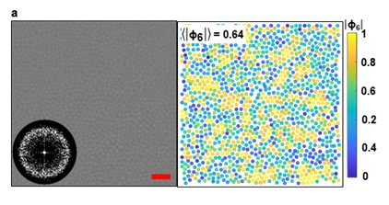 |  | 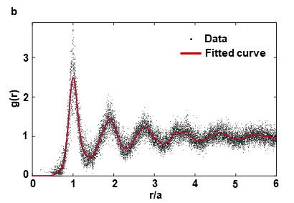
Fig.28. Disordered particle arrangement in sample C1. a, Left: Confocal image 40.68µm x 40.68µm, with $\left\langle \left|φ_{6}\right|\right\rangle =0.64$ centered at $X=5.8mm,Y=0.5mm,Z=18μm$; red scale bar $5μm$ 2DFFT spectrum of the image grayscale (Methods) in the corner shows the Bragg halo. Right: Map shows the local hexatic order parameter (or six-bond orientational parameter) for each particle center $\left|φ_{6}\right|$ and the average $〈\left|φ_{6}\right|〉$ over the entire image (Methods), particles illustrated by filled circles; particles at the image boundary not included; $\left|φ_{6}\right|$ fluctuates within $\sim 0.1-0.9.$b, 2D radial distribution function $g(r)$(Methods) of the particle centers in 20 images at different locations: X = -8,901µm to +8,985µm, at Y = -400µm, Z = 1µm and X=5,800µm, Y = 500µm, Z = 18μm. The smooth spline curve ($p = 1$) fits the data with $R^{2}=0.88;$particle diameter $=1.32μm$. The first minimum of $g(r)$ is achieved at $r/a=1.38.$

