Table.S1 Metabolic gene qPCR primer sequences.
Name | Encode Enyzme |  | Forward | Reverse
GAPDH  (Endogenous Control gene) |  | Glyceraldehyde-3-phosphate dehydrogenase | GGAATTGCAATTAGAGTCCCAGT | TCGCTGGAAACGATTGGCTC
deoB | Phosphopentose isomerase |  | AGCTCTCGGCCAGAATGAAA | GAATCAAGAATTGATTTCGGCGG
fba | Fructose-1,6-bisphosphate aldolase |  | TCCCAGTCGCTCTCCATTTG | GCCAACTTCAGCTTCAACGG
pdhB | Pyruvate dehydrogenase |  | CGAAACCGTTCTCGCAGT | GCGGCAATTAAAAGTCCCTTTG
ldh | Lactate dehydrogenase |  | TTCCGATTAGTGTCTCCCGTTAT | TTATCAGCTACTAATTCAAGCCGAG
Table S2. Primer sequences of virulence gene qPCR.
Name | Function | Forward | Reverse
P97 | Adhesion | AGTTCATCAAAGCGAGTA | ATCATTGGGTGGCTAAGTTTCTG
P216 | Adhesion; Enhanced colonization ability | GGGACAGTTGTTGGCTTGG | AATTCCGAGATAACCACCTGATA
P146 | Enhanced adhesion and inflammatory response | ATTGCCTCTTCTTGGTTTCCG | CGGGAAACTGATTTTTCAGTCGA
P95 | Adhesion; Immune interference | CCCGAGTTAGTAAAGGTTCAGCA | GGACCTTCATCCTGGGAATCTG
rnc | Encodes ribonuclease III | CGAATTTCACTAGCACCTCTACC | GGGAAATTCAACCCAAATTCGATCC
smf | Encodes DNA-processing proteins that maintain genome stability | GTGATCCACCTGATTTCCGAATTG | ATCTCTGAATATCCAACAGGATGC
Supplementary Figures & Tables in Results
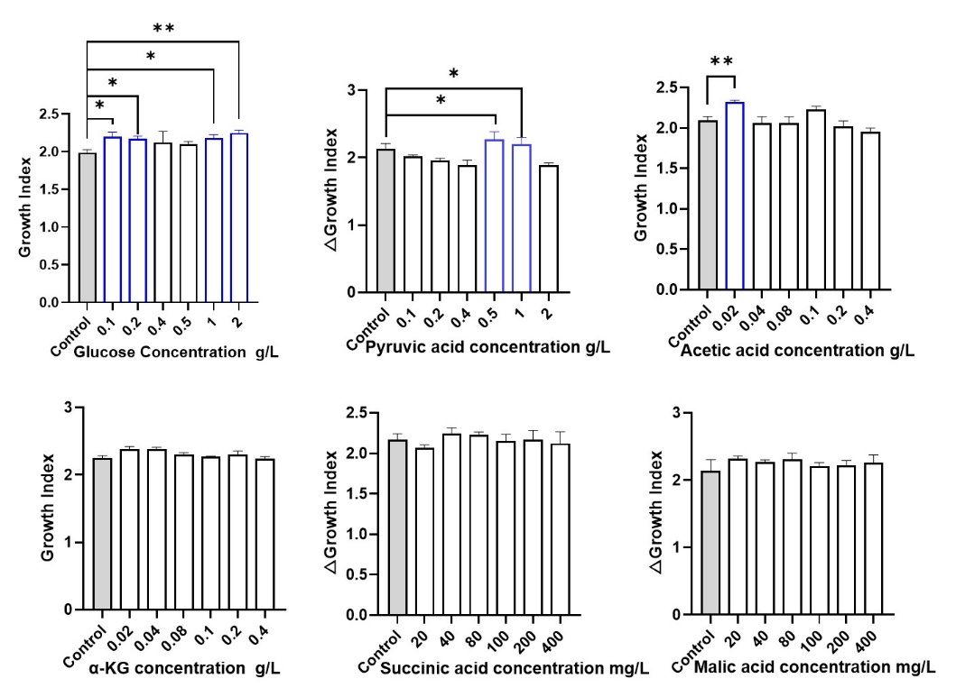
Fig. S1 The influence of adding glucose and organic acids on the growth of Mhp
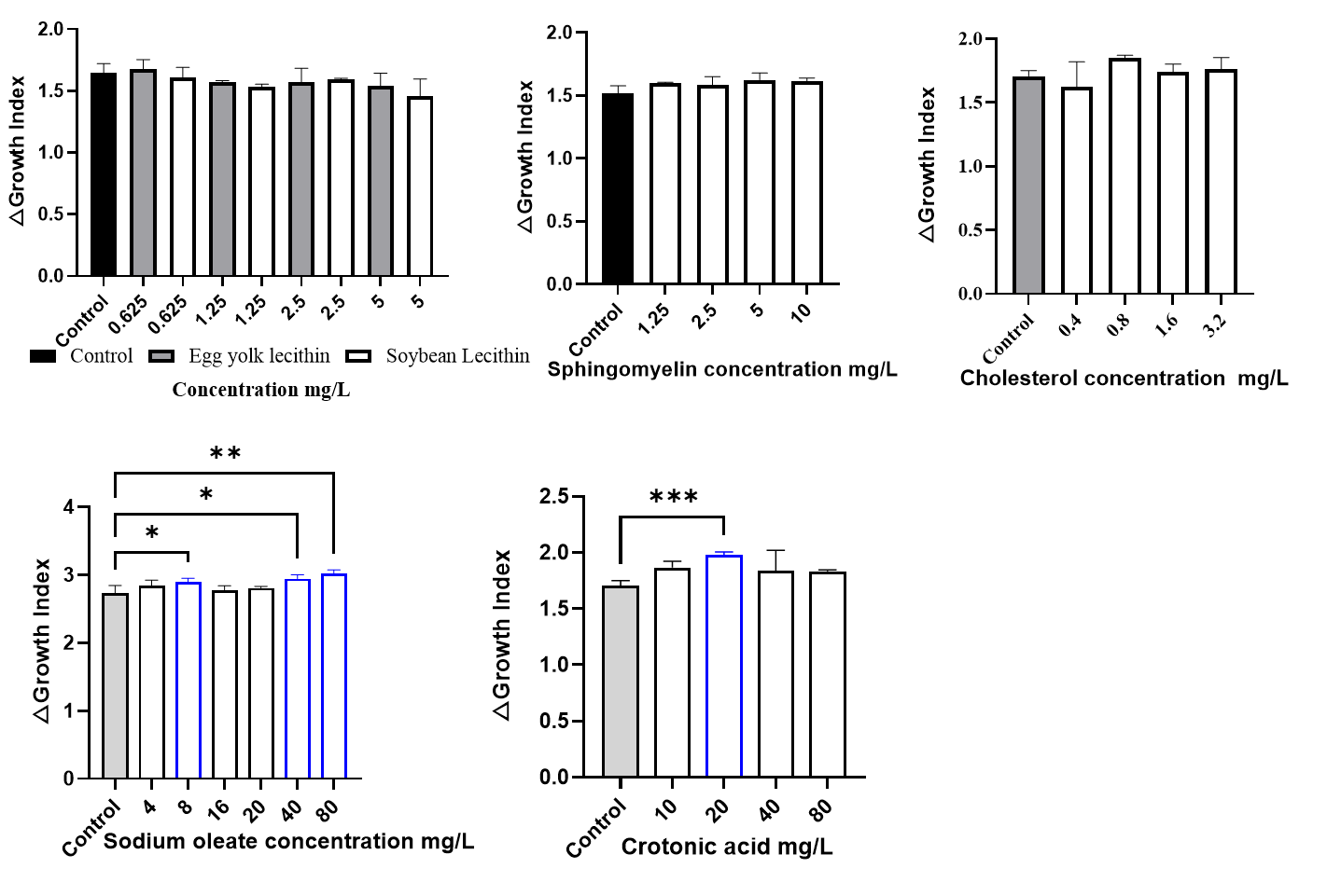
Fig. S2 The influence of adding lipid substances on the growth of Mhp
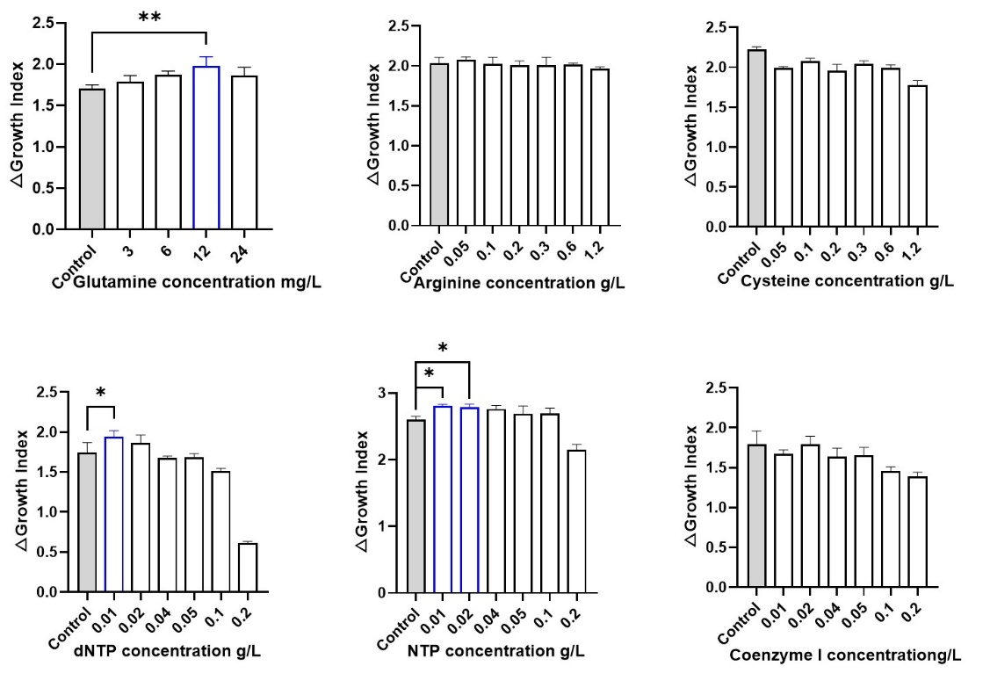
Fig. S3 The influence of adding amino acid and nucleotide substances on the growth of Mhp

