Supplementary materials

Figures 3 and 4 show mean diagnostic delay by age at ADHD diagnosis for men and women, with and without anxiety disorders by gender. They illustrate how diagnostic delay remains relatively constant across age for men, while it increases after approximately 25 years of age for women. When accounting for anxiety disorders, the increase in diagnostic delay by age among women appears linked to this associated anxious symptomatology.

Figure 3 : Mean diagnosis delay by age at ADHD diagnosis for men and women.

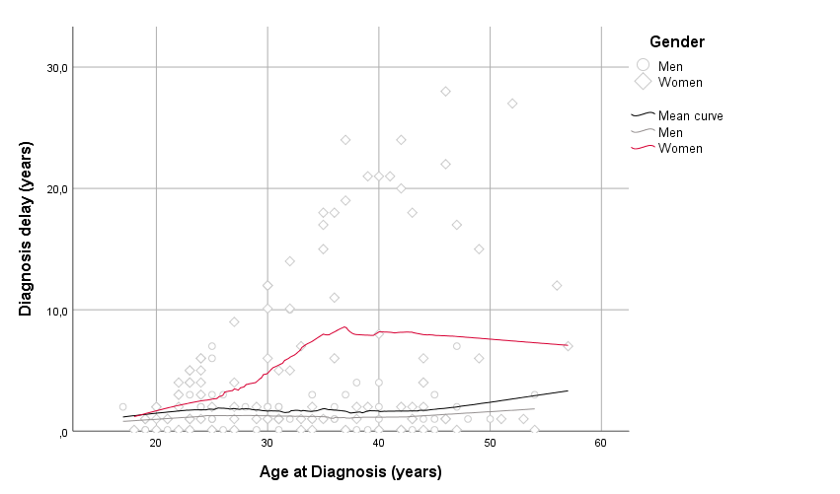

Figure 4 : Mean diagnosis delay by age at ADHD diagnosis for men and women, with or without anxiety disorders.

