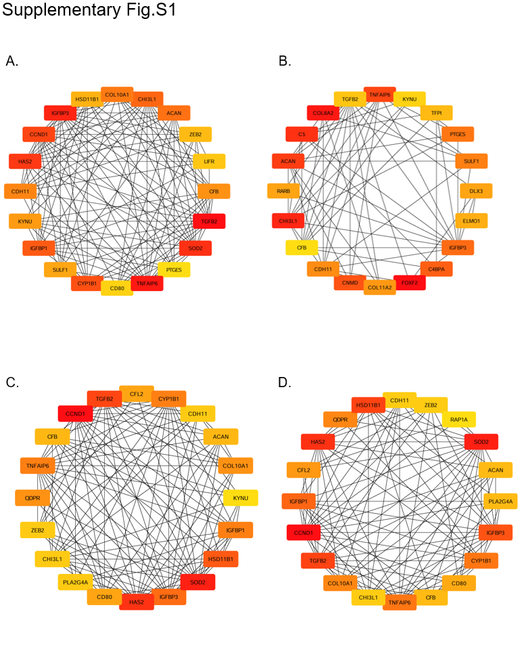
Supplementary Fig.S1: PPI network for screening top20 candidate genes by four cytohubba algorithms.
(A-D) Four types od cytohubba algorithms which are Degree algorithms, MNC algorithms, DMNC algorithms and MCC algorithms.
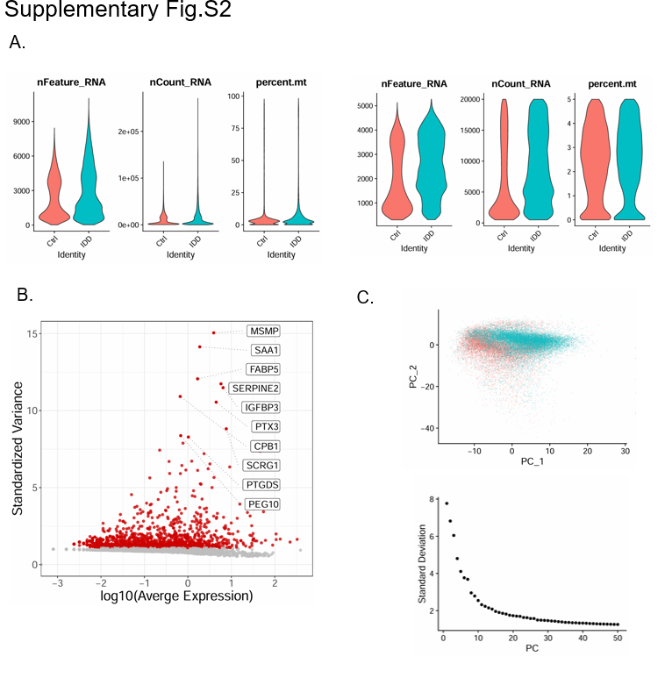
Supplementary Fig.S2:
(A) Number of genes, gene expression count and percentage distribution of mitochondrial genes after data filtering. Quality-control violin plots displaying key single-cell RNA-seq metrics across the two experimental groups (Ctrl vs. IDD). (B) Screening of highly variable genes. Scatter plot showing the log-transformed average expression (log10) of selected genes across cell subsets. Each point represents a gene, with its position indicating expression level on the y-axis. Key genes are labeled, including MSMP, SAA1, FABP5, SERPINE2, IGFBP3, PTX3, CPB1, SCRG1, PTGDS, and PEG10. The dashed horizontal line at y = 10 serves as a reference threshold for high expression. (C) PCA dimension reduction analysis diagram and PCA gravel diagram. Top figure shows principal-component analysis (PCA) plot of single-cell transcriptomes. The bottom figure is a bar plot showing the percentage of variance explained by the first 50 principal components.

