Interventions with dual benefits for climate change and nutrition: a systematic scoping review, mapping and synthesis

Supplementary Results

Table of Contents

Supplementary Fig. 1: Framework of interventions with benefits for human nutrition and/or climate outcomes 2
Supplementary Fig. 2: PRISMA flow diagram of included studies. 3
Supplementary Fig. 3: Bar chart of the number of included studies (n=607) by year of publication, disaggregated by study design 4
Supplementary Fig. 4: Bar chart of the number of included studies (n=607) by year of publication, disaggregated by World Bank country income classification. 5
Supplementary Fig. 5: Summary of risk of bias across experimental and quasi-experimental studies (n=124). 6
References for Supplementary Results 7

Supplementary Fig. 1: Framework of interventions with benefits for human nutrition and/or climate outcomes
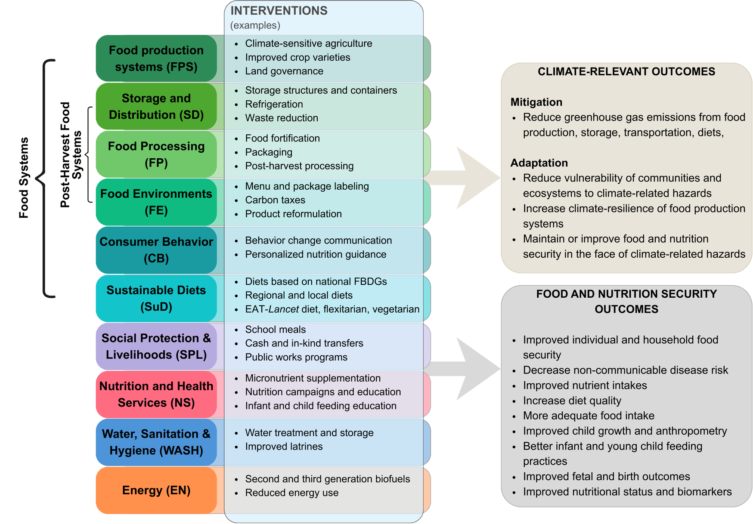
Adapted from FAO, Climate Action and Nutrition - Pathways to Impact,¹ to include additional food systems areas and sectors. Post-harvest food system areas (storage and distribution, food processing, food environments) were included as gap areas. Consumer behavior interventions operate on individual factors that determine food choice and diets (including their sustainability aspects) are considered an outcome of food systems.² The energy sector was also included. FBDG, food-based dietary guidelines.

Supplementary Fig. 2: PRISMA flow diagram of included studies.
The figure summarizes the search strategy and inclusion/exclusion chart associated with our systematic review and evidence and gap map concerning interventions with dual climate and nutrition benefits.

Supplementary Fig. 3: Bar chart of the number of included studies (n=607) by year of publication, disaggregated by study design

* The year 2024 includes records from a search up to September 11, 2024

Supplementary Fig. 4: Bar chart of the number of included studies (n=607) by year of publication, disaggregated by World Bank country income classification.

*The year 2024 includes records from a search up to September 11, 2024

Supplementary Fig. 5: Summary of risk of bias across experimental and quasi-experimental studies (n=124).
Fig. S5a) shows the response breakdowns on whether studies adequately control the risk of bias from each of the seven categories; S5b) shows the percentage of studies according to the three overall risk of bias ratings (critical, high and medium). No studies were classified as having low risk of bias.

References for Supplementary Results

1. FAO. Climate Action and Nutrition - Pathways to Impact. http://dx.doi.org/10.4060/cc8415en (2023) doi:10.4060/cc8415en.
2. Fanzo, J. et al. The Food Systems Dashboard is a new tool to inform better food policy. Nat Food 1, 243–246 (2020).

