The nerve injuries interfere with the development of psoriasis

Supplementary material

#1. The surgical denervation
#2. Annotation of skin denervation surgery
#3. RNA sequencing and bioinformatics analysis
#4. Case of thigh psoriasis aggravated by herpes zoster
#5. Delayed recovery of psoriasiform dermatitis by denervation surgery

#1. Surgical denervation operation procedure

1). Intraperitoneally inject anesthetic of pentobarbital sodium.
2). Disinfect the dorsal skin with 75% alcohol.
3). Cut the skin along the midline of the back using a sterile scalpel. Expose the subcutaneous tissue from the scapular fat pad near the neck to the position on the hind limb.
4). Bluntly separate the right skin and subcutaneous tissue from the incision, and expose the nerves located at the right anatomical site of T3-12. They are in white dendritic branch appearance.
5). The nerves at the bend of the wall were cut off and removed off the position where they enter the skin.
6). The distal branches of the dorsal cutaneous nerves scattered in the dermal connective tissue were also removed.
7). On the left side, only perform the blunt separation of the skin and subcutaneous tissue to expose the nerves. No surgery was performed and the nerves remain intact.
8). During the whole operation, the adjacent blood vessels were protected, and 0.9% saline was applied regularly to keep the tissue moist.
9). After the operation, suture the skin intermittently using 4.0 absorbable suture.
10). Mice were kept warm, and monitored until regaining consciousness, and then put into the cage after awakening.
11). Use surgical tweezers to gently pinch the skin on both sides, and observe the reactions of mice. Under normal circumstances, mice will turn their heads or shake when stimulated by pain. No response or weakened response of mice suggests that the operation of denervation is successful.
12). Immunofluorescence staining of protein gene product 9.5 (PGP9.5) was performed to further demonstrate the successful intervention on the nerves.

#2. Annotation of skin denervation surgery.

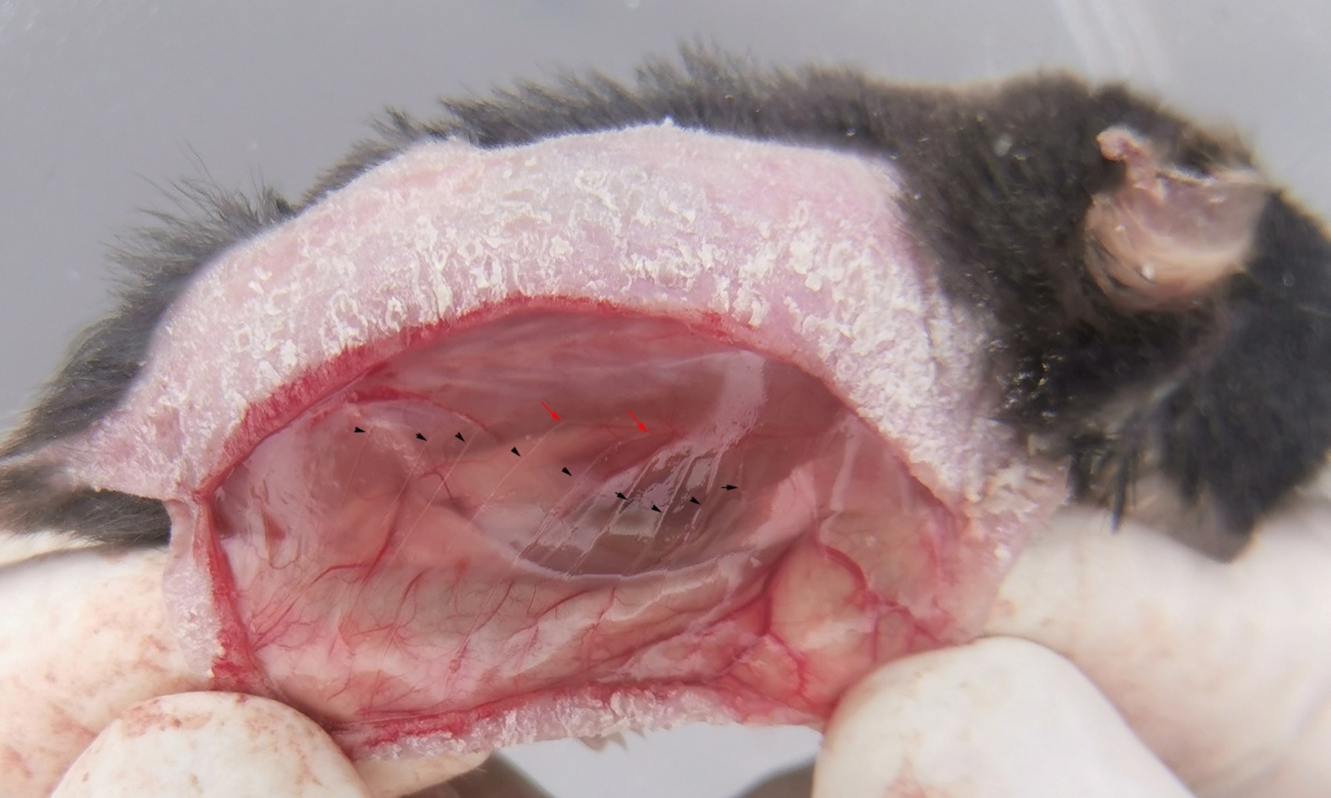

The dorsal cutaneous nerves of white dendritic branch appearance (T3-12) were exposed and cut off by the surgery of skin denervation. The black arrowheads indicate the dorsal cutaneous nerves, and red arrows indicate the sites where the nerves are cut off.

#3. RNA sequencing and bioinformatics analysis
3.1 Sample and RNA isolation
Total RNA was extracted using RNeasy FFPE kit (Qiagen, Hilden, Germany) according to the manufacturer’s protocol.The quality and integrity of total RNA were measured using Agilent 4200 TapeStation (AgilentTechnologies, CA, USA), and the concentration was assessed by NanoDrop One (Thermofisher Scientific, DE, USA).The samples with RNA integrity values ≧6.5 and the apparent ratio of 28S rRNA to 18S rRNA ≧1.0 were used for library preparation.
3.2 Library preparation and Illumina PE150 sequencing
Sequencing libraries were prepared using NEBNext® Ultra™ RNA Library Prep Kit for Illumina® (NEB, USA) following the manufacturer’s recommendations. Briefly, mRNA was first purified from total RNA using poly-T oligo-attached magnetic beads, and fragmentation was carried out using divalent cations under elevated temperature in NEBNext First Strand Synthesis Reaction Buffer (5X). First strand cDNA was synthesized using random hexamer primer and M-MuLV Reverse Transcriptase (RNase H-). Subsequently, second strand cDNA was synthesized using DNA Polymerase I and RNaseH. Then end-repair, A-tailed, and adaptor ligation were performed.The cDNA fragments with 200bp were selected using the AMPure XP system (Beckman Coulter, Beverly, USA) through purifying the fragments. Then PCR was performed on these cDNA fragments.Finally, PCR products were purified using AMPure XP system. The quality of librarieswas assessed using Kapa qPCR and Agilent 4200 TapeStation. At last, the libraries were used for paired-end (PE) sequencing with the Illumina PE150 platform.
3.3 Data analysis
3.3.1 Quality control and reads mapping. Raw reads produced from sequencing may contain dirty reads with adapters, unknown or low quality bases. These reads negatively affect the following bioinformatics analysis, and were removed using Fastp software (Bioinformatics. 2018;34:i884-i890). Clean reads were mapped to the reference mouse genome (NCBI37/mm10) using HISAT2. HISAT (http://www.nature.com/nmeth/journal/v12/n4/full/nmeth.3317.html) was published (Nature Methods, 2015;12:357-360.) with a better mapping accuracy than other mapping tools.
3.3.2 Differential expression analysis. Read counts of each transcript or gene were calculated using HTSeq software (Bioinformatics. 2015;31:166-169). The abundance was expressed in FPKM ( fragments per kilobase of exon per million reads mapped), and the calculation of gene expression was performed by RPKM method (ReadsPer kb per Million reads). The differentially expressed genes (DEGs) were identified using the false discovery rate (FDR) and the fold change (FC). FDR (or q value) ≤ 0.05 & |log2FC| ≥ 1 was set as the threshold for significantly differential expression.
3.3.3 Functional annotation and classification. All transcripts and their corresponding genes were compared with the Gene Ontology (GO, http://www.geneontology.org) and Kyoto Encyclopedia of Genes and Genomes (KEGG, http://www.genome.jp/kegg) databases. Functional enrichment analysis of the DEGs was performed using the cluster Profiler analysis tool. GO functional analysis provides GO functional classification annotation for DEGs as well as GO functional enrichment analysis for DEGs. Different genes usually cooperate to exercise their biological functions. Pathway-based analysis of KEGG helps to further understand gene biological functions.

#4. Case of thigh psoriasis aggravated by herpes zoster
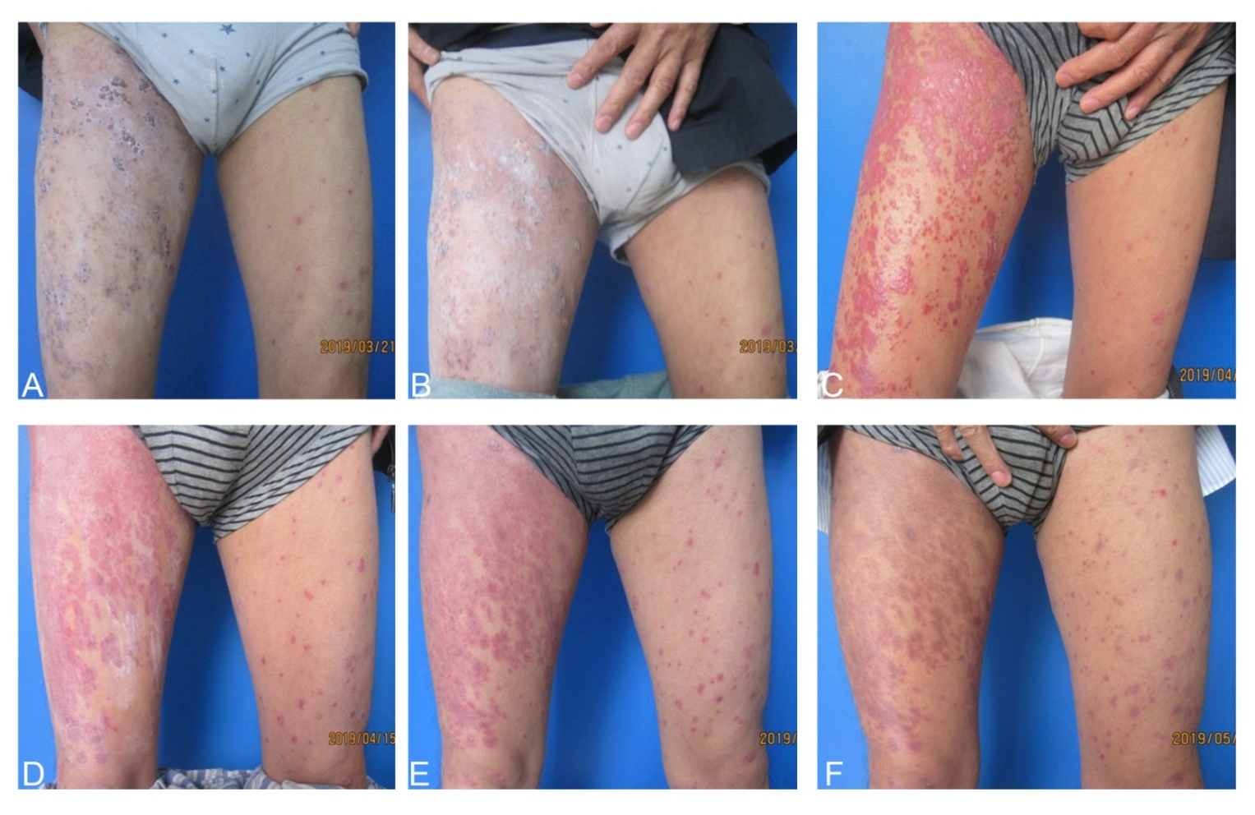
A 45-year-old psoriatic patient complicated with herpes zoster on his right thigh. Herpes zoster worsened his psoriasis on the site of herpes zoster two weeks after the recovery of his herpes zoster. A: Lesions of herpes zoster at the time of treatment; B: After one-week treatment of herpes zoster; C: Worsened psoriatic lesions after two weeks of treatment of herpes zoster; D: After one-week treatment of psoriasis; E: After two-week treatment of psoriasis; E: After three-week treatment of psoriasis.

#5. Delayed recovery of psoriasiform dermatitis by denervation surgery

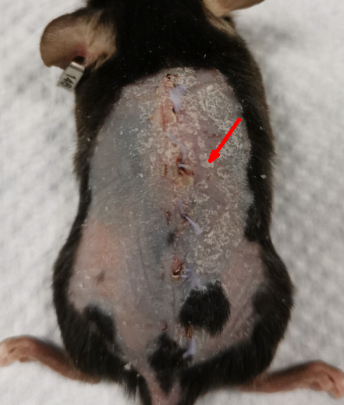

Unlike most mice, very few mice in this study were found to delay the recovery of psoriasiform dermatitis (Right side, arrow) by denervation surgery.

