SUPPLEMENTARY FIGURES
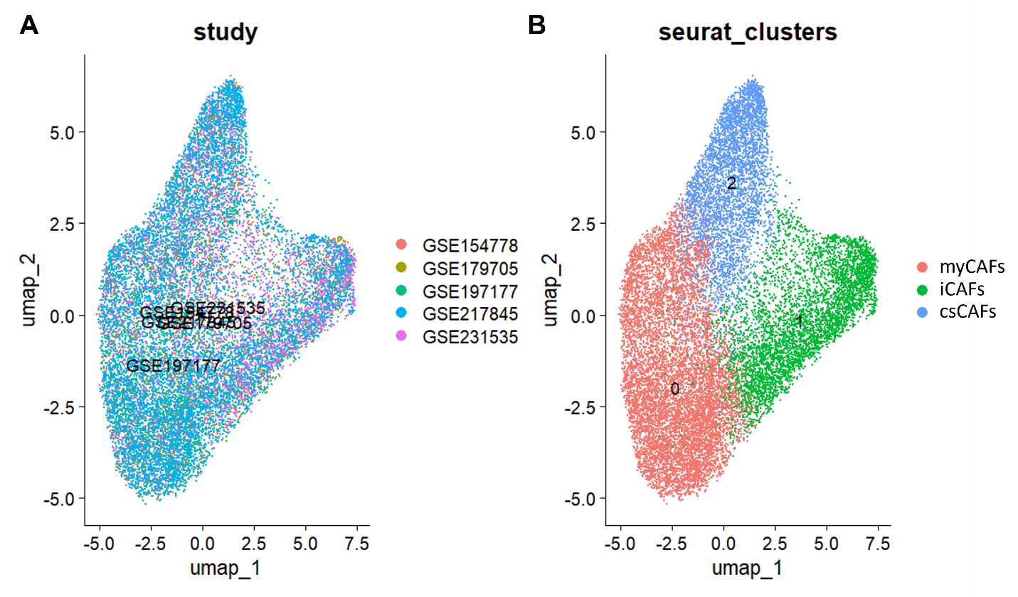
Supplementary Figure S1. UMAP plot of CAF dataset. (A) UMAP plot of cells labelled by study. (B) UMAP plot of cells labelled by cluster.
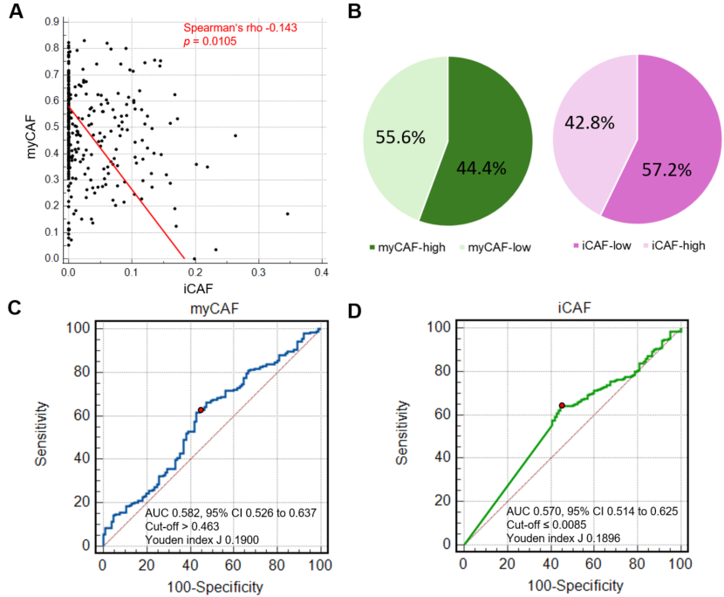
Supplementary Figure S2. CAF proportions in the TCGA PDAC cohort. (A) myCAF and iCAF proportions were inversely correlated (Spearman’s rho -0.143, p = 0.0105). (B) A total of 178 of 320 (55.6%) cases were classified as myCAF-high, and 183 of 320 (57.2%) were classified as iCAF-low. (C) Optimal thresholds for CAF proportions as a predictor for overall survival were obtained by optimizing the AUC of the ROC curves for each stratum.

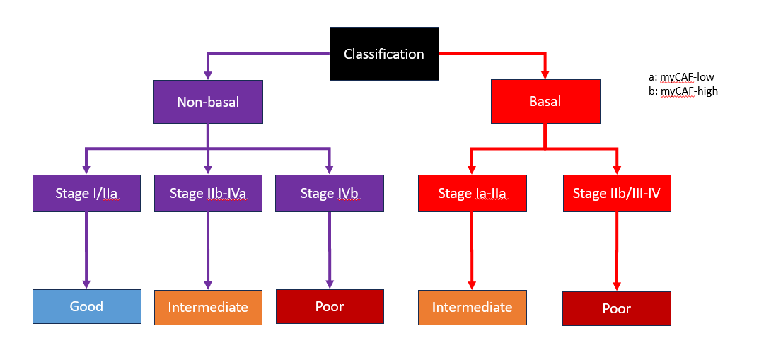Supplementary Figure S3. Flowchart of the staging algorithm adopted in the TMI staging system.

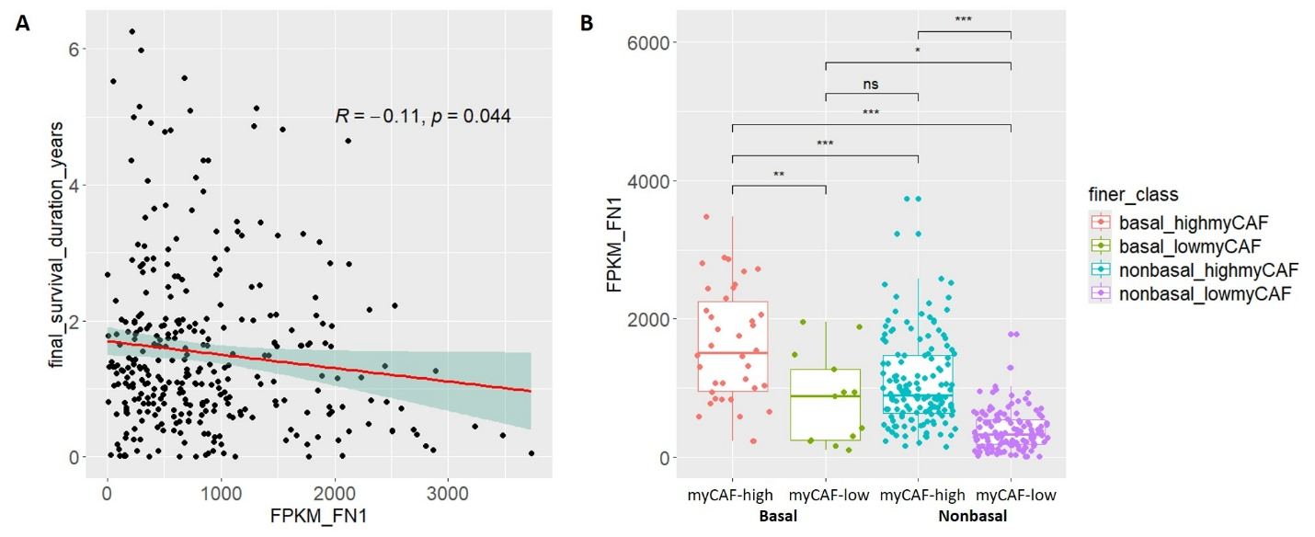Supplementary Figure S4. FN1 association with prognosis and tumor subtype in the TCGA cohort. (A) Scatterplot of survival duration against FN1 expression in FPKM in the TCGA cohort. (B) Boxplot of FN1 expression in FPKM in the TCGA cohort segregated by basal and nonbasal subtypes and subsequently by “myCAF-high” and “myCAF-low” status. n.s., no significance; * < 0.05; ** < 0.01, *** < 0.001.

