Supplementary Materials for

Real-Time Monitoring of CAR T Cell Dynamics in Tumor Patient-Derived Organoids using OrganoIDNet-based algorithm

Nathalia Ferreira et al.

*Corresponding author. Email: falves@gwdg.de

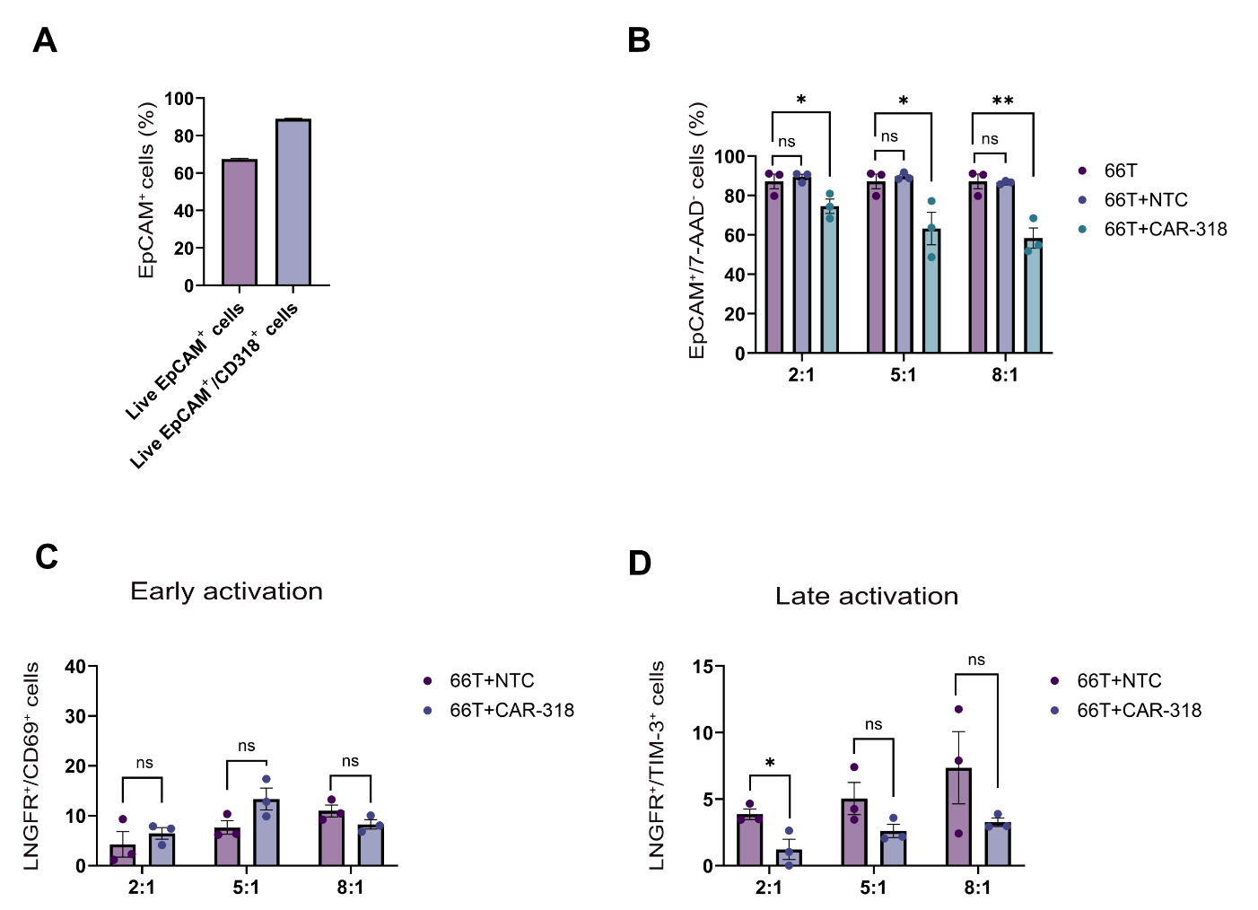

Fig. S1. Flow cytometric analysis of tumor and immune cell populations in human 66T PDAC PDO co-cultures with CAR-318 T cells. (A) Quantification of live EpCAM+CD318⁺ cells as a percentage of total live CD318⁺ tumor cells in 66T human PDAC organoids. Data represent mean ± S.E.M. from two independent experiments. (B) Frequency of EpCAM⁺7-AAD- tumor cells as a percentage of total live tumor cells in 66T PDAC PDOs after 3-day co-culture with CAR-318 T cells (66T+CAR-318), non-transduced control T cells (66T+NTC), or in the absence of T cells (66T) at varying effector-to-target (E:T) ratios. Data represent mean ± S.E.M. from three independent CAR/NTC donor co-cultures. Statistical significance was assessed using a One-Way ANOVA test followed by Dunnett’s for comparison test; p < 0.05 (*), p < 0.01 (**). (C) Proportion of LNGFR⁺/CD69⁺ double-positive cells indicating early T cell activation following 3-day co-culture of CAR-318 or NTC T cells with 66T PDAC PDOs at different E:T ratios. Data represent mean ± S.E.M. from three independent donors. (D) Proportion of LNGFR⁺/TIM-3⁺ double-positive cells indicating late T cell activation under the same co-culture conditions. In c and d, data represent mean ± S.E.M. from three independent donors. Statistical significance was assessed using a two-tailed unpaired Student’s t-test; p < 0.05 (*).

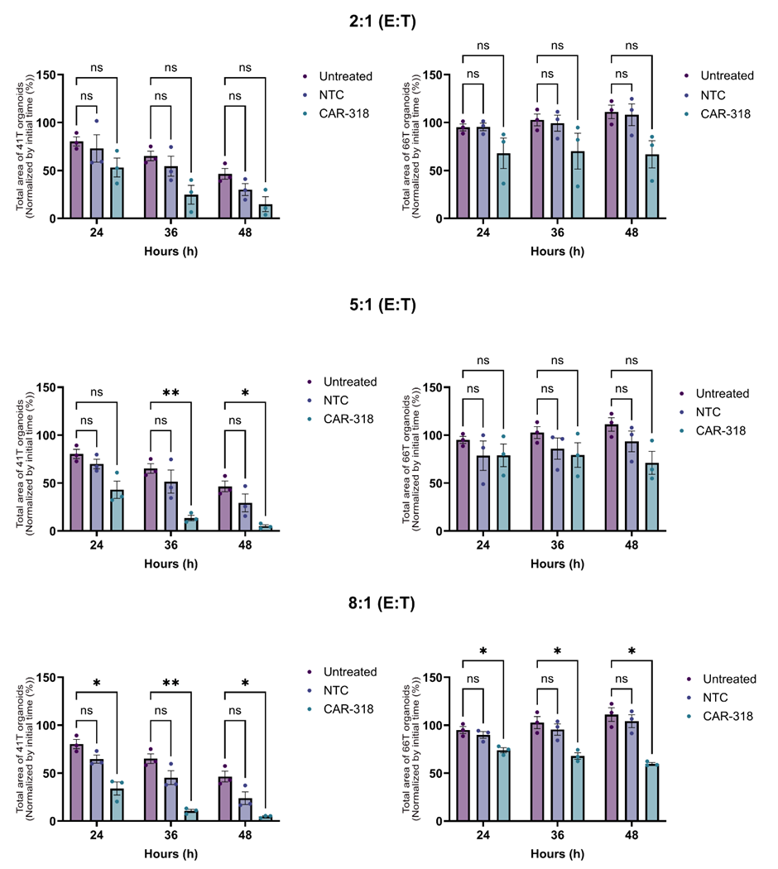

Fig. S2. OrganoIDNet analysis of real-time human 41T and 66T PDAC PDO area in response to CAR T cell targeting. Real-time quantification of changes in organoid area at multiple time points in 41T and 66T PDAC organoids cultured alone (Untreated), co-cultured with non-transduced control T cells (NTC), or co-cultured with CAR-318 T cells at varying effector-to-target (E:T) ratios (CAR-318). Data represent mean ± S.E.M. from three independent CAR/NTC donors, performed in triplicate. Statistical significance was assessed using the One-Way ANOVA test followed by Dunnett’s for comparison test; p < 0.05 (*), p < 0.01 (**).

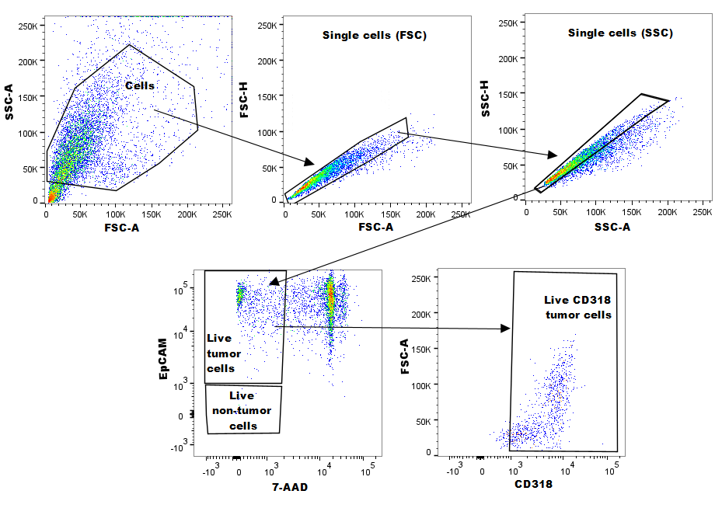

Fig. S3. Gating strategy for flow cytometric analysis of tumor and immune cells in human PDAC organoid co-cultures. Gating scheme for assessing CD318 expression in human PDAC PDOs. Debris was excluded based on forward scatter area (FSC-A) versus side scatter area (SSC-A), followed by doublet discrimination using FSC-A versus FSC-H and SSC-A versus SSC-H. Live tumor cells were identified as EpCAM⁺7-AAD⁻, and CD318 expression was quantified from this population using a CD318 versus FSC-A plot.

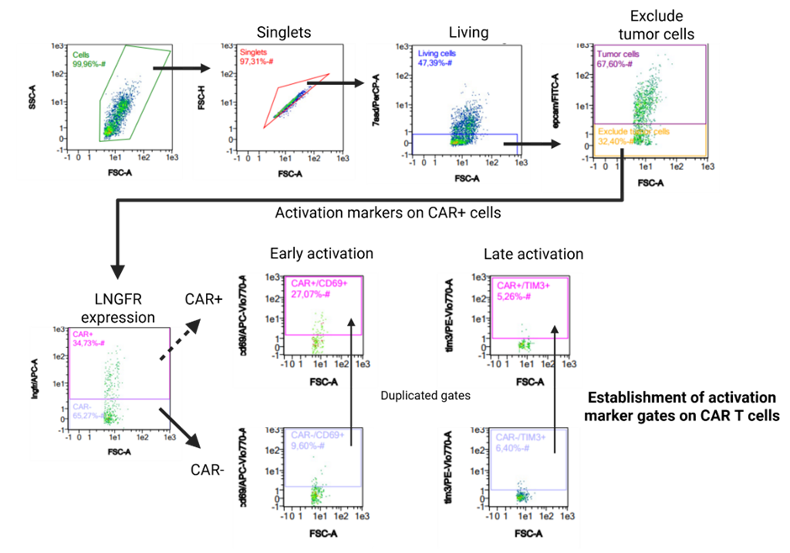

Fig. S4. Gating strategy for flow cytometric analysis of immune cells in human PDAC organoid co-cultures. Gating strategy for characterizing immune cell populations in human PDAC organoid–CAR T cell co-cultures. Initial gating steps excluded debris and doublets (FSC-A vs SSC-A, FSC-A vs FSC-H). Dead cell and tumor cell populations were excluded from analysis based on 7-AAD and EpCAM staining, respectively. Live CAR T cells were gated as LNGFR⁺ to distinguish CAR⁺ and CAR⁻ T cells. Early and late activation markers were assessed by the expression of CD69 and TIM-3, respectively. Activation-marker gates were established using CAR⁻ cells and the non-transduced control (NTC) and then applied to the CAR⁺ population to ensure that activation marker assessment was based on uniform, unbiased thresholds across all T-cell subsets. Created with BioRender.com

