SUPPLEMENTARY MATERIAL
Patient Selection
Patients were selected from patients included in four cardiac arrest clinical registries located at Boston Medical Center. The inclusion and exclusion for each registry are as follows:
- MOCA: Multimodal network connectivity architecture of the brain and its role in the recovery of consciousness in comatose cardiac arrest patients
  - IRB: H-37760
  - Dates: 2019-2024
  - Inclusion: Age ≥18; Clinical diagnosis of coma secondary to cardiac arrest (Glasgow Coma Scale ≤ 8); No known previous history of dementia; Legally authorized representative is available to provide written informed consent if patient is unable to provide consent
  - Exclusion: Not able to tolerate or safely undergo MRI before discharge; Any contraindication for MRI, e.g. presence of a pacemaker, ferromagnetic aneurysm clip, etc.; Women known to be pregnant, lactating or having a positive or indeterminate pregnancy test; Rapid awakening and following commands post-return of spontaneous circulation; Brain death; Pre-cardiac arrest condition that carries a poor likelihood of survival at 1 year (e.g. terminal cancer); Written living will that excludes the patient from life-sustaining treatment; Made “comfort measures only” prior to enrollment; Known history of dementia; Likely to have a CPC score of 2 or greater based on a pre-arrest condition; Clinical team deems the patient inappropriate for the study
- Retrospective MOCHA: Multimodal outcome characterization in comatose cardiac arrest patients- retrospective
  - IRB: H-37113
  - Dates: 2016-2022
  - Inclusion: Age ≥18; Admitted patients with cardiac arrest from any non-perfusing cardiac rhythm with successful return of spontaneous circulation
  - Exclusion: Patients without sustained return of spontaneous circulation; Patients deceased within 24 hours of cardiac arrest
- The New England Brain Death Collaboration Study
  - IRB: H-41069
  - Dates: 2016-2024
  - Inclusion: Age ≥18; Declared Death by Neurologic Criteria
  - Exclusion: No declaration of Death by Neurologic Criteria
- Oculography to Predict Coma Recovery
  - IRB: H-40365
  - Dates: 2020-2024
  - Inclusion: Age 18-90; Admitted patients with cardiac arrest from any non-perfusing cardiac rhythm with successful return of spontaneous circulation; Initially comatose post-ROSC (Glasgow Coma Scale ≤8); Electroencephalogram (EOG/EEG) data obtained
  - Exclusions: Any history of opthalmoplegia or extraocular eye movement dysfunction; Prosthetic eyes; Pupil enucleation; Rapid awakening post-ROSC; Brain death; Status Epilepticus; Comfort Measures Only; Inability to tolerate EEG/EOG; Prior dementia; Prior modified Rankin Score of >3
Clinical Data Extraction
Clinical data were obtained via chart review of the electronic medical record and independently verified by a second reviewer. Demographics (age, sex, race, and ethnicity) were recorded as documented in the medical record. Arrest location was classified as in-hospital or out-of-hospital. An arrest was considered witnessed if it was observed (e.g., occurred in the hospital or the patient was seen collapsing); otherwise, it was classified as unwitnessed. The initial cardiac rhythm was defined as the first rhythm documented during cardiac arrest and categorized as Ventricular Fibrillation, Ventricular Tachycardia, Pulseless Electrical Activity, Asystole, or Unknown/Other. The date and time of cardiac arrest were determined from either the neurology consult note or the patient history. For unwitnessed arrests, the time the patient was found down (by a bystander or EMS) was used. For witnessed arrests without a documented arrest time, the time Advanced Cardiac Life Support (ACLS) was initiated was used. The initial Glasgow Coma Scale (GCS) was the first GCS recorded by the neurology consult team after arrest. Seizures and their timing were recorded from the chart, with seizure onset estimated based on the timing of EEG monitoring and corresponding physicians’ notes.
All neuroimaging (MRI and CT) performed within 10 days of cardiac arrest was reviewed by a trained neurologist (CJO or DMG) for the presence of diffuse cerebral edema. Patients were classified into three categories: 1) No cerebral edema (No evidence of edema on any imaging from arrest through post-cardiac arrest day 10); 2) Indeterminate cerebral edema (Mild or questionable findings, often not global cerebral edema); 3) Diffuse Cerebral Edema (Presence of moderate to severe edema, characterized by features such as herniation, basal cistern effacement, or >60% loss of gray-white differentiation.
Discharge details were determined through manual chart review. Patients were determined to have withdrawal of life sustaining therapy if they were made comfort measures only during their hospitalization. Discharge summaries and PT/OT notes were reviewed to determine modified Rankin Scale (mRS) at discharge.
Model Training
EEG Data Preprocessing
Data was trimmed precisely from CA+24 hours to the 4-, 8-, 12-, and 24- hours following that time point. We created 18 bipolar EEG channels: (Fp1-F7, F7-T3, T3-T5, T5-O1, Fp2-F8, F8-T4, T4-T6, T6-O2, Fp1-F3, F3-C3, C3-P3, P3-O1, Fp2-F4, F4-C4, C4-P4, P4-O2, Fz-Cz, Cz-Pz) and applied bandpass filtering between 0.1 Hz to 40 Hz. EEG signals were then resampled at 100 Hz.
Three specific artifact types were targeted for artifact removal: High amplitude artifacts: EEG signals exceeding 500 μV; Low standard deviation artifacts: Signals showing low variance for more than 2 seconds within a 5-second window; Rapid amplitude change artifacts: Signals exhibiting amplitude changes greater than 900 within 0.1 seconds (Supplementary Table 1). The EEG data were windowed into 5-minute intervals. To interrogate signal quality, we quantified artifact percentage over these 5-minute EEG windows, and weighed “cleaner” windows (i.e., less artifact) more heavily in analysis. Each 5-minute window was weighted inversely proportional to the percentage of windows affected by the artifacts described above.
To address missing data for the 4- and 8- hour prediction models, we created an average template signal using EEG data from 36 subjects with complete 4-hour recordings and 31 subjects with complete 8- hour recordings. We computed the mean amplitude at each time point and channel across subjects. For incomplete recordings, missing segments were imputed by tiling this average template to match the required sample length, preserving the temporal and channel-specific structure of the EEG. The same method was applied to patients with missing EEG data in the indeterminate cohort detection model and the 24-hour primary detection model (Supplementary Table 2).
Data Augmentation
To enhance the diversity and robustness of our dataset, each original EEG data sample was augmented using three complementary techniques. These methods simulate realistic variations and potential perturbations encountered during EEG recordings while ensuring that physiologically relevant characteristics are maintained.
- Noise Addition: Controlled, normally distributed random noise was added to the original EEG signals. The noise amplitude was carefully scaled to mimic minor sensor and environmental disturbances without distorting the underlying neural activity. This process was governed by a parameter σ (standard deviation), which was chosen based on preliminary analyses to maintain signal integrity within physiologically plausible limits.
- Channel Shuffling: The spatial configuration of the EEG channels was perturbed by shuffling, with constraints to preserve inherent spatial correlations between neighboring channels. This approach emulated potential variations in electrode placement or connectivity without compromising the relative signal information between adjacent channels.
- Smooth Time Masking: Smooth time masking involves selectively obscuring continuous segments of the EEG signal. A time window of predetermined length was chosen, and the signal within this window was smoothly attenuated using a tapering function. The gradual transitions at the boundaries prevented abrupt discontinuities, simulating real-world conditions such as transient signal dropouts or brief data loss.
The number of augmented samples used during both primary detection model training and prediction model fine-tuning was determined empirically through systematic experimentation. For primary detection model training, we experimented with multiple augmentation sizes, including 70, 84, and 100 samples, finding that 100 augmented samples provided an optimal balance between data diversity and preservation of physiological signal characteristics. This choice was supported by incremental improvements in model accuracy and robustness as compared to smaller augmentation sets. Similarly, for prediction model fine-tuning, we evaluated augmentation sets of 20, 21, and 22 samples per class. Among the tested values, 22 augmented samples per class yielded the best performance improvements, with quantitative gains in accuracy. However, because the dataset contained only 19 patients per class, eight of whom were reserved for testing, leaving 11 patients for training, selecting more than 11 augmented samples per class would result in synthetic data surpassing the quantity of original data, potentially causing the model to overfit on artificial patterns rather than generalize to real-world signals. These carefully chosen augmentation sizes ensured that the models benefited from enhanced data variability without compromising learning on authentic physiological EEG patterns.
Feature Construction
After augmentation, both the original and the augmented EEG recordings were windowed into non-overlapping 5-minute intervals, yielding 12*h windows for each h-hour period. For each window, a comprehensive suite of features was extracted to characterize the spectral, statistical, and temporal dynamics of the EEG data. The features include:
- Shannon Entropy: Quantifies the signal’s randomness by measuring the entropy of the probability distribution of its amplitude values. Higher entropy suggests increased signal complexity or disorder.
- Regularity: Assesses the temporal consistency of the EEG waveform. This metric is computed by analyzing the periodicity and repeatability of the signal over time, which can be indicative of both normal and abnormal neural oscillatory behavior.
- Delta Band Power (0.1–4 Hz): The power within the delta frequency band is calculated using spectral analysis techniques (e.g., Fast Fourier Transform). Delta activity is closely associated with slow-wave sleep and pathological brain states.
- Theta Band Power (4–8 Hz): Measures the energy within the theta frequency band. Variations in theta power can correlate with cognitive states and transitional stages between sleep and wakefulness.
- Alpha Band Power (8–13 Hz): Computes the energy contained in the alpha band, which is typically linked to relaxed wakefulness and idling rhythms.
- Beta Band Power (13–30 Hz): Quantifies the energy in the beta frequency band, often associated with active cognitive processes and sensorimotor activity.
- Alpha-Delta Ratio: The ratio of alpha to delta band power is computed to provide a comparative measure of fast versus slow wave activities. This ratio has been implicated in various clinical assessments and can offer insights into underlying neural mechanisms.
- Spike Frequency: Spikes, characterized by transient high-amplitude deflections, are detected using threshold-based algorithms. The frequency of these events per 5-minute window is computed to assess abnormal neuronal firing patterns.
- Burst Suppression Ratio: This metric quantifies the proportion of time during which the EEG exhibits burst suppression—a pattern typically associated with certain pathological conditions or deep anesthetic states. The ratio is derived by segmenting the EEG into windows and identifying periods of suppressed activity versus bursts.
The detailed segmentation and rigorous feature extraction process are designed to encapsulate both the spectral properties and the temporal dynamics of the EEG data. By integrating the original and augmented datasets within this framework, we achieve a robust representation of the neural signals that serve as a solid foundation for subsequent model training and analysis.
Transformer Architecture
In this study, each 5-minute EEG window was treated as a “token.” The EEG data were initially provided as a 3D tensor with dimensions [batch size, number of channels, sequence length] and reshaped to [batch size, 12 × h, 162], where h is the number of hours included, 12 is the number of 5-minute segments per hour, 18 is the number of bipolar channels, and 9 is the number of features per channel. This transformation tokenized the data, preparing it for Transformer-based processing.
Each token, representing a 162-dimensional vector (18 × 9), was projected into a higher-dimensional feature space using a linear embedding layer, denoted as ff_dim (tuned to 600), to capture a richer representation of the EEG signals. Because Transformers lack inherent awareness of temporal structure, learnable positional encodings were added to the embedded tokens. These encodings, initialized with shape [1, 12 × h, ff_dim], allowed the model to retain information about the relative positions of tokens over time.
The embedded input was then permuted to match the Transformer’s expected input format of [sequence length, batch size, embedding dimension] and passed through a stack of num_layers Transformer encoder layers. Each layer included a multi-head self-attention mechanism with num_heads to capture complex interdependencies across tokens, a feed-forward network with hidden dimension ff_dim, as well as residual connections and layer normalization to ensure stable gradients and efficient training dynamics.
After processing through the Transformer encoder, the output—now shaped [batch size, sequence length, ff_dim]—was averaged across the sequence dimension using mean pooling. This operation aggregated token-level features into a single, fixed-length global representation for each sample. The aggregated vector was then passed through a fully connected output layer that produced a single logit for binary classification of cerebral edema status. This logit was passed through a sigmoid activation during evaluation or when computing the loss using BCEWithLogitsLoss.
Model training was performed using the Adam optimizer with early stopping. Hyperparameter tuning was conducted using Optuna, an automated hyperparameter optimization framework. We explored over 35 hyperparameter combinations, tuning batch size, number of layers (num_layers), number of attention heads (num_heads), maximum epochs (num_epochs), feature dimension (ff_dim), dropout rate, and learning rate to optimize model performance (Supplementary Table 3).
LSTM Architecture
For the LSTM model, we used the same methods as outlined by Zheng et al in 2023.¹¹ Similarly, the LSTM architecture was tuned using Optuna with hyperparameters such as batch size, number of layers, dropout rate, number of epochs, and learning rate (Supplementary Table 4).
Referent Matching
We excluded 8 diffuse cerebral edema patients due to insufficient EEG duration. Consequently, we had a subgroup of 19 diffuse cerebral edema patients and 19 matched non-cerebral edema referents. For each diffuse cerebral edema case, the effective EEG analysis window used to predict cerebral edema was defined as the 4- or 8-hour segment preceding the time of cerebral edema detection (radiographically determined), constrained to lie between the later of the EEG start time and cardiac arrest time, and the earlier of the EEG end time and cerebral edema detection. For each matched referent, we simulated a “virtual cerebral edema time” by adding the cerebral edema delay (i.e., time from cardiac arrest to cerebral edema) of the matched case to the referent’s cardiac arrest time. The referent’s effective EEG window was then defined as the 4- or 8-hour segment ending at this virtual cerebral edema time, bounded by the referent’s available EEG data.
Results
Cohort
For the detection model, we assigned 84.0% (104 patients) to the training set and the remaining 16.0% to the balanced test set (20 patients, with 10 per class). After augmentation with 100 samples, the training set included 204 training samples evenly split between classes.
For the prediction model, we assigned 42.0% (8 patients per class) to the test set and 58.0% (11 patients per class) to the training set. Augmentation with an additional 11 samples per class resulted in a final training set of 44 samples (22 per class). Cohort characteristics can be found in Supplementary Table 5.
Cerebral Edema Detection
The 4-hour Transformer model outperformed the 4-hour LSTM model across all metrics, with statistically significant differences based on one-sided Wilcoxon rank-sum tests (all p-values < 0.00006) (Supplementary Table 6). The performance gap was most pronounced under data augmentation conditions. The best performing model overall was the 4-hour Transformer model with augmentation. In the 8-hour segment, the Transformer model with augmentation demonstrated AUC 70.0% [65.0%-80.0%], accuracy 70.0% [65.0%-80.0%], sensitivity 80.0% [62.5% - 80.0%], specificity 70.0% [60.0%-90.0%]. In the 12-hour segment, it had AUC 72.5% [65.0%-80.0%], accuracy 72.5% [65.0%-80.0%], sensitivity 70.0% [60.0%-80.0%], specificity 80.0% [70.0%-90.0%]. In the 24- hour segment, it had AUC 80.0% [70.0%-85.0%], accuracy 80.0% [70.0$-85.0%], sensitivity 80.0% [70.0%-90.0%], specificity 80.0% [62.5%-90.0%]. The lowest-performing model was the non-augmented LSTM using 4-hour segments, with median AUC 54.5% [51.2%- 55.8%], accuracy 46.2% [38.5%- 53.8%], sensitivity 45.5% [40.0%-54.5%], and specificity 44.4% [40.0%- 55.6%] (Supplementary Figure 1). Shannon Entropy and Alpha-Delta Ratios were consistently among the top four most important features across all time segments based on SHAP value analyses (Supplementary Figure 2).
Secondary Analyses
When comparing in v. out of cardiac arrest, the best-performing model achieved equal or higher AUC and sensitivity in all time segments for the out-of-hospital subgroup (Supplementary Figure 3). Cohort characteristics can be found in Supplementary Table 7.
In the indeterminate secondary analysis, we followed the same training, testing, and augmentation procedures as the primary detection model, using 86.0% of the cohort for training and 14.0% for testing. Cohort Characteristics can be found in Supplementary Table 8. Results can be found in Supplementary Figure 4 and Supplementary Figure 5.
In an analysis of EEG < 24 from cardiac arrest, we followed the same training, testing, and augmentation procedure as the primary detection model. All patients included in the primary cohort were included in this secondary analysis. This model achieved equal or lower AUC, accuracy, sensitivity, and specificity in all time segments when compared to our primary model. Results can be found in Supplementary Figure 6.
Cerebral Edema Prediction Model
When the best-performing detection model was fine-tuned on pre-cerebral edema data, we found that the 8-hour model outperformed the 4-hour model. The 4-hour model had median AUC 81.7% [76.7%-89.4%], accuracy 81.2% [75.0%-87.5%], sensitivity 85.7% [77.8%-100.0%], specificity 83.3% [73.3%-87.5%] (Supplementary Figure 7).
SUPPLEMENTARY FIGURES
Supplementary Figure 1. Cerebral Edema Detection Model Performance Across Architectures and Time Segments
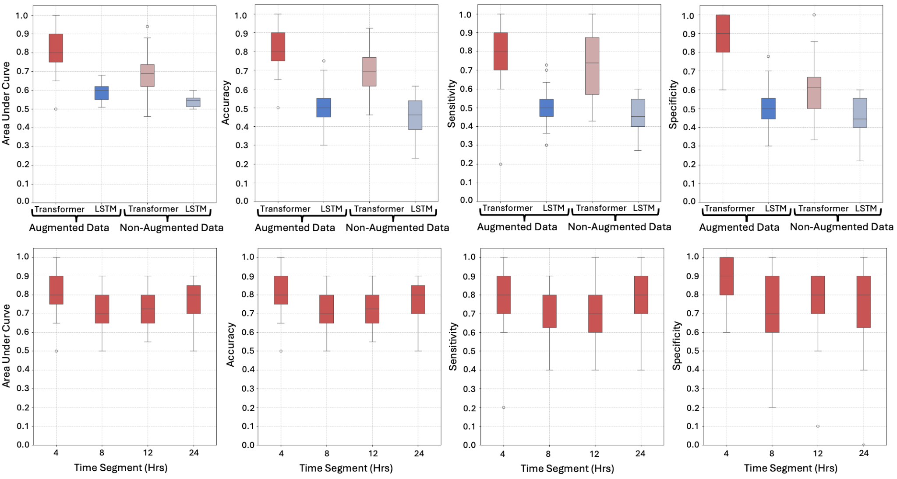
Abb: LSTM: Long Short-Term Memory; Hrs: Hours
Supplementary Figure 2. Quantitative EEG Feature Importance for Detection Model at Different Time Segments
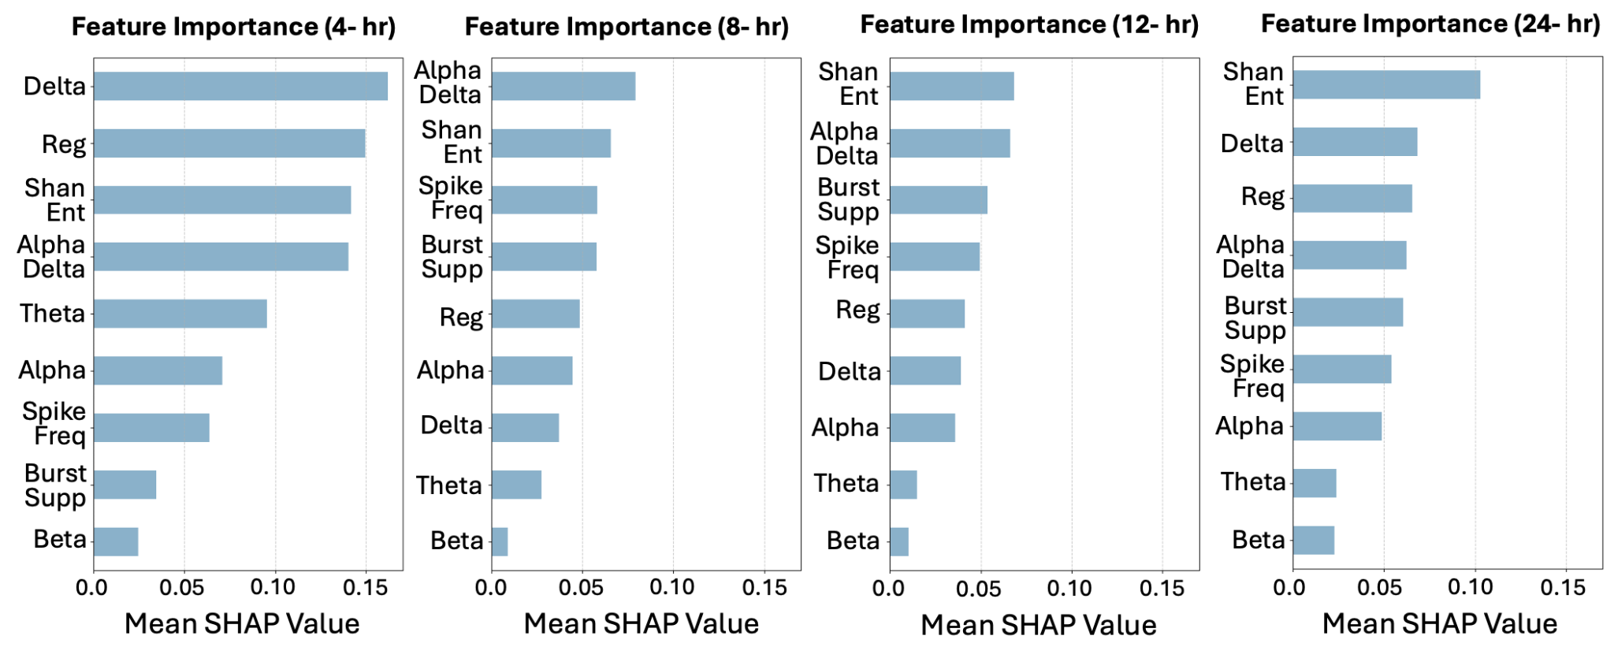
Abb: Reg: Regularity, Shan Ent: Shannon Entropy; Spike Freq: Spike Frequency; Burst Supp: Burst Suppression; Hr: Hour
Supplementary Figure 3 In Hospital Cardiac Arrest v. Out of Hospital Cardiac Arrest Subgroup Analysis
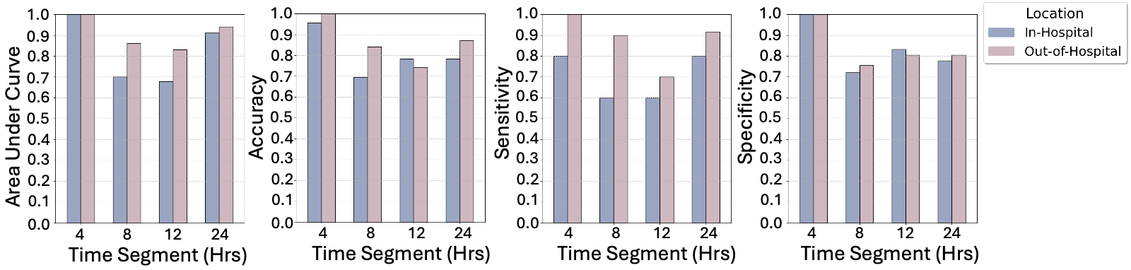
Abb: Hrs: Hours
Supplementary Figure 4. Model Performance in Secondary Analysis Including Indeterminate Outcomes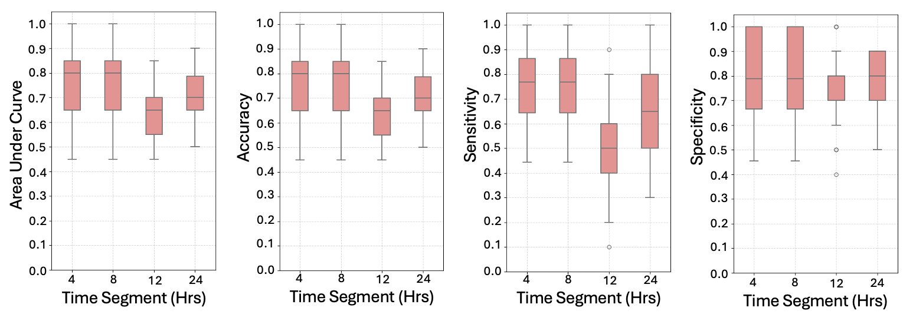
Abb: Hrs: Hours

Supplementary Figure 5. Quantitative EEG Feature Importance in Secondary Analysis Including Indeterminate Outcomes
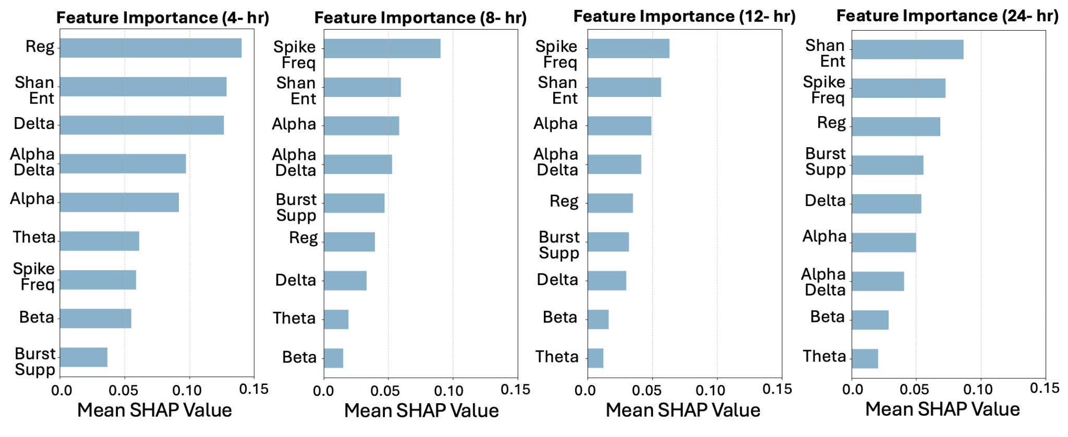
Abb: Reg: Regularity, Shan Ent: Shannon Entropy; Spike Freq: Spike Frequency; Burst Supp: Burst Suppression; Hr: Hour

Supplementary Figure 6. Model Performance Metric for Cerebral Edema Detection- EEG Within 24 Hours of Cardiac Arrest
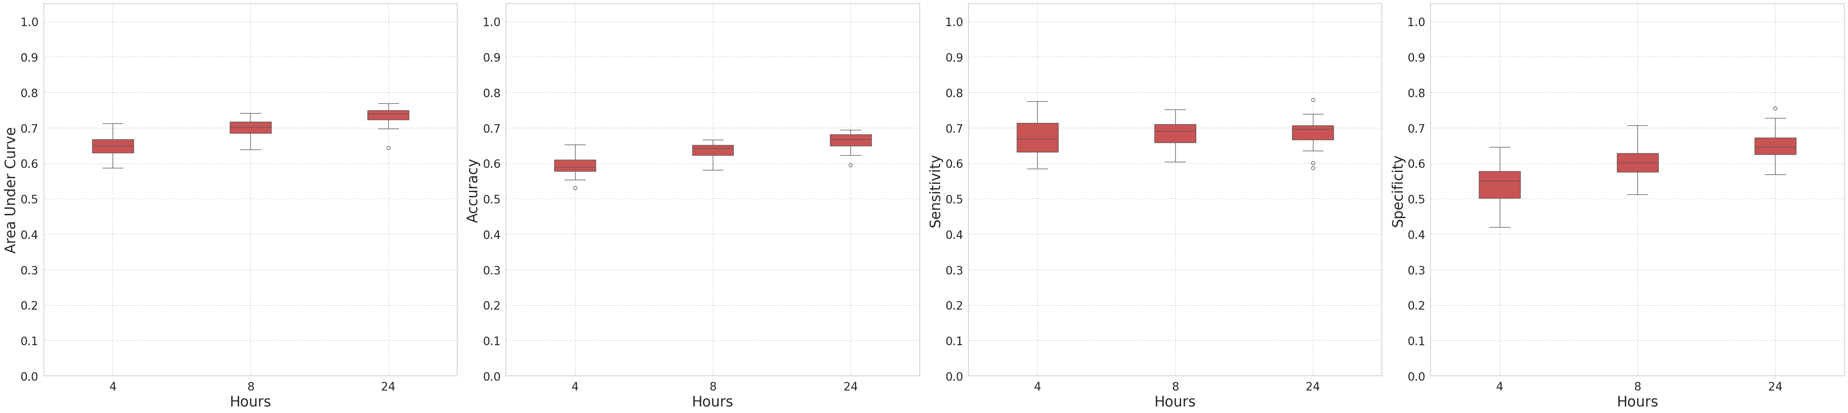
Supplementary Figure 7. Model Performance Metrics for Cerebral Edema Prediction at Different Time Segments
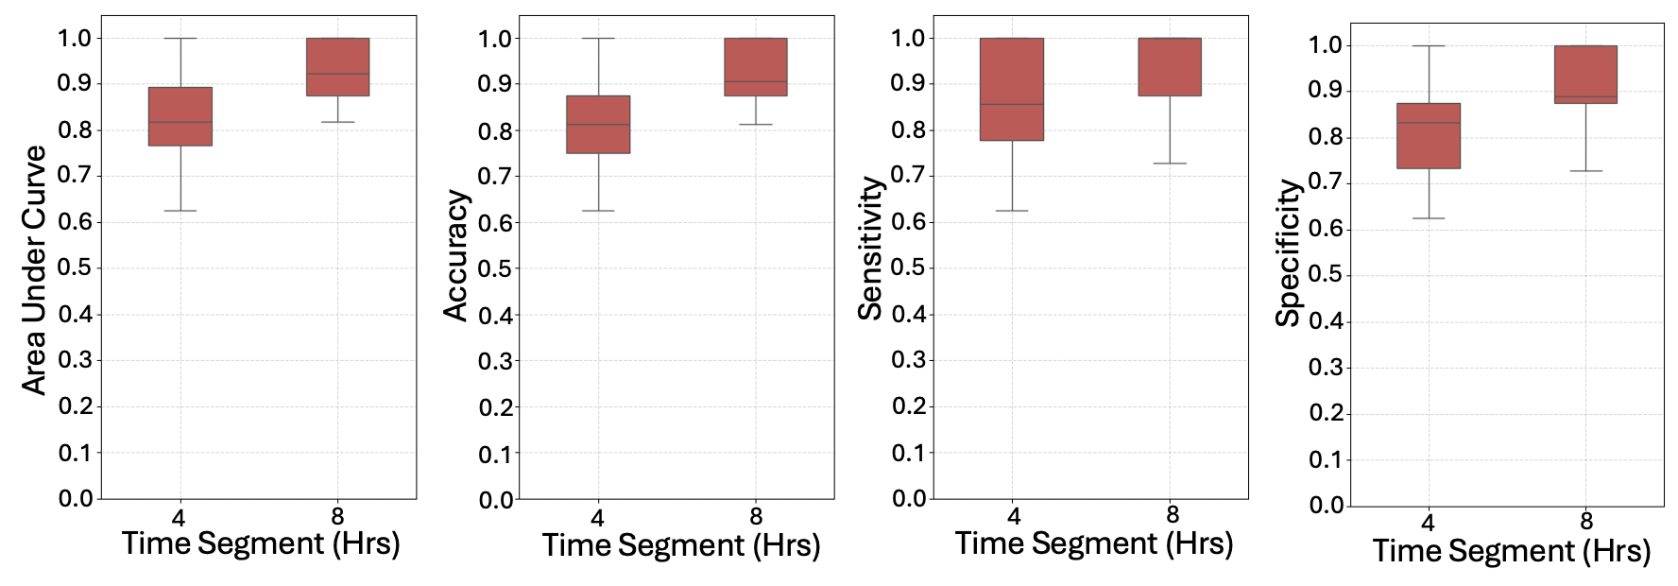Abb: Hrs: Hours

Supplementary Table 1: Artifact Removal Statistics for the first 24 hours of EEG Data
Artifact Type | Minutes Removed - Post 24 hour EEG | Minutes Removed- Within 24 hour EEG
High Amplitude | 103.1 (7.2%) | 136.8 (9.5%)
Fast Amplitude Change | 35.6 (2.5%) | 47.2 (3.3%)
Low Standard Deviation | 0.01 (0.0%) | 0.01 (0.0%)
Total | 138.7 (9.6%) | 184.0 (12.8%)

Supplementary Table 2: Missing Exposure Data Quantification
Model Type | Time Segment (Hrs) | Cohort Size | Patients with Imputed Data | Average Hours of Imputed Data
Detection | - | - | - | -
Detection | 4 | 124 | - | -
Detection | 8 | 124 | - | -
Detection | 12 | 124 | - | -
Detection | 24 | 124 | 5 | 2.29
Prediction | 4 | 38 | 2 | 2.6
Prediction | 8 | 38 | 7 | 4.8
In v. Out of Hospital | 4 | 124 | - | -
In v. Out of Hospital | 8 | 124 | - | -
In v. Out of Hospital | 12 | 124 | - | -
In v. Out of Hospital | 24 | 124 | - | -
Indeterminant | 4 | 25 | - | -
Indeterminant | 8 | 25 | 2 | 0.6
Indeterminant | 12 | 23 | 3 | 1.3
Indeterminant | 24 | 15 | 3 | 3.4

Supplementary Table 3: Hyperparameters, Search Space, and Best Performing Parameters for Transformer Models
Hyperparameter | Search Space | Best Performing Parameter
Batch Size | 2, 4, 10, 16, 20, 24, 32, 64 | 20
Num Heads | 1, 2, 3, 4, 5, 6, 7, 8, 9, 10 | 6
Num Layers | 1, 3, 4, 5, 6, 7, 8, 9, 10 | 6
FF Dim | 64, 162, 200, 288, 300, 600, 603, 640, 700, 900 | 600
Dropout | 0.10 to 0.6 | 0.6
Num Epochs | 50, 100, 150, 200, 250, 300, 350, 400, 1000 | 150
Learning Rate | 0.00001 to 0.01 | 0.008

Supplementary Table 4: Hyperparameters, Search Space, and Best Performing Parameters for LSTM Models
Hyperparameter | Search Space | Best Performing Parameter
Batch Size | 4, 8, 10, 20 | 20
Num Layers | 4, 6 | 6
Dropout | 0.2, 0.3, 0.5, 0.6 | 0.5
Num Epochs | 50, 150, 300, 350 | 300
Learning Rate | 0.001, 0.0015, 0.008, 0.01 | 0.01

 | Supplementary Table 5: Prediction Characteristics
 |  |  | Total Cohort  N=38 |  | Diffuse Cerebral Edema  N=19 (50%) |  | No Cerebral Edema Referents  N=19 (50%)
 | Demographics
 | Age |  | 55 [42.00, 59.75] |  | 54 [37.50, 57.00] |  | 55 [50.50, 60.50]
 | Sex- Male |  | 32 (84.2%) |  | 16 (84.2%) |  | 16 (84.2%)
 | Race |  | - |  | - |  | -
 | White |  | 6 (15.8%) |  | 4 (21.1%) |  | 2 (10.5%)
 | Black |  | 19 (50.0%) |  | 9 (47.4%) |  | 10 (52.6%)
 | Asian |  | 1 (2.6%) |  | 0 (0.0%) |  | 1 (5.3%)
 | Other |  | 6 (15.8%) |  | 3 (15.8%) |  | 3 (15.8%)
 | Unknown/Declined |  | 6 (15.8%) |  | 3 (15.8%) |  | 3 (15.8%)
 | Hispanic/Latino |  | 7 (18.4%) |  | 4 (21.1%) |  | 3 (15.8%)
 | Cardiac Arrest Details
 | Out of Hospital Arrest |  | 32 (84.2%) |  | 18 (94.7%) |  | 14 (73.7)
 | Witnessed Arrest |  | 17 (44.7%) |  | 8 (42.1%) |  | 9 (47.4%)
 | Initial Rhythm |  | - |  | - |  | -
 | Asystole |  | 13 (34.2%) |  | 7 (36.8%) |  | 6 (31.6%)
 | Pulseless Electrical Activity |  | 10 (26.3%) |  | 4 (21.1%) |  | 6 (31.6%)
 | Ventricular Fibrillation/Tachycardia |  | 5 (13.1%) |  | 2 (10.06) |  | 3 (15.8%)
 | Unknown/Other |  | 10 (26.3%) |  | 6 (31.6%) |  | 4 (21.1%)
 | Hospitalization Details
 | Time to Initial Imaging (hr) |  | 1.82 [1.33, 3.25] |  | 1.87 [1.69, 3.54] |  | 1.57 [1.20, 2.93]
 | Time to EEG (hr) |  | 17.5 [13.7, 22.5] |  | 18.4 [14.3, 22.8] |  | 17.1 [13.1, 22.0]
 | Time to Radiographic Cerebral Edema Detection (hr) |  | 47.5 [35.2, 72.0] |  | 47.5 [35.2, 72.0] |  | -
 | EEG duration prior to Radiographic Cerebral Edema detection (hr) |  | 29.0 [19.8, 47.9] |  | 29.0 [19.8, 47.9] |  | -
 | Time from EEG window stop to Radiographic Cerebral Edema detection (hr) |  | 1.34 [0.29-1.64] |  | 1.34 [0.29-1.64] |  | -
 | Cerebral Edema diagnosed on first post-admission scan |  | 1 (2.6%) |  | 1 (5.3%) |  | -
 | Initial GCS |  | 3 [3, 4.25] |  | 3 [3, 6] |  | 3 [3, 4]
 | Seizures |  | 14 (36.8%) |  | 4 (21.1%) |  | 10 (52.6%)
 | Seizures prior to Cerebral Edema |  | 2 (5.3%) |  | 2 (10.5%) |  | -
 | Secondary Outcomes
 | Downward Herniation |  | 8 (21.1%) |  | 8 (42.1%) |  | 0 (0.0%)
 | Complete Basilar Cistern Effacement |  | 14 (36.8%) |  | 14 (73.7%) |  | 0 (0.0%)
 | Loss of Grey-white Differentiation |  | 14 (36.8%) |  | 14 (73.7%) |  | 0 (0.0%)
 | Discharge Details
 | Withdrawal of Life Sustaining Therapy |  | 14 (36.8%) |  | 9 (45.0%) |  | 5 (26.3%)
 | Brain Death |  | 10 (26.3%) |  | 10 (52.6%) |  | 0 (0.0%)
 | Discharge modified Rankin Scale (mRS) |  | - |  | - |  | -
mRS 0-3 |  | 4 (10.6%) |  | 0 (0.0%) |  | 4 (21.0%)
mRS 4 |  | 2 (5.3%) |  | 0 (0.0%) |  | 2 (10.05)
mRS 5 |  | 7 (18.4%) |  | 1 (5.3%) |  | 6 (31.6%)
mRS 6 |  | 24 (63.2%) |  | 18 (94.7%) |  | 6 (31.6%)
Unknown |  | 1 (2.6%) |  | 0 (0.0%) |  | 1 (1.7%)

Supplementary Table 6: Wilcoxon One-Sided Rank-Sum Test
4-hour Transformer v. LSTM model (with augmented data)
Metric | Test Statistic (W) | One-sided p-value
AUC | 464.0 | 1.9e-9
Accuracy | 434.0 | 1.4e-6
Sensitivity | 448.0 | 1.9e-7
Specificity | 459.0 | 1.3e-8
4-hour Transformer v. LSTM model (without augmented data)
AUC | 440.0 | 8.4e-7
Accuracy | 385.5 | 1.6e-5
Sensitivity | 453.0 | 6.5e-8
Specificity | 346.5 | 5.4e-4

Supplementary Table 7: IHCA v. OHCA Characteristics
 | Total Cohort N=124 | IHCA  N=23 (18.5%) | OHCA  N=101 (81.5%)
Demographics
Age | 53 [39, 60.25] | 54 [42, 62] | 52 [38, 60]
Sex- Male | 74 (59.7%) | 9 (39.1%) | 65 (64.4%)
Race | - | - | -
White | 28 (22.6%) | 3 (13.0%) | 25 (24.8%)
Black | 64 (51.6%) | 16 (69.6%) | 48 (47.5%)
Asian | 5 (4.0%) | 0 (0.0%) | 5 (5.0%)
Other | 13 (10.5%) | 2 (8.7%) | 11 (10.9%)
Unknown/Declined | 14 (11.3%) | 2 (8.7%) | 12 (11.9%)
Hispanic/Latino | 17 (13.7%) | 3 (13.0%) | 14 (13.9%)
Cardiac Arrest Details
Witnessed Arrest | 66 (53.2%) | 22 (95.7%) | 44 (43.6%)
Initial Rhythm | - | - | -
Asystole | 30 (24.2%) | 2 (8.7%) | 28 (27.7%)
Pulseless Electrical Activity | 53 (42.7%) | 13 (56.5%) | 40 (39.6%)
Ventricular Fibrillation/Tachycardia | 19 (15.3%) | 1 (4.3%) | 18 (17.8%)
Unknown/Other | 21 (16.9%) | 7 (30.4%) | 15 (14.9%)
Hospitalization Details
Time to Initial Imaging (hr) | 2.14 [1.52, 3.50] | 3.20 [1.70, 9.77] | 1.97 [1.48, 3.12]
Diffuse Cerebral Edema | 65 (52.4%) | 5 (21.7%) | 60 (59.4%)
Time to EEG (hr) | 19.1 [13.5, 27.9] | 18.6 [14.3, 30.6] | 19.1 [13.6 27.0]
Time to Radiographic Cerebral Edema Detection (hr) | 14.1 [2.2, 49.1] | 10.8 [3.2, 44.3] | 14.4 [2.1, 52.9]
Cerebral Edema diagnosed on first post-admission scan | 33 (26.6%) | 2 (8.7%) | 31 (30.7%)
Initial GCS | 3 [3, 4] | 3 [3, 5] | 3 [3, 4]
Seizures | 46 (37.1%) | 6 (26.1%) | 40 (39.6%)
Seizures before Cerebral Edema | 10 (8.1%) | 2 (8.7%) | 8 (7.9%)
Secondary Outcomes
Downward Herniation | 16 (12.9%) | 2 (8.7%) | 14 (13.9%)
Complete Basilar cistern effacement | 46 (37.1%) | 3 (13.0%) | 43 (42.6%)
Loss of Grey-white Differentiation | 45 (36.3%) | 4 (17.4%) | 41 (40.6%)
Discharge Details
Withdrawal of Life Sustaining Therapy | 38 (30.6%) | 3 (13.0%) | 35 (34.7%)
Brain Death | 32 (25.8%) | 2 (8.7%) | 30 (29.7%)
Discharge modified Rankin Scale (mRS) | - | - | -
mRS 0-3 | 15 (12.1%) | 5 (21.7%) | 10 (10%)
mRS 4 | 12 (9.7%) | 6 (26.1%) | 6 (5.9%)
mRS 5 | 21 (16.9%) | 5 (21.7%) | 16 (15.8%)
mRS 6 | 75 (60.5%) | 7 (30.4%) | 68 (67.3%)

Supplementary Table 8: Indeterminate Patient Characteristics
 | Total Cohort N=149 | Diffuse Cerebral Edema  N=65 (43.6%) | No Cerebral Edema  N=59 (39.6%) | Indeterminate Cerebral Edema N = 25 (16.8%)
Demographics
Age | 53 [40, 60] | 48 [37, 58] | 56 [45, 66] | 51 [43, 59]
Sex- Male | 91 (61.1%) | 38 (58.5%) | 36 (61.0%) | 17 (68.0%)
Race | - | - | - | -
White | 35 (23.5%) | 19 (29.2%) | 9 (15.3%) | 7 (28.0%)
Black | 76 (51.0%) | 30 (46.2%) | 34 (57.6%) | 12 (48.0%)
Asian | 5 (3.4%) | 2 (3.1%) | 3 (5.1%) | 0 (0.0%)
Other | 15 (10.1%) | 5 (7.7%) | 8 (13.6%) | 2 (8.0%)
Unknown/Declined | 18 (12.1%) | 9 (13.8%) | 5 (8.5%) | 4 (16.0%)
Hispanic/Latino | 22 (14.8%) | 8 (12.3%) | 9 (15.3%) | 5 (20.0%)
Cardiac Arrest Details
Out of Hospital Arrest | 123 (82.6%) | 60 (92.3%) | 41 (70.7%) | 22 (88.0%)
Witnessed Arrest | 80 (53.7%) | 27 (41.5%) | 39 (66.1%) | 14 (56.0%)
Initial Rhythm | - | - | - | -
Asystole | 35 (23.5%) | 18 (27.7%) | 12 (20.3%) | 5 (20.0%)
Pulseless Electrical Activity | 62 (41.6%) | 31 (47.7%) | 22 (37.3%) | 9 (36.0%)
Ventricular Fibrillation/Tachycardia | 24 (16.1%) | 5 (7.7%) | 14 (23.7%) | 5 (20.0%)
Unknown/Other | 28 (18.8%) | 11 (16.9%) | 11 (18.6%) | 6 (24.0%)
Hospitalization Details
Time to Initial Imaging (hr) | 2.12 [1.50, 3.95] | 1.98 [1.57, 3.47] | 2.32 [1.36, 3.70] | 2.07 [1.45. 6.48]
Time to EEG (hr) | 18.8 [12.2, 26.9] | 17.8 [11.3, 25.2] | 22.1 [15.8, 30.0] | 14.4 [10.7, 26.1]
Time to Radiographic Cerebral Edema Detection (hr) | 14.1 [2.2, 49.1] | 14.1 [2.2, 49.1] | - | -
Cerebral Edema diagnosed on first post-admission scan | 33 (22.1%) | 33 (50.7%) | - | -
Initial GCS | 3 [3, 4] | 3 [3, 3] | 3 [3, 5] | 3 [3, 3]
Seizures | 56 (37.6%) | 23 (35.4%) | 23 (39.0%) | 10 (40.0%)
Seizures prior to Cerebral Edema | 10 (6.7%) | 10 (15.4%) | - | -
Secondary Outcomes
Downward Herniation | 16 (10.8%) | 16 (24.6%) | 0 (0.0%) | 0 (0.0%)
Complete Basilar cistern effacement | 47 (31.8%) | 46 (70.8%) | 0 (0.0%) | 0 (0.0%)
Loss of Grey-white Differentiation | 46 (31.1%) | 45 (69.2%) | 0 (0.0%) | 0 (0.0%)
Discharge Details
Withdrawal of Life Sustaining Therapy | 54 (36.2%) | 25 (38.5%) | 13 (22.0%) | 16 (64.0%)
Brain Death | 33 (22.1%) | 32 (49.2%) | 0 (0.0%) | 1 (4.0%)
Discharge modified Rankin Scale (mRS) | - | - | -
mRS 0-3 | 15 (13.1%) | 1 (1.5%) | 14 (23.8%) | 0 (0.0%)
mRS 4 | 13 (8.7%) | 2 (3.1%) | 10 (16.9%) | 1 (4.0%)
mRS 5 | 25 (16.8%) | 2 (3.1%) | 19 (32.2%) | 4 (16.0%)
mRS 6 | 95 (63.8%) | 60 (92.3%) | 15 (25.4%) | 20 (80.0%)

