Supplementary information

Interface-directed charge regulation enables efficient perovskite/organic hybrid tandem LEDs
Ye Wang¹, Dong-Ying Zhou^{1*}, Aziz Khan¹, Sheng-Fu Wang², Wei-Zhi Liu¹, Wan-Shan Shen¹, Zuo-Quan Jiang¹, Yun Chi³, Pi-Tai Chou², Ya-Kun Wang^{1*}, and Liang-Sheng Liao^{1,4*}

¹ Institute of Functional Nano & Soft Materials (FUNSOM), Jiangsu Key Laboratory for Carbon-Based Functional Materials & Devices, State Key Laboratory of Bioinspired Interfacial Materials Science, Soochow University, Suzhou 215123, Jiangsu, China.
² Department of Chemistry, National Taiwan University, Taipei 10617, Taiwan
³ Department of Chemistry, Department of Materials Science and Engineering, Center of Super-Diamond and Advanced Films (COSDAF), City University of Hong Kong, Hong Kong, China
⁴ Macao Institute of Materials Science and Engineering, Macau University of Science and Technology, Taipa 999078, Macau, China

^{z}Corresponding addresses: dyzhou@suda.edu.cn; wangyakun@suda.edu.cn; lsliao@suda.edu.cn

Contents

1. Experimental Section
2. Supporting Figures

- Experimental Section
1.1 Materials
Formamidine acetate (HN=CHNH₂·CH₃COOH, 99%, Sigma-Aldrich), Lead (II) iodide (PbI₂, 99%, Sigma-Aldrich), Oleylamine (OAm, technical grade 70%, Sigma-Aldrich), Oleic acid (OA, technical grade 90%, Sigma-Aldrich), 1-Octadecene (ODE, technical grade 90%, Sigma-Aldrich), Methyl acetate (ReagentPlus, 99%, Sigma-Aldrich). Octane (anhydrous, ≥99%, Sigma-Aldrich). PEDOT:PSS solution (Clevios PVP AI 4083), poly-TPD and PO-T2T were purchased from Xi’an Polymer Light Technology Corp. All the chemicals were used directly as received.

1.2 Synthesis of FAPbI₃ QDs
In a typical synthesis, 624 mg FAAC and 12 mL OA were dried in a 3-necked round bottom flask at room temperature for 15 min. The reaction mixture was degassed for 5 min at room temperature and was rapidly heated to 110℃ and continued to be degassed for 60 minutes. After the reaction to form a clear FA-oleate precursor solution. Nitrogen (N₂) was introduced, and the temperature is kept at 100℃. Before hot injection, the system temperature of the Cs-precursor was dropped to 80°C.

In another flask, 350 mg PbI₂ was mixed with 2 mL of OAm/OA mixture and 20 mL of ODE followed by vacuum drying at 100℃ for 100 min. Under N₂ atmosphere, the lead halide precursors were kept at reaction temperature 80℃ until all solids were dissolved. Then, 4.0 mL FA -precursor solution was rapidly injected into the flask containing the lead halide precursor. The solution was then swiftly cooled using an ice water bath. The solution was centrifuged at 7800 rpm to remove unreacted precursors. The supernatant was discarded, and the precipitation was collected. Then dissolve the precipitate with octane. During the two-step purification process, methyl acetate was added to the QDs solution. The mixture was then centrifuged to collect the precipitant and dissolve in the octane. The crude solution was centrifuged at 7800 rpm to remove unreacted precursors. The supernatant was discarded, and the precipitation was collected. Then dissolve the precipitate with octane to obtain FAPbI₃ crude QDs solution.

1.3 Two-Step Purification Strategy
Methyl acetate was added to the crude QDs solution. The mixture was then centrifuged to collect the precipitant and dissolve in the octane. Then add methyl acetate into the solution and centrifuge again. Collect the precipitant and dissolve in the octane to obtain purified FAPbI₃ solution. The QDs solution was stored at 4 °C until further use.

1.4 FAPbI₃ QLEDs Fabrication
For fabricating FAPbI₃ QLEDs, ITO/glass substrates were cleaned using deionized water, acetone, and 2-propanol ultrasonically for 60, 60, 60 min, respectively. After this, the substrate was dried with nitrogen flow and treated with UV-ozone for 15 min. Then, PEDOT:PSS was spin-coated at 4000 rpm for 30 s, followed by annealing on a hotplate at 150 °C for 15 min. After the substrate was cooled to room temperature, a solution of 8 mg/mL poly-TPD chlorobenzene was spin-coated onto the PEDOT:PSS layer at 4000 rpm for 40 s and baked for 15 min at 100℃ under nitrogen atmosphere. FAPbI₃ QDs were then spin-coated onto the Poly-TPD at 3000 rpm for 40 s and anneal for 60s to evaporate solvent. Finally, ∼60 nm of POT2T/ANPO, ∼2 nm of Liq, and ∼80 nm of Al was deposited using a thermal evaporation system (Suzhou Fangsheng FS380-S12) through shadow masks under a high vacuum (< 10⁻⁴ Pa).

1.5 Tandem LEDs Fabrication
For fabricating Tandem QLEDs, ITO/glass substrates were cleaned using deionized water, acetone, and 2-propanol ultrasonically for 60, 60, 60 min, respectively. After this, the substrate was dried with nitrogen flow and treated with UV-ozone for 15 min. Then, PEDOT:PSS was spin-coated at 4000 rpm for 30 s, followed by annealing on a hotplate at 150 °C for 15 min. After the substrate was cooled to room temperature, a solution of 8 mg/mL poly-TPD chlorobenzene was spin-coated onto the PEDOT:PSS layer at 4000 rpm for 40 s and baked for 15 min at 100℃ under nitrogen atmosphere. FAPbI₃ QDs were then spin-coated onto the Poly-TPD at 3000 rpm for 40 s and anneal for 60s to evaporate solvent. After that, the substrate was moved into a thermal evaporation system (Suzhou Fangsheng FS380-S12) through shadow masks under a high vacuum (< 10⁻⁴ Pa) and deposited POT2T/ANPO, Bphen:LiNH2, mCP:MoO₃, mCP, Dph-3-f, CNT2T (60 nm), Liq (1 nm), and Al (100 nm).

1.6 Characterization Methods
UV-Vis absorption spectra were measured by a Shimadzu UV-3600PC scanning spectrophotometer. The photoluminescence (PL) spectra were collected by a fluorescence spectrometer (NIR-VIS, FL3). PL decay spectra were obtained by using the PL-TCSPC fluorescence lifetime measurement system (C12132-38, Hamamatsu Photonics Co.). The FTIR spectra were measured by VERTEX 70 FT-IR Spectrometer under transmission mode. The samples were prepared through dripping solution into KBr powder and pressed in powder compaction presses. Transient PL decays were measured by HORIB-FM-2015. 1H NMR spectra were measured by utilizing the JNM-ECZ400S/L1 with a frequency of 400 MHz. XRD patterns were measured using a Bruker AXS D8 diffractometer with Cu Kα radiation (λ = 1.54178 Å). The UPS and XPS measurements were conducted using KRATOS AXIS Ultra DLD with a base pressure of ~10⁻⁹ torr. Atomic force microscopy (AFM) measurements were operated by using a Cypher-S atomic force microscope (Asylum Research, Oxford Instruments, UK). GIWAXS measurements were performed using an X-ray wavelength of 1.5413 Å. The two-dimensional scattering patterns were collected with a detector calibrated using a pixel size of 75 μm × 75 μm (horizontal × vertical) and a sample-to-detector distance of 74.5 mm. The direct beam center was located at (x, y) = (321.8570, 84.2256) in pixel coordinates.

1.7 Density Functional Theory Calculations.
We carried out all the DFT calculations in the Vienna ab initio simulation (VASP 6.3.0) code. The exchange-correlation is simulated with PBE functional and the ion-electron interactions were described by the PAW method. The vdWs interaction was included by using empirical DFT-D3 method.4 The FAPbI₃(100) and the FAPbI₃_F_{Av}_I_{v} with FA-I co-vacancy were used to simulate the adsorption of DIPO and POT2T. The Monkhorst-Pack-grid-mesh-based Brillouin zone k-points are set as 1×1×1 for all periodic structure with the cutoff energy of 400 eV. The atom in top two layers are allowed to move freely while that in the bottom two layers are frozen during the geometry optimization. The convergence threshold for structural optimization was set to be 10⁻⁴ eV in energy and 0.05 eV/Å in force.
The adsorption energy of species adsorption (ΔE) is based on following model,
$E=Etotal-Eads-Esub$ (1)
Where the E_{total}, E_{ads}, and E_{sub} are the electronic energy of whole adsorption system, the adsorbate and the substrate, respectively.

1.8 Characterization of NIR LEDs
Current density–voltage (J–V) characteristics were monitored by using a computer-controlled Keithley 2400 source meter. Electroluminescence (EL) spectra and external quantum efficiency (EQE) were tested by using a calibrated photonic multichannel PMA-12 analyzer system (Hamamatsu C10027-01 (360–950 nm) and C10028-01 (950–1600 nm)). The PMA-12 system was connected to an integrating sphere (3.3 in, collecting device forward light) and a power supply system (controlling current output) while a PR-745 instrument (Photo Research, 380–1060 nm) was used to calibrate the absolute radiance. All the measurements assumed Lambertian emission.

- Supporting Figures

Supplementary Fig. 1. EQE-current density plots of the organic and QDs device.

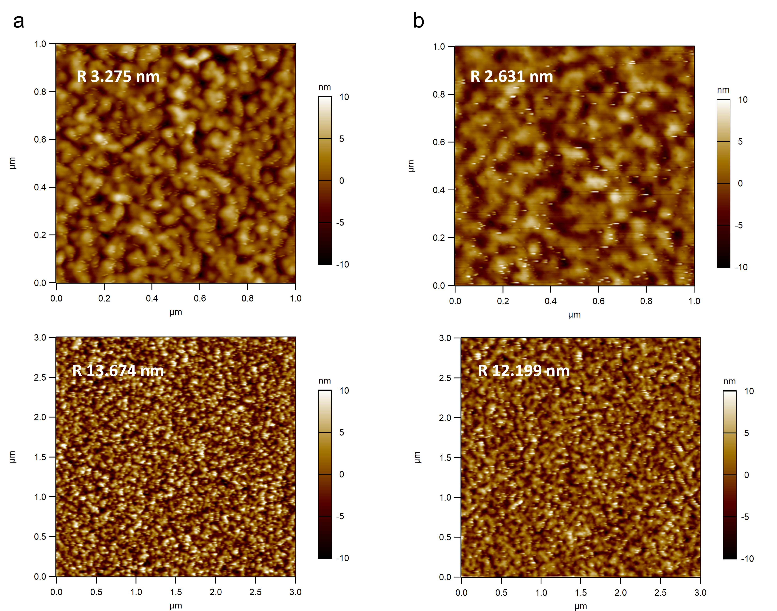
Supplementary Fig. 2. a,b, AFM images for POT2T and ANPO under different scale bar.

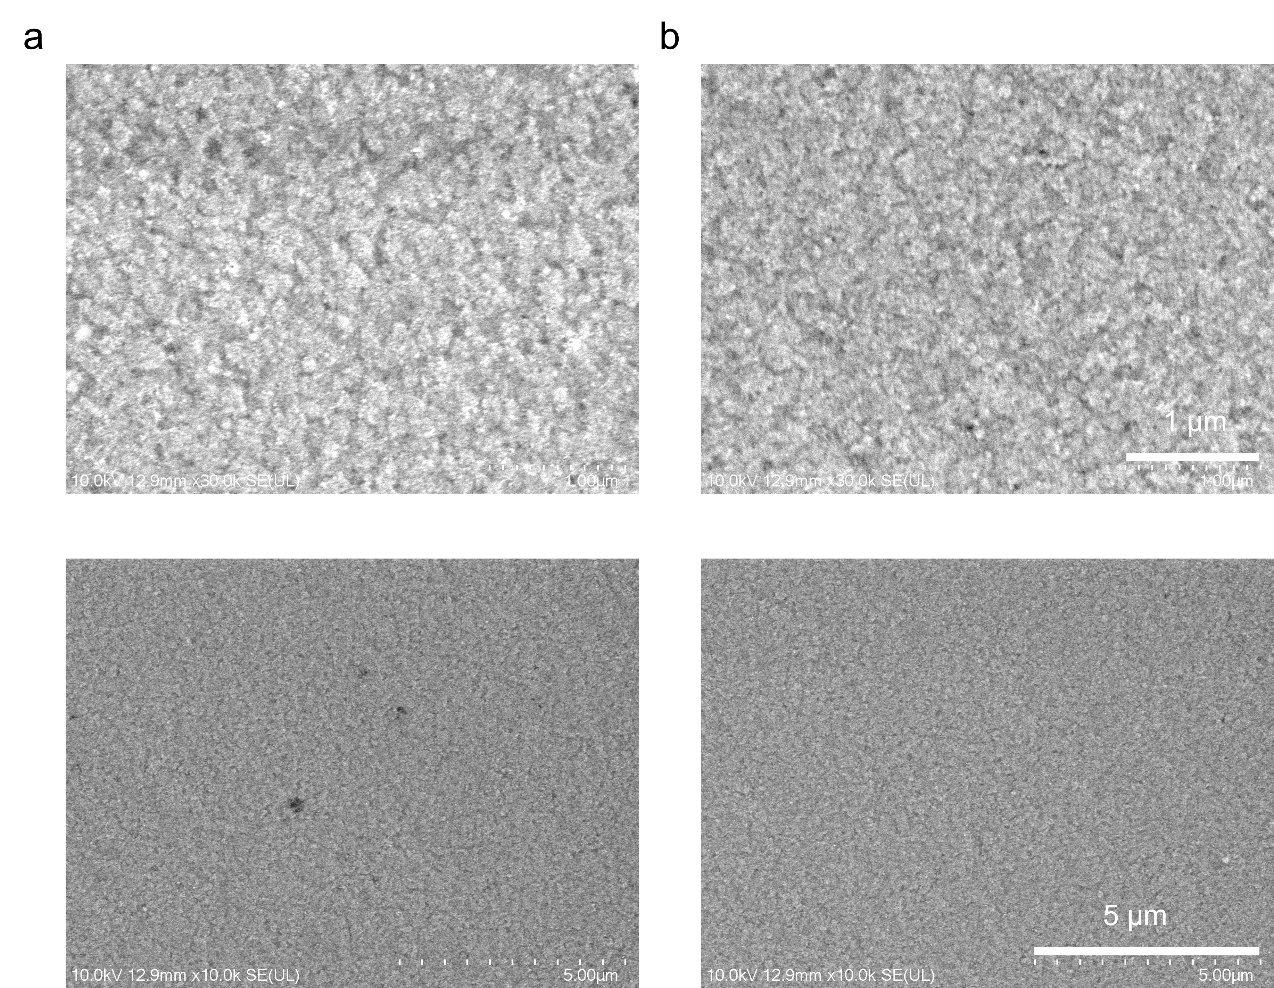
Supplementary Fig. 3. a,b, SEM images for POT2T and ANPO films under 30 K (up) and 10 K (down) magnification.

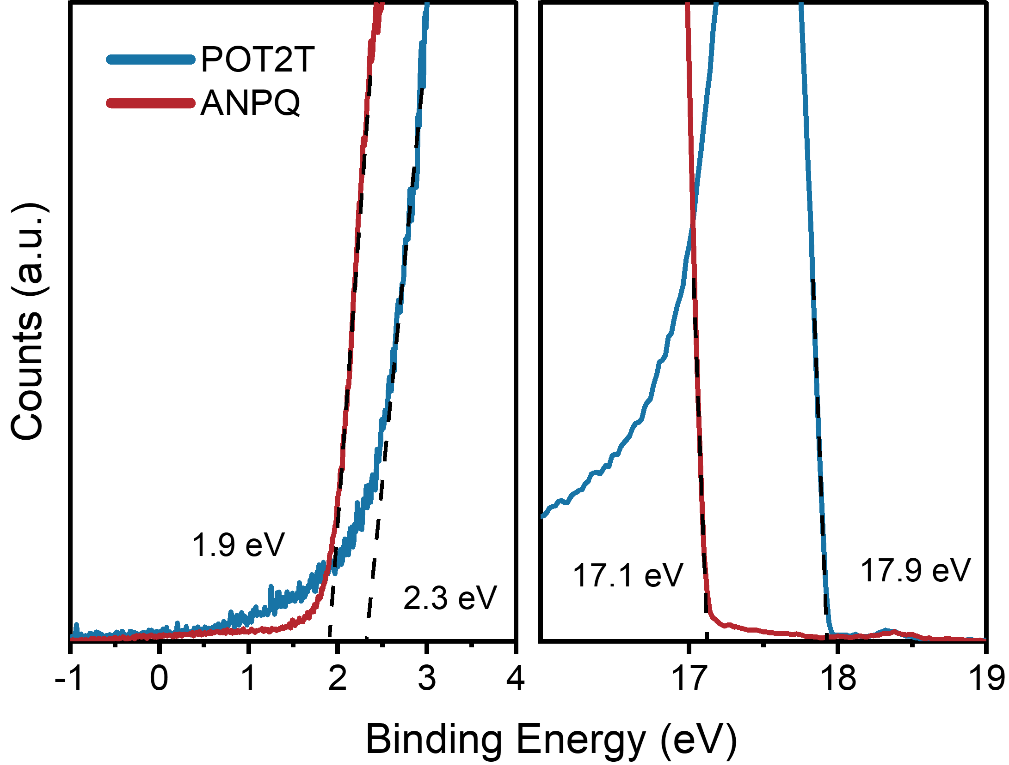
Supplementary Fig. 4. UPS spectra of different ETLs.

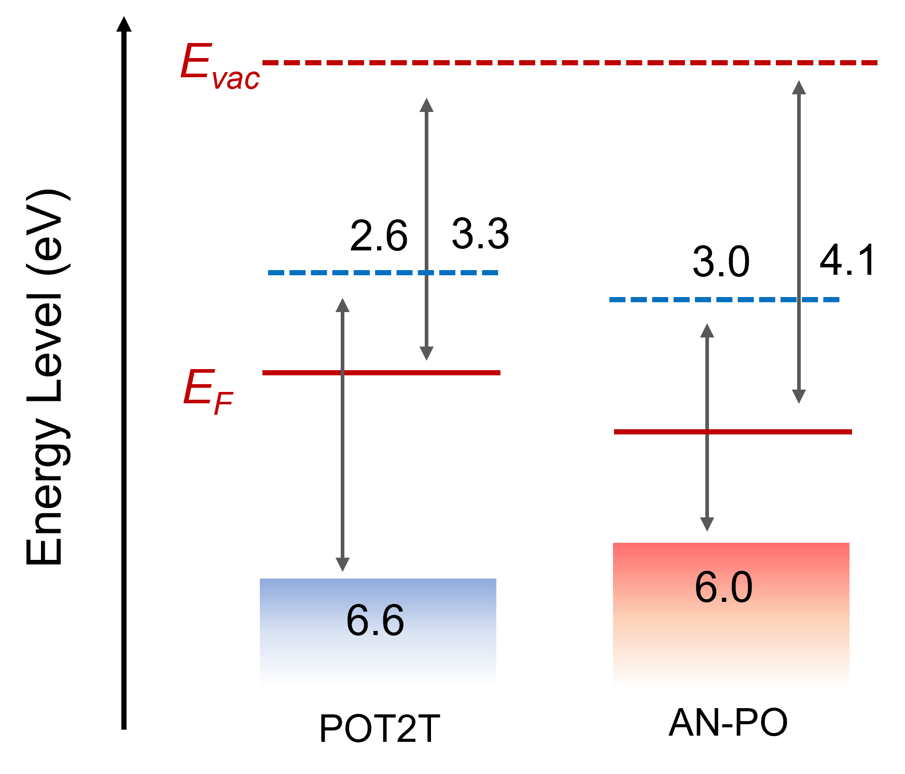
Supplementary Fig. 5. Energy level of POT2T and ANPO

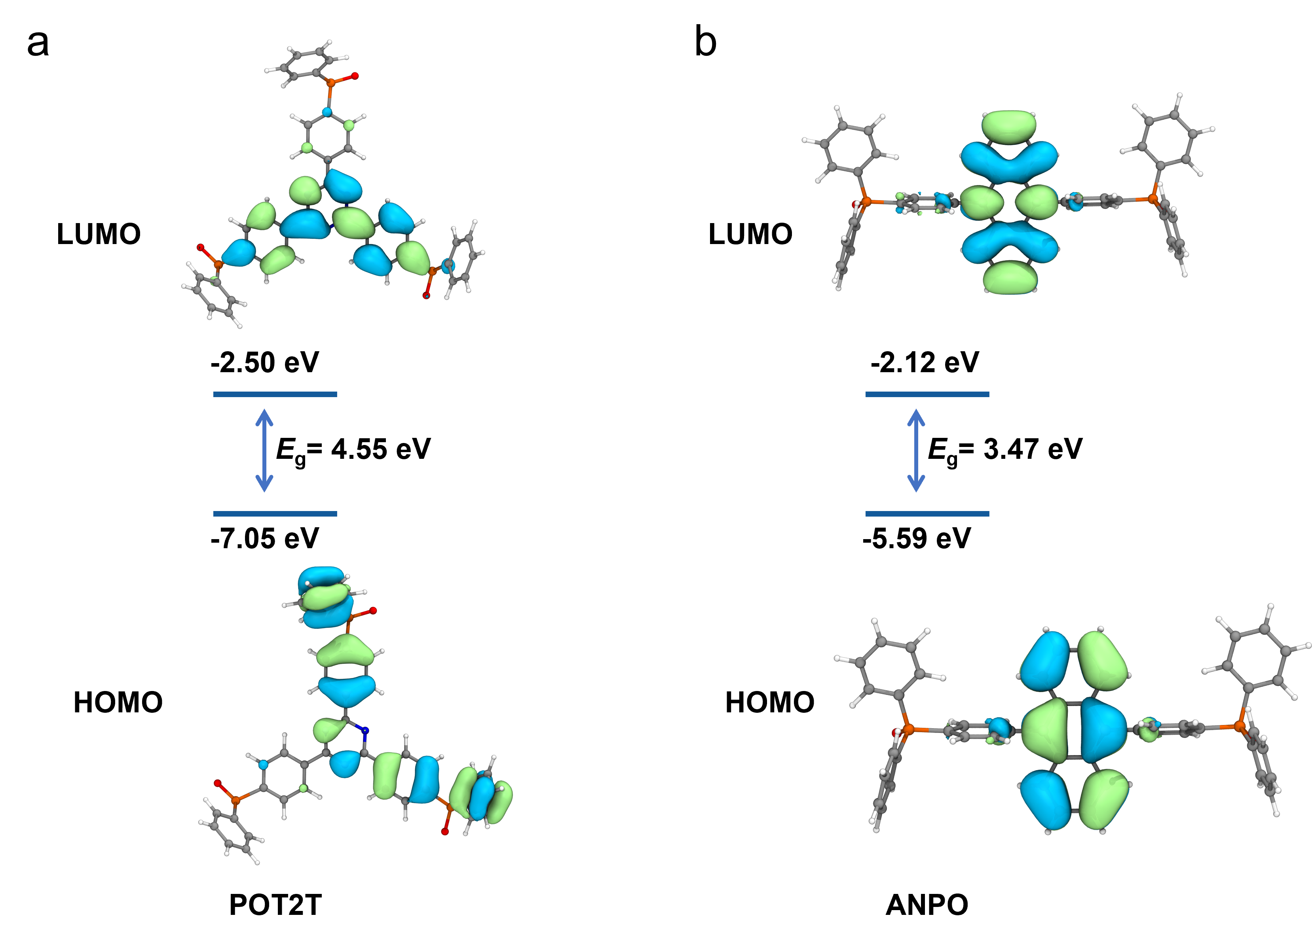
Supplementary Fig. 6. a,b, HOMO and LUMO distributions of POT2T and ANPO.

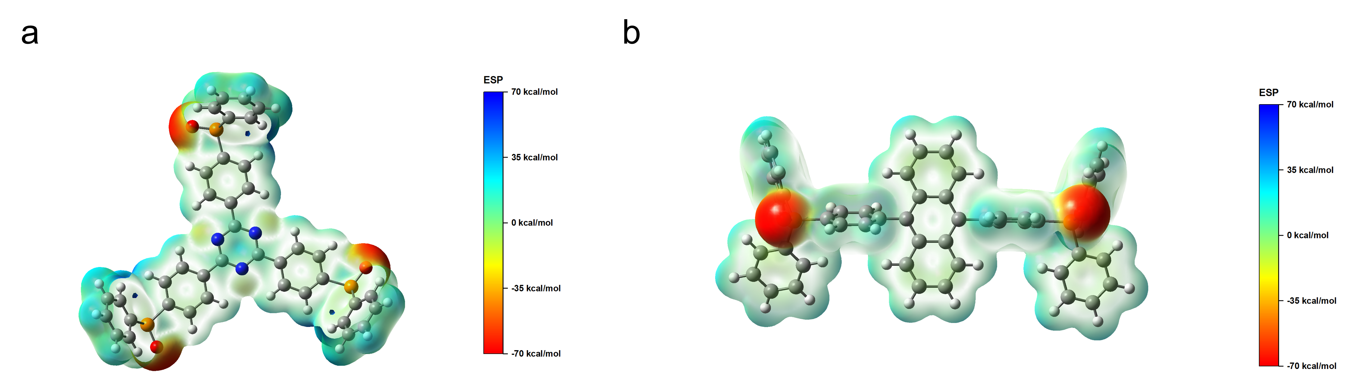
Supplementary Fig. 7. a,b, Electrostatic potential (ESP) iso-surface with the minimum point of POT2T and ANPO respectively.

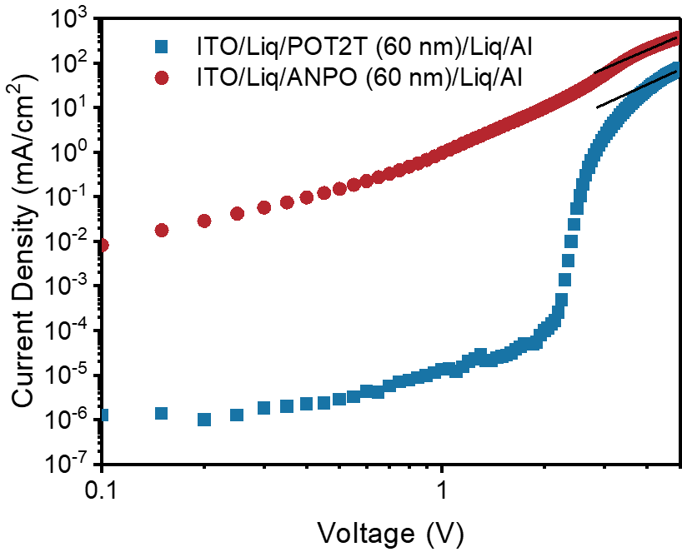
Supplementary Fig. 8. I-V curves of the device with structure of ITO/Liq/ANPO/Liq/Al and ITO/Liq/POT2T/Liq/Al.

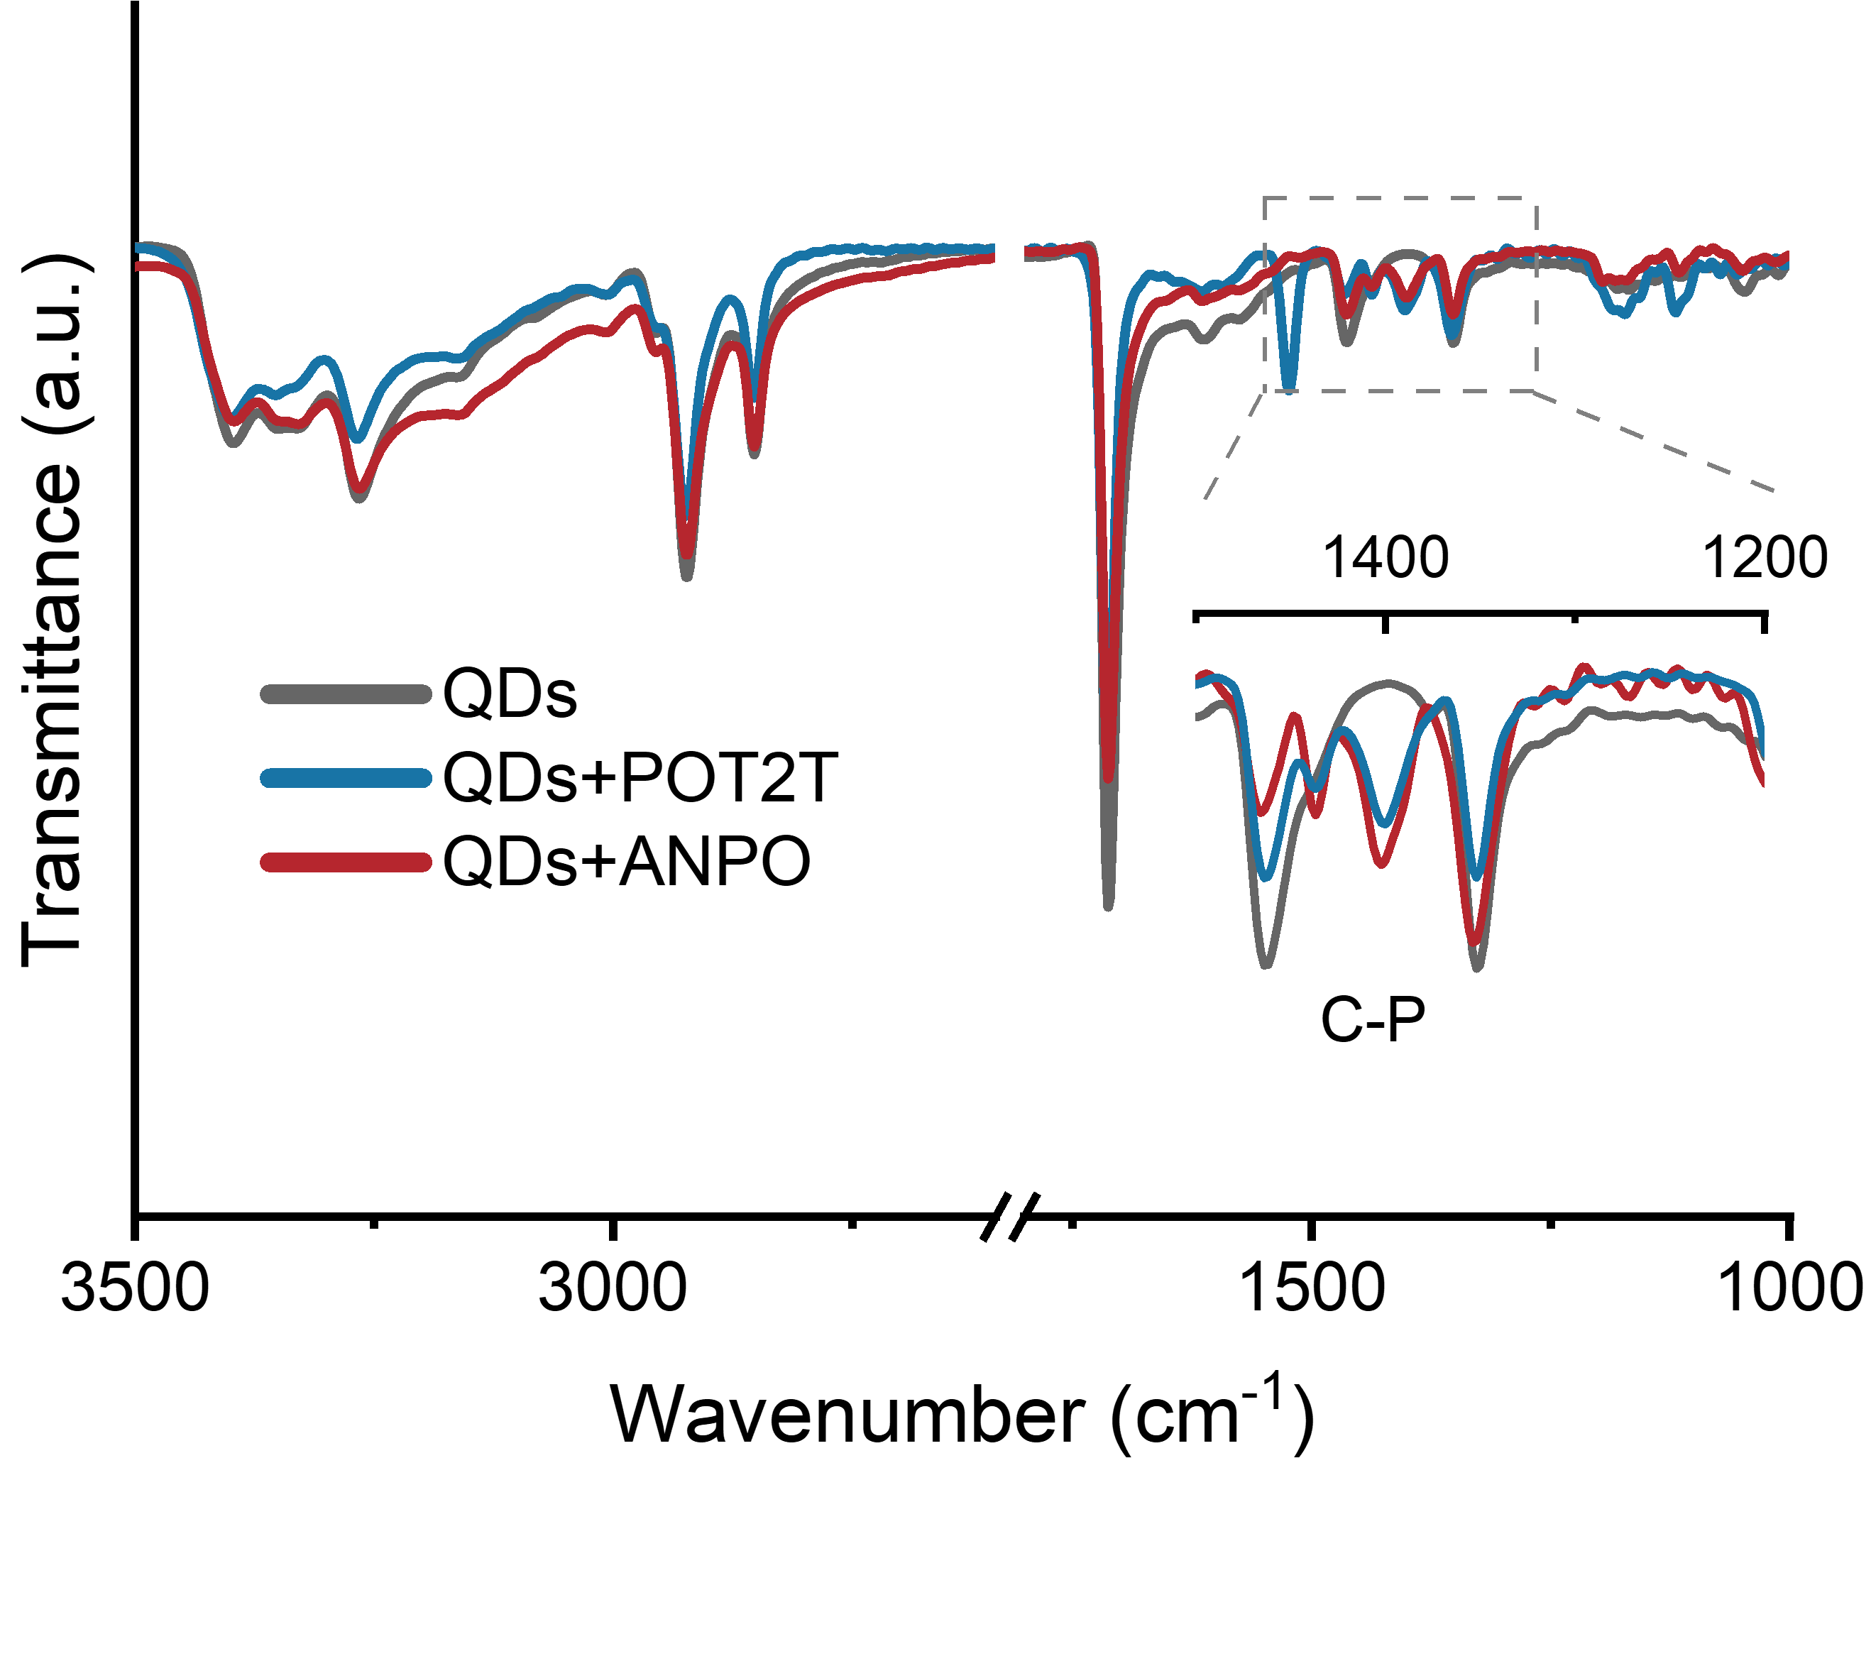
Supplementary Fig. 9. FTIR spectra of QDs, QDs with POT2T and QDs with ANPO.

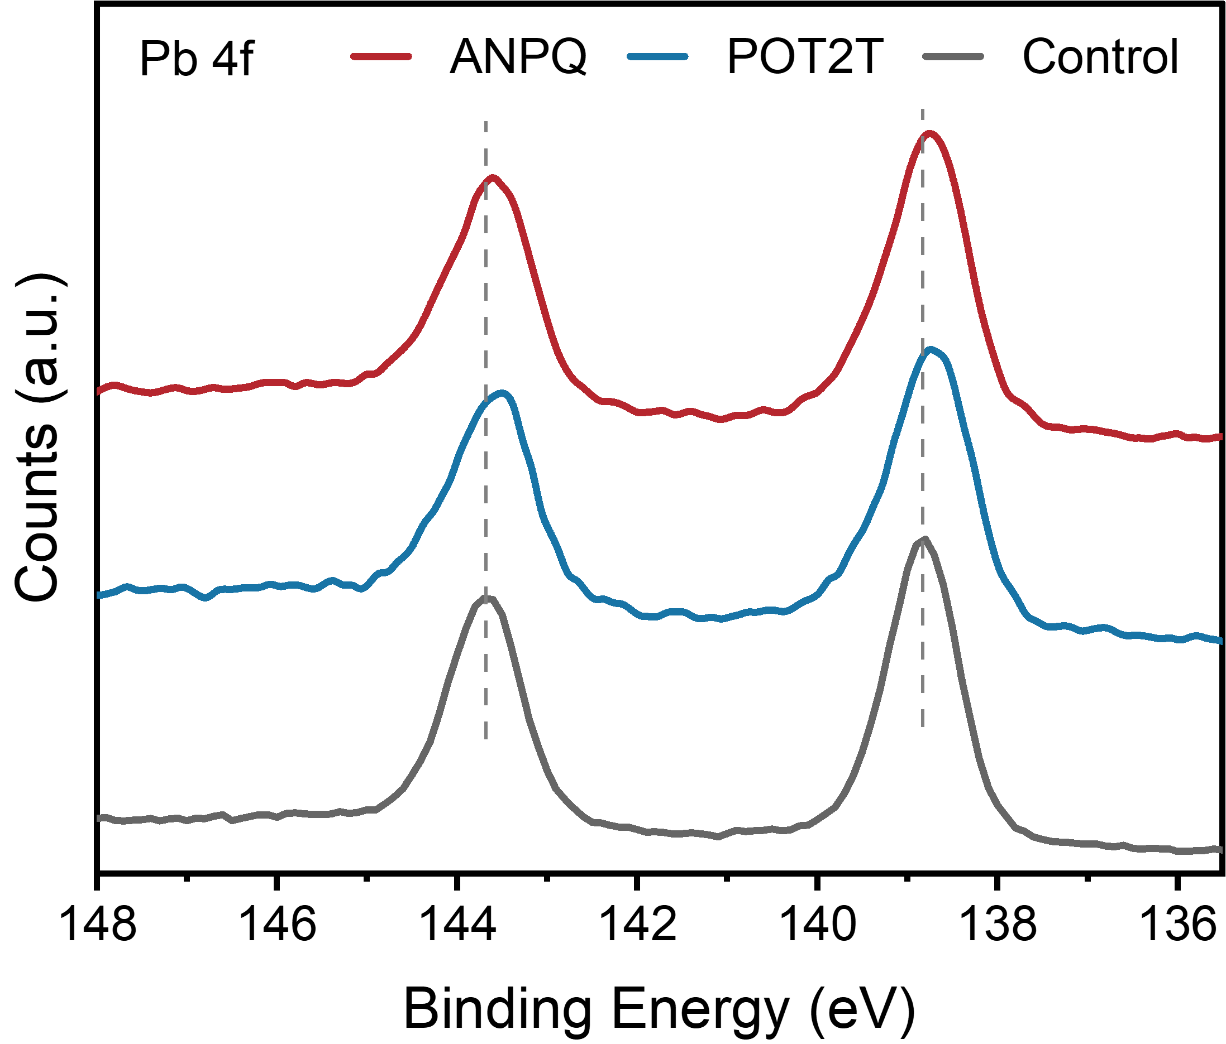
Supplementary Fig. 10. XPS spectra of QDs (control), QDs with POT2T and QDs with ANPO.

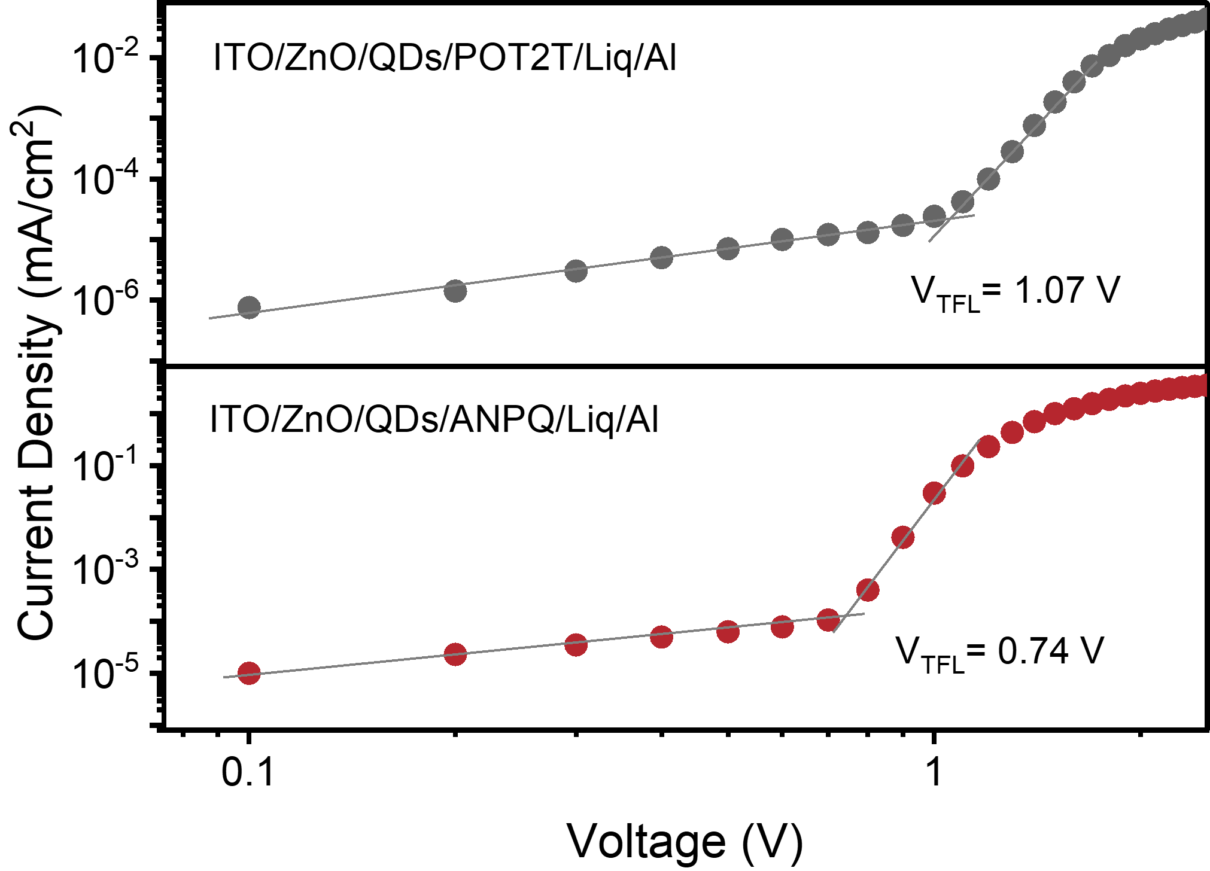
Supplementary Fig. 11. SCLC spectra of single electron device with POT2T and ANPO.
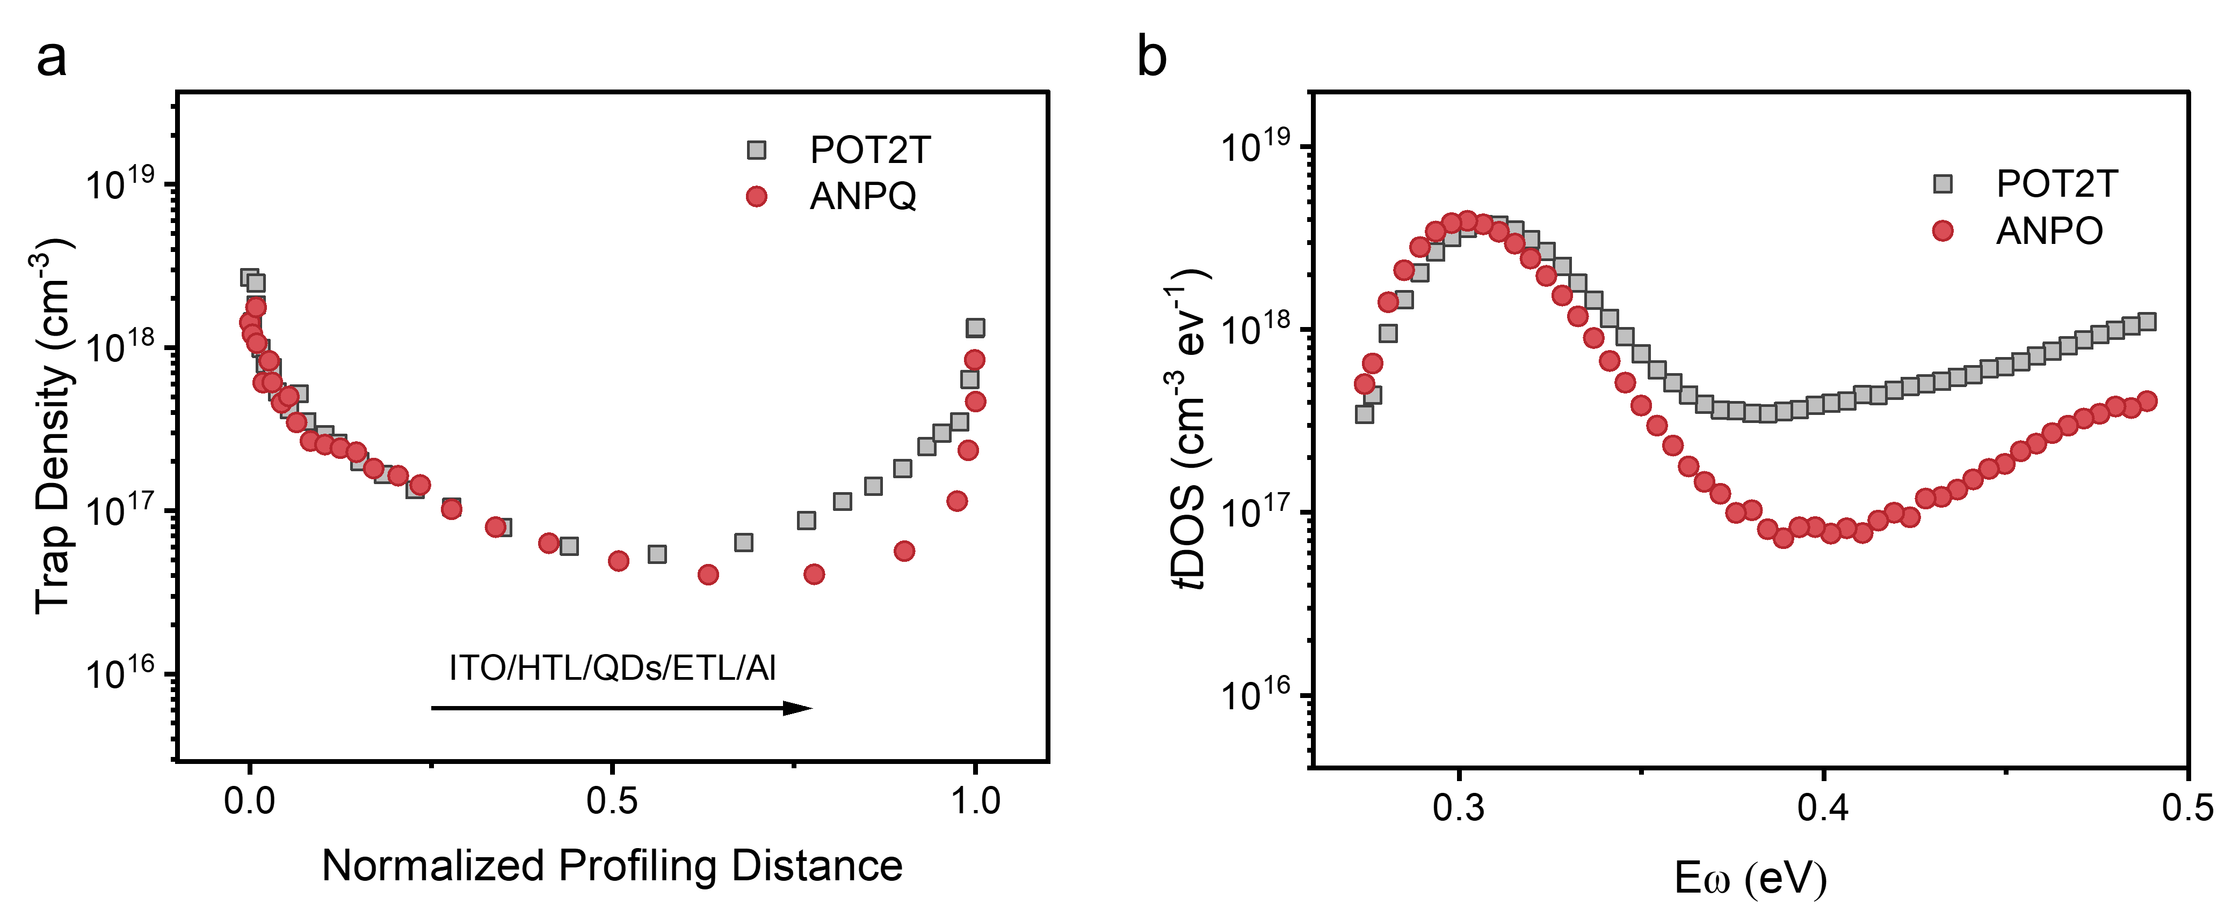

Supplementary Fig. 12. a, The DLCP curves of the QLED with POT2T and ANPO. b, The tDOS curves of the QLED with POT2T and ANPO.

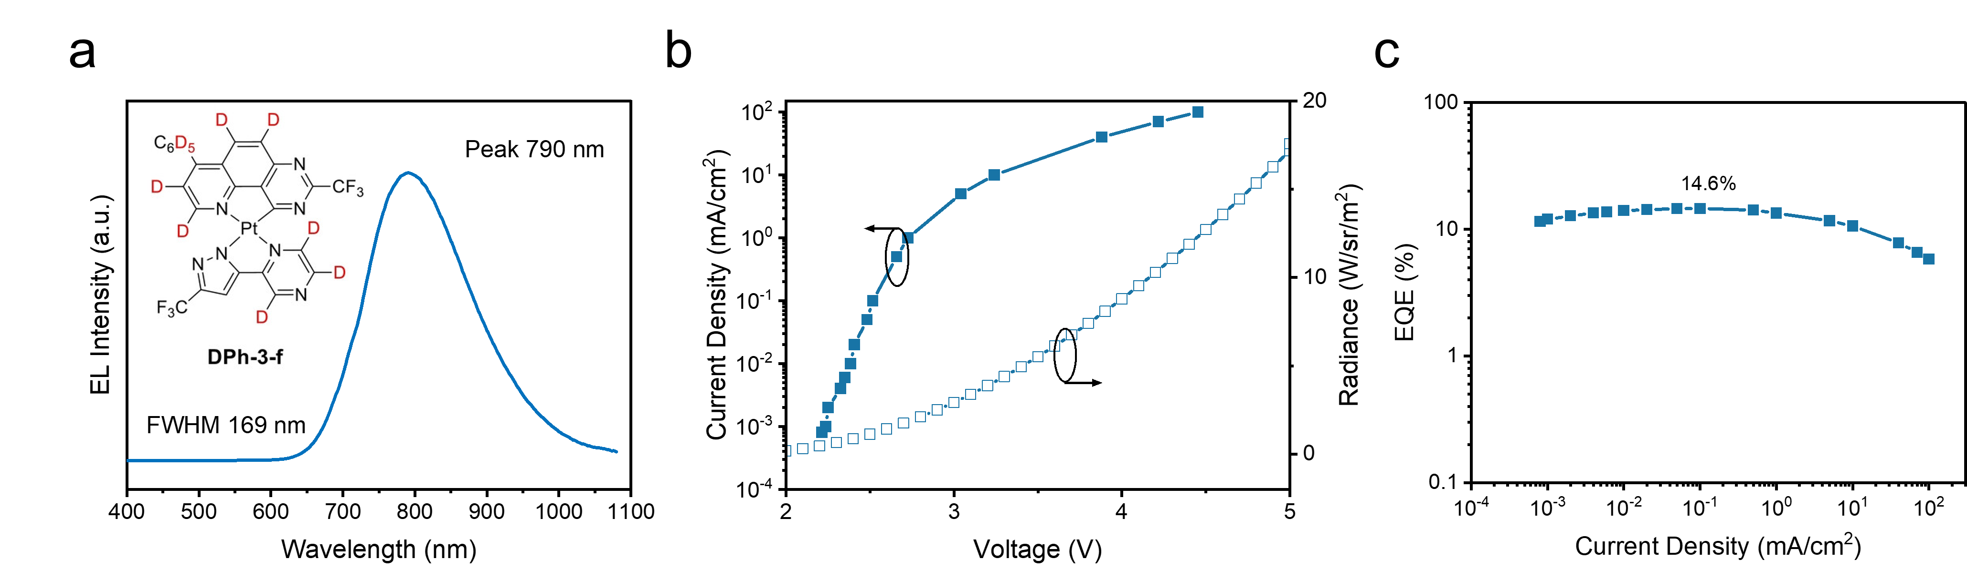

Supplementary Fig. 13. a, Electroluminescence (EL) spectra of target device under 4 V. b, Current density-voltage and Radiance-voltage curves. c, EQE-current density plots of the organic device

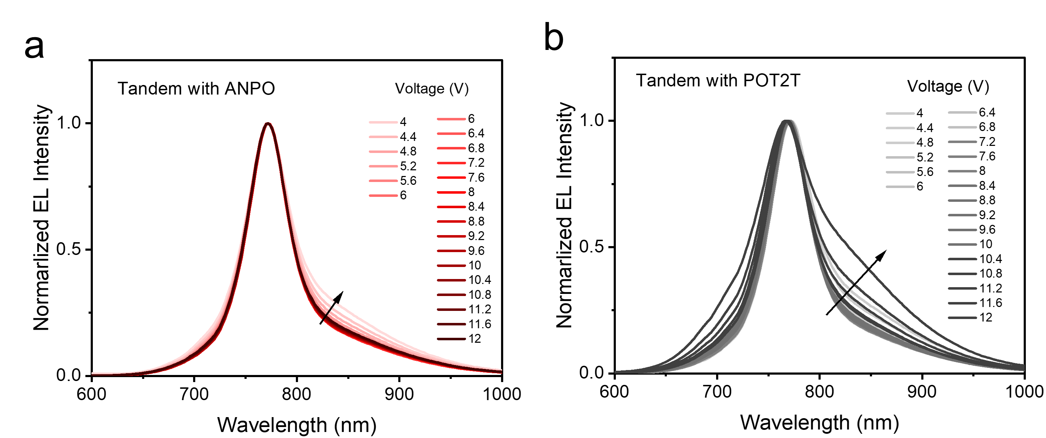
Supplementary Fig. 14. Electroluminescence (EL) spectra of a, target device and b, control device under different bias.

