Supplemental Materials A

Association between PFOA exposure and liver enzymes: A systematic review and meta-analysis of longitudinal cohort studies
Tian-Qi Wang, Yue-Nan Chen, Si-Yu Gui, Zheng-Xuan Jiang, Ze-Lian Li, Heng Jiang, Qi Hong, Jian-Chao Qiao, Ke-Jia Wu, Chao Zhang
Table and Figure of contents
Table S1. Preferred Reporting Items for Systematic reviews and Meta-Analysis (PRISMA) 2009 Checklist.
Table S2. Literature search strategy (dated to July 10, 2021).
Table S3. Quality assessment of the included studies.
Table S4. Criteria for the risk of bias assessment of each included study, adapted from the OHAT and Navigation Guide tool.
Table S5. Details of risk of bias assessment for each study included in the systematic review and meta-analysis.
Table S6. Sensitivity analyses of the associations between PFOA with diverse indicators of liver enzymes for continuous. exposure.

Table S7. Confidence in the body of evidence and level of evidence for each exposure-outcome combination.
Fig S1. Forest plot on the effect of PFOA with ALT for continuous exposure.
Fig S2. Forest plot on the effect of PFOA with AST for continuous exposure.
Fig S3. Forest plot on the effect of PFOA with GGT for continuous exposure.
Fig S4. Forest plot on the effect of PFOA with ALP for continuous exposure.
Fig S5. Doi plot and LFK index analysis of publication bias in reported associations between PFOA with ALT for continuous exposure.
Fig S6. Doi plot and LFK index analysis of publication bias in reported associations between PFOA with AST for continuous exposure.
Fig S7. Doi plot and LFK index analysis of publication bias in reported associations between PFOA with GGT for continuous exposure.
Fig S8. Doi plot and LFK index analysis of publication bias in reported associations between PFOA with ALP for continuous exposure.

Table S1. Preferred Reporting Items for Systematic reviews and Meta-Analysis (PRISMA) 2009 Checklist.
Section/topic | # | Checklist item | Reported on page #
TITLE
Title | 1 | Identify the report as a systematic review, meta-analysis, or both. | 1
ABSTRACT
Structured summary | 2 | Provide a structured summary including, as applicable: background; objectives; data sources; study eligibility criteria, participants, and interventions; study appraisal and synthesis methods; results; limitations; conclusions and implications of key findings; systematic review registration number. | 2-3
INTRODUCTION
Rationale | 3 | Describe the rationale for the review in the context of what is already known. | 4-6
Objectives | 4 | Provide an explicit statement of questions being addressed with reference to participants, interventions, comparisons, outcomes, and study design (PECOS). | 7
METHODS
Protocol and registration | 5 | Indicate if a review protocol exists, if and where it can be accessed (e.g., Web address), and, if available, provide registration information including registration number. | NA
Eligibility criteria | 6 | Specify study characteristics (e.g., PECOS, length of follow-up) and report characteristics (e.g., years considered, language, publication status) used as criteria for eligibility, giving rationale. | 6-7
Information sources | 7 | Describe all information sources (e.g., databases with dates of coverage, contact with study authors to identify additional studies) in the search and date last searched. | 7-8
Search | 8 | Present full electronic search strategy for at least one database, including any limits used, such that it could be repeated. | 7-8
Study selection | 9 | State the process for selecting studies (i.e., screening, eligibility, included in systematic review, and, if applicable, included in the meta-analysis). | 7-8
Data collection process | 10 | Describe method of data extraction from reports (e.g., piloted forms, independently, in duplicate) and any processes for obtaining and confirming data from investigators. | 8
Data items | 11 | List and define all variables for which data were sought (e.g., PICOS, funding sources) and any assumptions and simplifications made. | 7-8
Risk of bias in individual studies | 12 | Describe methods used for assessing risk of bias of individual studies (including specification of whether this was done at the study or outcome level), and how this information is to be used in any data synthesis. | 8-9
Summary measures | 13 | State the principal summary measures (e.g., risk ratio, difference in means). | 9-11
Synthesis of results | 14 | Describe the methods of handling data and combining results of studies, if done, including measures of consistency (e.g., I²) for each meta-analysis. | 9-11
Risk of bias across studies | 15 | Specify any assessment of risk of bias that may affect the cumulative evidence (e.g., publication bias, selective reporting within studies). | 11
Additional analyses | 16 | Describe methods of additional analyses (e.g., sensitivity or subgroup analyses, meta-regression), if done, indicating which were pre-specified. | 10-11
RESULTS
Study selection | 17 | Give numbers of studies screened, assessed for eligibility, and included in the review, with reasons for exclusions at each stage, ideally with a flow diagram. | 13
Study characteristics | 18 | For each study, present characteristics for which data were extracted (e.g., study size, PICOS, follow-up period) and provide the citations. | 13
Risk of bias within studies | 19 | Present data on risk of bias of each study and, if available, any outcome level assessment (see item 12). | 13-14
Results of individual studies | 20 | For all outcomes considered (benefits or harms), present, for each study: (a) simple summary data for each intervention group (b) effect estimates and confidence intervals, ideally with a forest plot. | 14-15
Synthesis of results | 21 | Present results of each meta-analysis done, including confidence intervals and measures of consistency. | 14-15
Risk of bias across studies | 22 | Present results of any assessment of risk of bias across studies (see Item 15). | 16-17
Additional analysis | 23 | Give results of additional analyses, if done (e.g., sensitivity or subgroup analyses, meta-regression [see Item 16]). | 15-16
DISCUSSION
Summary of evidence | 24 | Summarize the main findings including the strength of evidence for each main outcome; consider their relevance to key groups (e.g., healthcare providers, users, and policy makers). | 18-26
Limitations | 25 | Discuss limitations at study and outcome level (e.g., risk of bias), and at review-level (e.g., incomplete retrieval of identified research, reporting bias). | 27-29
Conclusions | 26 | Provide a general interpretation of the results in the context of other evidence, and implications for future research. | 30
FUNDING
Funding | 27 | Describe sources of funding for the systematic review and other support (e.g., supply of data); role of funders for the systematic review. | 30
Table S2. Literature search strategy (dated to July 10, 2021)
Database | Search strategies | Results
PubMed | (liver enzyme*[Title/Abstract] OR hepatase[Title/Abstract] OR hepatic enzyme*[Title/Abstract] OR ALT[Title/Abstract] OR Alanine transaminase[Title/Abstract] OR AST[Title/Abstract] OR aspartate transaminase[Title/Abstract] OR GGT[Title/Abstract] OR γ-glutamyl transpeptadase[Title/Abstract] OR ALP[Title/Abstract] OR alkaline phosphatase[Title/Abstract]) AND (PFOA[Title/Abstract] OR pfoa[Title/Abstract] OR Perfluorooctanoic Acid[Title/Abstract] OR Pentadecafluorooctanoic acid[Title/Abstract] OR Perfluorocaprylic acid[Title/Abstract]) | 35
Web of Science | TOPIC: (liver enzyme OR liver enzymes OR hepatase OR hepatic enzyme OR ALT OR Alanine transaminase OR AST OR aspartate transaminase OR GGT OR γ-glutamyl transpeptadase OR ALP OR alkaline phosphatase) AND TOPIC: (PFOA OR pfoa OR Perfluorooctanoic Acid OR Pentadecafluorooctanoic acid OR Perfluorocaprylic acid) | 133
EMBASE | ('liver enzyme or liver enzymes':ti,ab,kw OR hepatase:ti,ab,kw OR 'hepatic enzyme':ti,ab,kw OR alt:ti,ab,kw OR 'alanine transaminase':ti,ab,kw OR 'ast or aspartate transaminase':ti,ab,kw OR ggt:ti,ab,kw OR 'γ-glutamyl transpeptadase':ti,ab,kw OR alp:ti,ab,kw OR 'alkaline phosphatase':ti,ab,kw) AND ('pfoa or pfoa':ti,ab,kw OR 'perfluorooctanoic acid':ti,ab,kw OR 'pentadecafluorooctanoic acid':ti,ab,kw OR 'perfluorocaprylic acid':ti,ab,kw) | 18
Table S3. Quality assessment of the included studies.
Reference | Sample size | Study design | Study site | Time frame | Response rate | Outcome definition | Outcome assessment | Assessment of PFOA | Bio-phsyco-social plausibility | Adjustments for personal covariates | Adjustments for environmental covariates | Effect size calculation | Quality
Lyndsey A. Darrow (2016) | 1 | 1 | 1 | 1 | 1 | 0.5 | 1 | 1 | 0.75 | 1 | 0.75 | 1 | 0.92
Edward Anthony Emmett (2006) | 1 | 1 | 1 | 1 | 0.75 | 1 | 1 | 1 | 0.75 | 0.25 | 1 | 1 | 0.90
Chien-Yu Lin (2010) | 1 | 1 | 1 | 1 | 1 | 0.5 | 1 | 1 | 0.75 | 1 | 0.75 | 1 | 0.92
Ana M. Mora (2018) | 1 | 1 | 1 | 1 | 1 | 0.5 | 1 | 1 | 0.75 | 0.75 | 1 | 1 | 0.92
Min Nian (2019) | 1 | 1 | 1 | 1 | 1 | 1 | 1 | 1 | 0.75 | 1 | 0.75 | 1 | 0.96
Geary W. Olsen (2000) | 0.5 | 1 | 1 | 1 | 1 | 1 | 1 | 1 | 0.75 | 0.5 | 1 | 1 | 0.90
Geary W. Olsen (2007) | 1 | 1 | 1 | 1 | 0.75 | 1 | 1 | 1 | 0.75 | 0.5 | 1 | 1 | 0.92
Geary W. Olsen (2012) | 1 | 1 | 1 | 1 | 1 | 1 | 1 | 1 | 0.75 | 0.5 | 1 | 1 | 0.94
Jianshe Wang (2012) | 1 | 1 | 1 | 1 | 0.75 | 0.5 | 1 | 1 | 0.75 | 0.5 | 1 | 1 | 0.88
Note:
Sample size: 1 – completely satisfactory/justified by power analysis; 0.5 – somewhat satisfactory; 0 – not sufficient/not justified.
Design: 1 – cohort; 0.75 – case-control; 0.25 – cross-sectional/ecological.
Study country: 1 – with good working and living conditions/high socio-economic standard; 0.5 – difficult conditions/lower socio-economic standard; 0.25 – very difficult conditions/very low socio-economic standard; 0 – not reported.
Timeframe: 1 – reported; 0 – not reported.
Response rate: 1 – ≥ 80%/considerable part of the population; 0.75 – 60 to 80 %; 0.5 – < 60%; 0 – not reported.
Definition of outcome: 1 – clearly define all outcomes; 0.5 – define partly outcomes; 0 – not reported.
Assessment of outcome: 1 – medical records/physician’s exam/valid database; 0.25 – self-report; 0 – not specified.
Assessment of PFAS exposure: 1 – Testing by body fluids (serum indicators); 0.75 –The diet-history questionnaire or environmental measurements in living (occupationally exposed) areas report ; 0.5 – not study-specific official records; 0.25 – self-report.
Adjustments for personal covariates (cov): 1 – 12 to 17 (cov) including age or alcohol or smoking or BIM ; 0.75 – 6 to 12 (cov) including age or alcohol or smoking or BIM; 0.5 – 1 to 6 (cov) including age or alcohol or smoking or BIM; 0.25 – 6 to 17 (cov) without age or alcohol or smoking or BIM; 0.1 – 1 to 6 (cov) without age or alcohol or smoking or BIM; 0 – no covariates;(According to the sex, body mass index (BMI), alcohol consumption, race, regular exercise, smoking status, education, household income, fasting status, history of working at DuPont plant, and insulin resistance described by (Modeled Perfluorooctanoic Acid (PFOA) Exposure and Liver Function in a Mid-Ohio Valley Community: 2005 or 2006 in the C8HP, 2016)
Adjustments for environmental covariates: 1 – organochlorine pesticides (OCPs) + polybrominated diphenylethers (PBDEs) + polychlorinated biphenyls (PCBs); 0.75 – organochlorine pesticides (OCPs) + polybrominated diphenylethers (PBDEs); 0.5 – one or two of OCPs + PBDEs + PCBs, 0 – no adjustments.
Effect size calculation for meta-analysis: 1 – no transformations and no data imputation; 0.75 – mild transformation and no data imputation; 0.5 – several transformations and no data imputation, 0.25 – considerable transformations and data imputation.

Table S4. Criteria for the risk of bias assessment of each included study, adapted from the OHAT and Navigation Guide tool.
Bias |  | Risk of Bias Domains and Ratings | Answer
Key Criteria | Detection bias, exposure assessment | Can we be confident in the exposure characterization? | -LOW risk: There is high confidence that the exposure to residential greenness is the true average population exposure.  -PROBABLY LOW: There is indirect evidence that suggests low risk of bias.  -PROBABLY HIGH risk: There is insufficient information to permit a judgment of high risk of bias, but there is indirect evidence that suggests high risk of bias.  -HIGH risk: There is direct evidence of high risk of misclassification bias.
 | Detection bias, outcome assessment | Can we be confident in the outcome assessment? | -LOW risk: Outcome was classified based on diagnosis standard criteria (International Classification System code) and provided by a national or regional database.  -PROBABLY LOW: Outcome was assessed based on diagnosis standard criteria and collected by researcher  -PROBABLY HIGH risk: Outcome was not assessed based on standard diagnosis criteria AND is accompanied by validation sub-study or sensitivity analysis to suggest that the risk is minimum.  -HIGH risk: Outcome was assessed based on self-reports (parents, family) and data collected by the researcher.
 | Confounding bias | Did the study design or analysis account for important confounding and modifying variables? | -LOW risk: Study accounted for all important confounders which were measured consistently  -PROBABLY LOW: Study accounted for most of confounders AND is not expected to introduce bias  -PROBABLY HIGH risk: Study accounted for some but not all of confounders AND is expected to introduce bias  -HIGH risk: Study did not account for potential confounders OR were inappropriately measured
Other Criteria | Selection bias | Did selection of study participants result in appropriate comparison groups? | -LOW risk: The descriptions of the studied population were sufficiently detailed to support the assertion that risk of selection effects was minimal.  -PROBABLY LOW risk: There is insufficient information about population selection to permit a judgment of low risk of bias, but there is indirect evidence that suggests low risk of bias.  -PROBABLY HIGH risk: There is insufficient information about population selection to permit a judgment of high risk of bias, but there is indirect evidence that suggests high risk of bias.  - HIGH risk: There were indications from descriptions of the studied population of high risk of bias.
Other Criteria | Attrition/exclusion bias | Were outcome data complete without attrition or exclusion from analysis? | -LOW risk: There were no missing outcome data or missing data unrelated to true outcome  -PROBABLY LOW: There was insufficient information about incomplete data to judge for low risk, but indirect evidence that suggests low risk of bias  -PROBABLY HIGH risk: There was insufficient information about incomplete data to judge for high risk, but indirect evidence that suggests high risk  -HIGH risk: Missing outcome data is related to true outcome
 | Selective reporting bias | Were all measured outcomes reported? | -LOW risk: All of the studies pre-specified outcomes and findings are reported  -PROBABLY LOW: There was insufficient information about selective outcome to judge for low risk, but indirect evidence that suggests study was free of selective report  -PROBABLY HIGH risk: There was insufficient information about selective reporting to judge for high risk, but indirect evidence suggests that study was not free of selective reporting  -HIGH risk: Not all pre-specified outcomes and findings were reported, or one/more of the primary outcomes or analyses were assessed or executed with other methods than the pre-specified one, or one/more of the reported outcomes/findings was/were not pre-specified
 | Conflict of interest | Potential source of bias in reporting through source of funding | -LOW risk: The study did not receive funding from an entity with financial interest in the outcome of study  -PROBABLY LOW: There is insufficient information to judge for low risk, but indirect evidence suggests study was free of financial interest  -PROBABLY HIGH risk: There is insufficient information to judge for high risk, but indirect evidence suggests study was not free of financial interest  -HIGH risk: The study received support from an entity with financial interest in the outcome of study
 | Other source of bias | Bias due to other problems not covered elsewhere (statistical methods were appropriate and researchers adhere to the study protocol) | -LOW risk: No other sources of bias  -PROBABLY LOW: There is insufficient information to judge for low risk, but indirect evidence suggests study was free of other problems  -PROBABLY HIGH risk: There is insufficient information to judge for high risk, but indirect evidence suggests study was not free of other problems  -HIGH risk: There was at least one important risk of bias

Table S5. Details of risk of bias assessment for each study included in the systematic review and meta-analysis.
Study ID | Domain | Judgement | Comment
Lyndsey A. Darrow (2016) | DETECTION BIAS [Key element]: can we be confident in the exposure characterization? | Probably low | For each follow-up year for each subject, we calculated a measure of cumulative serum PFOA exposure by summing all previous yearly estimates of PFOA serum concentrations
Lyndsey A. Darrow (2016) | DETECTION BIAS [Key element]: can we be confident in the outcome assessment? | Probably low | We examined three markers of liver injury measured in 2005–2006 for the C8HP.
Lyndsey A. Darrow (2016) | CONFOUNDING BIAS [Key element]: did the study design or analysis account for important confounding and modifying variables? | Definitely low | Analysis adjusted age, sex, BMI, alcohol consumption, regular exercise, smoking status, education, insulin resistance, fasting status, history of working at DuPont plant, and race.
Lyndsey A. Darrow (2016) | SELECTION BIAS: did selection of study participants result in appropriate comparison groups? | Definitely low | The authors stated: “We used data from markers of liver toxicity, were obtained from blood samples collected in the C8 Health Project (2005–2006)”. Thus, selection bias may be ruled out.
Lyndsey A. Darrow (2016) | ATTRITION/EXCLUSION BIAS: were outcome data incomplete due to attrition or exclusion from analysis? | Probably low | There is no evidence of exclusions that may bias the results reported in the manuscript. The cross-sectional design prevents the loss of follow-up of participants.
Lyndsey A. Darrow (2016) | SELECTIVE REPORTING BIAS: were all measured outcomes reported? | Probably low | The authors stated: “Results are consistent with previous cross-sectional studies showing association between PFOA and ALT, a marker of hepatocellular damage..”. So, all the outcomes have been reported.
Lyndsey A. Darrow (2016) | CONFLICT OF INTEREST | Probably low | The authors declare they have no actual or potential competing financial interests.
Edward Anthony Emmett (2006) | DETECTION BIAS [Key element]: can we be confident in the exposure characterization? | Probably low | PFOA was analyzed using HPLC/tandem mass spectrometer
Edward Anthony Emmett (2006) | DETECTION BIAS [Key element]: can we be confident in the outcome assessment? | Probably low | The authors stated: “). Thirty milliliters of blood were drawn into red-topped Vacationer tubes:  10 ml were immediately sent for serum chemistry”.
Edward Anthony Emmett (2006) | CONFOUNDING BIAS [Key element]: did the study design or analysis account for important confounding and modifying variables? | Probably high | No adjustment was made for confounding factors.
Edward Anthony Emmett (2006) | SELECTION BIAS: did selection of study participants result in appropriate comparison groups? | Probably low | Serum (PFOA), hematologic and biochemical biomarkers, and a questionnaire were administered to 371 residents selected by stratified random sampling and a lottery among volunteers.
Edward Anthony Emmett (2006) | ATTRITION/EXCLUSION BIAS: were outcome data incomplete due to attrition or exclusion from analysis? | Probably low | There is no evidence of exclusions that may bias the results reported in the study.
Edward Anthony Emmett (2006) | SELECTIVE REPORTING BIAS: were all measured outcomes reported? | Probably low | The authors stated: “We have found no significant positive association between serum(PFOA) and markers of a number of potential health effects from PFOA in a sample of residents from a community with markedly elevated serum (PFOA) compared with general population levels”. So all the outcomes have been reported.
Edward Anthony Emmett (2006) | CONFLICT OF INTEREST | Probably low | The study did not address the issue of benefits.
Chien-Yu Lin (2010) | DETECTION BIAS [Key element]: can we be confident in the exposure characterization? | Probably low | Detection and quantification were done by negative-ion Turboprop ionization tandem mass spectroscope and isotope-labeled internal standards.
Chien-Yu Lin (2010) | DETECTION BIAS [Key element]: can we be confident in the outcome assessment? | Probably low | Total bilirubin, aniline aminotransferase (ALT), aspartame aminotransferase, γ -glutamyltransferase (GGT), and alkaline phosphate were the liver enzymes parameters available from NHANES.
Chien-Yu Lin (2010) | CONFOUNDING BIAS [Key element]: did the study design or analysis account for important confounding and modifying variables? | Probably low | Analysis adjusted for exposure year, maternal age, parity, education level at interview, smoking status at interview.
Chien-Yu Lin (2010) | SELECTION BIAS: did selection of study participants result in appropriate comparison groups? | Definitely low | In this study, 2,216 adults (18 years of age or older) were recruited in a National Health and Nutrition Examination Survey (NHANES) in 1999-2000 and 2003-2004.
Chien-Yu Lin (2010) | ATTRITION/EXCLUSION BIAS: were outcome data incomplete due to attrition or exclusion from analysis? | Probably low | There is no evidence of exclusions that may bias the results reported in the manuscript.
Chien-Yu Lin (2010) | SELECTIVE REPORTING BIAS: were all measured outcomes reported? | Probably low | The authors stated: “On the basis of these data, we conclude that a higher serum concentration of PFOA may cause liver enzymes to increase abnormally in the general population, particularly in obese individuals. Further studies are warranted to clarify the casual relationship between PFCs and these liver enzymes”. So all the outcomes haven been reported.
Chien-Yu Lin (2010) | CONFLICT OF INTEREST | Probably low | The authors reported no other financial interests related to this research.
Ana M. Mora (2018) | DETECTION BIAS [Key element]: can we be confident in the exposure characterization? | Definitely low | All samples were analyzed using online solid-phase extraction coupled with isotope dilution high-performance liquid chromatography-tandem mass spectroscope, as previously described.
Ana M. Mora (2018) | DETECTION BIAS [Key element]: can we be confident in the outcome assessment? | Probably low | We measured fasting TC, HDL-C, TG, and ALT using enzymatic assays, in the same plasma samples used for quantification of mid-childhood PFASs.
Ana M. Mora (2018) | CONFOUNDING BIAS [Key element]: did the study design or analysis account for important confounding and modifying variables? | Probably low | Models were adjusted for maternal education, prenatal smoking, and child's sex, race/ethnicity, age at lipids/ALT measurements, and all PFAS analyses.
 | SELECTION BIAS: did selection of study participants result in appropriate comparison groups? | Definitely low | The studied 682 mother-child pairs from a Boston-area pre-birth cohort.
 | ATTRITION/EXCLUSION BIAS: were outcome data incomplete due to attrition or exclusion from analysis? | Probably low | There is no evidence of exclusions that may bias the results reported in the manuscript.
 | SELECTIVE REPORTING BIAS: were all measured outcomes reported? | Probably low | The authors stated: “Our data suggest that prenatal and mid-childhood PFAS exposure may be associated with modest,but somewhat conflicting changes in the lipid profile and ALT levels in children”. The outcome is unique and has been reported.
 | CONFLICT OF INTEREST | Probably low | None of the other authors declares any actual or potential comfeting financial interests.
Min Nian (2019) | DETECTION BIAS [Key element]: can we be confident in the exposure characterization? | Probably low | Analysis of 18 PFAAs in 0.5 ml serum, including eight isomeric PFAAs.
Min Nian (2019) | DETECTION BIAS [Key element]: can we be confident in the outcome assessment? | Probably low | Values for nine serum liver function biomarkers were determined by full-automatic blood biochemical analyzer.
Min Nian (2019) | CONFOUNDING BIAS [Key element]: did the study design or analysis account for important confounding and modifying variables? | Probably low | Adjusted for age, sex, career, income, education, drink, smoke, giblet and seafood consumption, exercise and BMI.
Min Nian (2019) | SELECTION BIAS: did selection of study participants result in appropriate comparison groups? | Definitely low | The 'Isomers of C8 Health Project in China' is a study.
 | ATTRITION/EXCLUSION BIAS: were outcome data incomplete due to attrition or exclusion from analysis? | Probably low | There is no evidence of exclusion bias.
 | SELECTIVE REPORTING BIAS: were all measured outcomes reported? | Definitely low | The authors stated: “In this study, clear association between serum PFAA concentrations and liver function biomarkers was found in adults. We observe new evidence that branched PFAAs isomer exposure increases the risk of clinically adverse hepatocellular dysfunction”. So all outcomes have been reported.
 | CONFLICT OF INTEREST | Probably low | The authors declare no competing financial interest.
Geary W. Olsen (2000) | DETECTION BIAS [Key element]: can we be confident in the exposure characterization? | Probably low | The authors stated: “ serum PFOA determination and several male reproductive hormone assays”.
Geary W. Olsen (2000) | DETECTION BIAS [Key element]: can we be confident in the outcome assessment? | Probably low | The authors stated: “Serum chemises and hematology were evaluated at Allina Laboratories (Minneapolis, Minnesota)”.
Geary W. Olsen (2000) | CONFOUNDING BIAS [Key element]: did the study design or analysis account for important confounding and modifying variables? | Probably low | Analysis adjusted Adjusted for age, BMI, cigarette use, and non-respondents to alcohol question (all four years) and testosterone level.
Geary W. Olsen (2000) | SELECTION BIAS: did selection of study participants result in appropriate comparison groups? | Probably low | Voluntary medical surveillance examinations were offered to the agrochemical production workers in 1993, 1995 and 1997. The total number of male subjects, by year, who participated in these three cross-sectional investigations were.
Geary W. Olsen (2000) | ATTRITION/EXCLUSION BIAS: were outcome data incomplete due to attrition or exclusion from analysis? | Probably low | There is no evidence of exclusions that may bias the results reported in the manuscript.
Geary W. Olsen (2000) | SELECTIVE REPORTING BIAS: were all measured outcomes reported? | Probably low | Our findings continue to suggest there is no significant clinical hepatic toxicity associated with PFOA levels as measured in this workforce. Unlike a previously reported observation, PFOA did not appear to modulate hepatic responses to either obesity or alcohol consumption.
Geary W. Olsen (2000) | CONFLICT OF INTEREST | Probably high | The authors did not state whether there was an interest.
Geary W. Olsen (2007) | DETECTION BIAS [Key element]: can we be confident in the exposure characterization? | Probably low | Informed consent was obtained to measure specific fluorochemical concentrations in the blood of program participants, including PFOA.
Geary W. Olsen (2007) | DETECTION BIAS [Key element]: can we be confident in the outcome assessment? | Probably low | Clinical chemistry variables considered in the analyses were: alkaline phosphatase (IU/l), gamma glutamyl transferase (GGT, IU/l), aspartate aminotransferase (AST, IU/l), alanine aminotransferase (ALT, IU/l), total and direct bilirubin (mg/dl), blood glucose (mg/dl), cholesterol (mg/dl), LDL (mg/dl), HDL (mg/dl), and triglycerides (mg/dl).These measurements were performed at Allina Laboratorie(St Paul, MN).
Geary W. Olsen (2007) | CONFOUNDING BIAS [Key element]: did the study design or analysis account for important confounding and modifying variables? | Probably high | Adjusted for age, BMI, alcohol and location
Geary W. Olsen (2007) | SELECTION BIAS: did selection of study participants result in appropriate comparison groups? | Probably low | The study was a cohort study.
Geary W. Olsen (2007) | ATTRITION/EXCLUSION BIAS: were outcome data incomplete due to attrition or exclusion from analysis? | Probably low | There is no evidence of exclusion bias.
Geary W. Olsen (2007) | SELECTIVE REPORTING BIAS: were all measured outcomes reported? | Probably low | The authors stated: “PFOA concentrations measured in this workforce of 506 male fluorochemical production workers were not associated with total cholesterol, LDL, hepatic enzymes or thyroid hormones.”. So all the outcomes have been reported.
Geary W. Olsen (2007) | CONFLICT OF INTEREST | Probably low | The authors do not mention whether there is a financial conflict of interest.
Geary W. Olsen (2012) | DETECTION BIAS [Key element]: can we be confident in the exposure characterization? | Probably low | Blood (serum) was collected for analysis of PFOA and PFOS and standard clinical chemistries.
Geary W. Olsen (2012) | DETECTION BIAS [Key element]: can we be confident in the outcome assessment? | Probably low | Clinical chemistry were analyzed by Quest Diagnostics (Madison, NJ) and included total cholesterol (mg/dL), HDL cholesterol (mg/d), non-HDL cholesterol (mg/dL), total cholesterol/HDL ratio, total bilirubin (mg/dL), alkaline phosphate (U/L), aspartatetransaminase (AST, U/L), and aniline transmigrate (ALT, U/L).
Geary W. Olsen (2012) | CONFOUNDING BIAS [Key element]: did the study design or analysis account for important confounding and modifying variables? | Probably high | Adjusted for sex and baseline levels of age, body mass index, and alcohol.
Geary W. Olsen (2012) | SELECTION BIAS: did selection of study participants result in appropriate comparison groups? | Probably low | The study was a cohort study.
Geary W. Olsen (2012) | ATTRITION/EXCLUSION BIAS: were outcome data incomplete due to attrition or exclusion from analysis? | Probably low | There is no evidence of exclusion bias.
Geary W. Olsen (2012) | SELECTIVE REPORTING BIAS: were all measured outcomes reported? | Probably low | The authors stated: “ Adverse associations were not observed between changes in PFOA, PFOS, non-HDL cholesterol, HDL, and hepatic clinical chemises”, so all outcomes have been reported.
Geary W. Olsen (2012) | CONFLICT OF INTEREST | Probably high | The authors do not mention whether there is a financial conflict of interest.
Jianshe Wang (2012) | DETECTION BIAS [Key element]: can we be confident in the exposure characterization? | Probably low | All serum samples collected were used for biochemistry parameters analysis and PFCs analysis.
Jianshe Wang (2012) | DETECTION BIAS [Key element]: can we be confident in the outcome assessment? | Definitely low | Standard spectrophotometric methods for the HITAC7170A automatic analyzer were used to measure serum lipid and enzyme parameters, including TG, CHO, LDL-C, high-density lipoprotein cholesterol (HDLC), ALT, and AST.
Jianshe Wang (2012) | CONFOUNDING BIAS [Key element]: did the study design or analysis account for important confounding and modifying variables? | probably high | Adjusted for BMI and age.
Jianshe Wang (2012) | SELECTION BIAS: did selection of study participants result in appropriate comparison groups? | Probably low | The study was a cohort study.
Jianshe Wang (2012) | ATTRITION/EXCLUSION BIAS: were outcome data incomplete due to attrition or exclusion from analysis? | Probably low | There is no evidence of exclusion bias.
Jianshe Wang (2012) | SELECTIVE REPORTING BIAS: were all measured outcomes reported? | Probably low | The authors stated: “. Circulating miR-26b and miR-199a-3p were elevated with serum concentration of PFOA. Although the limitations of small sample size and the cross-sectional nature of the current study constrained causal inferences, the observed associations between PFOA and these serum biomarkers warrant further study”.
Jianshe Wang (2012) | CONFLICT OF INTEREST | Probably low | The authors declare they have no competing financial interests.

Table S6. Sensitivity analyses of the associations between PFOA with diverse indicators of liver enzymes for continuous exposure.
PFOA and liver enzymes indicators pairs | Study omitted | PFOA and liver enzymes indicators pairs | Study omitted
ALT(U/L)
PFOA | Lyndsey A. Darrow 2016 | 0.008 (-0.020, 0.035) | 0.939
PFOA | Min Nian 2019 | 0.009 (-0.001, 0.020) | 0.939
PFOA | Geary W. Olsen 2007 | 0.008 (-0.004, 0.020) | 0.939
PFOA | Geary W. Olsen 2012| | 0.012 (0.001, 0.023) | 0.939
PFOA | Jianshe Wang 2012 | 0.013 (0.004, 0.022) | 0.939
PFOA | Ana M. Mora 2018 | 0.012 (0.001, 0.023) | 0.939
PFOA | Geary W. Olsen 2000 | 0.013 (-0.012, 0.037) | 0.939
AST(U/L)
PFOA | Min Nian 2019 | 0.064 (-0.010, 0.138) | 0.060
PFOA | Geary W. Olsen 2007 | 0.036 (-0.002, 0.074) | 0.060
PFOA | Geary W. Olsen 2012 | 0.041 (-0.002, 0.084) | 0.060
PFOA | Jianshe Wang 2012 | 0.015 (-0.007, 0.037) | 0.060
PFOA | Edward Anthony Emmett 2006 | 0.047 (0.005, 0.089) | 0.060
PFOA | Geary W. Olsen 2000 | 0.069 (0.003, 0.135) | 0.060
GGT(U/L)
PFOA | Lyndsey A. Darrow 2016 | 0.039 (0.001, 0.077) | 0.063
PFOA | Chien-Yu Lin 2010 | | 0.008 (0.001, 0.017) | 0.063
PFOA | Min Nian 2019 | 0.004 (-0.001, 0.010) | 0.063
PFOA | Geary W. Olsen 2007 | 0.008 (-0.002, 0.018) | 0.063
PFOA | Edward Anthony Emmett 2006 | 0.011 (0.001, 0.021) | 0.063
PFOA | Geary W. Olsen 2000 | 0.039 (0.002, 0.077) | 0.063
ALP(U/L)
PFOA | Min Nian 2019 | 0.007 (0.003, 0.012) | 0.303
PFOA | Geary W. Olsen 2012 | 0.004 (-0.006, 0.015) | 0.303
PFOA | Edward Anthony Emmett 2006 | 0.003 (-0.010, 0.016) | 0.303
PFOA | Geary W. Olsen 2000| | -0.011 (-0.034, 0.011) | 0.303

Table S7. Confidence in the body of evidence and level of evidence for each exposure-outcome combination.
Exposure–Outcome Combination | Factors Decreasing Confidence  “---” If No Concern; “↓” If Serious Concern to Downgrade Confidence |  |  |  |  | Factors Increasing Confidence  “---” If Not Present; “↑” If Sufficient to Upgrade Confidence
Initial confidence for each body of evidence | Risk of Bias | Unexplained Inconsistency | Indirectness | Imprecision | Publication bias | Large magnitude | Dose Response | Environmental Confounding | Consistency | Final Confidence Rating | Level of evidence
PFOA
ALT  Moderate (7 studies) | ↓ | --- | --- | --- | --- | --- | --- | --- | --- | Low | Inadequate
AST  Moderate (6 studies) | --- | ↑ | --- | --- | ↓ | --- | --- | --- | --- | Moderate | Moderate
GGT  Moderate (6 studies) | --- | --- | --- | --- | --- | --- | --- | --- | --- | Moderate | Moderate
ALP  Moderate (4 studies) | --- | --- | --- | ↓ | --- | ↑ | --- | --- | --- | Moderate | Moderate

Fig S1. Forest plot on the effect of PFOA with ALT for continuous exposure.
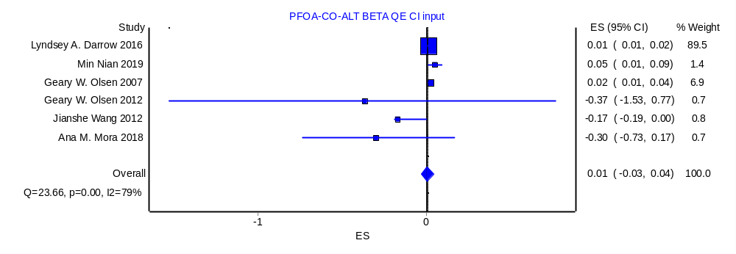
Fig S2. Forest plot on the effect of PFOA with AST for continuous exposure.
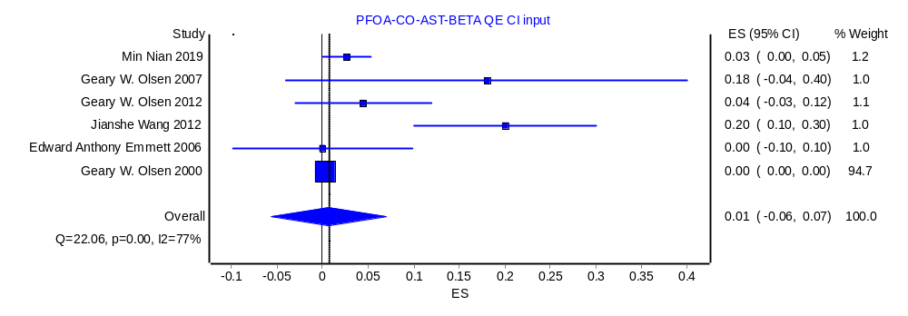
Fig S3. Forest plot on the effect of PFOA with GGT for continuous exposure.
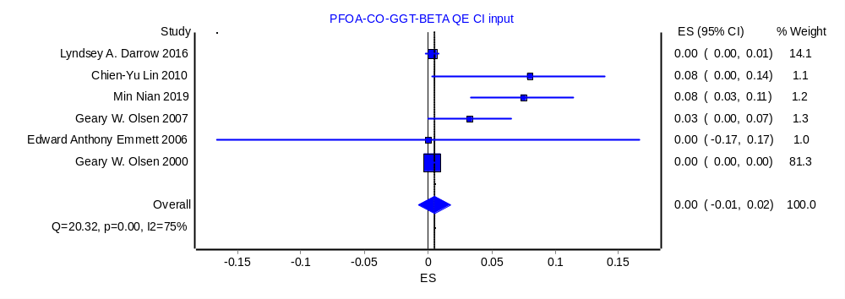
Fig S4. Forest plot on the effect of PFOA with ALP for continuous exposure.
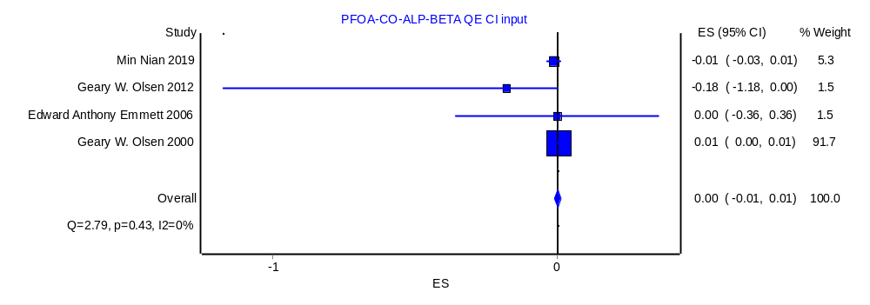
Fig S5. Doi plot and LFK index analysis of publication bias in reported associations between PFOA with ALT for continuous exposure.
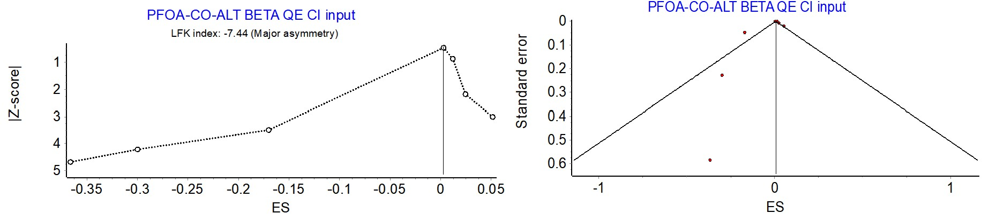
Fig S6. Doi plot and LFK index analysis of publication bias in reported associations between PFOA with AST for continuous exposure.
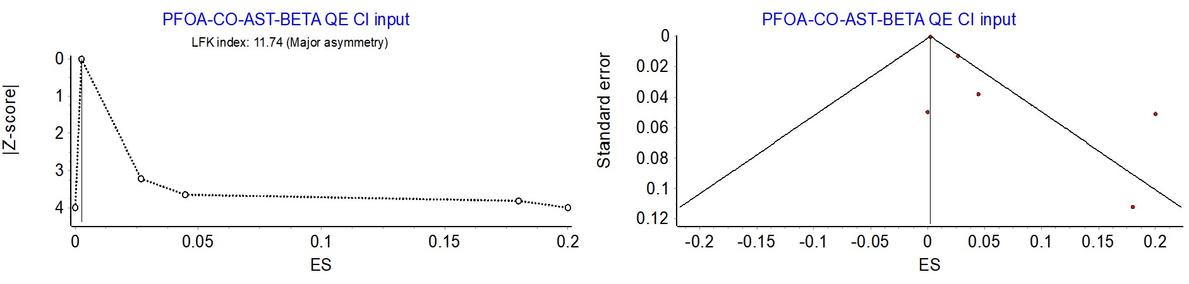
Fig S7. Doi plot and LFK index analysis of publication bias in reported associations between PFOA with GGT for continuous exposure.
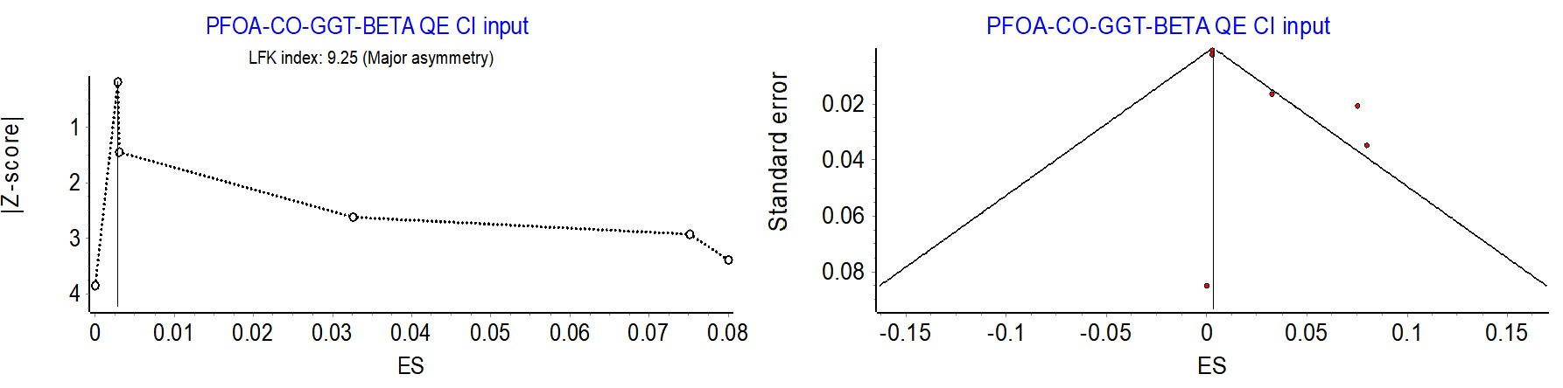
Fig S8. Doi plot and LFK index analysis of publication bias in reported associations between PFOA with ALP for continuous exposure.
