Supplementary Information
Utilizing machine-learning-based 3D image analysis for classifying charred grape seeds to the varietal level

Vlad Landa¹, Yekaterina Shapira², Michal David³, Avshalom Karasik⁴, Ehud Weiss³, Yuval Reuveni^{5*} and Elyashiv Drori^{2,6*}

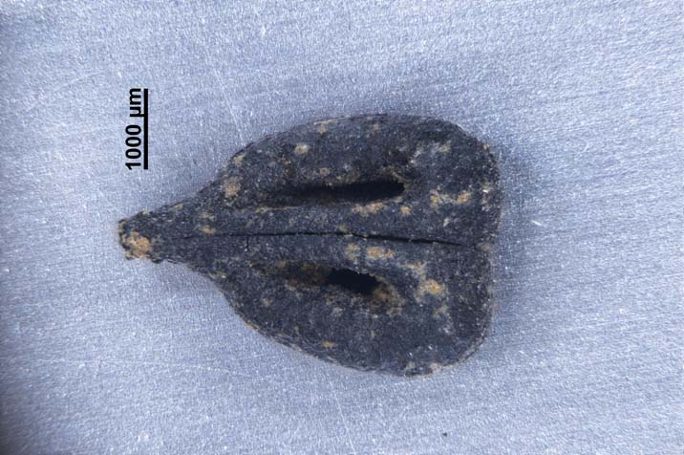
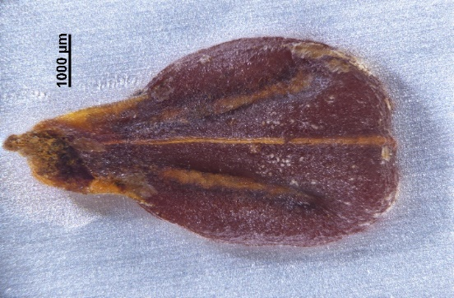
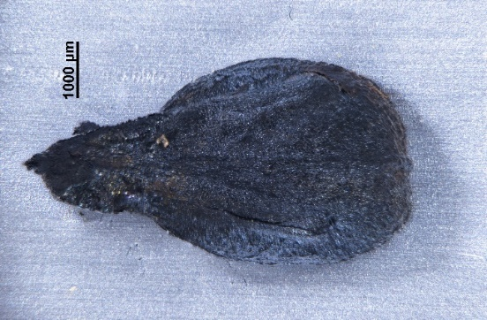
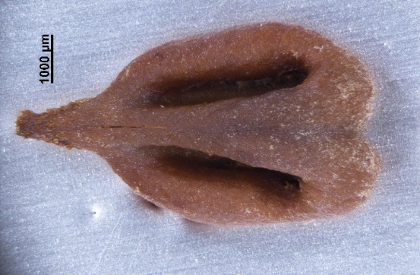
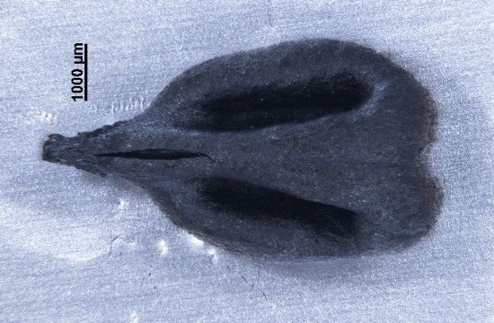
A
B
D
E

C

Supplementary Figure 1. 3D images of fresh and charred grape pips of variety 9003. A. Uncleaned fresh pip, B. Charred uncleaned grape pip. C. Cleaned fresh pip. D. Charred cleaned grape pip. E. Charred Uncleaned archaeological grape pip found in a winepress at Beit El, Israel.

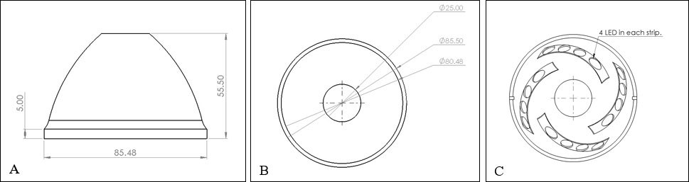

Supplementary Figure 2: PLA 3D printed light-cap: A – front view; B - top view and C – bottom view with four lamp stripes (mm).

