Figure S1. Unique metabolic reactions during latency reactivation.

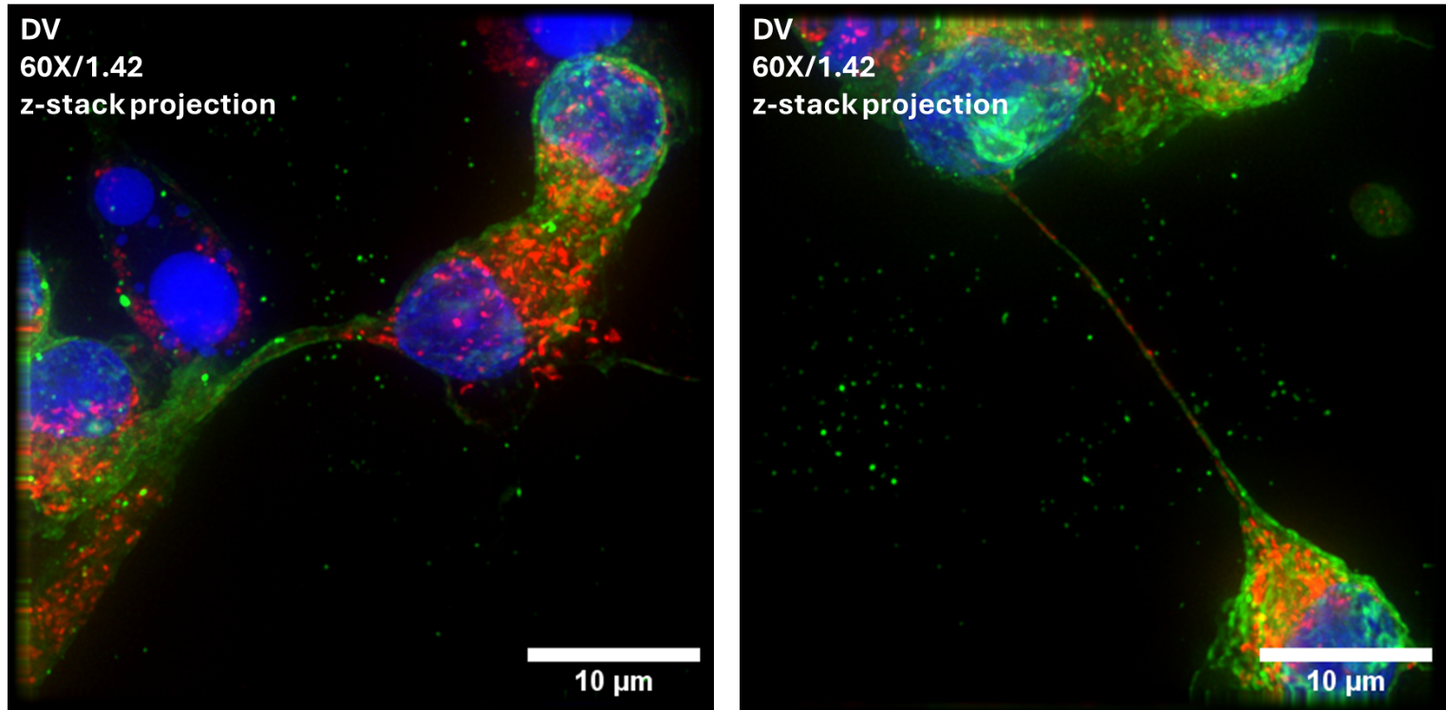
Figure S2. Formation of tunneling nanotubes (TNTs) during viral reactivation. Red GLA, Green: HIV p24 and Blue: Dapi

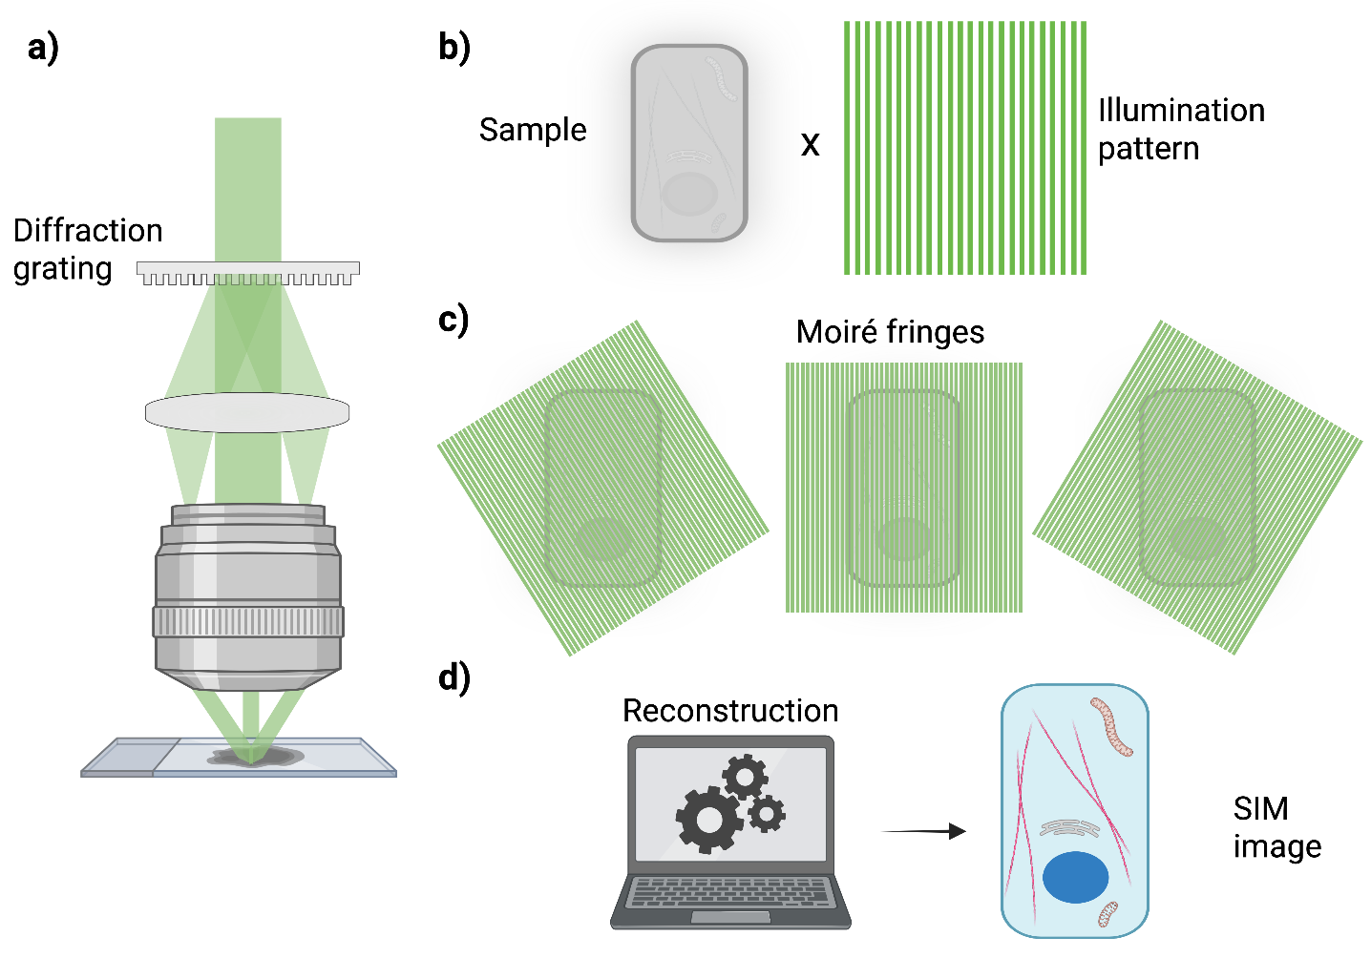
Figure S3. A custom-built QPM system working on Linnik interference configuration used for SIM analysis.

