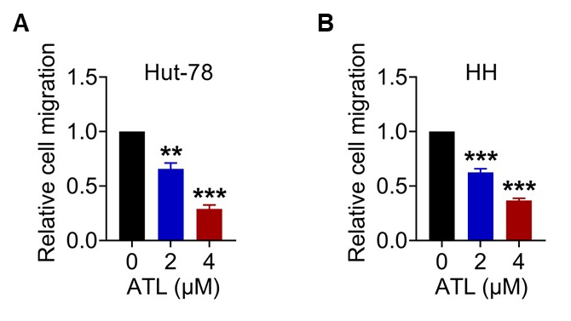
Supplementary Fig1. ATL inhibits the migration of TCL cells. A-B. TCL cells were treated with ATL for 24 h, and the migration capacity was determined by chamber migration assays. ***p < 0.001

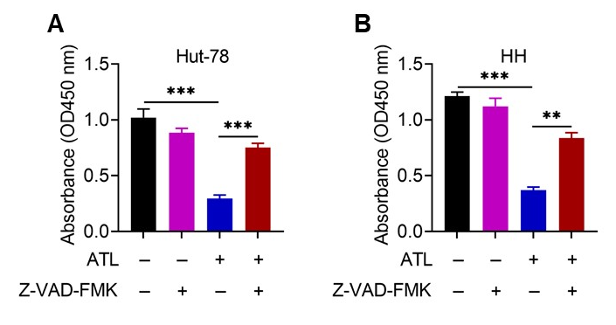
Supplementary Fig2. Alantolactone induces apoptosis in TCL cells. A-B. TCL cells were pre-incubated with or without Z-VAD-FMK (50 μM) for 1 h, and then treated with ATL (4 µM), cell viability was measured using the CCK-8 assay at 72 h.

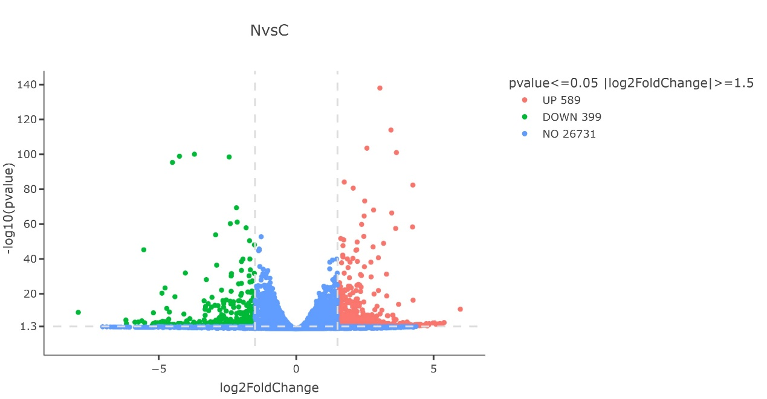
Supplementary Fig3 Differential gene analysis of TCLcells treated by control or ATL.

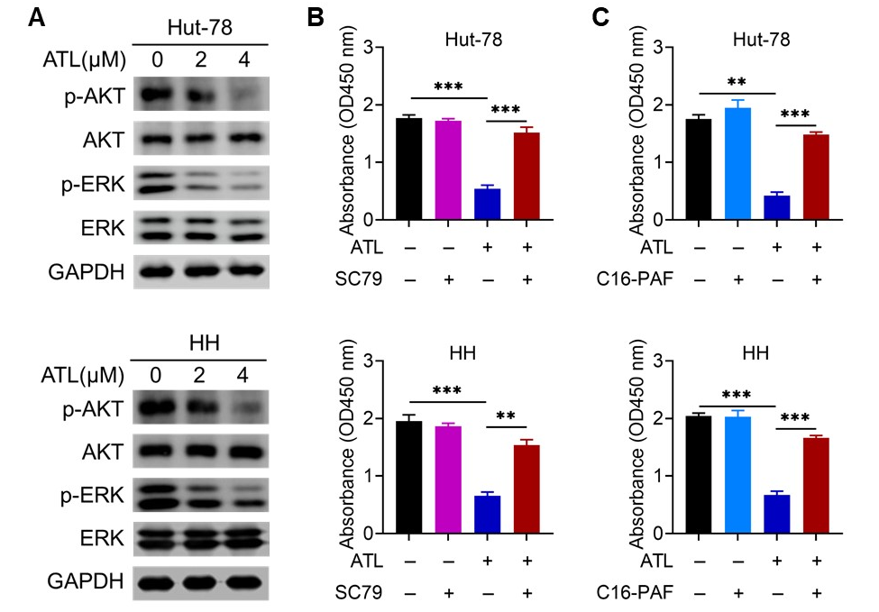
Supplementary Fig4. The PI3K/AKT and ERK signaling axis mediates the anti-TCL effect of ATL. A. Western blot analysis of p-AKT, AKT, p-ERK, and ERK protein levels in TCL cells treated with ATL for 48 h. B. TCL cells were pretreated with 8 μM AKT activator (SC79) for 1 h prior to ATL (4 µM) treatment. Cell viability was determined by CCK-8 assay at 96 h. C. ERK activator C16-PAF (2 µM) significantly reversed the inhibitory effect of ATL (4 µM) on cell viability.

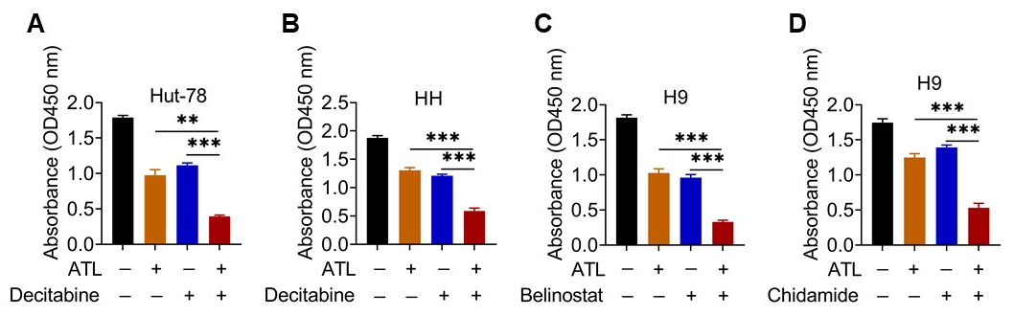
Supplementary Fig5. ATL exerts synergistic effects combined with clinical chemotherapy drugs in TCL. A-B. TCL cells were treated with 2 μM ATL, 0.5 μM decitabine, or the combination of both, and cell viability was determined by CCK-8 assay at 96 h. C-D. The combination of 2 μM ATL and 0.2 µM Belinostat (C) or 0.5 µM Chidamide (D) also synergistically inhibits the proliferation of H9 cells at 96 h.

